Name: Jayesh Gund
PRN: 123A9014
B.E AIML
Ecommerce Product Recommendation using Julius.ai

Aim: To develop and analyze an E-commerce Product Recommendation System using Julius AI by applying association rule mining, content-based filtering, and collaborative filtering techniques on customer-product interaction data.
Theory:
A product recommendation system analyzes customer behavior and product information to suggest products that are likely to be relevant to a customer. In an e-commerce environment, interactions such as product views, cart additions, and purchases can be used to understand customer preferences.
The experiment uses three recommendation techniques:
1. Association Rule Mining: Identifies products that are frequently purchased together. Support measures how often an item combination occurs, confidence measures the likelihood of purchasing one item given another, and lift measures how much stronger the association is than chance.
2. Content-Based Filtering: Recommends products similar to a selected product using product names and categories. TF-IDF converts text into numerical vectors and cosine similarity measures their similarity.
3. Collaborative Filtering: Uses the interaction history of users to identify customers with similar behavior. A user-product interaction matrix and Pearson correlation can be used to find similar users and generate personalized recommendations.
The uploaded synthetic dataset contains 5,000 e-commerce interaction records with Session_ID, User_ID, Product_ID, Product_Name, Category, Interaction_Type, Interaction_Score, and Timestamp. Interaction scores are View = 1, Add to Cart = 3, and Purchase = 5.

Prompts and Output:
Step-by-Step E-Commerce Demonstration Prompts
Run these three sequential phases in Julius AI to show how modern retailers like Amazon or Shopify drive up to 35% of their total revenue using recommendation engines.
🛍️ Phase 1: Frequently Bought Together (Association Rule Mining)
Demonstrate cross-selling based on transaction frequency, introducing the mathematical concept of Support and Confidence (Market Basket Analysis).
- Prompt to type into Julius AI:
"Analyze the dataset transactions. Find pairs of products that are most frequently purchased together in the same session or by the same User_ID. Calculate their association scores and display a horizontal bar chart of the top 5 'Frequently Bought Together' item pairs."
- The AI's Output: Julius will compute the transaction co-occurrences and present a neat bar chart showing pairings like (Smartphone, Screen Protector) or (Coffee Maker, Coffee Filters).
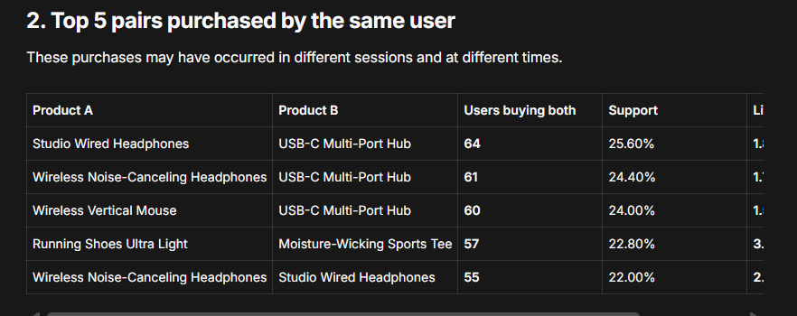
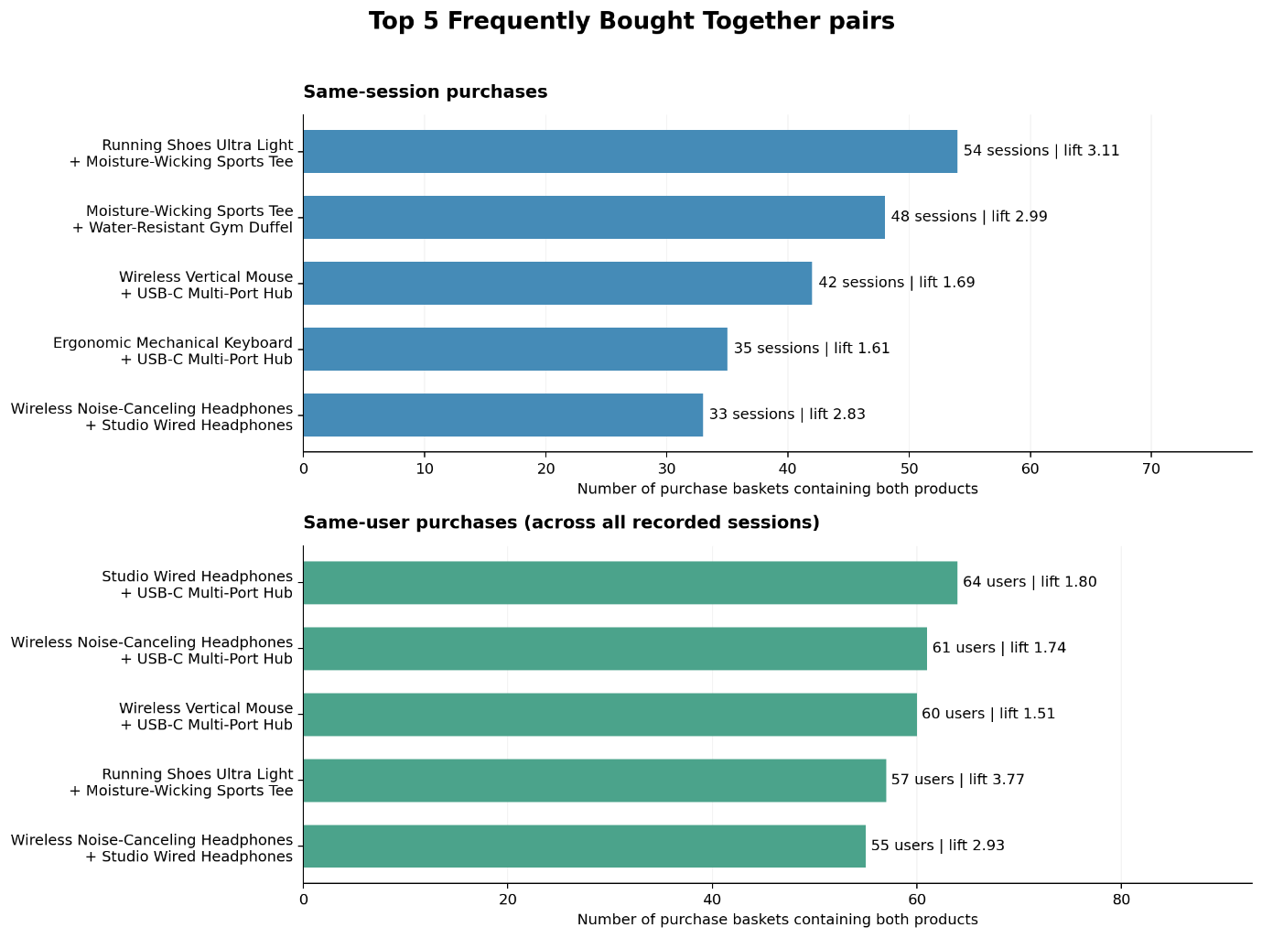
🎯 Phase 2: "You Might Also Like" (Content-Based Filtering via Cosine Similarity)
Demonstrate how the platform recommends highly similar items based strictly on text matching and categorization vectors when a user is actively viewing a single product page.
- Prompt to type into Julius AI:
"Create a content-based recommendation system using the 'Category' and 'Product_Name' columns. Apply Term Frequency-Inverse Document Frequency (TF-IDF) vectorization to the text. If a customer is viewing 'Wireless Noise-Canceling Headphones', calculate the Cosine Similarity and output the top 5 most similar items."
- The AI's Output: The system transforms the descriptive words into vectors, applies the Cosine Similarity formula, and populates an alternative product slider containing other audio gear or accessories.
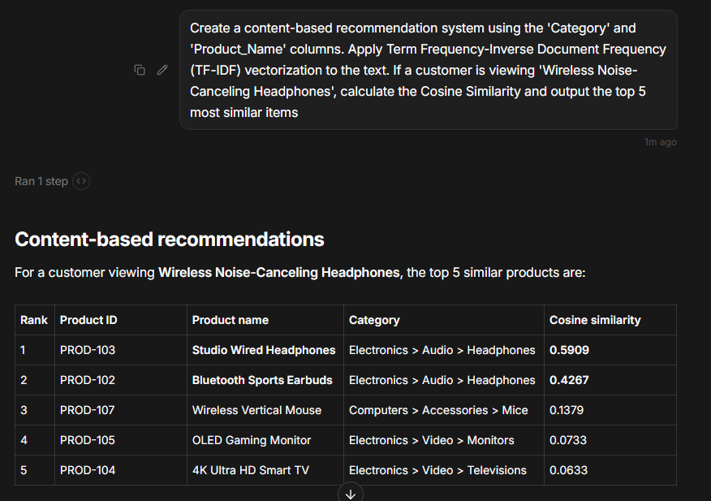
Phase 3: "Customers Who Bought This Also Bought..." (User-Item Collaborative Filtering)
Conclude by demonstrating how the platform surfaces highly personalized recommendations by identifying "lookalike" shoppers using behavioral history.
- Prompt to type into Julius AI:
"Pivot the data into a User-Product interaction matrix where the cells contain the 'Interaction_Score'. Apply a k-Nearest Neighbors (k-NN) algorithm using Pearson Correlation to identify users with identical shopping patterns to User_ID 101. Predict the top 5 products User 101 has not interacted with yet but is highly likely to buy."
- The AI's Output: Julius generates a custom dashboard for User 101, complete with predicted affinity scores, proving how big data can surface items a customer didn't even know they wanted.
- 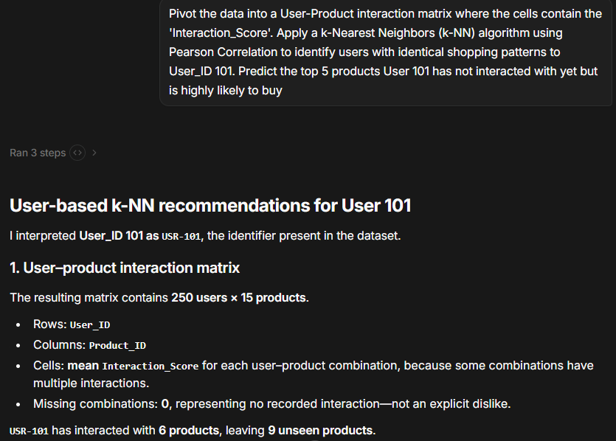
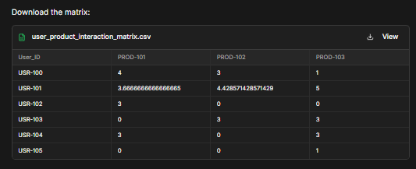
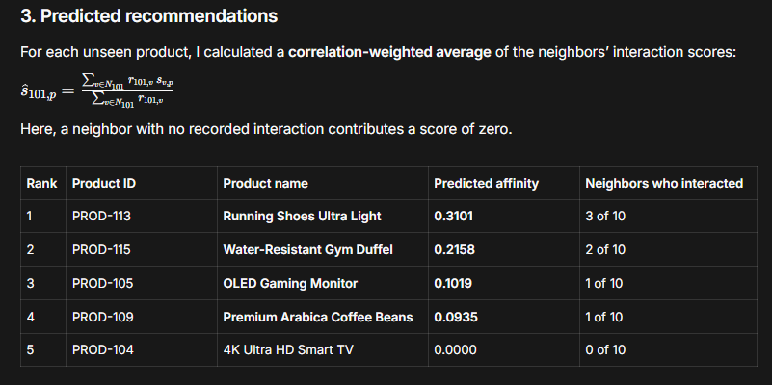
Conclusion:
The E-commerce Product Recommendation System was analyzed successfully using Julius AI and the provided 5,000-record dataset. Association rule mining identified products that occur together in purchase sessions, content-based filtering identified similar products using TF-IDF and cosine similarity, and collaborative filtering generated personalized recommendations from similar users. The experiment demonstrates how customer interaction data can be transformed into useful product recommendations for e-commerce applications.

