**AI-Powered Sustainable Agriculture**

|  |  |  |
| --- | --- | --- |
| **Guide Name** | | **Panel Head** |
|  | Dr D Saisanthiya | Subaja Chritra |
|  |  |  |
|  | **Faculty Advisor** | **Project Domain** |
|  | Dr K Meenakshi | AIML |
| M |  |  |
|  | **Student(s) Details: Name** | **Passport size photo(s)** |
|  | 1. Jayesh Poonia 2. Vedika Singh |  |
|  |  |  |

Registration Number(s)

1. RA2111030010261

2. RA2111030010295

**Email ID(s)&Mobile Number(s)**

|  |  |
| --- | --- |
| 1: jp0102@srmist.edu.in | 2: vt3264@srmist.edu.in |

**Abstract Architecture Diagram**

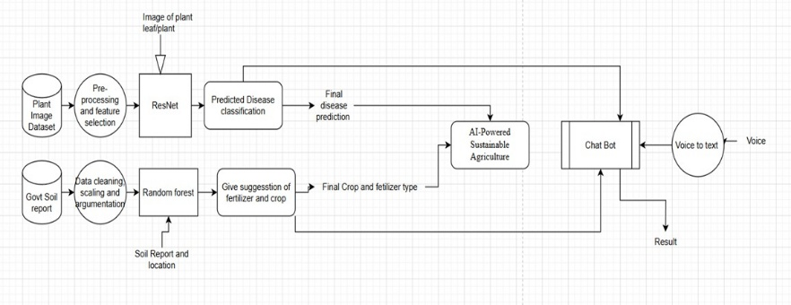

The system integrates three core modules: plant disease detection, crop recommendation, and an intelligent chatbot assistant. Plant disease detection is performed using a convolutional neural network based on the ResNet9 architecture, which analyzes leaf images to accurately identify a range of crop diseases. For crop recommendation, the system employs a Random Forest classifier, trained on agronomic datasets to suggest optimal crops based on soil type, climate conditions, and other environmental parameters. To enhance accessibility and farmer engagement, the platform includes a BERT-based chatbot that provides real-time, context-aware responses to agricultural queries. The chatbot is further enriched with domain-specific knowledge extracted from the Kissan Call Center (KCC) database, ensuring relevance and reliability in responses. This integrated AI solution aims to improve crop yield, reduce losses due to disease, and empower farmers through intelligent, data-driven support tailored to the Indian agricultural landscape.

**Significance of the Project Conclusion**

This project is significant as it brings together advanced AI techniques to tackle key challenges in Indian agriculture. By combining ResNet9-based plant disease detection, Random Forest crop recommendation, and a BERT-powered chatbot trained on Kissan Call Centre (KCC) data, the system provides accurate diagnosis, tailored crop suggestions, and real-time support to farmers. This integration promotes sustainable farming, improves crop yield, and empowers farmers with accessible, data-driven decision-making tools.

the AI-Powered Sustainable Agriculture system offers a practical and scalable solution to enhance farming practices. By integrating disease detection, crop recommendation, and a smart chatbot, it supports farmers with timely, accurate, and relevant information, ultimately contributing to improved productivity and sustainable agriculture.

**Conference/Journal Publication Details (Mandatory)**

ICDSBS'25 [**2nd IEEE International Conference on Data Science And Business Systems**](https://cmt3.research.microsoft.com/IEEEICDSBS2025)