WEEK 5 — FINAL PROJECT REPORT
WeatherAUS: End-to-End Rainfall Analysis and Strategic Decision Support
Comprehensive Data Science Internship Project
Weeks 1–5 | Australian Weather Dataset

Project element | Details
Dataset | weatherAUS.csv
Observations | 142,193
Features | 24
Locations | 49
Date range | 2007-11-01 to 2017-06-25
Target | RainTomorrow
Baseline ML model | Logistic Regression
Final test ROC-AUC | 0.8726
Prepared as the final integrated technical and strategic submission.

Contents
- 1. Executive Summary
- 2. Project Introduction
- 3. Business / Research Problem
- 4. Project Objectives
- 5. Dataset Description
- 6. Complete Methodology
- 7. Week 1 – Data Preparation and EDA
- 8. Week 2 – Exploratory Visualization and Storytelling
- 9. Week 3 – Statistical Analysis
- 10. Week 4 – Machine Learning
- 11. Integrated Key Findings
- 12. Strategic Recommendations
- 13. Business Impact / Practical Applications
- 14. Risk and Error Analysis
- 15. Limitations
- 16. Future Scope
- 17. Technology Stack
- 18. Project Workflow
- 19. Code Highlights
- 20. 30–35 Hour Workload
- 21. Conclusion
- 22. References

1. Executive Summary
This report is the final comprehensive submission for the WeatherAUS data science project. It integrates the progression from data preparation and exploratory analysis in Week 1, through visual storytelling in Week 2, formal statistical testing in Week 3, and supervised machine learning in Week 4. Week 5 synthesizes those findings into decision-oriented recommendations.
The project shows that next-day rainfall is a multivariable and context-dependent phenomenon. The dataset contains 142,193 observations across 49 Australian locations, with approximately 22.4% of valid RainTomorrow outcomes labelled Yes. Data quality is primarily affected by missing values, with 316,559 missing cells (9.28% of all cells), especially in Sunshine, Evaporation and cloud-cover variables. Rainfall is highly right-skewed, and seasonal and atmospheric conditions provide useful signals.
The strongest statistical evidence concerns Humidity3pm. The rain-tomorrow group has a mean of 68.80% versus 46.51% for the no-rain-tomorrow group, a difference of 22.29 percentage points. The Welch t-test reported t=182.608 with p≈0, a 95% confidence interval of [22.05, 22.53], and Cohen's d=1.198. The Week 3 logistic model also reported a humidity odds ratio of 1.0675 per one-percentage-point increase.
The Week 4 Logistic Regression baseline achieved 79.40% accuracy, 52.75% precision, 77.68% recall, 62.83% F1 and 87.26% ROC-AUC on the held-out test set. Its recall-oriented performance is useful for decision-support scenarios where missed rain is more costly than false alarms. However, it is not a production weather forecast and should be combined with current observations/forecast services before operational use.
The recommended strategic direction is therefore a probability-based, location- and season-aware decision-support system. Such a system should prioritize recall when necessary, expose uncertainty, incorporate real-time weather information, compare stronger nonlinear algorithms, and be retrained and monitored over time.

2. Project Introduction
The WeatherAUS project uses historical Australian weather observations to demonstrate a complete data science lifecycle. The project deliberately moves from descriptive understanding to explanation, statistical validation, prediction, and finally strategic interpretation. This sequencing reduces the risk of building a model before understanding the data and provides a defensible narrative for stakeholders.
The final objective is not to replace official meteorological forecasting. Instead, it is to demonstrate how historical observations can support rainfall-risk screening and planning for weather-sensitive activities.

3. Business / Research Problem
The central research problem is whether weather observations available for the current day contain useful information about whether rainfall will occur tomorrow. The corresponding business problem is how those signals can be translated into practical decisions when outdoor activities, travel, logistics, agriculture, tourism or maintenance may be disrupted by rain.
- Research question: Can historical weather observations provide useful information for RainTomorrow?
- Statistical question: Does Humidity3pm differ significantly between rain-tomorrow and no-rain-tomorrow observations?
- Operational question: How should prediction errors and uncertainty be handled when rain alerts affect real-world plans?

4. Project Objectives
- Acquire, inspect and clean the WeatherAUS dataset.
- Quantify missingness, duplicates, data types and descriptive patterns.
- Communicate rainfall patterns through a coherent visualization story.
- Formally test the relationship between afternoon humidity and next-day rainfall.
- Develop an interpretable binary classification baseline for RainTomorrow.
- Prevent target leakage by excluding RISK_MM from prediction.
- Evaluate performance with accuracy, precision, recall, F1-score, ROC-AUC and a confusion matrix.
- Translate findings into actionable strategic recommendations.
- Document limitations and define a realistic future improvement roadmap.

5. Dataset Description
Property | Reported value
Rows | 142,193
Columns | 24
Locations | 49
Date range | 2007-11-01 to 2017-06-25
Duplicate rows | 0
Missing cells | 316,559 (9.28%)
Target balance | ~77.6% No / 22.4% Yes
Key variables include temperature, rainfall, humidity, pressure, wind, cloud cover, location and categorical rain indicators. Date identifies the observation in time. RISK_MM requires special treatment because it represents future rainfall information and therefore must not be used as an input for a realistic RainTomorrow prediction.

6. Complete Methodology
- Data acquisition and structural inspection using Pandas.
- Duplicate detection and preservation of original observations when no exact duplicates are present.
- Missing-value profiling and explicit review of high-missingness variables.
- Date conversion to datetime for temporal interpretation.
- EDA using descriptive statistics, distributions, scatter plots, box plots and correlation analysis.
- Outcome-focused visualizations after excluding observations without a valid RainTomorrow label.
- Welch independent-samples t-test for Humidity3pm group means.
- 95% confidence interval and Cohen's d for magnitude and uncertainty.
- Chi-square test for RainToday versus RainTomorrow.
- One-predictor logistic regression to quantify humidity association.
- Week 4 preprocessing pipeline with median numerical imputation, most-frequent categorical imputation, one-hot encoding and numerical standardization.
- Stratified 80/20 train-test split with random_state=42.
- Balanced Logistic Regression baseline evaluated on the held-out test set.
- Error analysis focused on false positives and false negatives.
- Week 5 synthesis into operational recommendations, impact, risk controls and future scope.

7. Week 1 – Data Preparation and EDA
Week 1 established the data-quality foundation. No exact duplicate rows were found. Missingness was the dominant quality issue: Sunshine had 67,816 missing values (47.69%), Evaporation 60,843 (42.79%), Cloud3pm 57,094 (40.15%) and Cloud9am 53,657 (37.74%). The report explicitly cautions against replacing rainfall missing values with zero because zero has a real meteorological meaning.
Rainfall was strongly right-skewed: the median was 0.0 mm and the maximum was 371 mm. The analysis therefore treated extreme rainfall as potentially meaningful events rather than automatically deleting them.
The EDA also identified a meaningful outcome imbalance and useful relationships. RainTomorrow was approximately 77.6% No and 22.4% Yes. When RainToday was No, the observed proportion of RainTomorrow=Yes was about 15.2%; when RainToday was Yes, it was about 46.4%.
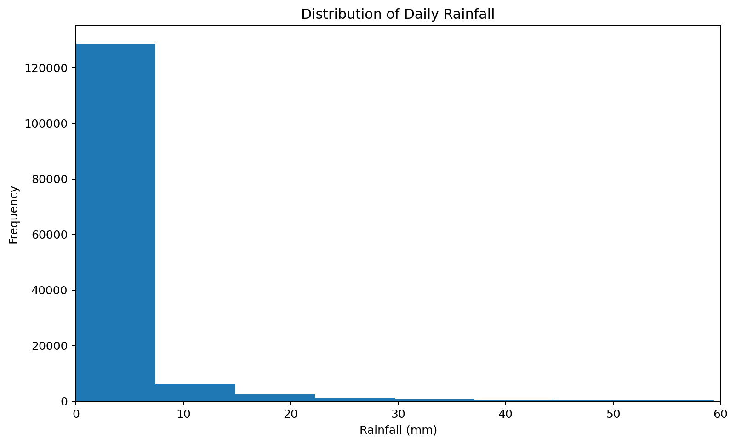
Figure 1. Week 1 rainfall distribution (source: supplied Week 1 repository).
Week 1 conclusion: the dataset is sufficiently rich for predictive work, but downstream modeling must use reproducible imputation, preserve categorical meaning, consider skewed variables, and prevent leakage.

8. Week 2 – Exploratory Visualization and Storytelling
Week 2 transformed the exploratory findings into a narrative for a non-technical audience. The story moves from temporal structure, to seasonal risk, to atmospheric conditions, and finally to multivariable relationships.
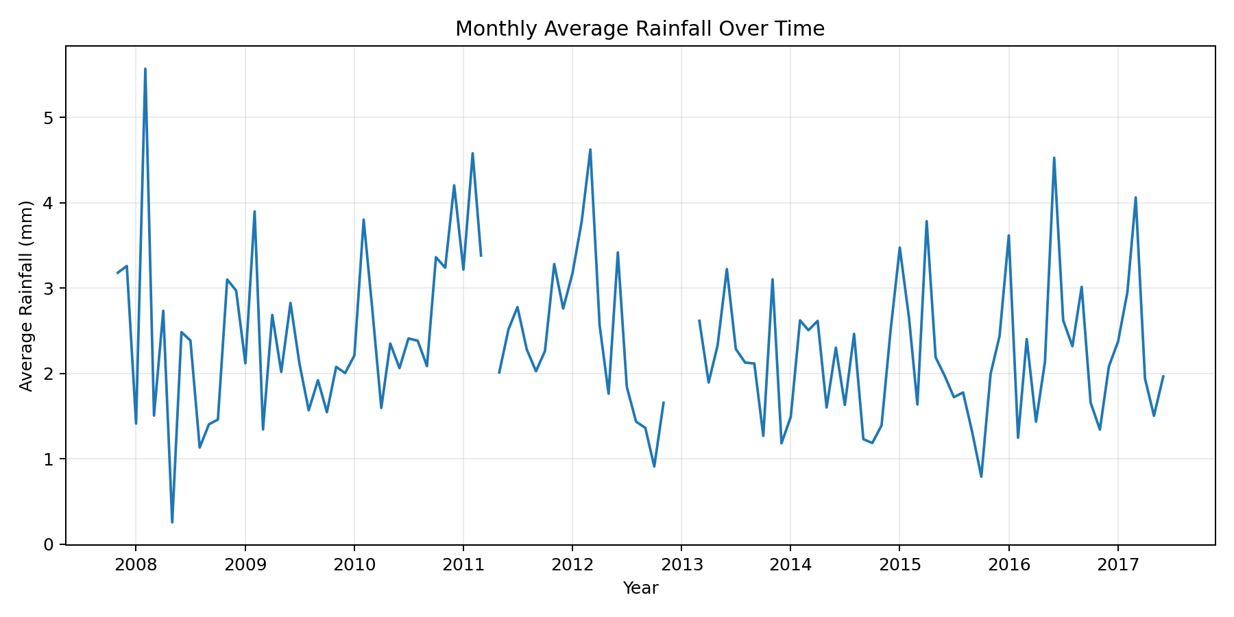
Figure 2. Monthly rainfall trend.
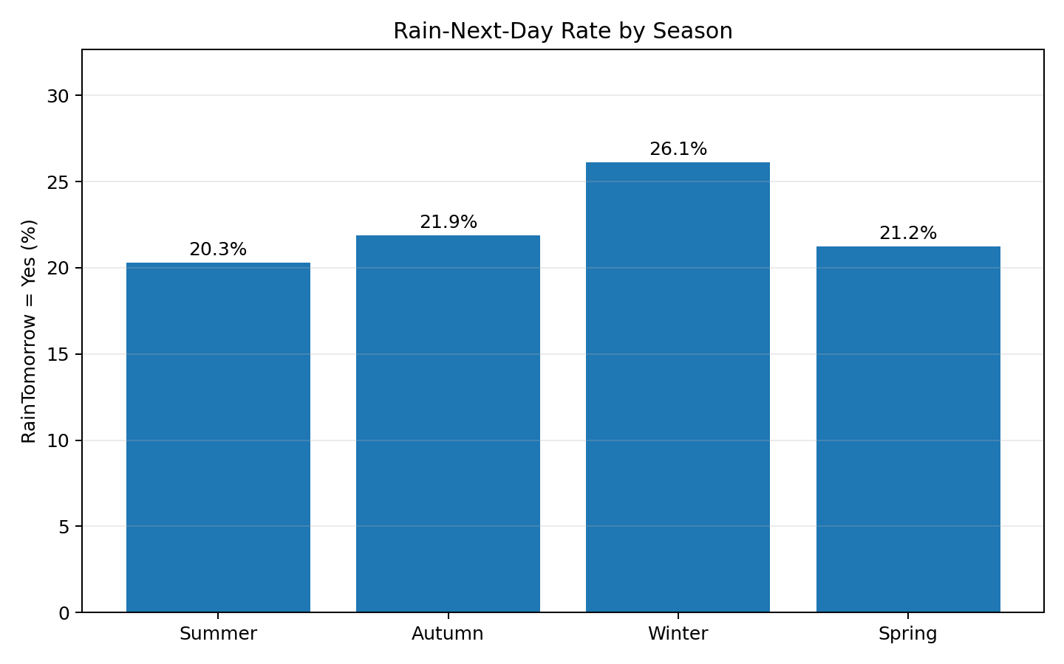
Figure 3. Seasonal next-day rain probability.
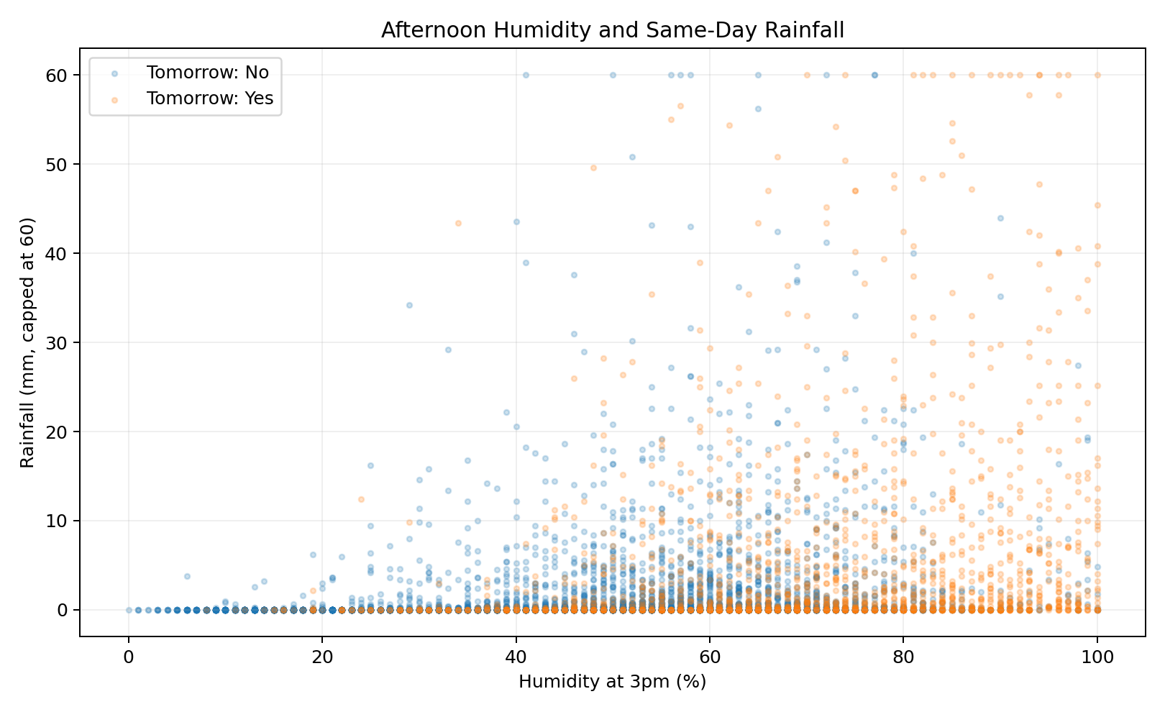
Figure 4. Afternoon humidity and rainfall outcome.
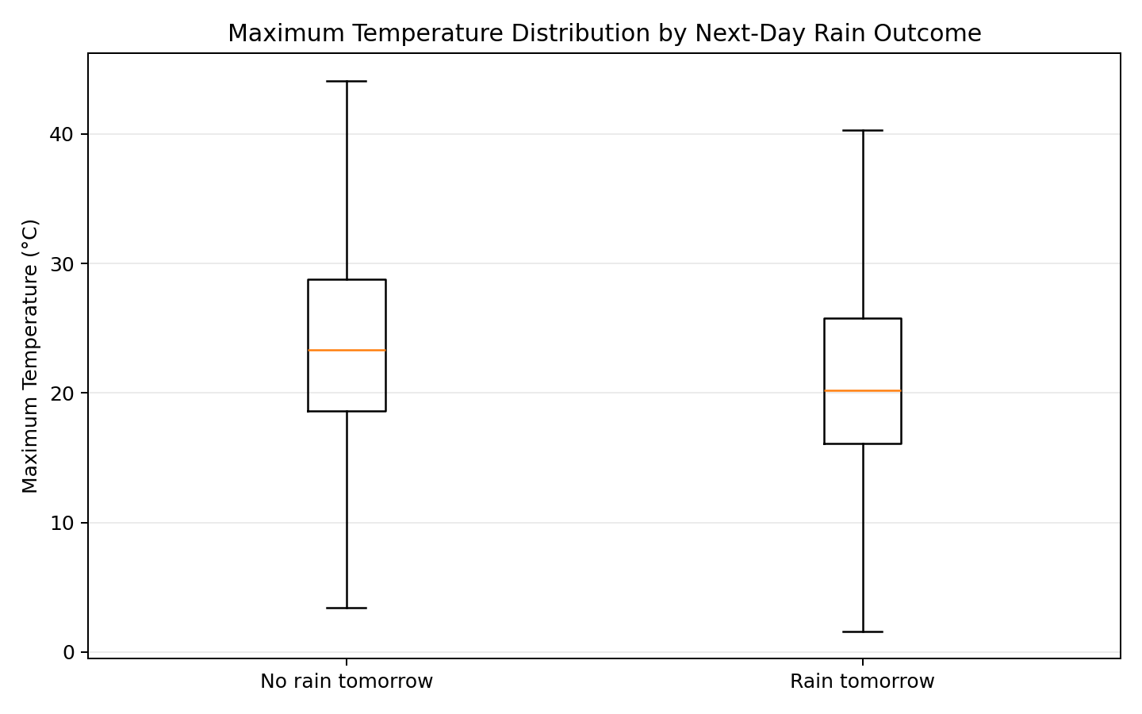
Figure 5. Temperature distribution by next-day rain outcome.
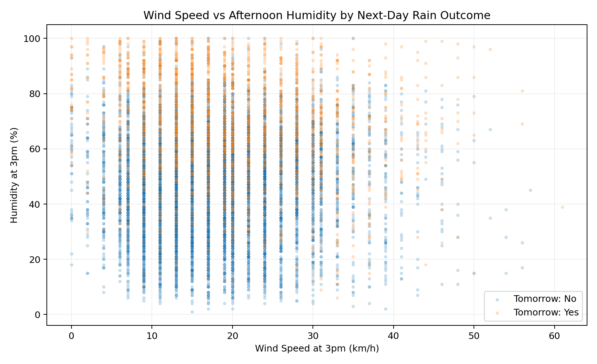
Figure 6. Wind speed and humidity by outcome.
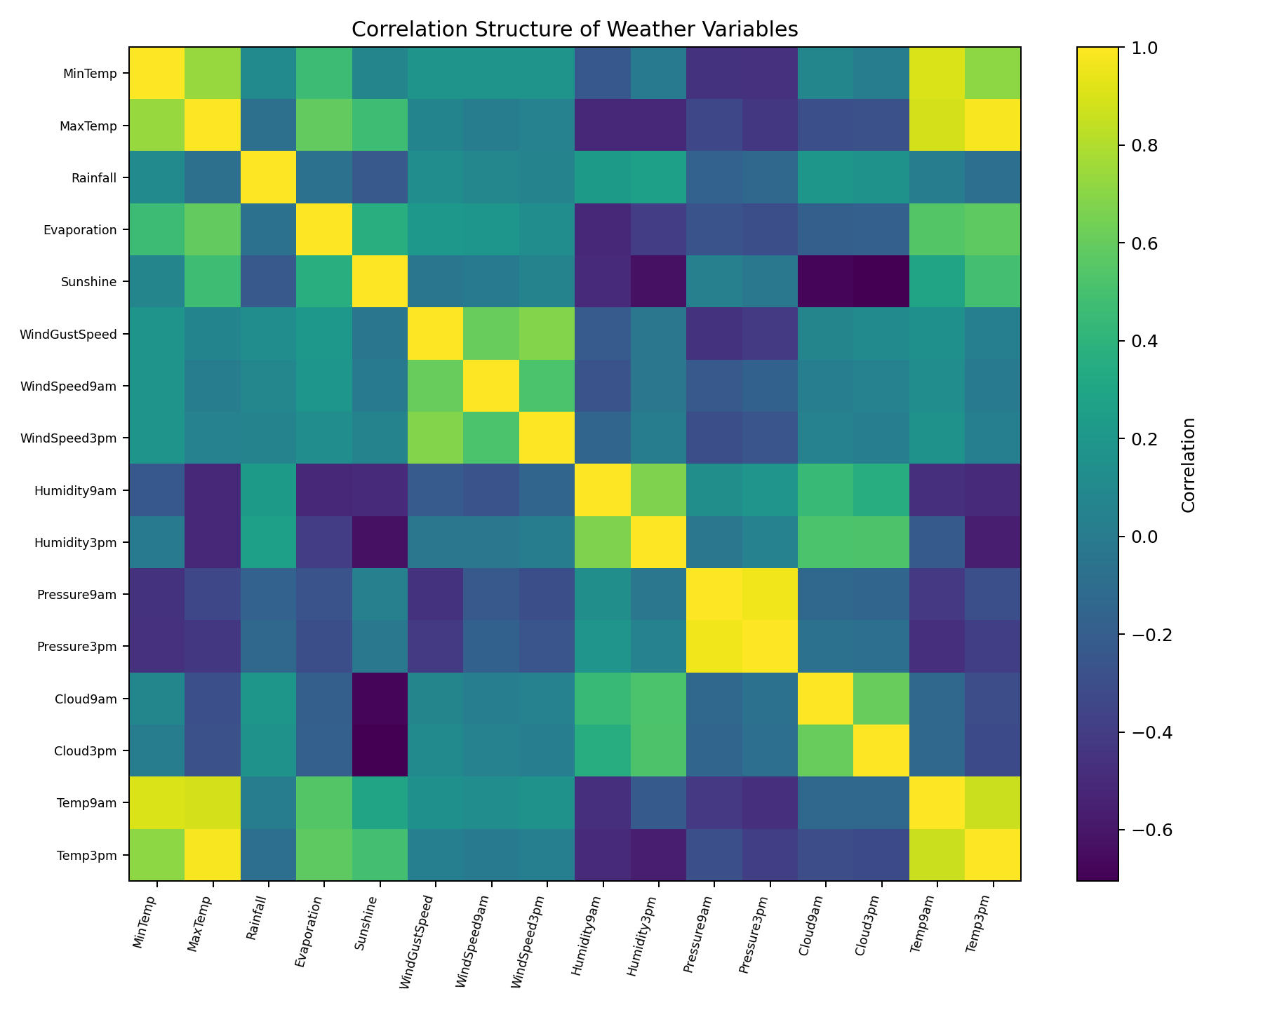
Figure 7. Correlation structure of numerical weather variables.
The most actionable visual finding was that winter had the highest observed next-day rain rate at approximately 26.1%. Afternoon humidity also separated the groups visually: median Humidity3pm was about 70.0% for observations followed by rain versus 47.0% when the next day was dry. Temperature distributions overlapped, reinforcing that rainfall should not be reduced to a single threshold such as 'cold means rain.'

9. Week 3 – Statistical Analysis
Week 3 converted the humidity observation into a formal hypothesis test. After selecting valid RainTomorrow labels and removing missing Humidity3pm values, 138,583 observations were used for the primary t-test.
Analysis | Result | Interpretation
Welch t-test | t=182.608, p≈0 | Reject H0 at α=0.05
Mean difference | 22.29 percentage points | Humidity higher before rainy outcomes
95% CI | [22.05, 22.53] | Difference excludes zero
Cohen's d | 1.198 | Large standardized difference
Chi-square | χ²=13722.841, df=2, p≈0 | RainToday and RainTomorrow associated
Logistic regression | β=0.06533, p≈0 | Humidity statistically significant
Humidity odds ratio | 1.0675 | Odds rise per 1 percentage point, as an association
The statistical evidence is strong, but the report correctly distinguishes association from causation. The data are observational, and a one-predictor logistic model is not a complete rainfall forecasting model.

10. Week 4 – Machine Learning
Week 4 implemented an interpretable Logistic Regression classification pipeline. The target was cleaned to Yes/No, numerical features were median-imputed and standardized, categorical features were most-frequently imputed and one-hot encoded, and the data were split using a stratified 80/20 design. The model used class_weight='balanced' to account for the unequal target classes.
Metric | Score
Baseline accuracy | 0.7758
Accuracy | 0.7940
Precision | 0.5275
Recall | 0.7768
F1-score | 0.6283
ROC-AUC | 0.8726
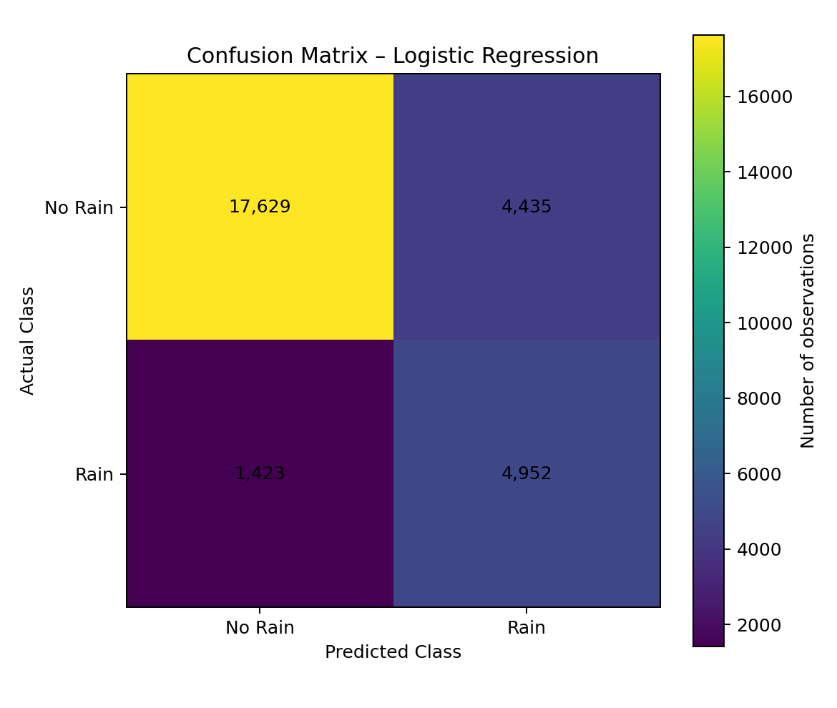
Figure 8. Week 4 confusion matrix.
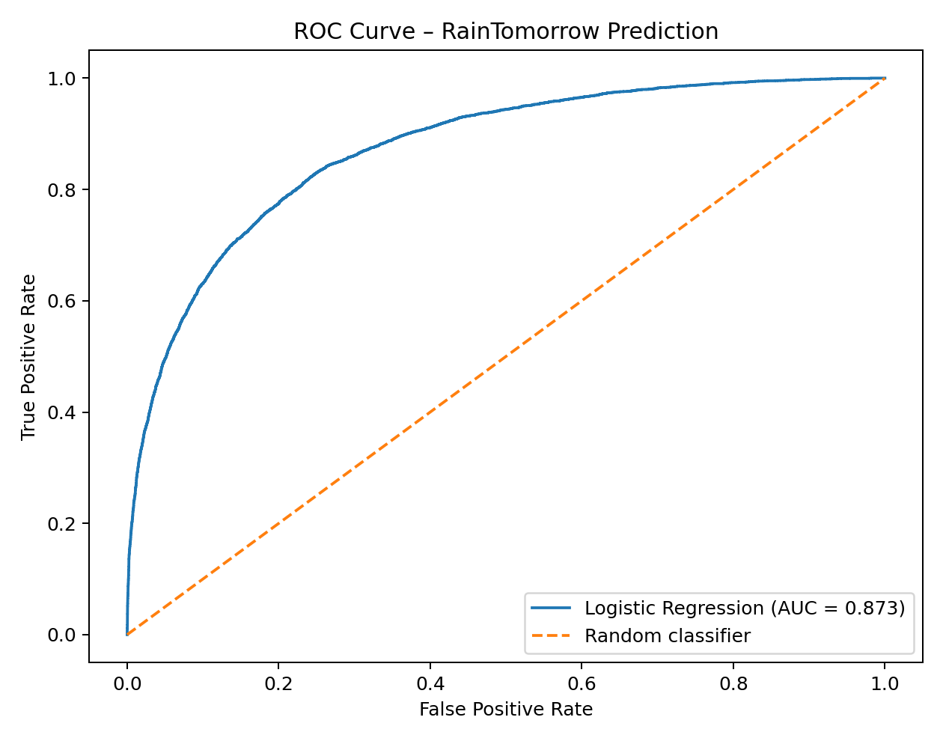
Figure 9. Week 4 ROC curve.
The confusion matrix contains 17,629 true negatives, 4,435 false positives, 1,423 false negatives and 4,952 true positives. Recall of 0.777 means the model detects a substantial majority of actual rainy days, but 1,423 rainy observations in the test set were still missed.
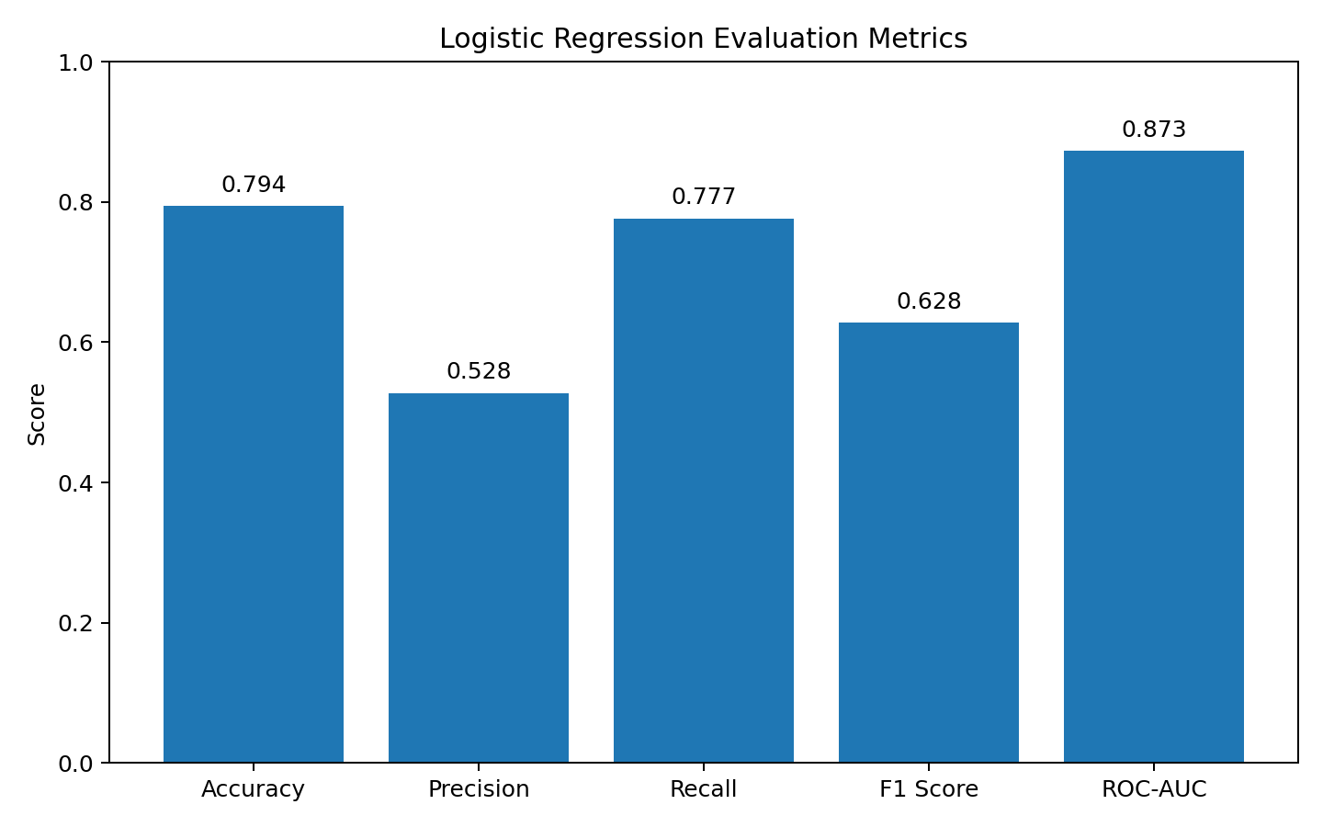
Figure 10. Week 4 model metric comparison.
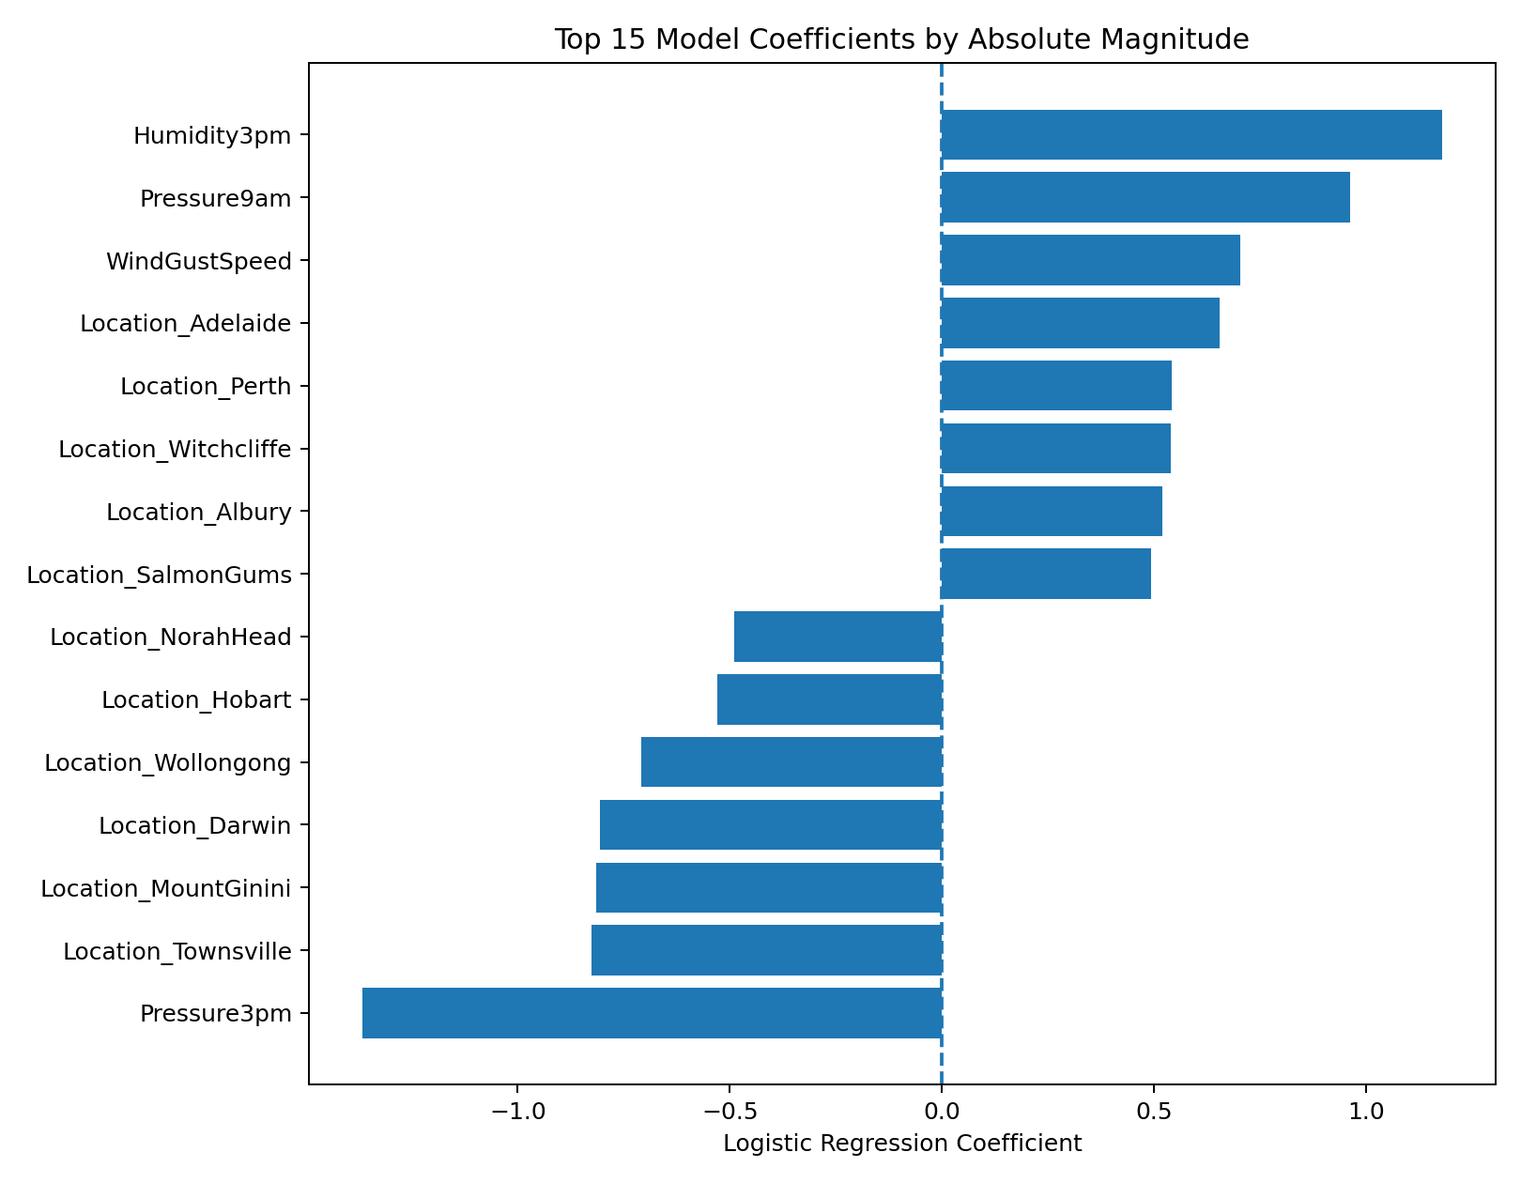
Figure 11. Week 4 leading logistic-regression coefficients.

11. Integrated Key Findings
- Data quality is manageable but missingness must be treated deliberately; high-missingness variables should be reviewed rather than blindly imputed.
- Rainfall is highly skewed and contains rare but important extreme events.
- Rainfall risk varies by season; winter had the highest observed next-day rain rate in the Week 2 analysis.
- Humidity is one of the clearest signals in both visualization and formal statistical testing.
- RainToday and RainTomorrow are statistically associated, supporting the value of temporal/contextual features.
- The ML model substantially improves on the majority-class baseline in accuracy and provides useful discrimination with ROC-AUC of 0.873.
- The model's relatively high recall compared with precision makes it more naturally suited to caution-oriented screening than to low-false-alarm applications.
- Location and nonlinear interactions are likely important because weather relationships differ across Australian regions.
- RISK_MM is a critical leakage risk and must remain excluded from a genuine RainTomorrow prediction pipeline.

12. Strategic Recommendations
Recommendation | Action
1. Build a rainfall-risk decision layer | Use model probabilities to classify conditions as Suitable, Caution or Not Recommended for outdoor activities. Avoid presenting the model as a guaranteed forecast.
2. Prioritize recall where missed rain is costly | For picnics, travel and outdoor events, consider a lower classification threshold if the operational goal is to catch more rainy days, accepting additional false alarms.
3. Combine ML with current weather information | Historical-model predictions should be combined with real-time weather observations and forecast/API data before operational decisions are made.
4. Show probability, not only YES/NO | Expose predicted rain probability and an uncertainty/confidence interpretation so users can make risk-adjusted decisions.
5. Develop location- and season-specific models | Weather relationships differ across Australia. Evaluate models by location and season and consider location/season interactions or specialized models.
6. Benchmark stronger algorithms | Compare Logistic Regression with Decision Tree, Random Forest and XGBoost to capture nonlinear relationships and interactions.
7. Retrain and monitor | Schedule periodic retraining and monitor precision, recall, ROC-AUC and calibration over time to identify temporal drift.
8. Establish leakage and governance controls | Keep future-information fields such as RISK_MM out of predictors, document feature availability at prediction time, and maintain reproducible preprocessing.

13. Business Impact / Practical Applications
- Outdoor planning: support picnic, travel and event decisions with risk-aware recommendations and contingency triggers.
- Tourism and hospitality: use historical/forecast rainfall risk to support staffing, outdoor programming and customer communication.
- Agriculture: provide an additional historical-risk signal for weather-sensitive scheduling, while relying on current forecasts for operational decisions.
- Logistics and maintenance: identify periods where weather risk justifies contingency planning or rescheduling.
- Research: provide a reproducible baseline for studying regional, seasonal and multivariable rainfall patterns.
The main practical value is not the raw prediction label; it is the conversion of weather uncertainty into a structured decision-support signal.

14. Risk and Error Analysis
Risk / error | Evidence | Management response
False negatives | 1,423 rainy test observations missed | Lower threshold / optimize recall for high-risk use cases
False positives | 4,435 dry observations flagged as rain | Use probability bands and tune threshold to business cost
Class imbalance | ~22.4% positive target | Use precision/recall/F1/ROC-AUC, not accuracy alone
Target leakage | RISK_MM contains future information | Exclude it and document feature availability
Regional variation | 49 locations | Evaluate location-wise performance
Temporal drift | Historical observations span 2007–2017 | Use temporal validation and periodic monitoring
Missing data | 9.28% of cells missing | Fit imputation on training data and monitor missingness patterns
A key lesson is that model performance should be evaluated in the context of decision costs. The same threshold is unlikely to be optimal for a casual picnic, a high-value outdoor event, or an agricultural operation.

15. Limitations
- The dataset is observational; statistical association does not establish causality.
- Weather relationships vary by location and season.
- The Logistic Regression model is a baseline and may underfit nonlinear relationships.
- Missing values require assumptions about how observations are missing.
- Results depend on the selected train-test split and classification threshold.
- Historical patterns may not remain constant in future periods.
- The model predicts the dataset's RainTomorrow label and should not be treated as an official meteorological forecast.
- The supplied Week 3 logistic regression is intentionally a one-predictor statistical model, while the Week 4 model is a broader multivariable ML baseline; their coefficients should not be interpreted as interchangeable.

16. Future Scope
- Use time-aware train/validation/test splits to better approximate future forecasting.
- Perform location-wise and seasonal evaluation and calibration.
- Engineer month, season, lagged weather and interaction features where available without leakage.
- Compare Random Forest and XGBoost with tuned hyperparameters.
- Use cross-validation and robust model selection rather than a single split.
- Optimize classification thresholds against explicit false-positive/false-negative costs.
- Evaluate probability calibration before presenting predicted probabilities to stakeholders.
- Create an interactive dashboard or API-backed decision-support application.
- Monitor temporal drift and data-quality changes after deployment.
- Investigate ensemble or hybrid approaches that combine historical ML with current forecast information.

17. Technology Stack
Technology | Role
Python | Core programming language
Pandas / NumPy | Data loading, cleaning and numerical analysis
Matplotlib | Static visualization
SciPy | Hypothesis testing
Statsmodels | Statistical regression
Scikit-learn | Preprocessing, Logistic Regression and model evaluation
Jupyter Notebook | Exploration and reproducible analysis
python-docx | Report generation/documentation
Git/GitHub structure | Versioned project organization

18. Project Workflow
Data Acquisition → Data Understanding → Cleaning & EDA → Visual Storytelling → Statistical Testing → Feature Preparation → Leakage-Controlled ML → Evaluation & Error Analysis → Integrated Findings → Strategic Recommendations → Future Deployment Roadmap
This progression is the central narrative of the five-week internship: exploration establishes what is happening; statistics tests whether an important pattern is unlikely to be random; machine learning combines multiple signals for prediction; Week 5 translates the evidence into decisions and governance.

19. Code Highlights
Week 1 – loading, inspection and leakage-aware preparation:
df = pd.read_csv("weatherAUS.csv")
df["Date"] = pd.to_datetime(df["Date"], errors="coerce")
clean_df = df.dropna(subset=["RainTomorrow"])
clean_df = clean_df.drop(columns=["RISK_MM"], errors="ignore")
Week 3 – Welch t-test and effect size:
rain = d.loc[d["RainTomorrow"]=="Yes", "Humidity3pm"]
no_rain = d.loc[d["RainTomorrow"]=="No", "Humidity3pm"]
t_stat, p_value = stats.ttest_ind(rain, no_rain, equal_var=False)
diff = rain.mean() - no_rain.mean()
Week 4 – leakage-controlled ML pipeline:
drop_cols = ["RainTomorrow", "RISK_MM", "Date"]
preprocessor = ColumnTransformer([
("num", Pipeline([
("imputer", SimpleImputer(strategy="median")),
("scaler", StandardScaler())
]), numeric_features),
("cat", Pipeline([
("imputer", SimpleImputer(strategy="most_frequent")),
("onehot", OneHotEncoder(handle_unknown="ignore"))
]), categorical_features)
])
model = Pipeline([
("preprocessor", preprocessor),
("model", LogisticRegression(
max_iter=1000, class_weight="balanced",
solver="liblinear", random_state=42))
])
The complete reproducible Week 5 pipeline is provided in src/week5_integrated_pipeline.py.

20. 30–35 Hour Workload
Activity | Estimated time
Dataset review and integration of Weeks 1–4 | 3 hours
Data preparation and leakage checks | 5 hours
Visualization and narrative synthesis | 5 hours
Statistical analysis integration | 4 hours
ML pipeline and evaluation integration | 5 hours
Strategic analysis and recommendations | 4 hours
DOC documentation and formatting | 4 hours
Final review and GitHub preparation | 3 hours
Total | 33 hours
The 33-hour plan is consistent with the prescribed 30–35 hour workload and reflects the integrated nature of the final report.

21. Conclusion
The WeatherAUS internship project demonstrates a coherent end-to-end data science workflow. Week 1 established data quality and exploratory understanding; Week 2 communicated temporal, seasonal and atmospheric patterns; Week 3 statistically validated the strong humidity association; and Week 4 demonstrated that multiple weather variables can support useful next-day rainfall classification.
The final model's ROC-AUC of 0.873 and recall of 0.777 show useful predictive discrimination and a meaningful ability to detect rainy observations, but the 4,435 false positives and 1,423 false negatives also demonstrate why prediction must be framed as risk management rather than certainty.
For practical deployment, the strongest recommendation is a probability-based decision-support layer that combines historical ML signals with current weather information, location and season context, explicit cost-sensitive thresholds, and continuous monitoring. The project therefore provides both a defensible technical baseline and a roadmap toward a more robust weather-sensitive planning solution.

22. References
- Australian Weather / WeatherAUS dataset supplied for the internship project.
- Australian Government Bureau of Meteorology – dataset/weather observation context as referenced in the supplied Week 3 report.
- Pandas documentation – data manipulation and analysis.
- NumPy documentation – numerical computing.
- Matplotlib documentation – data visualization.
- SciPy documentation – statistical hypothesis testing.
- Statsmodels documentation – regression and statistical modelling.
- Scikit-learn documentation – preprocessing pipelines, Logistic Regression and classification metrics.

Appendix A – Repository Artifact Map
Folder / file | Purpose
data/weatherAUS.csv | Canonical project dataset
weeks/week1 | Original Week 1 scripts, notebook, visuals and report
weeks/week2 | Original Week 2 scripts, notebook, visuals and report
weeks/week3 | Original Week 3 scripts, notebook, results and report
weeks/week4 | Original Week 4 scripts, notebook, visuals, results and report
src/week5_integrated_pipeline.py | Reproducible final baseline pipeline
visualizations/ | Consolidated visual evidence from Weeks 1–4
results/ | Consolidated statistical/model result tables
reports/ | Prior weekly reports
README.md | GitHub-oriented project overview and reproduction guide

