WEEK 1 DATA SCIENCE PROJECT
Data Acquisition, Cleaning & Exploratory Data Analysis
Australian Weather Dataset (weatherAUS.csv)

Dataset: Australian weather observations
Records: 142,193
Features: 24
Tools: Python, Pandas, NumPy, Matplotlib
Project focus: Data acquisition, cleaning, preprocessing and EDA

1. Introduction
The purpose of this Week 1 task is to simulate a practical data preparation workflow used in a data science project. The selected dataset contains daily weather observations from multiple Australian locations and includes meteorological measurements such as temperature, rainfall, humidity, pressure, wind and cloud cover.
The workflow covers dataset loading, structural inspection, missing-value analysis, duplicate detection, data-type correction, descriptive statistics and exploratory visualization. The final section summarizes the major patterns identified during EDA.

2. Dataset Selection and Acquisition
The weatherAUS dataset was selected because it is sufficiently large and contains both numerical and categorical variables, making it suitable for demonstrating realistic data-cleaning challenges. It also contains a target variable, RainTomorrow, which can support future predictive modeling.
Dataset characteristics:
Property | Value
Rows | 142,193
Columns | 24
Locations | 49
Date range | 2007-11-01 to 2017-06-25
Duplicate rows | 0
Total missing cells | 316,559 (9.28% of all cells)
Initial loading and inspection code:
import pandas as pd
df = pd.read_csv("weatherAUS.csv")
print(df.shape)
print(df.head())
print(df.info())
print(df.describe(include="all"))

3. Data Understanding
The dataset contains 24 columns. Date and Location identify the observation, while the remaining variables describe weather conditions. Numerical variables include temperature, rainfall, humidity, pressure, wind speed and cloud cover. Categorical variables include wind directions, RainToday and RainTomorrow.
The original dataset contains 142,193 observations. The Date column was initially stored as an object/string and therefore required conversion to a proper datetime type.
print(df.shape)
print(df.dtypes)
print(df.nunique())
print(df.describe())

4. Data Cleaning and Preprocessing

4.1 Duplicate Records
The duplicate check returned 0 duplicate rows. Because no exact duplicate records were found, no rows were removed. Keeping the original observations avoids unnecessary data loss.
duplicate_count = df.duplicated().sum()
print("Duplicate rows:", duplicate_count)
# Remove duplicates only if present
df = df.drop_duplicates()

4.2 Missing-Value Analysis
The dataset contains 316,559 missing cells, representing approximately 9.28% of all cells. Missingness is concentrated in Sunshine, Evaporation, Cloud3pm and Cloud9am, while several pressure and wind variables also have substantial missing values.
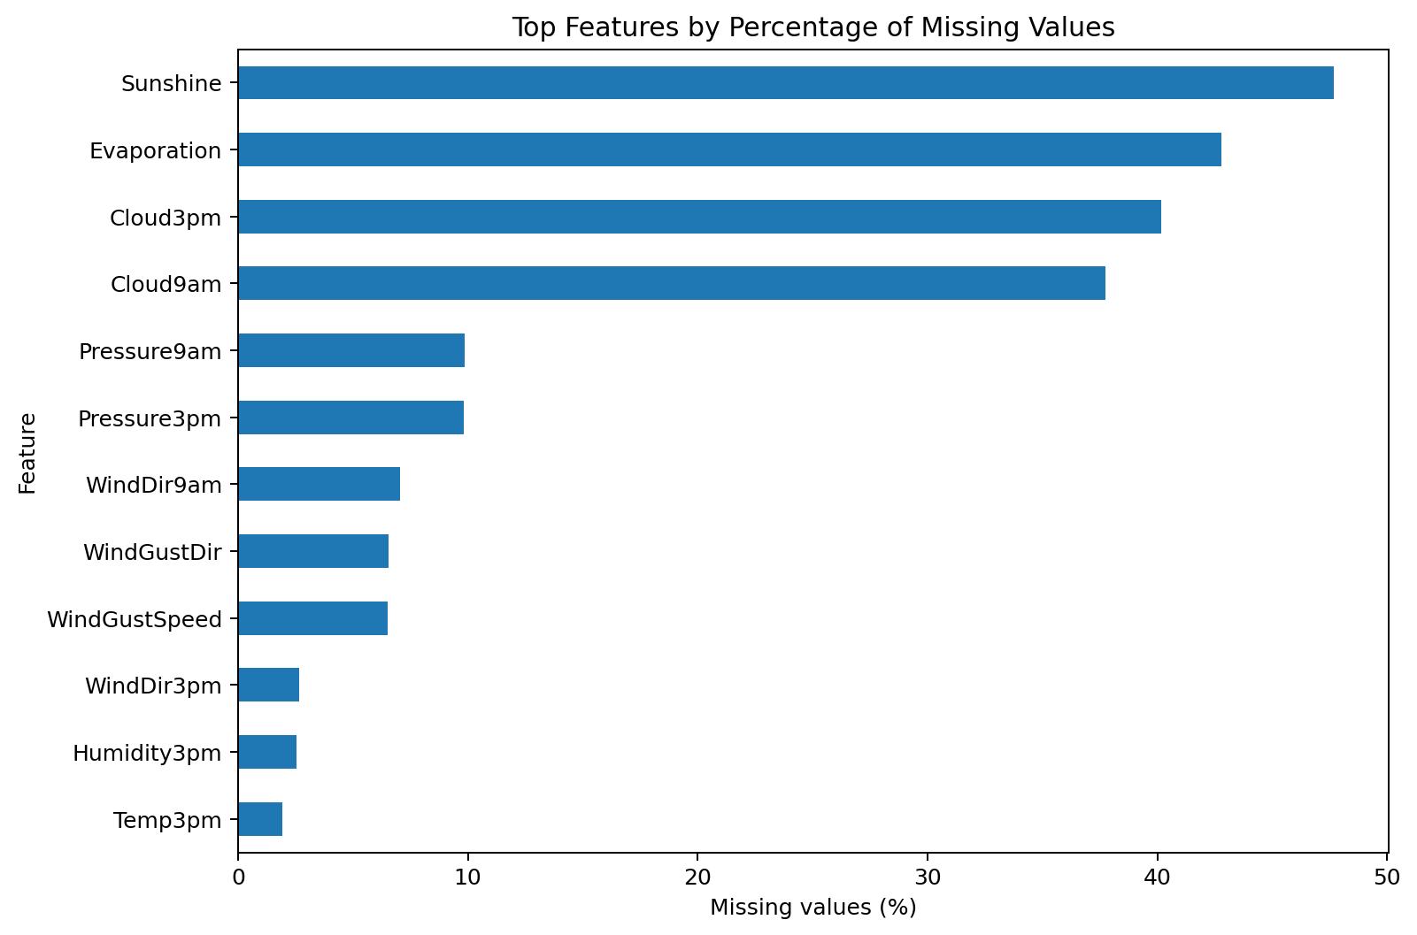
Figure 1. Features with the highest percentages of missing observations.
The principal missing-value counts are:
Feature | Missing values | Missing %
Sunshine | 67,816 | 47.69%
Evaporation | 60,843 | 42.79%
Cloud3pm | 57,094 | 40.15%
Cloud9am | 53,657 | 37.74%
Pressure9am | 14,014 | 9.86%
Pressure3pm | 13,981 | 9.83%
WindDir9am | 10,013 | 7.04%
WindGustDir | 9,330 | 6.56%
WindGustSpeed | 9,270 | 6.52%
WindDir3pm | 3,778 | 2.66%
Cleaning rationale: numerical missing values should not automatically be replaced with zero, because zero has a real meteorological meaning for variables such as rainfall. For a future modeling pipeline, numerical features can be imputed using a training-set median, preferably within location where appropriate, while categorical features can use the most frequent category or an explicit 'Unknown' category. Columns with extremely high missingness should also be reviewed before modeling rather than blindly imputed.
missing = df.isna().sum().sort_values(ascending=False)
missing_pct = (missing / len(df) * 100).round(2)
print(pd.DataFrame({
"missing_count": missing,
"missing_percent": missing_pct
}))

4.3 Data-Type Correction
The Date column was converted from object/string format to datetime. This enables chronological sorting, extraction of year/month/day information, seasonal analysis and time-based visualization.
df["Date"] = pd.to_datetime(df["Date"], errors="coerce")
print(df["Date"].dtype)

4.4 Categorical Variables
Wind direction fields, Location, RainToday and RainTomorrow are categorical variables. Their categories should be preserved rather than numerically imputed. Missing categorical observations can be handled using the most frequent category or an explicit missing/unknown label depending on the requirements of the downstream analysis.
categorical_cols = df.select_dtypes(include="object").columns
print(df[categorical_cols].isna().sum())

4.5 Outlier Considerations
The descriptive statistics show that rainfall is highly right-skewed: the median is 0.0 mm, while the maximum is 371 mm. This indicates that extreme rainfall events exist and should not automatically be deleted as errors. Similarly, temperature ranges should be investigated using domain knowledge before removing observations.
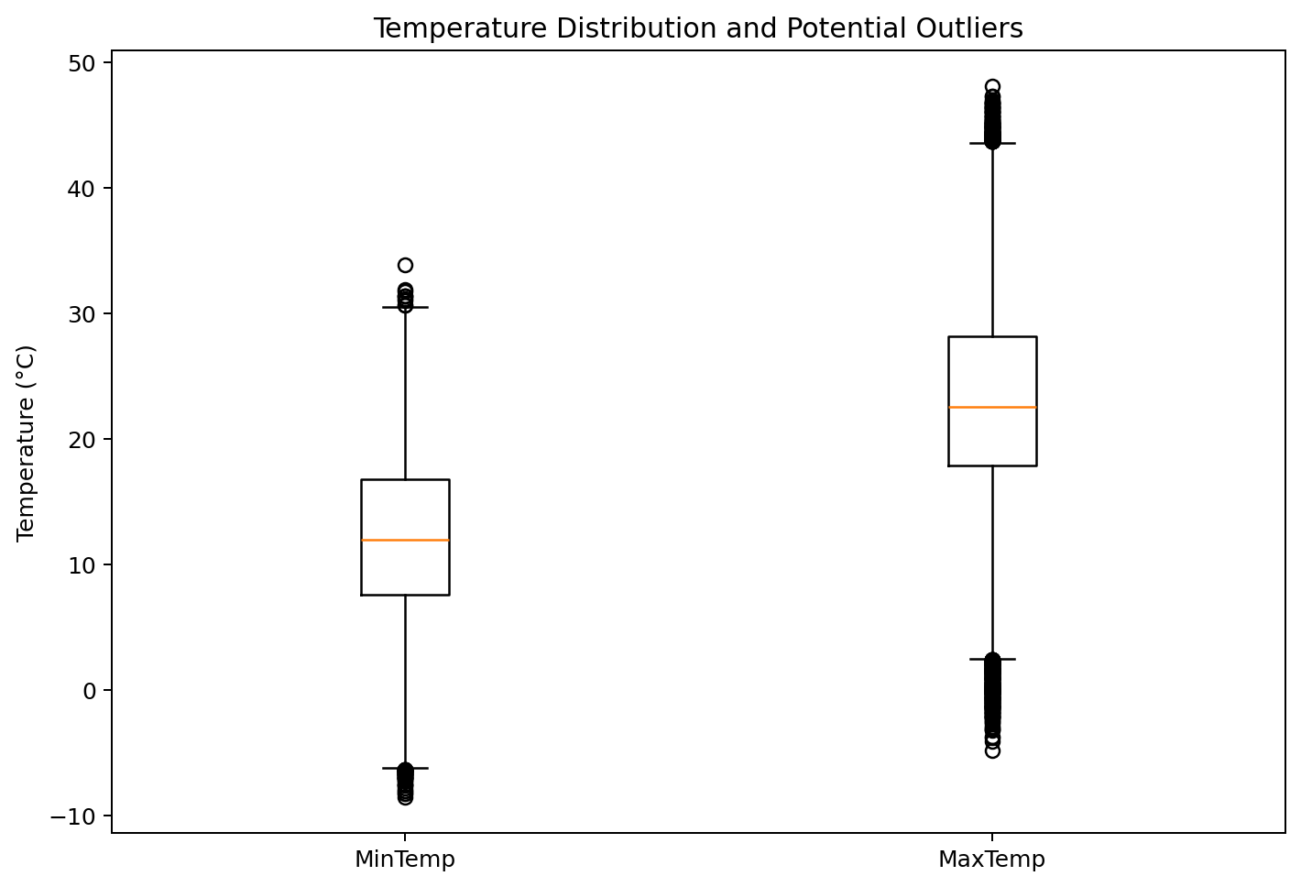
Figure 2. Box plot of minimum and maximum temperature.

5. Exploratory Data Analysis

5.1 Descriptive Statistics
Variable | Mean | Std Dev | Median | Maximum
MinTemp | 12.19 | 6.40 | 12.00 | 33.90
MaxTemp | 23.23 | 7.12 | 22.60 | 48.10
Rainfall | 2.35 | 8.47 | 0.00 | 371.00
Humidity9am | 68.84 | 19.05 | 70.00 | 100.00
Humidity3pm | 51.48 | 20.80 | 52.00 | 100.00
Pressure9am | 1017.65 | 7.11 | 1017.60 | 1041.00
Pressure3pm | 1015.26 | 7.04 | 1015.20 | 1039.60

5.2 Rainfall Distribution
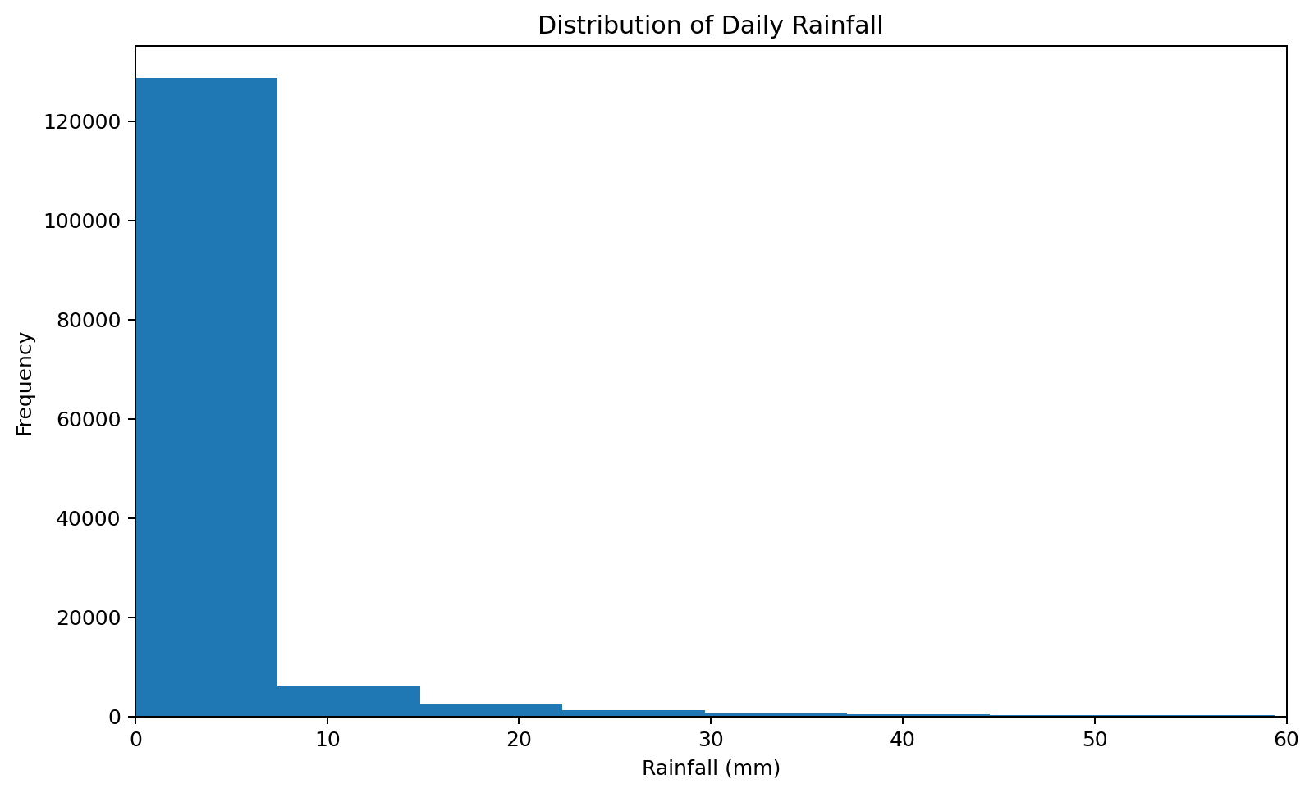
Figure 3. Distribution of daily rainfall, shown up to 60 mm for readability.
Rainfall is strongly concentrated near zero, with a long right tail. This means that most recorded days have little or no rain, while a comparatively small number of days experience heavy rainfall. For later statistical modeling, transformations or robust methods may be useful.

5.3 Humidity and Rainfall Relationship
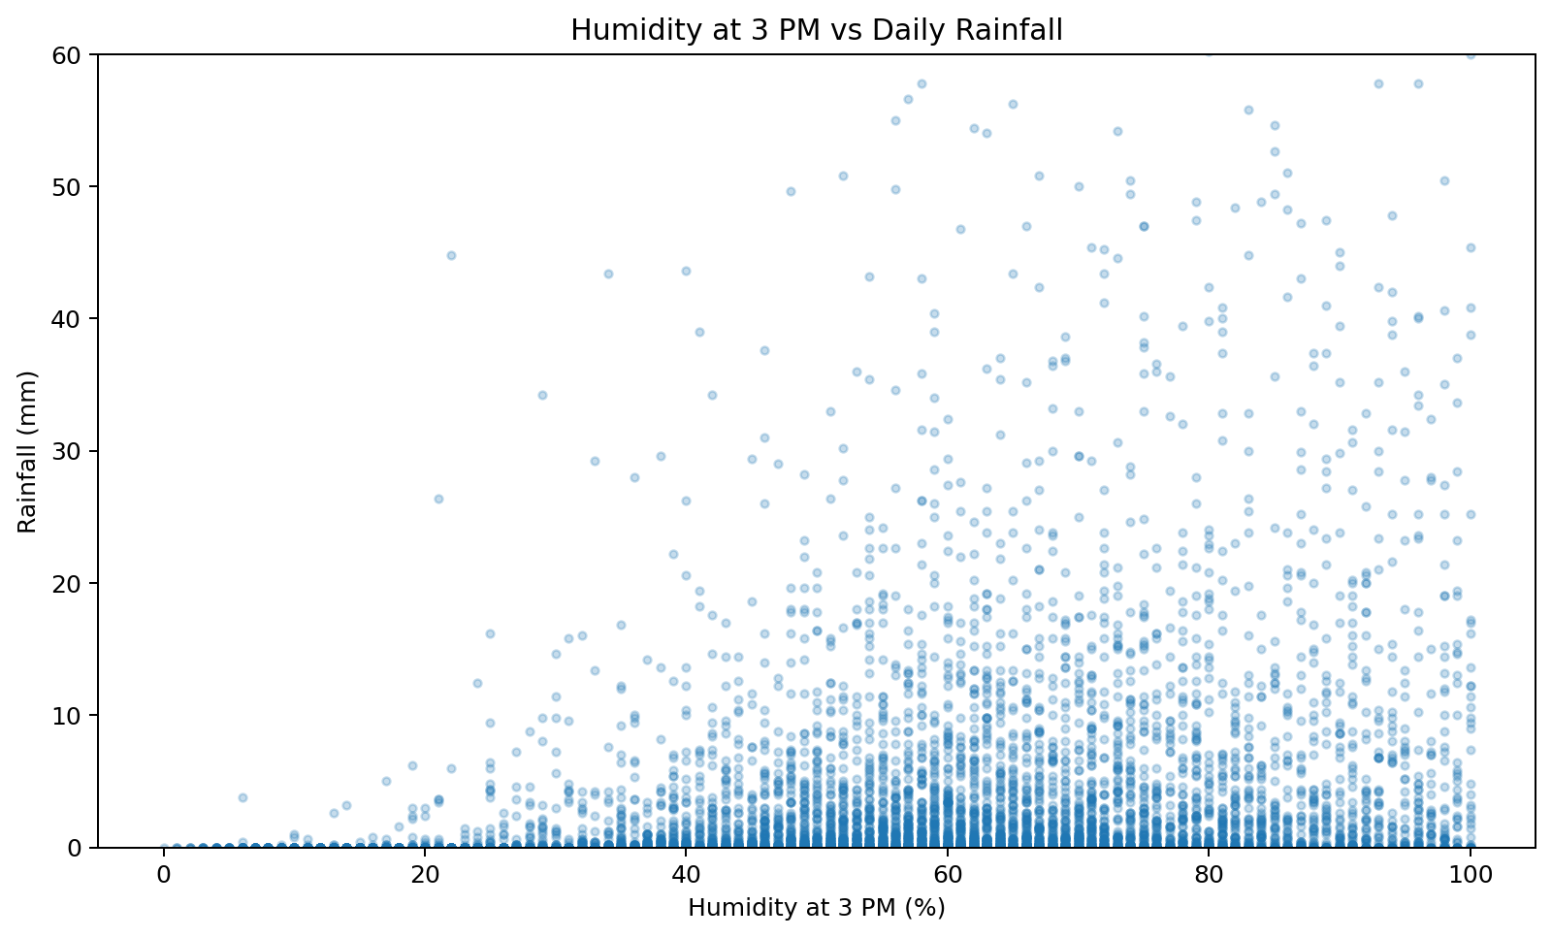
Figure 4. Relationship between 3 PM humidity and daily rainfall.
The scatter plot indicates that higher afternoon humidity is generally associated with greater rainfall occurrence/intensity, although the relationship is not deterministic. Many observations still have low rainfall across a broad humidity range. Therefore, humidity is useful as a predictive feature but should not be interpreted as a direct causal relationship from this EDA alone.

5.4 Correlation Analysis
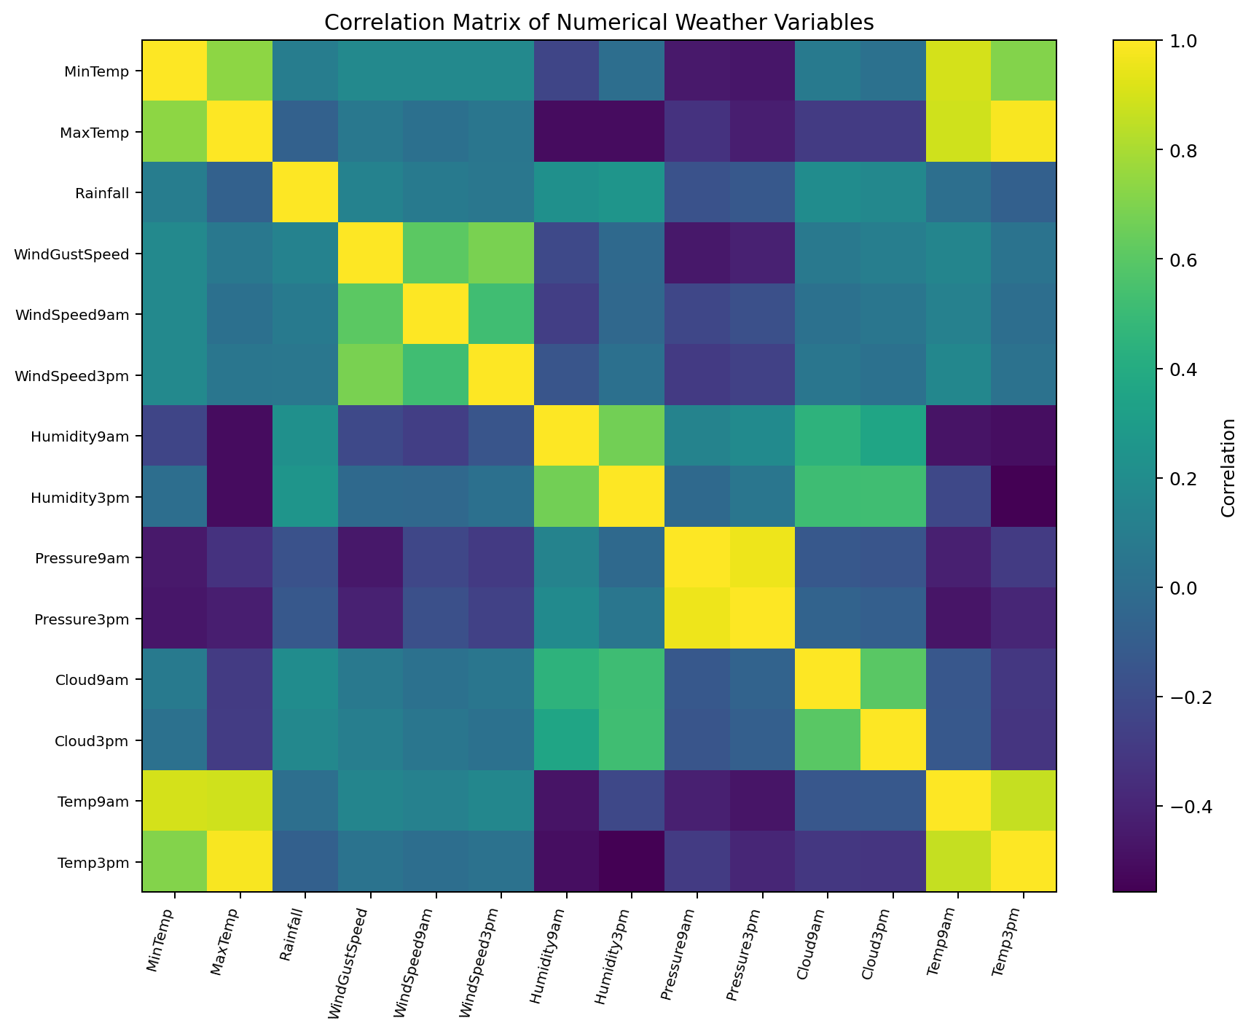
Figure 5. Correlation matrix of selected numerical weather variables.
The correlation matrix helps identify linear relationships and potential redundancy among numerical features. Temperature measurements show strong relationships with other temperature variables, while humidity and cloud-related measurements tend to move together. Correlation is useful for feature screening, but it does not establish causation.

5.5 RainTomorrow Class Balance
RainTomorrow contains approximately 77.6% 'No' and 22.4% 'Yes' observations. This indicates a moderately imbalanced binary target, so future predictive modeling should consider metrics such as precision, recall, F1-score and ROC-AUC rather than relying only on accuracy.

5.6 Relationship Between RainToday and RainTomorrow
When RainToday = No, the observed proportion of RainTomorrow = Yes is approximately 15.2%.
When RainToday = Yes, the observed proportion of RainTomorrow = Yes is approximately 46.4%.

6. Key Insights from EDA
- The dataset is large, with 142,193 observations across 49 locations.
- No exact duplicate rows were detected, so duplicate removal was not necessary.
- Missing values are the main data-quality issue, with approximately 9.28% of all cells missing.
- Sunshine, Evaporation and cloud-cover variables have the largest amounts of missing data and require careful treatment.
- Rainfall is heavily right-skewed: the median is 0 mm while the maximum reaches 371 mm, indicating rare but substantial rainfall events.
- Temperature variables have meaningful ranges and should be checked for domain-validity before any outlier removal.
- Afternoon humidity shows a positive association with rainfall, making humidity potentially useful for future prediction.
- The RainTomorrow target is imbalanced toward 'No', so future classification should use more than accuracy alone.
- RISK_MM should be treated carefully in any future RainTomorrow prediction model because it represents rainfall in the next period and can cause target leakage if used as an input feature.

7. Recommended Cleaning Pipeline for Future Modeling
The following code demonstrates a defensible baseline preprocessing strategy. It is intentionally shown as a pipeline rather than applied destructively to the original file. For machine learning, imputation statistics should be learned only from the training set.
# Work on a copy
clean_df = df.copy()
# Remove exact duplicates
clean_df = clean_df.drop_duplicates()
# Ensure Date is datetime
clean_df["Date"] = pd.to_datetime(clean_df["Date"], errors="coerce")
# Drop rows without the target for supervised learning
clean_df = clean_df.dropna(subset=["RainTomorrow"])
# Prevent target leakage in a RainTomorrow model
clean_df = clean_df.drop(columns=["RISK_MM"], errors="ignore")
# Example numerical imputation
numeric_cols = clean_df.select_dtypes(include="number").columns
clean_df[numeric_cols] = clean_df[numeric_cols].fillna(
clean_df[numeric_cols].median()
)
# Example categorical imputation
categorical_cols = clean_df.select_dtypes(include="object").columns
for col in categorical_cols:
clean_df[col] = clean_df[col].fillna(clean_df[col].mode()[0])

Note: the exact imputation strategy should be selected after understanding the missingness mechanism. For a production machine-learning workflow, use a reproducible preprocessing pipeline and fit all imputation parameters on the training partition only.

8. Conclusion
The Week 1 analysis successfully demonstrated the complete initial data-preparation workflow using the Australian weather dataset. The dataset was loaded and structurally examined, duplicate records were checked, missing values were quantified, the Date field was corrected to datetime, and numerical and categorical variables were identified. Exploratory analysis revealed strong rainfall skewness, substantial missingness in several weather variables, useful relationships between humidity and rainfall, and an imbalanced RainTomorrow target.
The cleaned and documented workflow provides a strong foundation for future feature engineering and machine-learning tasks, such as predicting whether it will rain tomorrow. The next stage should focus on robust train/test splitting, leakage prevention, feature engineering, encoding categorical variables and evaluating predictive models with appropriate classification metrics.

9. 30–35 Hour Work Breakdown
Activity | Estimated time
Dataset research and acquisition | 3 hours
Dataset understanding and documentation | 4 hours
Missing-value and duplicate analysis | 5 hours
Data-type correction and preprocessing design | 4 hours
Exploratory statistical analysis | 5 hours
Visualization development and interpretation | 6 hours
Documentation, formatting and review | 5 hours
Final validation and cleanup | 2 hours

10. Appendix – Core Python Imports
import pandas as pd
import numpy as np
import matplotlib.pyplot as plt
df = pd.read_csv("weatherAUS.csv")
# Inspection
print(df.shape)
print(df.head())
print(df.info())
print(df.describe(include="all"))
# Missing values
print(df.isna().sum().sort_values(ascending=False))
# Duplicates
print(df.duplicated().sum())
# Date conversion
df["Date"] = pd.to_datetime(df["Date"], errors="coerce")

