Week 2 – Advanced Data Visualization and Storytelling with Python
Australian Weather (WeatherAUS) Dataset
Advanced visualization, narrative analysis, and implications

Prepared as an internship Week 2 technical submission

1. Introduction
This project extends the Week 1 WeatherAUS analysis by moving from data quality and exploratory analysis toward visual storytelling. The goal is to communicate weather patterns to a non-technical audience through a sequence of charts that answer progressively more meaningful questions: how rainfall changes over time, which seasons have higher next-day rain rates, which weather conditions are associated with rainfall, and which variables move together. The narrative is designed to support practical interpretation rather than simply display isolated statistics.

2. Dataset and Method
The dataset contains 142,193 records and 24 columns covering observations from 2007-11-01 to 2017-06-25 across 49 locations. For visualization, exact duplicate rows were removed, Date was converted to datetime, rows without a valid RainTomorrow outcome were excluded from outcome-based charts, and missing values were left out only for the specific variables required by each visualization. This preserves as much information as possible while avoiding artificial imputation solely for charting.
Matplotlib was used to create the visualizations. Sampling was used for dense scatter plots so that individual observations remain interpretable. Extreme rainfall values were capped at 60 mm only in the humidity-rainfall scatter plot for visual readability; the underlying dataset was not altered.

3. Data Story: From Pattern to Explanation
The overall story begins with rainfall changing across time and seasons, then moves toward the conditions that distinguish rainy and non-rainy outcomes. In this dataset, 22.4% of valid observations have RainTomorrow = Yes. The visual sequence shows that rainfall is not evenly distributed across time or weather conditions. Humidity, temperature, wind, pressure, and cloud-related variables provide complementary signals.

4. Visualization 1 – Monthly Rainfall Trend
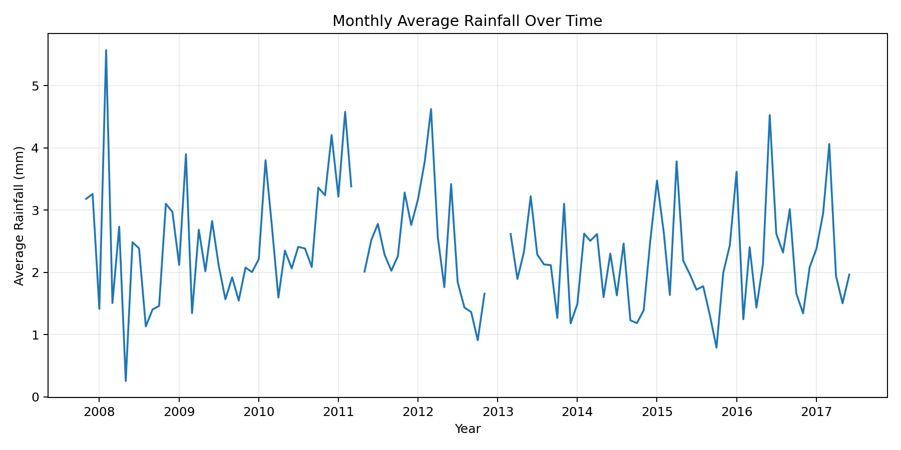
01_monthly_rainfall_trend.png

Why this visualization?
A line chart is used because time is continuous and the objective is to reveal changing patterns across months. The chart makes recurring seasonal behavior and unusually wet or dry periods easier to notice than a table of values.

What the audience should notice
The monthly average rainfall series shows strong variation over the observation period rather than a flat pattern. This supports the idea that rainfall should be interpreted in a seasonal and temporal context. For planning purposes, historical rainfall expectations can therefore differ substantially by time of year.

How it contributes to the story
This is the opening of the narrative: before asking what causes rainfall, we establish that rainfall itself has a clear temporal structure.

5. Visualization 2 – Seasonal Rain Probability
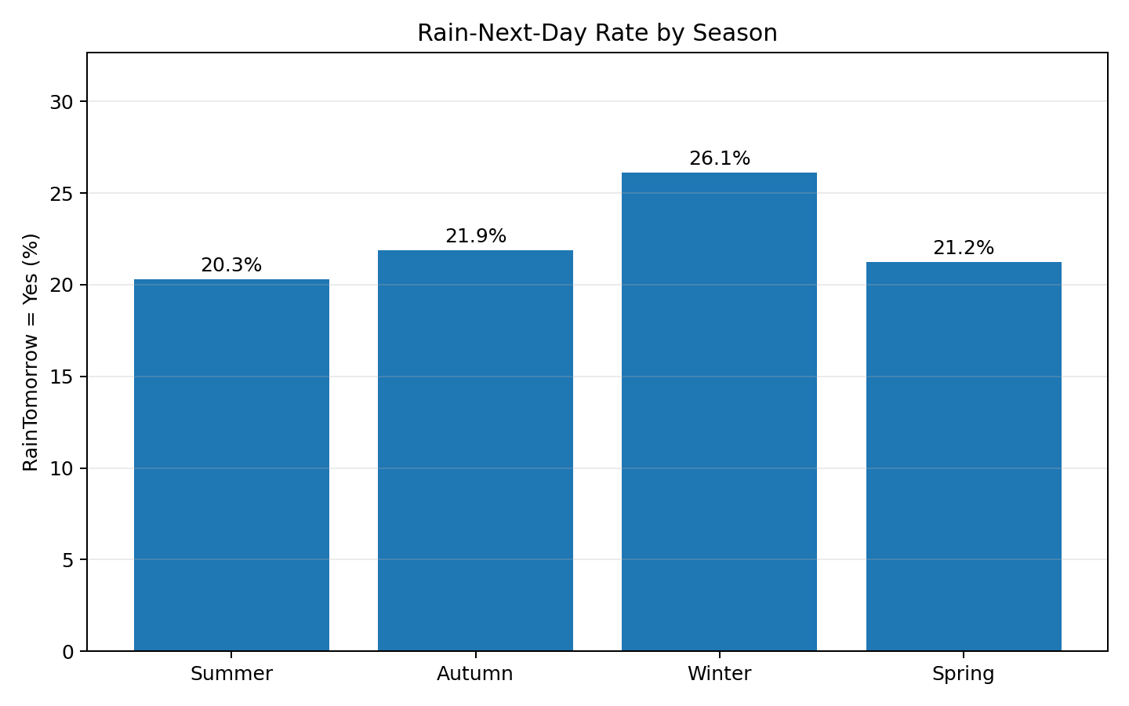
02_seasonal_rain_probability.png

Why this visualization?
A bar chart provides a direct comparison between four seasons. Percentages are used instead of raw counts so the audience can compare the likelihood of RainTomorrow = Yes across seasons.

What the audience should notice
Winter has the highest observed next-day rain rate at approximately 26.1%. The difference between seasons demonstrates that seasonality is a useful contextual feature when interpreting weather risk. Seasonal summaries are easier for a non-technical audience to act on than model coefficients.

How it contributes to the story
This narrows the time story into an actionable comparison: some parts of the year carry a higher historical rain risk.

6. Visualization 3 – Afternoon Humidity and Rainfall
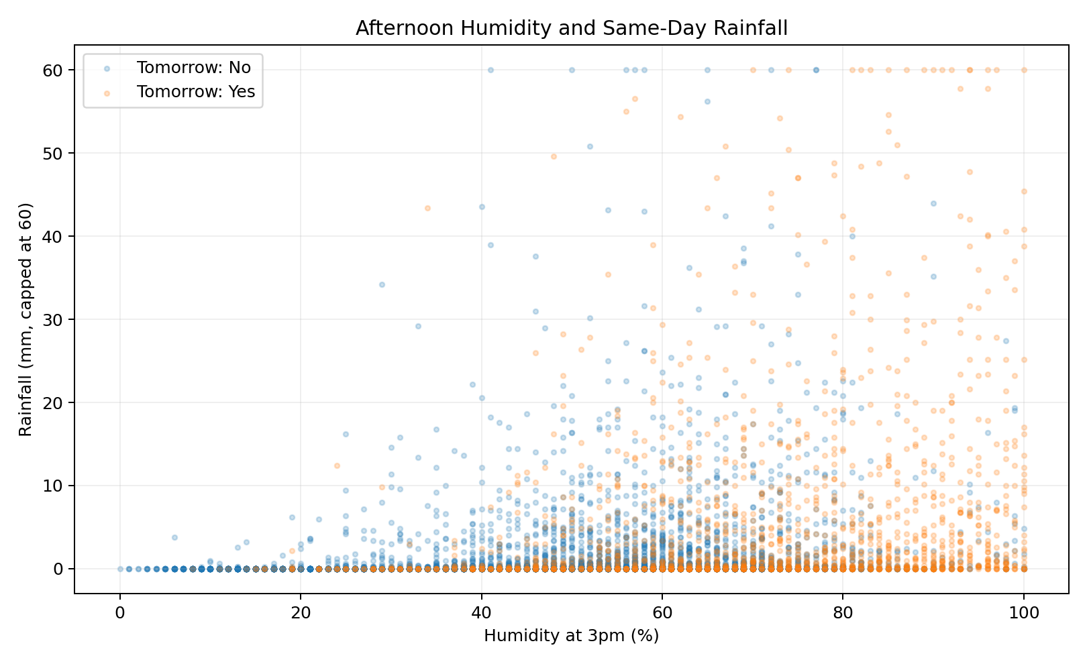
03_humidity_rainfall_story.png

Why this visualization?
A scatter plot was selected to show the relationship between a continuous weather measurement and rainfall while also separating observations by the next-day rain outcome. The rainfall axis is capped visually to prevent a small number of extreme storms from compressing the majority of points.

What the audience should notice
Median Humidity3pm is about 47.0% when tomorrow is dry versus 70.0% when tomorrow is rainy. The upward concentration of rainfall observations at higher humidity levels suggests that afternoon humidity is a meaningful contextual indicator. However, overlap remains substantial, so humidity alone is not sufficient to determine the outcome.

How it contributes to the story
This moves the narrative from when rain is common to what atmospheric conditions accompany it.

7. Visualization 4 – Temperature and Rain Outcome
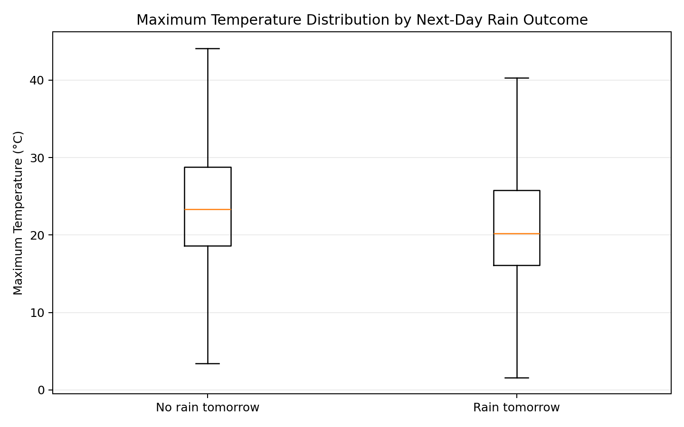
04_temperature_rain_outcome.png

Why this visualization?
Box plots are appropriate for comparing distributions because they show the median, spread, and overall range without being dominated by individual extreme observations. The two groups directly compare days followed by rain with days not followed by rain.

What the audience should notice
The median maximum temperature is approximately 23.3°C for observations followed by no rain and 20.2°C for observations followed by rain. The distributions overlap, indicating that temperature is informative but should be combined with other variables.

How it contributes to the story
The chart prevents an oversimplified story such as 'cold means rain.' Instead, it communicates that temperature is one part of a multi-factor weather system.

8. Visualization 5 – Wind Speed and Humidity
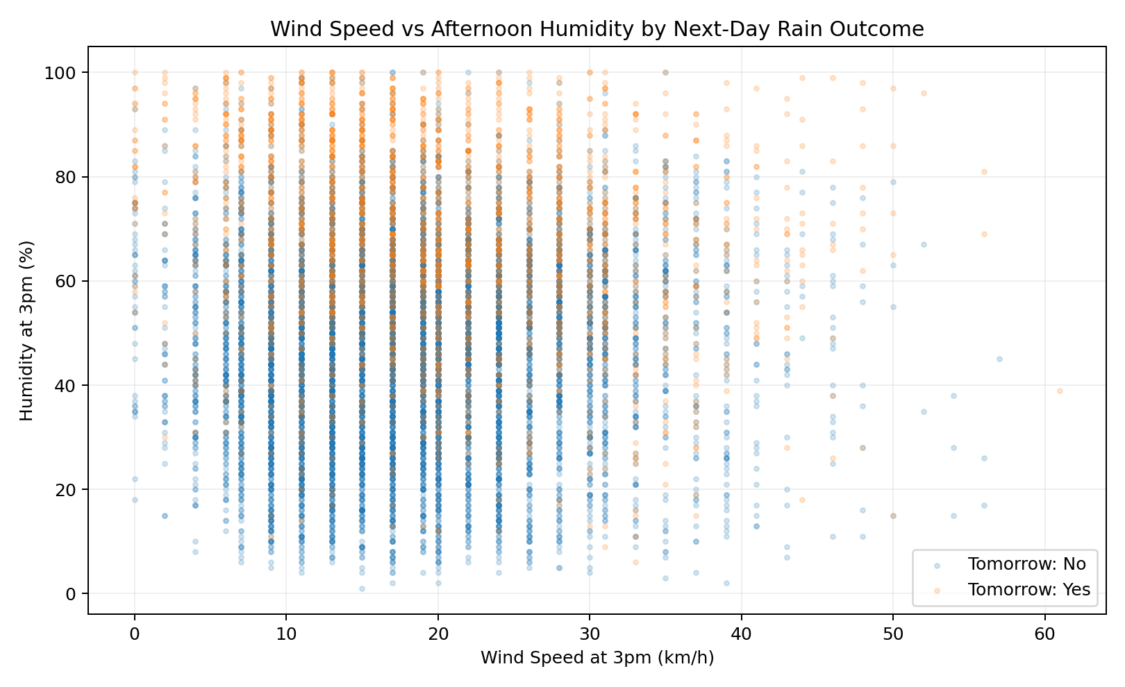
05_wind_humidity_outcome.png

Why this visualization?
A two-dimensional scatter plot combines wind speed and humidity and uses the next-day outcome as a visual grouping. This is useful for revealing clusters or regions where weather outcomes differ.

What the audience should notice
Rainy outcomes appear more frequently in portions of the feature space associated with higher humidity, while wind speed adds another dimension to the conditions. The overlap between classes reinforces that weather prediction is a multivariable problem rather than a single-threshold rule.

How it contributes to the story
This chart deepens the story by showing how multiple atmospheric signals can interact.

9. Visualization 6 – Correlation Structure
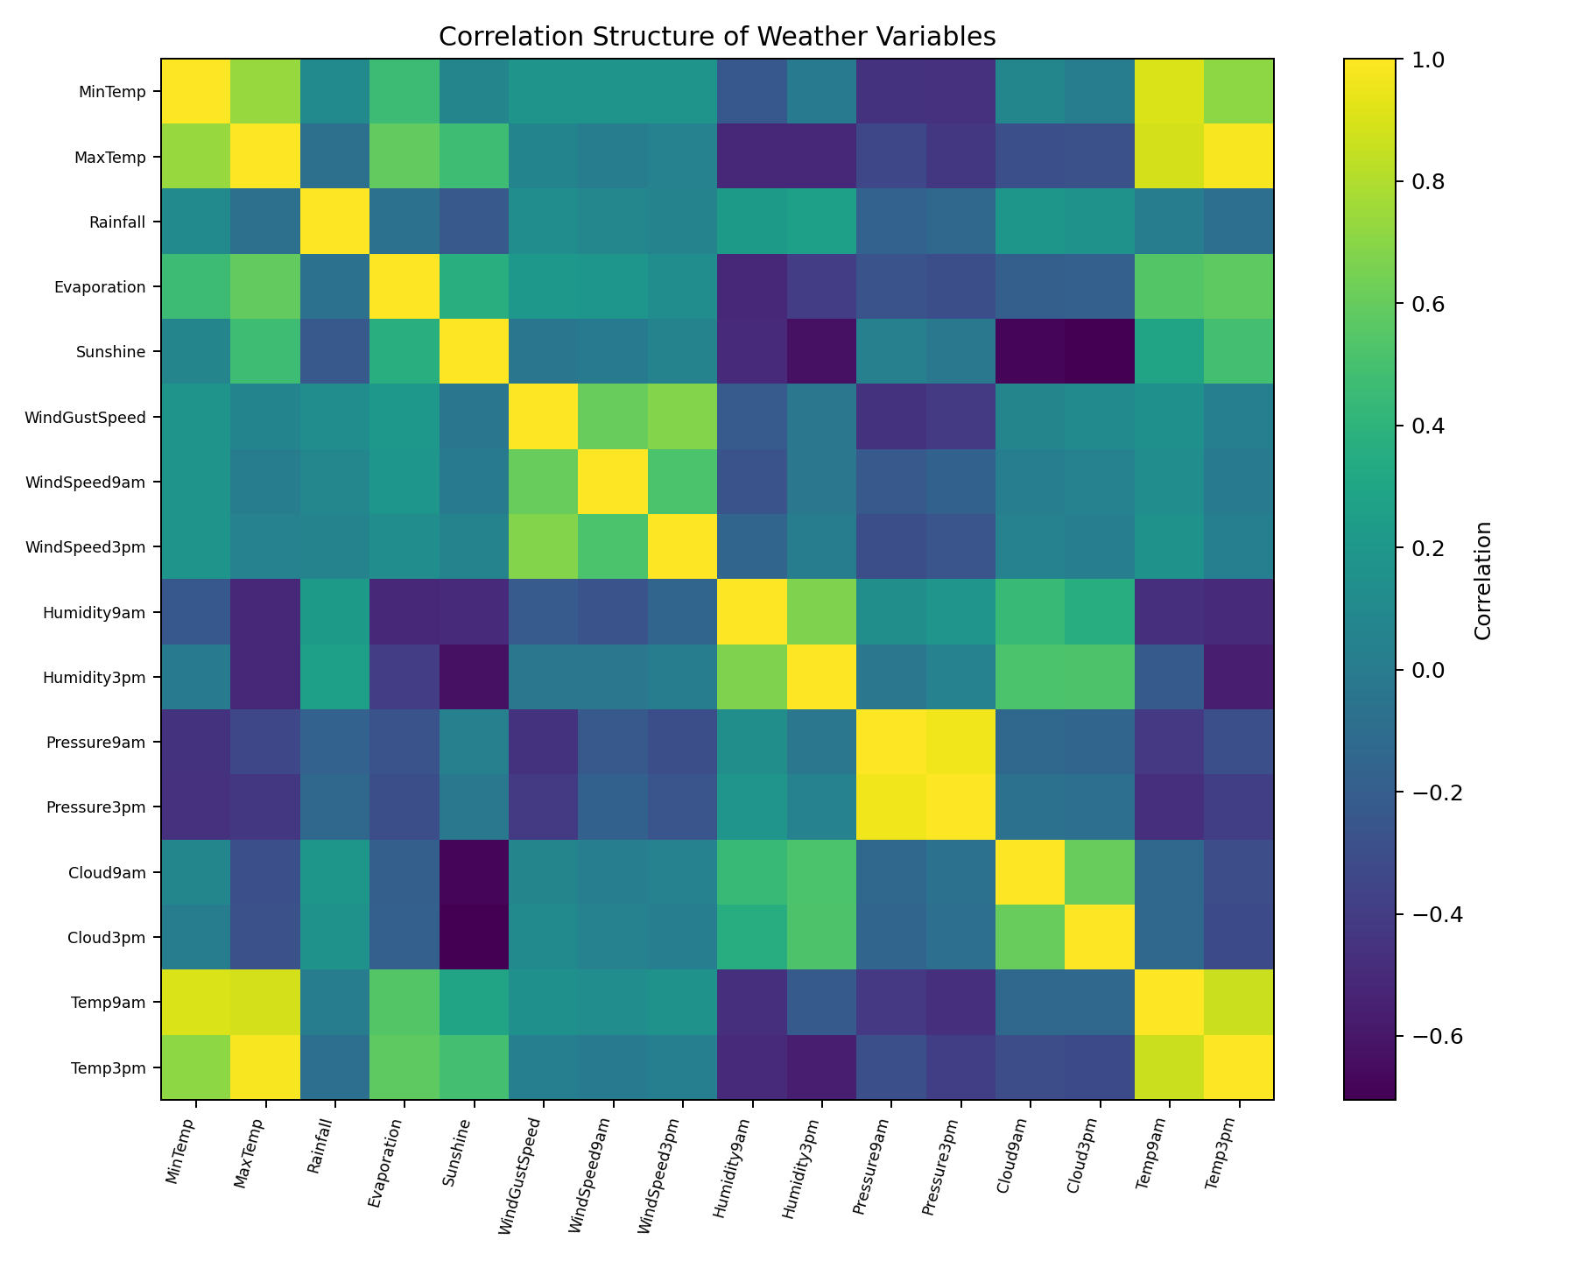
06_correlation_heatmap.png

Why this visualization?
A correlation heatmap provides a compact overview of linear relationships among numerical variables. It is used near the end because it summarizes relationships discovered in earlier charts rather than acting as the starting point.

What the audience should notice
The strongest relationships include expected temperature-variable associations and relationships among pressure, humidity, cloud, and temperature measurements. These correlations indicate redundancy as well as complementary information. Strong correlation does not imply causation, but it helps identify which variables may carry related information in future modeling.

How it contributes to the story
The final chart zooms out from individual relationships and gives a system-level view of the dataset.

10. Overall Insights
- Rainfall and rain risk vary substantially across time, supporting seasonal and temporal analysis rather than a one-size-fits-all interpretation.
- Winter shows the highest observed next-day rain rate at approximately 26.1%.
- Afternoon humidity is one of the clearest visual signals: the median is about 70.0% on observations followed by rain versus 47.0% when the next day is dry.
- Temperature distributions overlap considerably between outcomes, so temperature should be interpreted together with humidity, pressure, cloud, wind, and other variables.
- The correlation structure reveals groups of related weather variables, which can help reduce redundancy or guide feature engineering in future predictive modeling.
- The charts also show why extreme values should be handled carefully: they are important scientifically but can obscure the main pattern when plotted directly.

11. Business and Scientific Implications
From a scientific perspective, the analysis demonstrates that rainfall is influenced by a combination of atmospheric conditions and seasonal context. The visualization-first approach makes these relationships easier to inspect before building predictive models. It also highlights the importance of distinguishing association from causation and validating patterns across locations and time periods.
From a business and operational perspective, clearer rain-risk narratives can support agriculture scheduling, outdoor event planning, logistics, tourism, water-resource operations, and weather-sensitive maintenance. For example, higher historical rain-risk periods can be used to trigger additional planning or contingency checks. These implications are decision-support opportunities rather than guarantees; operational use should rely on validated predictive models and current forecasts.

12. Limitations and Future Work
The charts describe historical associations and do not establish causal relationships. Some variables contain missing values, and weather behavior differs by location. Future work could create location-specific dashboards, interactive Plotly visualizations, time-series decomposition, anomaly detection, and predictive models while carefully excluding future-information leakage such as RISK_MM when predicting RainTomorrow.

13. Estimated Workload – 30 to 35 Hours
Activity | Estimated Time
Dataset review and story planning | 3 hours
Data preparation and validation | 4 hours
Visualization design and experimentation | 10 hours
Chart refinement, captions, and annotations | 6 hours
Insight interpretation and implications | 4 hours
DOC documentation and formatting | 4 hours
Final review and GitHub preparation | 2 hours
Total estimated workload: 33 hours.

14. Conclusion
The Week 2 analysis transforms the WeatherAUS dataset into a coherent visual narrative. Instead of presenting charts independently, the sequence moves from time and seasonality to atmospheric conditions and finally to the overall correlation structure. The result is a clearer explanation of how rainfall risk varies and why multiple weather signals are needed for reliable interpretation. The analysis provides a strong foundation for future predictive modeling and interactive weather dashboards.

