WEEK 3 STATISTICAL ANALYSIS AND HYPOTHESIS TESTING
Does Humidity Significantly Affect the Probability of Rainfall?
Using the Australian Weather Dataset
Python | Pandas | SciPy | Statsmodels | Matplotlib
Submitted as a Week 3 Statistical Analysis Project

1. Abstract
This project investigates whether humidity at 3pm is statistically associated with rainfall on the following day. The analysis uses the Australian Weather dataset and separates observations into two groups: RainTomorrow = Yes and RainTomorrow = No. A Welch independent-samples t-test was selected because the groups are independent and unequal variances may be present. The analysis found a mean humidity difference of 22.29 percentage points. The t-test produced a p-value of 0, with a 95% confidence interval from 22.05 to 22.53 percentage points. Cohen's d was 1.198. A chi-square test was also used to examine the relationship between rainfall today and rainfall tomorrow, and logistic regression quantified the relationship between humidity and the odds of rain tomorrow. Overall, the statistical evidence supports a significant association between humidity and next-day rainfall, although statistical association should not be interpreted as proof of causation.

2. Introduction
Rainfall is an important environmental variable for agriculture, transportation, water management and outdoor planning. Weather observations contain multiple measurements that may provide information about future rainfall. Humidity is particularly relevant because higher atmospheric moisture can be associated with precipitation processes.
The purpose of this project is to apply formal statistical hypothesis testing to a real-world weather dataset rather than relying only on descriptive observations. The analysis focuses on Humidity3pm and RainTomorrow.

3. Problem Statement
Determine whether the average humidity measured at 3pm differs significantly between days followed by rainfall and days not followed by rainfall.

4. Research Question
Is there a statistically significant difference in 3pm humidity between observations where it rains tomorrow and observations where it does not rain tomorrow?

5. Hypotheses
- H0 (Null Hypothesis): The mean Humidity3pm is equal for RainTomorrow = Yes and RainTomorrow = No.
- H1 (Alternative Hypothesis): The mean Humidity3pm differs between RainTomorrow = Yes and RainTomorrow = No.
- Significance level: α = 0.05.
Decision rule: if p < 0.05, reject H0. Otherwise, fail to reject H0.

6. Dataset Description
The supplied file is weatherAUS.csv. The dataset contains 142,193 records and 24 columns before analysis. It includes daily Australian weather observations such as minimum and maximum temperature, rainfall, humidity, pressure, wind variables, location and the target variable RainTomorrow.
- Primary predictor: Humidity3pm — relative humidity measured at 3pm.
- Primary outcome: RainTomorrow — whether rainfall occurred the following day.
- Secondary categorical variables: RainToday and Location.
After selecting valid RainTomorrow labels and removing missing Humidity3pm values, 138,583 observations were used for the primary t-test.

7. Data Preparation
- Loaded the CSV using Pandas.
- Converted Humidity3pm and Rainfall to numeric values where applicable.
- Trimmed categorical labels and retained only RainTomorrow = Yes or No.
- Removed observations with missing Humidity3pm for the primary analysis.
- No artificial values were generated for the statistical tests.

8. Methodology

8.1 Descriptive Statistics
Descriptive statistics were calculated separately for the RainTomorrow = Yes and No groups to compare sample size, central tendency and variability.

8.2 Welch Independent-Samples t-test
A two-sided Welch t-test was used to compare the two independent group means. Welch's version does not require equal population variances and is therefore a conservative choice for observational weather data.

8.3 Confidence Interval
A 95% confidence interval was calculated for the difference between the mean Humidity3pm values of the rain-tomorrow and no-rain-tomorrow groups.

8.4 Effect Size
Cohen's d was calculated to quantify the standardized magnitude of the difference. This complements the p-value because a very large dataset can produce statistical significance even for relatively small practical differences.

8.5 Chi-square Test
A chi-square test of independence was applied to RainToday and RainTomorrow to determine whether rainfall today and rainfall tomorrow are statistically associated.

8.6 Logistic Regression
A binary logistic regression model was fitted with RainTomorrow as the dependent variable and Humidity3pm as the predictor. The humidity coefficient was converted to an odds ratio using exp(coefficient).

9. Descriptive Results
Group | N | Mean | Median | Std. Dev.
Rain Tomorrow = Yes | 30,913 | 68.80 | 70.00 | 19.04
Rain Tomorrow = No | 107,670 | 46.51 | 47.00 | 18.49
The rain-tomorrow group had a mean Humidity3pm of 68.80%, compared with 46.51% for the no-rain-tomorrow group. The raw mean difference was 22.29 percentage points.

10. Visual Analysis

Figure 1. Humidity Distribution
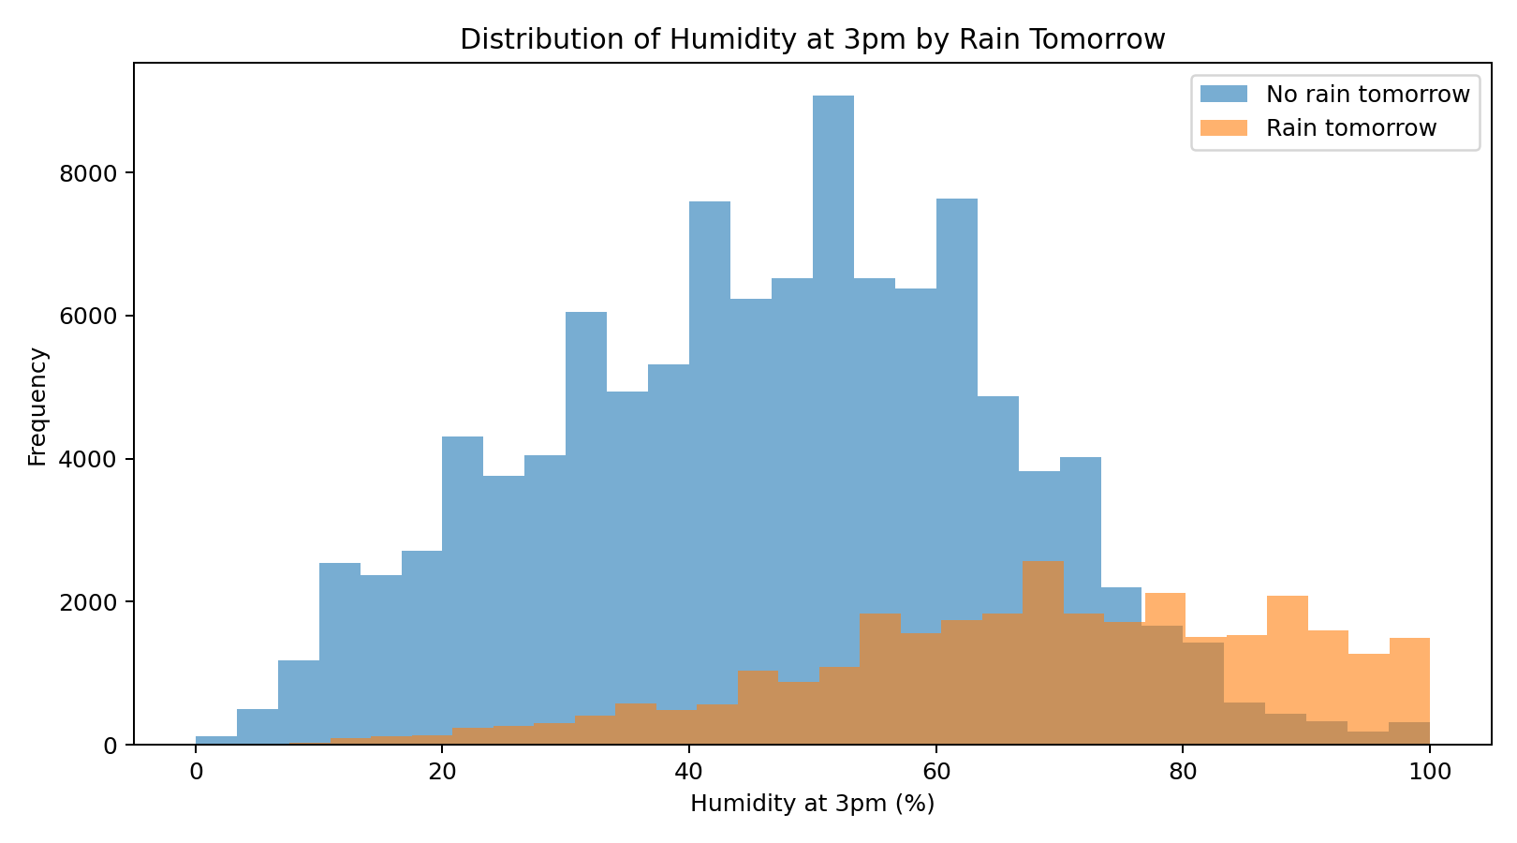
The two distributions show that observations followed by rainfall tend to have higher 3pm humidity.

Figure 2. Humidity Box Plot
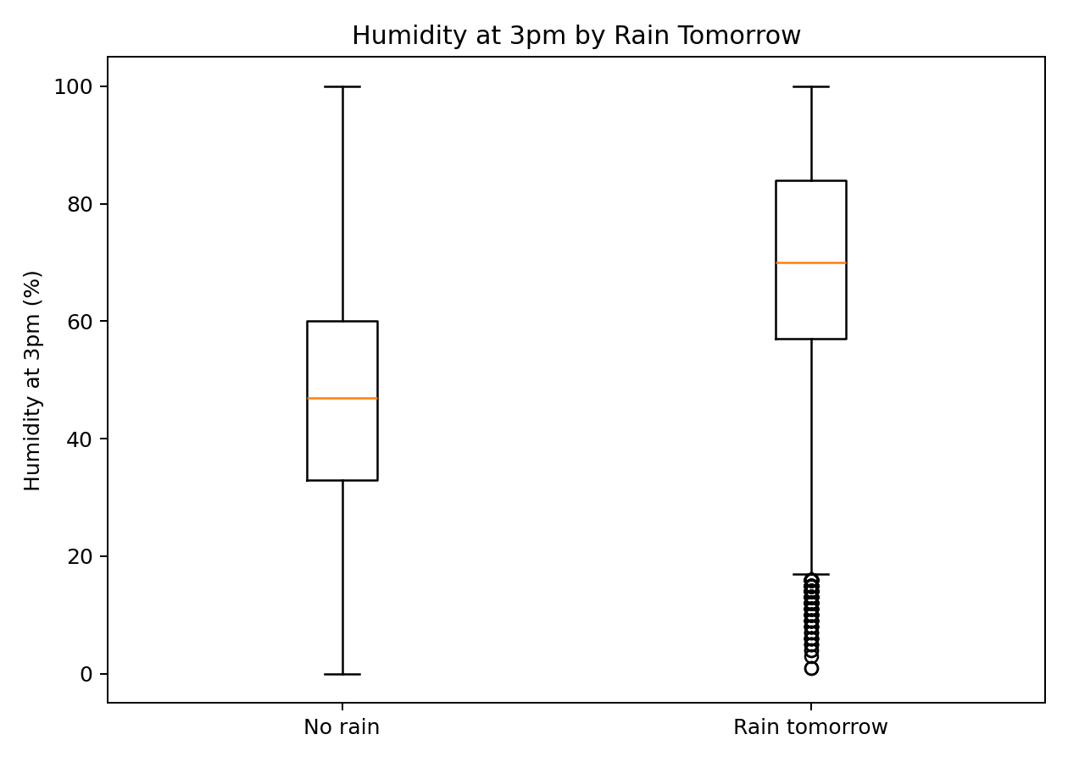
The median and overall distribution are shifted upward for observations followed by rainfall.

Figure 3. Mean Humidity
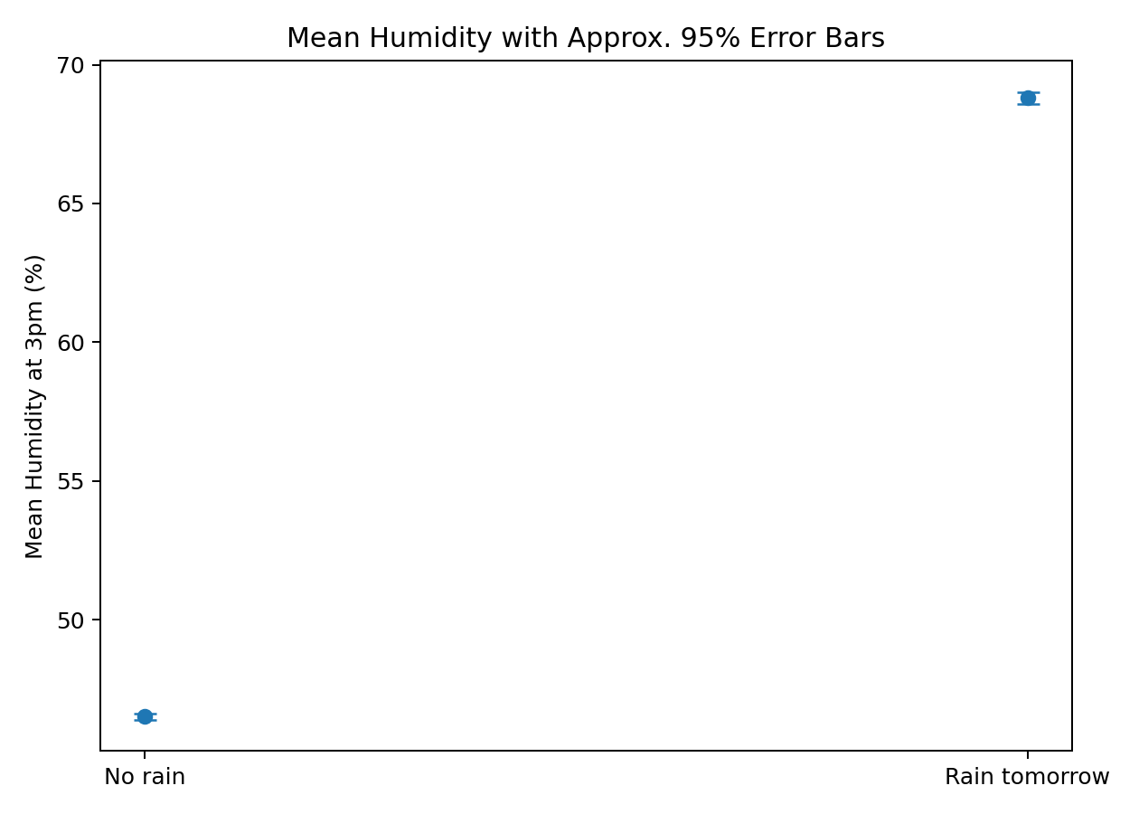
Mean humidity is higher in the rain-tomorrow group; the error bars provide approximate 95% intervals around each sample mean.

Figure 4. Rain Today vs Rain Tomorrow
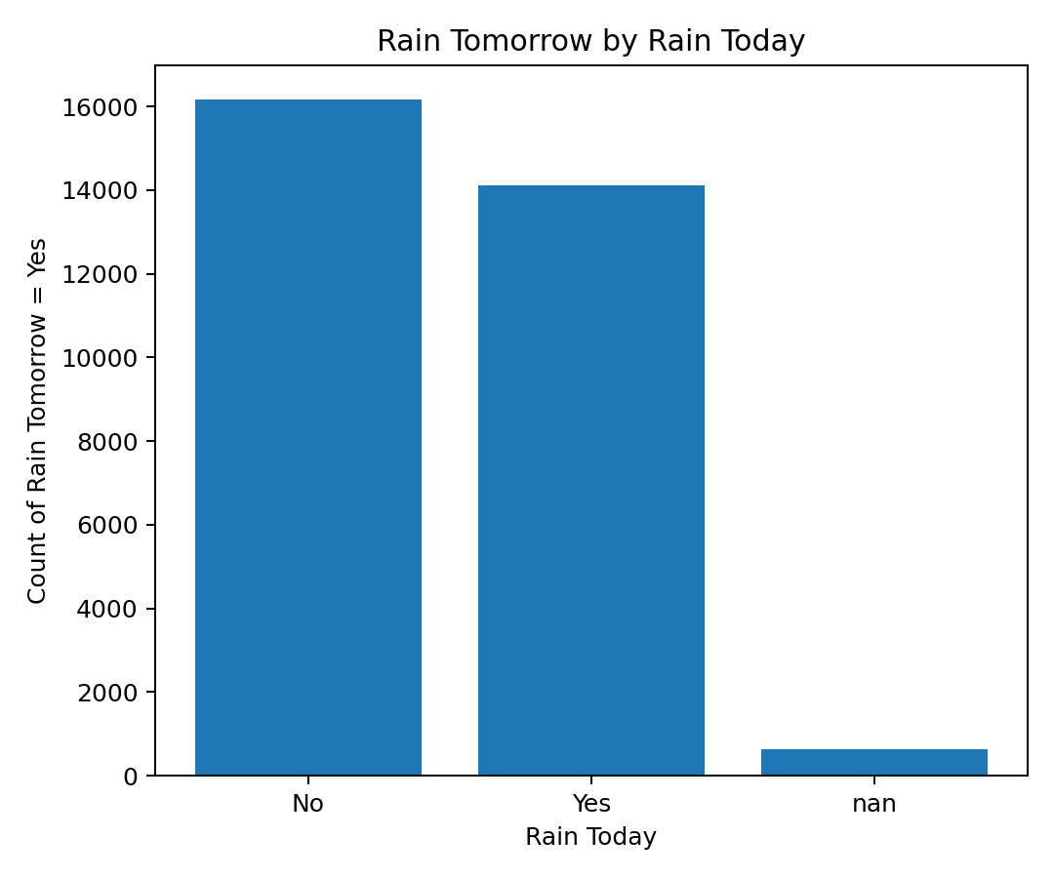
The count pattern illustrates the relationship examined by the chi-square test.

11. Hypothesis Test Results
Test | Statistic / Estimate | p-value
Welch t-test | t = 182.608 | 0
Chi-square independence | χ² = 13722.841; df = 2 | 0
Logistic regression | Humidity coefficient = 0.06533 | 0

12. Confidence Interval and Effect Size
The estimated difference in mean Humidity3pm (RainTomorrow = Yes minus No) was 22.289 percentage points. The 95% confidence interval was [22.050, 22.529]. Because the interval does not include zero, it is consistent with a statistically significant difference.
Cohen's d = 1.198. This indicates a large standardized difference under common interpretation guidelines.

13. Chi-square Interpretation
The chi-square test gave χ² = 13722.841, df = 2, p = 0. At α = 0.05, the null hypothesis of independence is rejected. Therefore, RainToday and RainTomorrow are statistically associated in this sample.

14. Logistic Regression Interpretation
The logistic regression coefficient for Humidity3pm was 0.06533. The corresponding odds ratio was 1.0675 for a one-percentage-point increase in humidity. The model pseudo-R² was 0.2092. The humidity predictor was statistically significant at α = 0.05.
The odds ratio should be interpreted as an association in this observational dataset. It does not establish that changing humidity itself would cause rainfall.

15. Overall Decision on the Hypothesis
Decision: REJECT H0. The Welch t-test p-value (0) is below α = 0.05. There is statistically significant evidence that mean Humidity3pm differs between observations followed by rain and observations not followed by rain.
The direction of the observed difference indicates higher average 3pm humidity on observations followed by rainfall. This supports the practical idea that atmospheric moisture is informative for next-day rainfall, while still avoiding causal claims.

16. Python Code Used
# Week 3 - Statistical Analysis and Hypothesis Testing
import pandas as pd
import numpy as np
from scipy import stats
from statsmodels.formula.api import logit
df = pd.read_csv("weatherAUS.csv")
# Prepare data
d = df[["Humidity3pm", "RainTomorrow", "RainToday"]].copy()
d["Humidity3pm"] = pd.to_numeric(d["Humidity3pm"], errors="coerce")
d["RainTomorrow"] = d["RainTomorrow"].astype(str).str.strip()
d["RainToday"] = d["RainToday"].astype(str).str.strip()
d = d[d["RainTomorrow"].isin(["Yes", "No"])].dropna(subset=["Humidity3pm"])
rain = d.loc[d["RainTomorrow"]=="Yes", "Humidity3pm"]
no_rain = d.loc[d["RainTomorrow"]=="No", "Humidity3pm"]
# 1. Descriptive statistics
print(d.groupby("RainTomorrow")["Humidity3pm"].describe())
# 2. Welch independent-samples t-test
t_stat, p_value = stats.ttest_ind(rain, no_rain, equal_var=False)
print("Welch t-test:", t_stat, p_value)
# 3. 95% CI for difference in means
diff = rain.mean() - no_rain.mean()
se = np.sqrt(rain.var(ddof=1)/len(rain) + no_rain.var(ddof=1)/len(no_rain))
df_w = (rain.var(ddof=1)/len(rain) + no_rain.var(ddof=1)/len(no_rain))**2 / (
(rain.var(ddof=1)/len(rain))**2/(len(rain)-1) +
(no_rain.var(ddof=1)/len(no_rain))**2/(len(no_rain)-1)
)
crit = stats.t.ppf(0.975, df_w)
print("Mean difference:", diff)
print("95% CI:", diff-crit*se, diff+crit*se)
# 4. Cohen's d
sp = np.sqrt(((len(rain)-1)*rain.var(ddof=1) +
(len(no_rain)-1)*no_rain.var(ddof=1)) /
(len(rain)+len(no_rain)-2))
print("Cohen's d:", diff/sp)
# 5. Chi-square test: RainToday vs RainTomorrow
table = pd.crosstab(d["RainToday"], d["RainTomorrow"])
chi2, p, dof, expected = stats.chi2_contingency(table)
print("Chi-square:", chi2, "p-value:", p, "df:", dof)
# 6. Logistic regression
d["y"] = (d["RainTomorrow"]=="Yes").astype(int)
model = logit("y ~ Humidity3pm", data=d).fit()
print(model.summary())
print("Humidity odds ratio:", np.exp(model.params["Humidity3pm"]))

17. Limitations
- The dataset is observational; statistical association does not establish causality.
- The primary hypothesis uses a single weather variable and does not represent all mechanisms involved in rainfall.
- The very large sample size can make small effects statistically significant.
- Weather relationships may vary by location and season.
- A one-predictor logistic regression is not intended to be a complete rainfall forecasting model.

18. Future Scope
- Perform location-wise and seasonal hypothesis tests.
- Use ANOVA to compare humidity across multiple rainfall categories or regions.
- Use multivariable logistic regression with pressure, temperature, wind and humidity.
- Apply multiple-testing corrections when conducting many hypotheses.
- Compare statistical findings with machine-learning models.

19. Conclusion
The statistical analysis provides strong evidence that 3pm humidity differs between observations followed by rainfall and those not followed by rainfall. The Welch t-test produced p = 0, and the 95% confidence interval for the mean difference was [22.05, 22.53] percentage points. The chi-square analysis additionally found a significant relationship between rainfall today and rainfall tomorrow. Logistic regression also indicated a statistically significant relationship between Humidity3pm and the odds of next-day rainfall. Therefore, the proposed alternative hypothesis is supported for this dataset: humidity is significantly associated with next-day rainfall. The findings are statistically meaningful, but the observational nature of the data means they should not be interpreted as proof that humidity alone causes rainfall.

20. References
- Australian Government Bureau of Meteorology, Australian weather observations/dataset context.
- SciPy documentation: statistical hypothesis testing functions.
- Statsmodels documentation: regression and statistical modelling.
- Pandas documentation: data manipulation and analysis.
- Matplotlib documentation: data visualization.

