WEEK 4 – MACHINE LEARNING MODEL DEVELOPMENT
AND EVALUATION
Rainfall Prediction Using the WeatherAUS Dataset
Python | Pandas | Scikit-learn | Matplotlib
Internship Technical Submission

1. Abstract
This project develops and evaluates a basic supervised machine learning model for predicting whether rainfall will occur on the following day using the Australian Weather (WeatherAUS) dataset. The work continues the same project developed in Weeks 2 and 3: visual analysis identified important weather patterns, while statistical testing demonstrated a significant relationship between afternoon humidity and next-day rainfall. For Week 4, Logistic Regression is used as an interpretable binary classification algorithm. The data pipeline includes target cleaning, missing-value handling, categorical encoding, numerical standardization, and a stratified 80/20 train-test split. The future-information variable RISK_MM is deliberately excluded to prevent target leakage. The final model is evaluated using accuracy, precision, recall, F1-score, ROC-AUC, a confusion matrix, and an ROC curve. The model achieved an accuracy of 0.794, precision of 0.528, recall of 0.777, F1-score of 0.628, and ROC-AUC of 0.873 on the held-out test set.

2. Introduction
Weather prediction is a practical machine learning problem because rainfall depends on multiple atmospheric conditions rather than one isolated variable. The WeatherAUS dataset contains temperature, humidity, pressure, wind, cloud and rainfall measurements collected across Australian locations. In the previous weeks, these variables were explored visually and statistically. Week 4 extends that analysis by building a predictive classification pipeline.
The objective is not to claim that a simple model can replace operational weather forecasting. Instead, the project demonstrates the complete machine learning development cycle: defining the target, preparing data, selecting an algorithm, training a model, evaluating predictions, identifying errors, and proposing improvements.

3. Problem Statement
Develop a basic machine learning model that predicts whether it will rain tomorrow from weather observations available for the current day, while avoiding data leakage and evaluating the model using appropriate classification metrics.

4. Objective
- Prepare the WeatherAUS dataset for supervised machine learning.
- Predict the binary target variable RainTomorrow.
- Implement Logistic Regression using Scikit-learn.
- Evaluate the model using multiple classification metrics.
- Visualize model performance using a confusion matrix and ROC curve.
- Identify sources of prediction error and propose improvements.

5. Dataset Description
The supplied WeatherAUS dataset contains 142,193 observations and 24 columns before preprocessing. It contains daily weather measurements from multiple Australian locations. The target variable is RainTomorrow, which indicates whether rainfall occurs on the following day.
- Target: RainTomorrow.
- Important weather features include temperature, rainfall, humidity, pressure, wind and cloud variables.
- Date was excluded from the basic model as an identifier/time field.
- RISK_MM was excluded because it represents future rainfall information and would introduce target leakage.
After retaining observations with valid RainTomorrow labels, 142,193 records were available for the modeling pipeline.

6. Data Preprocessing
- Loaded the CSV using Pandas.
- Standardized column names by removing surrounding whitespace.
- Removed rows without a valid binary RainTomorrow target.
- Separated predictors from the target variable.
- Used median imputation for missing numerical values.
- Used most-frequent imputation for missing categorical values.
- Applied one-hot encoding to categorical variables.
- Standardized numerical variables using StandardScaler.
- Used a stratified 80/20 train-test split.
- Set random_state=42 for reproducibility.
- Excluded RISK_MM to prevent target leakage.

7. Why Logistic Regression?
Logistic Regression was selected because RainTomorrow is a binary outcome. It is computationally efficient, relatively easy to interpret, and provides probability estimates that can be evaluated using an ROC curve. It is also an appropriate baseline for comparing future, more complex algorithms such as Random Forest and XGBoost.
The use of class_weight='balanced' helps the model account for the unequal number of rainy and non-rainy observations. This is particularly relevant because the WeatherAUS target is not evenly distributed.

8. Train-Test Design
The data was divided into 113,754 training observations (80%) and 28,439 test observations (20%). Stratification was used so that the proportion of rainy and non-rainy outcomes remains similar in the training and test sets. The test set was kept separate until final evaluation.

9. Evaluation Metrics
- Accuracy: proportion of all predictions that are correct.
- Precision: proportion of predicted rainy days that actually have rain.
- Recall: proportion of actual rainy days that the model successfully detects.
- F1-score: harmonic mean of precision and recall.
- ROC-AUC: measures how well the model ranks rainy days above non-rainy days across classification thresholds.
- Confusion matrix: separates true positives, true negatives, false positives and false negatives.

10. Model Results
Metric | Score | Interpretation
Accuracy | 0.7940 | Overall proportion of correct predictions.
Precision | 0.5275 | Reliability of positive/rain predictions.
Recall | 0.7768 | Ability to detect actual rainy days.
F1 Score | 0.6283 | Balance between precision and recall.
ROC-AUC | 0.8726 | Overall ranking/discrimination ability.
The majority-class baseline accuracy was 0.7758. The Logistic Regression model achieved 0.7940 accuracy, showing the value of using weather features rather than always predicting the most common class.

11. Visualization 1 – Confusion Matrix
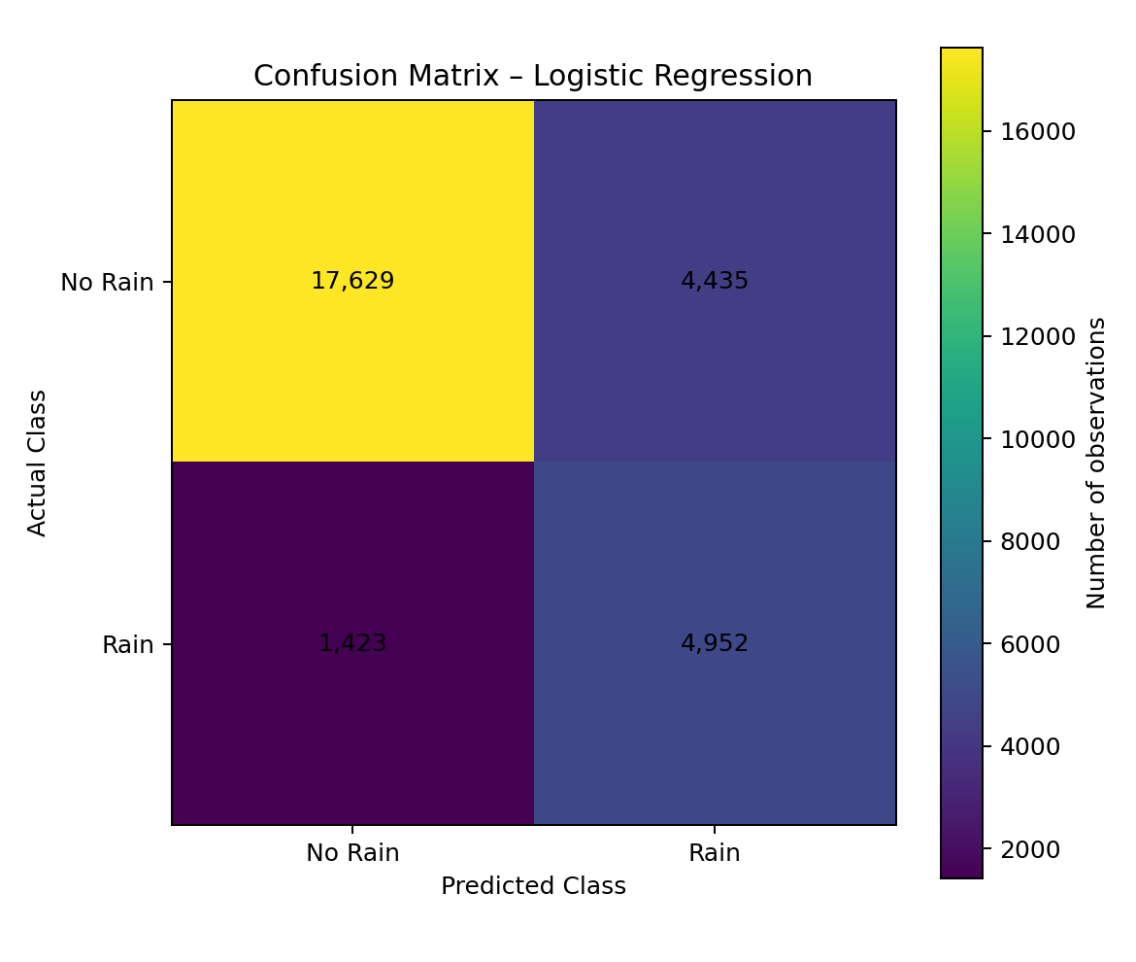
The confusion matrix contains 17,629 true negatives, 4,435 false positives, 1,423 false negatives and 4,952 true positives. False negatives are particularly important for rainfall prediction because they represent rainy days that the model incorrectly labels as dry.

12. Visualization 2 – ROC Curve
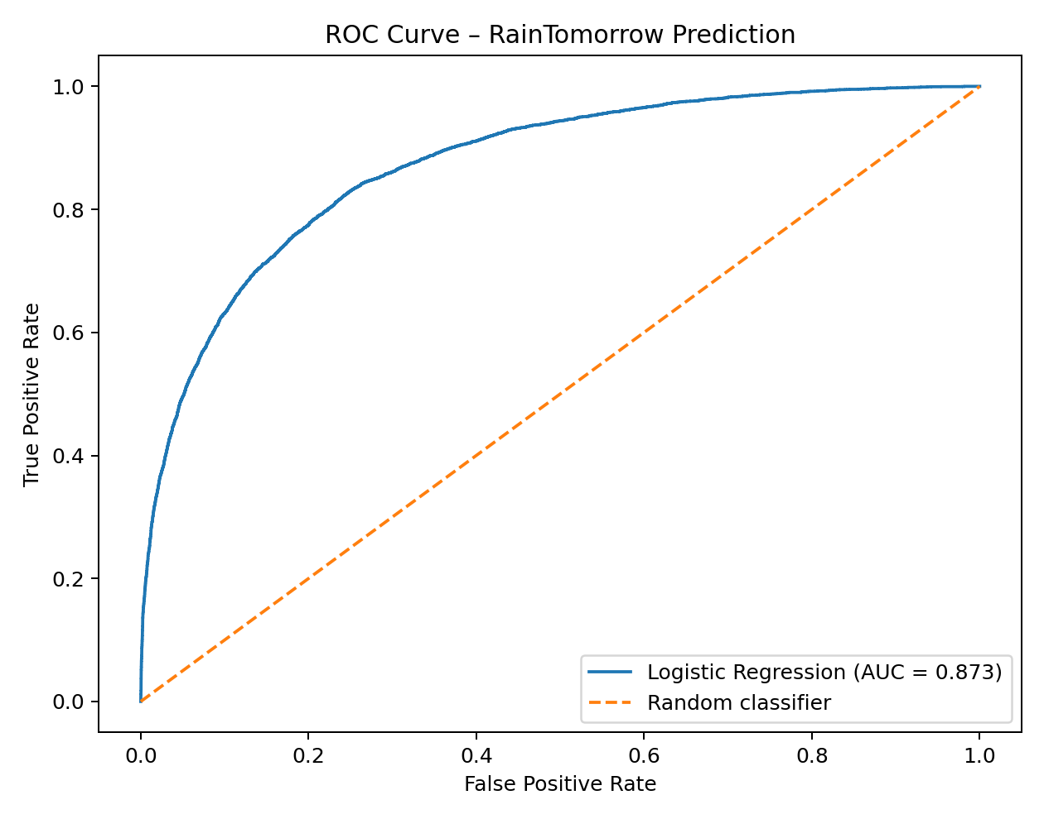
The ROC curve summarizes the trade-off between true-positive rate and false-positive rate across decision thresholds. The model's ROC-AUC is 0.873. An AUC substantially above 0.5 indicates that the model has useful discriminatory ability, although it does not mean that every individual prediction is correct.

13. Visualization 3 – Model Metrics
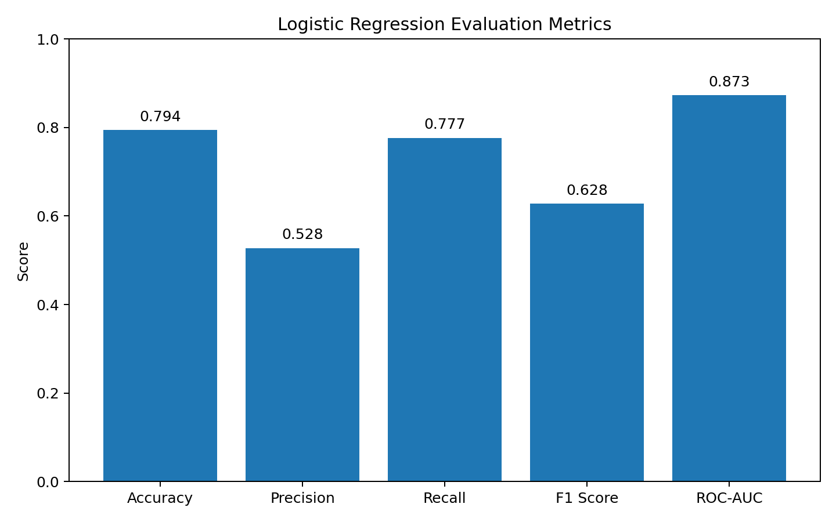
The metric comparison shows that model quality cannot be represented by accuracy alone. Precision, recall and F1-score provide additional information about the treatment of rainy observations.

14. Visualization 4 – Feature Coefficients
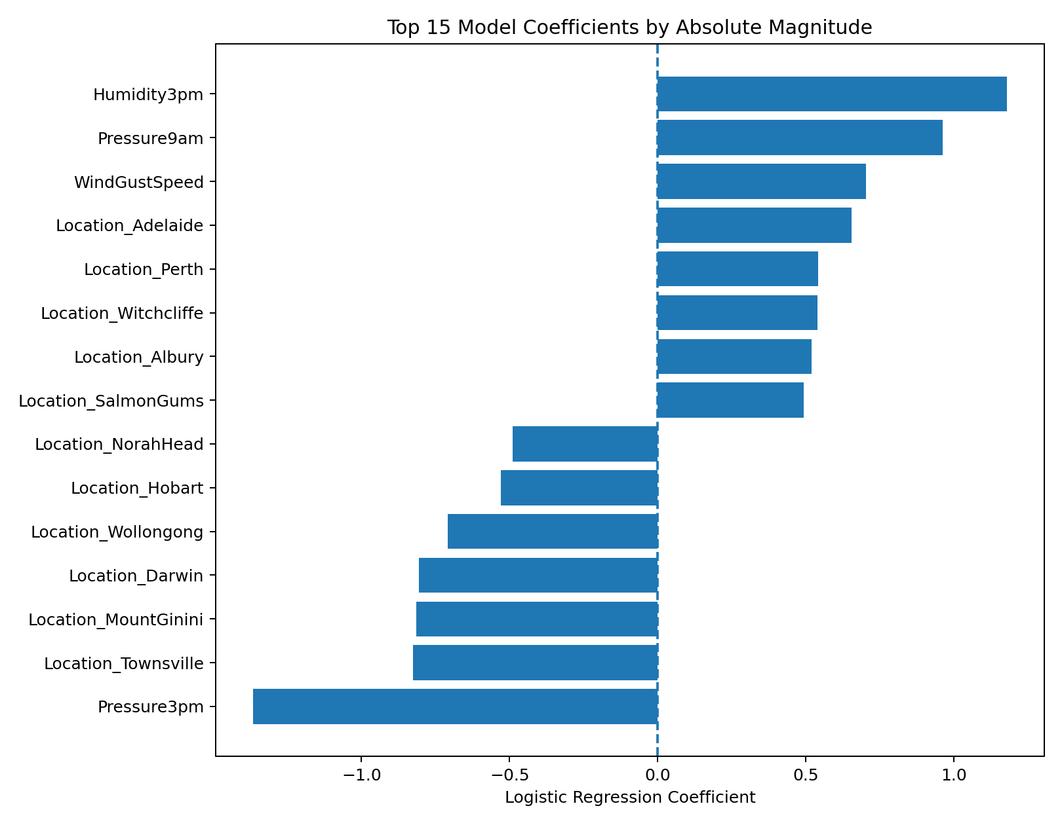
Logistic regression coefficients indicate the direction and relative strength of the model's linear relationship with the log-odds of rainfall after preprocessing. Positive coefficients increase the predicted log-odds of rain, while negative coefficients reduce them. Coefficients should be interpreted cautiously because correlated weather variables can share information.

15. Error Analysis
The test results show that the model does not perfectly separate rainy and non-rainy days. The model's recall of 0.777 means that some actual rainy days remain undetected. This is an important error type for outdoor planning because a missed rain event may lead to an incorrect decision.
False positives also have a practical cost: the model may predict rain when the next day is actually dry, potentially causing unnecessary changes to plans. The appropriate balance between false positives and false negatives depends on the application. For outdoor events, a user may prefer higher recall, even if that creates more false alarms.

16. Overfitting and Underfitting
Logistic Regression is less flexible than tree ensembles and may underfit complex nonlinear weather relationships. On the other hand, preprocessing inside a Scikit-learn Pipeline and evaluating on a separate test set reduces the risk of leakage during the basic experiment. Cross-validation should be used in future work to obtain a more stable estimate of generalization performance.

17. Critical Discussion
The model is useful as an interpretable baseline, but rainfall is a multivariable and location-dependent phenomenon. Weather observations from different regions can have different relationships between humidity, pressure, wind, cloud cover and rainfall. Seasonal effects can also change model performance. In addition, the class distribution is imbalanced, which is why accuracy should not be considered the only evaluation metric.
The most important methodological safeguard is prevention of target leakage. RISK_MM was deliberately excluded because it represents rainfall associated with the future day. Including such a variable would make the model appear much more accurate than it would be in a real prediction setting.

18. Suggestions for Model Improvement
- Compare Logistic Regression with Decision Tree, Random Forest and XGBoost.
- Use cross-validation rather than relying on one train-test split.
- Tune model hyperparameters using GridSearchCV or RandomizedSearchCV.
- Engineer seasonal and location-related features.
- Tune the classification threshold to prioritize recall when missed rain is costly.
- Investigate class-balancing techniques and compare them with class_weight='balanced'.
- Perform location-wise evaluation to detect regional differences.
- Monitor performance over time to identify temporal drift.
- Use calibration analysis if predicted probabilities will support decision-making.

19. Python Implementation
from pathlib import Path
import numpy as np
import pandas as pd
import matplotlib.pyplot as plt
from sklearn.model_selection import train_test_split
from sklearn.compose import ColumnTransformer
from sklearn.pipeline import Pipeline
from sklearn.preprocessing import OneHotEncoder, StandardScaler
from sklearn.impute import SimpleImputer
from sklearn.linear_model import LogisticRegression
from sklearn.dummy import DummyClassifier
from sklearn.metrics import (
accuracy_score, precision_score, recall_score, f1_score,
roc_auc_score, confusion_matrix, classification_report, roc_curve
)
ROOT = Path(__file__).resolve().parents[1]
DATA = ROOT / "data" / "weatherAUS.csv"
OUT = ROOT / "visualizations"
OUT.mkdir(exist_ok=True)
df = pd.read_csv(DATA)
df.columns = [c.strip() for c in df.columns]
# RainTomorrow is the target.
# RISK_MM is deliberately excluded because it contains future rainfall
# information and would cause target leakage.
target = "RainTomorrow"
drop_cols = ["RainTomorrow", "RISK_MM", "Date"]
features = [c for c in df.columns if c not in drop_cols]
d = df[features + [target]].copy()
d[target] = d[target].astype(str).str.strip()
d = d[d[target].isin(["Yes", "No"])]
X = d[features]
y = d[target].map({"No": 0, "Yes": 1})
numeric_features = X.select_dtypes(include=[np.number]).columns.tolist()
categorical_features = X.select_dtypes(exclude=[np.number]).columns.tolist()
preprocessor = ColumnTransformer([
("num", Pipeline([
("imputer", SimpleImputer(strategy="median")),
("scaler", StandardScaler())
]), numeric_features),
("cat", Pipeline([
("imputer", SimpleImputer(strategy="most_frequent")),
("onehot", OneHotEncoder(handle_unknown="ignore"))
]), categorical_features)
])
model = Pipeline([
("preprocessor", preprocessor),
("model", LogisticRegression(
max_iter=1000,
class_weight="balanced",
solver="liblinear",
random_state=42
))
])
X_train, X_test, y_train, y_test = train_test_split(
X, y, test_size=0.20, random_state=42, stratify=y
)
baseline = DummyClassifier(strategy="most_frequent")
baseline.fit(X_train, y_train)
model.fit(X_train, y_train)
pred = model.predict(X_test)
prob = model.predict_proba(X_test)[:, 1]
print("Baseline accuracy:", accuracy_score(y_test, baseline.predict(X_test)))
print("Accuracy:", accuracy_score(y_test, pred))
print("Precision:", precision_score(y_test, pred, zero_division=0))
print("Recall:", recall_score(y_test, pred, zero_division=0))
print("F1:", f1_score(y_test, pred, zero_division=0))
print("ROC-AUC:", roc_auc_score(y_test, prob))
print("\nClassification report:\n")
print(classification_report(y_test, pred, target_names=["No Rain", "Rain"], zero_division=0))
cm = confusion_matrix(y_test, pred)
print("\nConfusion matrix:\n", cm)
# Confusion matrix visualization
plt.figure(figsize=(6.5, 5.5))
plt.imshow(cm)
plt.title("Confusion Matrix – Logistic Regression")
plt.xlabel("Predicted Class")
plt.ylabel("Actual Class")
plt.xticks([0, 1], ["No Rain", "Rain"])
plt.yticks([0, 1], ["No Rain", "Rain"])
for i in range(2):
for j in range(2):
plt.text(j, i, f"{cm[i,j]:,}", ha="center", va="center")
plt.colorbar(label="Number of observations")
plt.tight_layout()
plt.savefig(OUT / "01_confusion_matrix.png", dpi=180)
plt.close()
# ROC curve
fpr, tpr, _ = roc_curve(y_test, prob)
auc = roc_auc_score(y_test, prob)
plt.figure(figsize=(7, 5.5))
plt.plot(fpr, tpr, label=f"Logistic Regression (AUC = {auc:.3f})")
plt.plot([0, 1], [0, 1], linestyle="--", label="Random classifier")
plt.xlabel("False Positive Rate")
plt.ylabel("True Positive Rate")
plt.title("ROC Curve – RainTomorrow Prediction")
plt.legend()
plt.tight_layout()
plt.savefig(OUT / "02_roc_curve.png", dpi=180)
plt.close()
print("\nAnalysis completed.")

20. Limitations
- The model is a basic baseline and does not represent a production weather forecasting system.
- Weather relationships are nonlinear and may not be fully captured by Logistic Regression.
- The dataset contains missing observations that require imputation.
- The observations come from multiple locations with different climatic conditions.
- Historical relationships may not remain constant in future periods.
- The test metrics depend on the chosen split and threshold.
- The model predicts the dataset's RainTomorrow label and should not be treated as an official forecast.

21. Estimated Workload – 30 to 35 Hours
Activity | Estimated Time
Dataset review and Week 2/3 integration | 3 hours
Data preprocessing and leakage checks | 5 hours
Model selection and pipeline design | 4 hours
Model training and experimentation | 5 hours
Evaluation metrics and error analysis | 4 hours
Visualization design and interpretation | 4 hours
DOC documentation and formatting | 4 hours
Final review and GitHub preparation | 3 hours
Total estimated workload: 32 hours.

22. Week 2 → Week 3 → Week 4 Progression
Week 2 established a visual story from the WeatherAUS dataset and showed that humidity, seasonality, temperature, wind and other variables contain useful rainfall-related patterns. Week 3 converted one of these observations into a formal statistical hypothesis and found strong evidence that afternoon humidity differs between rainy and non-rainy outcomes. Week 4 takes the next step by combining multiple weather features into a machine learning pipeline that attempts to predict RainTomorrow. This progression demonstrates a natural development from exploration to statistical validation to prediction.

23. Conclusion
The Week 4 project successfully developed a reproducible Logistic Regression classification pipeline for next-day rainfall prediction. The model was trained after cleaning the target, handling missing values, encoding categorical features, standardizing numerical variables and excluding the future-information variable RISK_MM. On the held-out test set, the model achieved an accuracy of 0.794, precision of 0.528, recall of 0.777, F1-score of 0.628, and ROC-AUC of 0.873. The confusion matrix and ROC curve demonstrate both the strengths and limitations of the classifier. The results show that machine learning can extract predictive information from historical weather observations, but the remaining errors also demonstrate why rainfall prediction is a complex multivariable problem. Future work should compare stronger algorithms, use cross-validation, tune thresholds, engineer temporal and location features, and evaluate performance across regions and seasons.

24. References
- Scikit-learn documentation – Logistic Regression, preprocessing pipelines and classification metrics.
- Pandas documentation – data loading and manipulation.
- NumPy documentation – numerical computing.
- Matplotlib documentation – visualization.
- Australian Weather / WeatherAUS dataset used for this project.

