Screenshots needed for Dashboards:

1. AWS login screen

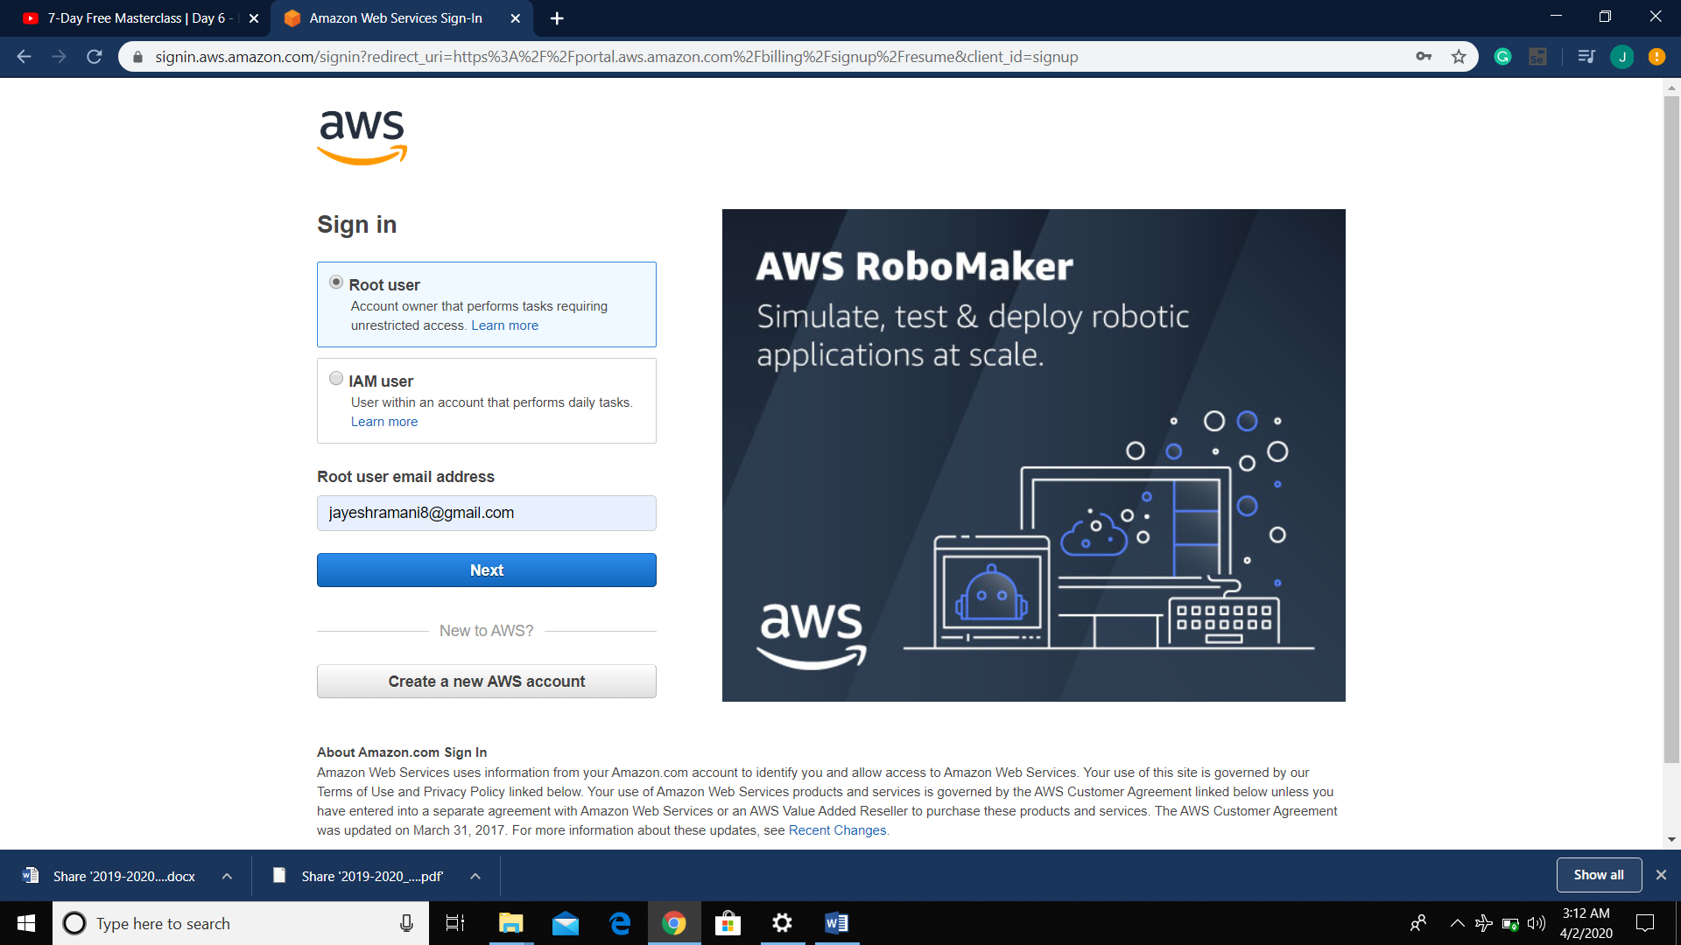

1. EC2 Dashboard

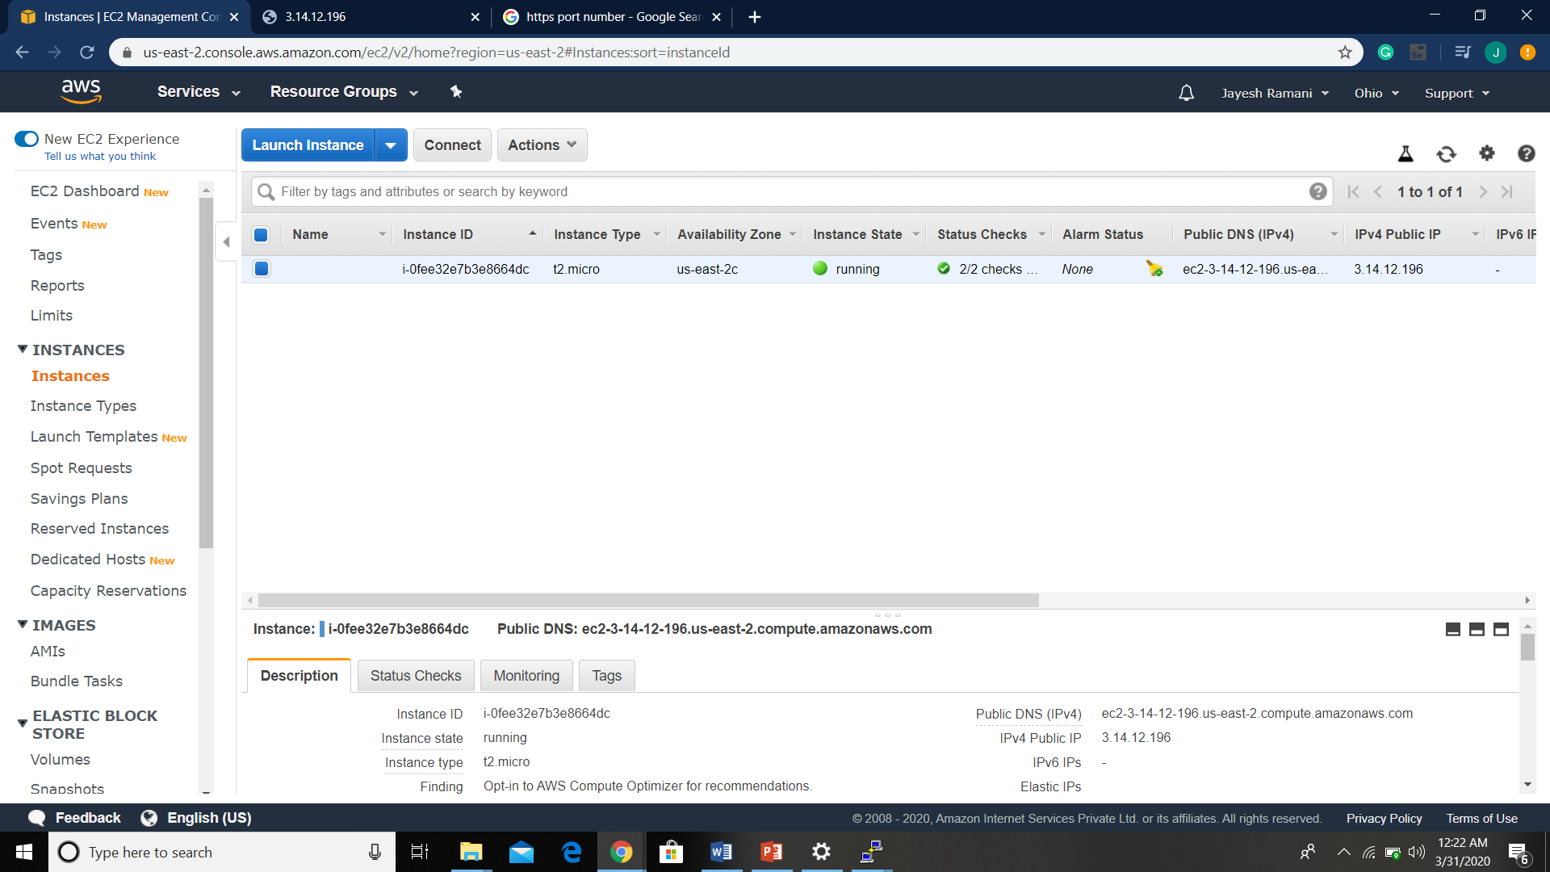

1. S3 Dashboard

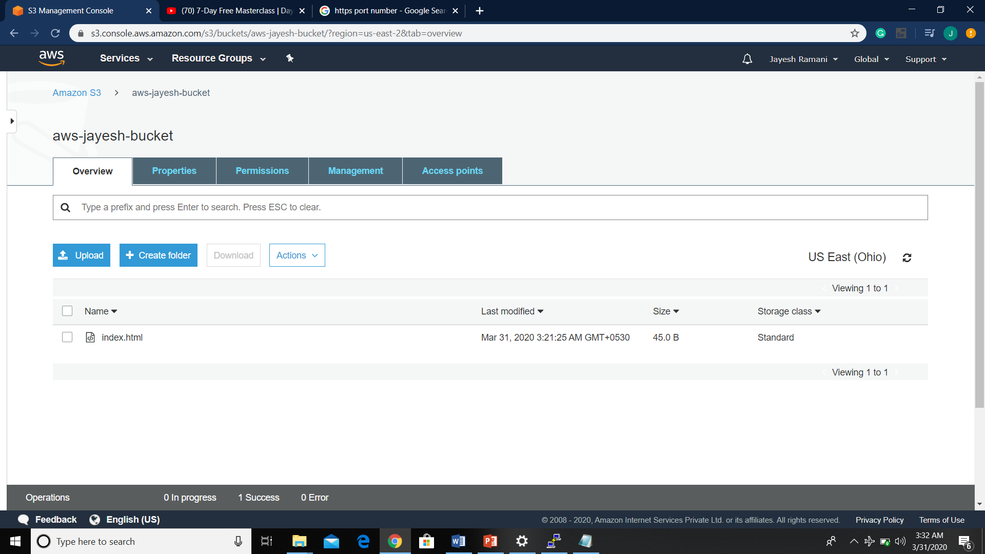

1. Rekognition Dashboard:

Screenshots needed for EC2:

1. Choosing an AMI

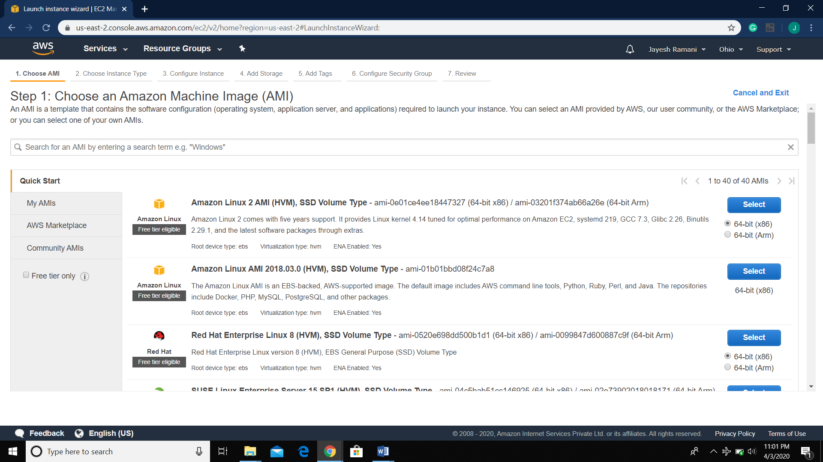

1. Choosing an Instance Type:

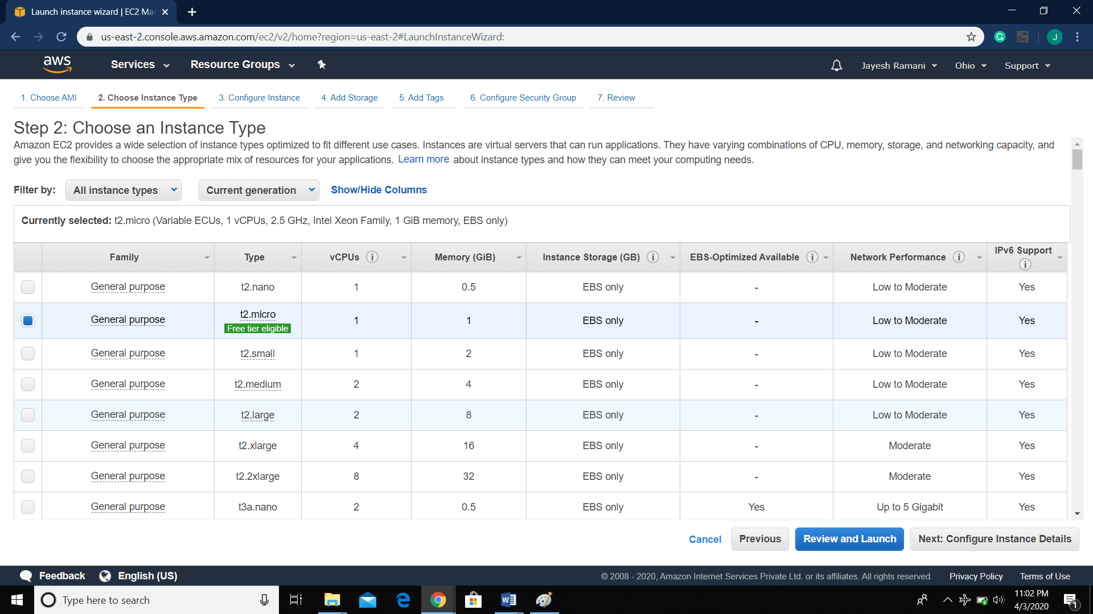

1. Adding Storage:

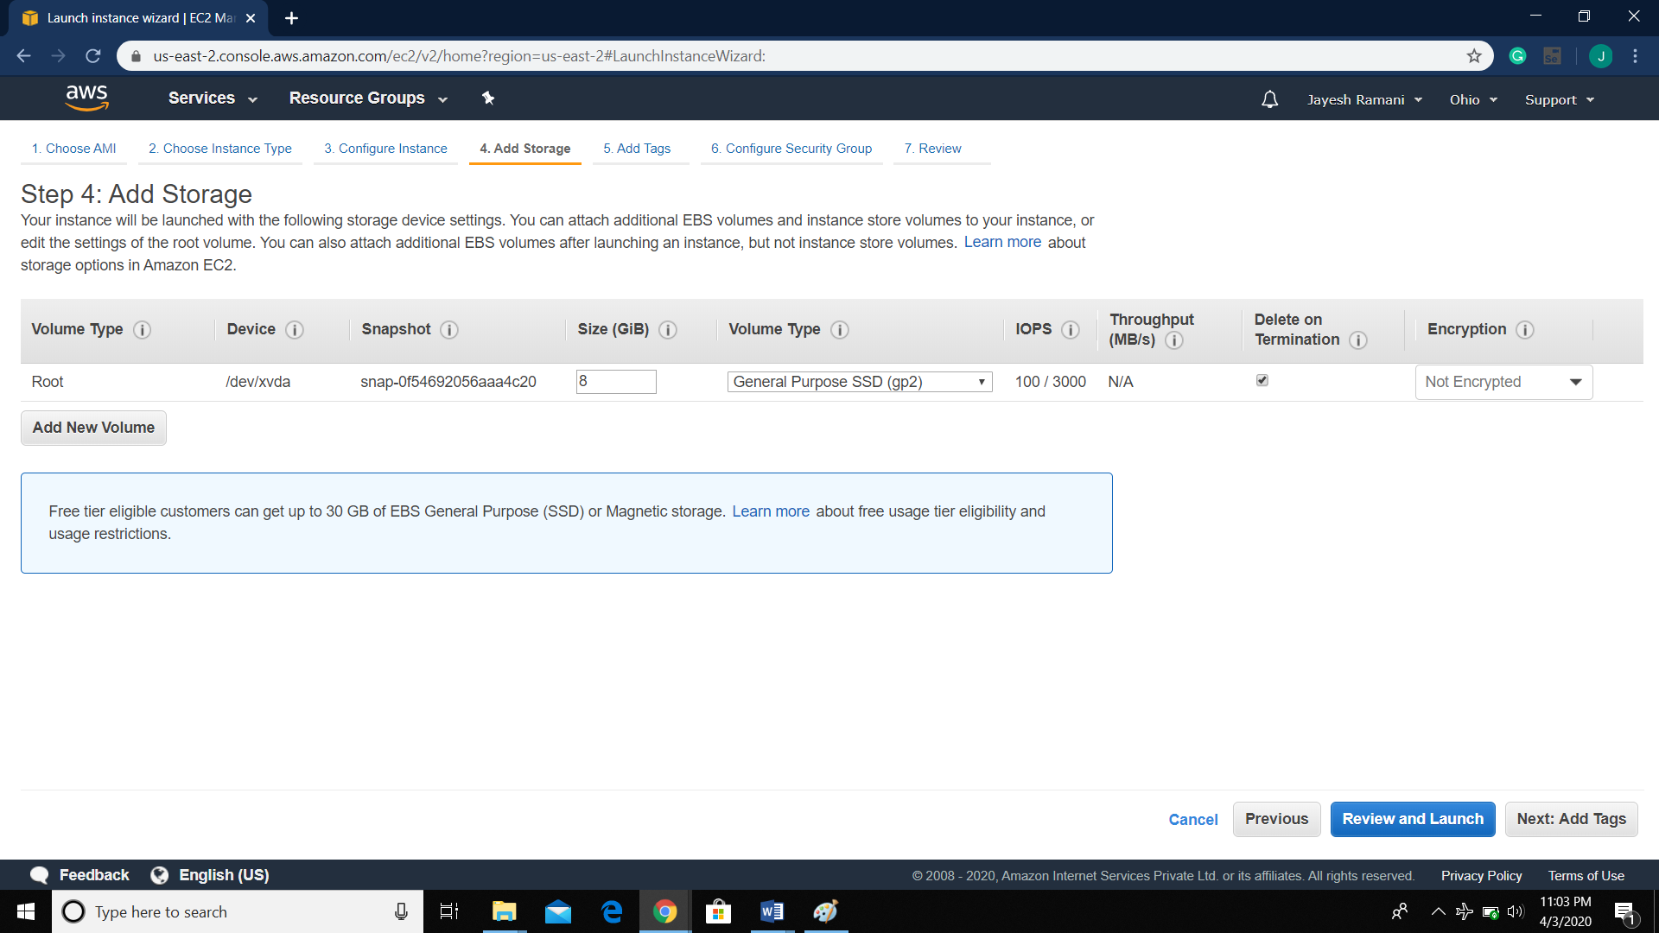

1. Configure Security group

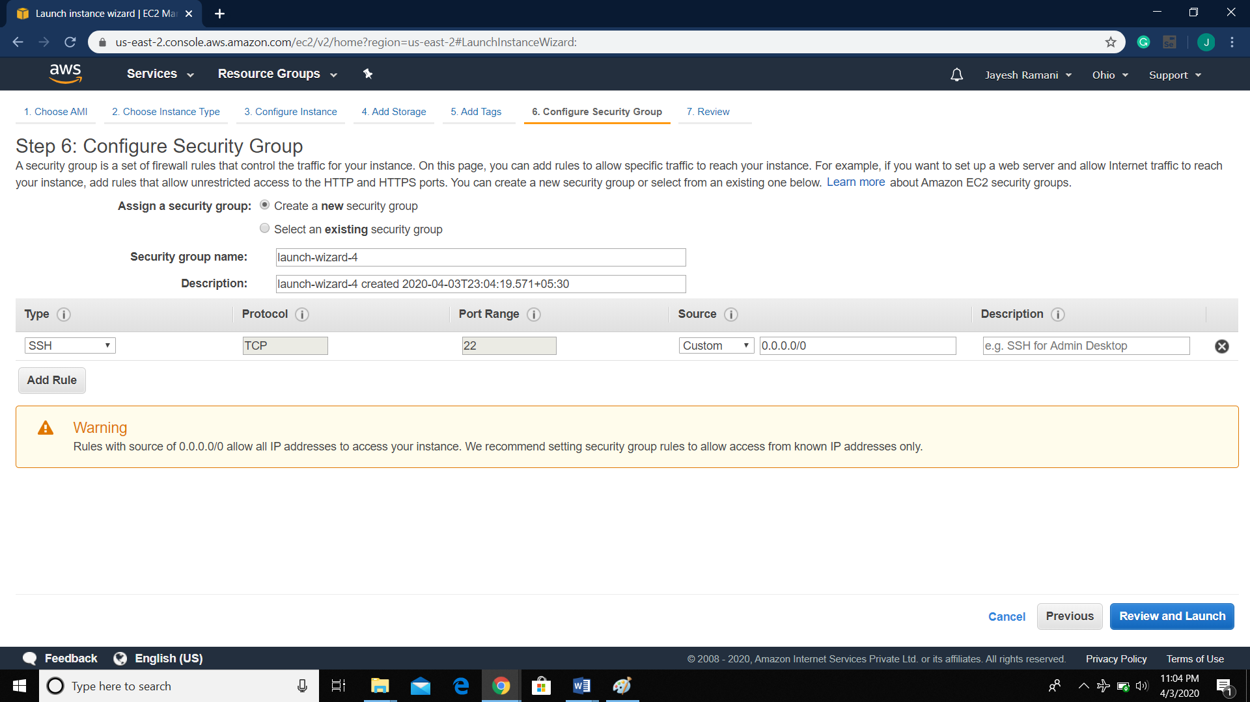

1. Key Pair download:

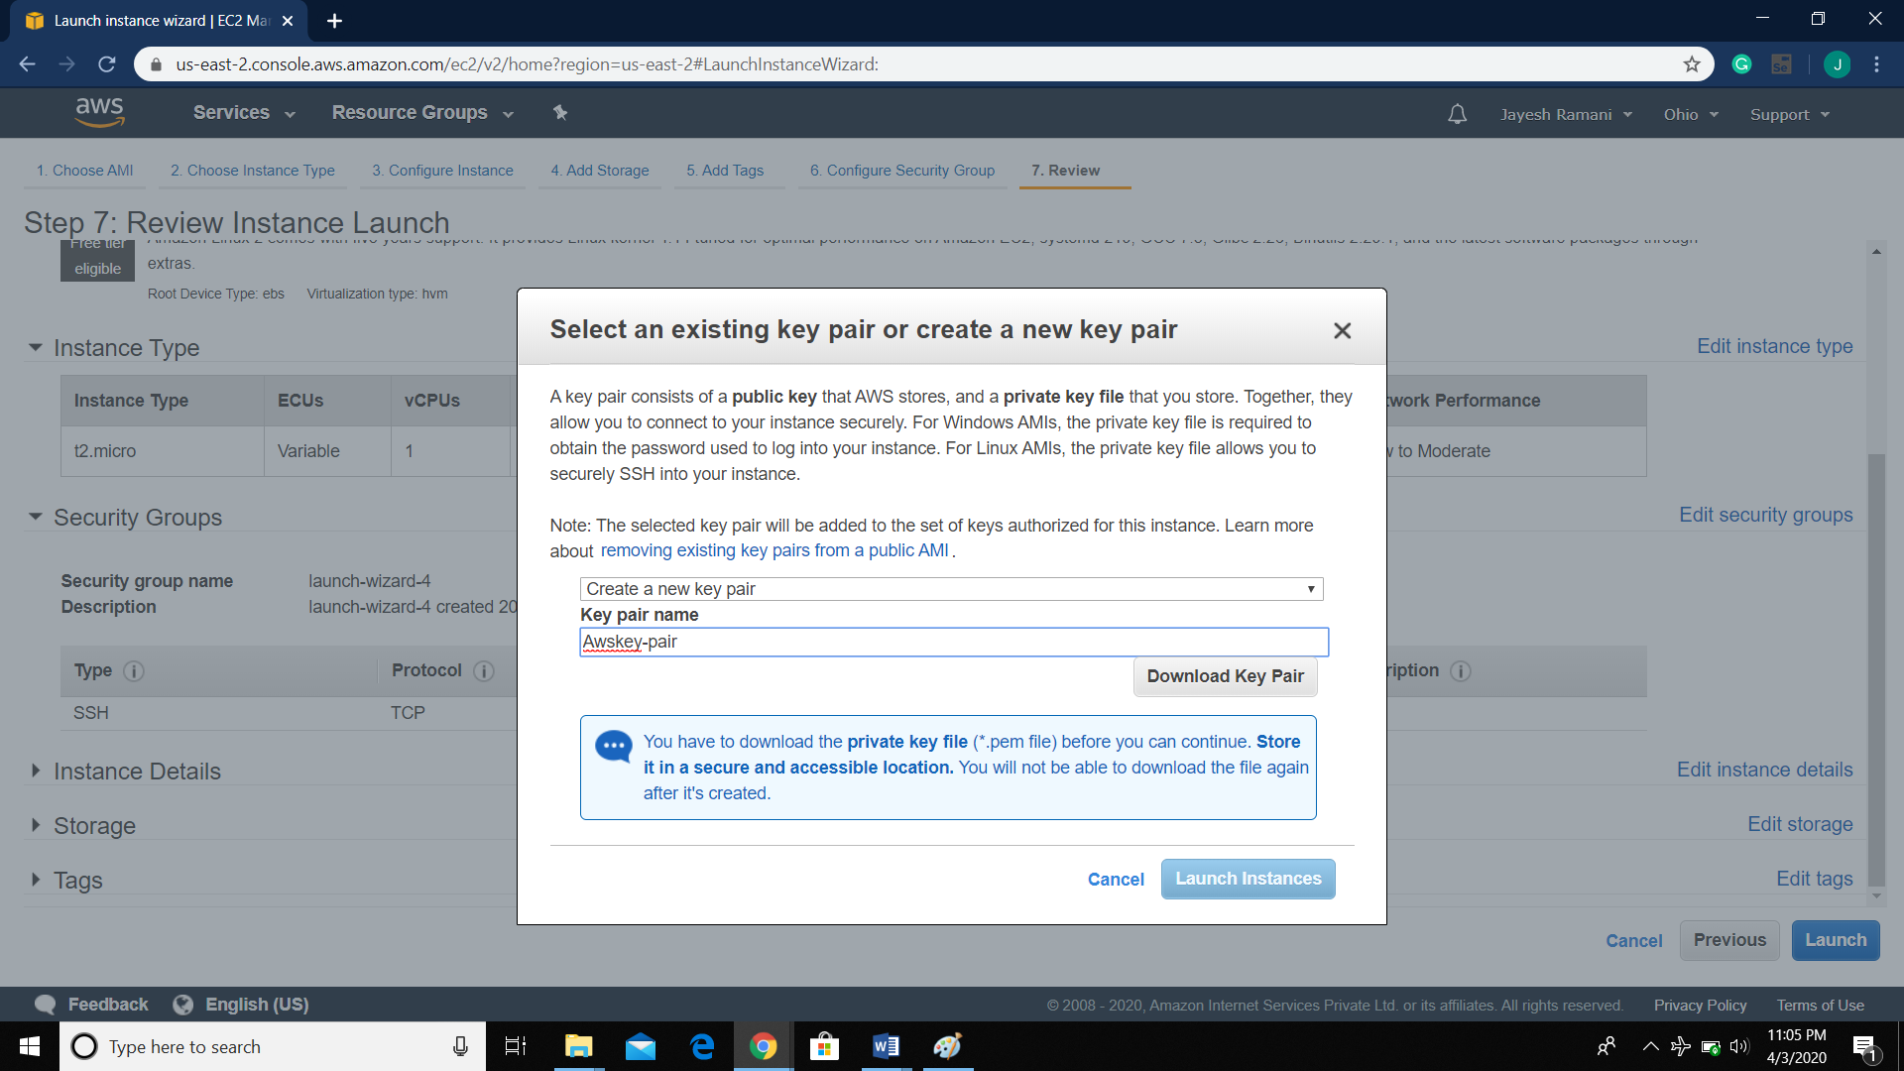

1. PuTTYgen coversion from pem to ppk:

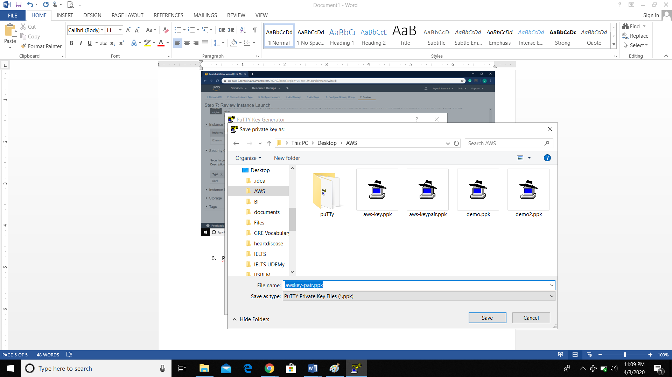

1. Logged into EC2 screen:

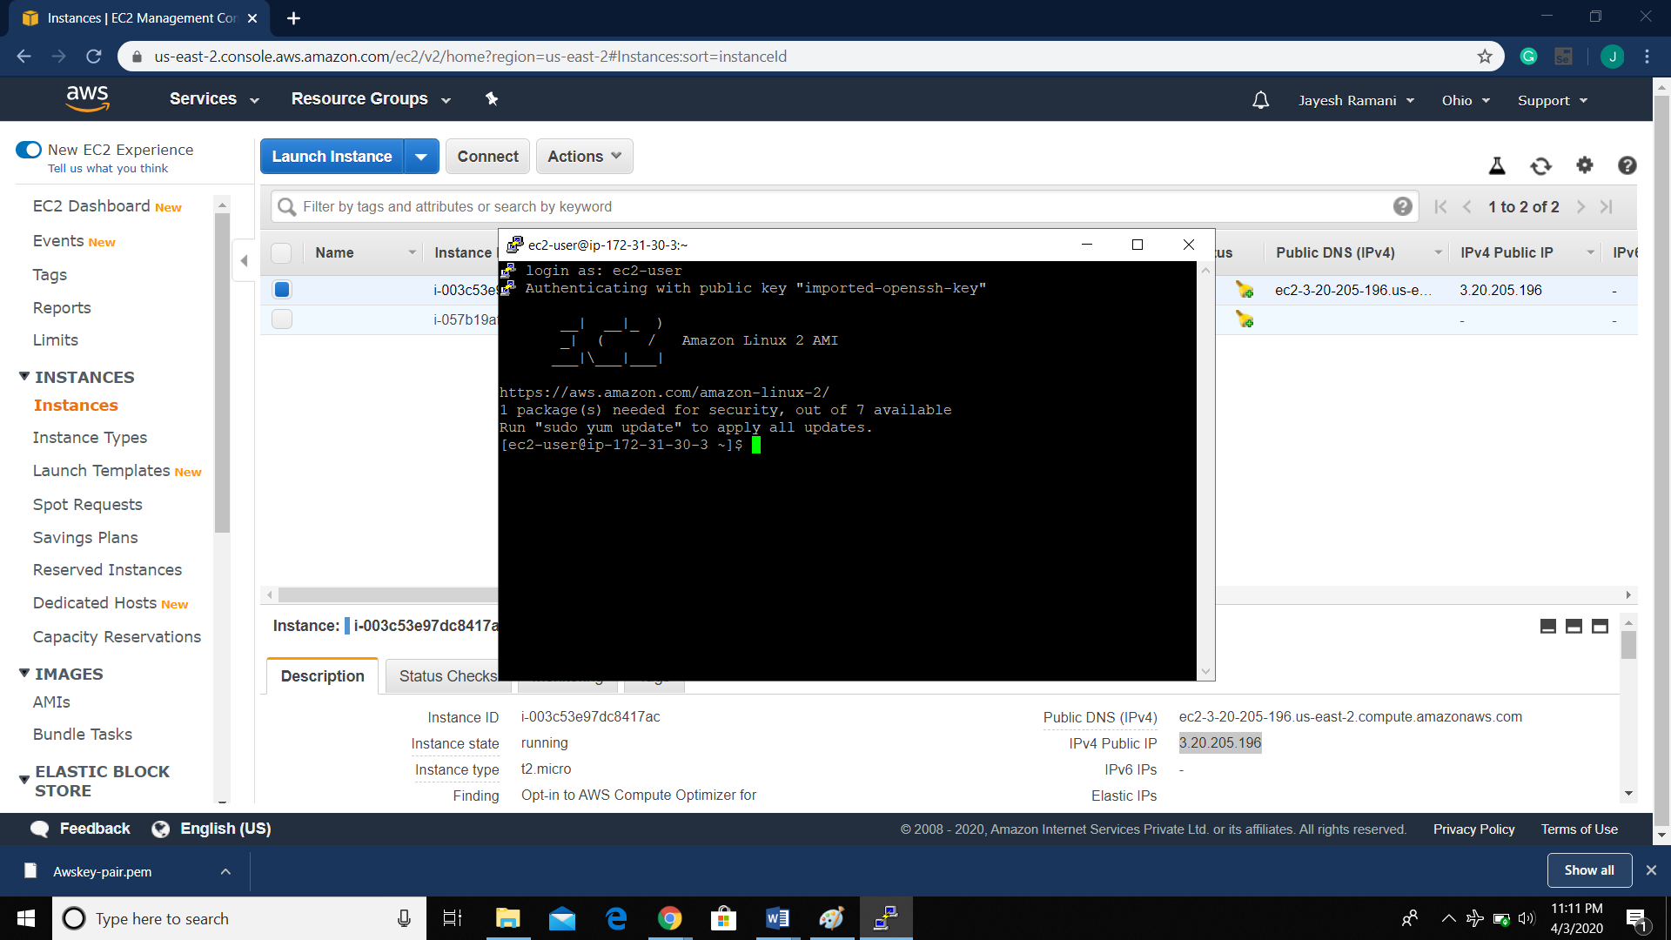

Screenshots needed for S3:

1. Creating a Bucket:

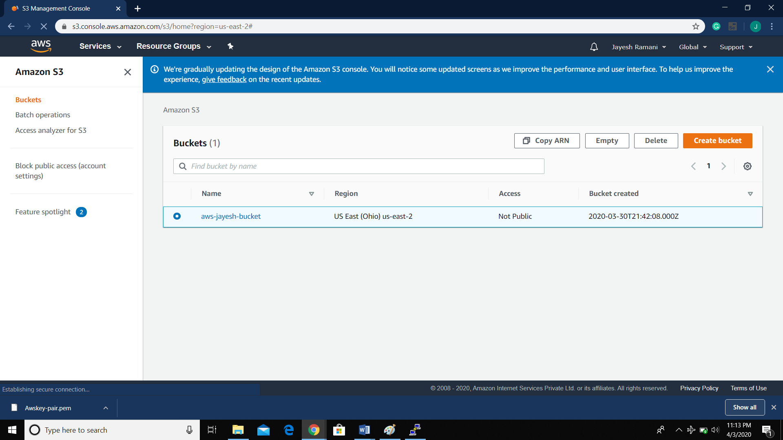

1. Uploading an Object



1. Enabling Static Website:

I)

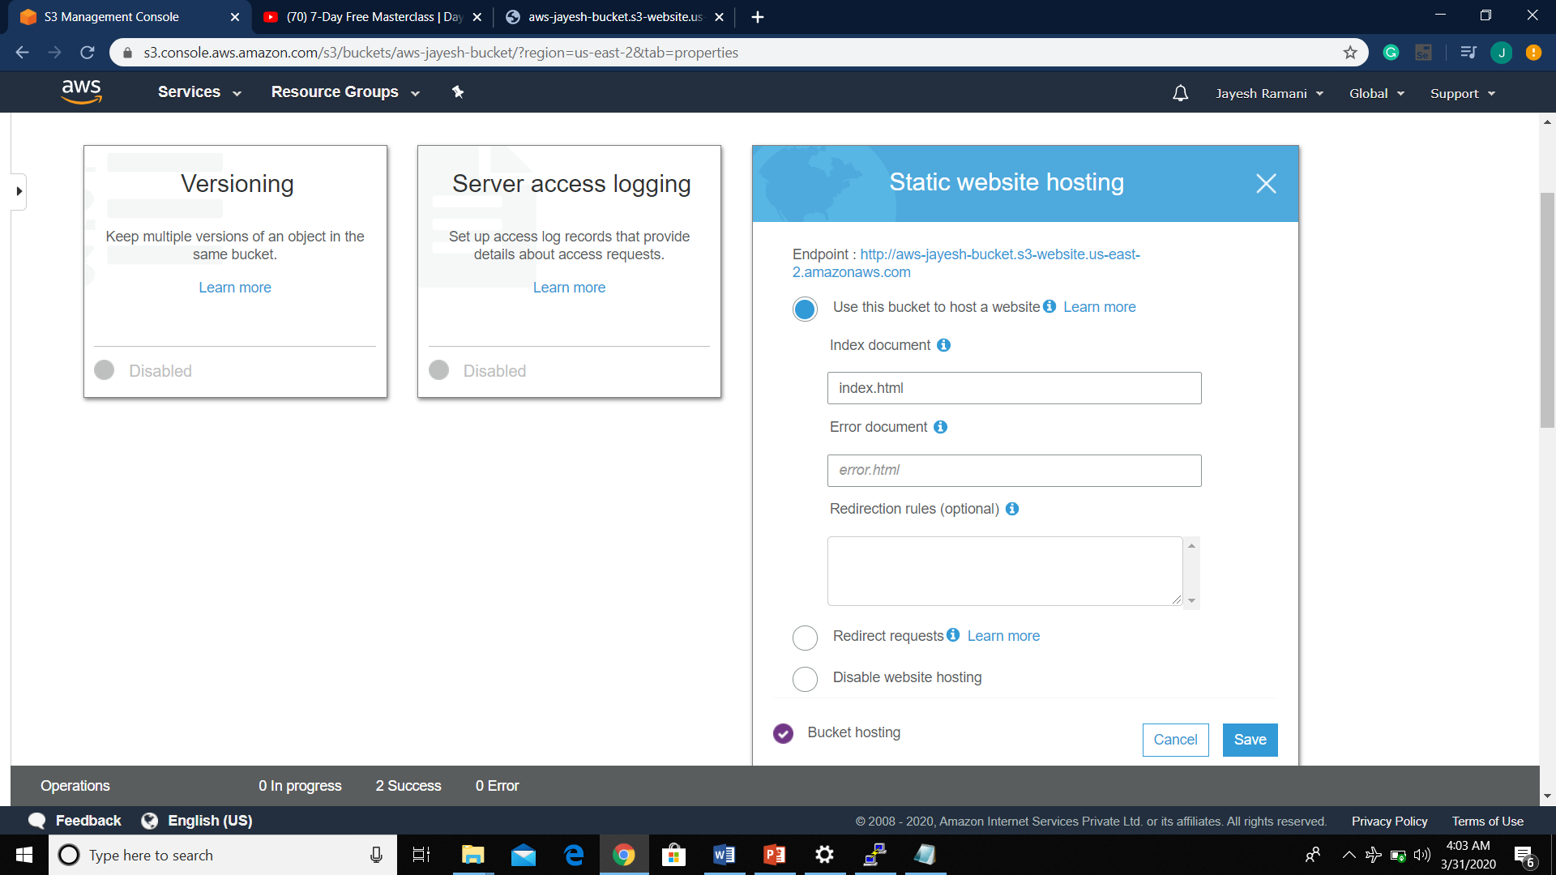

1. Making the object Public:

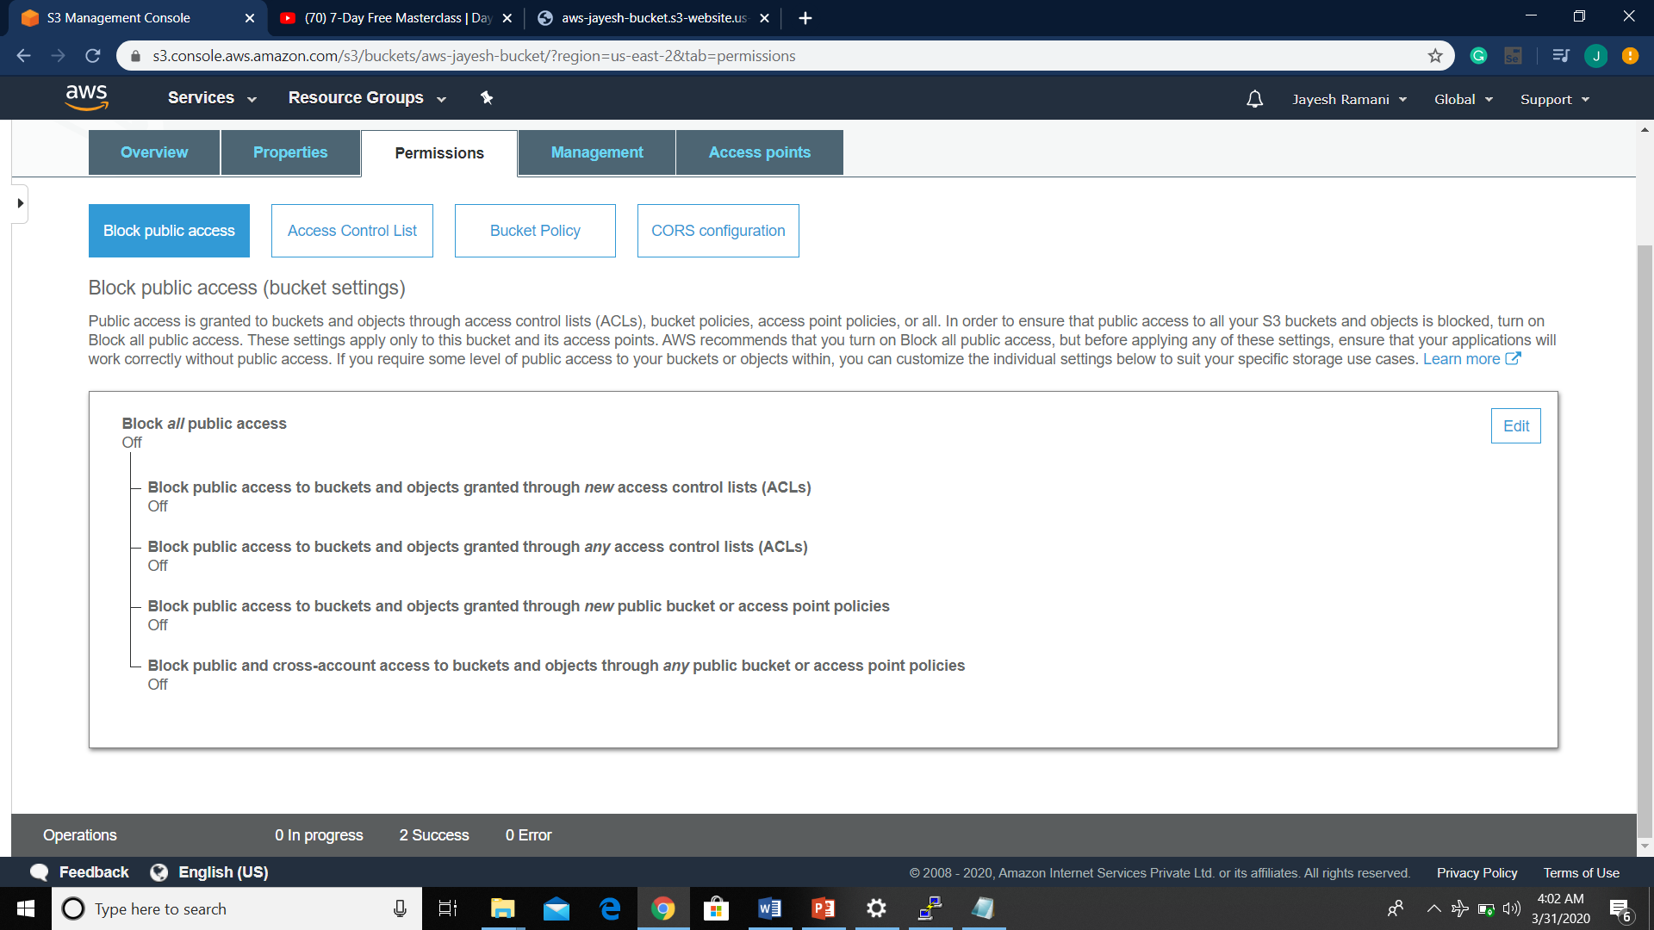

2. Checking S3 link on the browser:

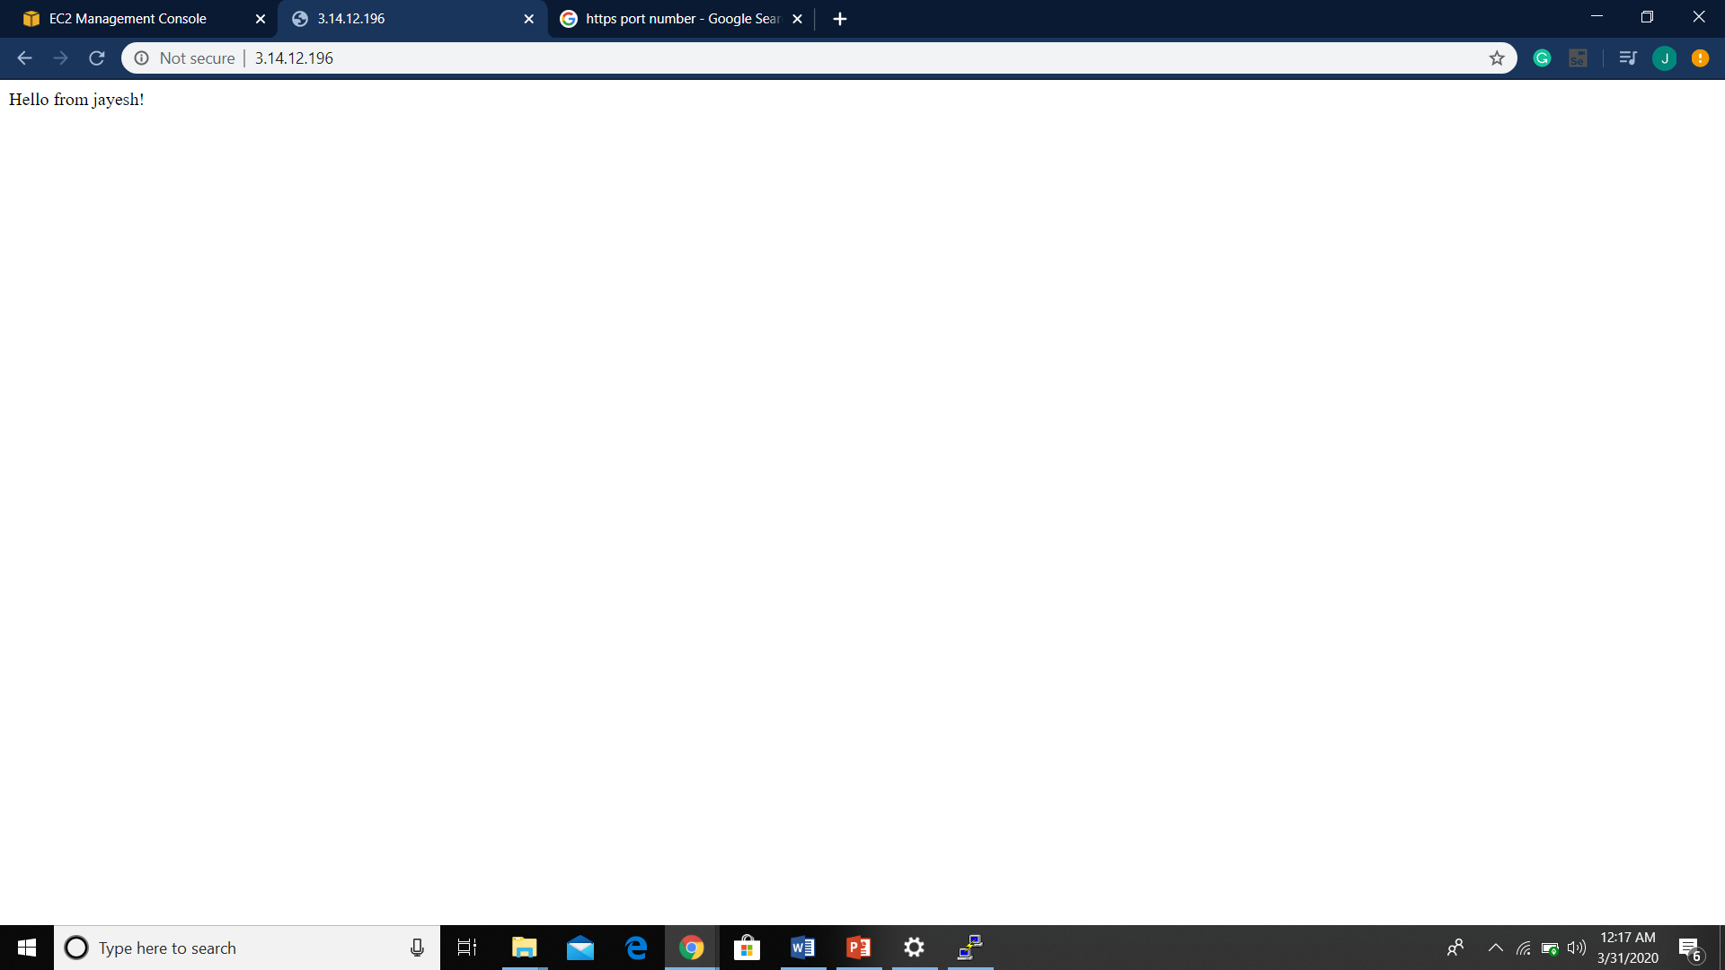

Screenshots needed for EC2 & S3:

1. Installing PHP

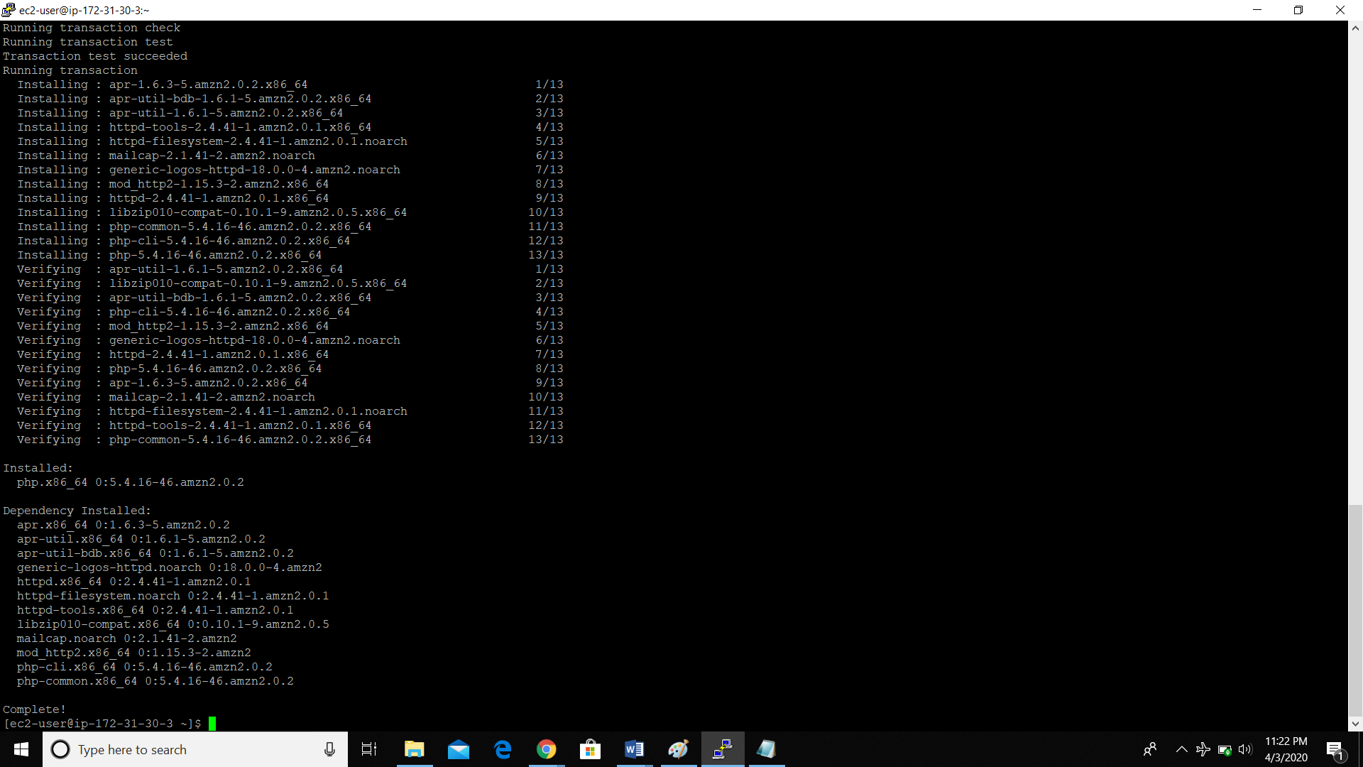

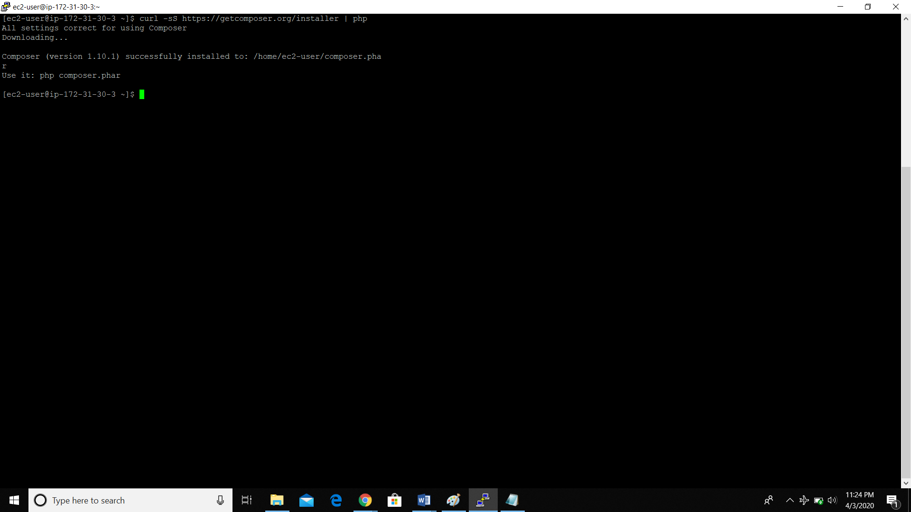

1. Installing aws-sdk:

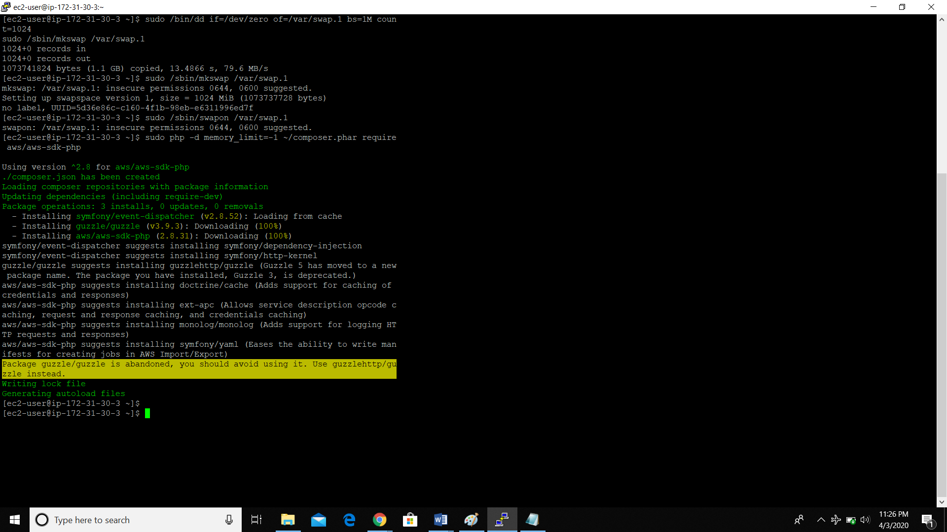

1. Index.php file code

