“SUMAGO INFOTECH PVT LTD”

INDUSTRIAL TRAINING REPORT

For partial fulfillment towards completion
of DIPLOMA in

COMPUTER ENGINEERING

Submitted by

Mr. Siddhesh Pradip More.

Guided by

Mrs.M.J.Gujar.

At


The Shirpur Education Society’s
R. C. PATEL POLYTECHNIC
Shirpur, District-Dhule (Maharashtra)

The Shirpur Education Society’s
R. C. Patel Polytechnic, Shirpur


MAHARASHTRA STATE BOARD
OF TECHNICAL EDUCATION, MUMBAI

Certificate of Completion

This is to certify that Mr. Siddhesh Pradip More with Enrollment No. 2118080054 has successfully completed Industrial Training (22057) in SUMAGO INFOTECH PVT LTD from 7/6/2023 to 22/7/2023 for partial fulfillment towards completion of Diploma in COMPUTER ENGINEERING from SES’ R. C. PATEL POLYTECHNIC, SHIRPUR Institute code 1808.

Date: -Aug-2023 place: shirpur

Mentor |  | HOD
Mrs.M.J.Gujar | Seal of the Institute | Mrs.S.N.Madavi
In-charge |  | Principal
Mrs.S.N.Madavi |  | Dr. N. G. Haswani

Industrial Training Completion Certificate

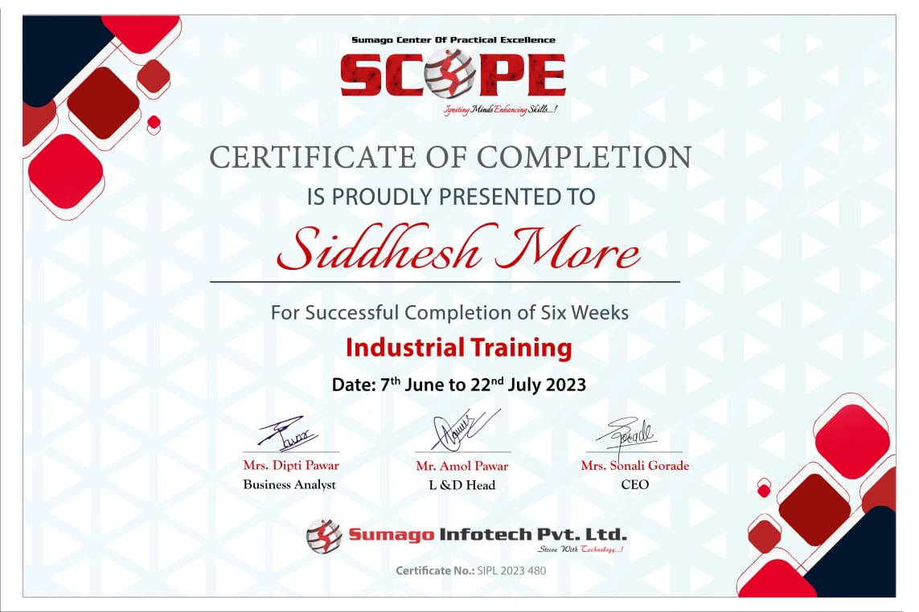

ACKNOWLEDGEMENT

The Acknowledgement is just like a drop in the ocean of the deep sense of gratitude within our heart for people who helped us out of most embarrassing part of our life when I was standing at most difficult step towards my dream of life.
Many people have contributed to the success of this in-plant training. Although a single sentence hardly suffices, I would like to thank CEO of Sumago Infotech Pvt Ltd Mrs. Sonali Gorade and Mr. Amol Pawar Learning and Development Head for giving me such golden opportunity to train at their site, and providing a chance to get more hands on approach for better understanding.
This Summer Industrial Training wouldn’t have been possible without the support of our honorable Principal Dr. N.G. Haswani, who has given his precious time and gave some ideas and suggestion towards this training.
I extend sincere and heartfelt thanks to central support of our department respected Mr. S.N.Madavi , Head of Department, Computer Engineering, for providing me the right ambience for carrying out this work.
I'm grateful and sincerely appreciate the effort of our respected In-Plant Training in-charge Mrs.S.N.Madavi who acted as a fulcrum for me and supported me during the ups and downs of this training. I profoundly indebted to my mentor Mrs.M.J.Gujar for valuable guidance and kind supervision given to me.
I express immense pleasure and thankfulness to all the teachers and staff of the Department of Computer Engineering for their cooperation and support.
Siddhesh Pradip More.
T. Y. Computer

Chapter 1 ABSTRACT

This report describes my internship at Sumago Infotech Pvt Ltd. My Company Is operating in Website Development , App development , Software Development , Digital Marketing ,Social Media, SEO, Training/Internship, Start up Consultancy and Web Hosting.

Industrial training is an important phase of a student life. A well planned, properly executed and evaluated industrial training helps a lot in developing a professional attitude. It develops an awareness of industrial approach to problem solving, based on a broad understanding of process and mode of operation of organization. The aim and motivation of this industrial training is to receive discipline, skills, teamwork and technical knowledge through a proper training environment, which will help me, as a student in the field of Information Technology, to develop a responsiveness of the self-disciplinary nature of problems in information are communication technology.

During my internship at Sumago Infotech Pvt Ltd we learned full stack development in python language. Firstly Backend part was taught which included basic of python language followed by all OOP concepts and file handling. For backend part Mr.Harshal Marathe was our mentor. After backend we started with frontend technology we started with HTML & CSS and after this we learned Bootstrap and template editing for web page development. For this part Mrs.Sonali Gorade was our mentor. Further we started with frontend development using D-JANGO ,here we learned to design web application and handling of web application . Mr.Harshal Marathe was our mentor for frontemd development using D-JANGO.

  - Vision of Company
We aspire to be the global sourcing choice of the world market and revolutionizes the way service processes function. To reach out to the common people across the globe and making Information Technology a tool for the “MASS” along with the tool for the “CLASS”. Creating innovative IT solutions and provide IT-enabled services to delight customers worldwide and build Relationships based on Trust, Values and Professionalism.

  - Mission of Company
At Sumago Infotech, We “Strive with Technology” to provide the most effective and affordable service that fulfills our customer’s needs and budget. We provide customized websites and software solutions that suit customer’s company objectives. We always keep involving our customers in an entire process starting from design through deployment, so that your ideas can be incorporated into our work.

Chapter 2 INTRODUCTION
  - Location Of Company

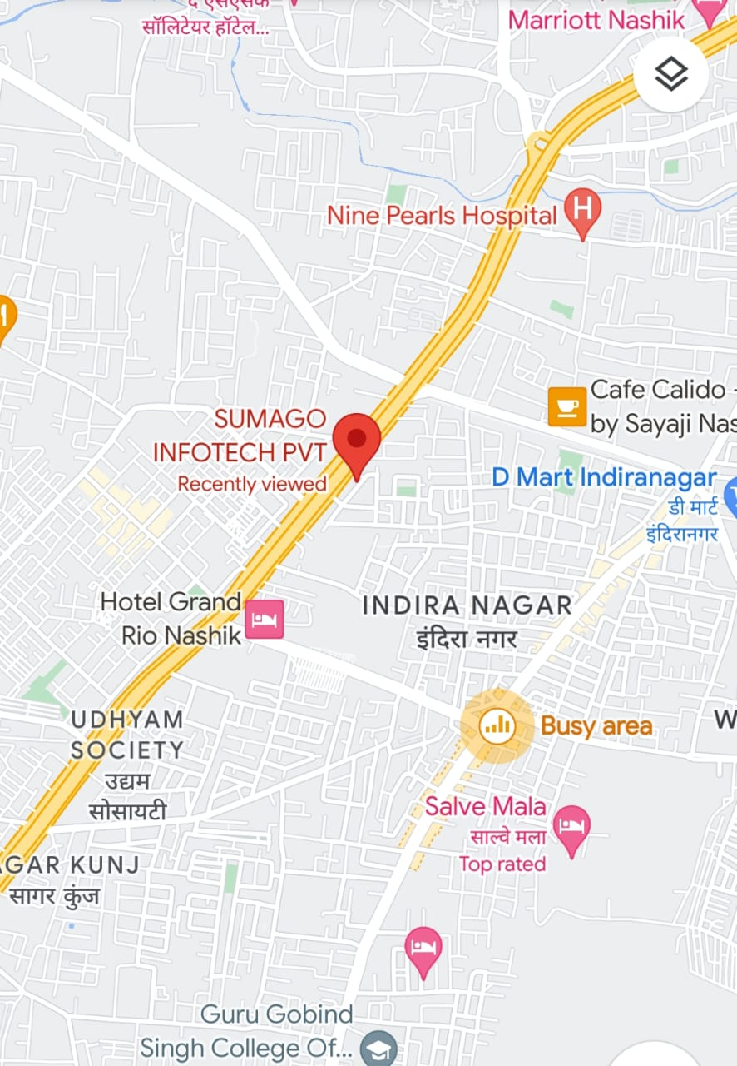

Address:-
3rd Floor, Gajra Chambers, Mumbai - Agra National Hwy, Kamod Nagar, Nashik, Maharashtra 422009

Sumago Infotech aspire to be the global sourcing choice of the world market and revolutionizes the way service processes function. To reach out to the common people across the globe and making Information Technology a tool for the “MASS” along with the tool for the “CLASS”. Creating innovative IT solutions and provide IT-enabled services to delight customers worldwide and build Relationships based on Trust, Values and Professionalism. Sumago Infotech has industry-specific software expertise in Technology, Financial, Healthcare, Media, Manufacturing, and many other sectors. The company specializes in offering Web Designing, Web Application Development, Mobile Application Development, Software Development, Digital Marketing, Software Testing, Quality Assurance services, and many more.

We are a team of committed innovative, client-sensitive and experienced software professionals who always strive to deliver customized, cost- effective and long-term software solutions that complement our client's objective and result in a satisfied customer

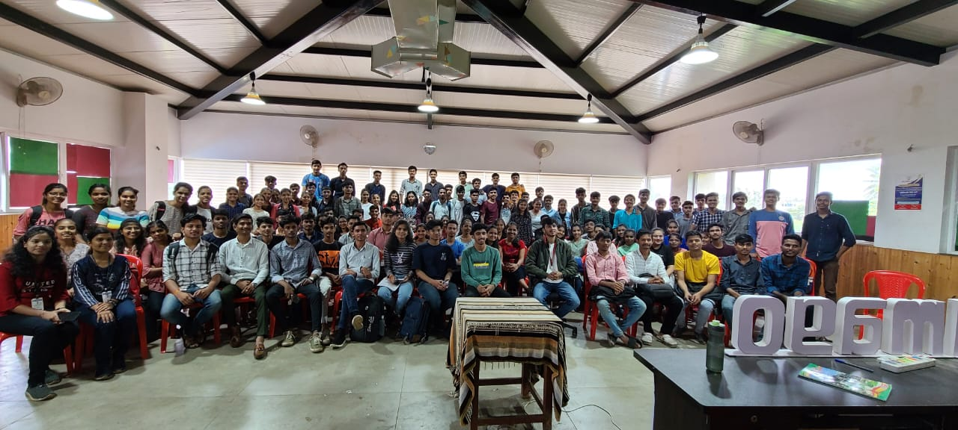

Chapter 3
SERVICES OFFERED

- Website Development
Sumago Infotech is a web design studio that offers corporate web design.

- App Development
As We Know, Android is the Latest technology. Most Companies Prefer Android development.

- Software Development
If you are searching for expert software developers for developing any kind of.

- Digital Marketing
Digital marketing is the use of the Internet, mobile devices, social media, search engines, and other channels to reach consumers.

- SEO
Search engine optimization (SEO) is the process of improving the ranking of your website in the leading search.

- Training/Internship
At Sumago Infotech we provide industrial training / Internship to BE, MCA, MCS and IT Students. We specialize in Mobile technologies.

- Starup Consultancy
From Idea to Product, We provide complete mentoring to startups, helping you to create a success story from your Idea.

- Web Hosting
If you are searching for expert software developers for developing any kind of application for

- Social Media
Whether it's creating your digital product or just designing it, whether it's engaging with your audiences or just.

Chapter 4 EXPERIMENT IN INDUSTRY
Week 1:

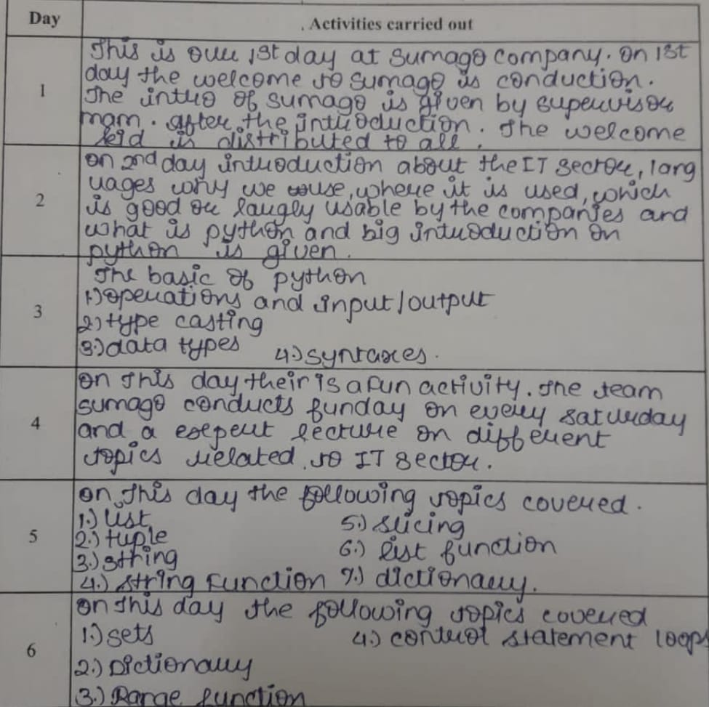

Week 2:

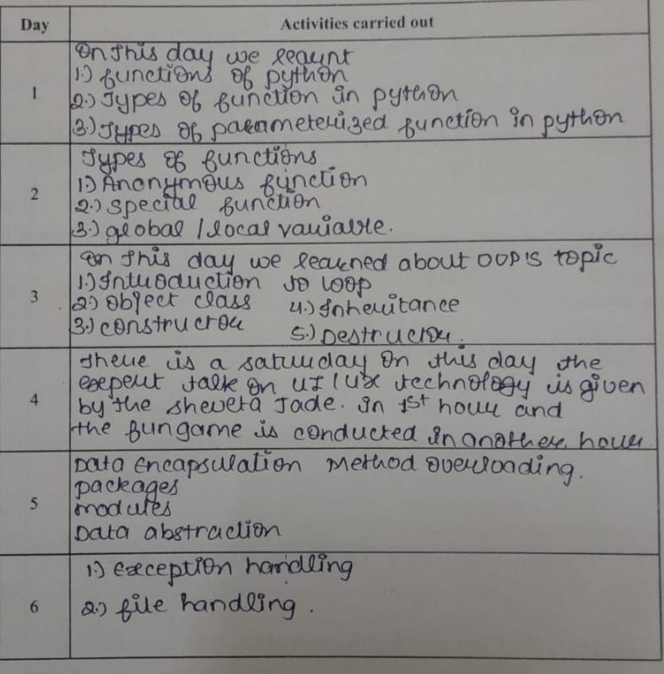

Week 3:

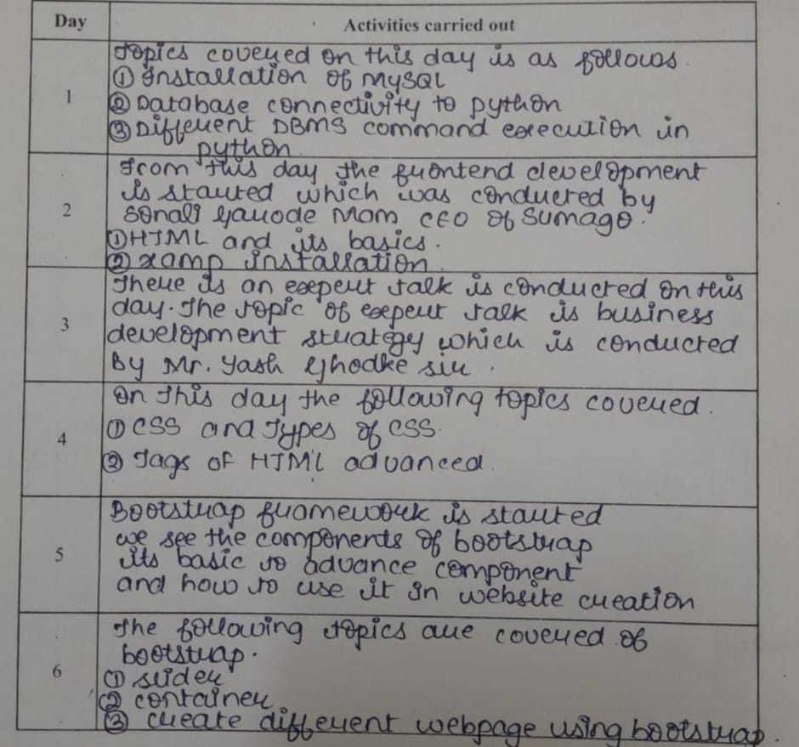

Week 4:

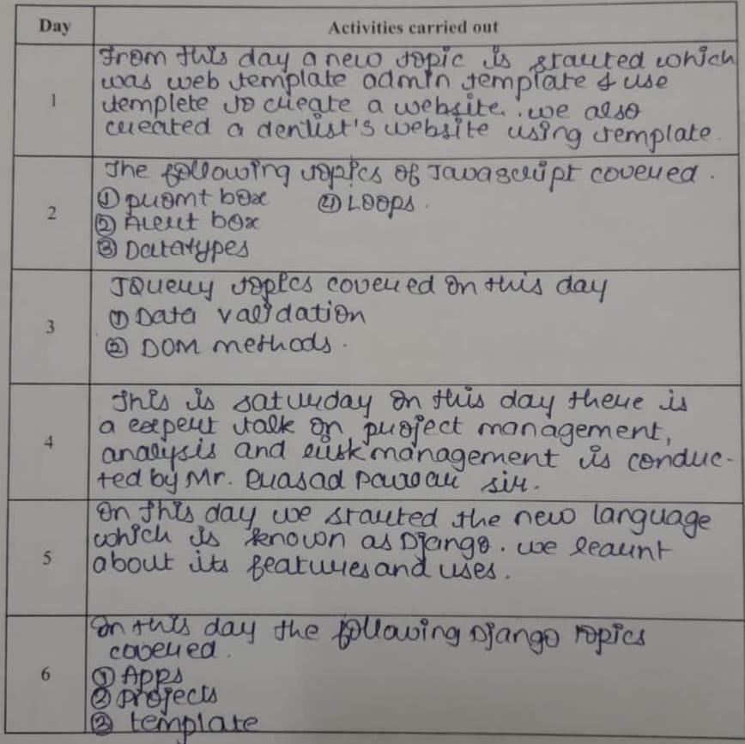

Week 5:

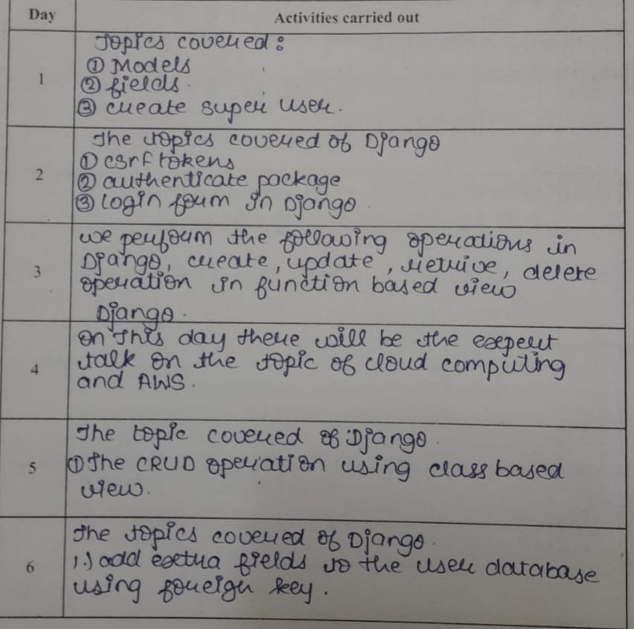

Week 6:

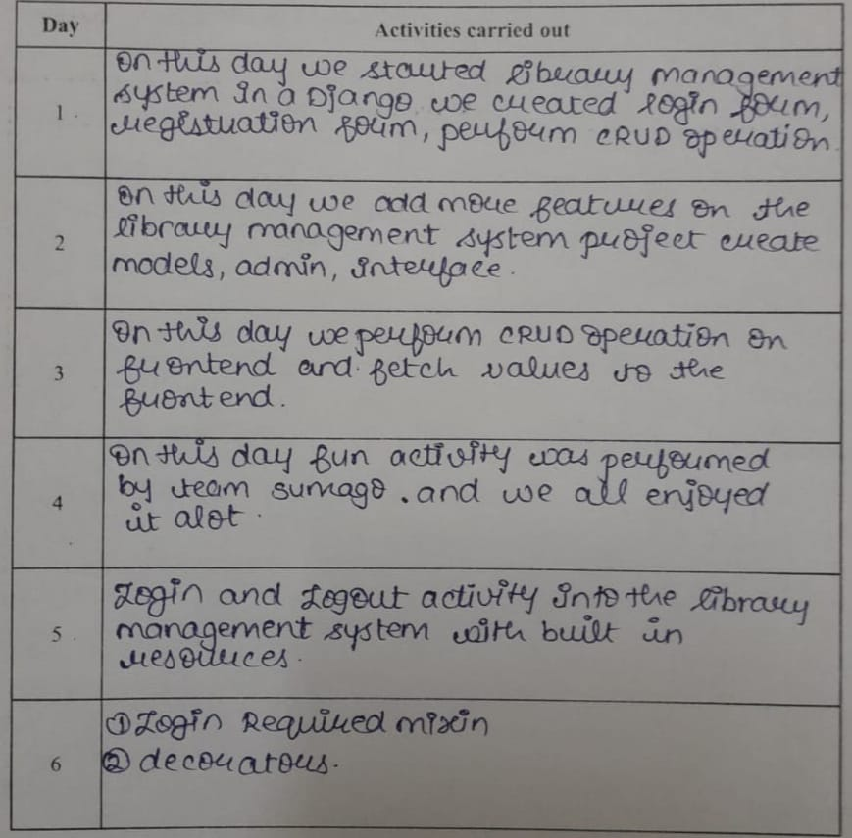

Chapter 5 –
DESCRIPTION OF PROJECT

We were assigned a group project my topic was email sending basically we have to design notes application with some additional extra features we had developed this project using Django ,Html , CSS and Bootstrap .
In this In this project main project name was notes and app created was named as document

Source Code:
Views.py file in app document
from django.shortcuts import render, redirect

from .models import Document

def editor(request):
docid = int(request.GET.get('docid', 0))
documents = Document.objects.all()

if request.method == 'POST':
docid = int(request.POST.get('docid', 0))
title = request.POST.get('title')
content = request.POST.get('content', '')

if docid > 0:
document = Document.objects.get(pk=docid)
document.title = title
document.content = content
document.save()

return redirect('/?docid=%i' % docid)
else:
document = Document.objects.create(title=title, content=content)

return redirect('/?docid=%i' % document.id)

if docid > 0:
document = Document.objects.get(pk=docid)
else:
document = ''

context = {
'docid': docid,
'documents': documents,
'document': document
}

return render(request, 'editor.html', context)

def delete_document(request, docid):
document = Document.objects.get(pk=docid)
document.delete()

return redirect('/?docid=0')

Models.py file in document

from django.db import models

class Document(models.Model):
title = models.CharField(max_length=255)
content = models.TextField(blank=True, null=True)

created_at = models.DateTimeField(auto_now_add=True)
modified_at = models.DateTimeField(auto_now=True)

class Meta:
ordering = ('title',)

admin.py file in document

from django.contrib import admin

from .models import Document

admin.site.register(Document)

Editior.html file in template folder

<!DOCTYPE html>

<html>
<head>
<meta charset="utf-8">
<meta name="viewport" content="width=device-width, initial-scale=1">
<title>Notes</title>
<link rel="stylesheet" href="https://cdn.jsdelivr.net/npm/bulma@0.9.0/css/bulma.min.css">
</head>

<body>
<nav class="navbar is-dark">
<div class="navbar-brand">
<a href="{% url 'editor' %}" class="navbar-item">Notes</a>
</div>

<div class="navbar-menu">
<div class="navbar-end">
<a href="{% url 'editor' %}?docid=0" class="navbar-item">New document</a>
</div>
</div>
</nav>

<section class="section">
<div class="columns">
<div class="column is-2">
<aside class="menu">
<p class="menu-label">Documents</p>

<ul class="menu-list">
{% for doc in documents %}
<li>
<a href="{% url 'editor' %}?docid={{ doc.id }}">{{ doc.title }}</a>
</li>
{% endfor %}
</ul>
</aside>
</div>

<div class="column is-10">
<form method="post" action="{% url 'editor' %}">
{% csrf_token %}

<input type="hidden" name="docid" value="{{ docid }}">

<div class="field">
<label class="label">
Title

{% if document %}
<span class="has-text-grey-light">
Created at: {{ document.created_at|date:"m/d Y" }} /
Modified at: {{ document.modified_at|date:"m/d Y" }}
</span>
{% endif %}
</label>

<div class="control">
<input type="text" class="input" name="title" placeholder="Title"{% if document %} value="{{ document.title }}"{% endif %}>
</div>
</div>

<div class="field">
<label class="label">Content</label>

<div class="control">
<textarea class="textarea" name="content" placeholder="Content">{% if document %}{{ document.content }}{% endif %}</textarea>
</div>
</div>

<div class="field is-grouped">
<div class="control">
<button class="button is-primary">Save</button>
</div>
{% if document %}
<div class="control">
<a href="{% url 'delete_document' document.id %}" class="button is-danger">Delete</a>
</div>
{% endif %}
</div>
</form>
</div>
</div>
</section>
</body>
</html>

Urls.py file in note

from django.contrib import admin
from django.urls import path

from document.views import editor, delete_document

urlpatterns = [
path('', editor, name='editor'),
path('delete_document/<int:docid>/', delete_document, name='delete_document'),
path('admin/', admin.site.urls),
]

Settings.py file in note
"""
Django settings for notes project.

Generated by 'django-admin startproject' using Django 3.0.8.

For more information on this file, see
https://docs.djangoproject.com/en/3.0/topics/settings/

For the full list of settings and their values, see
https://docs.djangoproject.com/en/3.0/ref/settings/
"""

import os

# Build paths inside the project like this: os.path.join(BASE_DIR, ...)
BASE_DIR = os.path.dirname(os.path.dirname(os.path.abspath(__file__)))

# Quick-start development settings - unsuitable for production
# See https://docs.djangoproject.com/en/3.0/howto/deployment/checklist/

# SECURITY WARNING: keep the secret key used in production secret!
SECRET_KEY = '&fw8cby(ggu&@-xe&a_9m1%hn8gvc5zh!%e@eh7lrohfqkqj5j'

# SECURITY WARNING: don't run with debug turned on in production!
DEBUG = True

ALLOWED_HOSTS = []

# Application definition

INSTALLED_APPS = [
'django.contrib.admin',
'django.contrib.auth',
'django.contrib.contenttypes',
'django.contrib.sessions',
'django.contrib.messages',
'django.contrib.staticfiles',

'document'
]

MIDDLEWARE = [
'django.middleware.security.SecurityMiddleware',
'django.contrib.sessions.middleware.SessionMiddleware',
'django.middleware.common.CommonMiddleware',
'django.middleware.csrf.CsrfViewMiddleware',
'django.contrib.auth.middleware.AuthenticationMiddleware',
'django.contrib.messages.middleware.MessageMiddleware',
'django.middleware.clickjacking.XFrameOptionsMiddleware',
]

ROOT_URLCONF = 'notes.urls'

TEMPLATES = [
{
'BACKEND': 'django.template.backends.django.DjangoTemplates',
'DIRS': [],
'APP_DIRS': True,
'OPTIONS': {
'context_processors': [
'django.template.context_processors.debug',
'django.template.context_processors.request',
'django.contrib.auth.context_processors.auth',
'django.contrib.messages.context_processors.messages',
],
},
},
]

WSGI_APPLICATION = 'notes.wsgi.application'

# Database
# https://docs.djangoproject.com/en/3.0/ref/settings/#databases

DATABASES = {
'default': {
'ENGINE': 'django.db.backends.sqlite3',
'NAME': os.path.join(BASE_DIR, 'db.sqlite3'),
}
}

# Password validation
# https://docs.djangoproject.com/en/3.0/ref/settings/#auth-password-validators

AUTH_PASSWORD_VALIDATORS = [
{
'NAME': 'django.contrib.auth.password_validation.UserAttributeSimilarityValidator',
},
{
'NAME': 'django.contrib.auth.password_validation.MinimumLengthValidator',
},
{
'NAME': 'django.contrib.auth.password_validation.CommonPasswordValidator',
},
{
'NAME': 'django.contrib.auth.password_validation.NumericPasswordValidator',
},
]

# Internationalization
# https://docs.djangoproject.com/en/3.0/topics/i18n/

LANGUAGE_CODE = 'en-us'

TIME_ZONE = 'UTC'

USE_I18N = True

USE_L10N = True

USE_TZ = True

# Static files (CSS, JavaScript, Images)
# https://docs.djangoproject.com/en/3.0/howto/static-files/

STATIC_URL = '/static/'

Output:
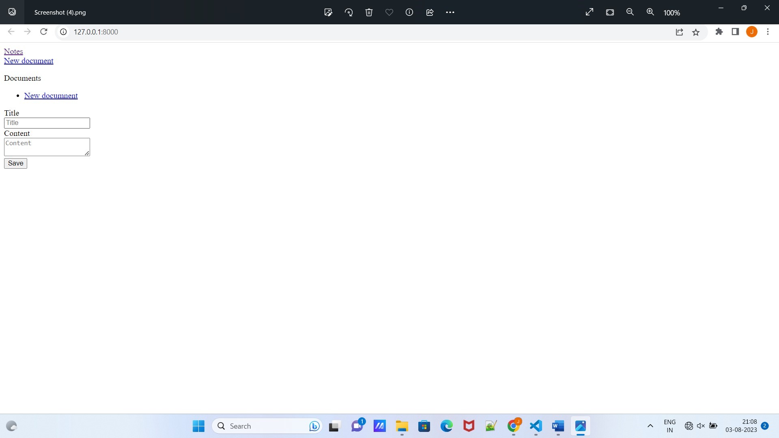

Chapter 6 – EXPERIENCE IN INDUSTRY

I had the incredible opportunity to undergo industrial training at Sumago Infotech, a leading software development company. This invaluable experience allowed me to immerse myself in the dynamic world of IT, gain practical insights, and expand my knowledge and skills. The following account outlines my journey and the valuable lessons I learned during my time at Sumago Infotech.
The team of experienced professionals at Sumago Infotech served as my mentors, guiding me through the intricacies of various technologies and methodologies. Their unwavering support and feedback were instrumental in my growth as a future IT professional.

Chapter 7 – REFERENCES

- https://www.sumagoinfotech.com/
- https://react.dev/
- https://www.npmjs.com/
- https://stackoverflow.com/

