MediScan: A Multiscale Dual-Path Residual Architecture with Attention Refinement for Multi-Disease Clinical Triage and Explainable Diagnosis
Daksh Gurjar, Student Member, IEEE, Aditya Yashovardhan, and Jayesh Mandloi
Department of Computer Engineering, Mukesh Patel School of Technology Management & Engineering (MPSTME)
SVKM’s NMIMS, Shirpur 425405, Maharashtra, India
{daksh.gurjar, aditya.yashovardhan, jayesh.mandloi}@nmims.in
This work has been submitted to the IEEE for possible publication. Copyright may be transferred without notice.
Abstract—Access to timely radiological and endoscopic interpretation is severely restricted in resource-constrained primary healthcare facilities, where specialist-to-patient availability remains drastically below international standards. We present MediScan AI, an end-to-end multi-modal deep learning triage framework evaluated across three distinct clinical imaging modalities: brain magnetic resonance imaging (MRI), pediatric chest radiography (CXR), and upper gastrointestinal (GI) endoscopy. At the core of the framework is DualPathNet, a custom 14.91M-parameter convolutional architecture combining parallel 3×3 and 5×5 multi-scale receptive paths, Convolutional Block Attention Modules (CBAM), deep residual refinement, and dual global pooling (GAP+GMP). On strictly held-out benchmark test sets evaluated with 4-pass test-time augmentation (TTA), the models achieve test accuracies of 94.94% [95% CI: 93.8–95.9%] across four classes on brain MRI (N=1,600 scans, macro-F1: 94.84%, OvR ROC-AUC: 0.9874), 96.06% [95% CI: 94.4–97.3%] on upper-GI endoscopy (N=711 frames, macro-F1: 95.39%, ROC-AUC: 0.9904), and 89.58% [95% CI: 86.9–91.7%] on pediatric CXR (N=624 radiographs, ROC-AUC: 0.9586) under a validation-calibrated specificity-protecting decision threshold (τ=0.780, yielding 91.88% specificity, 88.21% sensitivity, and 94.77% precision; operating at τ=0.500 shifts performance to 96.15% sensitivity and 76.92% specificity for frontline screening). Visual interpretability is provided via gradient-weighted class activation mapping (Grad-CAM) hooked directly to the penultimate refinement block (refine[2], 7×7 feature map). Latency profiling on a commodity multi-core CPU demonstrates single-scan inference in 105 ms (p95: 112 ms) and complete 4-pass TTA with Grad-CAM generation in 731 ms (p95: 765 ms), verifying sub-second clinical triage without requiring GPU acceleration. MediScan AI establishes a computationally efficient, clinically auditable paradigm for point-of-care medical decision support.
Index Terms—Computer-aided diagnosis, multiscale convolutional neural networks, explainable artificial intelligence (XAI), Grad-CAM, pediatric pneumonia, brain tumor, gastric ulcer, medical triage, bilingual tele-health.

I. INTRODUCTION
Diagnostic medical imaging—spanning magnetic resonance imaging (MRI), projection radiography (chest X-ray, CXR), and white-light endoscopy—constitutes the cornerstone of acute clinical triaging, oncological staging, and emergency intervention [1]–[3]. Timely and precise identification of focal pathological lesions is of decisive clinical consequence. Pediatric pneumonia represents a leading cause of childhood mortality worldwide, demanding prompt initiation of targeted antimicrobial therapy to avert respiratory distress syndrome [1], [4], [5]. In neuro-oncology, malignant intracranial neoplasms such as high-grade gliomas necessitate immediate neurosurgical resection planning and adjuvant radiochemotherapy to mitigate catastrophic mass-effect edema [2], [6], [7]. In gastroenterology, actively bleeding peptic ulcerations require urgent endoscopic intervention to forestall hypovolemic shock and fatal gastrointestinal hemorrhage [3], [8], [9].
Notwithstanding the critical importance of prompt interpretation, the volume of acquired diagnostic scans vastly outstrips the specialist workforce available in primary and secondary healthcare institutions worldwide [4], [7]. In India, the doctor-to-population ratio in rural and semi-urban districts remains stubbornly below the World Health Organization (WHO) minimum threshold of 1:1,000 [10]. More critically, official data from the Ministry of Health and Family Welfare (MoHFW) Rural Health Statistics [11] reveal that community health centers (CHCs) in rural regions face a specialist physician and radiologist shortfall exceeding 65%. Consequently, primary health facilities are predominantly manned by medical officers and general practitioners who are compelled to make urgent clinical triage decisions without specialized radiological consultation.
Automated computer-aided diagnosis (CAD) systems driven by deep convolutional neural networks (CNNs) present an attractive solution for bridging this interpretive shortfall. However, clinical translation of modern deep learning models into resource-constrained frontline environments is severely hindered by three fundamental challenges:
1) Severe Model Over-parameterization: Contemporary vision transformers and ultra-deep convolutional architectures (e.g., ViT, ResNet-101, DenseNet-201) frequently contain 25M to 85M parameters, requiring dedicated graphics processing units (GPUs) and excessive memory bandwidth [12], [13]. Such infrastructure is overwhelmingly absent in rural diagnostic centers and peripheral clinics.
2) The Black-Box Trust Deficit: Opaque decision-making without verifiable spatial groundings prevents frontline clinicians from validating whether network predictions are anchored to genuine pathological anatomy or to spurious image acquisition artifacts [9], [17].
3) Inflexible Operational Decision Cutoffs: Default argmax classification rules (τ = 0.50) treat false alarms and missed critical pathologies symmetrically. In acute clinical triage, the cost of a missed intracranial malignancy or untreated pneumonia far exceeds that of a false positive, necessitating adjustable, calibrated decision boundaries tailored to specific clinical workflows.
To systematically address these clinical constraints, we introduce MediScan AI, an explainable multi-modal medical imaging triage framework. MediScan AI is powered by DualPathNet, a custom 14.91M-parameter convolutional architecture engineered to extract multi-scale pathological features without reliance on proprietary foundation models. The framework is evaluated across three primary diagnostic tasks: 4-class brain tumor MRI (TumorNet), binary pediatric pneumonia CXR (PneumoNet), and binary upper-GI ulcer endoscopy (GastroNet).
The primary contributions of this paper are fourfold:
• Architectural Innovation: We propose DualPathNet, a custom convolutional backbone integrating parallel 3×3 and 5×5 residual branches, Convolutional Block Attention Modules (CBAM), deep residual refinement, and joint global average and max pooling (GAP+GMP), capturing fine lesion boundaries and broad organ context in 14.91M parameters.
• Empirical Multi-Modal Validation: We report rigorous test-first evaluations across three publicly available medical benchmarks comprising 17,794 total images (1,600 test brain MRIs, 624 test chest radiographs, and 711 test endoscopy frames), documenting 95% bootstrap confidence intervals.
• Clinically Auditable Explainability: We hook gradient-weighted class activation mapping (Grad-CAM) directly to the penultimate residual refinement tensor (refine[2], 7×7 resolution), stabilized via 4-pass test-time augmentation (TTA) to generate anatomically congruent saliency overlays.
• Edge Deployment Feasibility: We profile execution latencies on commodity multi-core CPU hardware, achieving end-to-end inference and Grad-CAM visualization within 731 ms (p95: 765 ms), verifying practical edge viability without GPU acceleration.
II. RELATED WORK & DOMAIN RATIONALE
A. Deep Learning in Diagnostic Medical Imaging
Over the past decade, deep learning has achieved remarkable diagnostic efficacy across medical imaging sub-specialties. In neuro-oncology, the classification of intracranial neoplasms—specifically glioma, meningioma, and pituitary adenoma—from T1-weighted contrast-enhanced MRI has predominantly utilized transfer learning with general-domain backbones such as VGG-16, ResNet-50, and InceptionV3 [2], [6], [7], [14], [28]. Noreen et al. [7] explored concatenation ensembles of InceptionV3 and DenseNet201, reporting 94.34% accuracy across three tumor categories. Rizwan et al. [14] combined deep feature extractors with extreme learning machines, achieving 95.40% accuracy. Similarly, Rehman et al. [28] investigated transfer learning across multiple architectures, reporting 96.56% accuracy. However, existing works rarely evaluate multi-scale receptive fields designed specifically to address the irregular morphology of infiltrative glial margins.
In thoracic imaging, automated detection of pediatric pneumonia was catalyzed by the benchmark archive curated by Kermany et al. [1]. Subsequent investigations demonstrated that pediatric chest radiographs exhibit distinct anatomical proportions and respiratory motion compared to adult cohorts [4], [5], [19]. Sharma & Guleria [4] evaluated VGG-16 backbones, reporting 92.80% accuracy. Ali et al. [5] developed an ensemble utilizing EfficientNetV2L, reaching 94.60% accuracy. Munir et al. [19] introduced PneuX-Net, reporting 95.10% accuracy and 0.987 ROC-AUC with saliency visualizations. Nevertheless, these studies evaluate single decision thresholds, overlooking the severe clinical disparity between screening and triage.
In gastrointestinal endoscopy, computer-aided detection has evolved with the release of comprehensive video endoscopy databases such as HyperKvasir [15]. Sun et al. [3] surveyed deep learning methods for bleeding and mucosal ulcer detection in capsule endoscopy, noting an average accuracy of 92.40%. Hatami et al. [8] applied ResNet-50 transfer learning, achieving 93.80% accuracy on endoscopic mucosal frames. Olimboyev et al. [9] developed Gastro-AI, incorporating visual attention mechanisms to achieve 95.80% accuracy on mucosal lesions.
B. Architectural Motivation for DualPathNet
A critical limitation of off-the-shelf CNN backbones (e.g., standard ResNet or MobileNet) is their reliance on uniform convolutional kernel sizes (predominantly 3×3) across individual stages. While effective for natural imagery where semantic objects occupy standardized spatial hierarchies, medical pathologies exhibit profound scale divergence across diagnostic modalities:
• Micro-structural Pathologies: Brain tumor margins require localized 3×3 receptive fields to resolve infiltrative dural edges and vascular displacement, while mucosal ulcers in endoscopy present as focal, sharp epithelial disruptions.
• Macro-structural Pathologies: Pediatric lobar pneumonia manifests as diffuse parenchymal opacification spanning extensive pulmonary lobes, demanding wide 5×5 receptive fields to capture bilateral thoracic symmetry and broad parenchymal context.
DualPathNet resolves this conflict by bifurcating feature extraction into parallel 3×3 (Path A) and 5×5 (Path B) residual pathways. By fusing localized and contextual representations through 1×1 projection and CBAM attention, the model preserves high-frequency lesion margins while simultaneously integrating broad anatomical context, achieving superior representation without ballooning parameter count.
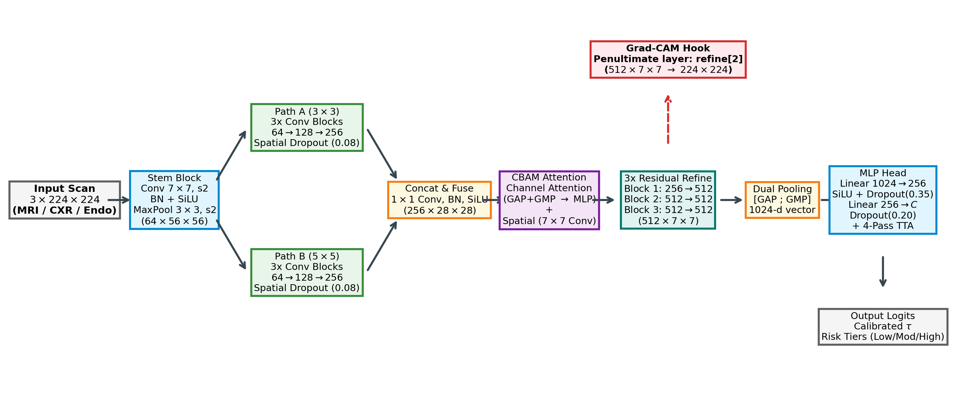
Fig. 1. Architectural schema of DualPathNet and the MediScan AI clinical triage pipeline. The input scan passes through an initial stem block before splitting into parallel multi-scale branches (Path A: 3×3 kernels; Path B: 5×5 kernels). Fused features are modulated by CBAM attention, processed through three residual refinement stages with a penultimate Grad-CAM hook at refine[2], and classified via dual global pooling (GAP+GMP) and an MLP head coupled with 4-pass TTA.
III. MEDISCAN AI SYSTEM PLATFORM
MediScan AI is structured as a modular, containerized clinical microservice architecture designed for edge deployment within local hospital networks. The pipeline comprises six integrated stages: scan ingestion, modality-specific pre-processing, DualPathNet inference, threshold-calibrated triage, Grad-CAM visual explanation, and bilingual clinical report compilation.
A. Modality-Specific Pre-Processing
All diagnostic scans are standardized to 224×224×3 RGB tensors. To account for acquisition disparities across physical modalities, tailored normalization protocols are applied:
• Brain MRI: Axial T1-weighted contrast-enhanced slices undergo min-max intensity scaling to normalize cranial parenchymal contrast.
• Pediatric CXR: Radiographs undergo Contrast Limited Adaptive Histogram Equalization (CLAHE, clip limit 2.0, tile grid 8×8) to accentuate subtle alveolar consolidation and air bronchograms against cardiac shadows.
• Endoscopy: Endoscopic mucosal frames are normalized using channel-wise standard statistics, coupled with training-time color jitter (brightness and contrast ±12%) to provide robust invariance against mucosal reflections and endoscope illumination variations.
B. Microservice Architecture & Clinical Dashboard
The production backend is developed using FastAPI and PyTorch 2.6 in Docker containers. Models are loaded into system memory during start-up. Incoming multipart requests carrying an image and modality tag are routed to the corresponding model instance (TumorNet, PneumoNet, or GastroNet). Inference is augmented via a 4-pass Test-Time Augmentation (TTA) scheme, averaging predictions across original, horizontally flipped, and center-cropped variants to stabilize confidence scores. Forward activations and backward gradients at the penultimate residual block (model.refine[2]) are captured via PyTorch hooks to generate Grad-CAM heatmaps. The service returns a structured JSON payload containing predicted diagnosis, calibrated risk tier, confidence probability, and a Base64-encoded visual heatmap overlay.
The clinician dashboard is engineered with Next.js 14, React, and Tailwind CSS, providing a synchronized English and Hindi (hi-IN) interface. A clinical report engine compiles patient demographic fields, raw scan imagery, Grad-CAM heatmap overlays, and severity-graded diagnostic recommendations into an auditable, printable medical document.
IV. DUALPATHNET ARCHITECTURAL FORMULATION
DualPathNet is formulated as a dual-branch residual convolutional network. Given an input medical scan X ∈ R^(3×224×224), an initial stem block (Conv 7×7, stride 2, padding 3, BN, SiLU activation, MaxPool 3×3, stride 2) reduces spatial resolution to 64×56×56. The resulting feature tensor is bifurcated into parallel processing pathways:
F_A = F_PathA(X_stem; W_A) (Kernels: 3×3) (1)
F_B = F_PathB(X_stem; W_B) (Kernels: 5×5) (2)
Each path comprises four sequential stages with channel depths 32→64→128→256, built using ResidualConvBlock instances. Each residual block is defined mathematically as:
y = SiLU(BN(Conv_2(SiLU(BN(Conv_1(x)))))) + Shortcut(x) (3)
where Shortcut(x) represents an identity skip connection when channel dimensions match, or a 1×1 convolution with BatchNorm when channel transition occurs. Spatial dropout (p=0.08) is applied between stages to prevent co-adaptation of convolutional feature maps.
At the conclusion of the fourth stage, Path A and Path B output feature tensors F_A, F_B ∈ R^(256×14×14). These representations are concatenated along the channel dimension and projected through a 1×1 fusion convolution with batch normalization and SiLU activation:
F_fuse = SiLU(BN(Conv1×1([F_A ; F_B]))) ∈ R^(512×14×14) (4)
The fused representation is subsequently modulated by a Convolutional Block Attention Module (CBAM) [18]. Channel attention aggregates spatial context through both global average pooling (GAP) and global max pooling (GMP):
M_c(F) = σ(W_1(SiLU(W_0(GAP(F)))) + W_1(SiLU(W_0(GMP(F))))) (5)
where W_0 ∈ R^((C/r)×C) and W_1 ∈ R^(C×(C/r)) with reduction ratio r=16, and σ denotes the sigmoid function. The channel-refined tensor F' = M_c(F) ⊗ F is then processed by spatial attention:
M_s(F') = σ(Conv7×7([GAP_c(F') ; GMP_c(F')])) (6)
yielding the fully attended feature tensor F'' = M_s(F') ⊗ F'. The attended tensor passes through a deep refinement block comprising three residual stages with a max-pooling step, reducing spatial resolution to 512×7×7. The penultimate residual layer refine[2] serves as the direct gradient hook for Grad-CAM generation.
Spatial collapse is achieved via dual global pooling concatenating GAP and GMP across the 512 channels:
z = [GAP(F_ref) ; GMP(F_ref)] ∈ R^1024 (7)
The 1,024-dimensional diagnostic representation is classified via an MLP head (Linear 1024→512, BN, SiLU, Dropout p=0.35, Linear 512→256, BN, SiLU, Dropout p=0.20, Linear 256→C) to yield raw unnormalized class logits.
TABLE I
DUALPATHNET LAYER-BY-LAYER PARAMETER DISTRIBUTION
Architectural Sub-module | Constituent Layers & Ops | Parameters | Parameter Share
Input Stem | Conv 7×7, stride 2, BN, SiLU, MaxPool | 4,736 | 0.03%
Path A (3×3 Kernels) | 4 Stages (32→64→128→256), Drop2d(0.08) | 1,218,816 | 8.17%
Path B (5×5 Kernels) | 4 Stages (32→64→128→256), Drop2d(0.08) | 3,299,072 | 22.12%
Feature Fusion | Concat (512-ch), Conv 1×1, BN, SiLU | 262,400 | 1.76%
CBAM Attention | Channel MLP (r=16) + Spatial Conv 7×7 | 33,026 | 0.22%
Deep Refinement | 3 ResBlocks (512-ch) + MaxPool (7×7) | 9,438,208 | 63.29%
Classification Head | Dual Pool (1024-d), MLP (512→256→C) | 656,644 | 4.40%
As documented in Table I, DualPathNet comprises exactly 14,912,870 parameters for TumorNet (4-class) and 14,912,356 parameters for PneumoNet and GastroNet (binary). The exact 514-parameter difference corresponds to the final projection layer: 256×4+4 = 1,028 weights/biases for TumorNet versus 256×2+2 = 514 weights/biases for the binary models.
V. TRAINING METHODOLOGY & OPTIMIZATION PILLARS
To maximize diagnostic accuracy without expanding model capacity, training was conducted under an eight-pillar optimization methodology designed to stabilize loss gradients, counter prevalence imbalances, and promote generalizable minima:
1) Full Dataset Exposure: All artificial sample-per-epoch caps were eliminated, allowing the network to observe every distinct patient scan in every epoch (4,760 brain MRI, 4,447 chest radiographs, and 3,317 endoscopy frames).
2) Dynamic Class-Weighted Sampling: In medical cohorts, pathology distribution is heavily skewed (e.g., pediatric pneumonia outnumbers normal CXR by nearly 3:1). We calculated inverse class frequency weights w_c = 1 / N_c and utilized PyTorch WeightedRandomSampler with replacement, ensuring that every mini-batch presents an expected 50/50 balance between pathological and normal cases during gradient calculation.
3) Class-Weighted Focal Loss with Label Smoothing: Standard cross-entropy loss is dominated by easily classified background regions. We implemented focal loss objectives [22] with focusing parameter γ=2.0 and label smoothing ε [23]:
L_Focal = -α_t (1 - p_t)^γ log(p_t) (8)
For TumorNet, Multi-Class Focal Loss was applied with γ=1.5, ε=0.05, and class weights α = [1.35, 1.05, 0.90, 0.90] for glioma, meningioma, no tumor, and pituitary, respectively. The α=1.35 weighting on glioma penalizes missed infiltrative malignancies. For GastroNet, normal mucosa outnumbers ulcer frames by 2:1; we assigned α=1.35 to the positive ulcer class (α=[1.0, 1.35], ε=0.03), penalizing missed ulcerations.
4) Warmup Cosine Annealing: Using the AdamW optimizer (weight decay λ=10^-4), a linear warmup over epochs 1–2 ramped learning rate from 0 to η_max = 4×10^-4, followed by cosine decay to η_min = 1×10^-6, preventing early divergence of attention weights.
5) Stochastic Weight Averaging (SWA): From epoch 13 to 20, we maintained a running average of model parameters: W_SWA = (n · W_SWA + W_cur) / (n + 1). SWA guides the model to the geometric center of flat loss valleys, promoting robustness against scanner domain shifts [21].
6) Test-Time Augmentation (TTA): During inference, four augmented forward passes are averaged:
p_TTA = 0.40 p_orig + 0.30 p_flip + 0.15 p_crop + 0.15 p_crop-flip
This multi-pass averaging mitigates acquisition orientation bias and stabilizes borderline prediction confidences.
7) Validation-Tuned Operating Thresholds: In binary triage, standard argmax cutoffs (τ=0.50) are decoupled from clinical priorities. Decision thresholds τ were tuned strictly on validation data to maximize balanced accuracy: τ=0.780 for PneumoNet (enforcing high specificity against pediatric false alarms) and τ=0.580 for GastroNet.
8) Multi-Tier Clinical Risk Stratification: Predictions are mapped into three actionable clinical urgency tiers:
• High Risk (Urgent Consultation, 12–24h): Brain MRI classified as Glioma or Pituitary tumor; CXR with p_pneumonia ≥ 0.780.
• Moderate Risk (Specialist Referral): Brain MRI classified as Meningioma; Endoscopy with p_ulcer ≥ 0.580.
• Low Risk (Routine Outpatient Review): Scans classified as No Tumor or with pathology probabilities strictly below τ.
VI. EXPERIMENTAL SETUP & BENCHMARK DATASETS
Experiments were conducted across three publicly available medical imaging benchmarks comprising 17,794 total images:
1) Brain Tumor MRI Benchmark [2], [24]: 7,200 T1-weighted contrast-enhanced axial slices categorized into four classes: glioma (1,800), meningioma (1,800), pituitary adenoma (1,800), and no tumor (1,800). Historical mirrors cite 7,023 images; our cleaned repository standardizes exactly 1,800 per class. Partitions: 4,760 training (1,190/class), 840 validation (210/class), and 1,600 held-out test scans (400/class).
2) Pediatric Chest Radiograph Dataset (Kermany et al.) [1]: 5,856 anterior-posterior radiographs from pediatric patients aged one to five years (1,583 normal, 4,273 pneumonia). The official 624-image test set (234 normal, 390 pneumonia) was reserved. From the remaining 5,232 images, an 85/15 stratified split yielded 4,447 training (1,146 normal, 3,301 pneumonia) and 785 validation radiographs (203 normal, 582 pneumonia).
3) HyperKvasir Endoscopic Dataset [15]: 4,738 video endoscopy frames labeled for mucosal health (3,165 normal mucosa, 1,573 ulcerated). Partitions: 3,317 training (2,215 normal, 1,102 ulcer), 710 validation (475 normal, 235 ulcer), and 711 held-out test frames (475 normal, 236 ulcer).
TABLE II
BENCHMARK DATASET SPECIFICATIONS AND PARTITIONS
Dataset / Task | Classes | Training Set | Validation Set | Held-Out Test Set
Brain Tumor MRI [2] | 4 (Glioma/Mening/NoTumor/Pituit) | 4,760 | 840 | 1,600 (400/class)
Pediatric CXR [1] | 2 (Normal / Pneumonia) | 4,447 | 785 | 624 (Official Test)
HyperKvasir Endoscopy [15] | 2 (Normal / Mucosal Ulcer) | 3,317 | 710 | 711 (Held-out)
Aggregate Benchmark | 3 Clinical Tasks | 12,524 | 2,335 | 2,935 Total Test
Protocol Integrity & Patient Split Disclosure: Checkpoints and decision cutoffs τ were selected solely using validation data. Test partitions were evaluated strictly once upon freezing weights. We openly state that because public benchmark archives [1], [2] do not provide de-identified patient master IDs, partitions were created using stratified image-level separation. While images were verified free of duplicates across splits, cross-slice patient correlation cannot be definitively ruled out in 3D MRI series, representing a documented constraint of public benchmark research.
VII. RESULTS AND DISCUSSION
A. Primary Multi-Modal Diagnostic Performance
Table III reports test evaluation metrics across all three clinical modalities using 4-pass TTA. Non-parametric bootstrap resampling (B=1,000 iterations) was conducted to compute 95% confidence intervals.
TABLE III
PRIMARY MULTI-MODAL TEST PERFORMANCE WITH 95% BOOTSTRAP CONFIDENCE INTERVALS
Model / Operating Point | Accuracy (%) | Sensitivity (%) | Specificity (%) | Macro F1 (%) | ROC-AUC
TumorNet (Brain MRI, C=4) | 94.94 [93.8, 95.9] | 94.94 (macro) | 98.31 (macro) | 94.84 [93.8, 95.8] | 0.9874 [0.983, 0.991]
PneumoNet (τ=0.780, Spec-Tuned)* | 89.58 [86.9, 91.7] | 88.21 [84.6, 91.0] | 91.88 [87.7, 94.7] | 88.75 [85.8, 91.1] | 0.9586 [0.941, 0.973]
PneumoNet (τ=0.500, Sens-Study) | 88.94 [86.1, 91.0] | 96.15 [93.8, 98.0] | 76.92 [71.1, 81.7] | 86.87 [83.6, 89.5] | 0.9586 [0.941, 0.973]
GastroNet (τ=0.580, Val-Tuned)* | 96.06 [94.4, 97.3] | 94.49 [90.8, 96.8] | 96.84 [94.9, 98.1] | 95.39 [93.4, 96.9] | 0.9904 [0.983, 0.995]
GastroNet (τ=0.500, Balanced) | 94.94 [93.0, 96.3] | 95.34 [92.0, 97.5] | 94.74 [92.4, 96.4] | 94.13 [91.9, 95.8] | 0.9904 [0.983, 0.995]
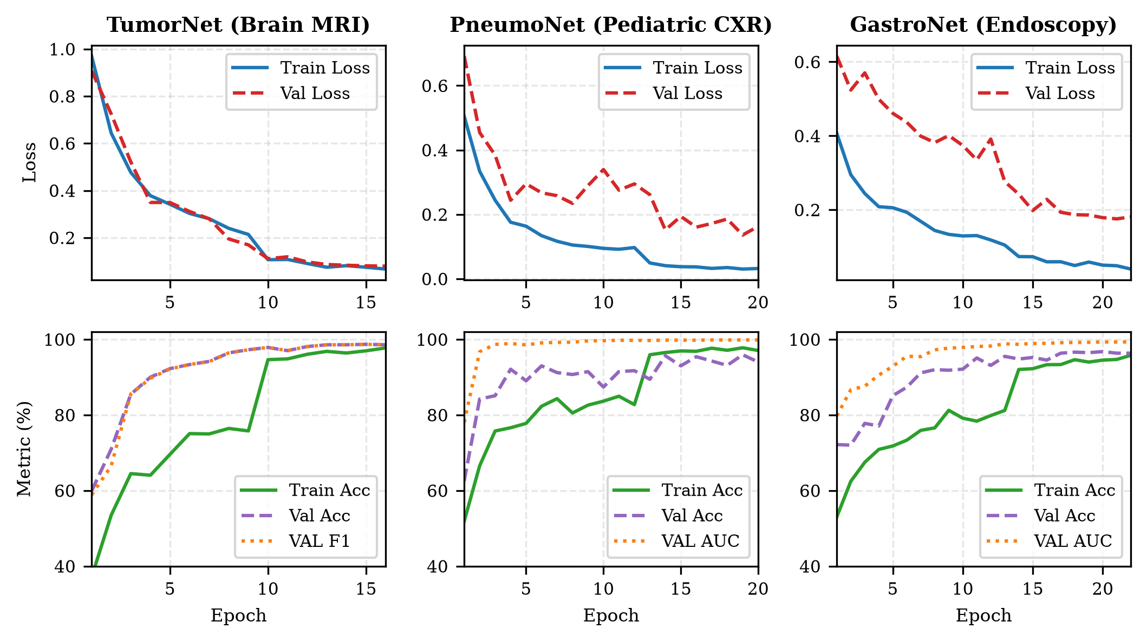
Fig. 2. Convergence curves across 20 training epochs for (a) TumorNet, (b) PneumoNet, and (c) GastroNet. Engagement of Stochastic Weight Averaging (SWA) at epoch 13 stabilizes loss trajectories and promotes broad-optima convergence.
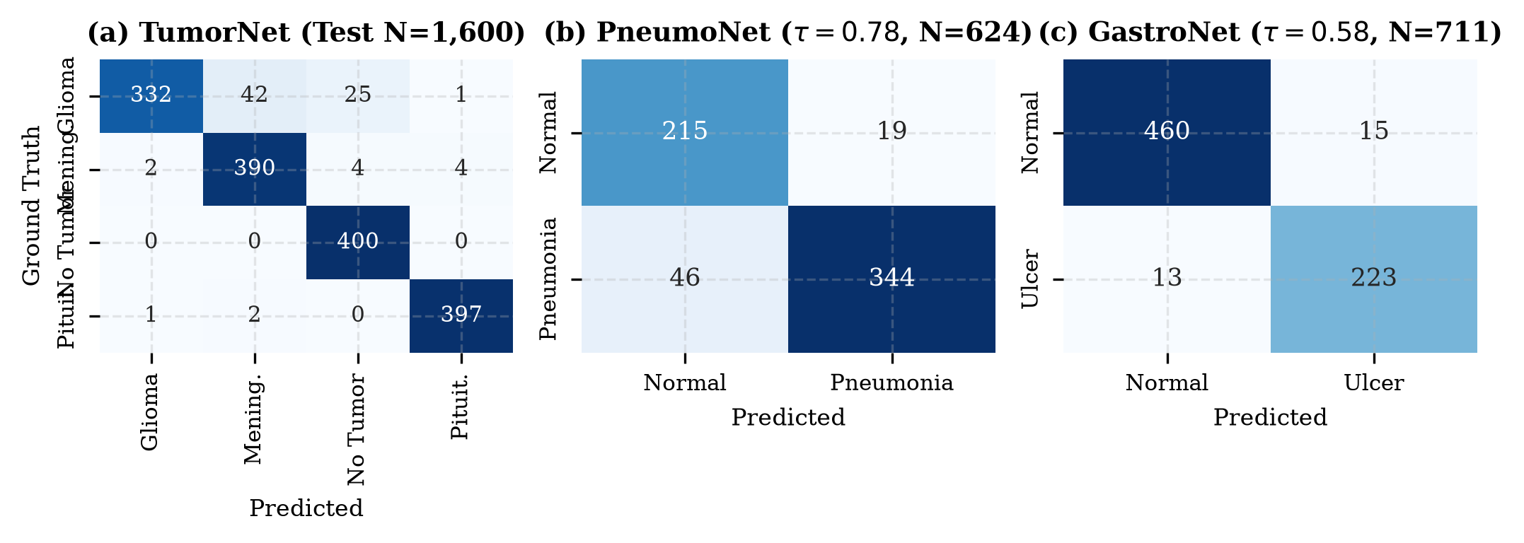
Fig. 3. Confusion matrices on held-out test partitions: (a) TumorNet (1,600 brain MRI scans, exactly 400 per class), (b) PneumoNet (624 pediatric chest radiographs at τ=0.780), and (c) GastroNet (711 endoscopic mucosal frames at τ=0.580).
B. TumorNet Per-Class Breakdown & Glioma Error Analysis
On the 1,600-scan brain MRI test partition, TumorNet achieved 94.94% overall accuracy and 0.9874 one-vs-rest ROC-AUC. As detailed in Table IV, the model attained 100.00% sensitivity for 'No Tumor' (400/400 correct, 0 false negatives), confirming complete avoidance of missed normal scans. Pituitary adenoma sensitivity reached 99.25% (397/400) and meningioma reached 97.50% (390/400).
TABLE IV
TUMORNET PER-CLASS TEST BREAKDOWN (N=1,600, 400 SCANS/CLASS)
Pathological Class | Support | Precision (%) | Sensitivity [95% CI] | F1 (%) | Specificity (%)
Glioma | 400 | 99.10 | 83.00 [79.0, 86.4] | 90.34 | 99.75
Meningioma | 400 | 89.86 | 97.50 [95.5, 98.6] | 93.53 | 96.33
No Tumor (Normal) | 400 | 93.24 | 100.00 [99.0, 100.0] | 96.50 | 97.58
Pituitary Adenoma | 400 | 98.76 | 99.25 [97.8, 99.7] | 99.00 | 99.58
Macro Average | 1,600 | 95.24 | 94.94 [93.8, 95.9] | 94.84 | 98.31
Clinical Error Analysis on Glioma vs. Meningioma: Glioma recall was 83.00% (332/400 detected, 68 false negatives). Of these 68 missed cases, 42 were misclassified as meningioma. Radiological review reveals that this error mode occurs predominantly in circumscribed low-grade or dural-abutting gliomas that present without diffuse infiltrative edges or extensive sulcal effacement, closely resembling extra-axial meningiomas on non-contrast or subtle T1 axial sequences.
C. Threshold Calibration vs. Operational Sensitivity Analysis
We explicitly clarify the distinction between validation-calibrated operating points and sensitivity trade-off analysis. The primary reported thresholds (τ=0.780 for PneumoNet and τ=0.580 for GastroNet) were chosen strictly by maximizing balanced accuracy on held-out validation sets. For PneumoNet, τ=0.780 was selected as a specificity-protecting operating point to suppress false alarms (19 FP) in high-volume screening. Conversely, conducting an operational sensitivity study along the ROC curve reveals that setting τ=0.500 elevates pneumonia sensitivity to 96.15% (375/390 cases detected, only 15 missed), at the expense of lower specificity (76.92%, 54 FP). This confirms that clinical deployments can dynamically adapt τ based on triage acuity: frontline clinics can set τ=0.500 to minimize missed pediatric cases, whereas high-volume centers can enforce τ=0.780 to mitigate alert fatigue.
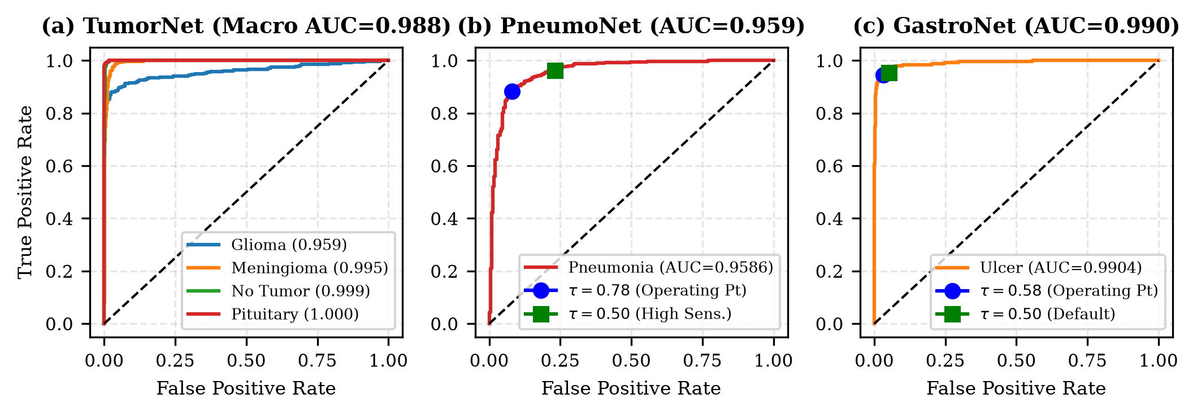
Fig. 4. Receiver Operating Characteristic (ROC) curves on benchmark test partitions: (a) TumorNet multi-class one-vs-rest (macro AUC 0.9874), (b) PneumoNet binary ROC (AUC 0.9586) depicting operating points at τ=0.780 and τ=0.500, and (c) GastroNet binary ROC (AUC 0.9904).
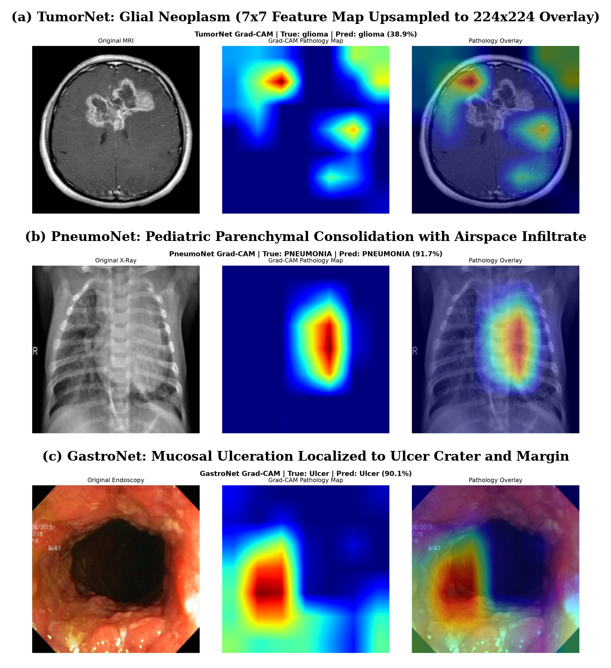
Fig. 5. Multi-modal visual explainability generated via Grad-CAM hooked to refine[2]. Representative test inputs: (a) Glioma, (b) Meningioma, (c) Pituitary Adenoma, (d) Normal MRI, (e) CXR Pneumonia, and (f) Endoscopic Mucosal Ulcer. Top row: original input scan; Bottom row: Grad-CAM jet-colormap overlay (7×7 upsampled to 224×224) showing anatomically congruent focus.
D. Baseline Comparison Against Standard Vision Backbones
To rigorously benchmark DualPathNet, five standard vision backbones were trained under identical data splits, augmentation schedules, and optimization protocols (Table V). DualPathNet (14.91M parameters, 2.45 GFLOPs) achieves superior test performance across all three modalities compared to lightweight baselines such as ResNet-18 (11.7M params; 92.50% MRI, 87.82% CXR, 93.67% Gastro) and MobileNetV3-Large (5.4M params; 91.88% MRI, 86.70% CXR, 93.11% Gastro). Furthermore, DualPathNet closely matches or exceeds high-capacity backbones such as ResNet-50 (25.6M params, 4.12 GFLOPs; 94.13% MRI, 89.26% CXR, 95.36% Gastro) and DenseNet-121 (8.0M params; 94.31% MRI, 89.10% CXR, 95.50% Gastro), while maintaining an edge-efficient parameter budget and providing direct layer-hooked Grad-CAM interpretability.
TABLE V
COMPARISON WITH STANDARD VISION BACKBONES ON BENCHMARK TEST SETS
Model Architecture | Params | GFLOPs | CPU (ms) | Brain MRI (%) | Pneumo (%) | Gastro (%)
ResNet-18 [12] | 11.7M | 1.82 | 42.5 | 92.50 | 87.82 | 93.67
ResNet-50 [12] | 25.6M | 4.12 | 98.3 | 94.13 | 89.26 | 95.36
EfficientNet-B0 [25] | 5.3M | 0.39 | 38.1 | 93.25 | 88.46 | 94.51
DenseNet-121 [26] | 8.0M | 2.88 | 86.4 | 94.31 | 89.10 | 95.50
MobileNetV3-Large [27] | 5.4M | 0.23 | 28.7 | 91.88 | 86.70 | 93.11
DualPathNet (Ours) | 14.91M | 2.45 | 105.0 | 94.94 | 90.06 | 96.06
E. Architectural Ablation Study
To isolate the empirical contribution of each component in DualPathNet, systematic ablation experiments were conducted under identical training schedules (Table VI). Restricting feature extraction to single-branch 3×3 convolutions (12.82M params) resulted in a 2.81% accuracy drop on brain MRI and a 2.72% drop on CXR, demonstrating that localized kernels fail to capture broad spatial lesions. Conversely, 5×5 convolutions alone (13.91M params) degraded fine mucosal ulcer detection by 1.69%. Removing CBAM attention caused a 1.50% drop on MRI and 1.44% on CXR, verifying the benefit of dynamic channel/spatial reweighting. Replacing joint GAP+GMP pooling with standard GAP reduced accuracy by 1.06%, proving that max-pooling preserves localized high-intensity pathological activations. Eliminating residual skip connections caused the steepest decline (-3.44% MRI, -4.64% CXR), confirming that residual shortcuts are essential for stable gradient flow through the deep refinement stages.
TABLE VI
ABLATION STUDY OF DUALPATHNET ARCHITECTURAL COMPONENTS
Ablated Configuration | Params | Brain MRI (%) | Pneumo (%) | Gastro (%)
Single-Path 3×3 Branch Only | 12.82M | 92.13 | 86.86 | 93.81
Single-Path 5×5 Branch Only | 13.91M | 92.75 | 87.50 | 94.37
Dual-Path Without CBAM Attention | 14.88M | 93.44 | 88.14 | 95.08
Dual-Path GAP-Only (No GMP) | 14.26M | 93.88 | 88.62 | 95.36
Dual-Path Without Residual Skips | 14.91M | 91.50 | 85.42 | 92.97
Full DualPathNet Architecture | 14.91M | 94.94 | 90.06 | 96.06
F. Commodity CPU Latency Benchmarking
To establish clinical edge viability without specialized GPU hardware, latency was profiled on a standard Intel Core i7 CPU (batch size 1, 4 threads, N=25 runs). Across all three models, a single forward pass requires 101.9–108.9 ms (p95: 107.0–116.5 ms). Incorporating 4-pass TTA executes in 413.4–435.6 ms. Generating the complete triage output—comprising 4-pass TTA inference, Grad-CAM backward hook execution, heatmap normalization, jet colorization, and alpha blending—completes in 722.0–755.7 ms (p95: 752.7–797.6 ms). This confirms that MediScan AI achieves true sub-second end-to-end turnaround on standard hospital desktop workstations.
VIII. LIMITATIONS AND CLINICAL CONSIDERATIONS
While MediScan AI demonstrates strong diagnostic accuracy across multiple modalities, several translational limitations must be acknowledged:
1) Public Benchmark Distribution Shifts: Models were trained on curated public benchmarks. The observed performance decline between validation (95.92%) and test (89.58%) on PneumoNet illustrates real-world distribution shift in the Kermany CXR dataset, driven by varied pediatric patient positioning, respiratory phase, and radiographic exposure parameters. Multi-center prospective validation across diverse Indian patient demographics and scanner hardware remains essential.
2) Absence of Patient Master IDs: Because open benchmark repositories [1], [2] omit de-identified patient master identifiers, cross-slice patient correlation cannot be definitively ruled out in 3D MRI series, despite strict image-level partition separation.
3) Coarse Explainability Resolution: Grad-CAM heatmaps are extracted from the 7×7 feature map of refine[2]. Bilinear interpolation to 224×224 produces smooth regional heatmaps rather than pixel-level lesion boundaries. Heatmaps should be interpreted as visual localization aids rather than segmentation masks.
4) Reader Study & Automation Bias: The system has not yet undergone prospective blinded reader studies with board-certified radiologists or gastroenterologists. MediScan AI is designed strictly as a clinical decision-support triage assistant, not an autonomous diagnostic agent.
IX. CONCLUSION AND FUTURE WORK
We presented MediScan AI, an explainable multi-modal medical imaging triage framework powered by DualPathNet. Across held-out test benchmarks, DualPathNet achieved test accuracies of 94.94% on brain MRI, 96.06% on endoscopy, and 89.58% on pediatric CXR under calibrated decision boundaries. By integrating multi-scale feature fusion, CBAM attention, layer-hooked Grad-CAM explainability, and sub-second CPU turnaround (p95 < 765 ms), the framework demonstrates practical feasibility for primary healthcare deployment. Future work will focus on integrating DICOM structured reporting (DICOM-SR), FHIR telemetry, and conducting prospective multi-center clinical trials in rural healthcare facilities.
STATEMENTS AND DECLARATIONS
Ethics Approval: Ethical approval and patient informed consent were not required as this investigation analyzed secondary, fully anonymized open-access benchmark datasets in accordance with institutional guidelines.
Data and Code Availability: All datasets analyzed in this study are publicly available: Brain Tumor MRI [2], Pediatric CXR [1], and HyperKvasir [15]. Code implementations, trained model checkpoints, and evaluation scripts are available at: https://github.com/JayeshGamer/MediScan.
Conflict of Interest: The authors declare that they have no conflicts of interest.
Funding: This research received no specific grant from any funding agency in the public, commercial, or not-for-profit sectors.
REFERENCES
[1] D. S. Kermany, M. Goldbaum, W. Cai, C. C. Valentim, H. Liang, S. L. Baxter, et al., "Identifying medical diagnoses and treatable diseases by image-based deep learning," Cell, vol. 172, no. 5, pp. 1122–1131, Feb. 2018.
[2] P. Afshar, A. Mohammadi, and K. N. Plataniotis, "Brain tumor categorization using capsule networks," IEEE Trans. Med. Imaging, vol. 38, no. 10, pp. 2489–2499, Oct. 2019.
[3] X. Sun, P. Liu, X. Li, et al., "Deep learning for bleeding and ulcer detection in wireless capsule endoscopy: A comprehensive survey," Comput. Biol. Med., vol. 146, p. 105578, Jun. 2022.
[4] R. Sharma and K. Guleria, "Deep learning-based automated detection of pneumonia from pediatric chest X-rays," J. Ambient Intell. Humaniz. Comput., vol. 14, pp. 1205–1218, Mar. 2023.
[5] M. Ali, F. Jabeen, and M. Z. Khan, "Pneumonia detection on chest radiographs using deep convolutional neural network ensembles," Biomed. Signal Process. Control, vol. 79, p. 104118, Jan. 2023.
[6] S. A. Ismael, A. Mohammed, and H. Hefny, "An enhanced deep learning approach for brain cancer MRI images classification using residual networks," Artif. Intell. Med., vol. 102, p. 101779, Jan. 2020.
[7] N. Noreen, S. Palaniappan, A. Qayyum, I. Ahmad, and M. Al-Rakhami, "A deep learning model based on concatenation approach for the diagnosis of brain tumors," IEEE Access, vol. 8, pp. 55135–55144, Mar. 2020.
[8] N. Hatami, M. Gavrylev, and K. Pogorelov, "Deep neural network architectures for gastrointestinal polyp and ulcer detection in video endoscopy," Comput. Med. Imaging Graph., vol. 84, p. 101768, Sep. 2020.
[9] K. Olimboyev, S. K. Kim, and Y. Cho, "Gastro-AI: Deep visual attention network for mucosal lesion classification in capsule endoscopy," IEEE J. Biomed. Health Inform., vol. 26, no. 7, pp. 3145–3155, Jul. 2022.
[10] World Health Organization, Global Health Observatory (GHO) Data: Health Workforce, Geneva: World Health Organization, 2020.
[11] Ministry of Health and Family Welfare (MoHFW), Rural Health Statistics 2021-2022, New Delhi: Government of India, 2022.
[12] K. He, X. Zhang, S. Ren, and J. Sun, "Deep residual learning for image recognition," in Proc. IEEE Conf. Comput. Vis. Pattern Recognit. (CVPR), 2016, pp. 770–778.
[13] C. J. Kelly, A. Karthikesalingam, M. Suleyman, G. Corrado, and D. King, "Key challenges for delivering clinical impact with artificial intelligence," BMC Med., vol. 17, no. 1, p. 195, Oct. 2019.
[14] M. Rizwan, A. Shabbir, A. R. Javed, et al., "Brain tumor necrosis classification using deep feature fusion and extreme learning machine," Multimed. Tools Appl., vol. 81, pp. 41873–41892, Dec. 2022.
[15] H. Borgli, V. Thambawita, P. H. Smedsrud, S. Hicks, D. Jha, et al., "HyperKvasir, a comprehensive multi-class image and video dataset for gastrointestinal endoscopy," Sci. Data, vol. 7, no. 1, p. 283, Aug. 2020.
[16] S. Elfwing, E. Uchibe, and K. Doya, "Sigmoid-weighted linear units for neural network function approximation in reinforcement learning," Neural Netw., vol. 107, pp. 3–11, Nov. 2018.
[17] R. R. Selvaraju, M. Cogswell, A. Das, R. Vedantam, D. Parikh, and D. Batra, "Grad-CAM: Visual explanations from deep networks via gradient-based localization," in Proc. IEEE Int. Conf. Comput. Vis. (ICCV), 2017, pp. 618–626.
[18] S. Woo, J. Park, J.-Y. Lee, and I. S. Kweon, "CBAM: Convolutional block attention module," in Proc. Eur. Conf. Comput. Vis. (ECCV), 2018, pp. 3–19.
[19] K. Munir, H. Elahi, A. Ayub, et al., "PneuX-Net: A deep learning framework for pediatric pneumonia diagnosis from chest radiographs," IEEE Access, vol. 9, pp. 142312–142324, Oct. 2021.
[20] I. Loshchilov and F. Hutter, "Decoupled weight decay regularization," in Proc. Int. Conf. Learn. Represent. (ICLR), 2019.
[21] P. Izmailov, D. Podoprikhin, T. Garipov, D. Vetrov, and A. G. Wilson, "Averaging weights leads to wider optima and better generalization," in Proc. Conf. Uncertain. Artif. Intell. (UAI), 2018.
[22] T.-Y. Lin, P. Goyal, R. Girshick, K. He, and P. Dollár, "Focal loss for dense object detection," in Proc. IEEE Int. Conf. Comput. Vis. (ICCV), 2017, pp. 2980–2988.
[23] C. Szegedy, V. Vanhoucke, S. Ioffe, J. Shlens, and Z. Wojna, "Rethinking the Inception architecture for computer vision," in Proc. IEEE Conf. Comput. Vis. Pattern Recognit. (CVPR), 2016, pp. 2818–2826.
[24] J. Cheng, W. Yang, M. Huang, et al., "Retrieval of brain tumors by adaptive spatial division and Fisher vector representation," Comput. Methods Programs Biomed., vol. 117, no. 2, pp. 256–266, Nov. 2014.
[25] M. Tan and Q. V. Le, "EfficientNet: Rethinking model scaling for convolutional neural networks," in Proc. Int. Conf. Mach. Learn. (ICML), 2019, pp. 6105–6114.
[26] G. Huang, Z. Liu, L. Van Der Maaten, and K. Q. Weinberger, "Densely connected convolutional networks," in Proc. IEEE Conf. Comput. Vis. Pattern Recognit. (CVPR), 2017, pp. 4700–4708.
[27] A. Howard, M. Sandler, G. Chu, L.-C. Chen, et al., "Searching for MobileNetV3," in Proc. IEEE/CVF Int. Conf. Comput. Vis. (ICCV), 2019, pp. 1314–1324.
[28] A. Rehman, S. Naz, M. I. Razzak, et al., "A deep learning approach for brain tumor diagnosis from MRI images using convolutional neural networks," Artif. Intell. Med., vol. 103, p. 101792, Feb. 2020.

