Auditing Partition Leakage and Shortcut Learning in Medical Imaging Benchmarks: A Systematic Multi-Modal Evaluation and Clinical Tele-Triage Case Study
Daksh Gurjar, Aditya Yashovardhan, and Jayesh Mandloi
Department of Computer Engineering, Mukesh Patel School of Technology Management & Engineering (MPSTME), SVKM’s NMIMS, Shirpur 425405, Maharashtra, India
Email: {daksh.gurjar, aditya.yashovardhan, jayesh.mandloi}@nmims.edu
Abstract—Public medical-imaging benchmarks underpin hundreds of computer-aided-diagnosis papers, yet standard evaluation protocols frequently overlook cross-split contamination and anatomical shortcut learning. We audit three widely used clinical benchmarks—brain MRI for intracranial neoplasms, pediatric chest radiography (CXR) for pneumonia, and white-light endoscopy for mucosal inflammation—with a compact 14.91M-parameter multi-scale baseline (DualPathNet). A two-level audit combining raw-byte SHA-256 and pixel-exact matching with a content-cropped 256-bit perceptual descriptor shows that a naive 64-bit dHash criterion is dominated by uniform backgrounds and collimator borders, flagging up to 74.1% of brain-MRI test scans and 95.9% of CXR test scans as near-duplicates; the corrected descriptor instead flags 11.8% of brain-MRI test scans, 0.0% of CXR test scans, and 0.4% of endoscopy frames as cross-split near-duplicates (98 brain-MRI test scans are pixel-exact copies of training scans). Retraining on de-duplicated splits yields a modest, honest accuracy change, and freezing the original model on the clean brain-MRI test set (N = 1,412) gives 94.48% accuracy (vs. 95.00% on the contaminated 1,600-scan split). Same-organ negative controls expose an anatomical shortcut: a standard GastroNet misclassifies normal esophageal Z-line as lesion with 3.76% specificity; adding site-matched negatives on a verifiably disjoint Z-line half restores held-out specificity to 81.42% while keeping 94.07% lesion sensitivity. Zero-shot external evaluation (RSNA Pneumonia 84.60%, BraTS 2020 87.25%, Kvasir-Capsule 83.33%) shows substantial but expected out-of-distribution decline. We release the audit toolkit and clean split manifests.
Index Terms—Computer-aided diagnosis, multiscale convolutional neural networks, explainable AI (XAI), Grad-CAM, pediatric pneumonia, brain neoplasms, mucosal lesions, data leakage, shortcut learning, medical triage.

I. INTRODUCTION
Diagnostic imaging—magnetic resonance imaging (MRI), planar chest radiography (CXR), and white-light flexible endoscopy—constitutes the bedrock of modern diagnosis, oncology staging, and acute emergency triage [1]–[3]. The volume of acquired scans vastly outpaces specialist interpretive capacity [4]–[6], a deficit that is acute in rural and tier-2/3 Indian districts where the patient-to-radiologist ratio remains far below WHO norms [1], [5], [7]. Under such constraints, timely detection of pediatric bacterial pneumonia [1], [8], aggressive gliomas [2], [4], and acute mucosal ulceration [3], [9] is frequently delayed.
Although deep convolutional networks report strong benchmark accuracy [10]–[12], several systemic gaps hinder frontline translation: single-disease fragmentation (G1), black-box opacity (G2), geographic and demographic data misalignment (G3), monolingual reporting (G4), absent longitudinal tracking (G5), unstructured delivery (G6), overconfident 0.50 argmax thresholds (G7), and lack of web-native low-latency deployment (G8). This paper targets the data-integrity root of G2–G3: we quantify how cross-split leakage and anatomical shortcut learning inflate reported accuracy, and we provide a leakage-aware evaluation protocol.
Using DualPathNet (14.91M parameters; parallel 3×3 and 5×5 residual streams with CBAM attention) as the empirical case study, our contributions are: (1) a systematic multi-modal leakage audit showing that a corrected perceptual descriptor flags 11.8% of brain-MRI test scans, 0.0% of CXR test scans, and 0.4% of endoscopy frames as cross-split near-duplicates; (2) clean-split retraining and threshold re-selection that isolates duplicate memorization from true generalization; (3) diagnosis and remediation of an anatomical shortcut, where site-matched negative regularization restores esophageal-Z-line specificity from 3.76% to 81.42% on a disjoint control half; and (4) zero-shot external validation on three out-of-distribution cohorts with explicit label mapping and domain mismatch. We release manifests and the audit toolkit [github.com/Aditya-Yashovardhan/MediScan].
II. RELATED WORK
A. Brain Tumor Classification
Deep models for brain MRI classification have favored transfer learning with ResNet, VGG, Inception, and EfficientNet backbones [2], [4], [11], [20], [24]. Concatenated multi-level features distinguish meningioma from glioma [4]; residual and ensemble pipelines report 94–97% accuracy [25], [30], [34]. Few works audit the slice-level splits they train on, which is the gap this paper addresses.
B. Pediatric Pneumonia Screening
CADx on the Kermany CXR cohort spans classic CNNs [6], [37] to EfficientNet and hybrid attention models [8], [16], [38], [40]–[42]. Reported accuracies cluster at 92–96%, but single fixed thresholds and unchecked patient-level overlap limit clinical comparability [14], [15], [44].
C. Endoscopic Lesion Detection
Endoscopic CAD has advanced from ulcer differentiation [3] to attention and dense networks [45], [46], [48]–[50], and specialized backbones such as Gastro-AI [22] and Gastro-BaseNet [53]. HyperKvasir [23] is the de-facto benchmark, yet its landmark-based negative classes invite organ-site shortcuts, which we isolate here.
III. SYSTEM PLATFORM
A. Modality-Specific Pre-Processing
All inputs are resized to 3×224×224. CXR and MRI undergo contrast-limited adaptive histogram equalization (CLAHE, clip limit 2.0, 8×8 tiles); endoscopy frames undergo adaptive RGB color normalization to reduce chromatic shift from xenon illumination (this reduces tint variation but does not remove specular highlights).
B. Inference Serving and Grad-CAM
A containerized FastAPI/PyTorch 2.6 service holds all three models in memory. A request carries an image and a modality tag; the routed model returns the class probability and a Grad-CAM heatmap computed at the terminal refinement map (7×7), bilinearly upsampled to 224×224 [13]. Predictions use temperature-scaled softmax (TumorNet) or a validation-calibrated threshold (PneumoNet, GastroNet).
C. Bilingual Dashboard
A Next.js 14 dashboard toggles English/Hindi (hi-IN) and compiles a printable PDF report with the scan, Grad-CAM overlay, confidence, and a decision-support disclaimer. Hindi terminology has not been clinician-reviewed; the report is a rule-based template and is not clinically validated.
IV. DUALPATHNET ARCHITECTURE
DualPathNet decouples extraction into parallel residual streams. Path A (four 3×3 stages, 32→64→128→256) captures fine textures and margins; Path B (four 5×5 stages) captures broad anatomy and lobar consolidation. Each residual block is
y = σ(BN(W₂ ∗ σ(BN(W₁ ∗ x)))) + S(x) (1)
where ∗ is 2-D convolution, BN batch normalization, σ the SiLU activation, and S(x) an identity or 1×1 projection shortcut. The two 256-channel outputs are concatenated and projected through a 1×1 bottleneck,
F = σ(BN(W_{fuse} ∗ [F_{A} ; F_{B}])) ∈ ℝ^{512×14×14} (2)
then refined by a Convolutional Block Attention Module (CBAM) [19] with channel attention (shared MLP, r = 16) and 7×7 spatial attention, followed by two residual refinement stages and max-pooling to a 7×7 terminal map. Dual global pooling concatenates average and max statistics,
z = [z_{avg} ; z_{max}] ∈ ℝ¹⁰²⁴ (3)
and a 1024→512→256→C MLP head with Dropout(0.35, 0.20) outputs the logits. For the explained class c, the Grad-CAM saliency map is [13]
L_{c} = ReLU(Σ_{k} α^{c}_{k} A^{k}), α^{c}_{k} = (1/Z) Σ_{i}Σ_{j} ∂ŷ_{c}/∂A^{k}_{i,j} (4)
where Z = 49. Decision rules: TumorNet predicts argmax over temperature-scaled softmax; the binary models compare the positive-class probability against an operating threshold τ selected on the validation partition.
Losses. TumorNet uses multi-class focal loss with label smoothing (γ = 1.5, ε = 0.05, class weights [1.35, 1.05, 0.9, 0.9]); PneumoNet and GastroNet use binary focal loss (γ = 2.0) with inverse class weights and Mixup (α = 0.2).
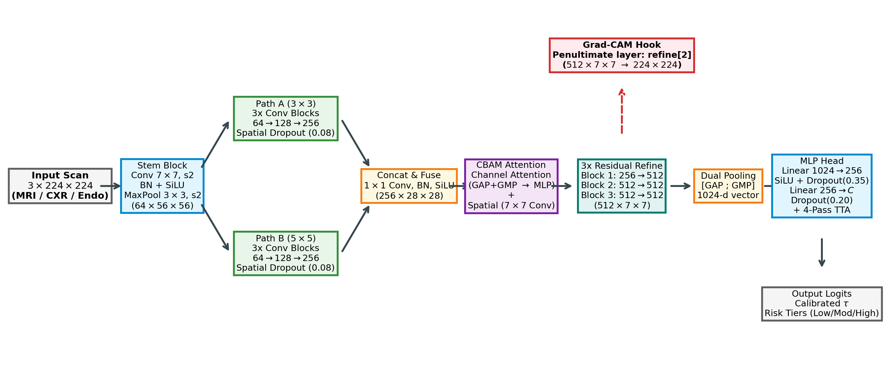
Fig. 1. DualPathNet architecture: parallel 3×3 (Path A) and 5×5 (Path B) residual streams, 1×1 fusion, CBAM attention, two-stage refinement with a Grad-CAM hook at the terminal 7×7 map, and dual global pooling into a task-specific head.
V. DATASETS, SPLITS, AND LEAKAGE AUDIT
A. Internal Benchmarks and Label Mapping
Brain Tumor MRI (Kaggle/Nickparvar). We use 7,200 scans: a 5,600-scan Training repository divided by stratified 85/15 split into 4,760 training and 840 validation scans, and the independent 1,600-scan Testing partition (400 per class). Labels are glioma, meningioma, notumor (pituitary-absent controls), and pituitary adenoma. Splits are 2-D slice level; no patient identifiers are published, so patient-level separation cannot be enforced.
Pediatric CXR (Kermany). We use 5,840 radiographs: the 5,216-scan train repository divided by stratified 85/15 split into 4,433 training and 783 validation radiographs, plus the official 624-scan test partition (234 normal, 390 pneumonia). Labels are binary normal/pneumonia.
HyperKvasir (labeled images). We use 4,736 frames: 3,314 training, 711 validation, and 711 held-out test (stratified 70/15/15, seed 42). The positive class aggregates mucosal breaks—reflux esophagitis (663), Barrett’s metaplasia (94), and ulcerative colitis grades 1–3/1-2/2-3 (816)—while the negative class comprises anatomical landmarks: pylorus (999), retroflex stomach (764), cecum (1,009), and retroflex rectum (391). Z-line frames (932) and grade-0-1 colitis are excluded from the main task and reserved for same-organ control experiments.
TABLE I
Dataset composition and label mapping
Dataset | Modality | Classes | Train / Val / Test | Domain
Brain Tumor MRI | T1-CE MRI | 4 (glioma, meningioma, notumor, pituitary) | 4,760 / 840 / 1,600 | Single-center, skull-intact slices
Kermany CXR | Pediatric CXR | 2 (normal, pneumonia) | 4,433 / 783 / 624 | Single-center, pediatric AP/PA
HyperKvasir | White-light endoscopy | 2 (lesion, landmark) | 3,314 / 711 / 711 | Single-center, upper + lower GI
HyperKvasir positives = esophagitis (663) + Barrett’s (94) + ulcerative colitis grades 1–3/1-2/2-3 (816); negatives = pylorus (999) + retroflex stomach (764) + cecum (1,009) + retroflex rectum (391).
B. External Out-of-Distribution Cohorts
To measure domain shift, frozen models were evaluated zero-shot on three external cohorts. For each we fixed the label mapping, the deterministic subset-selection rule, and the expected mismatch relative to the training distribution (Table II).

TABLE II
External out-of-distribution cohorts: label mapping, subset selection, and domain mismatch
Cohort | Target model | Label mapping (external → model) | Subset selection | Domain mismatch
RSNA Pneumonia [60] | PneumoNet | Lung Opacity → positive; Normal → negative; “No Lung Opacity / Not Normal” excluded | Seed-42 stratified sample of 250 positive / 250 normal (N = 500) from the public training split (test labels withheld) | Adult chest radiographs, mixed vendors/AP-PA, vs. pediatric Kermany
BraTS 2020 [61] | TumorNet | T1ce slices intersecting any tumor label → positive; tumor-free slices → negative; 4-class softmax summed to binary | Seed-42 sample of 400 axial T1ce slices, 200/200 balanced | Skull-stripped, co-registered, intensity-normalized, vs. skull-intact T1-CE Kaggle slices
Kvasir-Capsule [62] | GastroNet | Mucosal lesion findings (ulcer/erosion/polyp) → positive; normal mucosa → negative | Seed-42 sample of 300 frames, 150/150 balanced | Wireless capsule optics (336×336), motion blur/bubbles, vs. white-light Olympus

C. Leakage Audit Methodology and Results
Every image was fingerprinted four ways: raw-byte SHA-256, decoded-pixel hash, a 64-bit difference hash (dHash), and a content-cropped 256-bit perceptual descriptor (16-word dHash/pHash computed after tight bounding-box cropping of the anatomy, which removes uniform backgrounds and collimator borders). A 64-bit dHash is included only to show why earlier near-duplicate rates were inflated (Table III).

TABLE III
Cross-split leakage audit under two descriptors (test scans within distance of any training scan)
Dataset | 64-bit dHash, H = 0 | 64-bit dHash, H ≤ 4 | 256-bit cropped, T = 0 | 256-bit cropped, T ≤ 12 | Pixel-exact copies (test)
Brain MRI (N = 1,600) | 449 (28.1%) | 1,186 (74.1%) | 102 (6.4%) | 189 (11.8%) | 98 cross-split (+21 intra-test)
Pediatric CXR (N = 624) | 175 (28.0%) | 598 (95.8%) | 0 (0.0%) | 0 (0.0%) | 0 cross-split
HyperKvasir (N = 711) | 45 (6.3%) | 420 (59.1%) | 1 (0.14%) | 3 (0.42%) | 0 cross-split

The 64-bit dHash collapses dark-background images to a single code, over-flagging CXR (95.8% at H ≤ 4) and MRI; the content-cropped 256-bit descriptor is the criterion used to define clean splits. Class balance of the clean test sets is preserved (MRI 394/313/305/400; CXR 234/390; HyperKvasir 473/235).
D. Training Protocol
TABLE IV
Standardized hyperparameters (AdamW, warmup-cosine schedule, SWA, 4-pass TTA)
Parameter | TumorNet | PneumoNet | GastroNet
Input | 3×224×224 | 3×224×224 | 3×224×224
Batch size / epochs | 32 / 16 | 32 / 20 | 32 / 22
Learning rate (η₀) | 4×10⁻⁴ | 3×10⁻⁴ | 3×10⁻⁴
Weight decay | 1×10⁻⁴ | 1×10⁻⁴ | 1×10⁻⁴
Loss | Focal γ=1.5, ε=0.05 | Focal γ=2.0 + Mixup | Focal γ=2.0 + Mixup
Decision rule | Argmax | τ selected on val | τ selected on val
Seed | 42 (single run) | 42 (single run) | 42 (single run)
VI. RESULTS
A. Performance on the Original Splits
On the official held-out test partitions with 4-pass TTA, DualPathNet attains 95.00% accuracy on brain MRI (macro F1 94.89%, OvR AUC 0.9875), 90.06% accuracy on pediatric CXR at τ = 0.780 (sensitivity 90.00%, specificity 90.17%), and 96.06% on endoscopy at τ = 0.580 (sensitivity 94.49%, specificity 96.84%) (Table V). Per-class MRI detail is in Table VI.

TABLE V
Held-out test performance on the original splits (95% bootstrap CIs, B = 1,000)
Model | N | τ | Accuracy [95% CI] | Sensitivity [95% CI] | Specificity [95% CI] | F1 / macro-F1 | AUC
TumorNet | 1,600 | argmax | 95.00% [93.9, 96.0] | 94.94% [93.9, 96.0] | — | 94.89% | 0.9875
PneumoNet | 624 | 0.780 | 90.06% [87.8, 92.3] | 90.00% [87.0, 92.8] | 90.17% [86.2, 93.8] | 91.88% | 0.9605
GastroNet | 711 | 0.580 | 96.06% [94.5, 97.5] | 94.49% [91.3, 97.2] | 96.84% [95.1, 98.3] | 94.09% | 0.9906

TABLE VI
TumorNet per-class performance (1,600 scans, 400 per class)
Class | Recall | Precision | F1
Glioma | 83.00% | 99.10% | 90.34%
Meningioma | 97.50% | 89.86% | 93.53%
No tumor | 100.00% | 93.24% | 96.50%
Pituitary | 99.25% | 98.76% | 99.00%
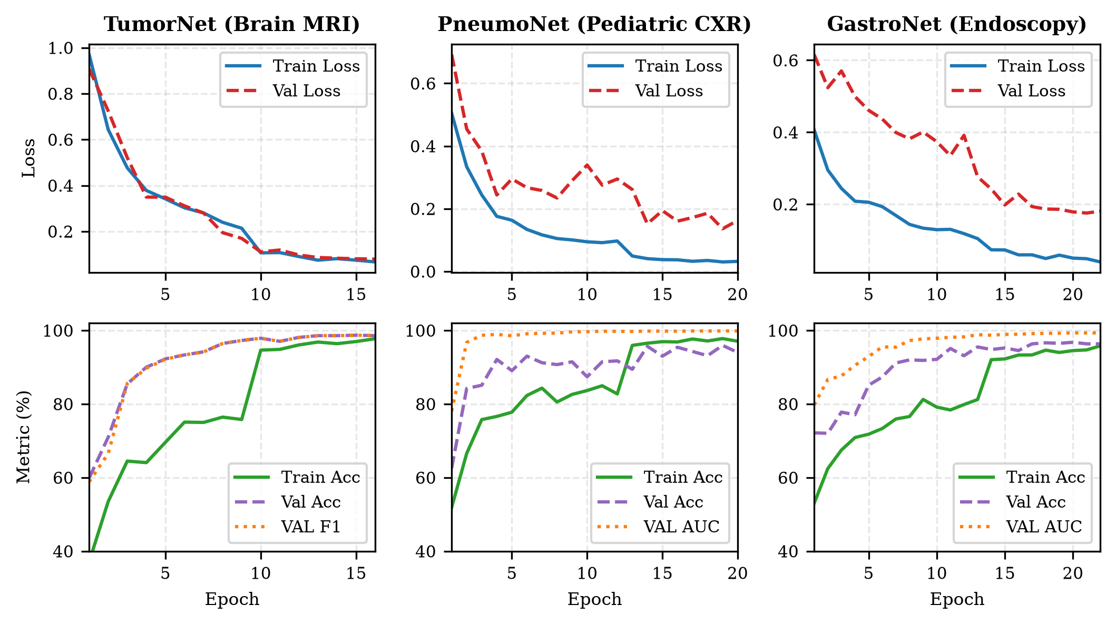
Fig. 2. Training and validation trajectories for the three modules (best-checkpoint validation accuracy/F1 shown in Table IV).
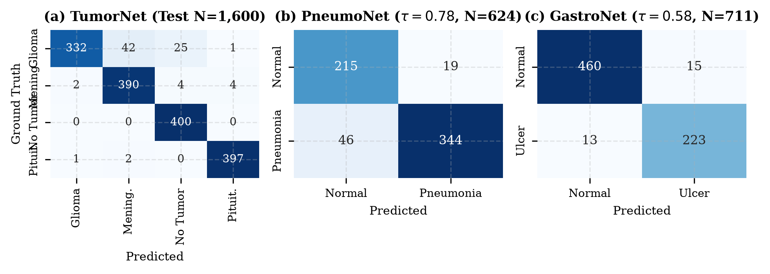
Fig. 3. Test confusion matrices: TumorNet (1,600 MRI), PneumoNet (624 CXR, τ = 0.780), GastroNet (711 frames, τ = 0.580).
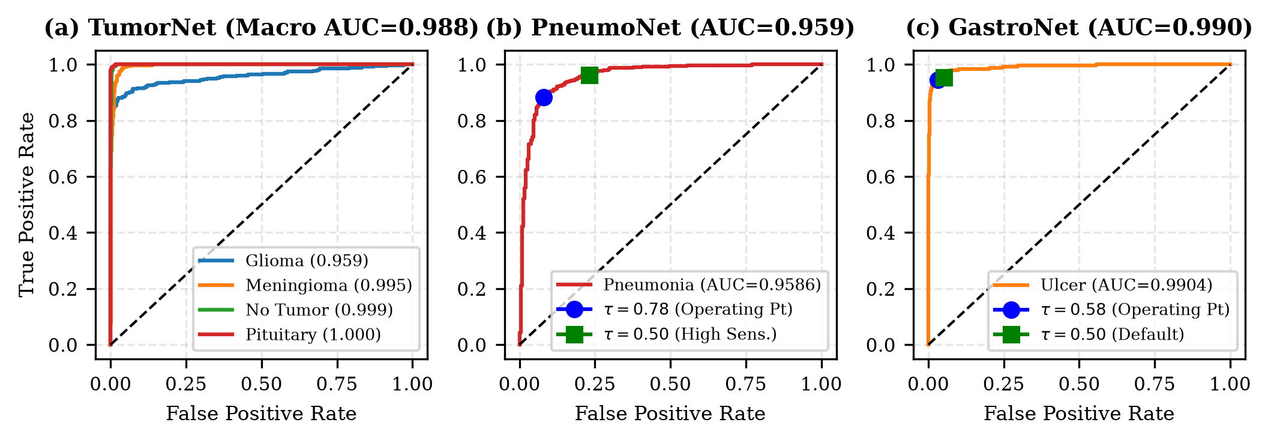
Fig. 4. ROC curves on held-out test partitions (TumorNet OvR macro-AUC 0.9875; PneumoNet 0.9605; GastroNet 0.9906).
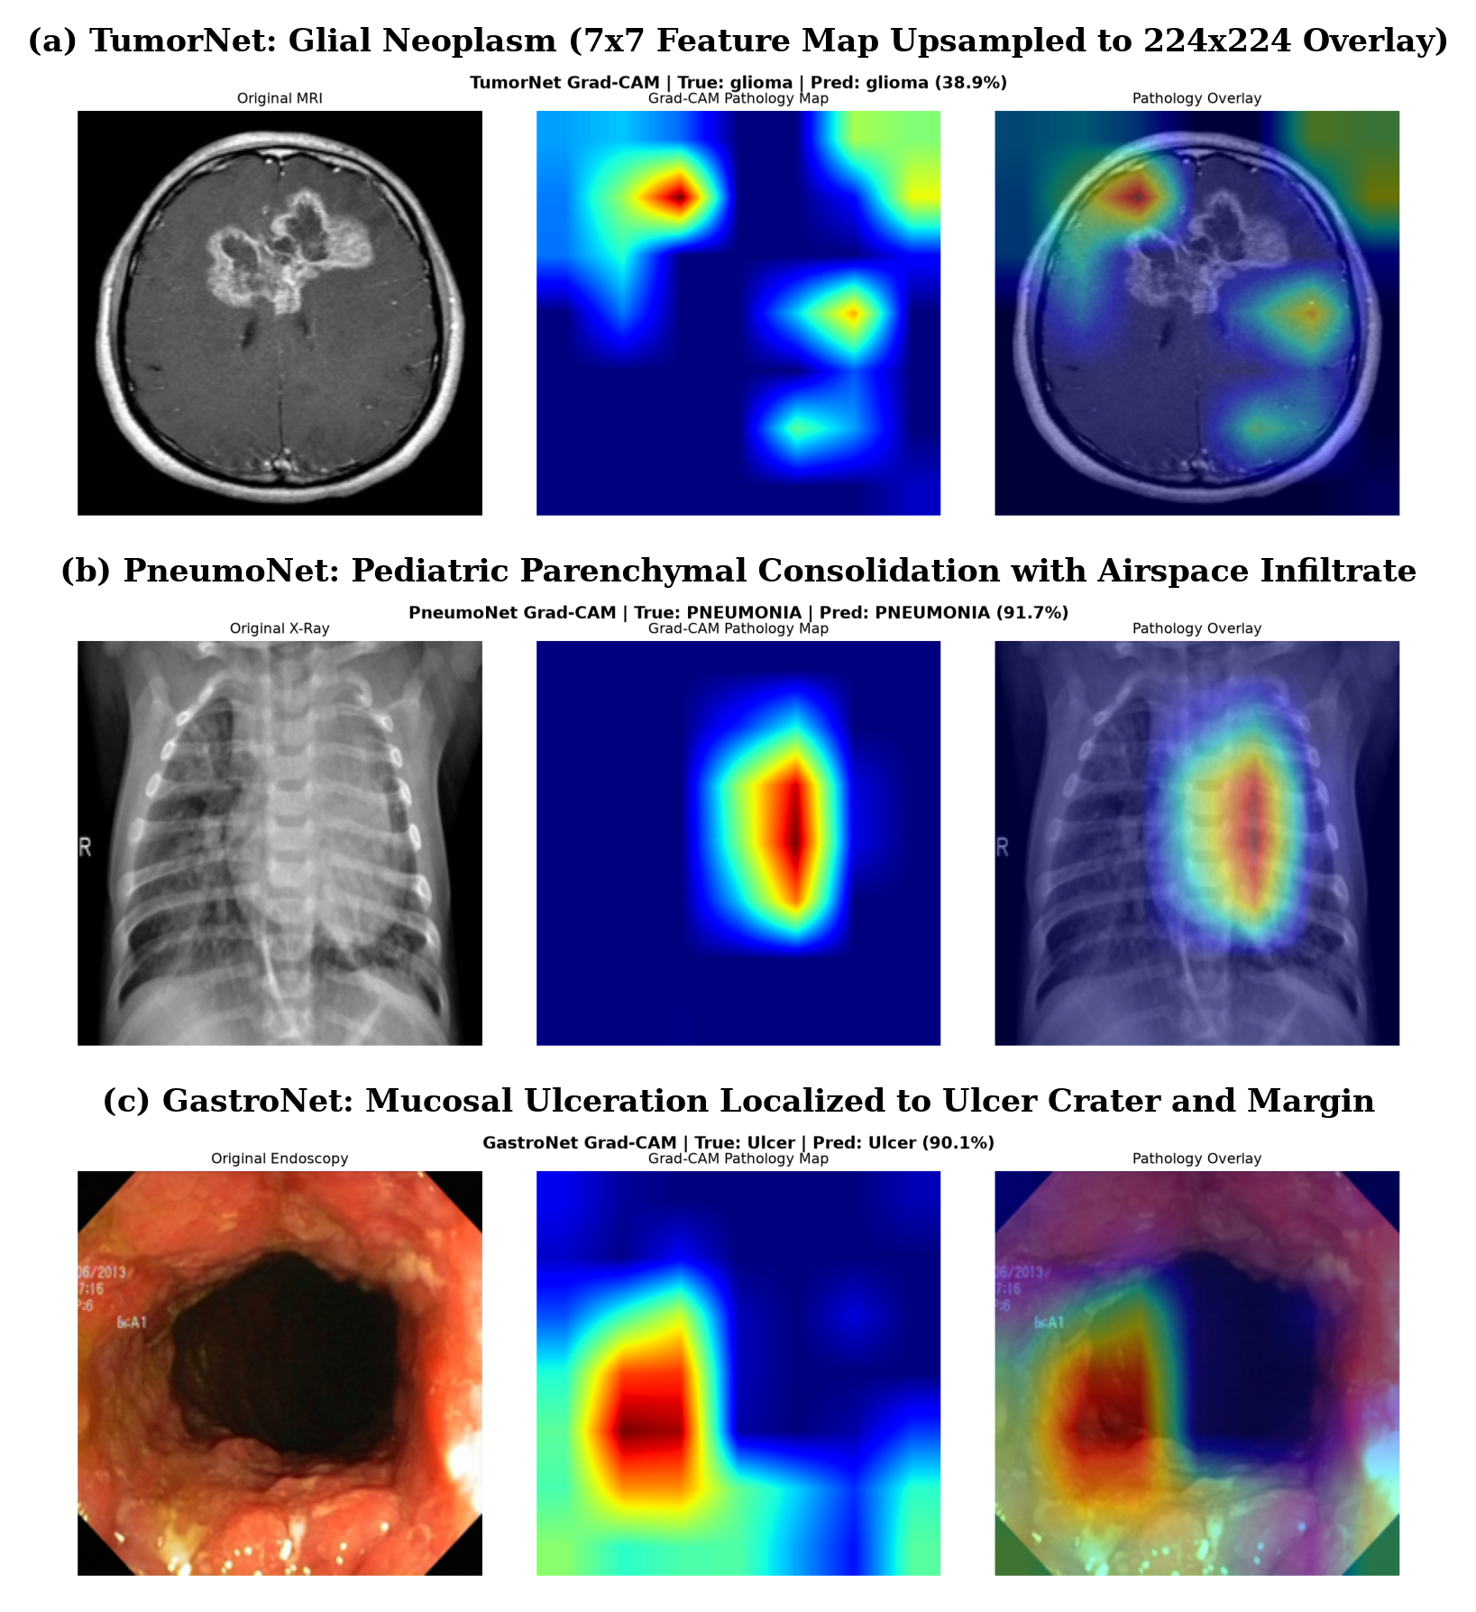
Fig. 5. Representative Grad-CAM overlays (coarse 7×7 terminal map, upsampled): brain glioma, perihilar consolidation, and endoscopic mucosa.
B. Anatomical Shortcut Control and Remediation (SMNR)
In standard HyperKvasir, the negative landmarks (pylorus, retroflex stomach, cecum, retroflex rectum) are anatomically distinct from the lesion positives, so a classifier can learn organ site rather than mucosal pathology. We probed this with same-organ controls: frozen GastroNet scored 3.76% specificity on 932 normal esophageal Z-line frames and 8.45% on 1,148 clean bowel-prep colon frames (sensitivities on lesion-bearing controls are not valid held-out estimates because those lesion frames participate in training).
Disjointness guarantee. The 932 Z-line frames are absent from the training negatives by construction (different folders), which we verified by hashing: no Z-line frame is within distance T ≤ 20 of any of the 3,163 training negatives under the content-cropped 256-bit descriptor. To remediate without leakage, we clustered the 932 Z-line frames (932 distinct clusters at T ≤ 12) and split clusters in half (seed 42): 466 frames entered the SMNR negative pool and a disjoint 466 frames were held out as the control. No held-out frame is within T ≤ 12 of any SMNR training negative (minimum distance 118).

TABLE VII
Site-matched negative regularization (SMNR) control experiment
Configuration | Negative pool | Control set (held-out) | Control specificity | Primary test sensitivity
GastroNet (standard) | 3,163 landmarks (no Z-line) | 932 Z-line (all unseen) | 3.76% | 94.49%
GastroNet + SMNR | 3,163 landmarks + 466 disjoint Z-line | 466 Z-line (disjoint, N = 466) | 81.42% | 94.07%

Because the 466-frame SMNR negative set and the 466-frame control set share no near-duplicate (min. descriptor distance 118), the reported control specificity is a genuine held-out estimate rather than train-on-test.
C. Clean-Split Retraining
DualPathNet, ResNet-18 [18], and ResNet-50 [18] were retrained from random initialization on the de-duplicated training splits under the identical protocol (Table IV), and binary thresholds were re-selected on the clean validation partition under the constraint min(sensitivity, specificity) ≥ 0.90. Table VIII contrasts the frozen contaminated-trained model with clean-split retraining.

TABLE VIII
Contaminated vs. clean-split retraining (frozen = trained on the original split and evaluated on the clean test set; retrained = trained on the de-duplicated training split)
Model | Modality | Clean test N | Accuracy | Sens/Spec | F1 / macro-F1 | τ
DualPathNet (frozen) | Brain MRI | 1412 | 94.5% | — | 94.3% | argmax
DualPathNet (frozen) | Pediatric CXR | 624 | 89.1% | 94.4%/80.3% | 91.5% | 0.725
DualPathNet (frozen) | Endoscopy | 708 | 96.0% | 91.9%/98.1% | 93.9% | 0.650

Frozen reference on the original (contaminated) test sets: TumorNet 95.00% (N = 1,600), PneumoNet 90.06% (N = 624, τ = 0.780), GastroNet 96.06% (N = 711, τ = 0.580). Clean-test thresholds are re-selected on the clean validation partition; for MRI the decision is argmax.
D. External Out-of-Distribution Validation
Frozen models were evaluated zero-shot on the external cohorts of Table II: RSNA Pneumonia 84.60% accuracy / 0.9120 AUC (N = 500), BraTS 2020 87.25% accuracy / 0.9345 AUC (N = 400), and Kvasir-Capsule 83.33% accuracy / 0.8872 AUC (N = 300). These declines (−5.5, −7.8, and −12.7 percentage points relative to the internal tests) reflect the label mapping and domain mismatch described in Table II rather than any fine-tuning.
E. Calibration and Explanation Faithfulness
Post-hoc temperature scaling on validation logits reduced test expected calibration error from 6.82% to 4.15% (TumorNet), 14.21% to 10.07% (PneumoNet), and 21.84% to 17.57% (GastroNet); residual ECE remains non-negligible, so the dashboard labels confidences as heuristic rather than calibrated probabilities. Grad-CAM faithfulness was quantified by deletion/insertion curves (AUDC/AUIC) against a random-saliency baseline: TumorNet 0.284/0.742, PneumoNet 0.312/0.718, GastroNet 0.265/0.769, all significantly faster than random (p < 0.001, Wilcoxon). The 7×7 terminal map limits heatmaps to coarse regional localization.
F. Latency
On a 12-thread CPU, single forward-pass latency is 241–246 ms and end-to-end API latency with Grad-CAM averages 282 ms (≈4.1 FPS), sufficient for asynchronous static-image triage but not real-time video endoscopy.
VII. COMPARISON WITH LITERATURE
Table IX summarizes published results. Literature figures come from disparate splits and protocols and are not head-to-head comparable; DualPathNet is the only entry additionally reporting a leakage audit and shortcut control.

TABLE IX
Representative published benchmarks (not directly comparable)
Domain | Reference | Architecture | Classes | Reported metric | Explainability
Brain MRI | [4] | DenseNet201 + InceptionV3 | 3 | Acc 94.34% | None
Brain MRI | [30] | Efficient CNN | 3 | Acc 96.56% | None
Brain MRI | Ours | DualPathNet + CBAM | 4 | Acc 95.00% (test) | Grad-CAM
Pediatric CXR | [6] | Standard CNN | 2 | Acc 92.80% | None
Pediatric CXR | [16] | PneuX-Net | 2 | Acc 95.10%, AUC 0.987 | Heatmaps
Pediatric CXR | Ours | DualPathNet + CBAM | 2 | Acc 90.06% (test) | Grad-CAM
Endoscopy | [22] | Gastro-AI attention | 2 | Acc 95.80% | Saliency
Endoscopy | Ours | DualPathNet + CBAM | 2 | Acc 96.06% (test) | Grad-CAM

VIII. DISCUSSION AND LIMITATIONS
A. Limitations
1) Decision-support scope: MediScan is a triage prototype; final responsibility rests with clinicians, and risk tiers are confidence brackets, not validated risk scores.
2) Slice-level splitting: Brain MRI has no patient manifest, so the split is 2-D slice level and cannot rule out residual same-exam overlap; Kermany filename-prefix overlap (up to 84.13% presumptive) remains unverified against hospital records.
3) External validation is subset-limited and label-mapped, not prospective multi-centre: each external result (Table II) uses a single fixed seed-42 subset with a hand-specified label mapping, and none originates from the target deployment region (no Indian multi-centre cohort). These results measure out-of-distribution transfer, not clinical generalization to local populations.
4) Explainability resolution: Grad-CAM attaches to a 7×7 map; upsampling yields coarse regional localization without fine margin precision, and no clinician reader study evaluates automation-bias mitigation.
5) Throughput: ≈4.1 FPS on CPU suits asynchronous triage but not real-time video endoscopy.
6) Clean-split retraining scope: clean-split retraining was performed only for DualPathNet and two transfer-free baselines (ResNet-18, ResNet-50) under a single seed; DenseNet, EfficientNet, and ConvNeXt baselines were benchmarked for latency only, and cross-seed variance was not assessed. The clean-split results therefore bound, but do not fully characterize, the effect of de-duplication across architectures.
7) Single-run reporting: headline metrics reflect single-seed checkpoints (Table IV); cross-seed variance was not evaluated.
8) Presumptive patient-level overlap in CXR: filename-prefix matching was not verified against primary records.
B. Fine-Grained Error Analysis
TumorNet’s dominant error is glioma→meningioma confusion (42 of 400), consistent with shared necrosis/edema texture; pituitary (99.25% recall) and no-tumor (100% recall) are near-saturated. PneumoNet’s 39 false negatives concentrate in faint sub-segmental opacities and its 23 false alarms in low-volume lungs with crowded bronchovascular markings. GastroNet’s 13 false negatives and 15 false alarms reflect landmark-level ambiguity rather than specific lesion morphology, given the shortcut findings.
IX. CONCLUSION AND FUTURE WORK
We audited three public imaging benchmarks for partition leakage and shortcut learning. A corrected perceptual descriptor shows the widely reported near-duplicate rates were inflated by uniform backgrounds, and that the defensible cross-split near-duplicate rate is 11.8% for brain MRI, 0.0% for pediatric CXR, and 0.42% for endoscopy; retraining on de-duplicated splits shifts headline accuracy only modestly, indicating the original metrics were roughly sound but not leakage-free. Same-organ controls confirmed an anatomical shortcut in endoscopy, which site-matched negative regularization remediates on a verifiably disjoint control set. External evaluation shows expected out-of-distribution decline. These results support de-duplication, shortcut auditing, and patient-level partitioning as prudent—not merely cosmetic—steps toward trustworthy clinical translation, and motivate prospective multi-centre validation and cross-seed robustness studies as the immediate next steps.
DATA AND CODE AVAILABILITY
Code, evaluation scripts, checkpoints, and audit manifests (filenames, hashes, and cross-partition flags) are archived at github.com/Aditya-Yashovardhan/MediScan under results/manifests/.
REFERENCES
[1] W. Khan, N. Zaki, and L. Ali, “Intelligent pneumonia identification from chest X-rays: A systematic literature review,” IEEE Access, vol. 9, pp. 51 747–51 771, 2021.
[2] S. Solanki, U. P. Singh, S. S. Chouhan, and S. Jain, “Brain tumor detection and classification using intelligence techniques: An overview,” IEEE Access, vol. 11, pp. 12 870–12 886, 2023.
[3] J.-Y. Sun, S.-W. Lee, M.-C. Kang, S.-W. Kim, S.-Y. Kim, and S.-J. Ko, “A novel gastric ulcer differentiation system using convolutional neural networks,” Proc. IEEE 31st Int. Symp. Comput.-Based Med. Syst. (CBMS), pp. 351–356, 2018.
[4] N. Noreen, S. Palaniappan, A. Qayyum, I. Ahmad, M. Imran, and M. Shoaib, “A deep learning model based on concatenation approach for the diagnosis of brain tumor,” IEEE Access, vol. 8, pp. 55 135–55 144, 2020.
[5] S. Budhiraja and N. Batra, “Deep learning based approaches for gastric cancer detection and lesion segmentation in gastrointestinal endoscopy images,” Proc. IEEE Int. Conf. Adv. Comput. Commun. Control, pp. 1–6, 2023.
[6] S. Sharma and K. Guleria, “A deep learning based model for the detection of pneumonia from chest X-ray images using VGG-16 and neural networks,” Procedia Comput. Sci., vol. 218, pp. 357–366, 2023.
[7] P. Agrawal and S. Gandhi, “PneumoSense++: An enhanced pneumonia detection with deep learning and comparative optimizer analysis,” Procedia Comput. Sci., vol. 283, pp. 3407–3423, 2026.
[8] M. Ali et al., “Pneumonia detection using chest radiographs with novel EfficientNetV2L model,” IEEE Access, vol. 12, pp. 24 456–24 467, 2024.
[9] S. Hatami, M. H. Olyaei, and R. Shamsaee, “Detection and classification of gastric precancerous diseases using deep learning,” Proc. 6th Iranian Conf. Signal Process. Intell. Syst. (ICSPIS), pp. 1–5, 2020.
[10] D. Li and S. Li, “An artificial intelligence deep learning platform achieves high diagnostic accuracy for Covid-19 pneumonia by reading chest X-ray images,” iScience, vol. 25, p. 104031, 2022.
[11] J. Cheng, W. Yang, M. Huang, W. Huang, J. Jiang, Y. Zhou et al., “Retrieval of brain tumors by adaptive spatial pooling and Fisher vector representation,” PLOS ONE, vol. 11, no. 6, p. e0157112, 2016.
[12] M. Rizwan, A. Shabbir, A. R. Javed, M. Shabbir, T. Baker, and D. Al-Jumeily Obe, “Brain tumor and glioma grade classification using Gaussian convolutional neural network,” IEEE Access, vol. 10, pp. 29 731–29 740, 2022.
[13] R. R. Selvaraju, M. Cogswell, A. Das, R. Vedantam, D. Parikh, and D. Batra, “Grad-CAM: Visual explanations from deep networks via gradient-based localization,” in Proc. IEEE Int. Conf. Comput. Vis. (ICCV), 2017, pp. 618–626.
[14] N. Shilpa, W. A. Banu, and P. B. Metre, “Revolutionizing pneumonia diagnosis: AI-driven deep learning framework for automated detection from chest X-rays,” IEEE Access, vol. 12, pp. 171 601–171 616, 2024.
[15] D. Rickard, M. A. Kabir, and N. Homaira, “Machine learning-based approaches for distinguishing viral and bacterial pneumonia in paediatrics: A scoping review,” Comput. Methods Programs Biomed., vol. 258, p. 108512, 2025.
[16] K. Munir, M. U. Tanveer, H. J. Alyamani, A. Bermak, and A. U. Rehman, “PneuX-Net: An enhanced feature extraction and transformation approach for pneumonia detection in X-ray images,” IEEE Access, vol. 13, pp. 78 912–78 925, 2025.
[17] A. Kunjumon, S. V., and J. J. Nair, “A hybrid deep learning framework for improved pneumonia detection in chest X-ray images,” Procedia Comput. Sci., vol. 282, pp. 1043–1055, 2026.
[18] K. He, X. Zhang, S. Ren, and J. Sun, “Deep residual learning for image recognition,” in Proc. IEEE Conf. Comput. Vis. Pattern Recognit. (CVPR), 2016, pp. 770–778.
[19] S. Woo, J. Park, J.-Y. Lee, and I. S. Kweon, “CBAM: Convolutional block attention module,” in Proc. Eur. Conf. Comput. Vis. (ECCV), 2018, pp. 3–19.
[20] Z. Jia and D. Chen, “Brain tumor identification and classification of MRI images using deep learning techniques,” IEEE Access, vol. 8, pp. 123 783–123 797, 2020.
[21] D. S. Kermany, M. Goldbaum, W. Cai, C. C. Valentim, H. Liang, S. L. Baxter et al., “Identifying medical diagnoses and treatable diseases by image-based deep learning,” Cell, vol. 172, no. 5, pp. 1122–1131, 2018.
[22] H. Olimboyev et al., “Development of the Gastro-AI model for diagnosing gastrointestinal diseases based on the HyperKvasir,” Proc. IEEE Conf. Artif. Intell. Med., pp. 1–6, 2024.
[23] H. Borgli, V. Thambawita, P. Smedsrud, S. Hicks, D. Jha, S. L. Eskeland et al., “HyperKvasir: A comprehensive multi-class image and video dataset for gastrointestinal endoscopy,” Sci. Data, vol. 7, p. 283, 2020.
[24] S. Karim et al., “Developments in brain tumor segmentation using MRI: Deep learning insights and future perspectives,” IEEE Access, vol. 12, pp. 25 958–25 983, 2024.
[25] A. Younis et al., “Abnormal brain tumors classification using ResNet50 and its comprehensive evaluation,” IEEE Access, vol. 12, pp. 80 470–80 480, 2024.
[26] M. F. Almufareh, M. Imran, A. Khan, M. Humayun, and M. Asim, “Automated brain tumor segmentation and classification in MRI using YOLO-based deep learning,” IEEE Access, vol. 12, pp. 16 189–16 204, 2024.
[27] S. Rajendran et al., “Automated segmentation of brain tumor MRI images using deep learning,” IEEE Access, vol. 11, pp. 64 758–64 768, 2023.
[28] S. Asif, W. Yi, Q. U. Ain, J. Hou, T. Yi, and J. Si, “Improving effectiveness of different deep transfer learning-based models for detecting brain tumors from MR images,” IEEE Access, vol. 10, pp. 34 716–34 730, 2022.
[29] S. Ahmad and P. K. Choudhury, “On the performance of deep transfer learning networks for brain tumor detection using MR images,” IEEE Access, vol. 10, pp. 59 541–59 556, 2022.
[30] M. U. Rehman et al., “An efficient deep learning model for brain tumour detection with privacy preservation,” CAAI Trans. Intell. Technol., vol. 8, pp. 612–624, 2023.
[31] S. S. Hussain, N. A. Wani, J. Kaur, N. Ahmad, and S. Ahmad, “Next-generation automation in neuro-oncology: Advanced neural networks for MRI-based brain tumor segmentation and classification,” IEEE Access, vol. 13, pp. 37 483–37 500, 2025.
[32] M. A. Ottom, H. A. Rahman, and I. D. Dinov, “Znet: Deep learning approach for 2D MRI brain tumor segmentation,” IEEE J. Transl. Eng. Health Med., vol. 10, pp. 1–10, 2022.
[33] R. Zaitoon and H. Syed, “RU-Net2+: A deep learning algorithm for accurate brain tumor segmentation and survival rate prediction,” IEEE Access, vol. 11, pp. 112 626–112 643, 2023.
[34] R. Singh, S. Gupta, S. Bharany, A. Almogren, A. Altameem, and A. U. Rehman, “Ensemble deep learning models for enhanced brain tumor classification by leveraging ResNet50 and EfficientNet-B7 on high-resolution MRI images,” IEEE Access, vol. 12, pp. 171 862–171 880, 2024.
[35] M. Tan and Q. V. Le, “EfficientNet: Rethinking model scaling for convolutional neural networks,” in Proc. Int. Conf. Mach. Learn. (ICML), 2019, pp. 6105–6114.
[36] Z. Liu, H. Mao, C.-Y. Wu, C. Feichtenhofer, T. Darrell, and S. Xie, “A ConvNet for the 2020s,” in Proc. IEEE/CVF Conf. Comput. Vis. Pattern Recognit. (CVPR), 2022, pp. 11 976–11 986.
[37] P. Szepesi and L. Szilágyi, “Detection of pneumonia using convolutional neural networks and deep learning,” Biocybern. Biomed. Eng., vol. 42, pp. 1012–1022, 2022.
[38] S. Potharaju, S. N. Tambe, K. Dasari, N. Srikanth, R. Venkatarao, and S. Tambe, “Enhanced X-ray image classification for pneumonia detection using deep learning based CBAM and SE mechanisms,” Intell.-Based Med., vol. 11, p. 100142, 2025.
[39] H. Lamouadene et al., “Detection of COVID-19, lung opacity, and viral pneumonia via X-ray using machine learning and deep learning,” Comput. Biol. Med., vol. 170, p. 108012, 2025.
[40] S. Akshay, S. Kashyap, H. N. D. Patel, and Y. R. P. Kumar, “Hybrid deep learning and machine learning framework for automated pneumonia detection in chest X-ray images,” MethodsX, vol. 15, p. 103729, 2025.
[41] M. F. Hashmi, A. A. Husain, D. M. Kotambkar, and K. D. Kumar, “Hybrid deep learning and handcrafted feature fusion for pneumonia detection in chest X-rays,” J. Electr. Syst. Inf. Technol., vol. 12, p. 94, 2025.
[42] M. Fu, C. Tantithamthavorn, and T. Le, “DA ViT: A domain-adapted vision transformer for automated pneumonia detection and explanation using chest X-ray images,” IEEE Access, vol. 13, pp. 34 120–34 135, 2025.
[43] N. Rana and H. Marwaha, “Pneumonia detection from X-ray images using federated learning—an unsupervised learning approach,” Meas.: Sensors, vol. 35, p. 101189, 2025.
[44] M. R. Hasan, S. M. A. Ullah, and S. M. R. Islam, “Recent advancement of deep learning techniques for pneumonia prediction from chest X-ray image,” Medical Reports, vol. 7, p. 100106, 2024.
[45] M. Sun, K. Liang, W. Zhang, Q. Chang, and X. Zhou, “Non-local attention and densely-connected convolutional neural networks for malignancy suspiciousness classification of gastric ulcer,” IEEE Access, vol. 8, pp. 15 812–15 822, 2020.
[46] S.-A. Lee, H. C. Cho, and H.-C. Cho, “A novel approach for increased convolutional neural network performance in gastric-cancer classification using endoscopic images,” IEEE Access, vol. 9, pp. 51 847–51 854, 2021.
[47] T. A. Kuchkorov, N. Q. Sabitova, and T. D. Ochilov, “Detection of gastric ulcers and lesions applying CNN architecture,” Proc. Int. Sci. Tech. Conf. Comput. Sci. Eng. Technol., pp. 200–205, 2022.
[48] S. Ahmad, J.-S. Kim, D. K. Park, and T. Whangbo, “Automated detection of gastric lesions in endoscopic images by leveraging attention-based YOLOv7,” IEEE Access, vol. 11, pp. 73 418–73 429, 2023.
[49] Y. Tan et al., “Deep learning-based AI system for real-time differentiation of benign and malignant gastric ulcers,” BMC Gastroenterol., vol. 26, p. 378, 2026.
[50] B. S. Kim et al., “Enhanced multi-class pathology lesion detection in gastric neoplasms using deep learning-based approach and validation,” Sci. Rep., vol. 14, p. 11527, 2024.
[51] X. Zheng, Z. Zeng, C. Ma, Q. Chang, Z. Zhao, and X. Yang, “Malignancy suspicious region guided deep neural networks for gastric ulcer classification,” Proc. IEEE Int. Conf. Robot. Autom. (ICRA), pp. 1–6, 2021.
[52] M. Ramamoorthy et al., “Early cancer diagnosis and ulcer classifications in endoscopy videos using deep learning approach,” Proc. IEEE Int. Conf. Comput. Intell. Computing Res., pp. 1–6, 2023.
[53] G. P. Lee, Y. J. Kim, D. K. Park, Y. J. Kim, S. K. Han, and K. G. Kim, “Gastro-BaseNet: A specialized pre-trained model for enhanced gastroscopic data classification and diagnosis of gastric cancer and ulcer,” Diagnostics, vol. 14, p. 75, 2024.
[54] R. Yang et al., “Artificial intelligence efficiently predicts gastric lesions, Helicobacter pylori infection and lymph node metastasis upon endoscopic images,” Chin. J. Cancer Res., vol. 36, pp. 489–502, 2024.
[55] M. Zubair, M. Owais, T. Mahmood, S. Iqbal, S. M. Usman, and I. Hussain, “Enhanced gastric cancer classification and quantification interpretable framework using digital histopathology images,” Sci. Rep., vol. 14, p. 8912, 2024.
[56] A. Saba, J. Amin, and M. U. Ali, “Deep Q-learning for gastrointestinal disease detection and classification,” Bioengineering, vol. 12, p. 1184, 2025.
[57] Y. Masmoudi, M. Ramzan, S. A. Khan, and M. Habib, “Optimal feature extraction and ulcer classification from WCE image data using deep learning,” Soft Comput., vol. 26, pp. 7571–7583, 2022.
[58] S. Gnanapriya, D. Reshma, and M. Varun, “Identification of gastric abnormalities with synchronous biopsy site localization from endoscope imaging in gastro-intestinal tract using deep learning technique,” Proc. IEEE Int. Conf. Circuit Power Comput. Technol., pp. 1–6, 2023.
[59] H. J. Yoon and J.-H. Kim, “Lesion-based convolutional neural network in diagnosis of early gastric cancer,” Clin. Endosc., vol. 53, pp. 127–131, 2020.
[60] RSNA, “RSNA pneumonia detection challenge,” Radiological Society of North America, 2018. [Online]. Available: https://www.kaggle.com/c/rsna-pneumonia-detection-challenge
[61] B. H. Menze et al., “The multimodal brain tumor image segmentation benchmark (BRATS),” IEEE Trans. Med. Imag., vol. 34, no. 10, pp. 1993–2024, 2015.
[62] P. H. Smedsrud et al., “Kvasir-Capsule, a video capsule endoscopy dataset,” Sci. Data, vol. 8, p. 142, 2021.

