A

REPORT ON PROJECT STAGE- I

**“AUTOMATED MULTI-STORIED CAR PARKING SYSTEM”**

BY

GAYATRI KULKARNI TUSHAR KHANDARE

(B150312559) (B150312554)

JAYESH KHAIRNAR VAISHNAWI PATIL

(B150312553) (B150312596)

BE ELECTRICAL

UNDER THE GUIDANCE OF

“PROF.SHEWTA JAIN”

IN PARTIAL FULFILLMENT OF

B E ELECTRICAL ENGINEERING

SAVITRIBAI PHULE

PUNE UNIVERSITY

YEAR 2016-17



DEPARTMENT OF ELECTRICAL ENIGNEERING

P. E. S’S MODERN COLLEGE OF ENGINEERING,

SHIVAJINAGAR, PUNE 411005



PES’s MODERN COLLEGE OF ENGINEERING,

PUNE -05

**CERTIFICATE**

This is to certify that the Project stage I report entitled “AUTOMATED **MULTI-STORIED CAR PARKING SYSTEM**”, submitted by

(Name of the student) Exam seat no

1. GAYATRI KULKARNI (B150312559)

2. TUSHAR KHANDARE (B150312554)

3. JAYESH KHAIRNAR (B150312553)

4. VAISHNAWI PATIL (B150312596)

is record of bonafied work carried out by him/her, under the guidance, in partial fulfillment of requirement of BE Electrical Engineering of Savitribai Phule Pune University, during the academic year 2016- 17.

Date:

Place: Pune

Prof. Dr. Mrs. N. R. KULKARNI External Prof. SHWETA JAIN

(H. O. D.) (GUIDE)

Dept. Of Electrical Engineering.

**AUTOMATED MULTI-STORIED CAR PARKING SYSTEM**

**Name of student Roll no Exam seat no**

1. GAYATRI KULKARNI 46038 (B150312559)

2. TUSHAR KHANDARE 46035 (B150312554)

3. JAYESH KHAIRNAR 46034 (B150312553)

4. VAISHNAWI PATIL 46061 (B150312596)

**ABSTRACT:**

As a town modernization progress, the number of vehicles increases accordingly. Drivers generally need to spend a major amount of time searching the blocks around their destination searching and in the offing for available parking spaces. To overcome above difficulty there is need of an advanced car parking system. Metropolitan cities strongly need advanced parking systems, providing drivers with parking information. Existing parking systems usually ignore the parking price factor and do not automatically provide optimal car parks matching drivers' demand. With the increased development of mechatronics system and scarcity of land space, this project introduces and prospects an engineering application to solve or reduce the mentioned issue by designing and implementing automated multilevel car parking system. The project discusses the research antiquity, brief model methodology, implementation, design analysis and recommendations.

Automatic car parking obtains information about available parking space, process it and then place the car at certain position. There will be parking of cars in multilevel car parking system which will allow more cars to be parked in less space and also provide security to the vehicles .It can provide the exact location of the free space where the vehicles have to be parked. Here we use the microcontroller AT89C52 and the IR Sensors to identify the vehicles entering in to the park .LCD is provided to display the Information about the total no of vehicles that can be parked and the place free For parking. This can provide the exact location of the free space where the Vehicles have to be parked. The difference between our system and the Other existing systems is that we aim to make our system as less human Dependent as possible by automating the cars as well as the entire parking Lot .The rack and pinion mechanism is used for lifting the car. For the

Movement of car to put it in the empty slot two motors will be used i.e. DC motor, servomotor.

**Guide**

**Prof.Shweta Jain**

**INDEX**

|  |  |  |  |
| --- | --- | --- | --- |
| **CHAPTER NO.** | **TITLE** | |  | | --- | | **PAGE NO.** | |
|  | Abstract |  |
| List of figure |  |
| List of table |  |
| List of Abbreviation |  |
|  |  |
| 1. | Introduction |  |
| 2. | Aim And objective |  |
| 3 | Literature survey |  |
| 4 | Methodology |  |
| 5 | Block diagram |  |
| 6 | Conclusion and future scope |  |
|  | References |  |

**CHAPTER 1**

INTRODUCTION

In order to handle the issue of parking in busy places various types of vehicle parking systems are used worldwide namely Car Parking. It is an amalgamation of the conventional stopping frameworks with the additional favourable position of lessened space inheritance by the configuration of a more straightforward and smaller stopping framework that is revolving and involves vertical parking spot. The nut and bolt component is utilized for driving the stopping stage.

* **DIFFICULTY IN FINDDING VACANT SPACE**- Rapidly finding an empty space in a multilevel parking garage is troublesome if not inconceivable, particularly on weekends or open occasions. Finding spaces during weekends or public holidays can take more than 10 minutes for about 66% of visitors. Stadiums or shopping malls are crowded at peak periods, and difficulty in finding vacant slots at these places is a major problem for customers. Deficient Auto Park spaces lead to activity blockage and driver disappointment.
* **IMPROPER PARKING**- On the off chance that an auto is stopped in a manner that it possesses two stopping openings as opposed to one, this is called inappropriate stopping .Improper stopping can happen when a driver is not watchful about another driver's rights. This is handled by the advancement of robotized stopping framework .This is a more genuine illustration of ill-advised stopping. The auto is clearly hindering the walkway yet all the more essentially, it is additionally discouraging road movement.
* **PARKING FEE PAYMENT**- Stopping expense instalment can be a period expending movement for individuals. Since flow instalment machines simply acknowledge little notes and coins, finding the precise sum and lining for instalment is not lovely for drivers. Consequently, giving administrations that make instalment helpful is alluring. One review demonstrated that lining up for instalment and discovering coins for stopping expense instalment is troublesome. Also, most respondents concurred that utilizing the Touch "n" Go (a framework that permits essentially swiping a card and deduct charges from inside credit) is helpful and will diminish line up time. Car parking has been, and still is, a growing problem with increasing vehicle sizes in the luxury segment. This is especially true when bearing in mind the confined parking spaces in parking lots and cities. A car parking is essentially a building with number of floors or layers for the cars to be parked. The different levels are accessed through interior or exterior ramps. An automated car parking has mechanized lifts which transport the car to the different levels at a certain position. These car parks need less building volume and less ground space and thus save on the cost of the building. Car parking is an issue of significance both at the local and at the strategic level of planning. In order for parking policy decisions to be well founded, the analysis of parking behaviour and the effects of parking policies should be fully integrated with the other elements of the transport planning and modelling process.

**History of multistage car parking system**

The earliest known multistage car parking system was built in 1918. It was built for the Hotel La Salle in Chicago.IL at 215 West Washington Street in the West Loop area of downtown. It was designed by Holabird and Roche. The Hotel La Salle was demolished in 1976, but the parking structure remained because it had been designated as preliminary landmark status and the structure was located several blocks from the hotel it was built to service. The Hotel LaSalle multi-level was demolished in 2005 after failing to receive landmark status from the city of Chicago. Jupiter Realty Corp. of Chicago is constructing a 49-level apartment tower in its place with construction underway as of March 2008. During the 1920’s and 1930’s a series of other patents were granted but it was not until the late 1940’s that the Bowser, Pigeon Hole and Roto Park systems became operational and installed in numerous locations. Some of these early systems were vertical elevator lift modules that placed cars on upper levels of a structure to be moved by attendant and others mechanical devices that could move vehicles into “slots” in a framework built around a central corridor. Capacities ranged typically from less than 100 spaces to more than 600. Automated car parks rely on similar technology that is used for mechanical handling and document retrieval. The driver leaves the car in an entrance module. It is then transported to a parking slot by a robot trolley. For the driver, the process of parking is reduced to leaving the car inside an entrance module. At peak periods a wait may be involved before entering or leaving. The wait is due to the fact that loading passengers and luggage occurs at the entrance and exit location rather than at the parked stall. This loading blocks the entrance or exit from being available to others. Whether the retrieval of vehicles is faster in an automatic car park or a self-park car park depends on the layout and number.

**CHAPTER 2**

AIM

Design and develop a prototype model of showing the concept of automatic car parking system which will show the working of application of operating car parking system. Also fabricate the model of the same which will show the working desired by Automatic car parking system.

OBJECTIVE

By this automatic car parking system, the following objectives will be achieved.

1. Reduces the human effort and time for parking.

2. Creating a cost-effective parking system.

3. Multi-level car parking system can be achieved.

**CHAPTER 3**

LIETERATURE SURVEY

**[2] Rotory Car Parking System using Sensors**

The concept of RFID and its interfacing with Arduino UNO is briefly explained in [2]. RFID Module can be used to assign the specific code to the specific no of parking slot.

**[4] Introduction to Multistage Car Parking System**

In [4] the concept of Multilevel Parking is explained. Basic idea for multi-level parking is elaborated and Mechanical structure can also be acknowledged from[4].

[1] **Advance Car Parking System using Arduino**

The idea of IR sensors for Car detection is discussed in [1]. We have also taken the idea for RFID Module from this paper. We have also referred embedded C programing which is essential for the interfacing of IR sensors and RFID Module with Arduino.

**[3] Smart Parking System Using Arduino UNO**

In [3] the concept of using Sensors to detect obstacles is explained. Ultrasonic sensors are mentioned in this paper for obstacle Detection. We have used this concept for detection of car in the parking slot using IR sensors.

**CHAPTER 4**

METHODOLOGY

A research design is considered as the framework or plan for a study that guides as well as helps the data collection and analysis of data. Present study is an analytical and descriptive in nature and based on empirical study. The data was collected from both primary and secondary sources. The primary source of data is various papers and guidance given by guide. The secondary sources include books, articles, periodicals, newspapers, various reports, websites etc.

**Data Sources:**

• The study is based on both primary and secondary data. Secondary Data: Secondary data is collected from the company records and publications of Journals,

• Newspapers and Websites.

Design concept generation refers to the actual conceptual design where the design concept is an approximate description of the technology, working principles and form of the product. It has a detailed description on how the product will satisfy and meet customer requirements. Existing design constraints may even be solved by having a good development in the design concept.

For this project, many alternative concepts have been generated. The various generated concepts were then individually evaluated to find the most appropriate concept for the product. The concepts that gave the most advantages were considered as the best concept and a waits further evaluation. The product sketch for the chosen concept was further drafted.

Design concept generation is usually expressed in the form of sketches or rough 3-D model sand often accompanied by a brief textual description for the overall design concepts.

* Literature review
* Identification of the problem
* Finding solution of the problem
* Data collection
* Design of product
* Market survey for required components
* Purchase of required components system
* Manufacturing and assembly
* Testing and experimentation
* Evolution of result of the project.

**CHAPTER 5**

BLOCK DIAGRAM

Fig5.1-Block diagram of automatic car parking system

**CIRCUIT DIAGRAM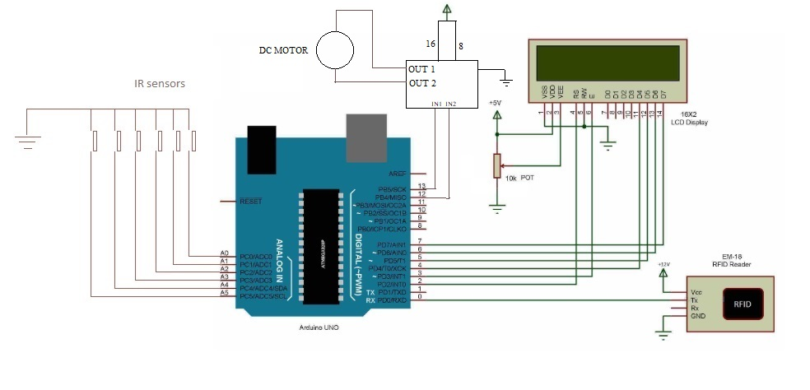**Fig5.2-Circuit diagram of automatic car parking system

**CHAPTER 6**

COMPONENTS

1. **ARDIUNO**

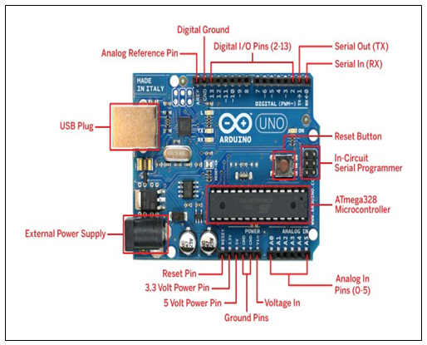

Fig6.1:-Arduino UNO

The Arduino Uno is a microcontroller board based on the ATmega328P (datasheet). It has 14 digital input/output pins (of which 6 can be used as PWM outputs), 6 analog inputs, a 16 MHz crystal oscillator, a USB connection, a power jack, an ICSP header, and a reset button. It contains everything needed to support the microcontroller; simply connect it to a computer with a USB cable or power it with an AC-to-DC adapter or battery to get started.

"Uno" means "One" in Italian and is named to mark the upcoming release of Arduino 1.0. The Uno and version 1.0 will be the reference versions of Arduino, moving forward. The Uno is the latest in a series of USB Arduino boards, and the reference model for the Arduino platform; for a comparison with previous versions, see the index of Arduino boards.

**Technical Specifications:**

|  |  |
| --- | --- |
| Microcontroller | ATmega328P |
| Operating Voltage | 5V |
| Input Voltage (recommended) | 7-9V |
| Input Voltage (limits) | 6-20V |
| Digital I/O Pins | 14 (of which 6 provide PWM output) |
| Analog Input Pins | 6 |
| DC Current per I/O Pin | 40 mA |
| DC Current for 3.3V Pin | 50 mA |
| Flash Memory | 32 KB (ATmega328) (0.5 KB used by boot loader) |
| SRAM | 2 KB (ATmega328) |
| EEPROM | 1 KB (ATmega328) |
| Clock Speed | 16 MHz |

Table 6.1:-Specifications of Arduino

**Power Supply for Arduino:**

The Arduino Uno can be powered via the USB connection or with an external power supply (230V, 50 HZ). The power source is selected automatically. External (non-USB) power can come either from an AC-to-DC adapter or battery. The adapter can be connected by plugging a 2.1mm centre-positive plug into the board's power jack. Leads from a battery can be inserted in the Ground and Vin pin headers of the POWER connector.

The board can operate on an external supply of 6 to 20 volts. If supplied with less than 7V, however, the 5V pin may supply less than five volts and the board may be unstable. If using more than 12V, the voltage regulator may overheat and damage the board. The recommended range is 7 to 12 volts.

1. **BATTERY:**

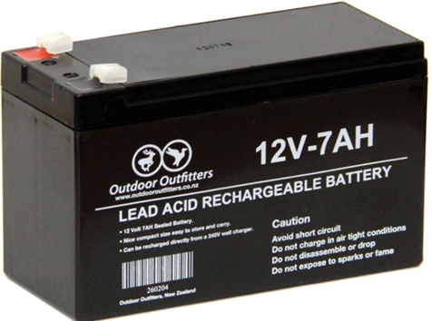

Fig6.2:-12 volts lead acid battery

Battery to provide energy to D.C. motor we require a D.C. Power source. It is in batteries which provide D.C. power to drive a motor. There are various ranges of batteries available. We have selected a battery. A completely drained battery could give only 100 recharges. By using 80% of the battery capacity we increase the no of recharge to 300-400 cycles. The battery can be completely recharged in 6-8 hr. using the standard battery charger. The optional quick charge can recharge the battery in approximately 3 hr.

**Specification:**

|  |  |
| --- | --- |
| Type | Lead Acid rechargeable battery |
| Output Voltage | 12V |
| Output current | 7A |
| Dimension | 15x9x6 cu.cm |
| Charging Time | 3 hrs –for fast charging |

Table 6.2:-Specifications of Lead acid rechargeable battery

1. **IR SENSOR**

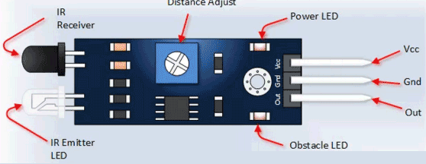

Fig6.3:-Pin diagram of IR sensor

|  |  |
| --- | --- |
| Brand | CENTIOT |
| Range | 2-30 cm |
| Input Voltage | 3.3-5 V |
| Input Current | 23-43 mA |
| Output Logic | Low logic |

Table 6.3:-Specifications of IR sensor

**4. DC MOTOR**

100RPM Centre Shaft Economy Series DC Motor is high quality low cost DC geared motor. It has steel gears and pinions to ensure longer life and better wear and tear properties. The gears are fixed on hardened steel spindles polished to a mirror finish. The output shaft rotates in a plastic bushing. The whole assembly is covered with a plastic ring. Gearbox is sealed and lubricated with lithium grease and require no maintenance. The motor is screwed to the gear box from inside.

Although motor gives 100 RPM at 12V but motor runs smoothly from 4V to 12V and gives wide range of RPM, and torque. Tables below gives fairly good idea of the motor’s performance in terms of RPM and no load current as a function of voltage and stall torque, stall current as a function of voltage.

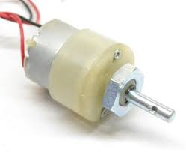

Fig 6.4:-DC Motor

|  |  |
| --- | --- |
| DC Supply | 4-12 V |
| RPM | 100RPM at 12V |
| Brush Type | Precious metal |
| Weight | 100 grams |

Table 6.4:-Specifications of DC Motor

|  |  |  |  |  |  |  |  |  |  |  |  |  |  |  |  |  |  |  |  |  |  |  |  |  |  |  |  |  |  |  |  |  |  |  |  |  |  |  |  |  |  |  |  |  |  |  |  |  |  |  |  |  |  |  |  |  |  |  |  |  |  |
| --- | --- | --- | --- | --- | --- | --- | --- | --- | --- | --- | --- | --- | --- | --- | --- | --- | --- | --- | --- | --- | --- | --- | --- | --- | --- | --- | --- | --- | --- | --- | --- | --- | --- | --- | --- | --- | --- | --- | --- | --- | --- | --- | --- | --- | --- | --- | --- | --- | --- | --- | --- | --- | --- | --- | --- | --- | --- | --- | --- | --- | --- |
| |  |  |  | | --- | --- | --- | | **Voltage (V)** | **RPM (No Load)** | **Current (A)** | | 4 | 30 | 0.016 | | 5 | 36 | 0.017 | | 6 | 46 | 0.019 | | 7 | 53 | 0.020 | | 8 | 60 | 0.022 | | 9 | 68 | 0.024 | | 10 | 76 | 0.027 | | 11 | 83 | 0.030 | | 12 | 92 | 0.035 | | |  |  |  | | --- | --- | --- | | **Voltage (V)** | **Stall torque (Kg/cm)** | **Stall Current (A)** | | 4 | 1.720 | 0.314 | | 5 | 2.472 | 0.394 | | 6 | 2.558 | 0.474 | | 7 | 3.182 | 0.557 | | 8 | 3.891 | 0.630 | | 9 | 4.321 | 0.722 | | 10 | 5.031 | 0.793 | | !11 | 5.375 | 0.826 | | 12 | 5.783 | 0.943 | |

Table 6.5:-motor performance in terms Table 6.6:-motor performance in terms of

of RPM and NO load Current as a function stall torque and stall current as a function

of input voltage of input voltage

1. **L293D Motor Driver**

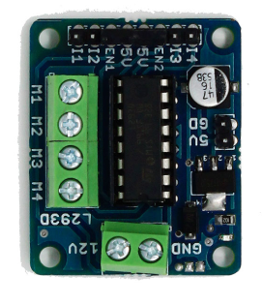

It has two connections for 5v servos connected to the arduino’s high resolution timer. It’s

4 H-bridges and L293D chipset provides 0.6A per bridge it comes with thermal shut-down protection. It can run Motors on 4.5V-25V DC.It provides upto 4 bi-directional dc motors with individual 8bit speed selection with single coil. The pull down resistors keep motors disabled during power up

1. **LCD Display**

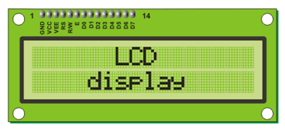

Fig 6.5:-16X2 LCD display

16X2 display is used to display availability of free parking space, its contrast can be adjusted by using potentiometer, pin configuration of LCD display can be know from data sheet

|  |  |
| --- | --- |
| GND | 0V |
| Supply | 5V (4.7V-5.3V) |
| Type | 16*2 LCD Display |

Table 6.7:-Specifications of LCD

1. **EM-18 RFID MODULE**  
   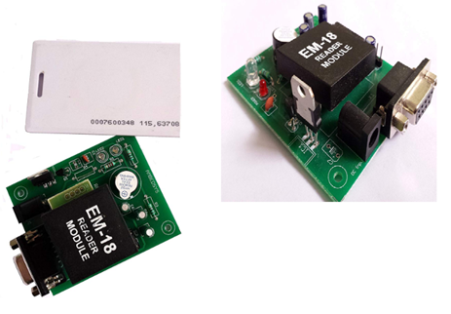
2. Fig 6.6:-RFID Sensor module

The EM-18 RFID Reader module operating at 125 kHz is an inexpensive solution for your RFID based application. The Reader module comes with an on-chip antenna and can be powered up with a 5V power supply. Power-up the module and connect the transmit pin of the module to receive pin of your microcontroller. Show your card within the reading distance and the card number is thrown at the output.

**8. Adapter for Arduino UNO**

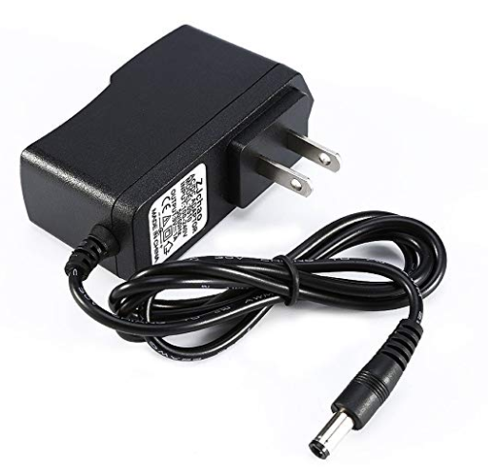

Arduino needs 7-9v dc supply for operation. this adapter provides required dc input to the arduino uno

**CALCULATIONS**  
  
Motor selection system

Assumed,

Diameter for shaft=6mm

Weight of assembly is=5kg

Torque required for motor

Torque=force X radius of shaft

=5 x 9.81 x 3

=147Nmm

=1.47kgcm

So torque required for one motor is =1.47kgcm

Therefore we are selecting DC motor with 1.72 kgcm torque and 4V, 30rpm ratings.

**CHAPTER 7**

COST ESTIMATION

|  |  |  |
| --- | --- | --- |
| **SR NO** | **COMPONENT** | **COST IN RS.** |
| 1 | ARDUINO UNO | 600 |
| 2 | Adapter 5-12v dc | 600 |
| 3 | BATTERY | 650 |
| 4 | IR SENSOR | 660 |
| 5 | LCD DISPLAY(16x2) | 450 |
| 6 | RFID | 580 |
| 7 | WOODEN BOARD | 950 |
| 8 | DC MOTOR(30RPM) | 600 |
| 9 | RACK AND PINION | 1100 |
| 10 | METAL AND FLUX | 1000 |
| 11 | MAIL TO FEMALE CONNECTOR | 100 |
| 12 | L293D Motor Driver | 250 |
|  | **TOTAL** | **Rs.7540** |

Table 7.1:- Cost Estimation

**CHAPTER 8**

FUTURE SCOPE

* For developing Countries it will tackle cost and availability of space problem
* System can be made simpler using current trends of technology.
* This framework can be enhanced by including different applications, For Example internet booking by utilizing GSM. The driver or client can book their parking area at home or while in transit to the shopping center. This can diminish the season of the client to seeking the empty parking area.
* In future charging points for electric cars can also be integrated with this system, as electric cars is the future for road transportation

CONCLUSION

The car parking system has been designed and all the composite parts in it have been manufactured and assembled. The mechanical model has been designed and the software as well as the control circuit has been implemented successfully. It demonstrates the working of the planned car parking system. The size and number of trolleys can be customized according to the needs and capacity of the organization or garage space availability.

**REFERENCES**

[1] Hemant Choudhary , Pratik Bansal , Dr.B.Valarmathi, “Advance Car Parking System using Arduino UNO” 2017 International Conference on Advanced Computing and Communication System (ICACCS-2017) Jan-06-07-2017 , Coimbatore India

[2] Kunal Torne , Saurabh Suryavanshi , Harikrishna Bhadani, “Rotory Car Parking using Sensor” International Conference on India and Innovation in Mechanical Engineering (ICIIIME)2017 ,ISSN:2321-8169

[3] Suwarna Ndyal , Sadaf Anjum ,Sabia Sultana , “Mechanical Designe of Smart Parking System using Arduino UNO” International Journal of Computer Application vol-169-No.1,July 2017

[4] Akash Waghmare , Trupti Nirwan , Gaurav Rahate , Ashrif Ali “Introduction to Multistage Car Parking System” International Journal of Mechanical Engineering vol-4 issue-4,April 2016

[5] https://www.youtube.com/watch?v=v7x6JjRMaIY

[6] https://nptel.ac.in/courses/112103174/5