**Mini Project Report on Library Management Application**

**Chapter 1: Introduction**

The Library Management Application is a user-friendly Java-based software developed using the Swing framework. It simplifies the process of Arranging books by allowing users to select the books easily ,and make the process quick. The system is designed to automate books sequentially, making it efficient for individual users to find, access and records data easily. The application retrieves item data from a database and presents it in a graphical user interface (GUI), making it easier for non-technical users to understandand record data swiftly.

This project addresses the common challenges of Librarian to manage data of thousands of books, such as **new book added, books return, Deleted book** from the librrary,**book issue** from the library . By utilizing Java's robust Swing library and database connectivity, the application ensures reliable and accurate.

**Chapter 2: Problem Definition**

Many Librariaan rely on manual methods to records data, leading to inefficiencies and potential errors in recordinng data. This process often involves manual work of noteing name’s of boooks, calculation of prices based on categories, and generating and mainting a final records. This traditional approach can be time-consuming and prone to mistakes, especially when dealing with multiple items. The Library Management Application is designed to automate these tasks, streamlining the Library Management process by retrieving item data from a database and calculating the total uses of books, , including prices and categories , with minimal user input.

**Chapter 3: Modules**

**3.1 Home Page (HomePage.java)**

The Home Page is the introductory screen of the application. It displays a welcome message and includes a button that allows users to navigate to the Library Management screen.

Purpose: Serve as the entry point for users.

Features: Welcome message displayed at the center. Button to navigate to the Library Management page.

**3.2 Main Page (MainPage.java)**

The Main Page is the core component of the application where users can select books to **Add ,Issue ,Return ,View ,and Delete**. This page displays a table that dynamically updates as the user choice.

Purpose: Enable users to select items, specify quantities,etc..

Features: Automated selected and quantity item are recorded. Button to navigate to Main page and save the final selection.

**3.3 Summary Page**

The Summary Page provides a sequencly selected items accordance to there choice and which get display. It also includes an option to return to the Main page.

Purpose: Display a summary of the books selected.

Features: Shows Book ID, Title, Author name, Issued book.

**Chapter 4: Database**

**Database Screenshot**

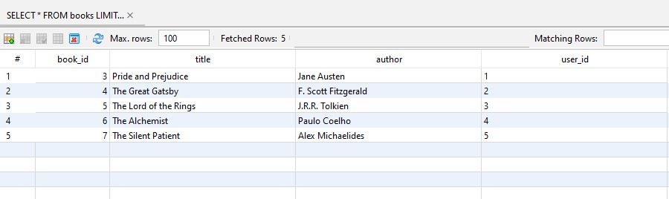

**Chapter 5: Results**

**Step 1:**

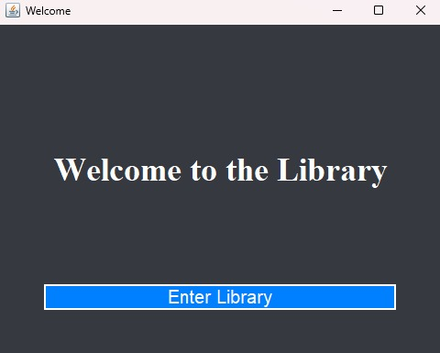

**Step 2:**

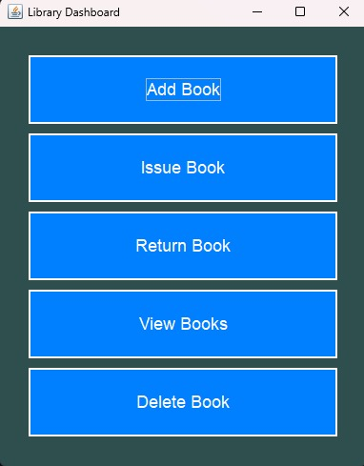

**Step 3:**

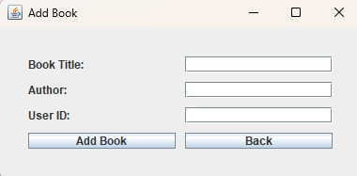

**Step 4:**

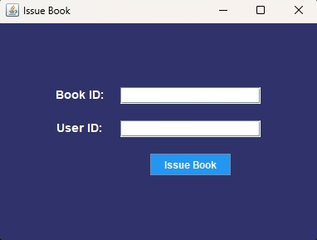

**Step 5:**

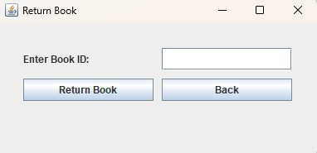

**Step 6:**

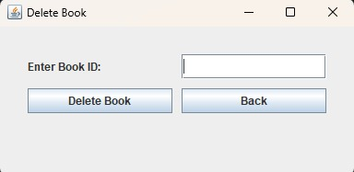

**Step 7:**

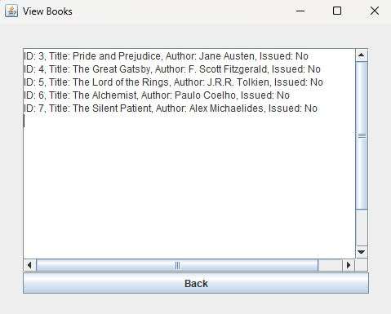

**Chapter 7: Conclusion**

The Library Management Application successfully simplifies to record data of hunndereds of books by users selection, based on authors name, and specification. The application is easy to use, with an intuitive GUI and reliable database connectivity for fetching item data. The system effectively reduces manual errors and increases efficiency, making it ideal for Large book house to manage.

**Chapter 8: References**

1. Oracle Java Swing Documentation

2. MySQL JDBC Documentation

3. Stack Overflow