**NINJAKEY SPEED TYPING TEST**

**Web-Based application Project**

**MINI PROJECT REPORT**

***Submitted by***

**Jayesh Patil**

**Apurv Ahire**

**Roshan Gaikwad**

***In partial fulfilment of the requirements for the******Degree of***

**BBA(CA)**

**In**

Bachelor of Computer Application

**Mahatma Gandhi Vidyamandir M.S.G. College****Loknete Vyankatrao Hire road Malegao camp****Tal: Malegaon Dist: Nashik, Pincode: 423105**

April 2024

**DEPARTMENT OF BBA  
(C.A) M.S.G COLLEGE MALEGAON**

**CERTIFICATE**

*Certified that this is a bonafide record of the projectwork entitled “NinjaKey-Speed-Typing-Test (Web-Based Projetc) Done By the following students.*

***PATIL JAYESH BABULAL***

***AHIRE APURV KISHOR***

***GAIKWAD ROSHAN NANAJ***

*Of The 6Th Semester, Bachelor Of Computer Application in the Year 2024 In Partial Fulfilment Of The BBA(CA) Of MSG College Malegaon.*

*Mr .D.J.Deore Miss .Sayali Ma’am*

*Head Of The Department Project Guide*

*Place:Malegaon*

*Date:20-04-2024*

***ACKNOWLEDGEMENT***

Here we gladly present this project report on **“NinjaKey Speed Typing Test (The Web-Based Project)”** as part of the 6th semester BCA. At this time of submitting this report we use this opportunity to mention those people who are with us along the work. We take this occasion to thank God, almighty for blessing us with his grace and taking our endeavour to a successful culmination. We extend our sincere and heartfelt thanks to our esteemed ***guide, Sayali Ma’am*** for providing us with the right guidance and advice at the crucial junctures and for showing us the right way. We extend our sincere thanks to our respected ***Head of the Department Mr. D.J. Deore Sir*,** for allowing us to use the facilities available. We would like to thank the other faculty members also, at this occasion. Last but not the least; we would like to thank friends for the support and encouragement they have given us during the course of our work.

*Submitted By*

*Jayesh Patil*

*Apurv Ahire*

*Roshan Gaikwad*

***ABSTRACT***

**Project Title :- NinjaKey Speed Typing Test**

NinjaKey Speed Typing Test is a web-based application designed to help users improve their typing speed and accuracy. The test offers two time options, 30 seconds and 60 seconds, catering to different user preferences and skill levels. Users can also choose between beginner and pro difficulty levels, ensuring a tailored experience.

The interface is user-friendly, featuring a clean design and intuitive controls. Upon starting the test, users are presented with a series of random words to type. As they type, the application provides real-time feedback, highlighting correctly typed words in green and incorrectly typed words in red.

The test includes a countdown timer, motivating users to type quickly and accurately within the allotted time. Upon completion, users receive detailed statistics, including their words per minute (WPM) and accuracy percentage.

NinjaKey Speed Typing Test is not only a tool for measuring typing speed but also a valuable resource for anyone looking to enhance their typing skills efficiently.

***INTRODUCTION***

**Project Overview :**

The Speed-Typing-Test project is a web-based application designed to help users enhance their typing speed and accuracy. In today's digital age, proficient typing skills are essential for efficient communication and productivity, making this project highly relevant and beneficial.

The primary goal of the Speed-Typing-Test is to provide users with a platform where they can practice and improve their typing abilities. The application offers various time options, including 30 seconds and 60 seconds, catering to different user preferences and skill levels. Additionally, users can choose between beginner and pro difficulty levels, ensuring a customized experience based on their proficiency.

The interface of the Speed-Typing-Test is user-friendly, featuring a clean design and intuitive controls. Upon starting the test, users are presented with a series of random words to type. As they type, the application provides real-time feedback, highlighting correctly typed words in green and incorrectly typed words in red. This instant feedback mechanism encourages users to focus on accuracy and speed simultaneously.

One of the standout features of the Speed-Typing-Test is the inclusion of a countdown timer. This timer creates a sense of urgency, motivating users to type quickly and accurately within the allotted time frame. Upon completing the test, users receive comprehensive statistics, including their Words Per Minute (WPM) and accuracy percentage. These statistics serve as valuable insights into the user's progress and areas for improvement.

Overall, the Speed-Typing-Test project is not only a tool for measuring typing speed but also a valuable resource for anyone looking to enhance their typing skills efficiently. Whether you are a beginner aiming to learn touch typing or an experienced typist striving for mastery, this application provides a structured and engaging platform to achieve your goals.

**Project Objectives :**

1. *Enhancing Typing Speed:* The primary objective of the Speed-Typing-Test project is to help users improve their typing speed. By providing a platform with timed typing sessions, users can practice and gradually increase their words per minute (WPM) rate.

2. *Improving Typing Accuracy:* Alongside speed, another key objective is to enhance typing accuracy. The application offers real-time feedback on typed words, highlighting correct and incorrect entries. This feedback mechanism encourages users to focus on accuracy while maintaining speed.

3. *Customized User Experience:* The project aims to provide a customized experience by offering different time options (30 seconds and 60 seconds) and difficulty levels (beginner and pro). This allows users to tailor their typing sessions according to their skill level and preferences.

4. *User-Friendly Interface:* A crucial objective is to create a user-friendly interface that is easy to navigate and visually appealing. Clear instructions, intuitive controls, and a clean design contribute to a seamless user experience.

5. *Motivation and Progress Tracking:* The inclusion of a countdown timer and detailed statistics (WPM, accuracy percentage) serves to motivate users during typing sessions. Additionally, the statistics provide insights into the user's progress over time, helping them track their improvement.

6. *Educational Resource:* Beyond measurement and practice, the Speed-Typing-Test project aims to be an educational resource for individuals looking to enhance their typing skills efficiently. By providing structured typing sessions and feedback, users can learn touch typing and adopt best practices for efficient typing.

7. *Scalability and Accessibility:* The project objectives include ensuring scalability to accommodate a growing user base and accessibility across different devices and browsers. This ensures that users can access the typing test seamlessly from various platforms.

8. *Continuous Improvement:* Lastly, the project aims for continuous improvement based on user feedback and technological advancements. Regular updates and enhancements will be implemented to enhance the overall user experience and effectiveness of the Speed-Typing-Test application.

**Existing System :**

The existing system of NinjaKey Speed Typing Test comprises several key components that collectively enable users to practice and improve their typing skills. Here's an overview of the existing system:

1. *Web-Based Application:* NinjaKey Speed Typing Test is a web-based application accessible through a standard web browser. This eliminates the need for users to download or install any software, making it convenient and accessible across various devices.

2. *Typing Test Options:* The system offers two primary time options for typing tests: 30 seconds and 60 seconds. This flexibility caters to users with different preferences and time availability for practicing typing skills.

3. *Difficulty Levels:* Users can choose between two difficulty levels: beginner and pro. The beginner level is ideal for those starting with typing practice, while the pro level offers a more challenging experience for users looking to refine their skills.

4. *Real-Time Feedback:* During typing sessions, the system provides real-time feedback to users. Correctly typed words are highlighted in green, while incorrectly typed words are highlighted in red. This instant feedback helps users identify and correct errors efficiently.

5. *Countdown Timer:* Each typing test includes a countdown timer, creating a sense of urgency and motivating users to type quickly and accurately within the allotted time frame. The timer adds a competitive element to the practice sessions.

6. *Detailed Statistics:* Upon completing a typing test, users receive detailed statistics regarding their performance. This includes metrics such as words per minute (WPM), accuracy percentage, and the number of correct/incorrect words typed. These statistics help users track their progress and identify areas for improvement.

7. *User-Friendly Interface:* The existing system features a user-friendly interface with intuitive controls and clear instructions. This ensures that users can navigate the application easily and focus on their typing practice without distractions.

8. *Responsive Design:* The system is designed to be responsive, adapting seamlessly to different screen sizes and devices. Whether accessed from a desktop computer, laptop, tablet, or smartphone, users can enjoy a consistent and optimized experience.

**Advantages :**

Speed-Typing-Test offers several advantages that contribute to its effectiveness and appeal for users looking to enhance their typing skills:

1. *Improves Typing Speed:* By providing timed typing tests with countdown timers, the platform encourages users to type quickly and efficiently, thereby enhancing their typing speed over time.

2. *Enhances Typing Accuracy:* The real-time feedback system highlights correctly typed words in green and incorrectly typed words in red, helping users identify and correct mistakes, leading to improved accuracy in typing.

3. *Customizable Difficulty Levels:* The option to choose between beginner and pro difficulty levels caters to users of varying skill levels, ensuring that each user can practice at a level that challenges them appropriately.

4. *User-Friendly Interface:* The platform's intuitive controls and clear instructions make it easy for users to navigate and use the application, promoting a seamless and enjoyable user experience.

5. *Convenient Web-Based Access:* As a web-based application, Speed-Typing-Test is accessible from any device with an internet connection and a web browser, offering convenience and flexibility for users to practice typing anytime, anywhere.

6. *Detailed Performance Statistics:* Users receive comprehensive statistics after each typing test, including words per minute (WPM) and accuracy percentage, allowing them to track their progress and identify areas for improvement.

7. *Motivational Features:* The countdown timer and real-time feedback system create a motivating environment for users, encouraging them to focus and strive for better performance in each typing session.

8. *Responsive Design:* The platform's responsive design ensures that it adapts seamlessly to different screen sizes and devices, providing a consistent and optimized user experience across desktops, laptops, tablets, and smartphones.

**Hardware Configuration:**

Hardware Configuration ---- Since NinjaKey Speed Typing Test is a web-based application, the hardware configuration primarily revolves around the server infrastructure required to host the application and manage user interactions

Processor : Intel(R) Core(TM) i3-2350M

System memory : 128 Mb minimum 500 Mb recommended

Cache size : 512 KB

RAM : 1 GB(Minimum)

Hard disk : 128Gb

Monitor : SVGA Colour 15”

Mouse : 104 keys US Key Serial, USB or PS/2

**Software Configuration :**

A major element in building a system is the section of Compatible software since the oftware in the market is experiencing geometric progression. Selected software should be acceptable by the firm and one user as well as it should be feasible for the system.

This document gives a detailed description of the software requirement specification. The study of requirement specification is focused especially on the functioning of the system. It allows the developer or analyst to understand the system, function to be carried out, the performance level to be obtained and corresponding interfaces to be established

Front-End Tool : HTML, CSS, JAVASCRIPT.

Operating System : Windows 10.

**Use Case Diagram:**

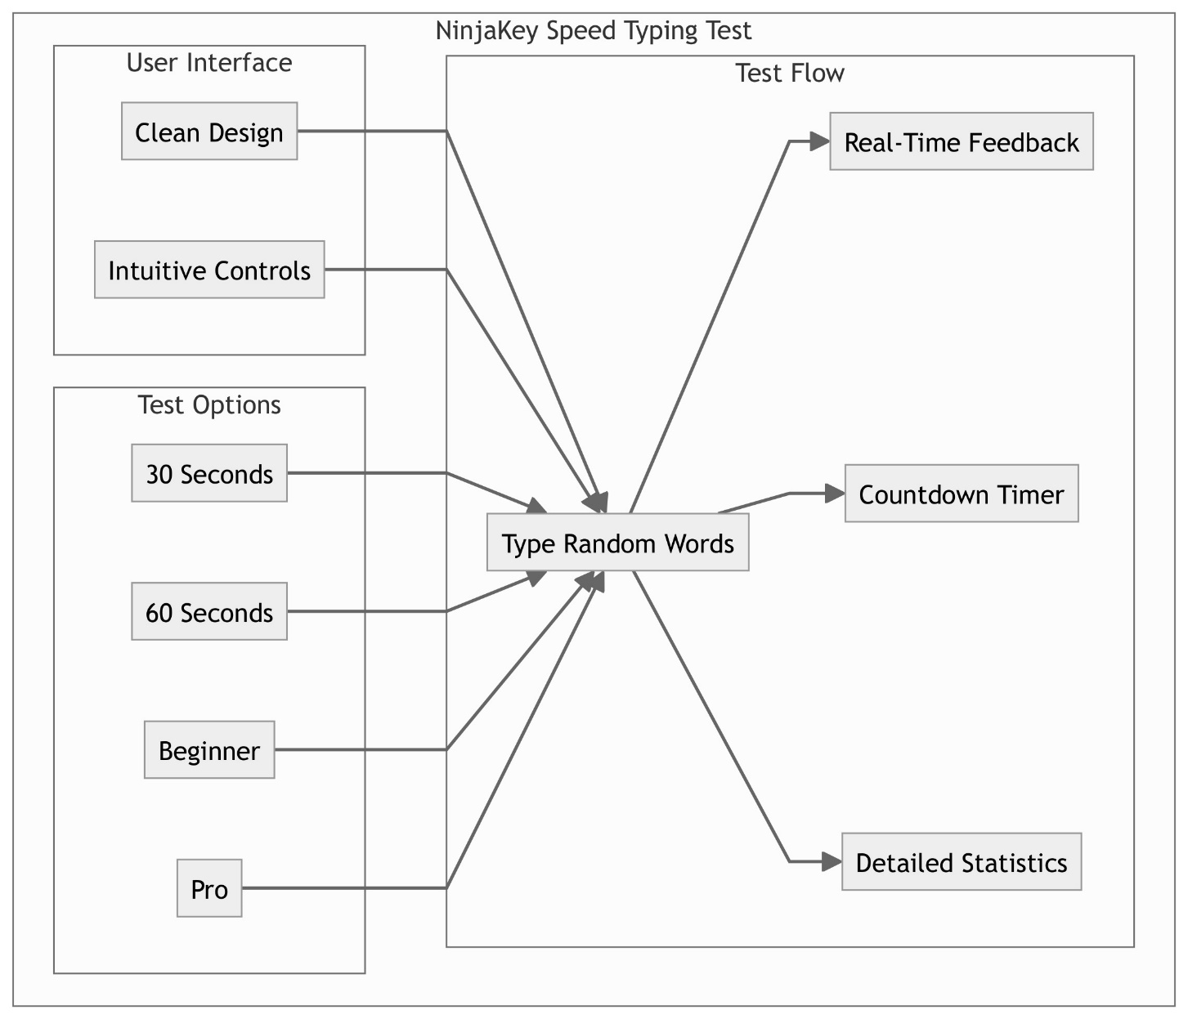

**Sequene Diagrams:**

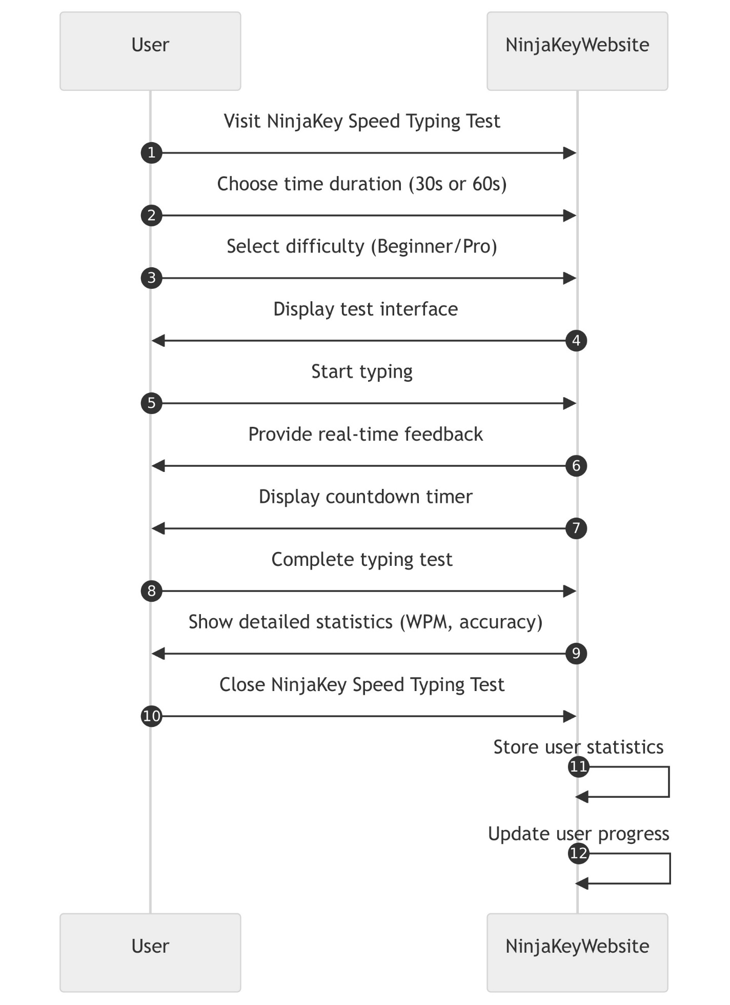

**DataFlow Diagram :**

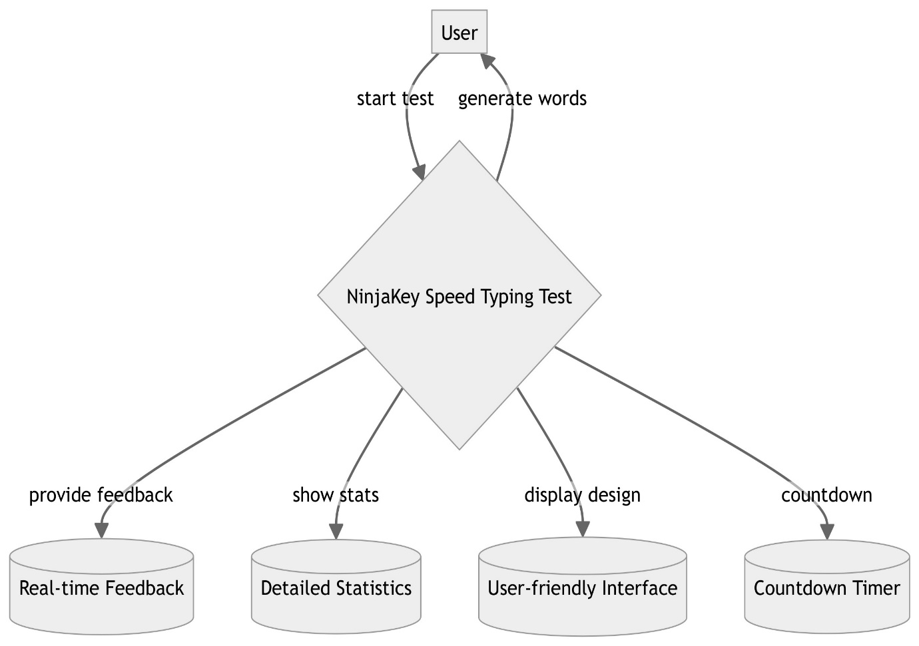

***CODE***

Index.html :

<!DOCTYPE html>

<html lang="en" dir="ltr">

  <head>

    <meta charset="utf-8">

    <meta name="viewport" content="width=device-width, initial-scale=1, shrink-to-fit=no">

    <meta name="description" content="This Speed Typing Test will give you an acuurate speed test and help increase your typing speed"/>

    <title>NinjaKey</title>

    <link rel="icon" href="favicon.png">

    <link

    href="https://cdn.jsdelivr.net/npm/remixicon@4.2.0/fonts/remixicon.css"

    rel="stylesheet"/>

    <link rel="stylesheet" href="https://maxcdn.bootstrapcdn.com/bootstrap/4.0.0/css/bootstrap.min.css" integrity="sha384-Gn5384xqQ1aoWXA+058RXPxPg6fy4IWvTNh0E263XmFcJlSAwiGgFAW/dAiS6JXm" crossorigin="anonymous">

    <link rel="stylesheet" href="styles.css">

    <!-- Fonts -->

    <link rel="preconnect" href="https://fonts.gstatic.com">

    <link href="https://fonts.googleapis.com/css2?family=Montserrat:wght@400;500;700&family=Source+Code+Pro:wght@300;400;700&display=swap" rel="stylesheet">

    <!-- fontawesome -->

    <link rel="stylesheet" href="https://use.fontawesome.com/releases/v5.15.3/css/all.css" integrity="sha384-SZXxX4whJ79/gErwcOYf+zWLeJdY/qpuqC4cAa9rOGUstPomtqpuNWT9wdPEn2fk" crossorigin="anonymous">

  </head>

  <body>

    <div class="container-fluid box ">

      <div class="top">

          <h1 id="heading" class = "yellow">Typing Speed Test</h1>

          <div class="limits-box">

            <div class="limit">

              <a id="thirty" class="yellow"  href="#" >30s</a>

              <a id="sixty"  href="#" >60s</a>

            </div>

            <div class="limit">

              <a id="beg" class="yellow"  href="#" >beginner</a>

              <a id="pro"  href="#" >pro</a>

            </div>

          </div>

      </div>

      <div class="stats center">

        <div class="stat-block if">

          <div id="timeName" class = "stat-name yellow if">Time</div>

          <div id="time" class="details if ">30</div>

        </div>

        <div class="stat-block if">

          <div id="cwName" class = "stat-name yellow if">CW</div>

          <div id="cw" class="details if">0</div>

        </div>

      </div>

      <div class="text-display" id="textDisplay">

      </div>

      <div class="input-area center">

        <!-- <h4 class="pl ">Start typing here</h4> -->

        <textarea rows="1" class="text-input" id="textInput" autofocus autocomplete="off" autocorrect="off" autocapitalize="off" spellcheck="false"></textarea>

      </div>

      <div  class="restart-button center">

        <a id="restartBtn" class = "current" href="#">

          <i class="fas fa-redo"></i>

        </a>

      </div>

      <footer class="center ftext"> <a class="grey" href="https://github.com/Jayeshpatil9869/NinjaKey-Speed-Typing-Test" target="_blank"><i class="ri-github-fill"></i>Github Link</a><footer>

    </div>

    <script src="https://code.jquery.com/jquery-3.2.1.slim.min.js" integrity="sha384-KJ3o2DKtIkvYIK3UENzmM7KCkRr/rE9/Qpg6aAZGJwFDMVNA/GpGFF93hXpG5KkN" crossorigin="anonymous"></script>

    <script src="https://cdnjs.cloudflare.com/ajax/libs/popper.js/1.12.9/umd/popper.min.js" integrity="sha384-ApNbgh9B+Y1QKtv3Rn7W3mgPxhU9K/ScQsAP7hUibX39j7fakFPskvXusvfa0b4Q" crossorigin="anonymous"></script>

    <script src="https://maxcdn.bootstrapcdn.com/bootstrap/4.0.0/js/bootstrap.min.js" integrity="sha384-JZR6Spejh4U02d8jOt6vLEHfe/JQGiRRSQQxSfFWpi1MquVdAyjUar5+76PVCmYl" crossorigin="anonymous"></script>

    <!-- My Javascript -->

    <script src="app.js"></script>

  </body>

</html>

Styles.css

html,

body{

  font-family: 'Source Code Pro', monospace;

  background: #212121;

  color: #52575d;

}

a{

  color: #52575d;

}

.yellow{

  color: #ffd369;

}

.correct{

  color: #29bb89;

}

.wrong{

  color: #e84545;

  text-decoration: underline;

}

.current{

  color: #eeeeee;

}

.center{

  text-align: center;

}

.if{

  display: inline-flex;

}

.box {

  max-width: 900px;

  padding: 0 30px;

}

#heading{

  align-self: left;

  margin-top: 50px;

  font-size: 1.75rem;

  font-family: 'Montserrat', sans-serif;

  font-weight: 500;

}

.limits-box{

  text-align: right;

  margin: 0 35px 0 0 ;

  font-size: 15px;

}

.stats{

  margin: 10px auto 20px auto;

}

.details{

  font-size: 6rem;

}

.stat-block{

  padding: 0 30px;

  min-width: 250px;

}

.ftext .grey{

  color: #ffd369;

  font-size: 20px;

}

.ftext .grey i{

  margin-right: .8vw;

  font-size: 22px ;

}

.input-area {

  position: relative;

  overflow: hidden;

}

.pl {

  position: absolute;

  top: 25%;

  left: 39%;

  transform: translateY(-50%, -50%);

  font-size: 18px;

  color: #aaa;

  transition: opacity 0.3s ease-in-out;

  pointer-events: none;

}

.text-input {

  padding: 10px;

  font-size: 16px;

  border: 1px solid #ccc;

  border-radius: 5px;

  transition: border-color 0.3s ease-in-out;

}

.input-area:hover .pl,

.text-input:focus + .pl {

  opacity: 0;

  display: none;

}

.input-area:hover .text-input,

.text-input:focus {

  border-color: #007bff;

}

@media(max-width: 600px){

  .details{

    font-size: 5rem;

  }

  .stat-block{

    min-width: 0;

  }

  .pl{

    display: none;

  }

}

.stat-name{

  font-size: 1rem;

  position: relative;

  top: 45px;

  right: 5px;

}

.text-display{

  margin: 0 0 22px 0;

  font-size: 21px;

  text-align: left;

  min-height: 200px;

}

input:focus, textarea:focus, select:focus, a:focus{

  outline: 0 ;

}

a:focus,a:hover{

  color: #ffd369;

  text-decoration: none;

}

.restart-button{

  padding: 10px;

}

textarea{

  background: #212121;

  border: solid, #52575d;

  border-width: 1.2px;

  border-radius: 10px;

  color: #eeeeee;

  padding: 10px;

  font-size: 1.2rem;

  resize: none;

  text-align: center;

  margin-bottom: 2px;

}

App.Js :

const testItem = document.getElementById("textDisplay");

const inputItem = document.getElementById("textInput");

const timeName = document.getElementById("timeName");

const time = document.getElementById("time");

const cwName = document.getElementById("cwName");

const cw = document.getElementById("cw");

const restartBtn = document.getElementById("restartBtn");

const thirty = document.getElementById("thirty");

const sixty = document.getElementById("sixty");

const beg = document.getElementById("beg");

const pro = document.getElementById("pro");

var wordNo = 1;

var wordsSubmitted = 0;

var wordsCorrect = 0;

var timer = 30;

var flag=0;

var factor=2;

var seconds;

var difficulty=1;

displayTest(difficulty);

//on Input

inputItem.addEventListener('input', function(event){

  if(flag===0){

    flag=1;

    timeStart();

  }

  var charEntered = event.data;

  if(/\s/g.test(charEntered)){  //check if the character entered is a whitespace

    checkWord();

  }

  else{

    currentWord();

  }

});

//time selection

thirty.addEventListener("click",function(){

  timer = 30;

  factor = 2;

  limitColor(thirty,sixty);

  time.innerText = timer;

});

sixty.addEventListener("click",function(){

  timer = 60;

  factor = 1;

  limitColor(sixty, thirty);

  time.innerText = timer;

});

//difficulty Selection

beg.addEventListener("click",function(){

  difficulty = 1;

  displayTest(difficulty);

  limitColor(beg,pro);

});

pro.addEventListener("click",function(){

  difficulty = 2;

  displayTest(difficulty);

  limitColor(pro,beg);

});

//set the color of time and difficulty

function limitColor(itema,itemr ){

  itema.classList.add('yellow');

  itemr.classList.remove('yellow');

}

//restart the Test

restartBtn.addEventListener("click",function(){

  wordsSubmitted = 0;

  wordsCorrect = 0;

  flag=0;

  time.classList.remove("current");

  cw.classList.remove("current");

  time.innerText = timer;

  timeName.innerText = "Time";

  cw.innerText = wordsCorrect;

  cwName.innerText = "CW";

  inputItem.disabled = false;

  inputItem.value = '';

  inputItem.focus();

  displayTest(difficulty);

  clearInterval(seconds);

  limitVisible();

});

//start the timer countdown

function timeStart(){

  limitInvisible();

  seconds = setInterval(function() {

    time.innerText--;

    if (time.innerText == "-1") { // Check if timer reached -1

        timeOver(); // Call timeOver() function

        clearInterval(seconds); // Stop the timer

    }

  }, 1000); // Timer runs every 1000ms (1 second)

}

//diable textarea and wait for restart

function timeOver(){

  inputItem.disabled = true;

  restartBtn.focus();

  displayScore();

}

//set Limit visibility

function limitVisible(){

  thirty.style.visibility = 'visible';

  sixty.style.visibility = 'visible';

  beg.style.visibility = 'visible';

  pro.style.visibility = 'visible';

}

function limitInvisible(){

  thirty.style.visibility = 'hidden';

  sixty.style.visibility = 'hidden';

  beg.style.visibility = 'hidden';

  pro.style.visibility = 'hidden';

}

//display the score

function displayScore(){

  let percentageAcc = 0;

  if(wordsSubmitted!==0){

    percentageAcc = Math.floor((wordsCorrect/wordsSubmitted)*100);

  }

  time.classList.add("current");

  cw.classList.add("current");

  time.innerText = percentageAcc+"%";

  timeName.innerText = "PA";

  cw.innerText = factor*wordsCorrect;

  cwName.innerText = "WPM";

}

//check if the user is entering correcrt word

function currentWord(){

  const wordEntered = inputItem.value;

  const currentID = "word "+wordNo;

  const currentSpan = document.getElementById(currentID);

  const curSpanWord = currentSpan.innerText;

  if(wordEntered == curSpanWord.substring(0,wordEntered.length)){

    colorSpan(currentID, 2);

  }

  else{

    colorSpan(currentID, 3);

  }

}

//checks word entered

function checkWord(){

  const wordEntered = inputItem.value;

  inputItem.value='';

  const wordID = "word "+wordNo;

  const checkSpan = document.getElementById(wordID);

  wordNo++;

  wordsSubmitted++;

  if(checkSpan.innerText === wordEntered){

    colorSpan(wordID, 1);

    wordsCorrect++;

    cw.innerText=wordsCorrect;

  }

  else{

    colorSpan(wordID, 3);

  }

  if(wordNo>40){

    displayTest(difficulty);

  }

  else{

    const nextID = "word "+wordNo;

    colorSpan(nextID, 2);

  }

}

//color the words

function colorSpan(id, color){

  const span = document.getElementById(id);

  if(color === 1 ){

    span.classList.remove('wrong');

    span.classList.remove('current');

    span.classList.add('correct');

  }

  else if(color ===2){

    span.classList.remove('correct');

    span.classList.remove('wrong');

    span.classList.add('current');

  }

  else{

    span.classList.remove('correct');

    span.classList.remove('current');

    span.classList.add('wrong');

  }

}

//display the random words on screen

function displayTest(diff){

  wordNo = 1;

  testItem.innerHTML = '';

  let newTest = randomWords(diff);

  newTest.forEach(function(word, i){

    let wordSpan = document.createElement('span');

    wordSpan.innerText = word;

    wordSpan.setAttribute("id", "word " + (i+1));

    testItem.appendChild(wordSpan);

  });

  const nextID = "word "+wordNo;

  colorSpan(nextID, 2);

}

//Generate an array of random 50 words

function randomWords(diff){

  var topWords = ["ability", "able", "about", "above", "accept", "according", "account", "across", "action", "activity", "actually",  "address", "administration", "admit", "adult", "affect", "after", "again", "against",  "agency", "agent", "ago", "agree", "agreement", "ahead",  "allow", "almost", "alone", "along", "already", "also", "although", "always", "American", "among", "amount", "analysis", "and", "animal", "another", "answer",  "anyone", "anything", "appear", "apply", "approach", "area", "argue",  "around", "arrive", "article", "artist",  "assume", "attack", "attention", "attorney", "audience", "author", "authority", "available", "avoid", "away", "baby", "back",   "ball", "bank",  "beat", "beautiful", "because", "become",  "before", "begin", "behavior", "behind", "believe", "benefit", "best", "better", "between", "beyond",  "bill", "billion",  "black", "blood", "blue", "board", "body", "book", "born", "both", "break", "bring", "brother", "budget", "build", "building", "business", "call", "camera", "campaign",  "cancer", "candidate", "capital", "card", "care", "career", "carry", "case", "catch", "cause", "cell", "center", "central", "century", "certain", "certainly", "chair", "challenge", "chance", "change", "character", "charge", "check", "child", "choice", "choose", "church", "citizen", "city", "civil", "claim", "class", "clear", "clearly", "close", "coach", "cold", "collection", "college", "color", "come", "commercial", "common", "community", "company", "compare", "computer", "concern", "condition", "conference", "congress", "consider", "consumer", "contain", "continue", "control", "cost", "could", "country", "couple", "course", "court", "cover", "create", "crime", "cultural", "culture", "cup", "current", "customer",  "dark", "data", "daughter",  "dead", "deal", "death", "debate", "decade", "decide", "decision", "deep", "defense", "degree", "Democrat", "democratic", "describe", "design", "despite", "detail", "determine", "develop", "development",  "difference", "different", "difficult", "dinner", "direction", "director", "discover", "discuss", "discussion", "disease", "doctor",  "door", "down", "draw", "dream", "drive", "drop", "drug", "during", "each", "early", "east", "easy",  "economic", "economy", "edge", "education", "effect", "effort", "eight", "either", "election", "else", "employee",  "energy", "enjoy", "enough", "enter", "entire", "environment", "environmental", "especially", "establish", "even", "evening", "event", "ever", "every", "everybody", "everyone", "everything", "evidence", "exactly", "example", "executive", "exist", "expect", "experience", "expert", "explain", "eye", "face", "fact", "factor", "fail", "fall", "family", "far", "fast", "father", "fear", "federal", "feel", "feeling",  "field", "fight", "figure", "fill", "film", "final", "finally", "financial", "find", "fine", "finger", "finish", "fire", "firm", "first", "fish", "five", "floor", "fly", "focus", "follow", "food", "foot",  "force", "foreign", "forget", "form", "former", "forward", "four", "free", "friend", "from", "front", "full", "fund", "future", "game", "garden",  "general", "generation",  "girl", "give", "glass", "goal", "good", "government", "great", "green", "ground", "group", "grow", "growth", "guess", "guy", "hair", "half", "hand", "hang", "happen", "happy", "hard", "have",  "head", "health", "hear", "heart", "heat", "heavy", "help", "here", "herself", "high", "him", "himself", "his", "history",  "hold", "home", "hope", "hospital", "hot", "hotel", "hour", "house", "how", "however", "huge", "human", "hundred", "husband", "I", "idea", "identify", "if", "image", "imagine", "impact", "important", "improve",  "include", "including", "increase", "indeed", "indicate", "individual", "industry", "information", "inside", "instead", "institution", "interest", "interesting", "international", "interview", "into", "investment", "involve", "issue",  "item", "it's", "itself", "join", "just", "keep",  "kill", "kind", "kitchen", "know", "knowledge", "land", "language", "large", "last", "late", "later", "laugh", "law", "lawyer", "lead", "leader", "learn", "least", "leave", "left",  "legal", "less",  "letter", "level",  "life", "light", "like", "likely", "line", "list", "listen", "little", "live", "local", "long", "look", "lose", "loss", "love", "machine", "magazine", "main", "maintain", "major", "majority", "make", "man", "manage", "management", "manager", "many", "market", "marriage", "material", "matter", "maybe",  "mean", "measure", "media", "medical", "meet", "meeting", "member", "memory", "mention", "message", "method", "middle", "might", "military", "million", "mind", "minute", "miss", "mission", "model", "modern", "moment", "money", "month", "more", "morning", "most", "mother", "mouth", "move", "movement", "movie", "Mr", "Mrs", "much", "music", "must", "my", "myself", "name", "nation", "national", "natural", "nature", "near", "nearly", "necessary", "need", "network", "never",  "news", "newspaper", "next", "nice", "night",  "none",  "north",  "note", "nothing", "notice",  "number", "occur", "off", "offer", "office", "officer", "official", "often", "once", "only", "onto", "open", "operation", "opportunity", "option",  "order", "organization", "other", "others",  "outside", "over", "own", "owner", "page", "pain", "painting", "paper", "parent", "part", "participant", "particular", "particularly", "partner", "party", "pass", "past", "patient", "pattern", "peace", "people", "perform", "performance", "perhaps", "period", "person", "personal", "phone", "physical", "pick", "picture", "piece", "place", "plan", "plant", "play", "player", "PM", "point", "police", "policy", "political", "politics", "poor", "popular", "population", "position", "positive", "possible", "power", "practice", "prepare", "present", "president", "pressure", "pretty", "prevent", "price", "private", "probably", "problem", "process", "produce", "product", "production", "professional", "professor", "program", "project", "property", "protect", "prove", "provide", "public", "pull", "purpose", "push",  "quality", "question", "quickly", "quite", "race", "radio", "raise", "range", "rate", "rather", "reach", "read", "ready", "real", "reality", "realize", "really", "reason", "receive", "recent", "recently", "recognize", "record", "red", "reduce", "reflect", "region", "relate", "relationship", "religious", "remain", "remember", "remove", "report", "represent", "republican", "require", "research", "resource", "respond", "response", "responsibility", "rest", "result", "return", "reveal", "rich", "right", "rise", "risk", "road", "rock", "role", "room", "rule",  "safe", "same", "save",  "scene", "school", "science", "scientist", "score", "sea", "season", "seat", "second", "section", "security", "see", "seek", "seem", "sell", "send", "senior", "sense", "series", "serious", "serve", "service", "set", "seven", "several", "sex", "sexual", "shake", "share", "she", "shoot", "short", "shot", "should", "shoulder", "show", "side", "sign", "significant", "similar", "simple", "simply", "since", "sing", "single", "sister",   "situation", "size", "skill", "skin", "small", "smile",  "social", "society", "soldier", "some", "somebody", "someone", "something", "sometimes", "song", "soon", "sort", "sound", "source", "south", "southern", "space", "speak", "special", "specific", "speech", "spend", "sport", "spring", "staff", "stage", "stand", "standard", "star", "start", "state", "statement", "station", "stay", "step", "still", "stock", "stop", "store", "story", "strategy", "street", "strong", "structure", "student", "study", "stuff", "style", "subject", "success", "successful", "such", "suddenly", "suffer", "suggest", "summer", "support", "sure", "surface", "system", "table", "take", "talk", "task", "tax", "teach", "teacher", "team", "technology", "television", "tell",  "tend", "term", "test", "than", "thank", "that",  "their", "them", "themselves", "then", "theory", "there", "these", "they", "thing", "think", "third", "this", "those", "though", "thought", "thousand", "threat", "three", "through", "throughout", "throw", "thus", "time", "today", "together", "tonight",  "total", "tough", "toward", "town", "trade", "traditional", "training", "travel", "treat", "treatment", "tree", "trial", "trip", "trouble", "true", "truth", "try", "turn", "TV",  "type", "under", "understand", "unit", "until", "usually", "value", "various", "very", "victim", "view", "violence", "visit", "voice", "vote", "wait", "walk", "wall", "want",  "watch", "water",  "weapon", "wear", "week", "weight", "well", "west", "western", "what", "whatever", "when", "where", "whether", "which", "while", "white",  "whole", "whom", "whose",  "wide", "wife", "will", "wind", "window", "wish", "with", "within", "without", "woman", "wonder", "word", "work", "worker", "world", "worry", "would", "write", "writer", "wrong", "yard", "yeah", "year", "young", "your", "yourself"];

  var basicWords = ["a", "about", "above", "across", "act",  "add", "afraid", "after", "again", "age", "ago", "agree", "air", "all", "alone", "along", "always", "am", "amount", "an", "and", "angry", "another", "answer", "any", "anyone",  "appear", "apple", "are", "area", "arm", "army", "around", "arrive", "art", "as", "ask", "at", "aunt",  "away", "baby", "back", "bad", "bag", "ball", "bank", "base",  "bath", "be", "bean", "bear",  "bed", "beer", "before", "begin", "bell", "below", "best", "big", "bird", "birth",  "bit", "bite", "black", "bleed", "block", "blood", "blow", "blue", "board", "boat", "body", "boil", "bone", "book", "border", "born", "both",  "bowl", "box", "boy", "branch", "brave", "bread", "break", "breathe", "bridge", "bright", "bring", "brother", "brown", "brush", "build", "burn",  "bus", "busy", "but", "buy", "by", "cake", "call", "can",  "cap", "car", "card", "care", "carry", "case", "cat", "catch",  "chair", "chase", "cheap", "cheese",  "child",   "choice",  "circle", "city", "class", "clever", "clean", "clear", "climb", "clock", "cloth",  "cloud",  "close", "coffee", "coat", "coin", "cold",  "colour", "comb",  "common", "compare", "come",  "control", "cook", "cool", "copper", "corn", "corner", "correct", "cost",  "count",   "cover", "crash", "cross", "cry", "cup",  "cut", "dance",  "dark",  "day", "dead", "decide", "deep", "deer",  "desk",   "die",  "dirty",  "dish", "do", "dog", "door",  "down", "draw", "dream", "dress", "drink", "drive", "drop", "dry", "duck", "dust", "duty", "each", "ear", "early", "earn", "earth", "east", "easy", "eat", "effect", "egg", "eight",   "else", "empty", "end", "enemy", "enjoy",  "enter", "equal",  "even",  "event", "ever", "every",  "exact",   "except",  "expect",  "explain",  "eye", "face", "fact", "fail", "fall", "false", "family", "famous", "far", "farm",  "fast", "fat", "fault", "fear", "feed", "feel", "fever", "few", "fight", "fill", "film", "find", "fine",  "fire", "first", "fish", "fit", "five", "fix", "flag", "flat", "float", "floor", "flour",  "fly", "fold", "food", "fool", "foot", "for", "force",  "forest", "forget",  "fork", "form", "fox", "four", "free", "freeze", "fresh", "friend",  "from", "front", "fruit", "full", "fun", "funny",   "future", "game",  "gate","get", "gift", "give", "glad", "glass", "go", "goat", "god", "gold", "good",   "grass", "grave", "great", "green", "gray",  "group", "grow", "gun", "hair", "half", "hall",  "hand",  "happy", "hard", "hat", "hate", "have", "he", "head",  "hear", "heavy", "heart",  "hello", "help", "hen", "her", "here", "hers", "hide", "high", "hill", "him", "his", "hit", "hobby", "hold", "hole",  "home", "hope", "horse",  "hot", "hotel", "house", "how",  "hour", "hurry",  "hurt", "I", "ice", "idea", "if",  "in",   "into", "invent", "iron",  "is", "island", "it", "its", "jelly", "job", "join", "juice", "jump", "just", "keep", "key", "kill", "kind", "king",  "knee", "knife", "knock", "know", "lady", "lamp", "land", "large", "last", "late", "laugh", "lazy", "lead", "leaf", "learn", "leave", "leg", "left", "lend", "length", "less", "lesson", "let", "letter", "lie", "life", "light", "like", "lion", "lip", "list",  "live", "lock", "lonely", "long", "look", "lose", "lot", "love", "low", "lower", "luck",  "main", "make", "male", "man", "many", "map", "mark", "may", "me", "meal", "mean", "meat",  "meet",  "milk", "mind",  "miss",  "mix", "model",   "money",  "month", "moon", "more",  "most",  "mouth", "move", "much", "music", "must", "my", "name",  "near", "neck", "need", "needle",  "net", "never", "new", "news",  "next", "nice", "night", "nine", "no", "noble", "noise", "none", "nor", "north", "nose", "not",  "notice", "now",  "obey",  "ocean", "of", "off", "offer", "office", "often", "oil", "old", "on", "one", "only", "open",  "or", "orange", "order", "other", "our", "out",  "over", "own", "page", "pain", "paint", "pair", "pan", "paper",  "park", "part",  "party", "pass", "past", "path", "pay", "peace", "pen",   "per",  "piano", "pick",  "piece", "pig", "pin", "pink", "place", "plane", "plant",  "plate", "play", "please",  "plenty",  "point",  "polite", "pool", "poor",    "pour", "power",  "press", "pretty",  "price", "prince", "prison",  "prize",      "pull", "punish", "pupil", "push", "put", "queen",  "quick", "quiet", "radio", "rain", "rainy", "raise", "reach", "read", "ready", "real",  "red",   "rent",   "reply", "rest",  "rice", "rich", "ride", "right", "ring", "rise", "road", "rob", "rock", "room", "round", "rude", "rule", "ruler", "run", "rush", "sad", "safe", "sail", "salt", "same", "sand", "save", "say", "school",  "search", "seat", "second", "see", "seem", "sell", "send",  "serve", "seven", "sex", "shade",  "shake", "shape", "share", "sharp", "she", "sheep", "sheet",  "shine", "ship", "shirt", "shoe", "shoot", "shop", "short",   "shout", "show", "sick", "side",   "silly", "silver",  "simple", "single", "since", "sing", "sink", "sister", "sit", "six", "size", "skill", "skin", "skirt", "sky", "sleep", "slip", "slow", "small", "smell", "smile", "smoke", "snow", "so", "soap", "sock", "soft", "some",  "son", "soon", "sorry", "sound", "soup", "south", "space", "speak",  "speed", "spell", "spend", "spoon", "sport", "spread", "spring", "square", "stamp", "stand", "star", "start",  "stay", "steal", "steam", "step", "still",  "stone", "stop", "store", "storm", "story",  "street", "study", "stupid",  "such", "sugar",  "sun", "sunny",  "sure",  "sweet", "swim", "sword", "table", "take", "talk", "tall", "taste", "taxi", "tea", "teach", "team", "tear",   "tell", "ten", "tennis", "test", "than", "that", "the", "their", "then", "there",  "these", "thick", "thin", "thing", "think", "third", "this",  "threat", "three", "tidy", "tie", "title", "to", "today", "toe", "too", "tool", "tooth", "top", "total", "touch", "town", "train", "tram",  "tree",  "true", "trust", "twice", "try", "turn", "type", "ugly", "uncle", "under",  "unit", "until", "up", "use", "useful", "usual", "usually",  "very",  "voice", "visit", "wait", "wake", "walk", "want", "warm", "was", "wash", "waste", "watch", "water", "way", "we", "weak", "wear",  "week", "weight",  "were", "well", "west", "wet", "what", "wheel", "when", "where", "which", "while", "white", "who", "why", "wide", "wife", "wild", "will", "win", "wind",  "wine",  "wire", "wise", "wish", "with",  "woman",  "word", "work", "world", "worry", "yard", "yell",  "yet", "you", "young", "your", "zero", "zoo"];

  if(diff==1){

    wordArray = basicWords;

  }

  else{

    wordArray =topWords;

  }

  var selectedWords = [];

  for(var i=0;i<40;i++){

    var randomNumber = Math.floor(Math.random()*wordArray.length);

    selectedWords.push(wordArray[randomNumber]+" ");

  }

  return selectedWords;

}

Output :

