Banavoo.in — Seller Guide
How to Register, Set Up Your Shop and Sell Your Handmade Products
banavoo.in | Free to Use | No GSTN Required
Before You Start — What You Need
You do not need any special documents or fees. Just keep these things ready:
- A smartphone or computer with internet
- Your email address
- Phone photos of your handmade products
No GSTN. No subscription. No hidden charges.
STEP 1 — Create Your Account
- 1. Open your browser and go to banavoo.in
- 2. Click Sign Up in the top right corner
- 3. Fill in: Full Name, Email address, Phone (optional), Password
- 4. Password must have: 8+ characters, one UPPERCASE letter, one number
- 5. Click Continue — you will receive a 6-digit OTP code in your email
- 6. Enter the 6-digit code on the verification screen
- 7. Done! Your account is created and you are now logged in.
Tip: You can also sign up instantly with Sign up with Google — no OTP needed.
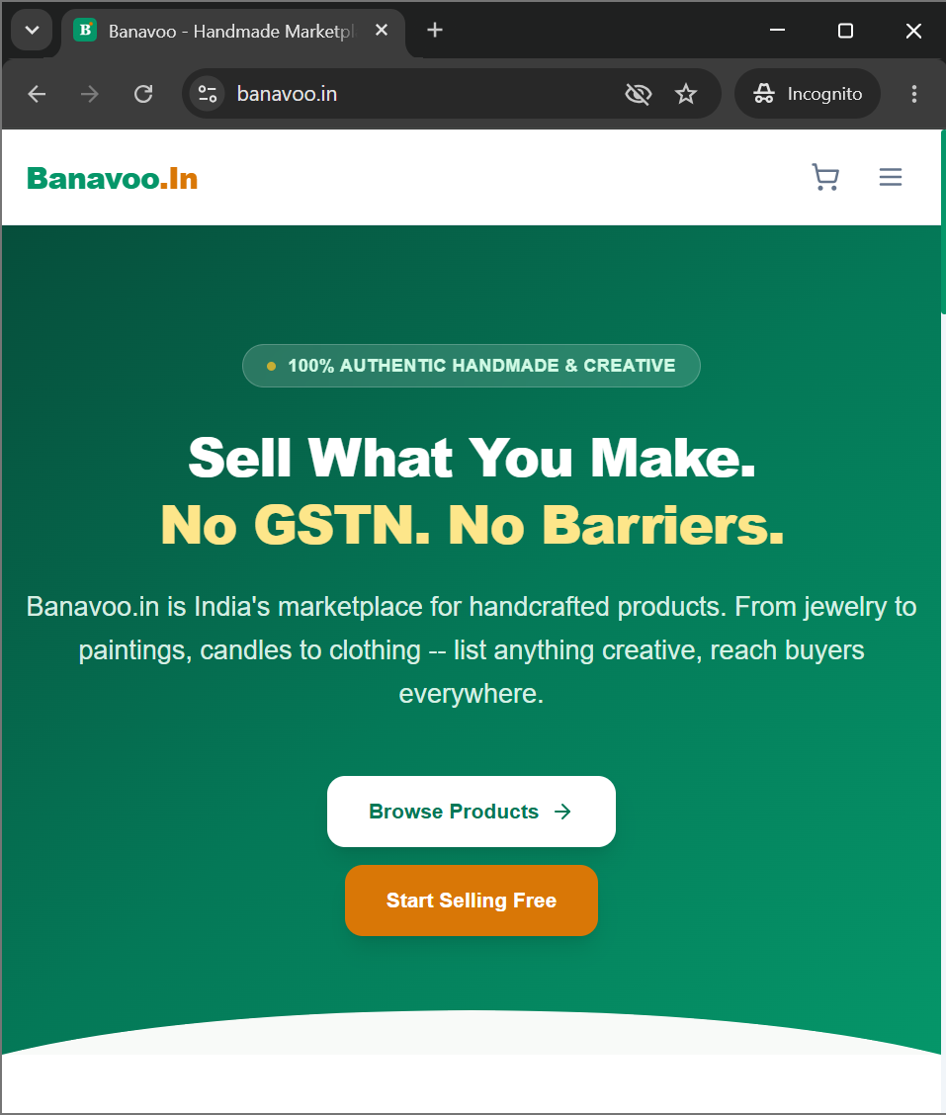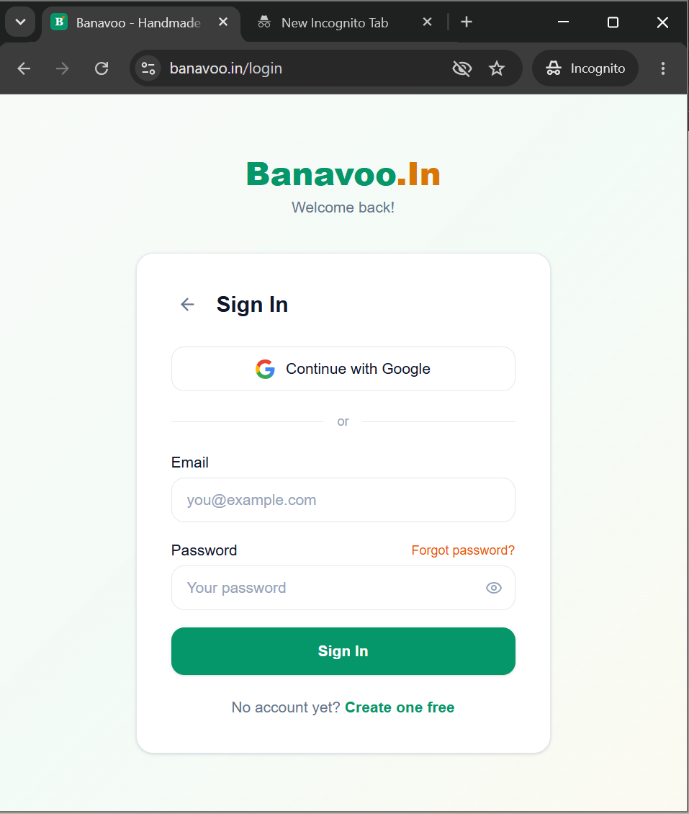
STEP 2 — Activate Your Seller Account
Your account starts as a Buyer. Follow these steps to become a Seller:
- 1. Click your name or avatar at the top right corner
- 2. Click Start Selling from the dropdown (OR go to banavoo.in/become-seller)
- 3. Enter your Shop Name (e.g. Priya's Handmade Jewels)
- 4. Enter your Shop Description (2-3 sentences about what you make)
- 5. Enter your Shop City, Shop State and Pickup Pincode
- 6. Click Activate My Shop
- 7. You will receive a confirmation email. Your dropdown will now show Seller Dashboard.
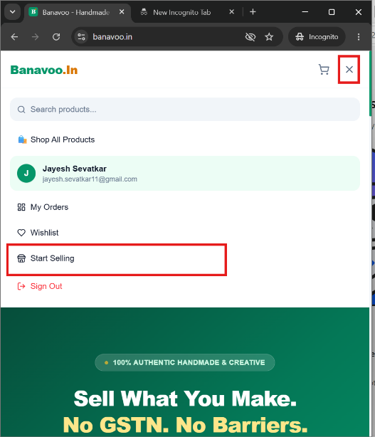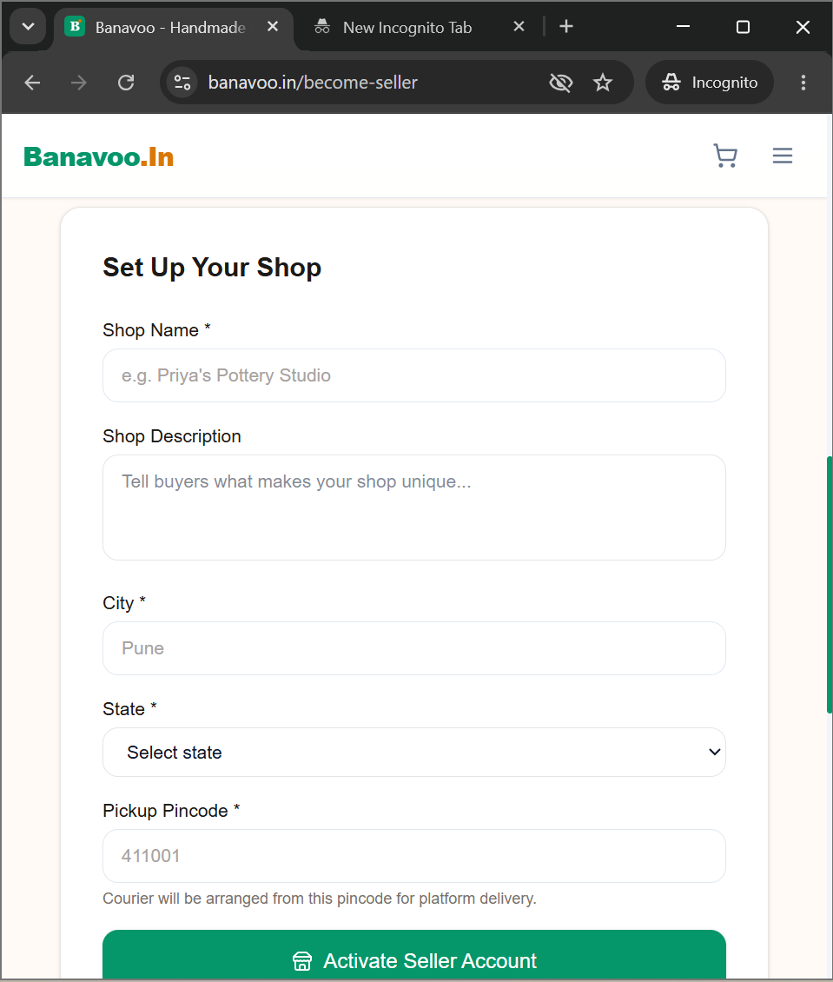
STEP 3 — Add Your First Product
Go to banavoo.in/seller and click Add New Product. Then fill in each section:
Section A: Basic Information
- Product Name — Be specific. Example: Handmade Blue Terracotta Earrings
- Category — Choose from: Jewellery, Home Decor, Clothing, Pottery, Paintings, Candles, Bags, Skincare
- Short Description — One line shown on the product card to buyers
- Full Description — Materials used, size, care instructions, what makes it special
Section B: Pricing and Stock
- Price (Rs.) — The amount buyers will pay
- Compare Price (Rs.) — Optional. The original crossed-out price (e.g. was Rs.500, now Rs.350)
- Stock Quantity — How many pieces you have available right now
Section C: Product Photos
Click Upload Images and add at least 1 photo. Up to 5 recommended. The first photo is the main display image.
- Use natural daylight — avoid dark or blurry photos
- Use a plain white or wooden background
- Photograph from multiple angles
- Show size comparison if needed (place near a coin or ruler)
Click Publish Product — your product is now LIVE on Banavoo.in and visible to all buyers!
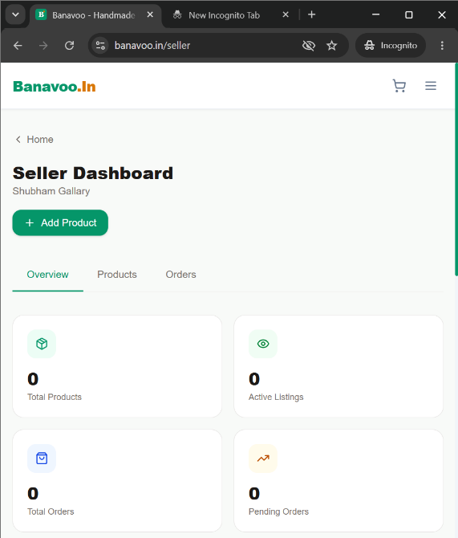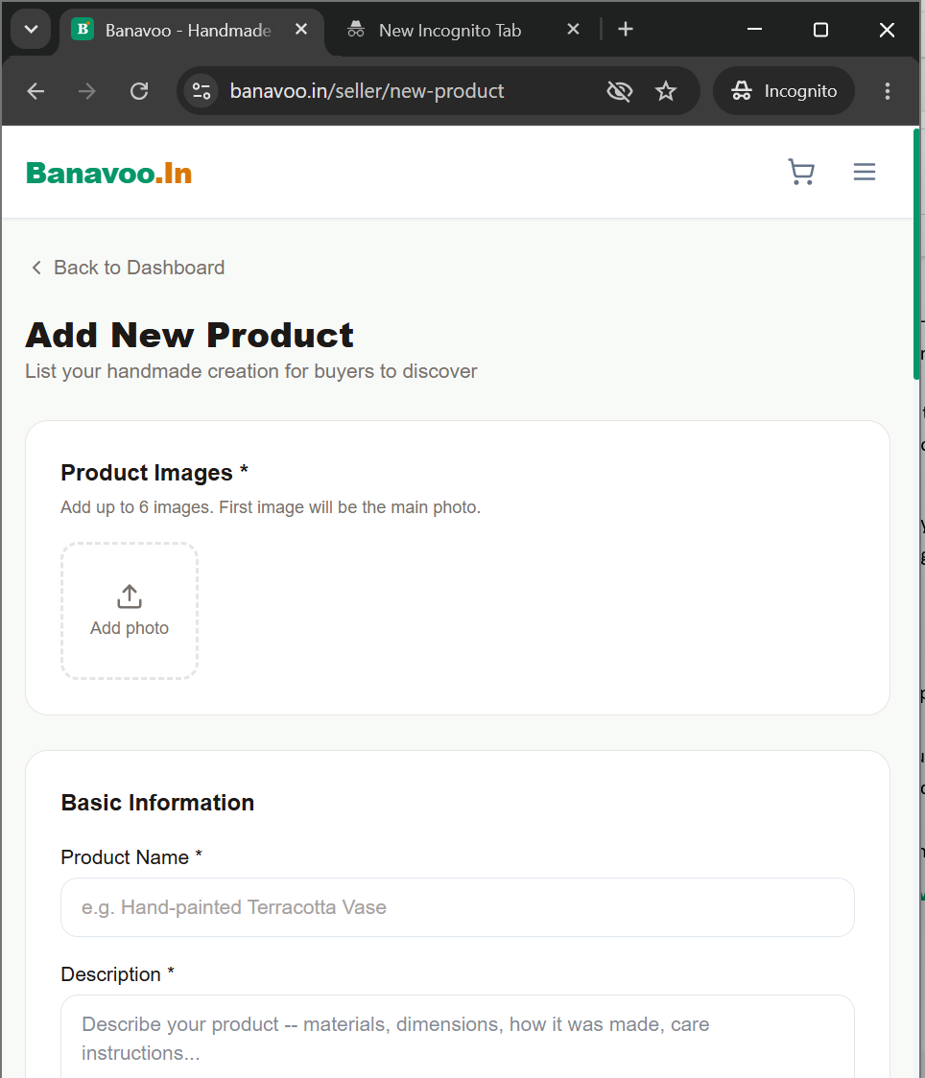
STEP 4 — Delivery Options
When a buyer places an order, they choose one of 3 delivery methods:
- Self Ship — You send the product via your own courier (DTDC, India Post, Delhivery etc.)
- Local Pickup — The buyer comes to collect from your location. No shipping needed at all.
Tip for beginners: Local Pickup is the easiest way to start — the buyer contacts you directly to arrange collection.
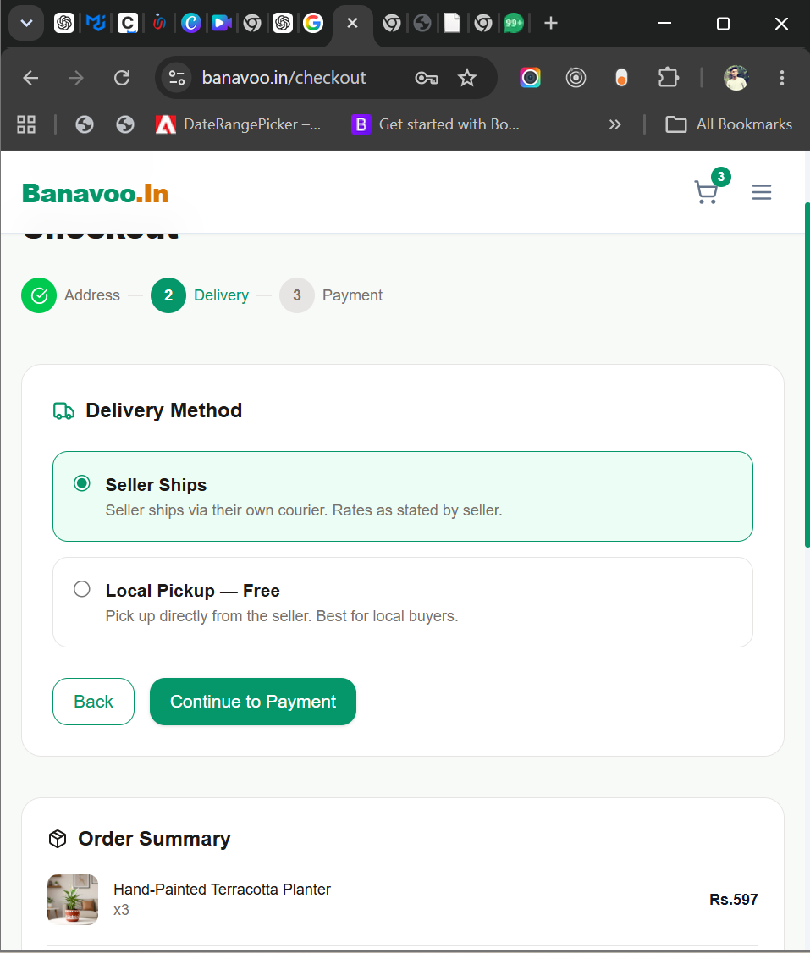
STEP 5 — You Received an Order! What to Do
- 1. You will receive an email with full order details — buyer name, item, address, amount
- 2. Log in to Banavoo.in and go to your Seller Dashboard — the order appears with status Pending
- 3. Click the order and update status to Processing (this means you are packing it)
- 4. Pack the product carefully in a box or bubble wrap
- 5. Ship using whichever method was chosen ( Self Ship / Local Pickup)
- 6. Update status to Shipped and enter the tracking number
- 7. The buyer automatically gets an email with tracking information
- 8. Once delivered, update status to Delivered
Important: Always respond to a new order within 24 hours. If you do not act, the Banavoo admin team will contact you as a reminder.
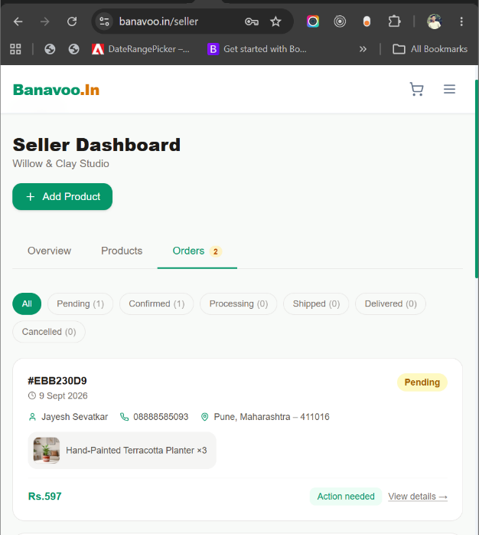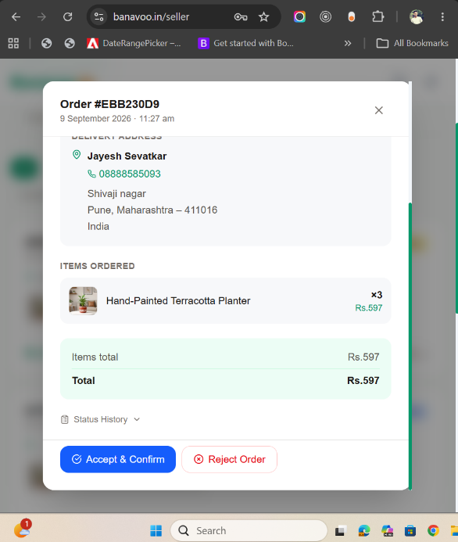
STEP 6 — Getting Paid
- Cash on Delivery — Buyer pays you directly when they receive the product.
- Local Pickup — Buyer pays you directly when they come to collect.
To receive online payments, complete your Razorpay KYC after your first order.
STEP 7 — Tips to Get Your First Sale Faster
- Upload 3-5 clear photos per product — more photos = more trust = more sales
- Write a detailed description — material, dimensions, colors available, care tips
- Price competitively — check similar products on Banavoo.in first
- Share your shop link on WhatsApp, Instagram and Facebook — tell your contacts!
- Respond to orders quickly — fast sellers appear higher in search results
- Keep stock updated — mark as sold out immediately if you run out
- Offer Local Pickup if you are in a city — many buyers prefer it for speed
Common Questions
Can I sell without a GSTN?
Yes. Banavoo.in does not require GSTN. Anyone can sell.
Is there any monthly fee?
No. Creating a shop and listing products is completely free. Banavoo only takes a small 2% platform fee when you make a sale.
What if a buyer cancels?
Buyers can cancel before the order is shipped. Once you mark it Shipped, it cannot be cancelled.
What if a buyer wants to return the product?
The buyer raises a return request from their dashboard. You will be notified and can coordinate directly.
I did not get the OTP email during signup?
Check your spam or junk folder. If still not found, go back and click Resend OTP after 30 seconds.
My product is not showing in search?
Make sure the product status is Active and stock quantity is greater than 0.
Quick Reference — Important Links
- Register (Create Account) → banavoo.in/register
- Login → banavoo.in/login
- Forgot Password → banavoo.in/forgot-password
- Become a Seller → banavoo.in/become-seller
- Seller Dashboard → banavoo.in/seller
- Add New Product → banavoo.in/seller/new-product
- My Orders (buyer view) → banavoo.in/dashboard
A new seller can follow Steps 1 to 3 and have their first product live in under 15 minutes.
Welcome to Banavoo.in — India's marketplace for handmade creators

