chapter 1 - 1 -
1.1 - 1 -
1.1.1 - 1 -

basic

1.1

1.1.1
TensorFlow基于数据流图，用于大规模分布式数值计算的开源框架。节点表示某种抽象的计算，边表示节点之间相互联系的张量。

TensorFlow支持各种异构的平台，支持多CPU/GPU，服务器，移动设备，具有良好的跨平台的特性；TensorFlow架构灵活，能够支持各种网络模型，具有良好的通用性；此外，TensorFlow架构具有良好的可扩展性

系统概述
TensorFlow的系统结构以C API为界，将整个系统分为「前端」和「后端」两个子系统：
前端系统：提供编程模型，负责构造计算图；
后端系统：提供运行时环境，负责执行计算图。
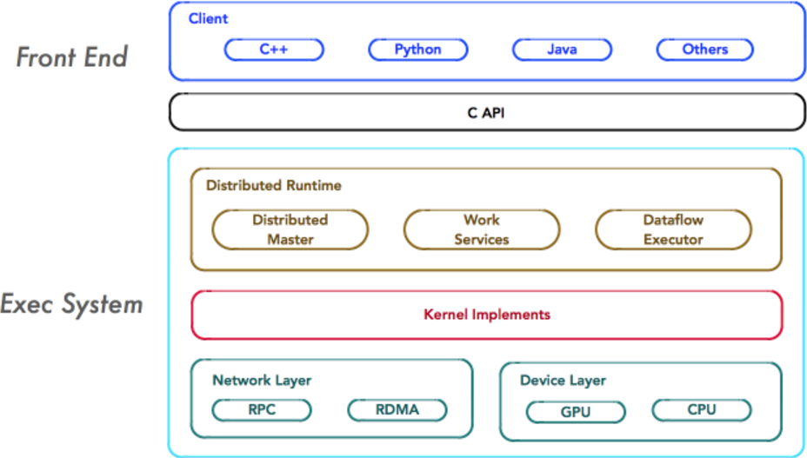
如上图所示，重点关注系统中如下4个基本组件，它们是系统分布式运行机制的核心。

Client
Client是前端系统的主要组成部分，它是一个支持多语言的编程环境。它提供基于计算图的编程模型，方便用户构造各种复杂的计算图，实现各种形式的模型设计。
Client基于TensorFlow的编程接口，构造计算图。目前，TensorFlow主流支持Python和C++的编程接口，并对其他编程语言接口的支持日益完善。

Client通过Session为桥梁，连接TensorFlow后端的「运行时」，并启动计算图的执行过程。
Distributed Master
在分布式的运行时环境中，Distributed Master根据Session.run的Fetching参数，从计算图中反向遍历，找到所依赖的「最小子图」。
然后，Distributed Master负责将该「子图」再次分裂为多个「子图片段」，以便在不同的进程和设备上运行这些「子图片段」。
最后，Distributed Master将这些「子图片段」派发给Work Service；随后Work Service启动「子图片段」的执行过程。
Worker Service
对于每以个任务，TensorFlow都将启动一个Worker Service。Worker Service将按照计算图中节点之间的依赖关系，根据当前的可用的硬件环境(GPU/CPU)，调用OP的Kernel实现完成OP的运算(一种典型的多态实现技术)。

组件交互:
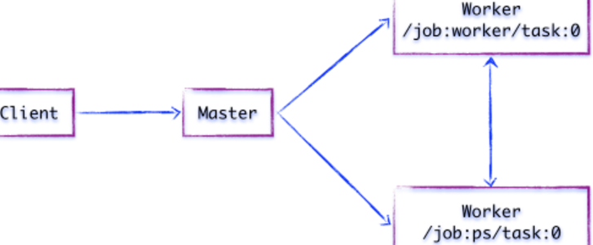
如上图所示，假设存在两个任务：
/job:ps/task:0: 负责模型参数的存储和更新
/job:worker/task:0: 负责模型的训练或推理

1.1.1 TensorFlow graphs
TensorFlow is based on graph based computation – “what on earth is that?”, you might say. It’s an alternative way of conceptualising mathematical calculations. Consider the following expression a=(b+c)∗(c+2). We can break this function down into the following components:
d=b+c
e=c+2
a=d∗e
Now we can represent these operations graphically as:
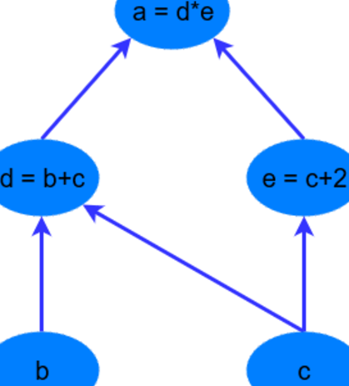
This may seem like a silly example – but notice a powerful idea in expressing the equation this way: two of the computations (d=b+c and e=c+2 ) can be performed in parallel. By splitting up these calculations across CPUs or GPUs, this can give us significant gains in computational times. These gains are a must for big data applications and deep learning – especially for complicated neural network architectures such as Convolutional Neural Networks (CNNs) and Recurrent Neural Networks (RNNs). The idea behind TensorFlow is to ability to create these computational graphs in code and allow significant performance improvements via parallel operations and other efficiency gains.

1.1 overview

1.1.1 tensorflow的运行流程
tensorflow的运行流程主要有2步，分别是构造模型和训练。
在构造模型阶段，我们需要构建一个图(Graph)来描述我们的模型。所谓图，也可以理解为流程图，就是将数据的输入->中间处理->输出的过程表示出来，就像下面这样。
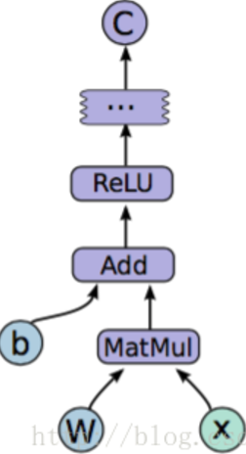
注意此时是不会发生实际运算的。而在模型构建完毕以后，会进入训练步骤。此时才会有实际的数据输入，梯度计算等操作。那么，如何构建抽象的模型呢？这里就要提到tensorflow中的几个概念:Tensor,Variable,placeholder,而在训练阶段，则需要介绍Session。下面先解释一些上面的几个概念

1.1.1 Tensor
Tensor的意思是张量，不过按我的理解，其实就是指矩阵。也可以理解为tensorflow中矩阵的表示形式。Tensor的生成方式有很多种，最简单的就如

import tensorflow as tf # 在下面所有代码中，都去掉了这一行，默认已经导入
a = tf.zeros(shape=[1,2])

不过要注意，因为在训练开始前，所有的数据都是抽象的概念，也就是说，此时a只是表示这应该是个1*5的零矩阵，而没有实际赋值，也没有分配空间，所以如果此时print,就会出现如下情况:

print(a)
#===>Tensor("zeros:0", shape=(1, 2), dtype=float32)

只有在训练过程开始后，才能获得a的实际值
sess = tf.InteractiveSession()
print(sess.run(a))
#===>[[ 0. 0.]]
这边设计到Session概念，后面会提到
tf.Variable：主要在于一些可训练变量（trainable variables）
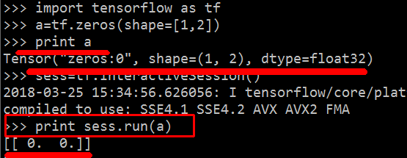

1.1.1 Variable
故名思议，是变量的意思。一般用来表示图中的各计算参数，包括矩阵，向量等。例如，我要表示上图中的模型，那表达式就是
y=Relu(Wx+b)
（relu是一种激活函数，具体可见这里）这里W和b是我要用来训练的参数，那么此时这两个值就可以用Variable来表示。Variable的初始函数有很多其他选项，这里先不提，只输入一个Tensor也是可以的

W = tf.Variable(tf.zeros(shape=[1,2]))
注意，此时W一样是一个抽象的概念，而且与Tensor不同，Variable必须初始化以后才有具体的值。

tensor = tf.zeros(shape=[1,2])
variable = tf.Variable(tensor)
sess = tf.InteractiveSession()
# print(sess.run(variable)) # 会报错
sess.run(tf.initialize_all_variables()) # 对variable进行初始化
print(sess.run(variable))
#===>[[ 0. 0.]]

Variable和Tensor之间的区别：

a = tf.Variable(tf.ones(1))
b = tf.add(a,tf.ones(1))

a是Variable，而b是Tensor。发现自己对Variable和Tensor之间的区分了解不多，所以搜索了一下，记录自己的思考，欢迎指教。

Variable是可更改的（mutable），而Tensor是不可更改的。一个直接的例子就是Tensor不具有assign函数，而Variable含有。
Variable用于存储网络中的权重矩阵等变量，而Tensor更多的是中间结果等。

1.1.1 tf.placeholder
又叫占位符，同样是一个抽象的概念。用于表示输入输出数据的格式。告诉系统：这里有一个值/向量/矩阵，现在我没法给你具体数值，不过我正式运行的时候会补上的！例如上式中的x和y。因为没有具体数值，所以只要指定尺寸即可

x = tf.placeholder(tf.float32,[1, 5],name='input')
y = tf.placeholder(tf.float32,[None, 5],name='input')

上面有两种形式，第一种x，表示输入是一个[1,5]的横向量。
而第二种形式，表示输入是一个[?,5]的矩阵。那么什么情况下会这么用呢?就是需要输入一批[1,5]的数据的时候。比如我有一批共10个数据，那我可以表示成[10,5]的矩阵。如果是一批5个，那就是[5,5]的矩阵。tensorflow会自动进行批处理

例如下面mnist训练的输入与label(X_train为28*28图片，None代表不确定每次输入的样本的个数)：
# Define placeholders
X_train = tf.placeholder(tf.float32, [None, 28*28])
labels = tf.placeholder(tf.float32, [None, 10])

1.1.1 tf.placeholder与tf.Variable
二者的主要区别在于：
tf.Variable：主要在于一些可训练变量（trainable variables），比如模型的权重（weights，W）或者偏执值（bias）；

声明时，必须提供初始值；
名称的真实含义，在于变量，也即在真实训练时，其值是会改变的，自然事先需要指定初始值；
weights = tf.Variable(
tf.truncated_normal([IMAGE_PIXELS, hidden1_units],
stddev=1./math.sqrt(float(IMAGE_PIXELS)), name='weights')
)
biases = tf.Variable(tf.zeros([hidden1_units]), name='biases')

tf.placeholder：用于得到传递进来的真实的训练样本：

不必指定初始值，可在运行时，通过 Session.run 的函数的 feed_dict 参数指定；
这也是其命名的原因所在，仅仅作为一种占位符；
images_placeholder = tf.placeholder(tf.float32, shape=[batch_size, IMAGE_PIXELS])
labels_placeholder = tf.placeholder(tf.int32, shape=[batch_size])

如下则是二者真实的使用场景：
for step in range(FLAGS.max_steps):
feed_dict = {
images_placeholder = images_feed,
labels_placeholder = labels_feed
}
_, loss_value = sess.run([train_op, loss], feed_dict=feed_dict)

当执行这些操作时，tf.Variable 的值将会改变，也即被修改，这也是其名称的来源（variable，变量）。

1.1.1 Session
session，也就是会话。我的理解是，session是抽象模型的实现者。为什么之前的代码多处要用到session？因为模型是抽象的嘛，只有实现了模型以后，才能够得到具体的值。同样，具体的参数训练，预测，甚至变量的实际值查询，都要用到session,看后面就知道了

1.1 mnist demo

1.1.1 NN mnist demo
The code uses built-in capabilities of TensorFlow to download the dataset locally and load it into the python variable. As a result (if not specified otherwise), the data will be downloaded into the MNIST_data/ folder.
We are also defining some of the values that will be use further in the code:
import tensorflow as tf
from tensorflow.examples.tutorials.mnist import input_data
# Read data
mnist = input_data.read_data_sets("MNIST_data/", one_hot=True)
image_size = 28
labels_size = 10
learning_rate = 0.05
steps_number = 1000
batch_size = 100
使用一般的神经网络，结构如下:
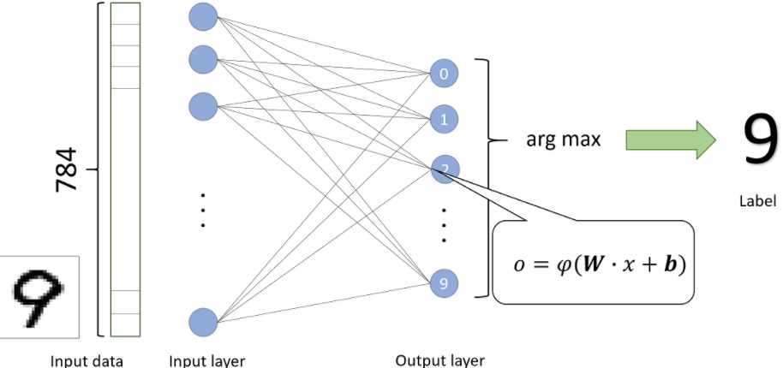
训练数据如下:占位符的None表示数据量不定(例如每个batch 100个样本，或者测试的时候10000个样本)
# Define placeholders
training_data = tf.placeholder(tf.float32, [None, image_size*image_size])
labels = tf.placeholder(tf.float32, [None, labels_size])
z=Wx+b
a=softmax(z)
# 建立抽象模型
x = tf.placeholder(tf.float32, [None, 784]) # 输入占位符
y = tf.placeholder(tf.float32, [None, 10]) # 输出占位符（预期输出）
W = tf.Variable(tf.zeros([784, 10]))
b = tf.Variable(tf.zeros([10]))
a = tf.nn.softmax(tf.matmul(x, W) + b) # a表示模型的实际输出

# Define the loss function
loss = tf.reduce_mean(tf.nn.softmax_cross_entropy_with_logits(labels=labels, logits=output))
# 梯度下降法，学习速率为0.5
optimizer = tf.train.GradientDescentOptimizer(0.5)
# 训练目标：最小化损失函数
train_step = optimizer.minimize(loss)
可以看到这样以来，模型中的所有元素(图结构，损失函数，下降方法和训练目标)都已经包括在train里面。我们可以把train叫做训练模型。那么我们还需要测试模型

# Accuracy calculation
correct_prediction = tf.equal(tf.argmax(output, 1), tf.argmax(labels, 1))
accuracy = tf.reduce_mean(tf.cast(correct_prediction, tf.float32))
上述两行代码，tf.argmax表示找到最大值的位置(也就是预测的分类和实际的分类)，然后看看他们是否一致，是就返回true,不是就返回false,这样得到一个boolean数组。tf.cast将boolean数组转成int数组，最后求平均值，得到分类的准确率

1.3 实际训练：
有了训练模型和测试模型以后，我们就可以开始进行实际的训练了
for i in range(steps_number):
# Get the next batch
input_batch, labels_batch = mnist.train.next_batch(batch_size)
feed_dict = {training_data: input_batch, labels: labels_batch}
# Run the training step
train_step.run(feed_dict=feed_dict)
# Print the accuracy progress on the batch every 100 steps
if i % 100 == 0:
train_accuracy = accuracy.eval(feed_dict=feed_dict)
print("Step %d, training batch accuracy %g %%" % (i, train_accuracy * 100))
输出测试集的准确率:
# Evaluate on the test set
test_accuracy = accuracy.eval(feed_dict={training_data: mnist.test.images, labels: mnist.test.labels})
print("Test accuracy: %g %%" % (test_accuracy*100))

https://blog.csdn.net/u014595019/article/details/52677412
https://www.katacoda.com/basiafusinska/courses/tensorflow-getting-started/tensorflow-mnist-beginner

1.1.1 NN(复杂点的) mnist demo
和上面的NN结构不同的是:上面是784*10，下面示例多了一个隐藏层:784*300*10
# Read data
mnist = input_data.read_data_sets("MNIST_data/", one_hot=True)
# Python optimisation variables
learning_rate = 0.5
epochs = 10
batch_size = 100
# declare the training data placeholders
# input x - for 28 x 28 pixels = 784
x = tf.placeholder(tf.float32, [None, 784])
# now declare the output data placeholder - 10 digits
y = tf.placeholder(tf.float32, [None, 10])
Notice the x input layer is 784 nodes corresponding to the 28 x 28 (=784) pixels, and the y output layer is 10 nodes corresponding to the 10 possible digits. Again, the size of x is (? x 784), where the ? stands for an as yet unspecified number of samples to be input – this is the function of the placeholder variable.

Now we need to setup the weight and bias variables for the three layer neural network. There are always L-1 number of weights/bias tensors, where L is the number of layers. So in this case, we need to setup two tensors for each:
输入的隐藏层，以及中间的隐藏层：
# now declare the weights connecting the input to the hidden layer
W1 = tf.Variable(tf.random_normal([784, 300], stddev=0.03), name='W1')
b1 = tf.Variable(tf.random_normal([300]), name='b1')
# and the weights connecting the hidden layer to the output layer
W2 = tf.Variable(tf.random_normal([300, 10], stddev=0.03), name='W2')
b2 = tf.Variable(tf.random_normal([10]), name='b2')
We initialise the values of the weights using a random normal distribution with a mean of zero and a standard deviation of 0.03.

Next, we have to setup node inputs and activation functions of the hidden layer nodes:
# calculate the output of the hidden layer
hidden_out = tf.add(tf.matmul(x, W1), b1)
hidden_out = tf.nn.relu(hidden_out)
In the first line, we execute the standard matrix multiplication of the weights (W1) by the input vector x and we add the bias b1. The matrix multiplication is executed using the tf.matmul operation. Next, we finalise the hidden_out operation by applying a rectified linear unit activation function to the matrix multiplication plus bias. Note that TensorFlow has a rectified linear unit activation already setup for us, tf.nn.relu.

This is to execute the following equations：
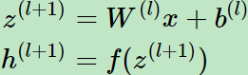
Now, let’s setup the output layer, y_:
# now calculate the hidden layer output - in this case, let's use a softmax activated
# output layer
y_ = tf.nn.softmax(tf.add(tf.matmul(hidden_out, W2), b2))

Again we perform the weight multiplication with the output from the hidden layer (hidden_out) and add the bias, b2. In this case, we are going to use a softmax activation for the output layer – we can use the included TensorFlow softmax function tf.nn.softmax.

接下来定义交叉熵loss函数：
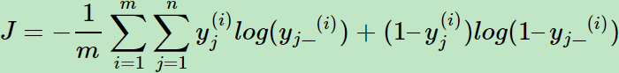
The first is the summation of the logarithmic products and additions across all the output nodes. The second is taking a mean of this summation across all the training samples. We can implement this cross entropy cost function in TensorFlow with the following code:
y_clipped = tf.clip_by_value(y_, 1e-10, 0.9999999)
cross_entropy = -tf.reduce_mean(tf.reduce_sum(y * tf.log(y_clipped)
+ (1 - y) * tf.log(1 - y_clipped), axis=1))

Some explanation is required. The first line is an operation converting the output y_ to a clipped version, limited between 1e-10 to 0.999999. This is to make sure that we never get a case were we have a log(0) operation occurring during training – this would return NaN and break the training process. The second line is the cross entropy calculation.
第一行限制:预测的y_不为0以免log(0)错误，第二行交叉熵计算.

# add an optimiser
optimiser = tf.train.GradientDescentOptimizer(learning_rate=0.5).minimize(cross_entropy)

# finally setup the initialisation operator
init_op = tf.global_variables_initializer()
# define an accuracy assessment operation
correct_prediction = tf.equal(tf.argmax(y, 1), tf.argmax(y_, 1))
accuracy = tf.reduce_mean(tf.cast(correct_prediction, tf.float32))
The correct prediction operation correct_prediction makes use of the TensorFlow tf.equal function which returns True or False depending on whether to arguments supplied to it are equal. The tf.argmax function is the same as the numpy argmax function, which returns the index of the maximum value in a vector / tensor. Therefore, the correct_prediction operation returns a tensor of size (m x 1) of True and False values designating whether the neural network has correctly predicted the digit.

开始训练：
# start the session
with tf.Session() as sess:
# initialise the variables
sess.run(init_op)
total_batch = int(len(mnist.train.labels) / batch_size)
for epoch in range(epochs):
avg_cost = 0
for i in range(total_batch):
batch_x, batch_y = mnist.train.next_batch(batch_size=batch_size)
_, c = sess.run([optimiser, cross_entropy],
feed_dict={x: batch_x, y: batch_y})
avg_cost += c / total_batch
print("Epoch:", (epoch + 1), "cost =", "{:.3f}".format(avg_cost))
print(sess.run(accuracy, feed_dict={x: mnist.test.images, y: mnist.test.labels}))
输出结果如下:
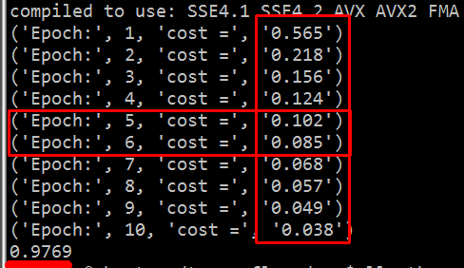
http://adventuresinmachinelearning.com/python-tensorflow-tutorial/
基本参考上面

1.1.1 CNN mnist demo
CNN构架如下:
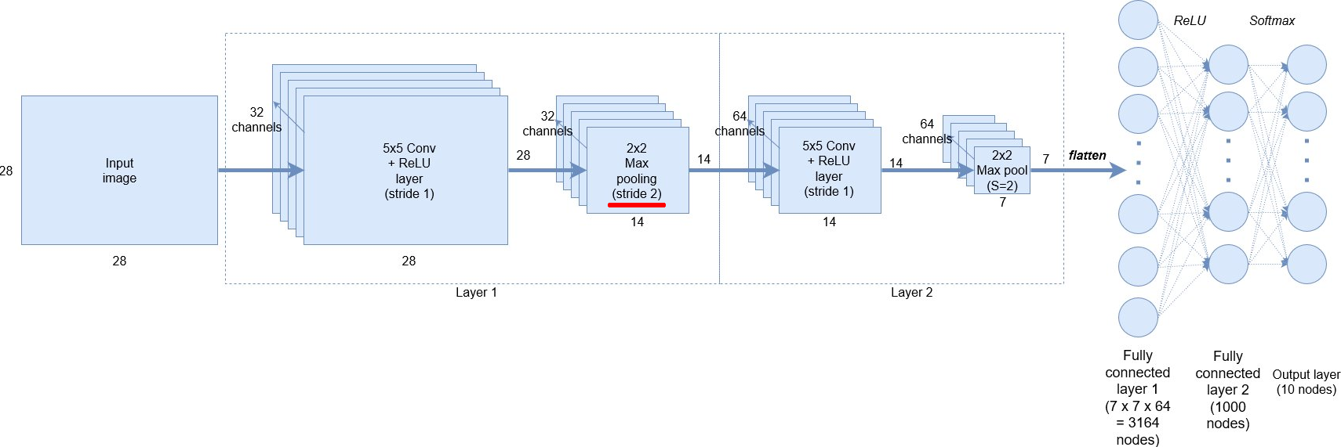
As can be observed, we start with the MNIST 28×28 greyscale images of digits. We then create 32, 5×5 convolutional filters / channels plus ReLU (rectified linear unit) node activations. After this, we still have a height and width of 28 nodes. We then perform down-sampling by applying a 2×2 max pooling operation with a stride of 2. Layer 2 consists of the same structure, but now with 64 filters / channels and another stride-2 max pooling down-sample. We then flatten the output to get a fully connected layer with 3164 nodes, followed by another hidden layer of 1000 nodes. These layers will use ReLU node activations. Finally, we use a softmax classification layer to output the 10 digit probabilities.

Input data and placeholders
The code below sets up the input data and placeholders for the classifier.
# declare the training data placeholders
# input x - for 28 x 28 pixels = 784 - this is the flattened image data that is drawn from
# mnist.train.nextbatch()
x = tf.placeholder(tf.float32, [None, 784])
# dynamically reshape the input
x_shaped = tf.reshape(x, [-1, 28, 28, 1])
# now declare the output data placeholder - 10 digits
y = tf.placeholder(tf.float32, [None, 10])
The format of the data to be supplied is [i, j, k, l] where i is the number of training samples, j is the height of the image, k is the weight and l is the channel number.
tf.reshape() allows us to put -1 in place of i and it will dynamically reshape based on the number of training samples as the training is performed. So we use [-1, 28, 28, 1] for the second argument in tf.reshape().
Finally, we need a placeholder for our output training data, which is a [?, 10] sized tensor – where the 10 stands for the 10 possible digits to be classified. We will use the mnist.train.next_batch() to extract the digits labels as a one-hot vector – in other words, a digit of “3” will be represented as [0, 0, 0, 1, 0, 0, 0, 0, 0, 0].
卷积层的定义：
Defining the convolution layers
Because we have to create a couple of convolutional layers, it’s best to create a function to reduce repetition:(下面代码创建卷积层以及 max pooling层)
def create_new_conv_layer(input_data, num_input_channels, num_filters,
filter_shape, pool_shape, name):
# setup the filter input shape for tf.nn.conv_2d
conv_filt_shape = [filter_shape[0], filter_shape[1], num_input_channels,
num_filters]
# initialise weights and bias for the filter
weights = tf.Variable(tf.truncated_normal(conv_filt_shape, stddev=0.03),
name=name+'_W')
bias = tf.Variable(tf.truncated_normal([num_filters]), name=name+'_b')
# setup the convolutional layer operation
out_layer = tf.nn.conv2d(input_data, weights, [1, 1, 1, 1], padding='SAME')
# add the bias
out_layer += bias
# apply a ReLU non-linear activation
out_layer = tf.nn.relu(out_layer)
# now perform max pooling
ksize = [1, pool_shape[0], pool_shape[1], 1]
strides = [1, 2, 2, 1]
out_layer = tf.nn.max_pool(out_layer, ksize=ksize, strides=strides,
padding='SAME')
return out_layer

下面以创建第一个卷积层为例说明上面的函数：
# create some convolutional layers
layer1 = create_new_conv_layer(x_shaped, 1, 32, [5, 5], [2, 2], name='layer1')
其中x_shaped为输入数据， 1代表channel(第一层gray图片只有一个channel), 32代表有32个filter，[5, 5]代表filter核大小，[2, 2]代表pool池化层的大小.

下面按照line/block解释上面的函数:
# setup the filter input shape for tf.nn.conv_2d
conv_filt_shape = [filter_shape[0], filter_shape[1], num_input_channels,
num_filters]
# initialise weights and bias for the filter
weights = tf.Variable(tf.truncated_normal(conv_filt_shape, stddev=0.03),
name=name+'_W')
bias = tf.Variable(tf.truncated_normal([num_filters]), name=name+'_b')
# setup the convolutional layer operation
out_layer = tf.nn.conv2d(input_data, weights, [1, 1, 1, 1], padding='SAME')
# add the bias
out_layer += bias
# apply a ReLU non-linear activation
out_layer = tf.nn.relu(out_layer)
其中：
conv_filt_shape = [filter_shape[0], filter_shape[1], num_input_channels,
num_filters]
构建conv2d的参数
[filter_height, filter_width, in_channels, out_channels]

初始化weights以及bias:
weights = tf.Variable(...)
bias = tf.Variable(...)

接下来创建convolutional filter
# setup the convolutional layer operation
out_layer = tf.nn.conv2d(input_data, weights, [1, 1, 1, 1], padding='SAME')
input_data, weights意思很明显，[1, 1, 1, 1] w,h的stride为1
padding='SAME', 如果没有这个那么第一层的输出就是28 - 5 + 1=24,现在有
padding='SAME'所以输出任然是28而不是24.

# 添加 bias
out_layer += bias
# 应用 ReLU 激活函数
out_layer = tf.nn.relu(out_layer)

接下来max pooling层：
# now perform max pooling
ksize = [1, pool_shape[0], pool_shape[1], 1]
strides = [1, 2, 2, 1]
out_layer = tf.nn.max_pool(out_layer, ksize=ksize, strides=strides,
padding='SAME')

使用上面的函数，创建两层卷积层:
# create some convolutional layers
layer1 = create_new_conv_layer(x_shaped, 1, 32, [5, 5], [2, 2], name='layer1')
layer2 = create_new_conv_layer(layer1, 32, 64, [5, 5], [2, 2], name='layer2')
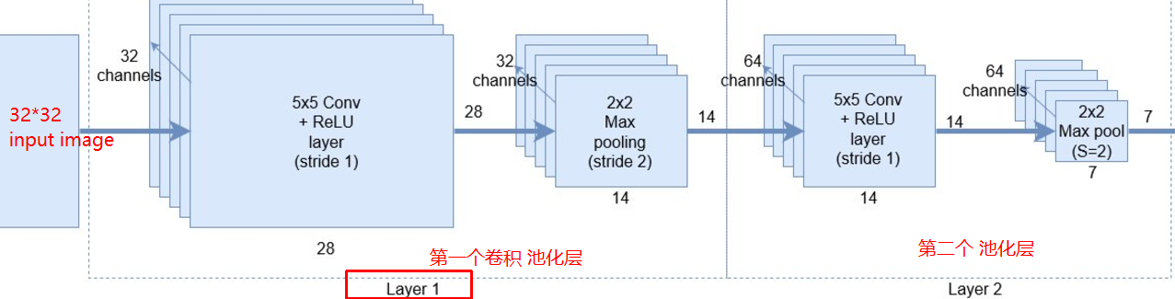
接下来是全连接层，首先7*7*64 reshape:
flattened = tf.reshape(layer2, [-1, 7 * 7 * 64])
其中-1代表训练中的某个sample
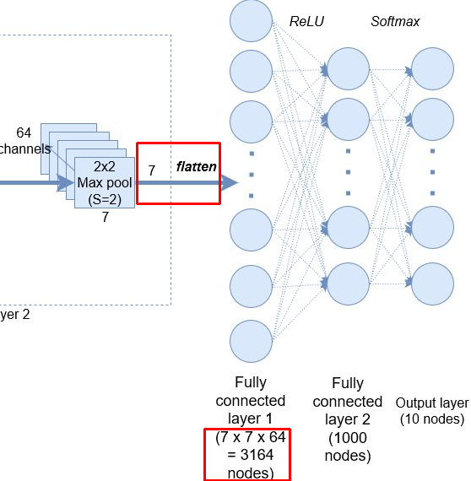
第一个全连接层：
# setup some weights and bias values for this layer, then activate with ReLU
wd1 = tf.Variable(tf.truncated_normal([7 * 7 * 64, 1000], stddev=0.03), name='wd1')
bd1 = tf.Variable(tf.truncated_normal([1000], stddev=0.01), name='bd1')
dense_layer1 = tf.matmul(flattened, wd1) + bd1
dense_layer1 = tf.nn.relu(dense_layer1)
第二个:
# another layer with softmax activations
wd2 = tf.Variable(tf.truncated_normal([1000, 10], stddev=0.03), name='wd2')
bd2 = tf.Variable(tf.truncated_normal([10], stddev=0.01), name='bd2')
dense_layer2 = tf.matmul(dense_layer1, wd2) + bd2
y_ = tf.nn.softmax(dense_layer2)
定义损失函数，以及训练优化optimiser
cross_entropy = tf.reduce_mean(tf.nn.softmax_cross_entropy_with_logits(logits=dense_layer2, labels=y))
# add an optimiser
optimiser = tf.train.AdamOptimizer(learning_rate=learning_rate).minimize(cross_entropy)
http://adventuresinmachinelearning.com/convolutional-neural-networks-tutorial-tensorflow/#comment-4248

1.1 lstm

1.1.1 NN mnist demo
The code uses built-in capabilities of TensorFlow to download the dataset locally and

http://adventuresinmachinelearning.com/recurrent-neural-networks-lstm-tutorial-tensorflow/

1.1 common network realize

1.1.1 alexnet
TensorFlow之深入理解AlexNet
https://zhuanlan.zhihu.com/p/30486789

