（NN_DL 3-35printed）

1.1 chapter 6 DL
deep neural networks are often much harder to train than shallow neural networks.深度神经网络通常比浅层神经网络更加难以训练。
Put another way: the chapter is not going to bring you right up to the frontier.换句话说，本章目标不是将最前沿的神经网络展现给你看。
frontier n.边界；边境；尖端；边缘 have frontiers with与…接壤
We did this using networks in which adjacent network layers are fully connected to one another. That is, every neuron in the network is connected to every neuron in adjacent layers:
我们使用了全连接的邻接关系的网络来完成这个工作。即，网络中的神经元与相邻的层上的每个神经元均连接
In particular, for each pixel in the input image, we encoded the pixel's intensity as the value for a corresponding neuron in the input layer.
特别地，对输入图像中的每个像素点，我们将其光强度作为对应输入层神经元的值。
network's weights and biases 网络的权重和偏置
But upon reflection, it's strange to use networks with fully-connected layers to classify images.
但是仔细推敲，使用全连接层的网络来分类图像是很奇怪的。
reflection n.倒影；反射；反映；沉思；考虑
reflect v.反映；反射；反省；归咎；显示 reflect the reality反映现实reflect from the water由水里反射出reflect well表明…很好reflect calmly静思
The reason is that such a network architecture does not take into account the spatial structure of the images. For instance, it treats input pixels which are far apart and close together on exactly the same footing.
原因是这样的一个网络架构不考虑图像的空间结构。例如，它在完全相同的基础上去对待相距很远和彼此接近的输入像素。
footing n.立足点；立场；基础；关系
foot n.脚；英尺；最底部；音步v.表演舞步；步行；付账；踏；共计
Such concepts of spatial structure must instead be inferred from the training data. 这样的空间结构的概念必须从训练数据中推断。
infer vt.推断；猜测；暗示vi.作出推论
But what if, instead of starting with a network architecture which is tabula rasa, we used an architecture which tries to take advantage of the spatial structure?
但是如果我们使用一个设法利用空间结构的架构，而不是从一个白板状态的网络架构开始，会怎样？
tabula n.横版；横隔
tabula rasa白板（没有写字的书写板）；[哲]白纸状的心灵
deep convolutional networks or some close variant are used in most neural networks for image recognition.
深度卷积网络或者一些近似的变化形式，被用在大多数图像识别的神经网络中。
Convolutional neural networks use three basic ideas: local receptive fields, shared weights, and pooling. Let's look at each of these ideas in turn.
卷积神经网络采用了三种基本概念：局部感受野（local receptive fields） ，共享权重（shared weights） ，和混合（pooling） 。让我们逐个看下：
receptive adj.易接受的；愿意接受的 receive v.接到；收到；接待
receptor n.感受器；受体；接受器；受话器
pool n.水塘；游泳池 n.共同储金；联营；美式撞球 v.共用；汇集

In the fully-connected layers shown earlier, the inputs were depicted as a vertical line of neurons.
在之前看到的全连接层的网络中，输入被描绘成纵向排列的神经元。
we only make connections in small, localized regions of the input image.
我们只是把输入图像进行小的，局部区域的连接。
That region in the input image is called the local receptive field for the hidden neuron.
这个输入图像的区域被称为隐藏神经元的局部感受野。
You can think of that particular hidden neuron as learning to analyze its particular local receptive field.
你可以把这个特定的隐藏神经元看作是在学习分析它的局部感受野。
before colliding with the right-hand side (or bottom) of the input image.
collide vi.碰撞；互撞；砥触
I've shown the local receptive field being moved by one pixel at a time.
In fact, sometimes a different stride length is used.
有时候会使用不同的跨距
I haven't precisely defined the notion of a feature. Informally, think of the feature detected by a hidden neuron as the kind of input pattern that will cause the neuron to activate:
我还没有精确定义特征的概念。非正式地，把一个隐藏神经元检测的特征看作一种引起神经元激活的输入模式：
formal adj.正式的；正规的；形式的；公开的；拘谨的；有条理的
informal adj.非正式的；不拘形式的
informal leader 非正式领导人 informal group非正式群体,非正式组织

To see why this makes sense, suppose the weights and bias are such that the hidden neuron can pick out, say, a vertical edge in a particular local receptive field.
要明白为什么是这个道理，把权重和偏置设想成隐藏神经元可以挑选的东西，例如，在一个特定的局部感受野的垂直边缘。
To put it in slightly more abstract terms, convolutional networks are well adapted to the translation invariance of images: move a picture of a cat (say) a little ways, and it's still an image of a cat
用稍微更抽象的术语，卷积⽹络能很好地适应图像的平移不变性：例如稍稍移动一幅猫的图像，它仍然是一幅猫的图像
For this reason, we sometimes call the map from the input layer to the hidden layer a feature map.
因为这个原因，我们有时候把从输入层到隐藏层的映射称为一个特征映射。
map n.地图vt.绘制地图；计划
We call the weights defining the feature map the shared weights. And we call the bias defining the feature map in this way the shared bias.
我们把定义特征映射的权重称为共享权重。我们把以这种方式定义特征映射的偏置称为共享偏置。
The shared weights and bias are often said to define a kernel or filter.
共享权重和偏置经常被称为一个卷积核或者滤波器。
Whiter blocks mean a smaller (typically, more negative) weight, so the feature map responds less to corresponding input pixels.
白色块意味着一个小（典型的，更小的负数）权重，所以这样的特征映射对相应的输入像素有更小的响应。
respond v.回答；响应；反应；反应灵敏；反响n.[建]壁联；[宗]应唱圣歌
It's clear there is spatial structure here beyond what we'd expect at random: many of the features have clear sub-regions of light and dark.
很明显这里有超出了我们期望的空间结构：这些特征许多有清晰的亮和暗的子区域。 expect v.预期；期待；盼望

a relatively modest 3030 hidden neurons 一个相对适中的30个隐藏神经元
modest adj.谦虚的；适度的；端庄的；有节制的
Incidentally, the name convolutional comes from the fact that the operation in Equation (125)is sometimes known as a convolution.
顺便提一下，卷积（convolutional）这一名称源自方程 (125) 中的操作符有时被称为一个卷积（convolution） 。
Incidentally adv.附带地；偶然地；顺便地
incident n.事变；事件；插曲adj.难免的；附带的
incidental adj.附带的；非主要的；偶然的；容易发生的n.附带事件；杂项
a0 is the set of input activations a0 是输⼊激活值的集合
Pooling layers are usually used immediately after convolutional layers.
混合层通常紧接着在卷积层之后使用。
What the pooling layers do is simplify the information in the output from the convolutional layer.
它要做的是简化从卷积层输出的信息
In detail, a pooling layer takes each feature map output from the
convolutional layer and prepares a condensed feature map.
详细地说，一个混合层取得从卷积层输出的每一个特征映射并且从它们准备一个凝缩的特征映射。
condense v.浓缩；凝结；缩短 condenser n.冷凝器；电容器
condensation n.浓缩；凝结；液滴
The nomenclature is being used loosely here. 这里使用的术语是不严格的。
nomenclature n.命名法；命名；术语 nomenclature principle命名原则
【近义词】terminology术语 loosely adv.松弛地；宽松地；不严谨地
In particular, I'm using "feature map" to mean not the function computed by the convolutional layer, but rather the activation of the hidden neurons output from the layer.
特别地，我用“特征映射”表示的意思不是通过卷积层计算出的函数，而是隐藏神经元从该层输出的激活值。
This kind of mild abuse of nomenclature is pretty common in the research literature. 这种术语的轻度滥用在研究文献中是相当普遍的。
mild adj.温和的；柔和的；宽大的；清淡的
mild climate温和的气候 climate n.气候；风气
mild punishment轻微的惩罚 punishment n.惩罚
punish vt.惩罚；粗暴对待vi.处罚
mild in disposition性情温和
disposition n.性情；倾向；安排；处置；控制；[计算机] 配置情况
cheerful disposition性格开朗 satisfactory disposition圆满解决
disposition of…的处置
dispose v.清除；处理掉；解决；杀死；打败
dispose briefly简要地处理 dispose carelessly粗心地处理
dispose for a walk去散步 dispose of处置,处理,安排,除掉,解决,卖掉,干掉
In max-pooling, a pooling unit simply outputs the maximum activation in the 2×2 input region
在最大值混合中，一个混合单元简单地输出其 2 × 2 输入区域的最大激活值
The next step is a max-pooling layer, applied to 2×2 regions, across each of the 3 feature maps.
下一步是一个最大值混合层，应用于 2 × 2 区域，遍及 3 个特征映射
Be warned that the problem will take some time to work through, unless you've really internalized the earlier derivation of backpropagation (in which case it's easy).
注意这个问题会花费些时间来完成，除非你确实已经吸收了前面的反向传播的推导（这种情况下是容易的） 。
internalize v.使内在化；使藏在心底
internal adj.国内的；内部的；身内的
Note also that network3.py incorporates ideas from the Theano library's documentation on convolutional neural nets (notably the implementation of LeNet-5), from Misha Denil's implementation of dropout, and from Chris Olah.
注意network3.py 包含了源自 Theano 库文档中关于卷积神经网络（尤其是 LeNet-5 的实现），Misha Denil 的弃权的实现，以及 Chris Olah 的概念。
dropout n.退学学生；拒绝传统社会的人；【计算机】磁盘信息失落；漏失信息，丢失信息
The programs network.py and network2.py were implemented using Python and the matrix library Numpy. Those programs worked from first principles,
and got right down into the details of backpropagation, stochastic gradient descent, and so on.
程序 network.py 和 network2.py 是用Python 和矩阵库 Numpy 实现的。这些程序从最初的原理工作，并致力于反向传播、随即梯度下降等细节。
Theano is also the basis for the popular Pylearn2 and Keras neural networks libraries. Other popular neural nets libraries at the time of this writing include Caffe and Torch.
Theano 也是流行的 Pylearn2 和 Keras 神经网络库的基础。其它在本书写作时流行的神经网络库包括 Caffe 和 Torch。
Running on a GPU provides a substantial speedup
运行于 GPU 上可以提供显著的增速
substantial adj.大量的；坚固的；实质的；可观的n.本质；重要部份
As I release this chapter 当我发布这一章时
To get a baseline, we'll start with a shallow architecture using just a single hidden layer,
containing 100 hidden neurons.
为了取得一个基线，我们将从一个浅层架构开始，它仅仅使用一个隐藏层，包含 100 个隐藏神经元。
We'll train for 60 epochs a mini-batch size of 10, and no regularization
我们会训练 60 迭代期，小批量数据大小为 10，没有规范化。
epoch n. 时期； 时代； 新纪元； 划时代的大事； <地质>世
Regularizing the current network does improve the accuracies, but the gain is only small, and so we'll hold off worrying about regularization until later.
规范化当前的网络确实可以提高准确率，但是得到的只是很小，所以我们将推迟到后面再来惦记规范化。
while the final layer in the earlier network used sigmoid activations and the cross-entropy cost function, the current network uses a softmax final layer, and the log-likelihood cost function.
虽然之前的网络中的最终层使用了 S 型激活值和交叉熵代价函数，当前网络使用一个柔性最大值的最终层，以及对数似然代价函数。
some extent a matter of taste. 一定程度上是一个个人喜好的问题
extent n.广度； 宽度； 长度； 大小； 范围； 程度n.[律]<英>扣押； <美>临时所有权令
network3.py treats them as a single layer because it makes the code
for network3.py a little more compact.
network3.py 视他们为单个层，因为它使得 network3.py 的代码更紧凑。
compact adj.紧密的；紧凑的；简洁的vt.使简洁；使装满；压实n.合约条约；梳妆粉盒；<美>小型汽车
it is easy to modify network3.py so the layers can be specified separately, if desired.
desire n.渴望；愿望；欲望v.渴望；向往；要求
That's a satisfying point of view, but gives rise to a second question.
这是一个令然满意的观点，但是引出了第二个问题。
changing the learning rate, or doing some rescaling
改变学习速率，或者做些调整 rescale v.重新攀登；重新调节
Try a half-dozen iterations on the learning hyper-parameters
试着用五六个迭代学习超参数
dozen n.(一)打；十二个adj.一打的；十二个的
half a dozen半打 long dozen十三个
In any case, in a moment we will find an advantage in switching to the rectified linear activation function,and so we won't go any deeper into the use of tanh.
无论如何，我们马上会发现切换到修正线性激活函数的一个优势，所以我们不会去深入使用tanh 函数。
rectify vt.改正；[化]精馏；[电]整流
rectify alcohol 精馏酒精 rectify the mistake 纠正错误
The network we've developed at this point is actually a variant of one of the networks used in the seminal 1998 paper introducing the MNIST problem,a network known as LeNet-5.
到现在为止，我们开发的网络实际上是一篇开创性的1998论文中使用的众多网络中一种的变化形式，这个网络被称为 LeNet-5
seminal adj.精液的；种子的；生殖的；创新的；影响深远的
seminal leaf子叶 seminal emission遗精 seminal sugar 精液糖 seminal stain 精液斑
a few people tried rectified linear units, often on the basis of hunches or heuristic arguments
一些人经常基于直觉或者启发式的理由试着用修正线性单元
hunch n.预感；块；肉峰v.弯腰驼背
hunch back驼背, 脊柱后凸 hunch up使隆起,使弯曲
have a hunch that…总预感到…
A common justification is that max(0,z)doesn't saturate in the limit of large z, unlike sigmoid neurons, and this helps rectified linear units continue learning.
一个通常的理由是 max(0,z) 在 z 取最大极限时不会饱和，不像 S 型神经元，而这有助于修正线性单元持续学习。
The argument is fine,as far it goes, but it's hardly a detailed justification, more of a just-so story.
到目前为止，这一辩解很好，但不是一个详细的理由，更多的是一个“就这样”的故事。
saturate v.使浸透；使充满；使饱和adj.浸透的；饱和的；深颜色的
justification n.辩护；正当的理由
justify vt.替 ... 辩护；证明 ... 正当；调整版面
justify action证明行为是正当的justify bail宣誓证明（自己）有财力作保
justify conduct证明行为是正当的
justify one's behaviour为某人的行为辩解
justify view证明观点是正当的 ustify amply充分证明
justify completely完全证明
justify oneself for one's conduct为自己的行为辩护
bail n.保释；杓；把手；保证金；担保人vt.保释；往外舀水；使摆脱困境vi.舀空
Today, we still have to rely on poorly understood rules of thumb and experience.
今天，我们仍然不得不依靠单凭经验的不足的理解。
shell prompt 提示符
prompt adj.迅速的；敏捷的；立刻的vt.激起；促进；推动；提示vi.提示n.提示；提示的内容n.[商]付款期限
prompt always一直提示 prompt sb's thought激起某人的思想
prompt words提台词
Using the expanded training data I obtained a 99.37 percent training accuracy.
So this almost trivial change gives a substantial improvement in classification accuracy.
所以这个几乎是微不足道的改变在分类准确率上给出了一个显著的改进。
trivial adj.不重要的；琐碎的 the trivial round日常的琐碎事务 trivial name俗名
They did this by rotating, translating, and skewing the MNIST training images.
他们通过旋转，位移和扭曲 MNIST 训练图像来扩展。
They also developed a process of "elastic distortion", a way of emulating the random oscillations hand muscles undergo when a person is writing.
他们还开发了一个“弹性扭曲”的流程，一种模拟当一个人写字时手部肌肉随机振动的方式。
elastic adj.灵活的；有弹性的；可变的n.橡皮圈；有松紧的东西
elastic body 弹性体 elastic principle 灵活的原则
emulate vt.效法；尽力赶上[计算机] 仿真.
oscillation n.振动；动摇；彷徨；振幅；单一的振动循环
oscillate v.振动；摆动；彷徨；犹豫
That's encouraging, but still falls short of a really decisive win.
这是令人鼓舞的，但仍然缺乏一个真正决定性的胜利。
decisive adj.决定性的；果断的 decisive action果敢的行动
decisive answer确定的答复
For instance, maybe we could use stronger regularization techniques to reduce the tendency to overfit.
例如，也许我们可以用更强有力的规范化技术来减少过度拟合的趋势。
This makes the model more robust to the loss of individual pieces of evidence, and thus less likely to rely on particular idiosyncracies of the training data.
这使得模型对单独依据的丢失更为强劲，因此不太可能依赖于训练数据的特质。
idiosyncracy n.特质 food idiosyncrasy食物特应性
eccentricity古怪 characteristic特点
dropout effectively omits many of the neurons while training
弃权有效地忽略了很多神经元
Using an ensemble of networks: An easy way to improve performance still further is to create several neural networks, and then get them to vote to determine the best classification.
使用一个组合的网络：一个简单的进一步提高性能的方法是创建一个神经网络，然后让它们投票来决定最好的分类。
ensemble n.全体；剧团；联合演出人员；合奏曲；系综
It's plausible that taking a vote amongst our 5 networks might yield a classification better than any individual network.
在这5个网络中进行一次投票来取得一个优于单个网络的分类，似乎是合理的。
plausible adj.似真实合理的；动听的；看起来有道理的，貌似可信的
plausible reasoning[计] 似然推理
This sounds too good to be true, but this kind of ensembling is a common trick with both neural networks and other machine learning techniques.
这听上去太好了，不像是真的，但是这种组合的方式是神经网络和其它机器学习技术都惯用的伎俩。
genuine errors by our ensemble 组合犯的真正的错误
genuine adj.真诚的；真正的；真实的；地道的
genuine breed纯种 genuine diamond真宝石
genuinely adv.真正地；诚实地；由衷地
Why we only applied dropout to the fully-connected layers
为什么我们只对全连接层应用弃权
If you look carefully at the code above, you'll notice that we applied dropout only to the fully-connected section of the network, not to the convolutional layers.
如果你仔细看上面的代码，你会注意到我们只在网络的全链接部分应用了弃权，而不是卷积层。
the convolutional layers have considerable inbuilt resistance to overfitting.
卷积层有相当大的先天的对于过度拟合的抵抗
is less need to apply other regularizers, such as dropout.
很少有必要来应用其它规范化，例如弃权。
Benenson has compiled an informative summary page, showing progress over the years
Benenson 汇编了一份信息汇总页面?，显示这几年的进展
I won't try to survey this recent work. But I can't resist making one exception.我不会概述这份近期成果的大部分内容。但是我忍不住有一个例外
it was a plain, vanilla network 这是一个清晰的，简单的网络
vanilla n.香草 vanilla ice cream香草冰淇淋 vanilla extract香草精

1.2 BP digit recogtition
The human visual system is one of the wonders of the world.
人类视觉系统是世界上众多奇迹之一
wonder n.惊奇；惊愕；奇迹；奇观v.惊奇；想知道；怀疑adj.奇妙的；非凡的
wonder very much 很想知道 wonder anxiously焦急地想知道
do wonders for 对…产生奇效 perform a wonder创造奇迹,取得惊人成就
natural wonder 自然界的奇观 the wonders of the world世界奇观
That ease is deceptive. 这么容易反而让人觉着迷惑了
deceptive adj.骗人的；虚伪的；诈欺的
deceptive advertisement 虚假广告
deceptive bend in the road易引人上当的弯路
In each hemisphere of our brain, humans have a primary visual cortex, also known as V1
在人类的每个脑半球中，有着一个初级视觉皮层，常称为 V1
hemisphere n.半球 hemisphere of special knowledge专业知识范围
cortex n.外皮；（大脑）皮层 perfect cortex 完全皮层
Rather, we humans are stupendously, astoundingly good at making sense of what our eyes show us. But nearly all that work is done unconsciously.
尽管人类在理解我们眼睛展现出来的信息上非常擅长，但几乎所有的过程都是无意识地。
stupendous adj.惊人的；巨大的
astound v.使惊骇；使大吃一惊 astounding adj.令人惊骇的
When you try to make such rules precise, you quickly get lost in a morass of exceptions and caveats and special cases.
而在你试着让这些识别规则越发精准时，就会很快陷入各种混乱的异常或者特殊情形的困境中
caveat n.防止误解的说明；警告
I recommend the deal, but with certain caveats.
我介绍这笔交易，但有几项要提请注意。
morass n.沼泽；陷阱；困境
Neural networks approach the problem in a different way.
approach v.靠近；接近；接洽；要求；达到；动手处理
n.途径；方法；接近；接洽；要求；路径；进场着陆；相似的事物
without human intervention.
intervene vi.干涉；干预；介入；调停；插入；阻挠
intervene actively 积极地干预 intervene hatefully可恶地干涉
intervene between 介入两者之间,调停争端 intervene in干涉〔调停〕
intervention n.介入；干预；调停
used by banks to process cheques cheque n.支票
cash a cheque 兑换支票 bad〔dishonored〕 cheque空头支票
empty cheque空白支票
We're focusing on handwriting recognition because it's an excellent prototype problem for learning about neural networks in general.
手写识别常常被当成学习神经网络的原型问题，因此我们聚焦在这个问题上
prototype n.原型；范例；雏形 the prototype of a car汽车的原型
As a prototype it hits a sweet spot: it's challenging - it's no small feat to recognize handwritten digits - but it's not so difficult as to require an extremely complicated solution, or tremendous computational power.
作为一个原型，它具备一个关键点：挑战性 —— 识别手写数字并不轻松 ——
但也不会难到需要超级复杂的解决方法，或者超大规模的计算资源。
sweet spot (平衡各种因素的)最有效点, 最有效位置,原来指棒球击球时的在球棒上的最佳击球位置等
sweet adj.甜的；芳香的；悦耳的；漂亮的n.甜食；糖
feat n.技艺；功绩；技艺表演
perform a feat表演技艺 accomplish〔achieve〕 a feat建功立业
brilliant〔notable, remarkable〕 feat 杰出的成就
A perceptron takes several binary inputs, x1,x2,…x1,x2,…, and produces a single binary output
perceptron n.视感控器；感知器
perceptive adj.敏感的；有洞察力的；感知的
disturbance of perceptive synthesis 感知综合障碍
To put it in more precise algebraic terms: 用更精确的代数形式
algebraic adj.代数的；代数学的 cheese festival 奶酪节
cheese n.干酪；乳酪；奶酪vt.使停止
eat cheese 吃奶酪 process cheese加工干酪 bad cheese变了味的奶酪
festival adj.节日的；喜庆的n.节日；欢宴；庆祝及祭祀
Is the festival near public transit 这个节日举办的地点是否靠近交通站点
transit n.运输；经过；转变；[天]中天；凌日；经纬仪vt.穿越旋转vi.越过
transit network传输网络 rapid transit system快速运输系统
suppose you absolutely adore cheese假设你是个嗜好奶酪的吃货
adore vt.爱慕；崇拜；很喜欢
adore a famous scientist 崇拜一位著名的科学家
adore this film十分喜欢这部电影
adore absolutely 绝对地疼爱 adore blindly盲目崇拜
But perhaps you really loathe bad weather 但是也许你确实厌恶糟糕的天气
loathe v.厌恶；憎恶
And it should seem plausible that a complex network of perceptrons could make quite subtle decisions
这看上去也可以大致解释一个感知器网络能够做出微妙的决定
plausible adj.似真实合理的；动听的；看起来有道理的，貌似可信的
subtle adj.微妙的；敏锐的；不明显的；精细的；狡猾的
subtle polluter 难形容的污染物 subtle effect 微细效应
In this way, a many-layer network of perceptrons can engage in sophisticated decision making.
engage v.雇佣；啮合；与……交战；答应；订婚；预定；参加；从事
engage a hall 租下大厅 engage a room 预订房间
engage at once 立即开始 engage actively 积极从事
engage sb as adviser 聘请某人当顾问
Incidentally, when.... 顺便提一下，当...
Incidentally adv.附带地；偶然地；顺便地
Incidental adj.附带的；非主要的；偶然的；容易发生的n.附带事件；杂项
Incident n.事变；事件；插曲adj.难免的；附带的
avoid an incident 避免事端 border incident边境事件
casual incident偶然事件,碰巧的事情
we can make two notational changes to simplify it
我们可以创建两个符号的变动来简化
notation n.记号；表示法；注释；记法
Another way perceptrons can be used is to compute the elementary logical functions we usually think of as underlying computation, functions such as AND, OR, and NAND
感知器被采用的另一种方式，是计算基本的逻辑功能，即我们通常认为的运算基础，例如“与” ， “或”和“与⾮”
underlying adj.潜在的；隐含的；在下面的；基本的；<经>优先的
underlying problem 基本问题 underlying reason内在原因
underlie v.位于 ... 之下；成为 ... 的基础；[经]优先于
shorthand n.速记；缩写 shorthand typist 速记打字员
shorthand notation简化符号

1.3 RNN
Humans don’t start their thinking from scratch every second.
人类并不是每时每刻都从头开始思考。
You don’t throw everything away and start thinking from scratch again.
你不会丢弃所有已知的信息而从头开始思考。
Your thoughts have persistence. 你的思想具有持续性。
Traditional neural networks can’t do this, and it seems like a major shortcoming.
传统的神经网络不能做到这点，而且这似乎也是它的主要缺陷。
It’s unclear how a traditional neural network could use its reasoning about previous events in the film to inform later ones.
目前还不清楚传统神经网络如何利用之前事件的推理来得出后来事件。
inform v.通知；告诉；使熟悉；告发；赋特征于
Recurrent neural networks address this issue. They are networks with loops in them,
allowing information to persist.
递归神经网络能够解决这一问题。这些网络中具有循环结构，能够使信息持续保存unroll the loop 展开循环 unroll v.(由卷曲状态)展开；展现；显示
This chain-like nature reveals that recurrent neural networks are intimately related to sequences and lists. They’re the natural architecture of neural network to use for such data.
这种链状的性质表明，递归神经网络与序列和列表密切相关。这是处理这种数据所使用的神经网络的自然结构。
chain n.束缚；链条；链；(一)连串；连锁店（常用复数）vt.束缚；用铁链锁住
break a chain打碎铁链 fasten a chain系紧锁链 bicycle chain自行车链
chain reaction连锁反应 chain store连锁店
there have been incredible success applying RNNs to a variety of problems: speech recognition, language modeling, translation, image captioning… The list goes on.
在过去的几年里，在许多问题上使用RNNs已经取得了难以置信的成功，比如语音识别，语言建模，翻译，图像字幕，这样的例子不胜枚举。
caption n.说明文字v.给（图片、照片等）加说明文字
I’ll leave discussion of the amazing feats one can achieve with RNNs to Andrej Karpathy’s excellent blog post, The Unreasonable Effectiveness of Recurrent Neural Networks. But they really are pretty amazing.
不过我不将讨论RNNs的惊人壮举，Andrej Karpathy对此写了篇非常棒的博客，
递归神经网络不可思议的有效性.它们真是太了不起了。
feat n.技艺；功绩；技艺表演
accomplish〔achieve〕 a feat建功立业 perform a feat表演技艺
brilliant〔notable, remarkable〕 feat 杰出的成就
Essential to these successes is the use of “LSTMs,” a very special kind of recurrent neural network
成功的关键是使用了“LSTMs”，一种特殊的递归神经网络
It’s these LSTMs that this essay will explore. 这篇文章就将探讨这些LSTMs。
essay n.论文；短评；散文；试图vt.尝试
literary essay 散文 write an essay 写一篇文章
The Problem of Long-Term Dependencies 长期依赖关系问题
One of the appeals of RNNs is the idea that they might be able to connect previous information to the present task
RNNs呼吁的一点就是，它们可能将前期信息与当前任务连接
appeal n.恳求；呼吁；上诉；吸引力n.(体育比赛中)诉请裁决v.呼吁；有吸引力；求助；诉请
address an appeal to 向…呼吁 broadcast an appeal 广播呼吁
appeal against不服…而上诉 appeal against an arbitration不服仲裁而上诉
eloquent appeal 有说服力的呼吁
eloquent adj.雄辩的；有口才的；动人的
If we are trying to predict the last word in “the clouds are in the sky,” we don’t need any further context – it’s pretty obvious the next word is going to be sky.
如果我们想要预测“the clouds are in the sky”中最后一个单词，我们不需要更多的上下文——很明显下一个单词会是“sky”。
In such cases, where the gap between the relevant information and the place that it’s needed is small, RNNs can learn to use the past information.
在这种情况下，如果相关信息与预测位置的间隔比较小，RNNs可以学会使用之前的信息。
Unfortunately, as that gap grows, RNNs become unable to learn to connect the information.
不幸的是，随着这种间隔的拉长，RNNs就会无法学习连接信息。
The problem was explored in depth by Hochreiter who found some pretty fundamental reasons why it might be difficult.
这种问题被Hochreiter深入探讨过，他们发现了造成这种可能的一些非常基本的原因。
solve toy problems of this form 解决这种简单的问题 toy n.玩具
Long Short Term Memory networks – usually just called “LSTMs” – are a special kind of RNN, capable of learning long-term dependencies.
长短期记忆网络——通常简称“LSTMs”——是一种特殊的RNN，能够学习长期依赖关系。
LSTMs are explicitly designed to avoid the long-term dependency problem. Remembering information for long periods of time is practically their default behavior, not something they struggle to learn!
LSTMs明确设计成能够避免长期依赖关系问题。记住信息很长一段时间几乎是它们固有的行为，而不是努力去学习！
LSTMs also have this chain like structure, but the repeating module has a different structure. Instead of having a single neural network layer, there are four, interacting in a very special way.
LSTMs同样也有这种链状的结构，但是重复模块有着不同的结构。它有四层神经网络层以特殊的方式相互作用，而不是单个神经网络层。
The pink circles represent pointwise operations, like vector addition, while the yellow boxes are learned neural network layers.
粉红色圆圈代表逐点操作，比如向量加法，而黄色框框表示的是已学习的神经网络层。
Lines merging denote concatenation, while a line forking denote its content being copied and the copies going to different locations.
线条合并表示串联，线条分叉表示内容复制并输入到不同地方。
concatenation n.连结；串联；一系列相互联系的事物
concatenate v.连结；连锁adj.连锁的
The Core Idea Behind LSTMs LSTMs核心理念
The key to LSTMs is the cell state, the horizontal line running through the top of the diagram.
LSTMs的关键点是单元状态，就是穿过图中的水平线。
The cell state is kind of like a conveyor belt. t runs straight down the entire chain, with only some minor linear interactions.
单元状态有点像是个传送带。它贯穿整个链条，只有一些小的线性相互作用。
belt n.腰带；带状物；地带；皮带vt.用皮带抽打；用带系上；用带标示vi.疾驰；大声歌唱
conveyor n.输送机；运送者；交付者
convey vt.表达；传达；运输；转移 convey coal 运煤
The LSTM does have the ability to remove or add information to the cell state,
carefully regulated by structures called gates.
LSTM有能力向单元状态中移除或添加信息，通过结构来仔细管理称为门限。
They are composed out of a sigmoid neural net layer and a pointwise multiplication operation.
它们由一个sigmoid神经网络层和逐点乘法运算组成
Step-by-Step LSTM Walk Through 一步一步剖析LSTM
The first step in our LSTM is to decide what information we’re going to throw away from the cell state.
LSTM中第一步是决定哪些信息需要从单元状态中抛弃。
This decision is made by a sigmoid layer called the “forget gate layer.”
这项决策是由一个称为“遗忘门限层”的sigmoid层决定的。
the cell state might include the gender of the present subject, so that the correct pronouns can be used.
单元状态可能包含当前主语的性别，所以可以使用正确的代词
gender n.性；性别 pronoun n.代词
subject n.话题；科目；主题；题材；主观；[语]主语n.实验对象；(君主国)国民adj.易患的；服从的vt.使服从；使隶属；使遭遇
For the language model example, since it just saw a subject, it might want to output
information relevant to a verb, in case that’s what is coming next.
对于语言模型例子来说，因为它只看到了一个主语，它可能想输出与动词相关的信息，为接下来出现的词做准备。
verb n.动词
A sentence usually contains a subject and a verb. 句子通常包括主词和动词。
The verb is in the present tense.这个动词使用的是现在时态。
For example, it might output whether the subject is singular or plural, so that we know what form a verb should be conjugated into if that’s what follows next.
比如，它可能输出主语是单数还是复数，那么我们知道接下来修饰动词的应该成对。
singular adj.单数的；奇特的；非凡的n.单数
singular matrix 退化(矩)阵, 降秩(矩)阵 singular functions 奇异函数
singular point 奇点 singular element 奇元素
conjugate v.结合；配合；（动词）词形变化adj.成对的；[数]共轭的；[语]同词根的n.[数]共轭值；[语]同根词
variants on Long Short Term Memory 长短期记忆变体 The differences are minor
minor adj.轻微的；较小的；次要的n.未成年人；辅修科目；[音]小调v.辅修
minor scale [音]小音阶 minor planet [天]小行星
One popular LSTM variant, introduced by Gers & Schmidhuber (2000), is adding “peephole connections.”
一种流行的LSTM变种，由Gers和Schmidhuber （2000）提出，加入了“窥视孔连接”（peephole connections）。
This means that we let the gate layers look at the cell state.
这意味着门限层也将单元状态作为输入。
peephole n.窥孔；门镜
Another variation is to use coupled forget and input gates.
另一个变种就是使用耦合遗忘和输入门限。
couple n.对；夫妇；数个v.连结；交配
coupled adj.成对的(连接的；共轭的；联系的)
A slightly more dramatic variation on the LSTM is the Gated Recurrent Unit, or GRU
稍微有戏剧性的LSTM变种是门限递归单元或GRU
Written down as a set of equations, LSTMs look pretty intimidating.
pretty adv.相当地adj.漂亮的；秀丽的；好看的vt.使漂亮n.漂亮的东西；美人
intimidate vt.胁迫；威胁；恐吓
Bob intimidate the witness into silence.鲍勃威胁证人保持沉默
intimidate the bank manager恐吓银行经理
intimidate the children by shouting叫嚷着吓唬孩子
写了一堆方程式，LSTMs看起来很吓人。
Hopefully, walking through them step by step in this essay has made them a bit more approachable.
希望通过这篇文章中一步一步的剖析，能更好理解它们。
LSTMs were a big step in what we can accomplish with RNNs.
LSTMs是我们使用RNNs的一个飞跃。
It’s natural to wonder: is there another big step?
那么很自然地会想：还有其他飞跃吗？
The idea is to let every step of an RNN pick information to look at from some larger collection of information.
这个想法是，让RNN中每一步都从更大的信息集中挑选信息作为输入。
There’s been a number of really exciting results using attention,
and it seems like a lot more are around the corner…
使用关注点还有一些其他令人兴奋的结果，而且似乎还有其他的效果还没被发现……
Attention isn’t the only exciting thread in RNN research.
关注点并不是RNN研究中唯一令人振奋的地方
Acknowledgments 致谢
I’m grateful to a number of people for helping me better understand LSTMs,
commenting on the visualizations, and providing feedback on this post.
我要感谢帮助我理解LSTMs的一群人，他们对网络模型的结构图进行了评论，并对这篇文章进行了反馈。
I’m very grateful to my colleagues at Google for their helpful feedback
我非常感谢我在谷歌的同事提供的反馈
comment n.注释；评论；闲话v.评论；注释 colleague n.同事
The applications of language models are two-fold:First, it allows us to score arbitrary sentences based on how likely they are to occur in the real world. This gives us a measure of grammatical and semantic correctness.
语言模型有两个方面的应用：一，基于每个序列在现实世界中出现的可能性对其进行打分，这实际上提供了一个针对语法和语义正确性的度量，语言模型通常为作为机器翻译系统的一部分
The idea behind RNNs is to make use of sequential information.
RNN背后的思想是利用顺序信息。
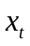is the input at time step t.For example, could be a one-hot vector corresponding to the second word of a sentence.
是t时刻的输入。例如，是句子中第二个词的one hot编码向量
is the hidden state at time step t. It’s the “memory” of the network. is calculated based on the previous hidden state and the input at the current step: =f(Ux_t + Ws_{t-1}). The function f usually is a nonlinearity such as tanh or ReLU. , which is required to calculate the first hidden state, is typically initialized to all zeroes.
是对应t时刻的隐藏状态，是网络的记忆单元。 通过前一步的隐藏状态和当前时刻的输入得到：s_{t}=f(Ux_{t}+Ws_{t-1}) 。函数f通常是非线性的，例如tanh和ReLU。通常用来计算第一个隐藏状态，会被全0初始化。
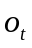is the output at step t. For example, if we wanted to predict the next word in a sentence it would be a vector of probabilities across our vocabulary. = softmax(Vs_t).
是t时刻的输出。例如，如果想要预测句子中的下一个词，那么它就会是包含词表中所有词的一个概率向量，=softmax(Vs_{t})。
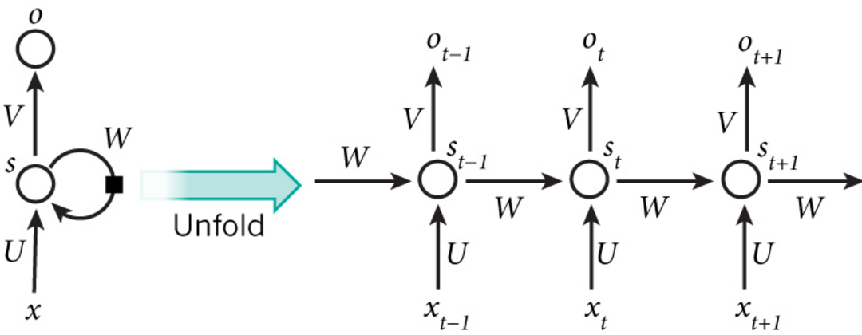
when predicting the sentiment of a sentence 在预测一句话的情感时
sentiment n.情绪；感情；观点；感伤
The main feature of an RNN is its hidden state, which captures some information about a sequence.
RNN的主要特征是它的隐藏状态，可以捕捉一句话中的信息。
Language Modeling and Generating Text 语言模型和文本生成
Language Models allow us to measure how likely a sentence is,
which is an important input for Machine Translation
语言模型可以度量一个句子出现的可能性，这可以作为机器翻译的一个重要输入
A side-effect of being able to predict the next word is that we get a generative model, which allows us to generate new text by sampling from the output probabilities.
能预测下一个词所带来的额外效果是我们得到了一个生成模型，这可以让我们通过对输出概率采样来生成新的文本。
Given an input sequence of acoustic signals from a sound wave, we can predict a sequence of phonetic segments together with their probabilities.
给定一段从声波中产生的输入声学信号序列，我们想要预测一个语音片段序列及其概率。
acoustic adj.听觉的；声音的；原声的；音响的
Together with convolutional Neural Networks, RNNs have been used as part of a model to generate descriptions for unlabeled images.
和卷及神经网络一起，RNN可以作为生成无标注图像描述模型的一部分。
We also use the backpropagation algorithm, but with a little twist
同样要使用反向传播算法，但会有一些变化
twist v.缠绕；捻；搓；拧；扭曲n.拧；捻；扭曲；盘旋；弯曲处
in order to calculate the gradient at t=4 we would need to backpropagate 3 steps and sum up the gradients.
为了计算t=4时刻的梯度，需要反向传播3步，并把前面的所有梯度加和。
This is called Backpropagation Through Time (BPTT)
这被称作随时间的反向传播（BPTT）
vanishing/exploding gradient problem 梯度消失或爆炸问题
I want this section to serve as a brief overview so that you are familiar with the taxonomy of models.
这一节只是一个简单的概述让你能够熟悉模型的类别
taxonomy n.(动植物的)分类学
Why would we want to assign a probability to observing a sentence?
为什么要对一句话赋予一个概率值？
such a model can be used as a scoring mechanism.
这样一个模型可以作为一个打分机制
But solving the Language Modeling problem also has a cool side effect.
但是，求解语言模型问题也会产生一个很有用的副产品。
I downloaded 15,000 longish reddit comments from a dataset available on Google’s BigQuery
我从谷歌提供的BigQuery数据集中下载了15000条稍长的reddit网站评论。
longish adj.稍长的；较长的
This means we must tokenize our comments into sentences, and sentences into words.
这意味着必须把我们的评论分成句子，再由句子分成词
Most words in our text will only appear one or two times.
It’s a good idea to remove these infrequent words.
我们的文本中的大多数词只出现一两次，把这些不频繁的词去除是个好主意。
the word with index 36 would be the vector of all 0’s and a 1 at position 36. So,each x_t will become a vector, and x will be a matrix, with each row representing a word.
索引为36的词应该表示成除了位置36处为1，其他位置都是0的one-hot向量。
因此，每一个x_{t}都是一个向量，x是一个矩阵，矩阵中每一行代表一个词。
Let’s recap the equations for the RNN from the first part of the tutorial
下面给出了教程中第一部分包含的RNN的公式
recap vt.翻新胎面；重述要点n.重述要点；翻新的轮胎
forward propagation 前向传播
To train our network we need a way to measure the errors it makes.
We call this the loss function L
为了训练我们的网络，我们需要一种方式来度量它产生的错误。我们把这个度量函数称之为损失函数L
A common choice for the loss function is the cross-entropy loss
常用的一个损失函数是交叉熵损失
The further away y (the correct words) and o (our predictions), the greater the loss will be.
y（正确的词）和o（预测结果）的偏差越大，损失也越大。
Let’s take a step back and think about what the loss should be for random predictions.
让我们后退一步并考虑一下随机预测值的损失是什么
we nudge the parameters into a direction that reduces the error.
把参数向减小误差的方法微调
nudge vt.轻推；轻触；推进 vi.轻推 n.轻推
As such there has been a lot of research on how to optimize SGD using batching, parallelism and adaptive learning rates.
因此有很多研究关于如何用批量化，并行化和自适应学习率来优化SGD。
Due to its popularity there are a wealth of tutorials floating around the web, and I don’t want to duplicate them here.
由于SGD的通用性，网上有大量相关的资料，在这里我就不重复了
If you know calculus, it really is just applying the chain rule.
如果你了解微积分，这实质上就是在使用链式法则
calculus n.微积分；算法；结石
operational calculus 运算微积分,运算微积,算子演算
differential calculus 微分学
The idea behind gradient checking is that derivative of a parameter is equal to the slope at the point, which we can approximate by slightly changing the parameter and then dividing by the change
梯度检查的思想是一个参数的梯度值等于在相应点处的斜率值，我们可以通过稍微改变参数并除以改变值来实现
A function sdg_step that calculates the gradients and performs the updates for one batch.
用一个函数sgd_step计算梯度值并按批进行更新
An outer loop that iterates through the training set and adjusts the learning rate.
用一个外层循环对训练集进行迭代并调整学习率。
Researchers have identified many ways to make models less computationally expensive,for example by using a hierarchical softmax or adding projection layers to avoid the large matrix multiplications
研究者们已经发现很多方式降低模型的计算复杂度，例如使用层次softmax或者添加映射层来避免大量矩阵乘法
A few selected (censored) sentences. I added capitalization.
下面是一些挑选出来的句子（首字母大写了）
Sometimes it mimics internet speech such as multiple exclamation marks or smileys
有时候它能模仿网络上的口语，比如多个惊叹号或者表情符。
smiley adj.微笑的n.[计]笑容符 exclamation n.惊呼；惊叹词
Our vanilla RNN can’t generate meaningful text because it’s unable to learn dependencies between words that are several steps apart.
我们的简易版RNN不能生成有意义的文本是因为它无法学习到相隔几步的词之间的依赖。
wild adj.野生的；野蛮的；未开发的；狂热的adv.胡乱地；失去控制地
n.荒野；荒地 wildML
deep learning glossary glossary n.词汇表；术语汇编
To fully understand this part of the tutorial I recommend being familiar with how partial differentiation and basic backpropagation works.
为了完全理解本部分的内容，我建议先熟悉一下偏微分和基本的反向传播是怎么工作的
in order of increasing difficulty 难度逐级递增
That’s only to stay consistent with some of the literature out there that I am referencing
这只是为了和我参考的一些资料保持一致。
But in my opinion BPTT is just a fancy name for standard backpropagation on an unrolled RNN.
在我看来，BPTT是应用于展开的RNN上的标准反向传播的另一个名字。
fancy adj.华丽装饰的；复杂的；引人注目的；时髦的；昂贵的；好的
n.喜爱；幻想；想像力
unroll v.(由卷曲状态)展开；展现；显示
We unrolled our sleeping bags. 我们打开了睡袋。
roll n.卷；滚动；名单；压路机；颤音；圆形物，面包卷
v.摇摆；滚；绕；转动；展开
roll badly 摇晃得厉害 roll dangerously危险地度过
crusty roll 硬皮面包 soft roll 软皮面包
a roll in the grass在草地上尽情打滚
crusty adj.有脆皮的；有硬壳的；顽固的；暴躁的
a naive implementation of BPTT BPTT的一个简易实现
In practice many people truncate the backpropagation to a few steps.
实践中，很多人会把发现传播截断至几步
The man who wore a wig on his head went inside
wig n.假发；呵斥vt.严斥；责骂
wear v.磨损；穿戴；使疲劳n.磨损；穿着；耐久性 wore 动词wear的过去式
the vanishing gradient problem 梯度消失问题
But it’s unlikely that a plain RNN would be able capture such information.
但是普通的RNN不可能捕捉这样的信息
Also note that because we are taking the derivative of a vector function with respect to a vector, the result is a matrix (called the Jacobian matrix) whose elements are all the pointwise derivatives.
注意到因为我们是用向量函数对向量求导数，结果是一个矩阵（称为JacobianMatrix），矩阵元素是每个点的导数。
derivative n.派生物；衍生字；导数adj.派生的；(贬)非独创的；庸乏的
derivative operator 导数算子 partial derivative[数]偏导数
derive v.获取；得自；起源
derive knowledge 获得知识 derive pleasure获得乐趣
derive corruptly 败坏源于 derive essentially基本起源于
It turns out that the 2-norm, which you can think of it as an absolute value, of the above Jacobian matrix has an upper bound of 1.
可以证明上面的Jacobian矩阵的二范数（可以认为是一个绝对值）的上界是1
norm n.规范；标准
above the norm 超过标准 below the norm 低于标准
production norm生产标准 abide by the norms遵守准则
establish the norm规定标准
abide v.遵守；忍受；坚持 abide a person 屈从一个人
abide an event 等待某件事的发生 trustworthly abide忠实地遵守
abide by appeal of 按照…的请求 abide by discipline遵守纪律
This makes intuitive sense because our tanh activation function maps all
values into a range between -1 and 1, and the derivative is bounded by 1
这很直观，因为激活函数tanh把所有制映射到-1和1之间，导数值得界限也是1
They approach a flat line. When this happens we say the corresponding neurons are saturated.
接近于平行线。当这种情况出现时，我们就认为相应的神经元饱和了
They have a zero gradient and drive other gradients in previous layers towards 0.
它们的梯度为0使得前面层的梯度也为0
Thus, with small values in the matrix and multiple matrix multiplications (t-k in particular) the gradient values are shrinking exponentially fast, eventually vanishing completely after a few time steps.
矩阵中存在比较小的值，多个矩阵相乘会使梯度值以指数级速度下降，最终在几步后完全消失。
It is easy to imagine that, depending on our activation functions and network parameters, we could get exploding instead of vanishing gradients if the values of the Jacobian matrix are large.
很容易想到，依赖于我们的激活函数和网络参数，如果Jacobian矩阵中的值太大，会产生梯度爆炸而不是梯度消失问题。
explode vi.爆炸；激增；爆发vt.使爆炸；驳倒
explode a bomb 爆炸了一颗炸弹 explode in爆发出…
The reason that vanishing gradients have received more attention than exploding gradients is two-fold.
梯度消失比梯度爆炸受到了更多的关注有两方面的原因
Secondly, clipping the gradients at a pre-defined threshold is a very simple and effective solution to exploding gradients.
其二，用预定义的阈值裁剪梯度可以简单有效的解决梯度爆炸问题
clip vt.夹住v.剪短v.疾驰；猛击
n.夹子；弹夹；回形针；钳n.修剪；(羊毛的)剪下量；(被剪下的)东西
give a clip修剪一下 show〔present〕 a clip放映影片的剪辑
clip a sheep剪羊毛 clip document〔the papers〕夹文件
there are a few ways to combat the vanishing gradient problem.
combat n.战斗；试图解决 v.战斗；与 ... 斗争；试图解决adj.战斗的
break off〔go into〕 combat停止〔投入〕战斗
close combat肉搏战 combat plane战斗机
combat between good and evil 善与恶的斗争
Neuro-Linguistic Programming NLP 神经语言程序学
linguistic adj.语言的；语言学的
I’m using。to mean elementwise multiplication 我使用。表示逐元素相乘
This is key to understanding the big picture.
这是理解整个全局的关键。
They care called gates because the sigmoid function squashes the values of these vectors between 0 and 1, and by multiplying them elementwise with another vector you define how much of that other vector you want to “let through”.
它们被称作门是因为sigmoid函数把这些向量的值挤压到了0和1之间，
把它们和其他的向量逐元素相乘，就定义了你想让其他向量能“剩下”多少
squash n.壁球；摺皱不堪；拥挤嘈杂的人群；浓缩果汁；美国南瓜
vt.压制；压扁vi.变扁；挤进
orange squash 桔子水 squash technique压片技术 squash into挤进
LSTM: A Search Space Odyssey empirically evaluates different LSTM architectures.
LSTM: A Search Space Odyssey这篇文章用实验比较了一些不同的LSTM架构。
empirically adv.经验主义地
empirical adj.经验主义的；以观察或实验为根据的
empirical design 经验设计 empirical coefficient 经验系数
if you have enough data, the greater expressive power of LSTMs may lead to better results.
如果你有足够的数据，LSTM的强大表达能力可能会产生更好的结果
libraries like Theano that support auto-differenation of expressions.
支持自动微分的库Theano
add an embedding layer 添加一个嵌入层
embed v.(使)插入；(使)嵌入；深留脑中
embedded software 嵌入式软件 embed in嵌入到
diminish vt.减少；减损；贬低 vi.变少；逐渐变细
diminish the costing 减少开支 diminish continuously 继续减少
a note on preformance 关于性能的注意点
legacy n.遗赠物；先人或过去遗留下来的东西 adj.[计算机]旧系统的
legacy tax 遗产税 cumulative legacy累积遗赠
cumulative adj.累积的；渐增的；（红利、利息等）累计的
cumulative probability 累积概率 cumulative dose累积剂量
cumulus n.积云；堆积 cumulus cloud积云
Capturing Diverse Time Scales 涵盖多种时间尺度
The purpose of this post is to give students of neural networks an intuition about the functioning of recurrent networks and purpose and structure of a prominent variation, LSTMs.
本页旨在帮助神经网络学习者了解循环网络的运作方式，以及一种主要的循环网络，即LSTM的功能和结构
prominent adj.显著的；杰出的；突出的
very prominent 很有名气的 prominent position显要的位置 prominent in science在科学界很突出
That is, it has no notion of order in time, and the only input it considers is the current example it has been exposed to
这是因为网络并没有时间顺序的概念，它所考虑的唯一输入是当前所接受的样例
Feedforward networks are amnesiacs regarding their recent past; they remember nostalgically only the formative moments of training.
前馈网络仿佛患有短期失忆症；它们只有早先被定型时的记忆
amnesiac adj.记忆缺失的；遗忘的n.健忘症患者；健忘者
Amnesiac is a loss of memory, but scientists in Britain have found that it can mean a loss of imagination as well.
健忘症是一种丧失记忆的表现，但是英国的科学家们发现健忘症也意味着想象力的丧失
That sequential information is preserved in the recurrent network’s hidden state, which manages to span many time steps as it cascades forward to affect the processing of each new example.
这些顺序信息保存在循环网络隐藏状态中，不断向前层层传递，跨越许多个时间步，影响每一个新样例的处理
span n.时期；跨度；间距vt.延续；横跨；贯穿；遍及；
When we say a person is haunted by their deeds, for example, we are simply talking about the consequences that past outputs wreak on present time.
例如，我们会说“一个人被往日所为之事纠缠”，这其实就是在讲过去的输出对当前造成了影响
haunt n.常到的地方vt.缠住；常到；出没(像鬼魂一样)
vi.徘徊；出没(像鬼魂一样)
The area was a haunt of criminals. 这个地区是罪犯经常出没的地方
haunt about a place with sb 经常同某人一起出没于某地
be haunted by anxiety 老是忧心忡忡 make out the haunt辨认出常去的地方
revisit the haunt 重游常去的地方 haunt still 仍然萦绕
haunted adj.闹鬼的；鬼魂出没的；受到困扰的
deed n.行为；事迹；[法]契约vt.立契转让
His deed claims our respect.他的行为值得我们尊敬
His deed revealed him to be a kind man.他的行为显示他是个好心的人
achieve deeds 立新功 agree with one's deed 与行动一致,符合行动
deed of courage 勇敢的行为
wreak vt.发泄；施行（报复）；造成（破坏等），带来（灾难性的后果）
Timid people always wreak their peevishness on the gentle.
怯懦的人总是把满腹牢骚向温和的人发泄
becomes recurrent as it unfurls over time 随时间展开后变为循环网络
He unfurled the newspaper and began to read. 他展开报纸开始阅读
nested composite functions like f(g(h(x))) 嵌套复合函数
composite adj.合成的；复合的n.合成物；复合材料
The play is a composite of reality and fiction.该剧是现实与想象的合成
compose v.作曲；创作；编排；形成；使镇静
Truncated BPTT is an approximation of full BPTT that is preferred for long sequences, since full BPTT’s forward/backward cost per parameter update becomes very high over many time steps
截断式BPTT是完整BPTT的近似方法，也是处理较长序列时的优先选择，因为时间步数量较多时，完整BPTT每次参数更新的正向/反向运算量会变的非常高
Just as a straight line expresses a change in x alongside a change in y, the gradient expresses the change in all weights with regard to the change in error
正如直线表示x如何随着y的变化而改变，梯度表示所有权重随误差变化而发生的改变
our network ceases to learn 网络就会停止学习
cease v.终止；停止n.停止
When can we cease from our labours? 我们什么时候才能免除劳役之苦?
cease one's activities 停止活动 cease one's attack 停止进攻
Recurrent nets seeking to establish connections between a final output and events many time steps before were hobbled, because it is very difficult to know how much importance to accord to remote inputs.
循环网络在寻找最终输出与许多时间步以前的事件之间的联系时遇到了重大障碍，因为很难判断应当为远距离的输入赋予多少重要性
accord n.协议；一致；符合v.与...一致；给予；调解
The two countries reached an accord. 两国签订了一项协议
His words are in accord with his ideas. 他心口一致
come to an accord 达成谅解 reach an accord 达成一致
in accord with 和…一致 in accord with the season合时令
accord against sb 与某人的意见不一致
accord in that opinion 同意那个意见
according adv.根据；按照adj.相符的，一致的，相应的；和谐的，调和的
According to expert opinions, they gave up the experiment immediately.
根据专家们的意见，他们马上放弃了这项试验
according to schedule 按计划(按照计划)
hobble v.蹒跚；跛行n.蹒跚
This may hobble the bull in the future.
这些可能会使得这头牛在未来步履蹒跚
Everyone who has studied compound interest knows that any quantity multiplied frequently by an amount slightly greater than one can become immeasurably large
凡是学过复合利率的人都知道，任何数值，只要频繁乘以略大于一的数，就会增大到无法衡量的地步
indeed, that simple mathematical truth underpins network effects and inevitable social inequalities
经济学中的网络效应和难以避免的社会不平等背后正是这一简单的数学真理
underpin v.从下头支持；支撑
China needs regional stability to underpin its continued economic growth.
中国需要地区稳定来巩固其持续的经济增长
Because the layers and time steps of deep neural networks relate to each other through multiplication, derivatives are susceptible to vanishing or exploding.
由于深度神经网络的层和时间步通过乘法彼此联系，导数有可能消失或膨胀
Exploding gradients treat every weight as though it were the proverbial butterfly whose flapping wings cause a distant hurricane
梯度膨胀时，每个权重就仿佛是一只谚语中提到的蝴蝶，所有的蝴蝶一齐扇动翅膀，就会在遥远的地方引发一场飓风
butterfly n.蝴蝶；蝶状物；蝶泳vt.(烹饪时把鱼肉等）切开摊平
social butterfly 交际花
proverbial adj.谚语的；如同谚语的；众所周知的
flap n.拍打；拍打声；片状垂悬物；副翼；<口>不安v.拍打；鼓翼而飞
A flap from the tail of the whale upset the boat.
鲸尾轻轻一拍便把小船打翻了
flap carelessly 粗心地移动 flap against拍打 flap at轻拍
hurricane n.飓风；暴风 hurricane lamp 防风灯
The hurricane destroyed the whole village. 飓风把整个村子都毁掉了
But exploding gradients can be solved relatively easily, because they can be truncated or squashed. 截断或挤压
Vanishing gradients can become too small for computers to work with or for networks to learn – a harder problem to solve.
The data is flattened until, for large stretches, it has no detectable slope
数据曲线越来越平缓，直至在较长的距离上无法检测到斜度
stretch v.伸展；延伸；张开；夸大n.伸展；张开；弹性；一段时间；
<俚>刑期adj.可伸缩的
I got out of the bed and had a good stretch.我起床后舒服地伸了个懒腰
stretch a point 不按规章办事,超过自己的权限,牵强附会
stretch oneself伸伸懒腰 stretch consciously 自觉地伸展
LSTMs help preserve the error that can be backpropagated through time and layers.
LSTM可保留误差，用于沿时间和层进行反向传递
preserve v.保护；保存；保持n.禁猎区；蜜饯
It is highly important to preserve the environment.保护自然环境至关重要
It's the duty of the police to preserve the public order.
维护公共秩序是警察的职责
preserve well 妥善保存,保养得很好 preserve apparently 明显地保护
preserve against pollution 使免受污染 preserve from decay 防止腐烂
By maintaining a more constant error, they allow recurrent nets to continue to learn over many time steps (over 1000), thereby opening a channel to link causes and effects remotely.
LSTM将误差保持在更为恒定的水平，让循环网络能够进行许多个时间步的学习（超过1000个时间步），从而打开了建立远距离因果联系的通道
so if you are new to LSTMs, don’t rush this diagram – contemplate it.
After a few minutes, it will begin to reveal its secrets
如果读者刚开始学习LSTM，别急着向下阅读－请先花一些时间思考一下这张图。只要几分钟，你就会明白其中的秘密
rush v.冲；仓促行事；突袭；奔；急速流动
n.抢购；匆忙；冲进；急速行进；蜂拥adj.繁忙的；紧急的
contemplate vt.注视；沉思；打算
It terrified me to contemplate the consequence of your action.
一想到你行动的后果,我就感到害怕
contemplate proposal 考虑建议 contemplate sky 凝视天空 contemplate on沉思默想
each gate can be open or shut
shut v.关闭；合拢；停止adj.关闭的；停止营业的n.关闭
shut one's ears to 充耳不闻 shut behind 顺手关上
shut the door against sb 不准某人进门,给某人吃闭门羹
It’s important to note that LSTMs’ memory cells give different roles to addition and multiplication in the transformation of input
应当注意的是，LSTM的记忆单元在输入转换中给予加法和乘法不同的角色
Furthermore, while we’re on the topic of simple hacks, including a bias of 1 to the forget gate of every LSTM cell is also shown to improve performance.
此外，讲到简单的窍门，将每个LSTM单元遗忘门的偏差设定为1，经证明可以提升网络表现
hack n.劈或砍；乱踢；咳嗽n.供出租的马车；雇佣文人；（美口）出租车
vt.非法侵入(他人计算机系统)vi.劈或砍；咳嗽
He was hacking at a tree.他正在砍树
The publisher paid his hacks low.出版商付给他雇佣的文人很低的费用
hack into 私自存取或篡改(他人电脑资料)
ingest v.咽下；摄取
You will ingest only the lightest of substances. 你只将摄取最轻的物质
The product itself is safe to ingest. 而产品本身是可以安全摄取的
while feedforward networks map one input to one output, recurrent nets can map one to many, as above (one image to many words in a caption),
many to many (translation), or many to one (classifying a voice).
前馈网络只能将一个输入映射至一个输出，而循环网络则可以像上图那样将一个输入映射至多个输出（从一张图像到标题中的许多词），也可以进行多对多（翻译）或多对一（语音分类）的映射
The API is commented where it’s not self-explanatory.
这个API在较难理解之处都附有说明
self-explanatory adj.自明的；不需加以说明的
The diagram is self-explanatory. 该图表本身即很清楚
explanatory adj.说明的；解释的
explanatory ability 解释能力 explanatory notes 注释说明 explanatory title 字幕
explain v.说明；解释 explanation n.解释；说明
LSTM Hyperparameter Tuning LSTM超参数调试
In general, stacking layers can help. 总体而言，堆叠层是有好处的
While recurrent networks may seem like a far cry from general artificial intelligence, it’s our belief that intelligence, in fact, is probably dumber than we thought
虽然循环网络可能距离通用人工智能还很遥远，但我们相信，智能实际上比我们所想的要“笨”
That is, with a simple feedback loop to serve as memory, we have
one of the basic ingredients of consciousness – a necessary but insufficient component.
也就是说，有了简单的反馈循环作为记忆，我们就有了意识的基本元素之一－一项必要但不充分条件
ingredient n.成分；原料；配料；因素
Mix all the ingredients in a bowl. 将原料放在盆里调匀
sufficient adj.足够的；充分的
I doubt whether they really have sufficient manpower. 我怀疑他们是否真有足够的人力
gradient n.倾斜度；坡度；梯度
The latter, ideally, would be part of a larger problem-solving loop that rewards success and punishes failure, much like reinforcement learning.
理想状态下，后者会成为一个更大的问题解决循环的一部分，奖励成功，惩罚失败，与强化学习十分相似
reward n.报答；赏金；报酬vt.奖赏；给 ... 报酬
punish vt.惩罚；粗暴对待vi.处罚
Dangerous driving should be severely punished. 危险驾驶应受严惩

1.3 CNN
Convolutional Neural Networks (ConvNets or CNNs)
ConvNets have been successful in identifying faces, objects and traffic signs apart from powering vision in robots and self driving cars.
卷积神经网络可以成功识别人脸、物体和交通信号，从而为机器人和自动驾驶汽车提供视力。
Lately, ConvNets have been effective in several Natural Language Processing tasks (such as sentence classification) as well.
最近，卷积神经网络也在一些自然语言处理任务（比如语句分类）上面展示了良好的效果。
However, understanding ConvNets and learning to use them for the first time can sometimes be an intimidating experience.
intimidate vt.胁迫；威胁；恐吓
intimidate the children by shouting 叫嚷着吓唬孩子
The LeNet Architecture (1990s)
LeNet was one of the very first convolutional neural networks which helped propel the field of Deep Learning.
LeNet 是推进深度学习领域发展的最早的卷积神经网络之一
propel v.推进；驱 propel forward 推动…前进 propel by ambition受雄心的驱策
He used a paddle to propel the boat.他用船桨将船推进。
This pioneering work by Yann LeCun was named LeNet5 after many previous successful iterations since the year 1988 [3].
经过多次成功迭代，到 1988 年，Yann LeCun 把这一先驱工作命名为 LeNet5
pioneer n.先锋；开拓者；先驱v.开辟；首倡
She was descended from a pioneer family. 她来自一个早期的开拓者家庭
act as pioneer 起先锋作用 reinforce pioneer增援先驱者
celebrated pioneer 著名的先驱者 early pioneer 早期的拓荒者 pioneer pilot 首航飞行员
recognition tasks such as reading zip codes, digits, etc
读取邮政编码、数字等等。
zip n. 拉链 n.活力；飞射声 v.拉拉链 v.飕飕飞过；注入活力
zip code 邮码 postcode邮政编码 zip across the horizon 一鸣惊人 Zip your lips!住口！

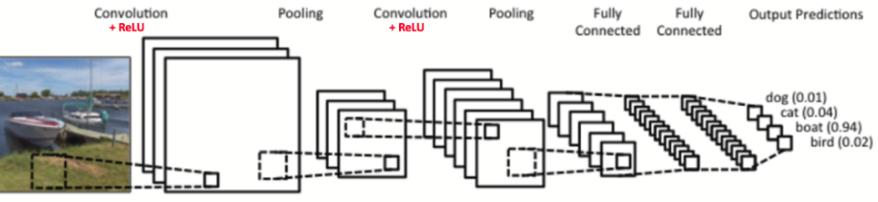
There are four main operations in the ConvNet
Convolution 卷积
Non Linearity (ReLU)非线性处理Pooling or Sub Sampling池化或者亚采样
Classification (Fully Connected Layer) 分类（全连接层）
These operations are the basic building blocks of every Convolutional Neural Network 这些操作对于各个卷积神经网络来说都是基本组件
ConvNets derive their name from the “convolution” operator.
卷积神经网络的名字就来自于其中的卷积操作
We slide the orange matrix over our original image (green) by 1 pixel (also called ‘stride’) and for every position
我们用橙色的矩阵在原始图像（绿色）上滑动，每次滑动一个像素（也叫做“步长”）
stride n.大步走；一大步；步伐；进步vt.跨；跨骑vi.迈大步走；跨过；分腿站立
In a few strides he crossed the room.他几大步就穿过了房间。
stride scale 步测比例尺 full stride大步滑行
take in one's stride轻而易举地应付
make great strides大有进步(突飞猛进)take something in one's stride从容地应付
Another good way to understand the Convolution operation is by looking at the animation in Figure 6 below
animate v.使有生气；赋予生命；鼓励adj.有生命的；有活力的
Jim's arrival served to animate the whole party.吉姆的到来使聚会的整个气氛活跃了起来。
animation n.活泼；生气；兴奋；动画片；动画片制作
computer animation 计算机直观显示 animation system动画制作系统
animation language 动画制作语言 animation timing特技同步
Zero-padding: Sometimes, it is convenient to pad the input matrix with zeros around the border,so that we can apply the filter to bordering elements of our input image matrix.
零填充（Zero-padding）：有时，在输入矩阵的边缘使用零值进行填充，这样我们就可以对输入图像矩阵的边缘进行滤波
Adding zero-padding is also called wide convolution, and not using zero-padding would be a narrow convolution.
使用零填充的也叫做泛卷积，不适用零填充的叫做严格卷积
Spatial Pooling (also called subsampling or downsampling) reduces the dimensionality of each feature map but retains the most important information.
空间池化（Spatial Pooling）（也叫做亚采用或者下采样）降低了各个特征图的维度，但可以保持大部分重要的信息。
Together these layers extract the useful features from the images, introduce non-linearity in our network and reduce feature dimension while aiming to make the features somewhat equivariant to scale and translation
这些层一起就可以从图像中提取有用的特征，并在网络中引入非线性，减少特征维度，同时保持这些特征具有某种程度上的尺度变化不变性
The output from the convolutional and pooling layers represent high-level features of the input image.
卷积和池化层的输出表示了输入图像的高级特征
The purpose of the Fully Connected layer is to use these features for classifying the input image into various classes based on the training dataset
全连接层的目的是为了使用这些特征把输入图像基于训练数据集进行分类
The Softmax function takes a vector of arbitrary real-valued scores and squashes it to a vector of values between zero and one that sum to one.
softmax 函数输入一个任意大于 0 值的矢量，并把它们转换为零一之间的数值矢量，其和为一
As discussed above, the Convolution + Pooling layers act as Feature Extractors from the input image while Fully Connected layer acts as a classifier.
正如上面讨论的，卷积 + 池化层的作用是从输入图像中提取特征，而全连接层的作用是分类器
The weights are adjusted in proportion to their contribution to the total error
权重的更新与它们对总误差的占比有关
proportion n.部分；比例；均衡；（复）规模vt.使成比例；使均衡；分摊
A large proportion of my time is spent in studying.我的大部分时间花在学习上。
direct〔inverse〕proportion 正〔反〕比例 due〔proper〕proportion适当的比例
in proportion 相称,恰如其分地,如实地 in proportion to与…成比例
proportionate adj.成比例的；相称的v.使相称；使成比例
Risk is always proportionate to reward.风险总是与回报成正比。
proportionate part 按比例的部分 proportionate increase 比例增加
proportional adj.成比例的；相称的n.[数]比例项
The pay will be proportional to the time put in.代价要和所花费的时间成比例
In the years from late 1990s to early 2010s convolutional neural network were in incubation
在上世纪 90 年代后期至 2010 年初期，卷积神经网络进入孵化期
incubation n.孵化；熟虑；[医]潜伏期
The four stages of creative thought are preparation, incubation, illumination, and verification.
创造性思考的四个阶段是准备、沉思、启迪、求证。
The incubation period usually is 8 to 14 days. 潜伏期通常为8-14天
artificial incubation 人工孵化 incubation period孵化期,保温培养期,发酵周期
incubation time 孵化期,保温培养期,发酵周期
extrinsic incubation period 外潜伏期
incubate v.孵；(细菌等)培养；逐渐发展；酝酿，深思；(传染病)潜伏
The female bird incubates the eggs for about sixteen days while the male brings food.
雌鸟孵蛋差不多十六天，在这期间，雄鸟带回食物。
He incubated germs in a laboratory. 他在实验室中培养细菌。
incubator n.孵卵器；早产儿保育器
An incubator is used to hatch chicken. 孵卵器用来孵小鸡。
ImageNet Large Scale Visual Recognition Challenge (ILSVRC) in 2012
大规模视觉识别大赛（ImageNet Large Scale Visual Recognition Challenge，ILSVRC）
A Taxonomy of Deep Convolutional Neural Nets for Computer Vision
taxonomic adj.分类学的
It falls outside the scope of the formal taxonomic categories.
它不属于正规植物分类学的分类阶元的范畴。
taxonomy n.(动植物的)分类学
conceptual taxonomy [计] 概念分类学 taxonomy grade分类等级 evolutionary taxonomy演化分类
CS231n的全称是CS231n: Convolutional Neural Networks for Visual Recognition 面向视觉识别的卷积神经网络
The whole network still expresses a single differentiable score function: from the raw image pixels on one end to class scores at the other.
整个网络依旧是一个可导的评分函数：该函数的输入是原始的图像像素，输出是不同类别的评分
ConvNet architectures make the explicit assumption that the inputs are images, which allows us to encode certain properties into the architecture.
卷积神经网络的结构基于一个假设，即输入数据是图像，基于该假设，我们就向结构中添加了一些特有的性质
encode vt.编码；译码
We should encode the message for security reasons.
为了确保安全，我们应该对信息进行编码。
decode and encode statement 译码和编码语句
encode video information 编码视频信息
Recall: Regular Neural Nets. As we saw in the previous chapter
回顾：常规神经网络。在上一章中
3D volumes of neurons 神经元的三维排列
volume n.卷；体积；册；音量；容量
This volume contains selections from his early works.
该卷包含了他的早期作品文选。
increase the volume 增大音量〔容量〕publish the volume出版书集
novel in three volumes 分为三册的小说 voice of great volume 洪亮的声音
Layers used to build ConvNets 用来构建卷积网络的各种层
a simple ConvNet is a sequence of layers, and every layer of a ConvNet transforms one volume of activations to another through a differentiable function.
一个简单的卷积神经网络是由各种层按照顺序排列组成，网络中的每个层使用一个可以微分的函数将激活数据从一个层传递到另一个层
We will stack these layers to form a full ConvNet architecture.
通过将这些层叠加起来，就可以构建一个完整的卷积神经网络
Overview and intuition without brain stuff 概述和直观介绍
During the forward pass, we slide (more precisely, convolve) each filter across the width and height of the input volume
在前向传播的时候，让每个滤波器都在输入数据的宽度和高度上滑动（更精确地说是卷积）
convolve v.卷；盘旋；缠绕 convolution n. 回旋；卷旋；盘旋 n.[数] 卷积
numerical convolution 数值卷积 periodic convolution 周期卷积
Intuitively, the network will learn filters that activate when they see some type of visual feature such as an edge of some orientation or a blotch of some color on the first layer, or eventually entire honeycomb or wheel-like patterns on higher layers of the network.
直观地来说，网络会让滤波器学习到当它看到某些类型的视觉特征时就激活，具体的视觉特征可能是某些方位上的边界，或者在第一层上某些颜色的斑点，甚至可以是网络更高层上的蜂巢状或者车轮状图案。
For example, suppose that the input volume has size [32x32x3] 假设输入数据体尺寸为[32x32x3]
Notice that the extent of the connectivity along the depth axis must be 3, since this is the depth of the input volume.
注意这个连接在深度维度上的大小必须为3，和输入数据体的深度一致
We can compute the spatial size of the output volume as a function of the input volume size (W)
输出数据体在空间上的尺寸可以通过输入数据体尺寸（W）
Constraints on strides. Note again that the spatial arrangement hyperparameters have mutual constraints.
步长的限制：注意这些空间排列的超参数之间是相互限制的
not an integer, indicating that the neurons don’t “fit” neatly and symmetrically across the input.
结果不是整数，这就是说神经元不能整齐对称地滑过输入数据体
neat adj.整洁的；简洁的；利索的adv.整洁地；利索地
symmetrical adj.对称的
It also looks symmetrical in profile. 在横剖面上它看起来也是对称的
symmetry n.对称(性)；匀称；整齐
These values constitute the symmetry waveform. 有这些数据来构成对称波形
bilateral symmetry 两面对称,两侧对称,双侧对称
axial symmetry 轴向对称性,轴对称
the use of zero-padding and some design guidelines will significantly alleviate.
使用零填充和遵守其他一些设计策略将会有效解决这个问题
alleviate vt.减轻；使 ... 缓和
The doctor gave her an injection to alleviate the pain.医生给她注射以减轻疼痛。
alleviate ache 减轻痛苦 alleviate an economic crisis 缓和经济危机
In other words, denoting a single 2-dimensional slice of depth as a depth slice (e.g. a volume of size [55x55x96] has 96 depth slices, each of size [55x55])
换言之，就是将深度维度上一个单独的2维切片看做深度切片（depth slice），比如一个数据体尺寸为[55x55x96]的就有96个深度切片，每个尺寸为[55x55]
The local regions in the input image are stretched out into columns in an operation commonly called im2col.
输入图像的局部区域被im2col操作拉伸为列
The backward pass for a convolution operation (for both the data and the weights) is also a convolution (but with spatially-flipped filters)
积操作的反向传播（同时对于数据和权重）还是一个卷积（但是是和空间上翻转的滤波器）
Dilated convolutions. A recent development (e.g. see paper by Fisher Yu and Vladlen Koltun) is to introduce one more hyperparameter to the CONV layer called the dilation.
扩张卷积：最近一个研究（Fisher Yu和Vladlen Koltun的论文）给卷积层引入了一个新的叫扩张（dilation）的超参数
variational autoencoders (VAEs) or generative adversarial networks (GANs). It seems likely that future architectures will feature very few to no pooling layers.
比如变化自编码器（VAEs：variational autoencoders）和生成性对抗网络（GANs：generative adversarial networks）。现在看起来，未来的卷积网络结构中，无汇聚层的结构不太可能扮演重要的角色
adversary n.敌手；对手
You may have a hidden adversary who would love to prove you wrong.
你可能有一个潜在的敌手，他时刻准备着与你作对。
dangerous adversary危险的对手 adversary of sb某人的对手
adversarial adj.对手的；敌对的；对抗的
The adversarial guys had a hell of time. 那些极力反对我们的人都感到不好受
hell n.地狱；阴间；苦境；极大的痛苦n.究竟（用以加强语气）int.该死(用以表示愤怒或惊讶)
adverse adj.不利的；逆向的；有害的
sometimes with the intentions of implementing inhibition schemes observed in the biological brain.
有时候是为了实现在生物大脑中观测到的抑制机制
Recent departures. It should be noted that the conventional paradigm of a linear list of layers has recently been challanged, in
Google’s Inception architectures and also in current (state of the art) Residual Networks from Microsoft Research Asia.
最新进展：传统的将层按照线性进行排列的方法已经受到了挑战，挑战来自谷歌的Inception结构和微软亚洲研究院的残差网络（Residual Net）结构
departure n.出发；离开；分歧；新的尝试
All the arrangements should have been completed prior to our departure.
全部安排都应该在我们出发之前完成
Departure Lounge 候机室 departures board出发时刻表
departure from违反 cumulative departure累积偏差
average departure平均距,平均偏差
departure hall 出发大厅 departure gate 登机口
Both of these (see details below in case studies section) feature more intricate and different connectivity structures.
这两个网络（下文案例学习小节中有细节）的特征更加复杂，连接结构也不同
intricate adj.复杂的；难懂的
The prisoners designed the intricate escape. 囚犯们策划了那起周密的越狱事件
intricate design 错综复杂的设计 amazingly intricate极其错综复杂
In practice: use whatever works best on ImageNet. If you’re feeling a bit of a fatigue in
thinking about the architectural decisions, you’ll be pleased to know that in 90% or more of applications you should not have to worry about these.
fatigue n.疲劳；疲乏；劳务杂役v.（使）疲劳adj.疲劳的
The aeroplane wing showed signs of metal fatigue. 机翼显出有金属疲劳的现象
combat fatigue 战斗疲劳症 fatigue strength 疲劳强度,疲乏强度,疲劳限度
fatigue resistance耐疲劳性,动强度
Until now we’ve omitted mentions of common hyperparameters used in each of the layers in a ConvNet.
到现在为止，我们都没有提及卷积神经网络中每层的超参数的使用
We will first state the common rules of thumb for sizing the architectures and then follow the rules with a discussion of the notation
现在先介绍设置结构尺寸的一般性规则，然后根据这些规则进行讨论
Compromising based on memory constraints. In some cases (especially early in the ConvNet architectures), the amount of memory can build up very quickly with the rules of thumb presented above.
因为内存限制所做的妥协：在某些案例（尤其是早期的卷积神经网络结构）中，基于前面的各种规则，内存的使用量迅速飙升
thumb n.拇指v.翻阅；示意要求搭车
He caught his thumb in the door. 他的拇指让门夹了
thumb a lift 搭便车 all thumbs笨手笨脚 stick out like a sore thumb显得十分不自然,惹人注目
Once you have a rough estimate of the total number of values (for activations, gradients, and misc)
一旦对于所有这些数值的数量有了一个大略估计（包含激活数据，梯度和各种杂项
It would be helpful to know, if my interpretation about your model is correct and a bit of guidance would be appreciated.

（NN_DL added-2/26）

1.2 chapter 2 NN and DL
The computational universality of perceptrons is simultaneously reassuring and disappointing.
感知器运算的通用性既是令人鼓舞的，又是令人失望的。
reassure v.使…安心；再保证；重拾(信心等)
reassure the sick man消除病人对健康的疑虑
reassuring adj.安心的；宽慰鼓励的
disappoint v.使失望；使破 disappoint very much非常失望
be disappointed at result对结果感到失望
sigmoid neurons s型神经元
Learning algorithms sound terrific 学习算法听上去非常棒
terrific adj.可怕的；极好的；非常的；危险的
But how can we devise such algorithms for a neural network?
devise vt.设计；发明；遗赠
devise an idea 想出一个主意 devise an instrument发明仪器
devise to将…遗赠给
The algebraic form of the sigmoid function may seem opaque and forbidding if you're not already familiar with it.
如果你不熟悉 S 型函数的代数形式，它看上去晦涩难懂又令人生畏。
opaque adj.不透明的；难懂的 opaque liquid 不透明的液体
opaque word含糊的词语
There was, however, a gap in our explanation: we didn't discuss how to compute the gradient of the cost function.
That's quite a gap! 这是很大的缺失！
Today, the backpropagation algorithm is the workhorse of learning in neural networks. 现在，反向传播算法已经是神经网络学习的重要组成部分了
workhorse n.驮马；做粗工者；重负荷机器
At the heart of backpropagation is an expression for the partial derivative ∂C/∂w of the cost function C with respect to any weight ww (or bias b) in the network.
反向传播的核心是一个对代价函数 C 关于任何权重 w（或者偏置 b ）的偏导数 ∂C/∂w 的表达式。
Warm up: a fast matrix-based approach to computing the output from a neural network 热身：神经网络中使用矩阵快速计算输出的方法
This notation is cumbersome at first, and it does take some work to master(消化、理解).
master n.主人；硕士；专家vt.控制；精通adj.主要的；主人的；精通
The last ingredient we need to rewrite (23) in a matrix form is the idea of vectorizing a function such as σ().
最后我们需要引入向量化函数（如 σ）来按照矩阵形式重写公式 (23)
ingredient n.成分；原料；配料；因素
gradient n.斜度；坡度；梯度
We met vectorization briefly in the last chapter, but to recap....
recap vt.翻新胎面；重述要点n.重述要点；翻新的轮胎
A lot of trucks recap their bursted tires to drive on the road again.
很多卡车翻新了已爆掉的轮胎，以再次开上路
recapitulate v.扼要重述
It will be helpful to recapitulate them.
在这里将其简要重述一下也是有帮助的
That global view is often easier and more succinct (and involves fewer indices!) than the neuron-by-neuron view we've taken to now.
这种全局的观点相比神经元层面的观点常常更加简明（没有更多的索引下标了！ ）
succinct adj.简洁的
Think of it as a way of escaping index hell, while remaining precise about what's going on. 把它看做是在保留清晰认识的前提下逃离下标困境的方法
hell n.地狱；阴间；苦境；极大的痛苦
n.究竟（用以加强语气）int.该死(用以表示愤怒或惊讶)
The two assumptions we need about the cost function
关于代价函数的两个假设
define an activation vector 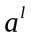 whose components are the activations 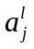.
定义激活向量，其元素是那些激活值。
drop the x subscript, writing the cost 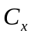 as C.
丢掉了其下标，将代价函数看做 C
subscript n.下标adj.写在下方的
subscript character下标字符subscript origin下标起始值
subscript range下标范围
We'll eventually put the x back in, but for now it's a notational nuisance that is better left implicit.
最终我们会把下标加上，现在为了简化表示其实没有这个必要
nuisance n.讨厌的人；讨厌的东西；伤害
He was a boring nuisance! I'm glad to be rid of him.
他这人真讨厌! 我很庆幸能摆脱他的纠缠
we first introduce an intermediate quantity 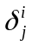
我们首先引入一个中间量
double the quantity 使数量翻一番 produce huge quantity 大量生产 great quantity大量
This company is more concerned with quality than with quantity.
这家公司对质量比对产量更重视。
By contrast, if 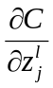 is close to zero, then the demon can't improve the cost much at all by perturbing the weighted input 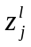.
相反，如果接近 0，那么调⽪⻤并不能通过扰动带权输入来改善太多代价
perturb vt.使烦恼；使不安 perturbed adj.烦躁不安的
perturbation n.扰动(微扰；波动；破坏；摄动)
perturbation technique 摄动技术 perturbation approximation微扰近似
random perturbation 随机扰动 perturbation equation扰动方程
As per our usual conventions, we use 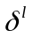 to denote the vector of errors associated with layer l.
按照我们通常的惯例，我们使用表示关联于l层的误差向量
The four fundamental equations behind backpropagation
反向传播的四个基本方程
Backpropagation is about understanding how changing the weights and biases in a network changes the cost function.
反向传播其实是对权重和偏置变化影响代价函数过程的理解
To understand how the error is defined, imagine there is a demon in our neural network
为了理解误差是如何定义的，假设在神经网络上有一个调皮鬼
demon n.魔鬼；恶魔；精力充沛的人；高手
a demon for work 精力过人的工作者
The demon charmed the woman with his spell.
这个恶魔用他的魔法控制这个女人
charm n.魅力；吸引力；迷人；美貌v.（使）着迷；施魔法
Her charm rests in her happy smile. 她的魅力在于她幸福的微笑
add charm增添魅力
wear a charm 戴着护身符 the charms of nature大自然的魅力
charm artlessly 天真自然地吸引 charm sb into doing sth哄诱某人做某事
rest n.剩余的部分；休息；支撑物；休止符
v.休息；(使)倚靠；使(视线)停留在；搁在；依赖；基于；搁置；埋葬
come to rest 静止下来,停止移动 a little rest稍事休息
active rest积极的休息
rest against the wall 靠墙立着 rest well休息得好
rest completely完全静止 plan of attack 灭火作战计划
He gave away the plan of attack to the Germans.
他把进攻计划泄漏给了德国人
attack n.攻击；抨击v.攻击；抨击；发动攻击；（疾病）侵袭
The police are launching a major attack on drug dealers.
警方对毒品贩子发动了大规模的攻击
Once you show any sign of fear, he will attack you.
你一旦露出任何恐惧的迹象,他就会攻击你
attack the enemy 攻击敌人
attack against 对…的进攻 air attack空袭 blitz attack闪电式袭击
you shouldn't expect to instantaneously assimilate the equations.
你不需要一下子能够同时理解这些公式
assimilate v.使同化；吸收
The USA has assimilated people from many different countries.
美国已经同化了许多来自不同国家的人
assimilate actively积极吸收assimilate easily很容易被吸收
assimilate...into 使…适应
assimilate oneself to new surroundings 使自己适应新环境
we'll develop an intuitive picture of what the backpropagation equations mean, and how someone might discover them from scratch.
我们会发展出一个关于反向传播方程含义的直觉画面，以及人们如何能够从零开始发现这个规律
scratch v.抓；搔（痒）；划破；划掉
n.抓痕；乱写；抓的声音；起跑线adj.无让步的
You can clean the scratch with alcohol. 你可以用酒精把擦痕去掉
The dog is scratching at the door. 狗正在抓门
Proof of the four fundamental equations (optional)
四个基本方程的证明（可选）
We'll now prove the four fundamental equations (BP1)-(BP4). All four are consequences of the chain rule from multivariable calculus.
我们现在证明这四个基本的方程 (BP1)–(BP4)。所有这些都是多元微积分的链式法则的推论。
calculus n.微积分；算法；结石
I had studied calculus before I got into college.
我在上大学以前,已经学过微积分
integral calculus 积分 differential calculus 微分学
consequence n.结果；后果；重要性；影响
It terrified me to contemplate the consequence of your action.
一想到你行动的后果,我就感到害怕。
He studied hard, and in consequence he passed the exam.
他努力学习，因此通过了考试
accept〔bear, suffer, take〕 the consequence 承担后果
consider the consequence考虑后果
as a consequence 因此 in consequence of 由于…的缘故,由于
consequent adj.作为结果的；随之发生的；合乎逻辑的 n.推论；结论；[数]后项
consequent on〔upon〕 由…引起
If you're comfortable with the chain rule, then I strongly encourage you to attempt the derivation yourself before reading on.
derivation n.派生；推导；来历衍生物；导数.
first derivation 一阶求导,一阶求微 direct derivation 直接推导
derive v.获取；得自；起源
We shall derive much benefit from reading good novels.
我们将从优秀小说中获得很大好处。
We derive our sustenance from the land. 我们从土地获取食物。
derive knowledge 获得知识 derive pleasure获得乐趣
derive essentially基本起源于
A little less succinctly, we can think of backpropagation as a way of computing the gradient of the cost function
by systematically applying the chain rule from multi-variable calculus.
succinct adj.简洁的
systematical adj.系统的；有条理的
In what sense is backpropagation a fast algorithm?
在哪种层面上，反向传播是快速的算法？
backpropagation is not a panacea.
panacea n.万灵药；灵丹妙药
It is not a panacea, but a stimulus to the economy is correct.
它不是什么万灵药，但给经济一个刺激是正确的

1.2 cs231n optimization 1(8-5)

NLP(4-17)

1.1
Data representation is a fundamental task in machine learning.
数据表示是机器学习中的基础工作
In a long history, the representation of data is done by feature engineering
传统机器学习思路下， 对数据的表示主要通过人工设计特征来完成
In natural language processing, the most widely used feature representation is the Bag-of-Words model.
在自然语言处理领域，最常用的语义表示方法是词袋子模型
This model has the data sparsity problem and cannot keep the word order information.
该方法存在数据稀疏问题，并且不能保留词序信息
Other features such as part-of-speech tagging or more complex syntax features can only fit for specific tasks in most cases.
早期方法中提出的词性、句法结构等复杂特征，往往只能对特定的任务带来性能提升
This thesis focuses on word representation and document representation.
本文从词和文档两个层次对文本的语义表示技术进行系统的总结分析
First, for generating word embeddings, we make comprehensive comparisons among existing word embedding models.
在这一部分中，本文对现有的词向量表示技术进行了系统的理论对比及实验分析
NLP, and Representations 自然语言处理和表征方法
deep neural networks have dominated pattern recognition.
深度神经网络在模式识别中占绝对主流
They blew the previous state of the art out of the water for many computer vision tasks.
它们在许多计算机视觉任务中完爆之前的顶尖算法
blew v.吹；风吹；擤(鼻子)；(保险丝)熔断；<口>浪费（动词blow 的过去式）
blow n.打击；殴打；吹v.风吹；擤(鼻子)；(保险丝)熔断；<口>浪费(机会)
I think it’s a very elegant perspective.
我认为这是个非常简练而优美的视角
A neural network with a hidden layer has universality: given enough hidden units, it can approximate any function.
单隐层神经网络有一个普适性（universality）：给予足够的隐结点，它可以估算任何函数
This is a frequently quoted – and even more frequently, misunderstood and applied – theorem.
这是一个经常被引用的理论，它被误解和应用的次数就更多了。
It’s true, essentially, because the hidden layer can be used as a lookup table.
本质上这个理论是正确的，因为隐层可以用来做查询表。
Universality means that a network can fit to any training data you give it.
普适性的真正意义是：一个网络能适应任何你给它的训练数据。
It doesn’t mean that it will interpolate to new data points in a reasonable way.
这并不代表插入新的数据点的时候它能表现地很理想
I’d like to start by tracing a particularly interesting strand of deep learning research: word embeddings.
我想从深度学习研究的一个非常有意思的部分讲起，它就是： word embeddings
embed v.(使)插入；(使)嵌入；深留脑中
You can embed URLs in your comment lines. 可以将URL嵌入注释行
embedded software 嵌入式软件 embed in 嵌入到
strand n.缕；(线等的)股；海滨，河岸，海滩v.使陷于困境；弄断；使落后；（使）搁浅
One strand of silk doesn't make a thread; one tree doesn't make a forest.
单丝不成线,独木不成林
strand line 岸边线,滨线,岸线,海岸线 master strand主链
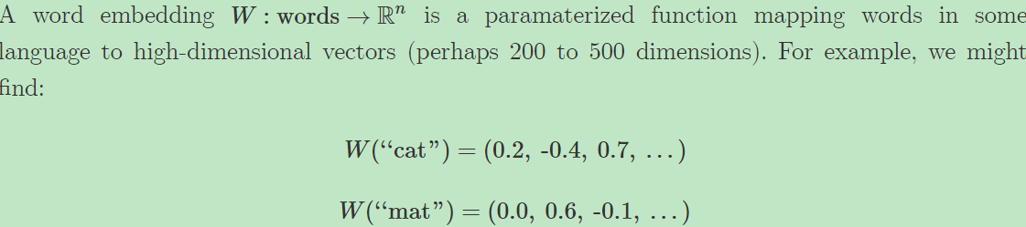
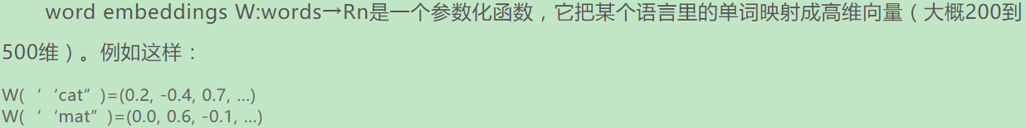
W is initialized to have random vectors for each word. It learns to have meaningful vectors in order to perform some task.
For example, one task we might train a network for is predicting whether a 5-gram (sequence of five words) is ‘valid.’
举个一个可能的任务的例子：训练一个网络让其预测一个5元组（5-gram）（连续的5个词）是否‘成立’
gram n.克
A dust particle weighs only a thousandth of a gram.一粒尘埃的重量仅有千分之一克
We can easily get lots of 5-grams from Wikipedia (eg. “cat sat on the mat”) and
then ‘break’ half of them by switching a word with a random word (eg. “cat sat song the mat”), since that will almost certainly make our 5-gram nonsensical.
我们可以随便从维基百科上选一堆5元组（比如cat sat on the mat）然后把其中一个词随便换成另外一个词（比如cat sat song the mat），那么一半的5元组估计都会变得荒谬且没意义了
nonsensical adj.没有意义的；荒谬的
mat n.垫子；席子v.编织；集结；铺席于 ... 上
The swimmer's wet hair was matted together.那游泳者的湿头发乱糟糟结成一团
exercise mat(体操或摔跤用的)海绵垫 leave sb on the mat拒绝接待某人
mat together 缠绕在一起
The model we train will run each word in the 5-gram through WW to get a vector representing it and feed those into another ‘module’ called R which tries to predict if the 5-gram is ‘valid’ or ‘broken.’ Then, we’d like
我们训练的模型会通过W把5元组中每个词的表征向量取出来，输入给另外一个叫R的模块，模块R会试图预测这个5元组是‘成立的’或者是‘破碎的’。然后我们希望看见:
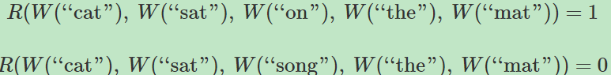
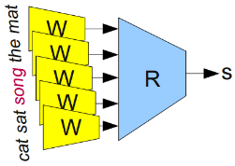
In order to predict these values accurately, the network needs to learn good parameters for both W and R.
为了准确地预测这些值，这个网络需要从W以及R中学习到好的参数
This kind of ‘map’ of words makes a lot of intuitive sense to us. Similar words are close together
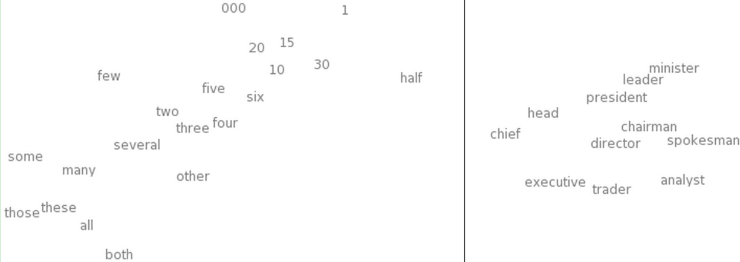
It seems natural for a network to make words with similar meanings have similar vectors.
网络能让意义相似的词拥有相似的向量，这看起来是很自然的事
If you switch a word for a synonym (eg. “a few people sing well” →→ “a couple people sing well”), the validity of the sentence doesn’t change.
如果你把一个词换成它的同义词(例如 “a few people sing well” → “a couple people sing well”)，句子的成立性并没有变化
While, from a naive perspective, the input sentence has changed a lot, if W maps synonyms (like “few” and “couple”) close together, from R’s perspective little changes.
虽然从字面上看，句子变化很大，但如果W把同义词（像“few”和”couple”这种）映射到相近的空间，从R的角度来看句子的变化很小
The number of possible 5-grams is massive and we have a comparatively small number of data points to try to learn from.
可能的5元组的数目是巨大的，相比之下我们的训练数据量很小
Similar words being close together allows us to generalize from one sentence to a class of similar sentences.
相似的单词距离近能让我们从一个句子演变出一类相似的句子
This doesn’t just mean switching a word for a synonym, but also switching a word for a word in a similar class (eg. “the wall is blue” →→ “the wall is red”).
这不仅指把一个词替换成一个它的同义词，而且指把一个词换成一个相似类别里面的词（如“the wall is blue” → “the wall is red” ）
So, clearly this is a very useful thing for W to do.
很明显，这是W的一个用武之地。但它是如何学会做这个的呢
But how does it learn to do this? It seems quite likely that there are lots of situations where it has seen a sentence like “the wall is blue” and know that it is valid before it sees a sentence like “the wall is red”.
看起来很可能很多情况下它是先知道“the wall is blue”这样的句子是成立的，然后才见到“the wall is red”这样的句子
As such, shifting “red” a bit closer to “blue” makes the network perform better.
这样的话，把“red”往”blue”那边挪近一点，网络的效果就更好
We still need to see examples of every word being used, but the analogies allow us to
generalize to new combinations of words.
我们并没见过每个单词使用的例子，但是类比能让我们泛化衍生出新的单词组合
You’ve seen all the words that you understand before, but you haven’t seen all the sentences that you understand before. So too with neural networks.
你懂的单词你都见过，但是你能懂的句子你并没有都见过。神经网络也是如此
Word embeddings exhibit an even more remarkable property: analogies between words seem to be encoded in the difference vectors between words.
word embeddings展示了一个更引人注目的属性：单词间的类比仿佛是被编码在了单词向量的区别中
For example, there seems to be a constant male-female difference vector:
这个看来是个男-女区别向量：
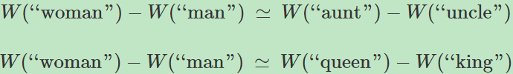
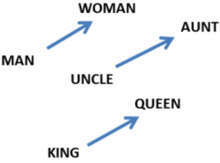
This may not seem too surprising. After all, gender pronouns mean that switching a word can make a sentence grammatically incorrect. You write, “she is the aunt” but “he is the uncle.” Similarly, “he is the King” but “she is the Queen.”
也许这看起来并不奇怪。毕竟表性别的代词意味着换一个词整个句子的语法就错了。正常话是这么说的
“she is the aunt” ，“he is the uncle.”。同样的，“he is the King”, “she is the Queen.”
If one sees “she is the uncle,” the most likely explanation is a grammatical error.
If words are being randomly switched half the time, it seems pretty likely that happened here.
如果你看见“she is the uncle,” 最可能的解释就是这句话有语法错误。这个情况看起来很可能是：一半的时候单词都被随机地替换了。
Of course!” We say with hindsight, “the word embedding will learn to encode gender in a consistent way. In fact, there’s probably a gender dimension.
Same thing for singular vs plural. It’s easy to find these trivial relationships!”
也许我们会放马后炮：“当然是这样啦！word embeddings会学着把性别按照一致的方式来编码。
事实上也许就存在一个性别的维度。对单复数来说也是一样。找出这些明显的关系太简单了！”
hindsight n.事后聪明，后见之明；枪的照门
Hindsight is always better than foresight.后见之明总胜于先见之明
kick the hindsight off 彻底打败
plural adj.复数的 n.复数
Most plural nouns in English end in s'. 英语的复数名词多以s结尾
plural service 不同源供电 plural noun 复数名词
plural nationality 多重国籍 plural marriage 一夫多妻制
It turns out, though, that much more sophisticated relationships are also encoded in this way. It seems almost miraculous!
然而，更复杂的关系也是这样被编码的。这看起来几乎像奇迹一样！
miraculous adj.奇迹的；不可思议的
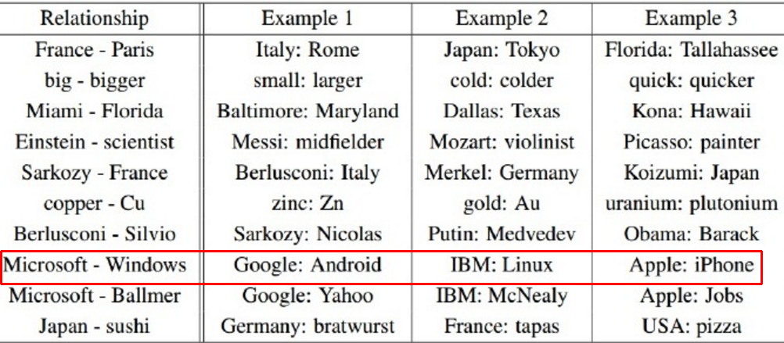
It’s important to appreciate that all of these properties of W are side effects.
能够充分意识到W的这些属性不过是副产品而已是很重要的
We didn’t try to have similar words be close together.
We didn’t try to have analogies encoded with difference vectors.
我们没有尝试着让相似的词离得近。我们没想把类比编码进不同的向量里
All we tried to do was perform a simple task, like predicting whether a sentence was valid. These properties more or less popped out of the optimization process.
我们想做的不过是一个简单的任务，比如预测一个句子是不是成立的。
这些属性大概也就是在优化过程中自动蹦出来的
This seems to be a great strength of neural networks: they learn better ways to represent data, automatically.
这看来是神经网络的一个非常强大的优点：它们能自动学习更好的数据表征的方法
Representing data well, in turn, seems to be essential to success at many machine learning problems.
反过来讲，能有效地表示数据对许多机器学习问题的成功都是必不可少的
Word embeddings are just a particularly striking example of learning a representation.
word embeddings仅仅是学习数据表示中一个引人注目的例子而已
strike n.罢工；打击；殴打v.打；撞；罢工；划燃
The dockers are coming out on strike for higher wages.
码头工人将举行罢工要求增加工资
strike a child 打小孩 strike aimlessly 无目的地打
strike against 撞在…上,反对…而罢工 gold strike突然发现一个金矿
striking adj.显著的；吸引人的

Shared Representations 共同表征
The properties of word embeddings are certainly interesting, but can we do anything useful with them? Besides predicting silly things, like whether a 5-gram is ‘valid’?
word embeddings的这些属性当然非常有意思，但是除了判断5元组是不是成立这种傻问题还能干点啥有用的么？
We learned the word embedding in order to do well on a simple task, but based on the nice properties
we’ve observed in word embeddings, you may suspect that they could be generally useful in NLP tasks.
In fact, word representations like these are extremely important:
之前我们学习word embeddings是为了在简单任务上有出色的表现，
但基于我们从word embeddings中发现的好属性，你也许会猜想它们对自然语言处理任务整体都适用。
实际上，这样的单词特征表示（word representations）是极其有用的：
The use of word representations… has become a key “secret sauce” for the success of many NLP systems in recent years, across tasks including named entity recognition, part-of-speech tagging, parsing, and semantic role labeling.
利用单词特征表示…已经成为近年来许多NLP系统成功的秘密武器，包括命名实体识别，词性标注，语法分析和语义角色标注
sauce n.酱汁；调味汁；<口>无礼vt.给 ... 调味；使 ... 增加趣味；对 ... 无礼
He sauced criticism with flattery 他用谄媚来冲淡批评
The sauce is thin and tasteless. 这酱汁淡而无味
This general tactic – learning a good representation on a task A and then using it on a task B – is one of the major tricks in the Deep Learning toolbox.
在深度学习工具箱里，把从任务A中学到的好表征方法用在任务B上是一个很主要的技巧
tactic n.战略；策略
The team won the game thanks to Jeff's fabulous spot tactic.
多亏了杰夫当场制定的英明战略，他的球队赢了。
delaying tactic 拖延战术 mass tactic 密集战术 win by surprise tactics出奇制胜
There’s a counterpart to this trick. Instead of learning a way to represent one kind of data and using it to perform multiple kinds of tasks, we can learn a way to map multiple kinds of data into a single representation!
这个技巧有个对应面。除了在一种数据上学习表征然后应用在不同任务上，我们还可以从多种数据中学习出一种单个的表征
One nice example of this is a bilingual word-embedding, produced in Socher et al. (2013a).
一个很好的例子就是Socher et al. (2013a) 提出的双语word embeddings
We can learn to embed words from two different languages in a single, shared space.
我们可以从两种不同语言中把word embeddings到一个共享的空间去
In this case, we learn to embed English and Mandarin Chinese words in the same space.
在这个例子里，我们学习把汉语和英语嵌入到同一个空间去
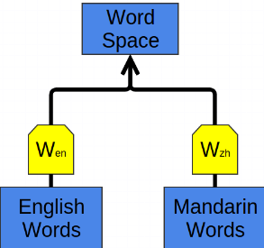
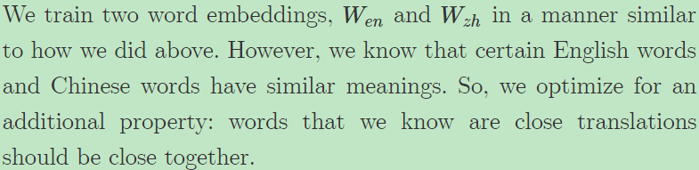
我们用和上面差不多的方法来训练Wen和Wzh两种嵌入。但是，我们已知某些中文和英文的词汇有相似的意思。所以，我们追加一个属性优化：我们已知的翻译过后意思相似的词应该离得更近。

Of course, we observe that the words we knew had similar meanings end up close together. Since we optimized for that, it’s not surprising. More interesting is that words we didn’t know were translations end up close together.
理所当然，我们会发现我们已知的有相似意思的词在最后结果中离得很近。我们本来就是针对这个做的优化，这个结果没什么让人惊讶的。但更有意思的是我们未知的翻译后意思相似的词结果距离也很近

Intuitively, it feels a bit like the two languages have a similar ‘shape’ and that by forcing them to line up at different points, they overlap and other points get pulled into the right positions.
直观来讲，仿佛就是两种语言有着相似的“形状”，通过对齐不同的点，两种语言就能够重叠，其他的点就自然能被放在正确的位置上。
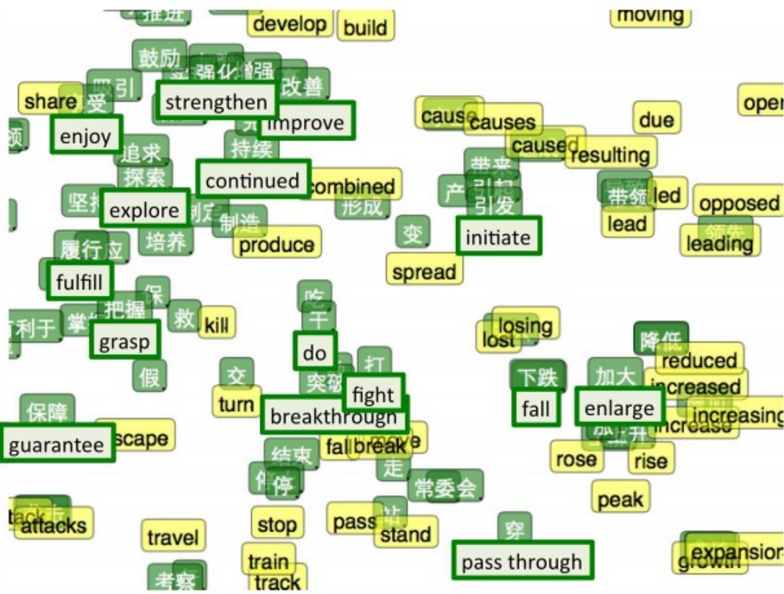
Recently, deep learning has begun exploring models that embed images and words in a single representation
近期，深度学习已经开始探索能够把单词和图像嵌入到同一个表征下的模型
The basic idea is that one classifies images by outputting a vector in a word embedding
基本思路就是你可以通过word embeddings输出的向量来对图像进行分类
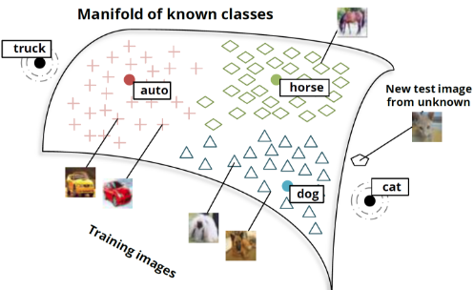
Images of cats aren’t mapped to random points in the word embedding space.
猫的图片并没有被映射到word embeddings空间的随机的点中
Instead, they tend to be mapped to the general vicinity of the “dog” vector, and, in fact, close to the “cat” vector
相反的，他们更倾向于被映射到整体上相近的“狗”的向量中去，并且事实上更接近于“猫”的向量
vicinity n.邻近；周边地区
There's a factory in the vicinity of the school.学校邻近有个工厂
in the vicinity of在 ... 附近boundary vicinity边界附近
vicious adj.恶毒的；恶意的；剧烈的；堕落的
She used vicious remarks to insult people. 她恶言伤人
vicious cycle恶性循环 vicious circle of poverty贫穷的恶性循环
vicious spiral of inflation 通货膨胀的恶性螺旋上升
vicious inflation恶性通货膨胀
inflate vt.使膨胀；使得意；使通货膨胀vi.膨胀
We all started to inflate our balloons and eventually one burst.
我们都开始给气球充气，结果有一个爆掉了
He is inflated with pride. 他趾高气扬
inflate the paper currency [经] 滥发纸币

inflate, dilate, distend, expand, swell这组词都有“增大,扩大”的意思。其区别是：expand指体积、数量的增大,可指展开、打开、散播开,而使其扩大的因素既可以是内在的,也可以是来自外界的外力;
swell是指由于受到内部力量的作用而在体积和容积方面增大,也可指数目或程度的增长,质量的提高,或曲面向上隆起,常表示“不正常的增大”;
distend指在内部力量的压迫下向各个方向扩张或膨胀,暗示原来就处于完全空虚或松弛状态;
inflate指用人工方法使某物膨胀起来;
dilate强调直径的增大
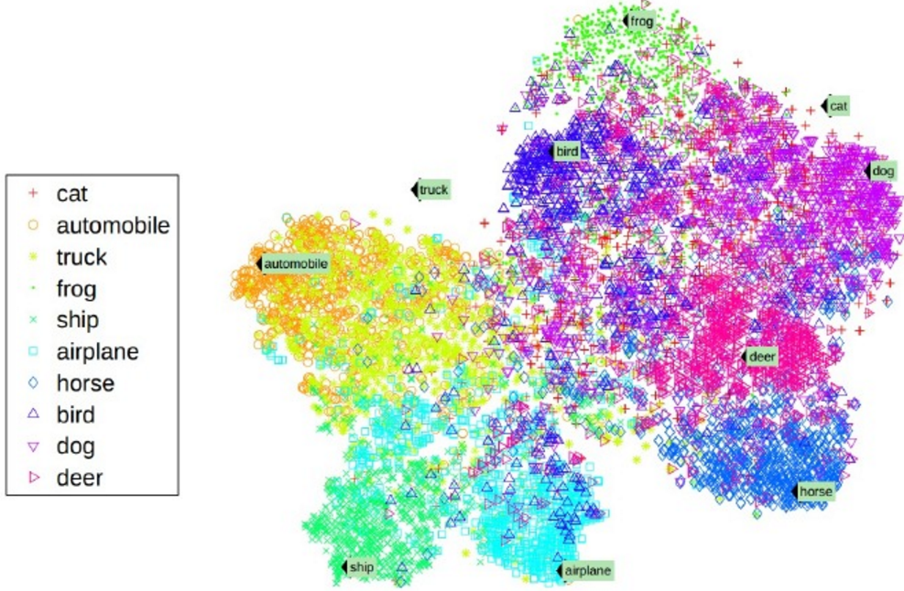

These results all exploit a sort of “these words are similar” reasoning.
些结果都利用到一种“这些词是相似的”的推断
But it seems like much stronger results should be possible based on relationships between words.
但是看起来根据词之前的关系应该有更有力的结果
In our word embedding space, there is a consistent difference vector between male and female version of words.
在我们的word embeddings空间里，在男性和女性词上有一个一致的差异向量
Similarly, in image space, there are consistent features distinguishing between male and female.
相似的，在图像空间中，也有一致的可以区分男性和女性的特征
Beards, mustaches, and baldness are all strong, highly visible indicators of being male.
胡子，八字胡，秃顶都是强烈的，可见的男性特征
Breasts and, less reliably, long hair, makeup and jewelery, are obvious indicators of being female.6
胸部，及没那么可靠的如长发，化妆品及珠宝这些是明显的女性特征（参见注解6）
Even if you’ve never seen a king before, if the queen, determined to be such by the presence of a crown, suddenly has a beard, it’s pretty reasonable to give the male version
即使你从来没见过一个国王，如果一个带着王冠的王后突然有了胡子，那把她变成男人也是很合理的
exploit vt.剥削；利用；开发；开拓n.功绩；英勇行为
The capitalists exploit the workers in order to maximize profits.
资本家剥削工人是为了使利润最大化
You must exploit all your spare time to learn English.
你必须利用一切空闲时间来学习英语
Great men are remembered for their notable exploits.
伟人们因其丰功伟绩而被世人铭记
The daring exploits of the soldiers were much admired.
战士们的英勇行为令人赞叹不已
exploit authority 利用职权
exploit one's authority for personal gains 以权谋私 exploit cleverly巧妙地使用
exploit commercially 作为商品开采 be exploited as expendable(s)成了牺牲品
be exploited by 受…的剥削 perform exploit作出业绩
astounding〔fantastic〕 exploits惊人〔极大〕的功绩daring〔heroic〕 exploits英勇事迹
dare vt.敢；挑战；冒...的风险vi.勇于；胆敢aux.胆敢n.胆量；挑战
He dared me to jump over the river.他激我跳过河
Don't worry! I am just trying my dare.
不用担心！我只不过在试试自己的胆量而已
dare any danger 敢承担〔冒〕任何危险 dare boisterously 兴高采烈地冒险dare bravely勇敢地冒险
daring adj.勇敢的；大胆的n.勇敢；勇气
He had proved himself a most daring airman.
他已证明自己是个极其勇敢的飞行员
The daring exploits of the parachutists were much admired.
跳伞者大胆的冒险动作令人赞叹不已
bold，brave，courageous，daring，heroic，fearless这些形容词均含有“勇敢的”之意。bold侧重指面对困难或危险时勇往直前，勇于进取的勇敢精神。brave含义广泛，指天生的勇敢，无所畏惧地面对困难与危险，侧重胆识与果断。courageous正式用词，侧重指在一切情况下都有胆量，无所畏惧，强调基于道德信念，经深思熟虑后所产生的勇敢。daring强调面临意外或危险时胆大心细，头脑冷静。褒义贬义均可用，贬义指胆大妄为。heroic正式用词，多指在战争或重大危险时，为他人为事业忘我献身的英雄气概。fearless语气肯定，侧重在危险时无所畏惧，毫无动摇
beard n.胡须vt.公开反对；抓住胡须
Why don't you shave your beard off?你怎麽不把胡子刮掉?
He thought I was not brave enough to beard him, but he was wrong because I did it.
他以为我没有那么大勇气向他挑战，但是他错了，我就这么做了
He bearded his boss and demanded an explanation.
他公然蔑视上司，并要求他作出解释
grow a beard 留胡须 have a beard 留胡须 dense beard浓胡子
mustache n.髭；小胡子；（动物）触须
The drooping mustache lifts in a nasty sad smile.
只见他那撇朝下的胡髭往上一耸，露出了一副难看的苦笑
bald adj.秃头的；单调的；无装饰的v.（使）变秃头
We planted some trees on the bald hill. 我们在一座秃山上种了些树
bald lie 赤裸裸的谎言 bald mountain光秃秃的山峦
breast n. 乳房；胸脯vt.(以胸)对着
The baby was being nursed at its mother's breast.
那个孩子正在吃母亲的奶
Who is the first to breast the tape?谁第一个到终点的?
give the breast to one's baby 给孩子喂奶
firm and elastic breast结实而有弹性的乳房flabby breast下垂的乳房
chicken breasts鸡胸肉at the breast未断奶的
Shared embeddings are an extremely exciting area of research and drive at why the representation focused perspective of deep learning is so compelling.
共享嵌入是一个非常让人兴奋的研究领域，它暗示着为何深度学习中这个注重表征方法的角度是如此的引人入胜
Models like the above are powerful, but they have an unfortunate limitation: they can only have a fixed number of inputs.
像上面那样的模型很有效，但很不幸它们有个局限：输入参数的个数必须是固定的
We can overcome this by adding an association module, A, which will take two word or phrase representations and merge them.
By merging sequences of words, AA takes us from representing words to representing phrases or even representing whole sentences! And because we can merge together different numbers of words, we don’t have to have a fixed number of inputs.
通过合并一系列的单词，A让我们不仅能够表示单词，而且能够表示词组甚至整个句子！另外因为我们可以合并不同数量的单词，我们就可以不固定死输入的个数了。
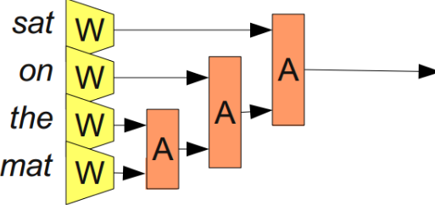
It doesn’t necessarily make sense to merge together words in a sentence linearly. If one considers the phrase “the cat sat on the mat”, it can naturally be bracketed into segments: “((the cat) (sat (on (the mat))))”. We can apply A based on this bracketing:
把句子中的单词线性地合并在一起的做法并不是在所有情况下都讲得通。考虑下面这个句子“the cat sat on the mat”，很自然地它可以被分成下面这样用括号分开的不同的段:“((the cat) (sat (on (the mat))”. 我们可以把A应用在这个分段上：
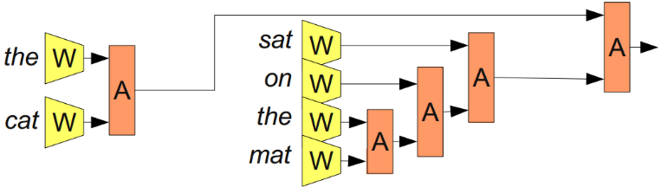
These models are often called “recursive neural networks” because one often has the output of a module go into a module of the same type. They are also sometimes called “tree-structured neural networks.”
这样的模型通常被称作“递归神经网络”因为一个模块经常会使用另外一个同类型模块的输出。有时候它们也被称作“树形神经网络tree
Recursive neural networks have had significant successes in a number of NLP tasks. For example, Socher et al. (2013c) uses a recursive neural network to predict sentence sentiment:
递归神经网络在一系列NLP任务中都有很重大的成功。比如Socher et al. (2013c) 就利用了一个递归神经网络来预测句子的情感
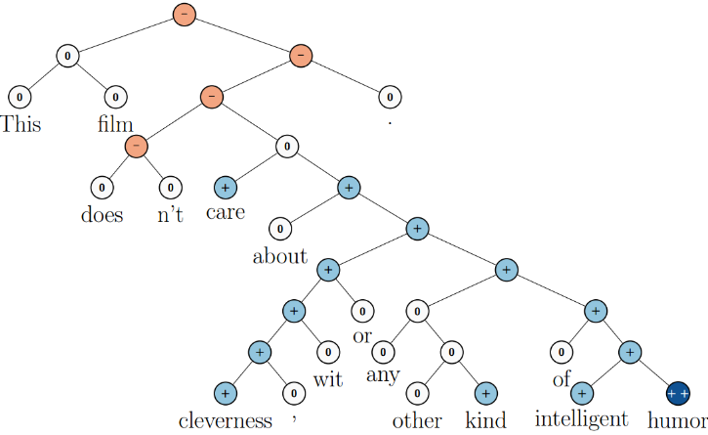
One major goal has been to create a reversible sentence representation, a representation that one can reconstruct an actual sentence from, with roughly the same meaning. For example, we can try to introduce a disassociation module, D, that tries to undo A:
一直以来，一个很主要的目标是如何创建一个可逆的句子表征（sentence representation），也就是能够通过这个表征来构建一个真正的有着相似意思的句子。例如，我们可以尝试引入一个分解模块（disassociation module）D来试着把A分解了：
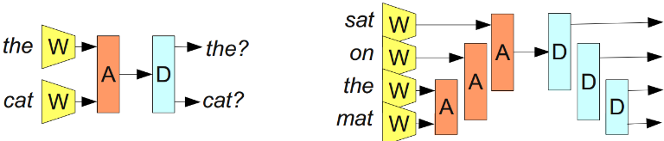
reverse v.逆转；倒退；互换；改变adj.相反的；反面的；颠倒的
n.相反；背面；失败；倒档
The government has failed to reverse the economic decline.
政府未能扭转经济滑坡的趋势
reverse appreciably 明显地改变
reverse automatically 自动地改变 see the reverse看到事物的反面
financial reverse 经济上的挫折 serious〔slight〕 reverse 严重〔轻微〕的挫折
reversible adj.可逆的；双向的；可反转的n.双面式衣服；双面布料
If we could accomplish such a thing, it would be an extremely powerful tool. For example, we could try to make a bilingual sentence representation and use it for translation.
如果这个能成功，将会是一个极其强大的工具。举个例子，我们可以尝试做一个双语句子表征然后把它用在翻译任务上
Unfortunately, this turns out to be very difficult. Very very difficult. And given the tremendous promise, there are lots of people working on it
不幸的是，这个实际上是很难实现的。非常，非常难。同时因为它一旦成功有巨大的前途，有很多人在为研究它而努力
Recently, Cho et al. (2014) have made some progress on representing phrases, with a model that can encode English phrases and decode them in French. Look at the phrase representations it learns!
最近，Cho et al. (2014)在词组表征上有了一些进展，他们做了一个能把英语词组编码，解码成法语的模型。来看看它学习出来的词组表征吧
I’ve heard some of the results reviewed above criticized by researchers in other fields, in particular, in NLP and linguistics.
有关上面我们综述的一些结果，我也听说有其他领域的研究人员，尤其是NLP和语言学的人，对他们进行了批判
I don’t feel qualified to articulate these concerns. I’d encourage someone who feels this way to describe the concerns in the comments.
我觉得自己的能力不足以清晰的表达这些顾虑。我鼓励有能力的人在（英文原文）评论里描述这些顾虑
Conclusion,The representation perspective of deep learning is a powerful view that seems to answer why deep neural networks are so effective.
结论,深度学习中的表征视角是非常有力的，也似乎能够解答为何深度神经网络如此有效
Because better ways of representing data can pop out of optimizing layered models.
因为在优化多层模型的过程中，更好的来数据表征方法会自动浮现出来
Deep learning is a very young field, where theories aren’t strongly established and views quickly change. That said, it is my impression that the representation-focused perspective of neural networks is presently very popular.
深度学习是个非常年轻的领域，理论根基还不强，观点也在快速地改变。我感觉神经网络中重视表征的这个方面目前是十分流行的
This post reviews a lot of research results I find very exciting, but my main motivation is to set the stage for a future post exploring connections between deep learning, type theory and functional programming. If you’re interested, you can subscribe to my rss feed so that you’ll see it when it is published.
在这篇文章里，我综述了一些我觉得十分让人兴奋的研究成果，但我写这篇文章的主要动力是为之后要写的一篇探索深度学习，类型论（type theory）和函数式编程（functional programming）之间关系的文章铺路。如果你感兴趣的话，可以订阅我的RSS（原文作者），这样文章发布时你就能看见了。
I would be delighted to hear your comments and thoughts: you can comment inline or at the end. For typos, technical errors, or clarifications you would like to see added, you are encouraged to make a pull request on github
我很乐意听听你们的想法和评论。如果针对英文原文你发现了错别字，技术错误，或者你认为需要添加的修正或者澄清，欢迎到github来pull
delight n.高兴；快乐v.(使)高兴；(使)欣喜
The children were prancing about with delight.孩子们高兴得蹦蹦跳跳
He delighted the audience with his performance.他用他的表演使观众喜悦
delight audience使观众满意
delight one's hearts使(某人)心情舒畅home-felt delight内心的喜悦
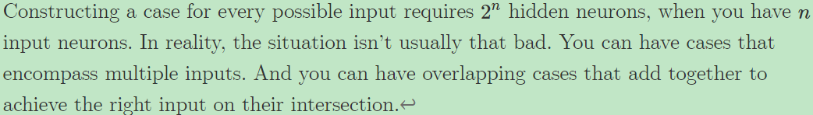
当你有n个输入神经元时，构建所有可能的输入情况需要2^n个隐神经元。在实际操作中，通常不会这么严重。你可以采取能够包含不同输入的情况。你也可以采用重叠的情况，他们利用叠加的方式来在交集处获得正确的输入
(It isn’t only perceptron networks that have universality. Networks of sigmoid neurons (and other activation functions) are also universal: give enough hidden neurons, they can approximate any continuous function arbitrarily well. Seeing this is significantly trickier because you can’t just isolate inputs.)
不仅是感知器网络才有普适性。多层感知器（sigmoid neurons）网络（及其他激发函数）也具有普适性：给予足够的隐节点，他们估算任何连续函数都可以得到不错的结果。因为你不能简单地孤立输入，所以想看明白这点是十分复杂的
Word embeddings were originally developed in (Bengio et al, 2001; Bengio et al, 2003), a few years before the 2006 deep learning renewal, at a time when neural networks were out of fashion. The idea of distributed representations for symbols is even older, e.g. (Hinton 1986)."
单词嵌入最初是由(Bengio et al, 2001; Bengio et al, 2003)开发的。那是2006年深度学习重构开始的前几年，那时神经网络被认为是过时的。而符号话的向量表示（distributed representations）的概念就更老了，比如(Hinton 1986)
renewal n.更新；恢复；革新；复苏；复活
We are all delighted at the renewal of negotiation.我们都对谈判能重新开始感到高兴
We've dealt with several renewals this week.我们在本周内处理了几件续约的事
renewal expense[经] 更新费用, 换新费用, 修补费用renewal process更新过程renewal function更新函数
The seminal paper, A Neural Probabilistic Language Model (Bengio, et al. 2003) has a great deal of insight about why word embeddings are powerful.
这篇开创性的文章：A Neural Probabilistic Language Model (Bengio, et al. 2003)里包含了很多单词嵌入为何有力的解释

