basic

1.1

1.1.1 equalizeHist
path = 'F:/lena.jpg'  img = cv2.imread(path)  cv2.imshow("source img", img)  img[:, :, 0] = cv2.equalizeHist(img[:, :, 0])  img[:, :, 1] = cv2.equalizeHist(img[:, :, 1])  img[:, :, 2] = cv2.equalizeHist(img[:, :, 2])  cv2.imshow("after equalize hist img", img)  cv2.waitKey(0) | 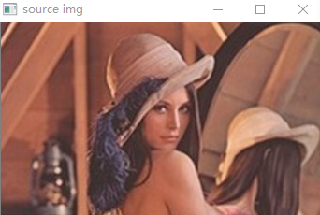  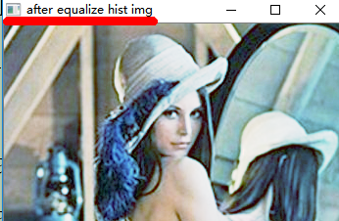

123
123

