chapter 1 - 1 -
1.1 - 1 -
1.1.1 - 1 -
chapter 1 - 1 -
1.1 - 1 -
1.1.1 - 1 -

cpp

1.1 c++ template

1.1.1

123
fsdf

1.1.1

123
fsdf

1.1.1 Using Templates in Practice
Template code is a little different from ordinary code. In some ways templates lie somewhere between macros and ordinary (nontemplate) declarations. Although this may be an oversimplification, it has consequences not only for the way we write algorithms and data structures using templates, but also for the day-to-day logistics of expressing and analyzing programs involving templates.
In this chapter we address some of these practicalities without necessarily delving into the technical details that underlie them. Many of these details are explored in Chapter 10. To keep the discussion simple, we assume that our C++ compilation systems consist of fairly traditional compilers and linkers (C++ systems that don't fall in this category are quite rare).
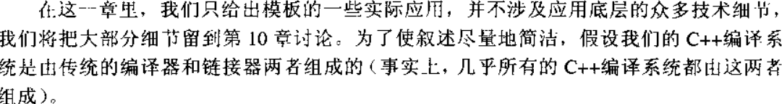
Another (more subtle) observation about the inclusion approach is that noninline function templates are distinct from inline functions and macros in an important way: They are not expanded at the call site. Instead, when they are instantiated, they create a new copy of a function. Because this is an automatic process, a compiler could end up creating two copies in two different files, and some linkers could issue errors when they find two distinct definitions for the same function. In theory, this should not be a concern of ours: It is a problem for the C++ compilation system to accommodate. In practice, things work well most of the time, and we don't need to deal with this issue at all. For large projects that create their own library of code, however, problems occasionally show up. A discussion of instantiation schemes in Chapter 10 and a close study of the documentation that came with the C++ translation system (compiler) should help address these problems.
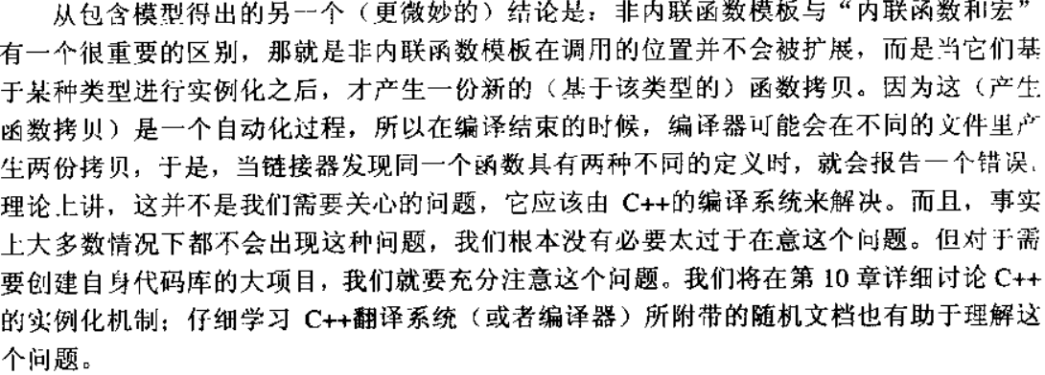
Declaring short functions to be inline is a common tool to improve the running time of programs. The inline specifier indicates to the implementation that inline substitution of the function body at the point of call is preferred over the usual function call mechanism. However, an implementation is not required to perform this inline substitution at the point of call.
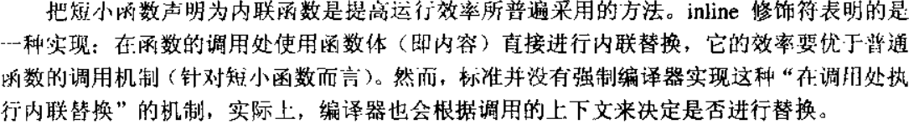
Even without templates, C++ header files can become very large and therefore take a long time to compile. Templates add to this tendency, and the outcry of waiting programmers has in many cases driven vendors to implement a scheme usually known as precompiled headers. This scheme operates outside the scope of the standard and relies on vendor-specific options. Although we leave the details on how to create and use precompiled header files to the documentation of the various C++ compilation systems that have this feature, it is useful to gain some understanding of how it works.
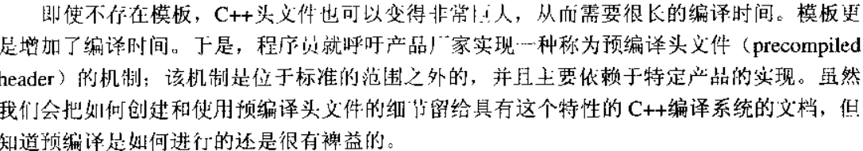
When a compiler translates a file, it does so starting from the beginning of the file and works through to the end. As it processes each token from the file (which may come from #include d files), it adapts its internal state, including such things as adding entries to a table of symbols so they may be looked up later. While doing so, the compiler may also generate code in object files.
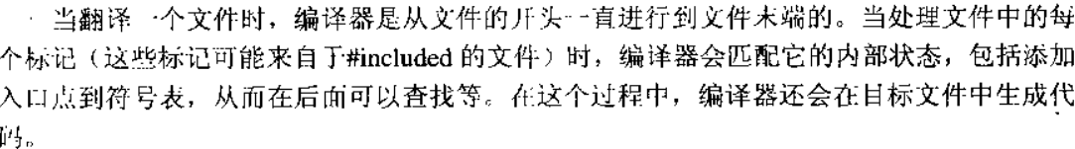
Templates raise two classes of challenges when it comes to debugging them. One set of challenges is definitely a problem for writers of templates: How can we ensure that the templates we write will function for any template arguments that satisfy the conditions we document? The other class of problems is almost exactly the opposite: How can a user of a template find out which of the template parameter requirements it violated when the template does not behave as documented?
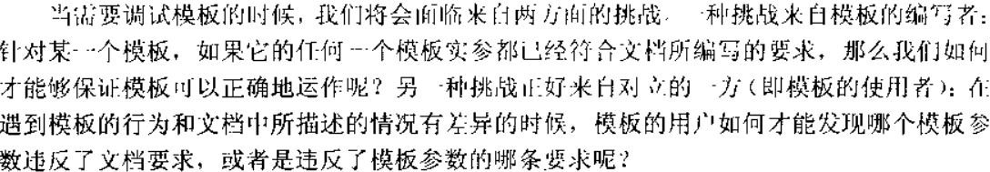
Before we discuss these issues in depth, it is useful to contemplate the kinds of constraints that may be imposed on template parameters. In this section we deal mostly with the constraints that lead to compilation errors when violated, and we call these constraints syntactic constraints. Syntactic constraints can include the need for a certain kind of constructor to exist, for a particular function call to be unambiguous, and so forth. The other kind of constraint we call semantic constraints. These constraints are much harder to verify mechanically. In the general case, it may not even be practical to do so. For example, we may require that there be a < operator defined on a template type parameter (which is a syntactic constraint), but usually we'll also require that the operator actually defines some sort of ordering on its domain (which is a semantic constraint).
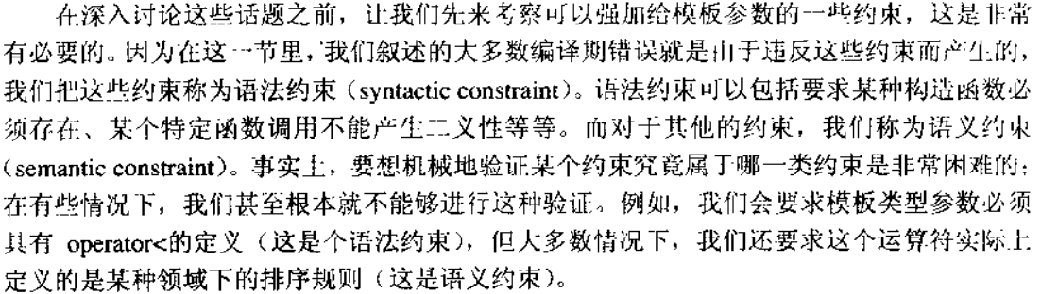
So far we have discussed bugs that arise when compiling or linking programs that contain templates. However, the most challenging task of ensuring that a program behaves correctly at run time often follows a successful build. Templates can sometimes make this task a little more difficult because the behavior of generic code represented by a template depends uniquely on the client of that template (certainly much more so than ordinary classes and functions). A tracer is a software device that can alleviate that aspect of debugging by detecting problems in template definitions early in the development cycle.
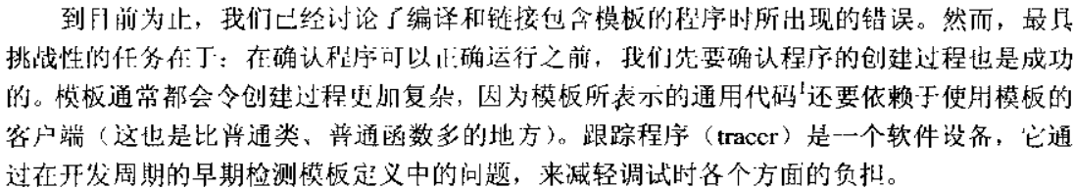
The inclusion versus separation model debate has been a controversial one. The inclusion model is a pragmatic answer dictated largely by existing practice in C++ compiler implementations. However, the first C++ implementation was different: The inclusion of template definitions was implicit, which created a certain illusion of separation (see Chapter 10 for details on this original model).
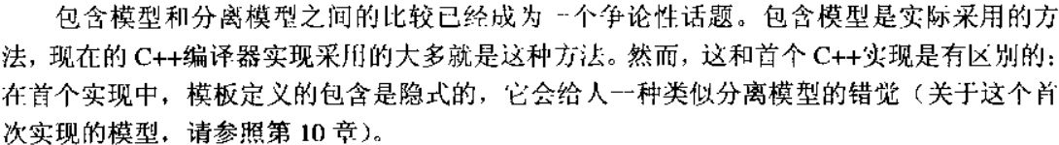
[StroustrupDnE] contains a good presentation of Stroustrup's vision for template code organization and the associated implementation challenges. It clearly wasn't the inclusion model. Yet, at some point in the standardization process, it seemed as if the inclusion model was the only viable approach after all. After some intense debates, however, those envisioning a more decoupled model garnered sufficient support for what eventually became the separation model. Unlike the inclusion model, this was a theoretical model not based on any existing implementation. It took more than five years to see its first implementation published (May 2002).
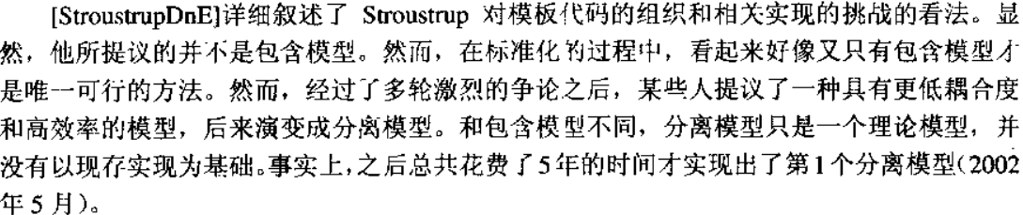

1.1.1 Basic Template Terminology（chapter 7）
So far we have introduced the basic concept of templates in C++. Before we go into details, let's look at the terms of the concepts we use. This is necessary because, inside the C++ community (and even in the standard), there is a lack of precision regarding concepts and terminology.
Instantiation and Specialization(实例化和特化)
The process of creating a regular class, function, or member function from a template by substituting actual values for its arguments is called template instantiation. This resulting entity (class, function, or member function) is generically called a specialization.
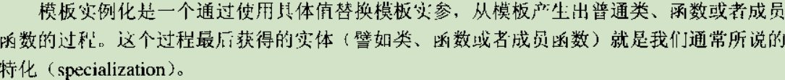
However, in C++ the instantiation process is not the only way to produce a specialization. Alternative mechanisms allow the programmer to specify explicitly a declaration that is tied to a special substitution of template parameters. As we introduced in Section 3.3 on page 27, such a specialization is introduced by template<>
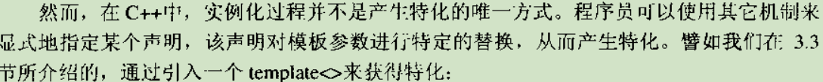
Declarations versus Definitions（声明和定义）
So far, the words declaration and definition have been used only a few times in this book. However, these words carry with them a rather precise meaning in standard C++, and that is the meaning that we use.
A declaration is a C++ construct that introduces or reintroduces a name into a C++ scope. This introduction always includes a partial classification of that name, but the details are not required to make a valid declaration. For example:
The One-Definition Rule (一处定义原则)
The C++ language definition places some constraints on the redeclaration of various entities. The totality of these constraints is known as the one-definition rule or ODR. The details of this rule are quite complex and span a large variety of situations. Later chapters illustrate the various resulting facets in each applicable context, and you can find a complete description of the ODR in Appendix A. For now, it suffices to remember the following ODR basics:
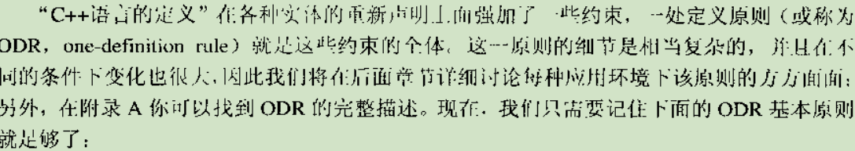
Noninline functions and member functions, as well as global variables and static data members should be defined only once across the whole program.
Class types (including structs and unions) and inline functions should be defined at most once per translation unit, and all these definitions should be identical.
A translation unit is what results from preprocessing a source file; that is, it includes the contents named by #include directives.

1.1.1 Fundamentals in Depth(chapter 8)
Templates in Depth(深入模板)
The first part of this book provided a tutorial for most of the language concepts underlying C++ templates. That presentation is sufficient to answer the majority of questions that may arise in everyday C++ programming. The second part of this book provides a reference that answers even the more unusual questions that arise when pushing the envelope of the language to achieve some advanced software effect. If desired, you can skip this part on a first read and return to specific topics as prompted by references in later chapters or after looking up a concept in the index.
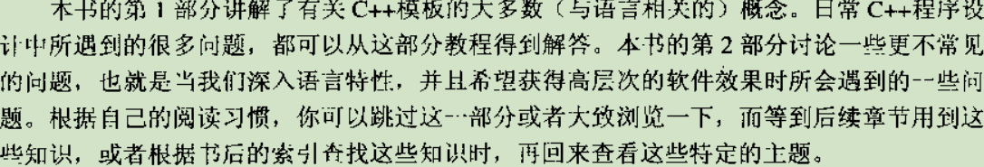
Our goal is to be clear and complete, but also to keep the discussion concise. To this end, our examples are short and often somewhat artificial. This also ensures that we don't stray from the topic at hand to unrelated issues.
In addition, we look at possible future changes and extensions for the templates language feature in C++. Topics include:
Fundamental template declaration issues基本的模板声明话题
The meaning of names in templates模板总命名的含义
The C++ template instantiation mechanisms C++模板实例化机制
The template argument deduction rules 模板实参演绎规则
Specialization and overloading 特化和重载
Future possibilities 将来的改变和扩展

Template Arguments（模板实参）
Template arguments are the "values" that are substituted for template parameters when instantiating a template. These values can be determined using several different mechanisms:
Explicit template arguments: A template name can be followed by explicit template argument values enclosed in angle brackets. The resulting name is called a template-id.
Injected class name: Within the scope of a class template X with template parameters P1 , P2 , …, the name of that template ( X ) can be equivalent to the template-id X<P1, P2, …> . See Section 9.2.3 on page 126 for details.
Default template arguments: Explicit template arguments can be omitted from class template instances if default template arguments are available. However, even if all template parameters have a default value, the (possibly empty) angle brackets must be provided.
Argument deduction: Function template arguments that are not explicitly specified may be deduced from the types of the function call arguments in a call. This is described in detail in Chapter 11. Deduction is also done in a few other situations. If all the template arguments can be deduced, no angle brackets need to be specified after the name of the function template.
Afternotes（后记）
The general concept and syntax of C++ templates have remained relatively stable since their inception in the late 1980s. Class templates and function templates were part of the initial template facility. So were type parameters and nontype parameters.
However, there were also some significant additions to the original design, mostly driven by the needs of the C++ standard library. Member templates may well be the most fundamental of those additions. Curiously, only member function templates were formally voted into the C++ standard. Member class templates became part of the standard by an editorial oversight.
Friend templates, default template arguments, and template template parameters are also relatively recent additions to the language. The ability to declare template template parameters is sometimes called higher-order genericity. They were originally introduced to support a certain allocator model in the C++ standard library, but that allocator model was later replaced by one that does not rely on template template parameters. Later, template template parameters came close to being removed from the language because their specification had remained incomplete until very late in the standardization process. Eventually a majority of committee members voted to keep them and their specifications were completed.
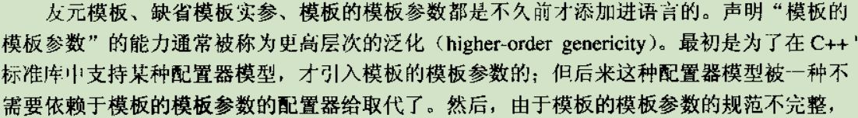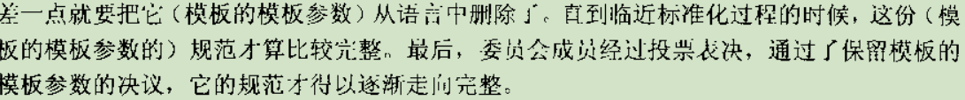

1.1.1 Names in Templates(chapter9)
Name Taxonomy（名称的分类）
C++ classifies names in a variety of ways—a large variety of ways in fact. To help cope with this abundance of terminology, we provide tables Table 9.1 and Table 9.2, which describe these classifications. Fortunately, you can gain good insight into most C++ template issues by familiarizing yourself with two major naming concepts:
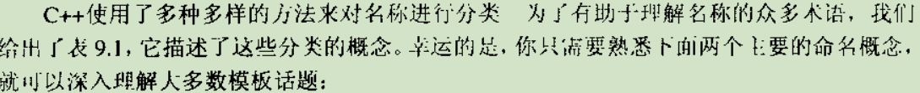
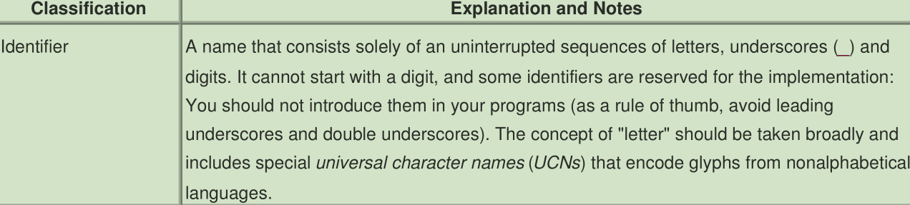
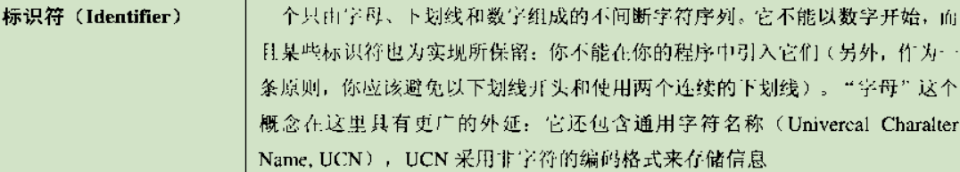
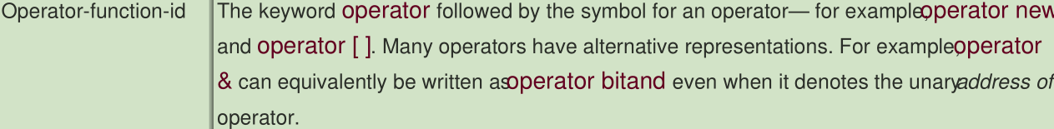
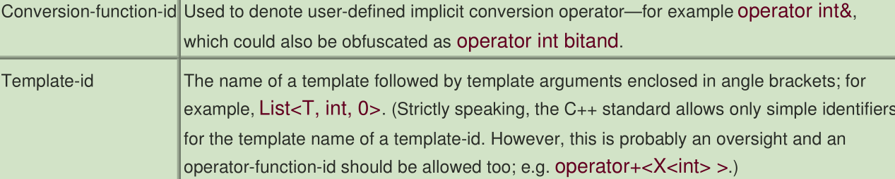
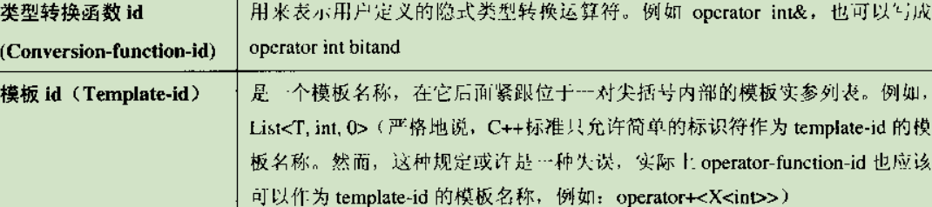
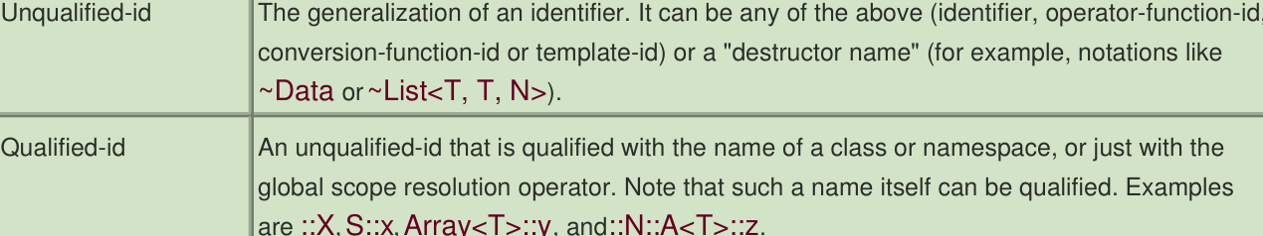
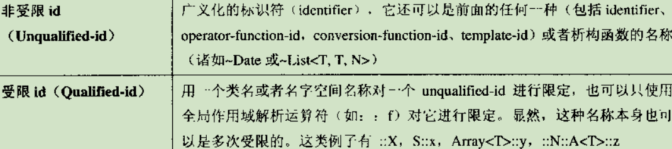
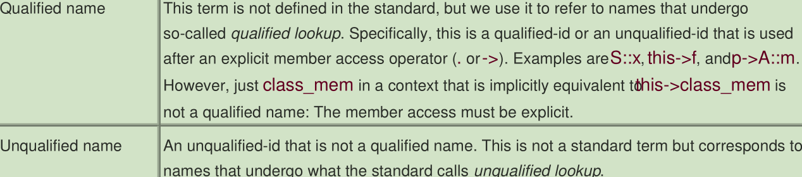
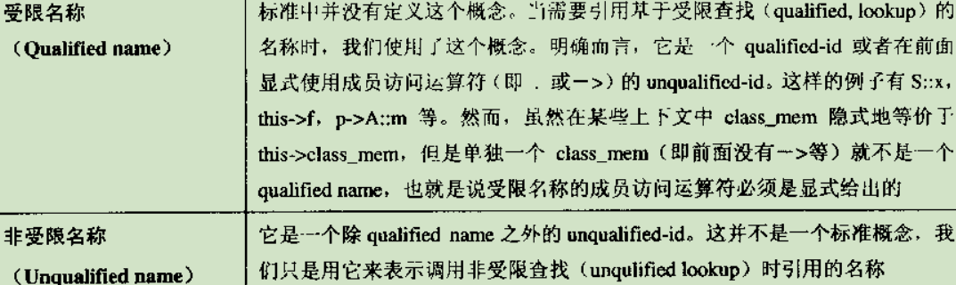
The first compiler really to parse template definitions was developed by a company called Taligent in the mid-1990s. Before that—and even after that—most compilers treated templates as a sequence of tokens to be played back through the parser at instantiation time. Hence no parsing was done, except for a minimal amount sufficient to find the end of a template definition. Bill Gibbons was Taligent's representative to the C++ committee and was the principal advocate for making templates unambiguously parsable. The Taligent effort was not released until the compiler was acquired and completed by Hewlett-Packard (HP), to become the aC++ compiler. Among its competitive advantages, the aC++ compiler was quickly recognized for its high quality diagnostics. The fact that template diagnostics were not always delayed until instantiation time undoubtedly contributed to this perception.
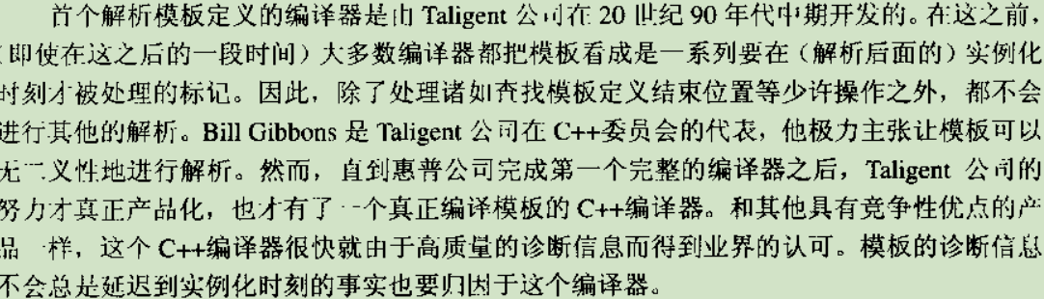
Relatively early during the development of templates, Tom Pennello—a widely recognized parsing expert working for Metaware—noted some of the problems associated with angle brackets. Stroustrup also comments on that topic in [StroustrupDnE] and argues that humans prefer to read angle brackets rather than parentheses. However, other possibilities exist, and Pennello specifically proposed braces (for example, List { ::X }) at a C++ standards meeting in 1991 (held in Dallas). [8] At that time the extent of the problem was more limited because templates nested inside other templates—so-called member templates—were not valid and thus the discussion of Section 9.3.3 on page 132 was largely irrelevant. As a result, the committee declined the proposal to replace the angle brackets.
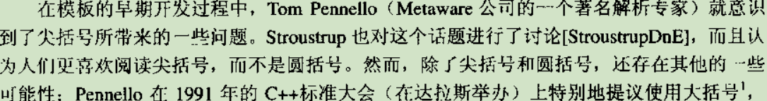
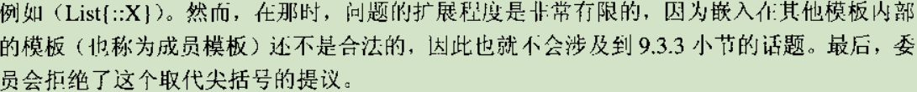

1.1.1 The Polymorphic Power of Templates(chapter14)
模板的多态威力
Polymorphism is the ability to associate different specific behaviors with a single generic notation. [1] Polymorphism is also a cornerstone of the object-oriented programming paradigm, which in C++ is supported mainly through class inheritance and virtual functions. Because these mechanism are (at least in part) handled at run time, we talk about dynamic polymorphism. This is usually what is thought of when talking about plain polymorphism in C++. However, templates also allow us to associate different specific behaviors with a single generic notation, but this association is generally handled at compile time, which we refer to as static polymorphism. In this chapter we review the two forms of polymorphism and discuss which form is appropriate in which situations.
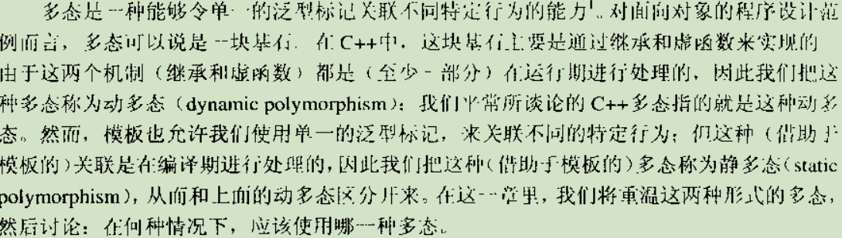
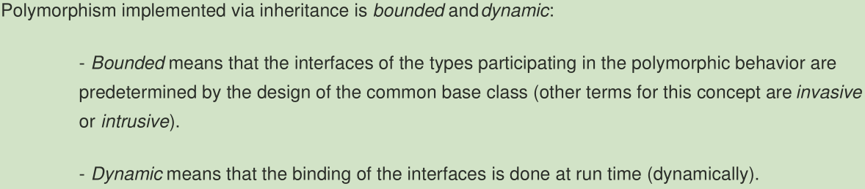
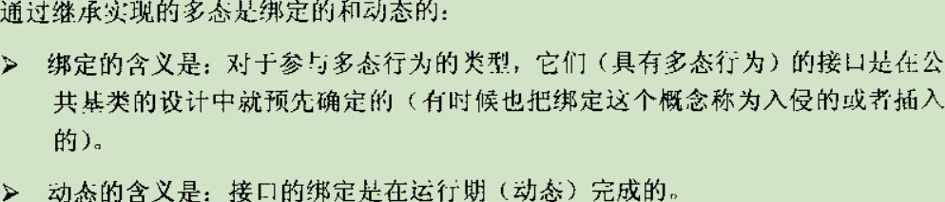
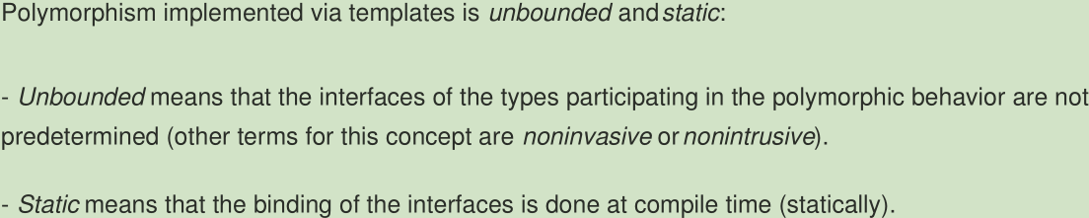
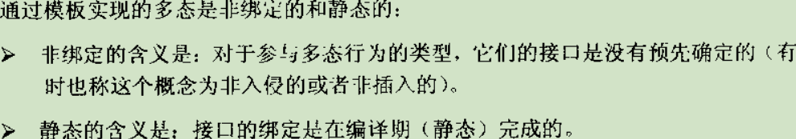

1.1.1 Fundamentals in Depth(chapter12)
Templates in Depth(深入模板)

chapter 1

1.1

1.1.1

123
fsdf

