Netty IA - 1 -
1.1 about - 1 -
Http TDG - 7 -
1.1 overview - 7 -
1.1.1 basic concepts - 7 -
1.1.1 URLs and Resource - 16 -
1.1.1 HTTP Messages - 22 -
1.1.1 Connection management - 25 -
1.1.1 HTTP Messages 错误！未定义书签。
1.1.1 HTTP Messages 错误！未定义书签。

Netty IA

1.1 about
Netty is a Java framework for the rapid development of high-performance network applications. It encapsulates the complexities of network programming and makes the most recent advances in networking and web technologies accessible to a broader range of developers than ever before.
Netty 是一款用于快速开发高性能的网络应用程序的 Java 框架。 它封装了网络编程的复杂性， 使网络编程和 Web 技术的最新进展能够被比以往更广泛的开发人员接触到
this book will show how Netty can help you to write more efficient, reusable, and maintainable code
本书还会展示 Netty 如何能够帮助开发人员编写更高效的、可复用的、可维护的代码
Roadmap Netty in Action has four parts and an appendix
导读 本书共分 4 个部分，且有一个附录
Part 1: Netty concepts and architecture Netty 的概念及体系结构
Part 1 is a detailed guide to the framework, covering its design, components, and programming interfaces
第一部分是对框架的详细介绍，涵盖了它的设计、组件以及编程接口
Chapter 1 begins with a brief overview of the blocking and non-blocking network API s and the corresponding JDK interfaces. We introduce Netty as a toolkit for build- ing highly scalable, asynchronous and event-driven networking applications. We take a first look at the basic building blocks of the framework: channels, callbacks, futures, events, and handlers
第 1 章首先简要概述了阻塞和非阻塞的网络 API， 以及它们对应的 JDK 接口。 我们引入 Netty 作为构建高度可伸缩的、异步的、事件驱动的网络编程应用的工具包。我们将首先看一下该框架 的基础构件块：Channel、回调、Future、事件及 ChannelHandler
Chapter 2 explains how to configure your system for building and running with the book’s sample code. We test it out with a simple application, a server that echoes the messages it receives from connected clients. We introduce bootstrapping—assem- bling and configuring all the components of an application at runtime.
第 2 章解释了如何配置读者的系统以构建并运行本书中的示例代码。 我们将用一个简单的应用程序来测试它，这是一个回送从连接的客户端接收到的消息的服务器应用程序。我们还介绍了 引导（Bootstrap）——在运行时组装和配置一个应用程序的所有组件的过程
Chapter 3 begins with a discussion of the technical and architectural aspects of Netty. The core components of the framework are introduced: Channel , EventLoop , ChannelHandler , and ChannelPipeline . The chapter concludes with an explanation of the differences between bootstrapping servers and clients.
第 3 章首先讨论了 Netty 的技术以及体系结构方面的内容。介绍了该框架的核心组件： Channel、EventLoop、ChannelHandler 以及 ChannelPipeline。这一章的最后解释了 引导服务器和客户端之间的差异
Chapter 4 discusses network transports and contrasts the use of blocking and non- blocking transports with the JDK API s and with Netty. We study the interface hierarchy underlying Netty’s transport API and the transport types they support.
第 4 章讨论了网络传输，并且对比了通过 JDK API 和 Netty 使用阻塞和非阻塞传输的用法。 我们研究了 Netty 的传输 API 的底层接口的层级关系以及它们所支持的传输类型
Chapter 5 is devoted to the framework’s data handling API — ByteBuf , Netty’s byte container. We describe its advantages over the JDK ’s ByteBuffer , and the ways in which the memory used by a ByteBuf can be allocated and accessed. We show how to manage memory resources using reference counting.
第 5 章专门介绍了该框架的数据处理 API——ByteBuf，Netty 的字节容器。我们描述了它 相对于 JDK 的 ByteBuffer 的优势，以及如何分配和访问由 ByteBuf 所使用的内存。我们展 示了如何通过引用计数来管理内存资源
Chapter 6 focuses on the core components ChannelHandler and ChannelPipeline , which are responsible for dispatching application processing logic and moving data and events through the network layer. Additional topics include the role of Channel- HandlerContext in implementing advanced use cases and the sharing of Channel- Handler s among multiple ChannelPipeline s. The chapter concludes with an illustration of handling exceptions triggered by inbound and outbound events.
第 6 章重点介绍了核心组件 ChannelHandler 和 ChannelPipeline，它们负责调度 应用程序的处理逻辑，并驱动数据和事件经过网络层。其他的主题包括在实现高级用例时 ChannelHandlerContext的角色， 以及在多个ChannelPipeline之间共享ChannelHandler 的缘由。这一章的最后说明了如何处理由入站事件和出站事件所触发的异常
Chapter 7 provides a general overview of threading models and covers Netty’s threading model in detail. We examine interface EventLoop , which is the principal component of Netty’s concurrency API , and explain its relationship with threads and Channel s. This information is essential for understanding how Netty implements asyn- chronous, event-driven networking. We show how to perform task scheduling using EventLoop
第 7 章提供了关于线程模型的一般概述，并详细地介绍了 Netty 的线程模型。我们研究了 interface EventLoop， 它 是 Netty 的并发 API 的主要部分， 并解释了它和线程以及 Channel 的关系。这个信息对于理解 Netty 是如何实现异步的、事件驱动的网络编程模型来说至关重要。 我们展示了如何通过 EventLoop 进行任务调度
Chapter 8 explores bootstrapping in depth, starting with the Bootstrap class hier- archy. We revisit the basic use cases as well as some special ones, such as bootstrapping a client connection within a server application, bootstrapping datagram channels, and adding multiple channels during the bootstrapping phase. The chapter concludes with a discussion of how to shut down an application gracefully and release all resources in an orderly fashion
第 8 章以介绍 Bootstrap 类的层级结构作为引子，深入地讲解了引导。我们重新审视了一 些基本用例以及一些特殊用例，例如，在一个服务器应用程序中引导一个客户端连接、引导数据 报 Channel， 以及在引导的过程中添加多个 ChannelHandler。 这一章最后讨论了如何优雅地 关闭应用程序并有序地释放所有的资源
Chapter 9 is about unit testing ChannelHandler s, for which Netty provides a special Channel implementation, EmbeddedChannel . The examples show how to use this class with JUnit to test both inbound and outbound handler implementations
第 9 章是关于对 ChannelHandler 进行单元测试的讨论，对此 Netty 提供了一个特殊的 Channel 实现——EmbeddedChannel。本章的示例展示了如何使用这个类和 JUnit 一起来测试 入站和出站 ChannelHandler 实现

Part 2: Codecs 编解码器
Data conversion is one of the most common operations in network programming. Part 2 describes the rich set of tools Netty provides to simplify this task
数据转换是网络编程中最常见的操作之一。第二部分介绍了 Netty 提供的用于简化这一任务 的丰富的工具集
Chapter 10 begins by explaining decoders and encoders, which transform sequences of bytes from one format to another. A ubiquitous example is converting an unstructured byte stream to and from a protocol-specific layout. A codec, then, is a component that combines both an encoder and a decoder in order to handle conver- sions in both directions. We provide several examples to show how easy it is to create custom decoders and encoders with Netty’s codec framework classes.
第 10 章首先解释了解码器和编码器，它们将字节序列从一种格式转换为另外一种格式。一 个无处不在的例子便是将一个非结构化的字节流转换为一个特定于协议的布局结构，或者相反 的。编解码器则是一个结合了编码器以及解码器以处理双向转换的组件。我们提供了几个例子， 展示了通过 Netty 的编解码器框架类创建自定义的解码器以及编码器是多么地容易
Chapter 11 examines the codecs and ChannelHandler s Netty provides for a variety of use cases. These classes include ready-to-use codecs for protocols such as SSL/TLS , HTTP/HTTPS , WebSocket, and SPDY , and decoders that can be extended to handle almost any delimited, variable length or fixed-length protocol. The chapter con- cludes with a look at framework components for writing large volumes of data and for serialization.
第 11 章研究了 Netty 提供的用于各种用例的编解码器以及 ChannelHandler。这些类包括 用于协议的（如 SSL/TLS、HTTP/HTTPS、WebSocket 以及 SPDY）即用型的编解码器，以及能够通过扩展来处理几乎任意的基于分隔符的协议、变长协议或者定长协议的解码器。这一章的最 后介绍了用于写入大型数据的和用于序列化的框架组件。
Part 3: Network protocols网络协议
Part 3 elaborates on several network protocols that have been touched on briefly earlier in the book. We’ll see once again how Netty makes it easy to adopt complex API s in your applications without having to be concerned with their internal complexities.
第三部分详细阐述了几种本书前面简要介绍过的网络协议。我们将会再次看到 Netty 是如何 使你能在自己的应用程序中轻松采用复杂的 API，而又不必关心其内部复杂性的
Chapter 12 shows how to use the WebSocket protocol to implement bidirectional communications between a web server and client. The example application is a chat room server that allows all connected users to communicate with one another in real time.
第 12 章展示了如何使用 WebSocket 协议来实现 Web 服务器和客户端之间的双向通信。示例 程序是一个聊天室服务器，其允许所有已连接的用户与其他已连接的用户进行实时通信
Chapter 13 illustrates Netty’s support for connectionless protocols with a server and client that utilize the broadcast capabilities of the User Datagram Protocol ( UDP ). As in the previous examples, we employ a set of protocol-specific support classes: DatagramPacket and NioDatagramChannel .
第 13 章通过利用了用户数据报协议（UDP）的广播能力的服务器和客户端应用程序，说明 了 Netty 对于无连接协议的支持。如同前面的那些示例一样，我们使用了一组特定于协议的支持 类：DatagramPacket 和 NioDatagramChannel
Part 4: Case studies 案例研究
Part 4 presents five case studies submitted by well-known companies that have used Netty to implement mission-critical systems. These examples illustrate not only real- world usages of the framework components we have discussed throughout the book, but also the application of Netty’s design and architectural principles to building highly scalable and extensible applications
第四部分介绍了由使用 Netty 实现了任务关键型系统的知名公司提交的 5 份案例研究。这些 案例不仅说明了我们在整本书中所讨论过的框架各个组件在现实世界中的应用，而且还演示了 Netty 的设计以及架构原则，在构建高度可伸缩和可扩展的应用程序方面的应用
Appendix: Introduction to Maven
Basic Maven concepts: the POM file, artifacts, coordinates, dependencies, plugins, and repositories
Maven 的基本概念——POM 文件、构件、坐标、依赖、插件及存储库
Example Maven configurations, POM inheritance, and aggregation
Maven 配置的示例，POM 的继承以及聚合
Maven’s command-line syntax Maven 的命令行语法
The class java.nio.channels.Selector is the linchpin of Java’s non-blocking I/ O implementation. It uses the event notification API to indicate which, among a set of non-blocking sockets , are ready for I/O .
linchpin n. 制轮楔；轮辖；关键
Controlling wages is the linchpin of the Government's policies.
控制工资是政府政策的关键
Security 安全性 Complete SSL/TLS and StartTLS support. Usable in restricted environments such as Applet or OSGI.
完整的 SSL/TLS 以及 StartTLS 支持 可用于受限环境下，如 Applet 和 OSGI
Community-driven Release early and often.
社区驱动 发布快速而且频繁

Http TDG

1.1 overview （18/5/13printed）

1.1.1 basic concepts
The world’s web browsers, servers, and related web applications all talk to each other through HTTP, the Hypertext Transfer Protocol. HTTP is the common language of the modern global Internet.
Web 浏览器、服务器和相关的 Web 应用程序都是通过 HTTP 相互通信的。HTTP 是 现代全球因特网中使用的公共语言
How web transactions work Web 事务是怎样工作的
The underlying TCP network transport 底层 TCP 网络传输
Some of the many HTTP architectural components installed around the Internet
因特网上安装的 大量 HTTP 架构组件中的一部分
HTTP: The Internet’s Multimedia Courier HTTP——因特网的多媒体信使
courier n. 送快信的；急差；旅行服务员
diplomatic courier外交信使courier service 快递服务
courier receipt 专递收据；快邮收据by courier 由快递公司传递
Billions of JPEG images, HTML pages, text files, MPEG movies, WAV audio files, Java applets, and more cruise through the Internet each and every day.
每天，都有数以亿万计的 JPEG 图片、HTML 页面、文本文件、MPEG 电影、WAV 音频文件、Java 小程序和其他资源在因特网上游弋
cruise n. 巡航；漫游； 游艇v. 慢速行驶；乘船游览；游弋；巡游
He and his wife were planning to cruise. 他和他妻子准备乘船周游世界
cruise about〔around〕 在…巡游cruise along 沿…巡游
journey，tour，travel，trip，voyage，excursion，expedition，cruise这些名词均含“旅行”之意。journey最普通用词，侧重指时间较长、距离较远的单程陆上旅行，也指水上或空中的旅行。tour指最后返回出发地，旅途中有停留游览点，距离可长可短，目的各异的周游或巡行。travel泛指旅行的行为而不指某次具体的旅行，多指到远方作长期旅行，不强调直接目的地，单、复数均可用。trip普通用词，口语多用，常指为公务或游玩作的较短暂的旅行。voyage指在水上旅行，尤指海上旅行，也可指空中旅行。excursion较正式用词，常指不超过一天的短时期娱乐性游玩，也可指乘火车或轮船往返特定景点的远足旅游。expedition指有特定目的远征或探险。cruise主要指乘船的游览并在多处停靠
Because HTTP uses reliable data-transmission protocols, it guarantees that your data will not be damaged or scrambled in transit, even when it comes from the other side of the globe.
HTTP 使用的是可靠的数据传输协议，因此即使数据来自地球的另一端，它也能够 确保数据在传输的过程中不会被损坏或产生混乱
You can focus on programming the distinguishing details of your application, without worrying about the flaws and foibles of the Internet.
开发人员可以专注于应用程序特有细节的编写，而不用考虑因特网中存 在的一些缺陷和问题
foible n. 小缺点；小毛病
Lazy is one of the foible in humanity. 人性的弱点之一是懒惰
eccentricity 古怪defect 缺点idiosyncrasy 特质vice 缺点weakness 软弱fault 缺点
Let’s look more closely at how HTTP transports the Web’s traffic.
下面，就让我们来近距离地观察一下 HTTP 是如何传输 Web 流量的
Media Types 媒体类型
Because the Internet hosts many thousands of different data types, HTTP carefully tags each object being transported through the Web with a data format label called a MIME type. MIME (Multipurpose Internet Mail Extensions) was originally designed to solve problems encountered in moving messages between different electronic mail systems.
因特网上有数千种不同的数据类型，HTTP 仔细地给每种要通过 Web 传输的对 象都打上了名为 MIME 类型（MIME type）的数据格式标签。最初设计 MIME （Multipurpose Internet Mail Extension，多用途因特网邮件扩展）是为了解决在不同 的电子邮件系统之间搬移报文时存在的问题
There are hundreds of popular MIME types, and many more experimental or limited-use types. A very thorough MIME type list is provided in Appendix D.
常见的 MIME 类型有数百个，实验性或用途有限的 MIME 类型则更多。附录 D 提 供了一个非常完整的 MIME 类型列表
thorough adj. 彻底的；完全的；详尽的；细致深入的
We are trying to get a thorough understanding of the government's fiscal policy.
我们正努力对政府的财政政策进行全面的了解
thorough cleaning 彻底打扫thorough description 详尽的描写enormously thorough 非常彻底的thorough in one's work 工作认真
fiscal adj. 财政的；国库的 financial 金融的economic 经济学的
The server resource name is called a uniform resource identifier, or URI. URIs are like the postal addresses of the Internet, uniquely identifying and locating information resources around the world.
服务器资源名被称为统一资源标识符（Uniform Resource Identifier，URI） 。 URI 就像因特网上的邮政地址一样，在世界范围内唯一标识并定位信息资源
postal adj. 邮政的n. 明信片
The postal service here is very unreliable. 这里的邮政服务很不可靠
He sent me some postal cards from Paris. 他从巴黎给我寄来几张明信片
postal card 明信片postal order 邮政汇票postcode 邮政编码
uniform n. 制服adj. 一致的；统一的
The students are wearing school uniforms. 学生们穿着校服
Their internal temperatures are essentially uniform with the environment.
它们的体温与周围环境基本上是一致的
in uniform 穿着制服out of uniform 穿着便服parade uniform 阅兵礼服
The second flavor of URI is the uniform resource name, or URN. A URN serves as a unique name for a particular piece of content, independent of where the resource currently resides.
URI 的第二种形式就是统一资源名（URN） 。URN 是作为特定内容的唯一名称使用 的，与目前的资源所在地无关
flavor n. 风味；特殊的滋味；风格；调味品vt. 加调料于...；给...添加情趣
The course has a distinctive Italian flavor.
这道菜很有意大利餐的风味
He flavored the evening with a poetry reading.
他以朗诵诗歌给夜晚增添情趣
These location-independent URNs allow resources to move from place to place. URNs also allow resources to be accessed by multiple network access protocols while maintaining the same name.
使用这些与位置无关的 URN，就可以将资源四处搬 移。通过 URN，还可以用同一个名字通过多种网络访问协议来访问资源
For example, the following URN might be used to name the Internet standards docu- ment “RFC 2141” regardless of where it resides (it may even be copied in several places)
比如，不论因特网标准文档 RFC 2141 位于何处（甚至可以将其复制到多个地方） ， 都可以用下列 URN 来命名它：urn:ietf:rfc:2141
Messages 报文
Now let’s take a quick look at the structure of HTTP request and response messages. We’ll study HTTP messages in exquisite detail in Chapter 3
现在我们来快速浏览一下 HTTP 请求和响应报文的结构。第 3 章会深入研究 HTTP 报文
exquisite adj. 精挑细选的；精致的；细腻的；强烈的n. 过分在意外表着装的人
The hostess had exquisite taste in clothes. 女主人对衣著十分讲究
The girl came up with a set of exquisite stamps. 那姑娘拿出一套精美的邮票
exquisite design 精美的图案exquisite sensibility 灵敏的感觉能力
HTTP messages are simple, line-oriented sequences of characters. Because they are plain text, not binary, they are easy for humans to read and write. * Figure 1-7 shows the HTTP messages for a simple transaction.
HTTP 报文是由一行一行的简单字符串组成的。HTTP 报文都是纯文本，不是二进 制代码，所以人们可以很方便地对其进行读写 1 。图 1-7 显示了一个简单事务所使用 的 HTTP 报文
HTTP messages sent from web clients to web servers are called request messages. Messages from servers to clients are called response messages.
从 Web 客户端发往 Web 服务器的 HTTP 报文称为请求报文（request message） 。从 服务器发往客户端的报文称为响应报文（response message）
HTTP messages consist of three parts:
Start line 起始行
The first line of the message is the start line, indicating what to do for a request or what happened for a response.
报文的第一行就是起始行，在请求报文中用来说明要做些什么，在响应报文中说 明出现了什么情况
Header fields首部字段
Zero or more header fields follow the start line. Each header field consists of a name and a value, separated by a colon (:) for easy parsing. The headers end with a blank line. Adding a header field is as easy as adding another line.
起始行后面有零个或多个首部字段。每个首部字段都包含一个名字和一个值，为 了便于解析，两者之间用冒号（:）来分隔。首部以一个空行结束。添加一个首 部字段和添加新行一样简单
Body主体
After the blank line is an optional message body containing any kind of data. Request bodies carry data to the web server; response bodies carry data back to the client. Unlike the start lines and headers, which are textual and structured, the body can contain arbitrary binary data (e.g., images, videos, audio tracks, software applications). Of course, the body can also contain text.
空行之后就是可选的报文主体了，其中包含了所有类型的数据。请求主体中包括 了要发送给 Web 服务器的数据；响应主体中装载了要返回给客户端的数据。起 始行和首部都是文本形式且都是结构化的，而主体则不同，主体中可以包含任意 的二进制数据（比如图片、视频、音轨、软件程序） 。当然，主体中也可以包含 文本
Connections 连接
Now that we’ve sketched what HTTP’s messages look like, let’s talk for a moment about how messages move from place to place, across Transmission Control Protocol (TCP) connections
概要介绍了 HTTP 报文的构成之后，我们来讨论一下报文是如何通过传输控制协议 （Transmission Control Protocol，TCP）连接从一个地方搬移到另一个地方去的
TCP/IP
HTTP is an application layer protocol. HTTP doesn’t worry about the nitty-gritty details of network communication; instead, it leaves the details of networking to TCP/IP, the popular reliable Internet transport protocol
HTTP 是个应用层协议。HTTP 无需操心网络通信的具体细节；它把联网的细节都 交给了通用、可靠的因特网传输协议 TCP/IP
TCP provides:
Error-free data transportation
无差错的数据传输
In-order delivery (data will always arrive in the order in which it was sent)
按序传输（数据总是会按照发送的顺序到达）
Unsegmented data stream (can dribble out data in any size at any time)
未分段的数据流（可以在任意时刻以任意尺寸将数据发送出去）
dribble vt. 使 ... 慢慢流下；运球；细流；流口水n. 少量；细流
Dribble the oil into the beaten egg yolks.往打匀的蛋黄里一滴滴加油.
He wiped a dribble of milk from his chin with a handkerchief.
他用手帕擦去淌在下巴上的一点牛奶

Protocol Versions
There are several versions of the HTTP protocol in use today. HTTP applications need to work hard to robustly handle different variations of the HTTP protocol. The versions in use are:
现在使用的 HTTP 协议有几个版本。HTTP 应用程序要尽量强健地处理各种不同的 HTTP 协议变体。目前仍在使用的版本如下
HTTP/0.9
The 1991 prototype version of HTTP is known as HTTP/0.9. This protocol con- tains many serious design flaws and should be used only to interoperate with legacy clients. HTTP/0.9 supports only the GET method, and it does not sup- port MIME typing of multimedia content, HTTP headers, or version numbers. HTTP/0.9 was originally defined to fetch simple HTML objects. It was soon replaced with HTTP/1.0
HTTP 的 1991 原型版本称为 HTTP/0.9。这个协议有很多严重的设计缺陷，只应 该用于与老客户端的交互。HTTP/0.9 只支持 GET 方法，不支持多媒体内容的 MIME 类型、各种 HTTP 首部，或者版本号。HTTP/0.9 定义的初衷是为了获取 简单的 HTML 对象，它很快就被 HTTP/1.0 取代了
HTTP/1.0
1.0 was the first version of HTTP that was widely deployed. HTTP/1.0 added version numbers, HTTP headers, additional methods, and multimedia object handling. HTTP/1.0 made it practical to support graphically appealing web pages and interactive forms, which helped promote the wide-scale adoption of the World Wide Web. This specification was never well specified. It represented a collection of best practices in a time of rapid commercial and academic evolu tion of the protocol.
1.0 是第一个得到广泛使用的 HTTP 版本。HTTP/1.0 添加了版本号、各种 HTTP 首部、一些额外的方法，以及对多媒体对象的处理。HTTP/1.0 使得包含生动图 片的 Web 页面和交互式表格成为可能，而这些页面和表格促使万维网为人们广 泛地接受。这个规范从未得到良好地说明。在这个 HTTP 协议的商业演进和学术 研究都在快速进行的时代，它集合了一系列的最佳实践
HTTP/1.0+
Many popular web clients and servers rapidly added features to HTTP in the mid-1990s to meet the demands of a rapidly expanding, commercially success- ful World Wide Web. Many of these features, including long-lasting “keep- alive” connections, virtual hosting support, and proxy connection support, were added to HTTP and became unofficial, de facto standards. This informal, extended version of HTTP is often referred to as HTTP/1.0+
在 20 世纪 90 年代中叶，很多流行的 Web 客户端和服务器都在飞快地向 HTTP 中添加各种特性，以满足快速扩张且在商业上十分成功的万维网的需要。其中很 多特性，包括持久的 keep-alive 连接、虚拟主机支持，以及代理连接支持都被加 入到 HTTP 之中，并成为非官方的事实标准。这种非正式的 HTTP 扩展版本通常 称为 HTTP/1.0+
HTTP/1.1
HTTP/1.1 focused on correcting architectural flaws in the design of HTTP, spec- ifying semantics, introducing significant performance optimizations, and remov- ing mis-features. HTTP/1.1 also included support for the more sophisticated web applications and deployments that were under way in the late 1990s. HTTP/1.1 is the current version of HTTP
HTTP/1.1 重点关注的是校正 HTTP 设计中的结构性缺陷，明确语义，引入重要 的性能优化措施，并删除一些不好的特性。HTTP/1.1 还包含了对 20 世纪 90 年 代末正在发展中的更复杂的 Web 应用程序和部署方式的支持。HTTP/1.1 是当前 使用的 HTTP 版本
Architectural Components of the Web Web的结构组件
In this overview chapter, we’ve focused on how two web applications (web browsers and web servers) send messages back and forth to implement basic transactions. There are many other web applications that you interact with on the Internet. In this section, we’ll outline several other important applications, including:
在本章的概述中，我们重点介绍了两个 Web 应用程序（Web 浏览器和 Web 服务器） 是如何相互发送报文来实现基本事务处理的。在因特网上，要与很多 Web 应用程序 进行交互。在本节中，我们将列出其他一些比较重要的应用程序，如下所示
Proxies 代理
HTTP intermediaries that sit between clients and servers
位于客户端和服务器之间的 HTTP 中间实体
Caches 缓存
HTTP storehouses that keep copies of popular web pages close to clients
HTTP 的仓库，使常用页面的副本可以保存在离客户端更近的地方
Gateways 网关
Special web servers that connect to other applications
连接其他应用程序的特殊 Web 服务器
Tunnels 隧道
Special proxies that blindly forward HTTP communications
对 HTTP 通信报文进行盲转发的特殊代理
Agents 代理
Semi-intelligent web clients that make automated HTTP requests
发起自动 HTTP 请求的半智能 Web 客户端
tunnel n. 隧道；地道；洞穴v. 挖地道；挖隧道
The heavy traffic crawled through the narrow tunnel.
拥挤的车辆慢吞吞地穿过狭窄的隧道
The engineers had to tunnel through solid rock.工程师须要在坚实的岩石中开凿隧道
tunnel test 隧道试验sewer tunnel 污水管道隧洞
Let’s start by looking at HTTP proxy servers, important building blocks for web security, application integration, and performance optimization
首先我们来看看 HTTP 代理服务器，这是 Web 安全、应用集成以及性能优化的重要 组成模块
Proxies are often used for security, acting as trusted intermediaries through which all web traffic flows. Proxies can also filter requests and responses; for example, to detect application viruses in corporate downloads or to filter adult content away from elementary-school students.
出于安全考虑，通常会将代理作为转发所有 Web 流量的可信任中间节点使用。代理 还可以对请求和响应进行过滤。比如，在企业中对下载的应用程序进行病毒检测， 或者对小学生屏蔽一些成人才能看的内容
Gateways are special servers that act as intermediaries for other servers. They are often used to convert HTTP traffic to another protocol. A gateway always receives requests as if it was the origin server for the resource. The client may not be aware it is communicating with a gateway
网关（gateway）是一种特殊的服务器，作为其他服务器的中间实体使用。通常用于 将 HTTP 流量转换成其他的协议。网关接受请求时就好像自己是资源的源端服务器 一样。客户端可能并不知道自己正在与一个网关进行通信
intermediate adj. 中间的；中级的n. 中间体；调解人；媒介物vi. 调解；干涉
I've passed the intermediate level exam of Japanese.
我已经通过了日语的中级水平考试
What is the structure of this intermediate
这个中间产物的结构是怎样的
We need him as the intermediate in the negotiations.
我们需要他做这次谈判的调解人
intermediate frequency 中频intermediate range missiles 中程导弹
intermediary n. 仲裁者；调解者；中介adj. 中间的；媒介的 [计算机] 媒介.
Tunnels are HTTP applications that, after setup, blindly relay raw data between two connections. HTTP tunnels are often used to transport non-HTTP data over one or more HTTP connections, without looking at the data
隧道（tunnel）是建立起来之后，就会在两条连接之间对原始数据进行盲转发的 HTTP 应用程序。HTTP 隧道通常用来在一条或多条 HTTP 连接上转发非 HTTP 数 据，转发时不会窥探数据
One popular use of HTTP tunnels is to carry encrypted Secure Sockets Layer (SSL) traffic through an HTTP connection, allowing SSL traffic through corporate fire- walls that permit only web traffic.
HTTP 隧道的一种常见用途是通过 HTTP 连接承载加密的安全套接字层（SSL， Secure Sockets Layer）流量，这样 SSL 流量就可以穿过只允许 Web 流量通过的防 火墙了
The End of the Beginning 起始部分的结束语
That’s it for our quick introduction to HTTP这就是我们对 HTTP 的简要介绍

1.1.1 URLs and Resource
URLs and Resources URL与资源
You’d use phone numbers for the fire department, the boss’s secretary, and your mother, who says you don’t call enough.
博物馆、饭店和家庭住址要使用街道 地址，消防局、老板的秘书，以及抱怨你太少打电话给她的母亲要使用电话号码
And because everyone agreed on standards for these different names, we can easily share the city’s treasures with each other
所有人都对这些名字的标准达成了一致，所以才能方便地共享这座城市的宝藏
treasure n. 财富；宝物vt. 珍藏；珍视
I shall always treasure the memory of our meetings.
我将永远记住我们相聚的情景
This museum has many art treasures.这家博物馆收藏了许多艺术珍品
treasure, appreciate, cherish, prize, value这组词的共同意思是“高度评价某事物”。其区别是：1.appreciate强调理解并欣赏其价值; value强调高度评价并珍视其价值; prize指珍视; treasure指珍藏。2.cherish与prize和treasure含义相同,指珍视或珍藏,但喜爱之意更甚
URL syntax and what the various URL components mean and do
URL 语法，以及各种 URL 组件的含义及其所做的工作
URL shortcuts that many web clients support, including relative URLs and expandomatic URLs
很多 Web 客户端都支持的 URL 快捷方式，包括相对 URL 和自动扩展 URL
URL encoding and character rules URL 编码和字符规则
Common URL schemes that support a variety of Internet information systems
支持各种因特网信息系统的常见 URL 方案
The future of URLs, including uniform resource names (URNs)—a framework to support objects that move from place to place while retaining stable names
URL 的未来，包括 URN——这种框架可以在对象从一处搬移到另一处时，保持稳定的访问名称
URLs identify resources by describing where resources are located, whereas URNs (which we’ll cover later in this chapter) identify resources by name, regardless of where they currently reside
URL 是通过描述资源的位置来标识资 源的，而 URN（本章稍后会介绍）则是通过名字来识别资源的，与它们当前所处位 置无关
reside vi. 居住；属于；存在
This family has resided in this city for 60 years.
这个家族住在本城已有60年了
reside, abide, inhabit, live, stay这几个词都有“住”的意思。其区别在于:live作“居住,住”解时,是普通用语,指住在某一地方,多用于日常生活口语中,是不及物动词,后面常与介词连用;reside为正式用语,指在某地固定居住或合法地居住;inhabit指人或动物因适应所生活地域的自然环境而定居下来,通常用作及物动词;abide常用在法律和文学上,是较为陈旧、文气的用法;stay指暂时住在某处,常用于旅途中在某处住宿,是不及物动词。例如:While the children are living under my roof, they will have to obey my orders.孩子们住在我这儿就得听我的话。The child abided with his grandparents for three years before returning to his home.那个孩子和祖父母一起居住了三年才回到自己的家里。This district is densely inhabited.这个地区的人口密度很高。They reside in a cottage at the foot of the mountain.他们居住在山脚下的一所小屋里。Where are you staying?你住在哪里
The HTTP specification uses the more general concept of URIs as its resource identi- fiers; in practice, however, HTTP applications deal only with the URL subset of URIs. Throughout this book, we’ll sometimes refer to URIs and URLs interchange- ably, but we’re almost always talking about URLs.
HTTP 规范将更通用的概念 URI 作为其资源标识符，但实际上，HTTP 应用程序处 理的只是 URI 的 URL 子集。本书有时会不加区分地使用 URI 和 URL，但我们讲的 基本上都是 URL
Say you want to fetch the URL http://www.joes-hardware.com/seasonal/index-fall.html:
The first part of the URL (http) is the URL scheme. The scheme tells a web client how to access the resource. In this case, the URL says to use the HTTP protocol.
URL 的第一部分（http）是 • URL 方案（scheme） 。方案可以告知 Web 客户端怎 样访问资源。在这个例子中，URL 说明要使用 HTTP 协议
The second part of the URL (www.joes-hardware.com) is the server location. This tells the web client where the resource is hosted.
URL 的第二部分（www.joes-hardware.com）指的是服务器的位置。这部分告知 • Web 客户端资源位于何处
The third part of the URL (/seasonal/index-fall.html) is the resource path. The path tells what particular local resource on the server is being requested.
URL 的第三部分（/seasonal/index-fall.html）是资源路径。路径说明了请求的是 • 服务器上哪个特定的本地资源
to files that are available through other protocols, such as the File Transfer Protocol (FTP): ftp://ftp.lots-o-books.com/pub/complete-price-list.xls
通过其他协议（比如 FTP 协议）访问的各种文件
to movies hosted off of streaming video servers:或者从流视频服务器上下载电影
rtsp://www.joes-hardware.com:554/interview/cto_video
So, for every resource out there and every way to get those resources, you have a single way to name each resource so that any- one can use that name to find it. However, this wasn’t always the case
因此，对网络上的每个资源以及获取这些资源的每种方式来说， 命名资源的方法都只有一种，这样不管是谁都可以用名字来找到这个资源了。但是， 事情并不是一开始就是这样的
URL Syntax URL的语法
URLs provide a means of locating any resource on the Internet, but these resources can be accessed by different schemes (e.g., HTTP, FTP, SMTP), and URL syntax var- ies from scheme to scheme
URL 提供了一种定位因特网上任意资源的手段，但这些资源是可以通过各种不同的 方案（比如 HTTP、FTP、SMTP）来访问的，因此 URL 语法会随方案的不同而有 所不同
Schemes: What Protocol to Use
The scheme is really the main identifier of how to access a given resource; it tells the application interpreting the URL what protocol it needs to speak. In our simple HTTP URL, the scheme is simply “http”.
Hosts and Ports
http://www.joes-hardware.com:80/index.html
http://161.58.228.45:80/index.html
Parameters
For example, take a protocol like FTP, which has two modes of transfer, binary and text. You wouldn’t want your binary image trans- ferred in text mode, because the binary image could be scrambled.
ftp://prep.ai.mit.edu/pub/gnu;type=d
Query Strings
Some resources, such as database services, can be asked questions or queries to nar- row down the type of resource being requested.
query string to be formatted as a series of “name=value” pairs, separated by “&” characters:
http://www.joes-hardware.com/inventory-check.cgi?item=12731&color=blue
Fragments片段
Some resource types, such as HTML, can be divided further than just the resource level. For example, for a single, large text document with sections in it, the URL for the resource would point to the entire text document, but ideally you could specify the sections within the resource.
有些资源类型，比如 HTML，除了资源级之外，还可以做进一步的划分。比如，对 一个带有章节的大型文本文档来说，资源的 URL 会指向整个文本文档，但理想的情 况是，能够指定资源中的那些章节
To allow referencing of parts or fragments of a resource, URLs support a frag com- ponent to identify pieces within a resource. For example, a URL could point to a par- ticular image or section within an HTML document.
为了引用部分资源或资源的一个片段，URL 支持使用片段（frag）组件来表示一个 资源内部的片段。比如，URL 可以指向 HTML 文档中一个特定的图片或小节
A fragment dangles off the right-hand side of a URL, preceded by a # character. For example:
片段挂在 URL 的右手边，最前面有一个字符“#” 。比如
http://www.joes-hardware.com/tools.html#drills
URL Shortcuts URL快捷方式
Web clients understand and use a few URL shortcuts. Relative URLs are a convenient shorthand for specifying a resource within a resource. Many browsers also support “automatic expansion” of URLs, where the user can type in a key (memorable) part of a URL, and the browser fills in the rest. This is explained in “Expandomatic URLs.”
Web 客户端可以理解并使用几种 URL 快捷方式。相对 URL 是在某资源内部指定一 个资源的便捷缩略方式。很多浏览器还支持 URL 的“自动扩展” ，也就是用户输入 URL 的一个关键（可记忆的）部分，然后由浏览器将其余部分填充起来。2.3.2 节 对此进行了解释
Resolving relative references 解析相对引用
Previously, we showed the basic components and syntax of URLs. The next step in converting a relative URL into an absolute one is to break up both the relative and base URLs into their component pieces
前面我们介绍了 URL 的基本组件和语法。要将相对 URL 转换为一个绝对 URL，下 一步要做的就是将相对 URL 和基础 URL 划分成组件段
Shady Characters 各种令人头疼的字符
shady adj. 荫凉的；可疑的
To complicate matters further, URLs also need to be complete. URL designers real ized there would be times when people would want URLs to contain binary data or characters outside of the universally safe alphabet. So, an escape mechanism was added, allowing unsafe characters to be encoded into safe characters for transport.
URL 还得是完整的，这就使问题变得更加复杂了。URL 的设计者们认识到有时人们 可能会希望 URL 中包含除通用的安全字母表之外的二进制数据或字符。因此，需要 有一种转义机制，能够将不安全的字符编码为安全字符，再进行传输
This section summarizes the universal alphabet and encoding rules for URLs.
本节总结了 URL 的通用字母表和编码规则
The URL Character Set URL字符集
Default computer system character sets often have an Anglocentric bias
默认的计算机系统字符集通常都倾向于以英语为中心
US-ASCII is very portable, due to its long legacy. But while it’s convenient to citizens of the U.S., it doesn’t support the inflected characters common in European languages or the hundreds of non-Romanic languages read by billions of people around the world.
由于 US-ASCII 的历史悠久，所以其可移植性很好。但是，虽然美国用户使用起来 很便捷，它却并不支持在各种欧洲语言或全世界数十亿人使用的数百种非罗马语言 中很常见的变体字符
Furthermore, some URLs may need to contain arbitrary binary data. Recognizing the need for completeness, the URL designers have incorporated escape sequences. Escape sequences allow the encoding of arbitrary character values or data using a restricted subset of the US-ASCII character set, yielding portability and completeness.
而且，有些 URL 中还会包含任意的二进制数据。认识到对完整性的需求之后，URL 的设计者就将转义序列集成了进去。通过转义序列，就可以用 US-ASCII 字符集的 有限子集对任意字符值或数据进行编码了，这样就实现了可移植性和完整性
Encoding Mechanisms编码机制
To get around the limitations of a safe character set representation, an encoding scheme was devised to represent characters in a URL that are not safe. The encoding simply represents the unsafe character by an “escape” notation, consisting of a per- cent sign (%) followed by two hexadecimal digits that represent the ASCII code of the character.
为了避开安全字符集表示法带来的限制，人们设计了一种编码机制，用来在 URL 中 表示各种不安全的字符。这种编码机制就是通过一种“转义”表示法来表示不安全字符的，这种转义表示法包含一个百分号（%） ，后面跟着两个表示字符 ASCII 码的 十六进制数
~ 126(0x7E) http://www.joes-hardware.com/%7Ejoe
Character Restrictions 字符限制
Several characters have been reserved to have special meaning inside of a URL. Oth- ers are not in the defined US-ASCII printable set. And still others are known to con- fuse some Internet gateways and protocols, so their use is discouraged.
在 URL 中，有几个字符被保留起来，有着特殊的含义。有些字符不在定义的 US- ASCII 可打印字符集中。还有些字符会与某些因特网网关和协议产生混淆，因此不 赞成使用
% Reserved as escape token for encoded characters 保留作为编码字符的转义标志
/ Reserved for delimiting splitting up path segments in the path component保留作为路径组件中分隔路径段的定界符
. Reserved in the path component保留在路径组件中使用
# Reserved as the fragment delimiter保留作为分段定界符使用
? Reserved as the query-string delimiter保留作为查询字符串定界符使用
{ } | \ ^ ~ [ ] ‘ Restricted because of unsafe handling by various transport agents, such as gateways由于各种传输 Agent 代理，比如各种网关的不安全处理，使用受限
< > " Unsafe; should be encoded because these characters often have meaning outside the scope of the URL,
such as delimiting the URL itself in a document (e.g., “http://www.joes-hardware.com”)不安全；这些字符在 URL 范围之外通常是有意义的，比如在文档中对 URL 自身
进行定界（比如 http://www.joes-hardware.com） ，所以应该对其进行编码
A Sea of Schemes 方案的世界
Table 2-4 summarizes some of the most popular schemes. Reviewing “URL Syntax” will make the syntax portion of the table a little more familiar
表 2-4 总结了最常见的一些方案。回顾一下 2.2 节有助于理解表格中的语法部分
http The Hypertext Transfer Protocol scheme conforms to the general URL format, except that there is no username
or password. The port defaults to 80 if omitted.
Basic form: http://<host>:<port>/<path>?<query>#<frag> Examples:
http://www.joes-hardware.com/index.html
http://www.joes-hardware.com:80/indexhtml
The Internet Engineering Task Force (IETF) has been working on a new standard, uniform resource names (URNs), for some time now, to address just this issue. URNs provide a stable name for an object, regardless of where that object moves (either inside a web server or across web servers).
为了应对这个问题，因特网工程任务组（Internet Engineering Task Force，IETF） 已经对一种名为统一资源名（uniform resource name，URN）的新标准做了一段时 间的研究了。无论对象搬移到什么地方（在一个 Web 服务器内或是在不同的 Web 服务器间） ，URN 都能为对象提供一个稳定的名称
Persistent uniform resource locators (PURLs) are an example of how URN functional- ity can be achieved using URLs.
永久统一资源定位符（persistent uniform resource locators，PURL）是用 URL 来实 现 URN 功能的一个例子

1.1.1 HTTP Messages
HTTP Messages HTTP报文
How messages flow 报文是如何流动的
The three parts of HTTP messages (start line, headers, and entity body)
HTTP 报文的三个组成部分（起始行、首部和实体的主体部分）
The differences between request and response messages
请求和响应报文之间的区别
The various functions (methods) that request messages support
请求报文支持的各种功能（方法）
The various status codes that are returned with response messages
和响应报文一起返回的各种状态码
What the various HTTP headers do
各种各样的 HTTP 首部都是用来做什么的
The Flow of Messages报文流
HTTP messages are the blocks of data sent between HTTP applications. These blocks of data begin with some text meta-information describing the message con- tents and meaning, followed by optional data. These messages flow between clients, servers, and proxies. The terms “inbound,” “outbound,” “upstream,” and “down- stream” describe message direction.
HTTP 报文是在 HTTP 应用程序之间发送的数据块。这些数据块以一些文本形式的 元信息（meta-information）开头，这些信息描述了报文的内容及含义，后面跟着 可选的数据部分。这些报文在客户端、服务器和代理之间流动。术语“流入” 、 “流 出” 、 “上游”及“下游”都是用来描述报文方向的
Messages Commute Inbound to the Origin Server报文流入源端服务器
HTTP uses the terms inbound and outbound to describe transactional direction. Messages travel inbound to the origin server, and when their work is done, they travel outbound back to the user agent
HTTP 使用术语流入（inbound）和流出（outbound）来描述事务处理（transaction） 的方向。报文流入源端服务器，工作完成之后，会流回用户的 Agent 代理中
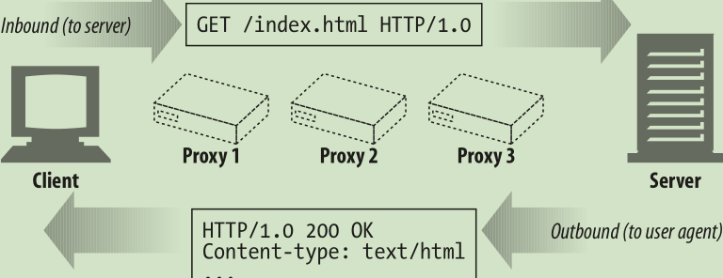
Messages Flow Downstream 报文向下游流动
HTTP messages flow like rivers. All messages flow downstream, regardless of whether they are request messages or response messages (see Figure 3-2). The sender of any message is upstream of the receiver. In Figure 3-2, proxy 1 is upstream of proxy 3 for the request but downstream of proxy 3 for the response.
HTTP 报文会像河水一样流动。不管是请求报文还是响应报文，所有报文都会向 下游（downstream）流动（参见图 3-2） 。所有报文的发送者都在接收者的上游 （upstream） 。在图 3-2 中，对请求报文来说，代理 1 位于代理 3 的上游，但对响应 报文来说，它就位于代理 3 的下游
The Parts of a Message 报文的组成部分
HTTP messages are simple, formatted blocks of data. Take a peek at Figure 3-3 for an example. Each message contains either a request from a client or a response from a server. They consist of three parts: a start line describing the message, a block of headers containing attributes, and an optional body containing data.
HTTP 报文是简单的格式化数据块。看一下图 3-3 给出的例子。每条报文都包含一 条来自客户端的请求，或者一条来自服务器的响应。它们由三个部分组成：对报文 进行描述的起始行（start line） 、包含属性的首部（header）块，以及可选的、包含 数据的主体（body）部分
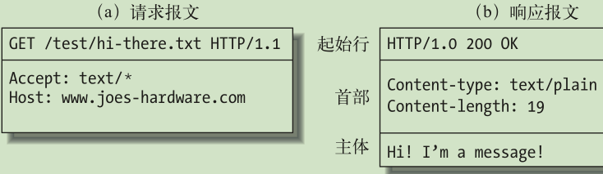
Here’s the format for a request message:
<method> <request-URL> <version>
<headers>
<entity-body>

Here’s the format for a response message (note that the syntax differs only in the
start line):
<version> <status> <reason-phrase>
<headers>
<entity-body>
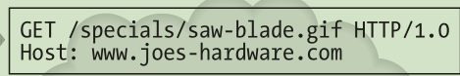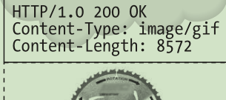
Reason phrases 原因短语
The reason phrase is the last component of the start line of the response. It provides a textual explanation of the status code. For example, in the line “HTTP/1.0 200 OK,” the reason phrase is OK.
数字状态码的可读版本，包含行终止序列之前的所有文本。本章稍后提供了 HTTP 规范定义的所有状态码的原因短语示例。原因短语只对人类有意义，因 此，比如说，尽管响应行 HTTP/1.0 200 NOT OK 和 HTTP/1.0 200 OK 中原因短 语的含义不同，但同样都会被当作成功指示处理
Header continuation lines 首部延续行
Long header lines can be made more readable by breaking them into multiple lines, preceding each extra line with at least one space or tab character.
将长的首部行分为多行可以提高可读性，多出来的每行前面至少要有一个空格或制 表符（tab）

1.1.1 Connection management
Connection Management连接管理
The HTTP specifications explain HTTP messages fairly well, but they don’t talk much about HTTP connections, the critical plumbing that HTTP messages flow through. If you’re a programmer writing HTTP applications, you need to under- stand the ins and outs of HTTP connections and how to use them
HTTP 规范对 HTTP 报文解释得很清楚，但对 HTTP 连接介绍的并不多，HTTP 连 接是 HTTP 报文传输的关键通道。编写 HTTP 应用程序的程序员需要理解 HTTP 连 接的来龙去脉以及如何使用这些连接
HTTP connection management has been a bit of a black art, learned as much from experimentation and apprenticeship as from published literature. In this chapter, you’ll learn about:
HTTP 连接管理有点像魔术，应当从经验与实践，而不仅仅是出版的文献中学习。 通过本章，可以了解到
How HTTP uses TCP connectionsHTTP 是如何使用 TCP 连接的
Delays, bottlenecks and clogs in TCP connections
TCP 连接的时延、瓶颈以及存在的障碍
HTTP optimizations, including parallel, keep-alive, and pipelined connections
HTTP 的优化，包括并行连接、keep-alive（持久连接）和管道化连接
Dos and don’ts for managing connections
管理连接时应该以及不应该做的事情
plumb v. （用铅垂）测量；探测n. 铅锤；垂直adj. 垂直的；<口>完全的adv. 恰恰；<口>彻底地
We need to plumb the line. 我们需要用铅垂测量这条线
We begin to plumb the mysteries of the universe.
我们开始探索宇宙的奥秘
vertical，perpendicular，upright，erect，plumb这些形容词均有“垂直的、竖式的”之意。vertical指与平面、水平线或基线成直角或几乎成直角向上延伸至顶点的物体。也可指呈直线上升或下降的。perpendicular指与水平线形成90度的线或面，或朝垂直方面延伸的，尤指向下的急剧运动。upright普通用词，指竖立、笔直而不是倾斜、倒塌的。erect指笔直挺拔，而非倾斜、佝偻、弯曲或倒塌的。plumb建筑上用词，凭锤球评判某物是否完全垂直
plumbing n. 管道装置；铅管工行业 动词plumb的现在分词.
TCP Reliable Data Pipes TCP的可靠数据管道
TCP gives HTTP a reliable bit pipe. Bytes stuffed in one side of a TCP connection come out the other side correctly, and in the right order
TCP 为 HTTP 提供了一条可靠的比特传输管道。从 TCP 连接一端填入的字节会从另 一端以原有的顺序、正确地传送出来
TCP Streams Are Segmented and Shipped by IP Packets
TCP流是分段的、由IP分组传送
TCP sends its data in little chunks called IP packets (or IP datagrams)
TCP 的数据是通过名为 IP 分组（或 IP 数据报）的小数据块来发送的
In this way, HTTP is the top layer in a “protocol stack” of “HTTP over TCP over IP,” as depicted in Figure 4-3a. A secure variant, HTTPS, inserts a cryptographic encryption layer (called TLS or SSL) between HTTP and TCP (Figure 4-3b).
这样的话， 如图 4-3a 所示，HTTP 就是“HTTP over TCP over IP”这个“协议栈”中的最顶层 了。其安全版本 HTTPS 就是在 HTTP 和 TCP 之间插入了一个（称为 TLS 或 SSL 的）密码加密层（图 4-3b）
When HTTP wants to transmit a message, it streams the contents of the message data, in order, through an open TCP connection. TCP takes the stream of data, chops up the data stream into chunks called segments, and transports the segments across the Internet inside envelopes called IP packets (see Figure 4-4). This is all han- dled by the TCP/IP software; the HTTP programmer sees none of it.
HTTP 要传送一条报文时，会以流的形式将报文数据的内容通过一条打开的 TCP 连 接按序传输。TCP 收到数据流之后，会将数据流砍成被称作段的小数据块，并将段 封装在 IP 分组中，通过因特网进行传输（参见图 4-4） 。所有这些工作都是由 TCP/ IP 软件来处理的，HTTP 程序员什么都看不到
Each TCP segment is carried by an IP packet from one IP address to another IP address. Each of these IP packets contains:
每个 TCP 段都是由 IP 分组承载，从一个 IP 地址发送到另一个 IP 地址的。每个 IP 分组中都包括
An IP packet header (usually 20 bytes)一个 IP 分组首部（通常为 20 字节）
A TCP segment header (usually 20 bytes) 一个 TCP 段首部（通常为 20 字节）
A chunk of TCP data (0 or more bytes)一个 TCP 数据块（0 个或多个字节）
The IP header contains the source and destination IP addresses, the size, and other flags. The TCP segment header contains TCP port numbers, TCP control flags, and numeric values used for data ordering and integrity checking.
IP 首部包含了源和目的 IP 地址、长度和其他一些标记。TCP 段的首部包含了 TCP 端口号、TCP 控制标记，以及用于数据排序和完整性检查的一些数字值
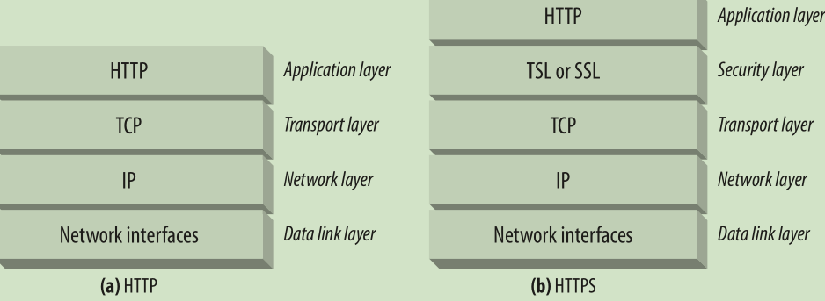

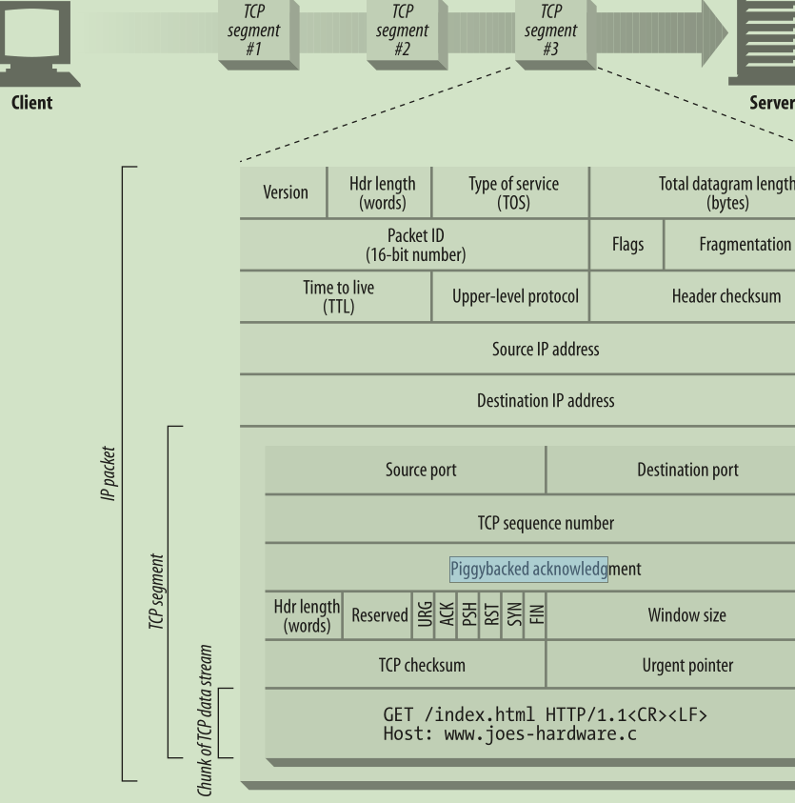
Fragmentation offset段偏移量 Time to live (TTL)生存时间
Upper-level protocol 高层协议 Header checksum 首部校验和
Piggybacked acknowledgment 捎带的确认 TCP checksum Urgent pointer紧急指针
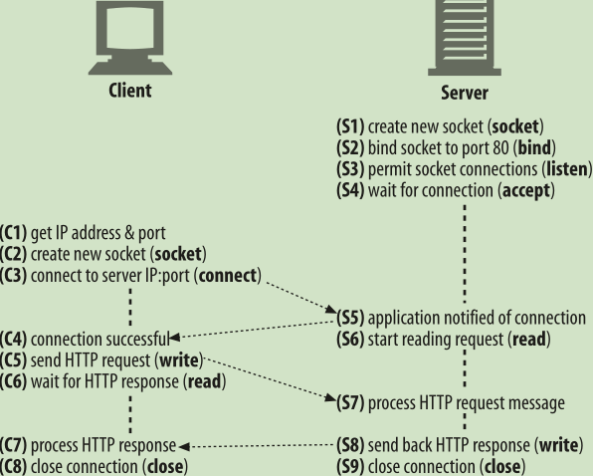
TCP Performance Considerations 对TCP性能的考虑
Because HTTP is layered directly on TCP, the performance of HTTP transactions depends critically on the performance of the underlying TCP plumbing. This section highlights some significant performance considerations of these TCP connections. By understanding some of the basic performance characteristics of TCP, you’ll better appreciate HTTP’s connection optimization features, and you’ll be able to design and implement higher-performance HTTP applications.
HTTP 紧挨着 TCP，位于其上层，所以 HTTP 事务的性能在很大程度上取决于底层 TCP 通道的性能。本节重点介绍了一些很重要的、对这些 TCP 连接的性能考虑。理 解了 TCP 的某些基本性能特点之后，就可以更好地理解 HTTP 的连接优化特性，这 样就能设计实现一些更高性能的 HTTP 应用程序了
HTTP Transaction Delays HTTP事务的时延
Let’s start our TCP performance tour by reviewing what networking delays occur in the course of an HTTP request. Figure 4-7 depicts the major connect, transfer, and processing delays for an HTTP transaction.
我们来回顾一下，在 HTTP 请求的过程中会出现哪些网络时延，并以此开始我们的 TCP 性能之旅。图 4-7 描绘了 HTTP 事务主要的连接、传输以及处理时
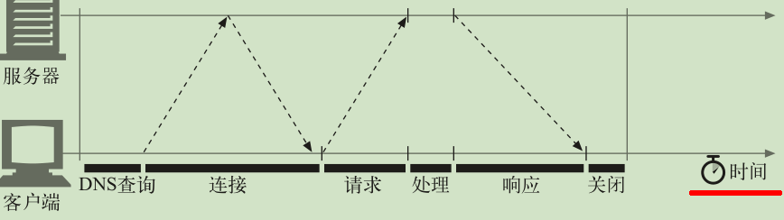
Timeline of a serial HTTP transaction串行 HTTP 事务的时间线
Notice that the transaction processing time can be quite small compared to the time required to set up TCP connections and transfer the request and response messages. Unless the client or server is overloaded or executing complex dynamic resources, most HTTP delays are caused by TCP network delays.
注意，与建立 TCP 连接，以及传输请求和响应报文的时间相比，事务处理时间可能 是很短的。除非客户端或服务器超载，或正在处理复杂的动态资源，否则 HTTP 时 延就是由 TCP 网络时延构成的
Performance Focus Areas 性能聚焦区域
The remainder of this section outlines some of the most common TCP-related delays affecting HTTP programmers, including the causes and performance impacts of:
本节其余部分列出了一些会对 HTTP 程序员产生影响的、最常见的 TCP 相关时延， 其中包括：
The TCP connection setup handshake TCP 连接建立握手
TCP slow-start congestion control TCP 慢启动拥塞控制
Nagle’s algorithm for data aggregation 数据聚集的 Nagle 算法
TCP’s delayed acknowledgment algorithm for piggybacked acknowledgments
用于捎带确认的 TCP 延迟确认算法
TIME_WAIT delays and port exhaustion
TIME_WAIT 时延和端口耗尽
congest vt. 使充满；使拥塞；使充血vi. 充塞；充血
The bus is much congested. 公共汽车非常拥挤
congestion n. 阻塞；拥挤；充血
Congestion frequently reduces traffic to walking pace.
交通阻塞经常把车流的速度降低得如步行一般缓慢
aggregate adj. 合计的；总的n. 总计；进球总数；集料v. （使）聚集；总计
The cause of unemployment was inadequate aggregate demand.
失业的原因在于总需求不足
The tax increases will, in the aggregate, cause much hardship.
增加税收归结起来将造成很多困难
piggy n. 小猪adj. 贪心的
piggyback adj. 在肩(背)上；骑在肩(背)上adv. 在肩(背)上地；骑在肩(背)上地n. 背负式运输vt. 背；附带发生 =pickaback
Doug gave all the children a piggyback ride.道格让所有的孩子在他背上骑了一回马
TCP Connection Handshake Delays TCP连接的握手时延
When you set up a new TCP connection, even before you send any data, the TCP software exchanges a series of IP packets to negotiate the terms of the connection (see Figure 4-8). These exchanges can significantly degrade HTTP performance if the connections are used for small data transfers.
建立一条新的 TCP 连接时，甚至是在发送任意数据之前，TCP 软件之间会交换一系 列的 IP 分组，对连接的有关参数进行沟通（参见图 4-8） 。如果连接只用来传送少量 数据，这些交换过程就会严重降低 HTTP 的性能
negotiate vi. 谈判；协商；交涉vt. 谈判达成；成功越过；议价出售
We've decided to negotiate with the employers about our wage claim.
我们决定就工资问题与雇主谈判
Since our contract is near its term we must negotiate a new one.
由于我们的合同快到期了，我们必须谈判新的合约
negotiate the contract 商订合约negotiate the steep hill 越过陡峭的山negotiate about〔for〕 就某事进行交涉
negotiate, arrange, concert这组词都可表示为“经过讨论或会谈双方一致成就某事”。其区别在于:negotiate多指外交、交易或法律上等为某事进行谈判; arrange一般指私人之间进行的商定或商妥; concert特指为取得协同一致所进行的协商
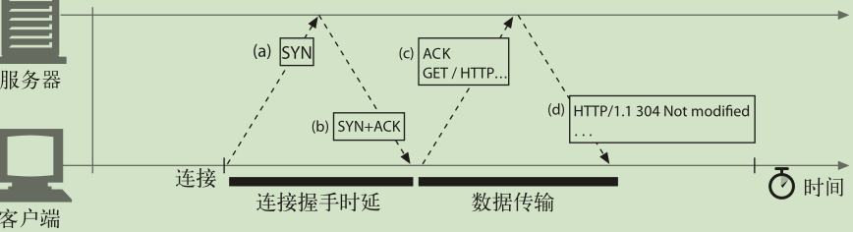
Here are the steps in the TCP connection handshake:
1. To request a new TCP connection, the client sends a small TCP packet (usually 40–60 bytes) to the server. The packet has a special “SYN” flag set, which means it’s a connection request. This is shown in Figure 4-8a.
2. If the server accepts the connection, it computes some connection parameters and sends a TCP packet back to the client, with both the “SYN” and “ACK” flags set, indicating that the connection request is accepted (see Figure 4-8b).
3. Finally, the client sends an acknowledgment back to the server, letting it know that the connection was established successfully (see Figure 4-8c). Modern TCP stacks let the client send data in this acknowledgment packet.
The SYN/SYN+ACK handshake (Figure 4-8a and b) creates a measurable delay when HTTP transactions do not exchange much data, as is commonly the case. The TCP connect ACK packet (Figure 4-8c) often is large enough to carry the entire HTTP request message, * and many HTTP server response messages fit into a single IP packet (e.g., when the response is a small HTML file of a decorative graphic, or a 304 Not Modified response to a browser cache request).
通常 HTTP 事务都不会交换太多数据，此时，SYN/SYN+ACK 握手（参见图 4-8a 和图 4-8b）会产生一个可测量的时延。TCP 连接的 ACK 分组（参见图 4-8c）通常 都足够大，可以承载整个 HTTP 请求报文 4 ，而且很多 HTTP 服务器响应报文都可 以放入一个 IP 分组中去（比如，响应是包含了装饰性图片的小型 HTML 文件，或 者是对浏览器高速缓存请求产生的 304 Not Modified 响应）
Delayed Acknowledgments 延迟确认
Because the Internet itself does not guarantee reliable packet delivery (Internet rout- ers are free to destroy packets at will if they are overloaded), TCP implements its own acknowledgment scheme to guarantee successful data delivery.
由于因特网自身无法确保可靠的分组传输（因特网路由器超负荷的话，可以随意丢 弃分组） ，所以 TCP 实现了自己的确认机制来确保数据的成功传输
Each TCP segment gets a sequence number and a data-integrity checksum. The receiver of each segment returns small acknowledgment packets back to the sender when segments have been received intact. If a sender does not receive an acknowledgment within a specified window of time, the sender concludes the packet was destroyed or corrupted and resends the data.
每个 TCP 段都有一个序列号和数据完整性校验和。每个段的接收者收到完好的段 时，都会向发送者回送小的确认分组。如果发送者没有在指定的窗口时间内收到确 认信息，发送者就认为分组已被破坏或损毁，并重发数据
Because acknowledgments are small, TCP allows them to “piggyback” on outgoing data packets heading in the same direction. By combining returning acknowledg- ments with outgoing data packets, TCP can make more efficient use of the network. To increase the chances that an acknowledgment will find a data packet headed in the same direction, many TCP stacks implement a “delayed acknowledgment” algo- rithm. Delayed acknowledgments hold outgoing acknowledgments in a buffer for a certain window of time (usually 100–200 milliseconds), looking for an outgoing data packet on which to piggyback. If no outgoing data packet arrives in that time, the acknowledgment is sent in its own packet.
由于确认报文很小，所以 TCP 允许在发往相同方向的输出数据分组中对其进行“捎 带” 。TCP 将返回的确认信息与输出的数据分组结合在一起，可以更有效地利用网 络。为了增加确认报文找到同向传输数据分组的可能性，很多 TCP 栈都实现了一种“延迟确认”算法。延迟确认算法会在一个特定的窗口时间（通常是 100 ～ 200 毫 秒）内将输出确认存放在缓冲区中，以寻找能够捎带它的输出数据分组。如果在那 个时间段内没有输出数据分组，就将确认信息放在单独的分组中传送
Unfortunately, the bimodal request-reply behavior of HTTP reduces the chances that piggybacking can occur. There just aren’t many packets heading in the reverse direc- tion when you want them. Frequently, the disabled acknowledgment algorithms introduce significant delays. Depending on your operating system, you may be able to adjust or disable the delayed acknowledgment algorithm.
但是，HTTP 具有双峰特征的请求 - 应答行为降低了捎带信息的可能。当希望有相 反方向回传分组的时候，偏偏没有那么多。通常，延迟确认算法会引入相当大的时 延。根据所使用操作系统的不同，可以调整或禁止延迟确认算法
Before you modify any parameters of your TCP stack, be sure you know what you are doing. Algorithms inside TCP were introduced to protect the Internet from poorly designed applications. If you modify any TCP configurations, be absolutely sure your application will not create the problems the algorithms were designed to avoid.
在对 TCP 栈的任何参数进行修改之前，一定要对自己在做什么有清醒的认识。TCP 中引入这些算法的目的是防止设计欠佳的应用程序对因特网造成破坏。对 TCP 配置 进行的任意修改，都要绝对确保应用程序不会引发这些算法所要避免的问题
TCP Slow Start TCP慢启动
The performance of TCP data transfer also depends on the age of the TCP connection. TCP connections “tune” themselves over time, initially limiting the maximum speed of the connection and increasing the speed over time as data is transmitted successfully. This tuning is called TCP slow start, and it is used to prevent sudden overloading and congestion of the Internet.
TCP 数据传输的性能还取决于 TCP 连接的使用期（age） 。TCP 连接会随着时间进行 自我“调谐” ，起初会限制连接的最大速度，如果数据成功传输，会随着时间的推移 提高传输的速度。这种调谐被称为 TCP 慢启动（slow start） ，用于防止因特网的突 然过载和拥塞
TCP slow start throttles the number of packets a TCP endpoint can have in flight at any one time. Put simply, each time a packet is received successfully, the sender gets permission to send two more packets. If an HTTP transaction has a large amount of data to send, it cannot send all the packets at once. It must send one packet and wait for an acknowledgment; then it can send two packets, each of which must be acknowl- edged, which allows four packets, etc. This is called “opening the congestion window.”
TCP 慢启动限制了一个 TCP 端点在任意时刻可以传输的分组数。简单来说，每成功 接收一个分组，发送端就有了发送另外两个分组的权限。如果某个 HTTP 事务有大 量数据要发送，是不能一次将所有分组都发送出去的。必须发送一个分组，等待确 认；然后可以发送两个分组，每个分组都必须被确认，这样就可以发送四个分组了， 以此类推。这种方式被称为“打开拥塞窗口”
由于存在这种拥塞控制特性，所以新连接的传输速度会比已经交换过一定量数据的、 “已调谐”连接慢一些。由于已调谐连接要更快一些，所以 HTTP 中有一些可以重用 现存连接的工具。本章稍后会介绍这些 HTTP“持久连接”
Because of this congestion-control feature, new connections are slower than “tuned” connections that already have exchanged a modest amount of data. Because tuned connections are faster, HTTP includes facilities that let you reuse existing connections. We’ll talk about these HTTP “persistent connections” later in this chapter.
Nagle’s Algorithm and TCP_NODELAY Nagle算法与TCP_NODELAY
TCP has a data stream interface that permits applications to stream data of any size to the TCP stack—even a single byte at a time! But because each TCP segment car- ries at least 40 bytes of flags and headers, network performance can be degraded severely if TCP sends large numbers of packets containing small amounts of data.
TCP 有一个数据流接口，应用程序可以通过它将任意尺寸的数据放入 TCP 栈中—— 即使一次只放一个字节也可以！但是，每个 TCP 段中都至少装载了 40 个字节的标 记和首部，所以如果 TCP 发送了大量包含少量数据的分组，网络的性能就会严重 下降
Sending a storm of single-byte packets is called “sender silly window syndrome.” This is inefficient, anti- social, and can be disruptive to other Internet traffic.
发送大量单字节分组的行为称为“发送端傻窗口综合症” 。这种行为效率很低、违反社会道德，而且 可能会影响其他的因特网流量
Nagle’s algorithm (named for its creator, John Nagle) attempts to bundle up a large amount of TCP data before sending a packet, aiding network efficiency. The algo- rithm is described in RFC 896, “Congestion Control in IP/TCP Internetworks.”
Nagle 算法（根据其发明者 John Nagle 命名）试图在发送一个分组之前，将大量 TCP 数据绑定在一起，以提高网络效率。RFC 896“IP/TCP 互连网络中的拥塞控 制”对此算法进行了描述
Nagle’s algorithm discourages the sending of segments that are not full-size (a maximum-size packet is around 1,500 bytes on a LAN, or a few hundred bytes across the Internet). Nagle’s algorithm lets you send a non-full-size packet only if all other packets have been acknowledged. If other packets are still in flight, the partial data is buffered. This buffered data is sent only when pending packets are acknowl- edged or when the buffer has accumulated enough data to send a full packet.
Nagle 算法鼓励发送全尺寸（LAN 上最大尺寸的分组大约是 1500 字节，在因特网 上是几百字节）的段。只有当所有其他分组都被确认之后，Nagle 算法才允许发送 非全尺寸的分组。如果其他分组仍然在传输过程中，就将那部分数据缓存起来。只 有当挂起分组被确认，或者缓存中积累了足够发送一个全尺寸分组的数据时，才会 将缓存的数据发送出去
TIME_WAIT Accumulation and Port Exhaustion TIME_WAIT累积与端口耗尽
TIME_WAIT port exhaustion is a serious performance problem that affects perfor- mance benchmarking but is relatively uncommon in real deployments. It warrants special attention because most people involved in performance benchmarking even- tually run into this problem and get unexpectedly poor performance.
TIME_WAIT 端口耗尽是很严重的性能问题，会影响到性能基准，但在现实中相对 较少出现。大多数遇到性能基准问题的人最终都会碰到这个问题，而且性能都会变 得出乎意料地差，所以这个问题值得特别关注
When a TCP endpoint closes a TCP connection, it maintains in memory a small con- trol block recording the IP addresses and port numbers of the recently closed con- nection. This information is maintained for a short time, typically around twice the estimated maximum segment lifetime (called “2MSL”; often two minutes * ), to make sure a new TCP connection with the same addresses and port numbers is not cre- ated during this time. This prevents any stray duplicate packets from the previous connection from accidentally being injected into a new connection that has the same addresses and port numbers. In practice, this algorithm prevents two connections with the exact same IP addresses and port numbers from being created, closed, and recreated within two minutes.
当某个 TCP 端点关闭 TCP 连接时，会在内存中维护一个小的控制块，用来记录最 近所关闭连接的 IP 地址和端口号。这类信息只会维持一小段时间，通常是所估计的 最大分段使用期的两倍（称为 2MSL，通常为 2 分钟 8 ）左右，以确保在这段时间内 不会创建具有相同地址和端口号的新连接。实际上，这个算法可以防止在两分钟内 创建、关闭并重新创建两个具有相同 IP 地址和端口号的连接
HTTP Connection Handling HTTP连接的处理
The first two sections of this chapter provided a fire-hose tour of TCP connections and their performance implications.
本章的前两节对 TCP 连接及其性能含义进行了精要的介绍
The Oft-Misunderstood Connection Header 常被误解的 Connection 首部
HTTP allows a chain of HTTP intermediaries between the client and the ultimate origin server (proxies, caches, etc.). HTTP messages are forwarded hop by hop from the client, through intermediary devices, to the origin server (or the reverse).
HTTP 允许在客户端和最终的源端服务器之间存在一串 HTTP 中间实体（代理、高 速缓存等） 。可以从客户端开始，逐跳地将 HTTP 报文经过这些中间设备，转发到源端服务器上去（或者进行反向传输）
In some cases, two adjacent HTTP applications may want to apply a set of options to their shared connection. The HTTP Connection header field has a comma-separated list of connection tokens that specify options for the connection that aren’t propa- gated to other connections. For example, a connection that must be closed after sending the next message can be indicated by Connection: close.
在某些情况下，两个相邻的 HTTP 应用程序会为它们共享的连接应用一组选项。 HTTP 的 Connection 首部字段中有一个由逗号分隔的连接标签列表，这些标签为 此连接指定了一些不会传播到其他连接中去的选项。比如，可以用 Connection: close 来说明发送完下一条报文之后必须关闭的连接
The Connection header sometimes is confusing, because it can carry three different types of tokens:
Connection 首部可以承载 3 种不同类型的标签，因此有时会很令人费解
HTTP header field names, listing headers relevant for only this connection
HTTP 首部字段名，列出了只与此连接有关的首部
Arbitrary token values, describing nonstandard options for this connection
任意标签值，用于描述此连接的非标准选项
The value close , indicating the persistent connection will be closed when done
值 close ，说明操作完成之后需关闭这条持久连接
If a connection token contains the name of an HTTP header field, that header field contains connection-specific information and must not be forwarded. Any header fields listed in the Connection header must be deleted before the message is for- warded. Placing a hop-by-hop header name in a Connection header is known as “protecting the header,” because the Connection header protects against accidental forwarding of the local header. An example is shown in Figure 4-9.
如果连接标签中包含了一个 HTTP 首部字段的名称，那么这个首部字段就包含了 与一些连接有关的信息，不能将其转发出去。在将报文转发出去之前，必须删除 Connection 首部列出的所有首部字段。由于 Connection 首部可以防止无意中对 本地首部的转发，因此将逐跳首部名放入 Connection 首部被称为“对首部的保 护” 。图 4-9 显示了一个这样的例子
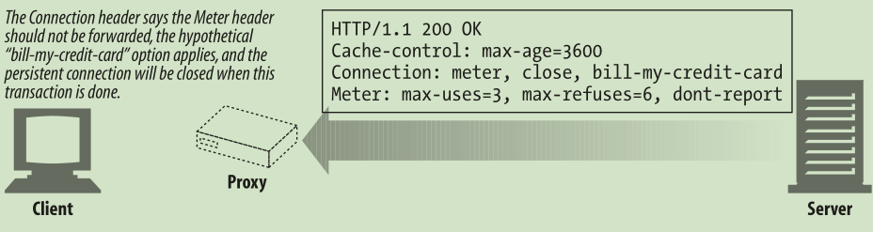
When an HTTP application receives a message with a Connection header, the receiver parses and applies all options requested by the sender. It then deletes the Connection header and all headers listed in the Connection header before forward- ing the message to the next hop. In addition, there are a few hop-by-hop headers that might not be listed as values of a Connection header, but must not be proxied. These include Proxy-Authenticate, Proxy-Connection, Transfer-Encoding, and Upgrade. For more about the Connection header, see Appendix C.
HTTP 应用程序收到一条带有 Connection 首部的报文时，接收端会解析发送端 请求的所有选项，并将其应用。然后会在将此报文转发给下一跳地址之前，删除 Connection 首部以及 Connection 中列出的所有首部。而且，可能还会有少量没 有作为 Connection 首部值列出，但一定不能被代理转发的逐跳首部。其中包括 Prxoy-Authenticate 、 Proxy-Connection 、 Transfer-Encoding 和 Upgrade 。 更多有关 Connection 首部的内容请参见附录 C
Serial Transaction Delays串行事务处理时延
TCP performance delays can add up if the connections are managed naively. For example, suppose you have a web page with three embedded images. Your browser needs to issue four HTTP transactions to display this page: one for the top-level HTML and three for the embedded images. If each transaction requires a new c
如果只对连接进行简单的管理，TCP 的性能时延可能会叠加起来。比如，假设有一个包含了 3 个嵌入图片的 Web 页面。浏览器需要发起 4 个 HTTP 事务来显示此页面： 1 个用于顶层的 HTML 页面，3 个用于嵌入的图片。如果每个事务都需要（串行地建 立）一条新的连接，那么连接时延和慢启动时延就会叠加起来（参见图 4-10）
