deep learning

2.2 CPU VS GPU
首先需要解释CPU和GPU这两个缩写分别代表什么。
CPU即中央处理器，GPU即图形处理器。其次，要解释两者的区别，要先明白两者的相同之处：两者都有总线和外界联系，有自己的缓存体系，以及数字和逻辑运算单元。一句话，两者都为了完成计算任务而设计。
GPU全称Graphic Processing Unit中文名为：图形处理器
1. GPU是一种专用型处理器，适用于大量同类型数据的高效计算。CPU是一种通用型处理器，适用于多种类型任务，但对特定数据的处理效率相对欠优。
2. 近年来，数据迁移成为限制计算性能提高的首要因素。CPU使用多级缓存来解决数据迁移的问题，但是由于CPU需要解决多类任务，缓存命中率偏低，需要频繁对内存进行读写，从而增加了延迟。而GPU则采用程序控制的方法解决数据局部性的问题，即一次性地将所需数据取来，并在处理器需要数据前就将其装入片内存储器，从而提升了执行效率。
3. GPU是一个多“核”处理器，每个“核”（SM）又可以处理8-16个线程块，从而使GPU适合使用多线程处理的并行度高的任务，这类任务的特点是线程之间的计算相同但逻辑关联性较弱。而CPU相较于GPU核数较少，而且核数的增长受“缓存一致性”带来的内存带宽拥挤限制。同时，其可执行的线程数又不超过核数的两倍，所以在CPU上任务是分时轮流执行，会伴有线程切换带来的延迟。
CPU和GPU之所以大不相同，是由于其设计目标的不同，它们分别针对了两种不同的应用场景。CPU需要很强的通用性来处理各种不同的数据类型，同时又要逻辑判断又会引入大量的分支跳转和中断的处理。这些都使得CPU的内部结构异常复杂。而GPU面对的则是类型高度统一的、相互无依赖的大规模数据和不需要被打断的纯净的计算环境。
GPU采用了数量众多的计算单元和超长的流水线，但只有非常简单的控制逻辑并省去了Cache。而CPU不仅被Cache占据了大量空间，而且还有有复杂的控制逻辑和诸多优化电路，相比之下计算能力只是CPU很小的一部分
什么类型的程序适合在GPU上运行？
- 计算密集型的程序。所谓计算密集型(Compute-intensive)的程序，就是其大部分运行时间花在了寄存器运算上，寄存器的速度和处理器的速度相当，从寄存器读写数据几乎没有延时。可以做一下对比，读内存的延迟大概是几百个时钟周期；读硬盘的速度就不说了，即便是SSD, 也实在是太慢了。
- 易于并行的程序。GPU其实是一种SIMD(Single Instruction Multiple Data)架构， 他有成百上千个核，每一个核在同一时间最好能做同样的事情。

当你操作电脑的时候，为了完成某项工作，需要电脑帮你工作，就像计算某个题目那样。计算题目，理解题目并且整理出解题的步骤以及解法，那是CPU的事情。但是解题的过程需要用到的众多计算，则需要一帮不需要很高逻辑理解力的计算者完成，他们只需要负责其中很简单但是数量又很大的简单运算就行了，最后他们把各自运算的结果交出来给CPU整理，那么这群计算者就是GPU。这就是一个博士带着100个小学生的意思了

2.3 cuda、OpenCL introduce
CUDA（Compute Unified Device Architecture，统一计算架构）是由NVIDIA所推出的一种集成技术亦是首次可以利用GPU作为C-编译器的开发环境。
CUDA是一个基于Nvidia GPU的并行计算的架构。CUDA最主要的包含两个方面：
一个是ISA指令集架构；
第二硬件计算引擎；实际上是硬件和指令集。 也就是说我们可以把CUDA看做是与X86或者cell类似的架构，但是是基于是GPU，而不是传统的CPU。
什么是OpenCL？
是由苹果（Apple）公司发起，业界众多著名厂商共同制作的面向异构系统通用目的并行编程的开放式、免费标准，也是一个统一的编程环境。便于软件开发人员为高性能计算服务器、桌面计算系统、手持设备编写高效轻便的代码，而且广泛适用于多核心处理器(CPU)、图形处理器(GPU)、Cell类型架构以及数字信号处理器(DSP)等其他并行处理器，在游戏、娱乐、科研、医疗等各种领域都有广阔的发展前景。
OpenCL实际上是什么？
OpenCL实际上是针对异构系统进行并行编程的一个全新的API，OpenCL可以利用GPU进行一些并行计算的工作。OpenGL是针对图形的，而OpenCL则是针对并行计算的API。OpenCL开发的过程中，技术平台均为NVIDIA的GPU，实际上OpenCL是基于NVIDIA GPU的平台进行开发的。另外OpenCL的第一次演示也是运行在NVIDIA的GPU上。从本质上来说，OpenCL就是一个相当于Windows平台中DirectX那样的技术。或者说，它是一个连接硬件和软件的API接口。在这一点上，它和OpenGL类似，不过OpenCL的涉及范围要比OpenGL大得多，它不仅是用来作用于3D图形。如果用一句话描述，OpenCL的作用就是通过调用处理器和GPU的计算资源，释放硬件潜力，让程序运行得更快更好。
CUDA实际上是什么？
CUDA架构是原生的，专门为计算接口而建造的这样的一个架构，这种硬件架构包括指令集都是非常适合于这种并行计算，为异构计算而设计的一整套的架构。CUDA架构可以支持API，包括OpenCL或者DirectX，同时CUDA还支持C、C++语言，还包括Fortran、Java、Python等各种各样的语言。
OpenCL与CUDA的关系是什么？
CUDA和OpenCL的关系并不是冲突关系，而是包容关系。OpenCL是一个API，在第一个级别，CUDA架构是更高一个级别，在这个架构上不管是OpenCL还是DX11这样的API，还是像C语言、Fortran、DX11计算，都可以支持。作为程序开发员来讲，一般他们只懂这些语言或者API，可以采用多种语言开发自己的程序，不管他选择什么语言，只要是希望调用GPU的计算能，在这个架构上都可以用CUDA来编程。关于OpenCL与CUDA之间的技术区别，主要体现在实现方法上。基于C语言的CUDA被包装成一种容易编写的代码，因此即使是不熟悉芯片构造的科研人员，也可能利用CUDA工具编写出实用的程序。而OpenCL虽然句法上与CUDA接近，但是它更加强调底层操作，因此难度较高，但正因为如此，OpenCL才能跨平台运行。CUDA是一个并行计算的架构，包含有一个指令集架构和相应的硬件引擎。OpenCL是一个并行计算的应用程序编程接口（API），在NVIDIA CUDA架构上OpenCL是除了C for CUDA外新增的一个CUDA程序开发途径。如果你想获得更多的对硬件上的控制权的话，你可以使用OpenCL这个API来进行编程，如果对API不是太了解，也可以用CUDA C语言来编程，这是两种不同编程的方式，他们有他们相同点和不同点。但是有一点OpenCL和CUDA C语言进行开发的时候，在并行计算这块，他们的概念是差不多的，这两种程序在程序上是有很大的相似度，所以程序之间的相互移植相对来说也是比较容易。CUDA C语言与OpenCL的定位不同，或者说是用人群不同。CUDA C是一种高级语言，那些对硬件了解不多的非专业人士也能轻松上手；而OpenCL则是针对硬件的应用程序开发接口，它能给程序员更多对硬件的控制权，相应的上手及开发会比较难一些。程序员的使用习惯也是非常重要的一方面，那些在X86 CPU平台使用C语言的人员，会很容易接受基于CUDA GPU平台的C语言；而习惯于使用OpenGL图形开发的人员，看到OpenCL会更加亲切一些，在其基础上开发与图形、视频有关的计算程序会非常容易。

2.3 cuda/cudnn
CUDA：是Nvidia推出的只能用于自家GPU的并行计算框架。只有安装这个框架才能够进行复杂的并行计算。主流的深度学习框架也都是基于CUDA进行GPU并行加速的，几乎无一例外。还有一个叫做cudnn，是针对深度卷积神经网络的加速库。

caffe practice

2.1 Kaggle’s Dogs vs Cats competition

2.1.1 getting dogs and cats data
First, we need to download 2 datasets from the competition page: train.zip and test1.zip. The train.zip file contains labeled cats and dogs images that we will use to train the network. The test1.zip file contains unlabeled images that we will classify to either dog or cat using the trained model. We will upload our predictions to Kaggle to get the score of our prediction model.
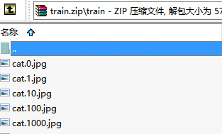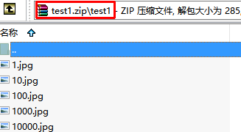
Next, we create an input folder for storing the training and test images.

2.1.1 caffe overview
Caffe is a deep learning framework developed by the Berkeley Vision and Learning Center (BVLC). It is written in C++ and has Python and Matlab bindings.

There are 4 steps in training a CNN using Caffe:

Step 1 - Data preparation: In this step, we clean the images and store them in a format that can be used by Caffe. We will write a Python script that will handle both image pre-processing and storage.
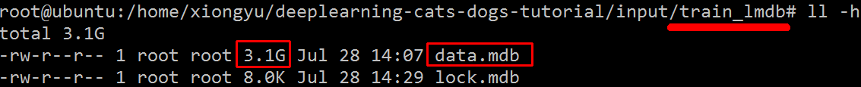
Step 2 - Model definition: In this step, we choose a CNN architecture and we define its parameters in a configuration file with extension .prototxt.

Step 3 - Solver definition: The solver is responsible for model optimization. We define the solver parameters in a configuration file with extension .prototxt.
Step 4 - Model training: We train the model by executing one Caffe command from the terminal. After training the model, we will get the trained model in a file with extension .caffemodel.
After the training phase, we will use the .caffemodel trained model to make predictions of new unseen data. We will write a Python script to this.

2.1.1 Data preparation
we run create_lmdb.py.
python create_lmdb.py
create_lmdb.py script does the following:

1. Run histogram equalization on all training images. Histogram equalization is a technique for adjusting the contrast of images.
2. Resize all training images to a 227x227 format.
3. Divide the training data into 2 sets: One for training (5/6 of images) and the other for validation (1/6 of images). The training set is used to train the model, and the validation set is used to calculate the accuracy of the model.
4. Store the training and validation in 2 LMDB databases. train_lmdb for training the model and validation_lmbd for model evaluation.

Below is the explanation of the most important parts of the code.

#Size of images
IMAGE_WIDTH = 227
IMAGE_HEIGHT = 227

def transform_img(img, img_width=IMAGE_WIDTH, img_height=IMAGE_HEIGHT):

#Histogram Equalization
img[:, :, 0] = cv2.equalizeHist(img[:, :, 0])
img[:, :, 1] = cv2.equalizeHist(img[:, :, 1])
img[:, :, 2] = cv2.equalizeHist(img[:, :, 2])

#Image Resizing
img = cv2.resize(img, (img_width, img_height), interpolation = cv2.INTER_CUBIC)

return img

transform_img takes a colored images as input, does the histogram equalization of the 3 color channels and resize the image.
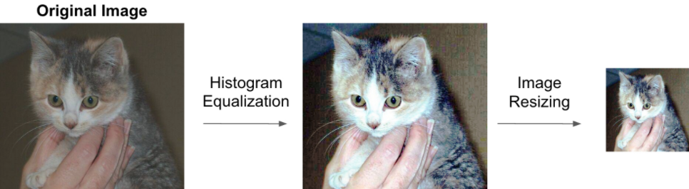
def make_datum(img, label):

return caffe_pb2.Datum(
channels=3,
width=IMAGE_WIDTH,
height=IMAGE_HEIGHT,
label=label,
data=np.rollaxis(img, 2).tostring())

make_datum takes an image and its label and return a Datum object that contains the image and its label.

train_lmdb = '/home/ubuntu/deeplearning-cats-dogs-tutorial/input/train_lmdb'
validation_lmdb = '/home/ubuntu/deeplearning-cats-dogs-tutorial/input/validation_lmdb'

os.system('rm -rf ' + train_lmdb)
os.system('rm -rf ' + validation_lmdb)

train_data = [img for img in glob.glob("../input/train/*jpg")]
test_data = [img for img in glob.glob("../input/test1/*jpg")]

#Shuffle train_data
random.shuffle(train_data)

print 'Creating train_lmdb'

in_db = lmdb.open(train_lmdb, map_size=int(1e12))
with in_db.begin(write=True) as in_txn:
for in_idx, img_path in enumerate(train_data):
if in_idx % 6 == 0:
continue
img = cv2.imread(img_path, cv2.IMREAD_COLOR)
img = transform_img(img, img_width=IMAGE_WIDTH, img_height=IMAGE_HEIGHT)
if 'cat' in img_path:
label = 0
else:
label = 1
datum = make_datum(img, label)
in_txn.put('{:0>5d}'.format(in_idx), datum.SerializeToString())
print '{:0>5d}'.format(in_idx) + ':' + img_path
in_db.close()

The code above takes 5/6 of the training images, transforms and stores them in train_lmdb. The code for storing validation data follows the same structure.

Generating the mean image of training data

We execute the command below to generate the mean image of training data. We will substract the mean image from each input image to ensure every feature pixel has zero mean. This is a common preprocessing step in supervised machine learning.

/home/ubuntu/caffe/build/tools/compute_image_mean -backend=lmdb /home/ubuntu/deeplearning-cats-dogs-tutorial/input/train_lmdb /home/ubuntu/deeplearning-cats-dogs-tutorial/input/mean.binaryproto
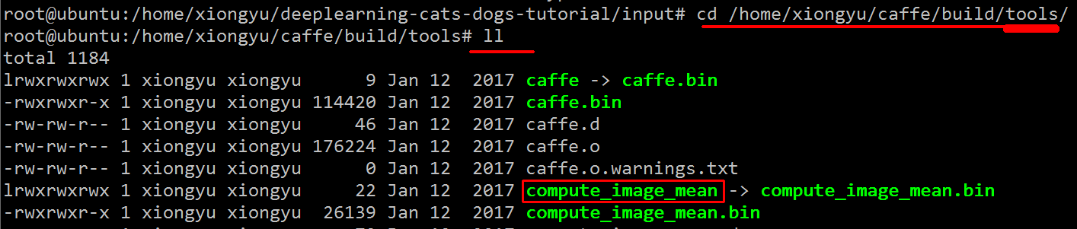
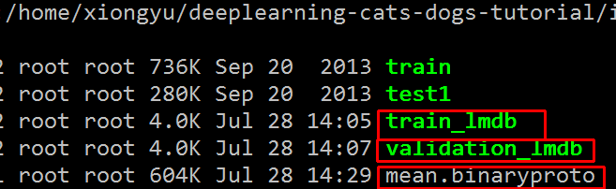

2.1.1 model definition
After deciding on the CNN architecture, we need to define its parameters in a .prototxt train_val file. Caffe comes with a few popular CNN models such as Alexnet and GoogleNet. In this tutorial, we will use the bvlc_reference_caffenet model which is a replication of AlexNet with a few modifications. Below is a copy of the train_val file that we call caffenet_train_val_1.prototxt. If you clone the tutorial git repository as explained above, you should have the same file under
deeplearning-cats-dogs-tutorial/caffe_models/caffe_model_1/.
We need to make the modifications below to the original bvlc_reference_caffenet prototxt file:
Change the path for input data and mean image: Lines 24, 40 and 51.
data_param {
source: "examples/imagenet/ilsvrc12_train_lmdb"
batch_size: 256
backend: LMDB
}

data_param {
source: "/home/ubuntu/cats-dogs-tutorial/input/train_lmdb"
batch_size: 256
backend: LMDB
}

Change the number of outputs from 1000 to 2: Line 373. The original bvlc_reference_caffenet was designed for a classification problem with 1000 classes.
inner_product_param {  num_output: 1000  weight_filler {  type: "gaussian"  std: 0.01  } | inner_product_param {  num_output: 2  weight_filler {  type: "gaussian"  std: 0.01  }
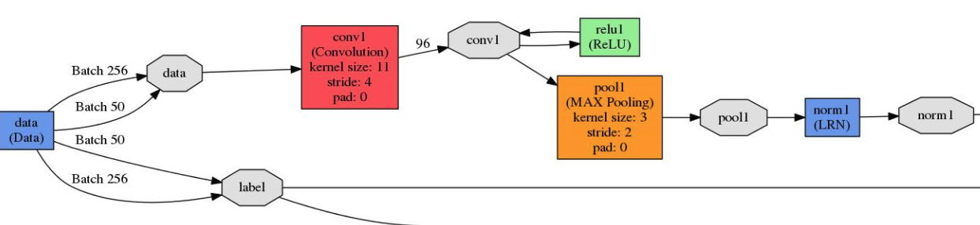
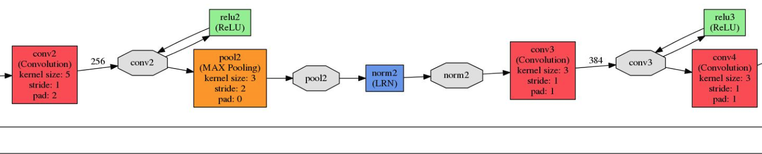
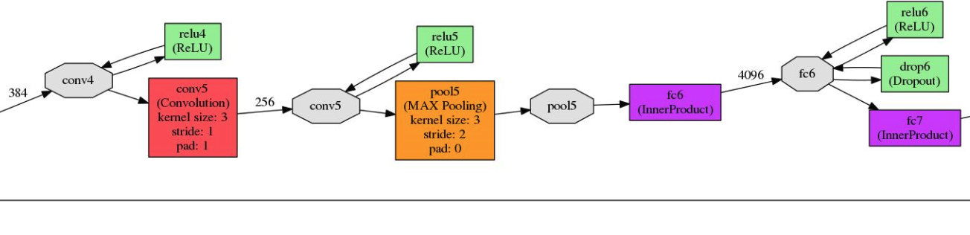
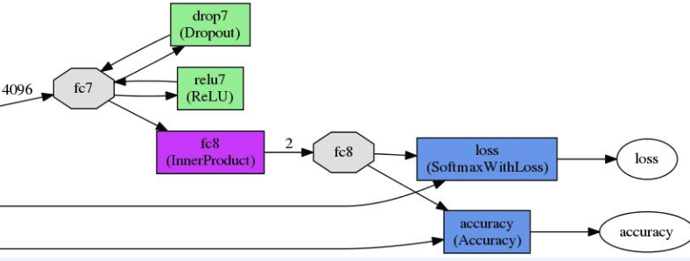
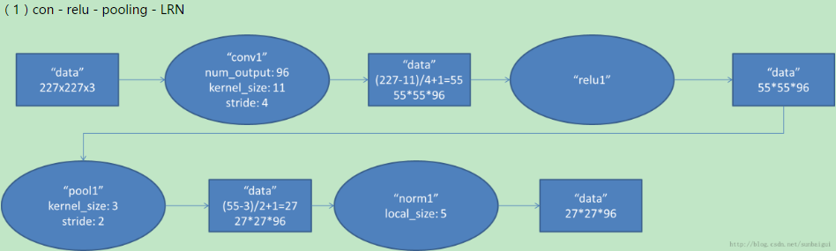
具体计算都在图里面写了，要注意的是input层是227*227，而不是paper里面的224*224，这里可以算一下，主要是227可以整除后面的conv1计算，224不整除。如果一定要用224可以通过自动补边实现，不过在input就补边感觉没有意义，补得也是0

2.1.1 solver definition
The solver is responsible for model optimization. We define the solver's parameters in a .prototxt file. You can find our solver under
deeplearning-cats-dogs-tutorial/caffe_models/caffe_model_1/ with name solver_1.prototxt. Below is a copy of the same.

This solver computes the accuracy of the model using the validation set every 1000 iterations. The optimization process will run for a maximum of 40000 iterations and will take a snapshot of the trained model every 5000 iterations.

base_lr, lr_policy, gamma, momentum and weight_decay are hyperparameters that we need to tune to get a good convergence of the model.

I chose lr_policy: "step" with stepsize: 2500, base_lr: 0.001 and gamma: 0.1. In this configuration, we will start with a learning rate of 0.001, and we will drop the learning rate by a factor of ten every 2500 iterations.

There are different strategies for the optimization process. For a detailed explanation, I recommend Caffe's solver documentation.
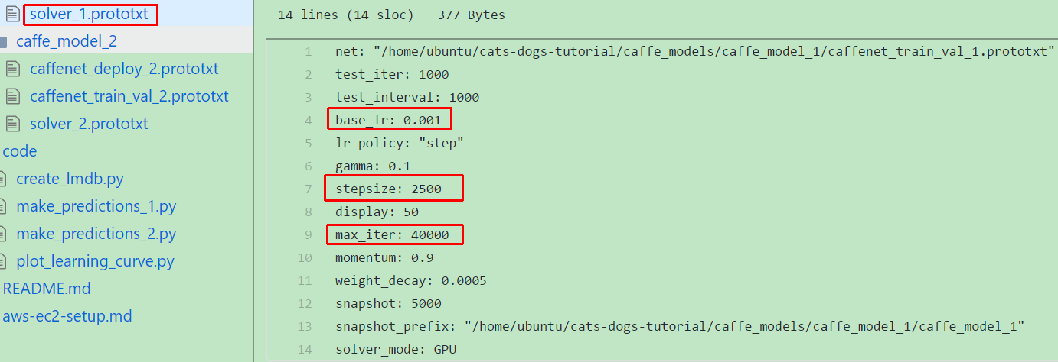

2.1.1 model training
After defining the model and the solver, we can start training the model by executing the command below:
/home/ubuntu/caffe/build/tools/caffe train --solver
/home/ubuntu/cats-dogs-tutorial/caffe_models/caffe_model_1/solver_1.prototxt 2>&1
|tee/home/ubuntu/cats-dogs-tutorial/caffe_models/caffe_model_1/model_1_train.log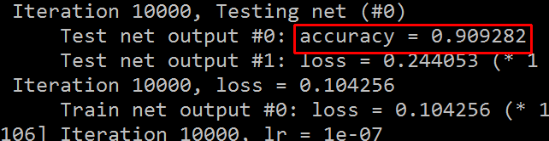
The training logs will be stored under
cats-dogs-tutorial/caffe_models/caffe_model_1/model_1_train.log.
During the training process, we need to monitor the loss and the model accuracy. We can stop the process at anytime by pressing Ctrl+c. Caffe will take a snapshot of the trained model every 5000 iterations, and store them under caffe_model_1 folder.
The snapshots have .caffemodel extension. For example, 10000 iterations snapshot will be called: caffe_model_1_iter_10000.caffemodel.

Plotting the learning curve
A learning curve is a plot of the training and test losses as a function of the number of iterations. These plots are very useful to visualize the train/validation losses and validation accuracy.
We can see from the learning curve that the model achieved a validation accuracy of 90%, and it stopped improving after 3000 iterations.

python /home/ubuntu/cats-dogs-tutorial/caffe_models/code/plot_learning_curve.py /home/ubuntu/cats-dogs-tutorial/caffe_models/caffe_models/caffe_model_1/model_1_train.log /home/ubuntu/deeplearning-cats-dogs-tutorial/caffe_models/caffe_models/caffe_model_1/caffe_model_1_learning_curve.png
(png is created by one’s own python code)
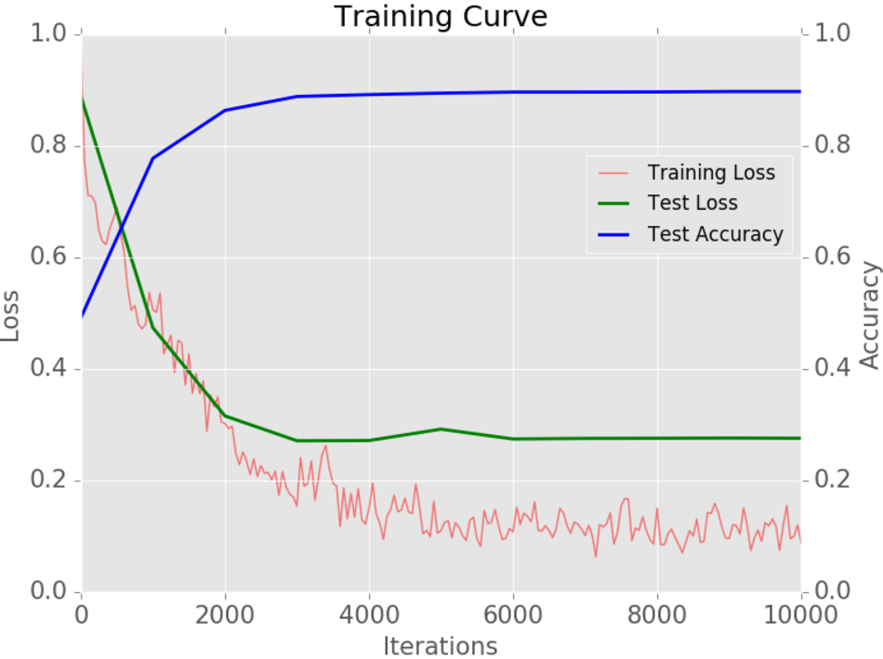

2.1.1 prediction on new data
Now that we have a trained model, we can use it to make predictions on new unseen data (images from test1). The Python code for making the predictions is make_predictions_1.py and it's stored under deeplearning-cats-dogs-tutorial/code. The code needs 4 files to run:

1.Test images: We will use test1 images.
2.Mean image: The mean image that we computed in section 4.4.
3.Model architecture file: We'll call this file caffenet_deploy_1.prototxt. It's stored under deeplearning-cats-dogs-tutorial/caffe_models/caffe_model_1. It's structured in a similar way to caffenet_train_val_1.prototxt, but with a few modifications. We need to delete the data layers, add an input layer and change the last layer type from SoftmaxWithLoss to Softmax.
4.Trained model weights: This is the file that we computed in the training phase. We will use caffe_model_1_iter_10000.caffemodel.

To run the Python code, we need to execute the command below. The predictions will be stored under cats-dogs-tutorial/caffe_models/caffe_model_1/submission_model_1.csv.
cd /home/ubuntu/deeplearning-cats-dogs-tutorial/code
python make_predictions_1.py

Below is the explanation of the most important parts in the code.

'''
Reading mean image, caffe model and its weights
'''
#Read mean image
mean_blob = caffe_pb2.BlobProto()
with open('/home/ubuntu/deeplearning-cats-dogs-tutorial/input/mean.binaryproto') as f:
mean_blob.ParseFromString(f.read())
mean_array = np.asarray(mean_blob.data, dtype=np.float32).reshape(
(mean_blob.channels, mean_blob.height, mean_blob.width))

#Read model architecture and trained model's weights
net = caffe.Net('/home/ubuntu/deeplearning-cats-dogs-tutorial/caffe_models/caffe_model_1/caffenet_deploy_1.prototxt',
'/home/ubuntu/deeplearning-cats-dogs-tutorial/caffe_models/caffe_model_1/caffe_model_1_iter_10000.caffemodel',
caffe.TEST)

#Define image transformers
transformer = caffe.io.Transformer({'data': net.blobs['data'].data.shape})
transformer.set_mean('data', mean_array)
transformer.set_transpose('data', (2,0,1))

The code above stores the mean image under mean_array, defines a model called net by reading the deploy file and the trained model, and defines the transformations that we need to apply to the test images.

img = cv2.imread(img_path, cv2.IMREAD_COLOR)
img = transform_img(img, img_width=IMAGE_WIDTH, img_height=IMAGE_HEIGHT)

net.blobs['data'].data[...] = transformer.preprocess('data', img)
out = net.forward()
pred_probas = out['prob']
print pred_probas.argmax()

The code above read an image, apply similar image processing steps to training phase, calculates each class' probability and prints the class with the largest probability (0 for cats, and 1 for dogs).

img = cv2.imread(img_path, cv2.IMREAD_COLOR)
img = transform_img(img, img_width=IMAGE_WIDTH, img_height=IMAGE_HEIGHT)

net.blobs['data'].data[...] = transformer.preprocess('data', img)
out = net.forward()
pred_probas = out['prob']
print pred_probas.argmax()

The code above read an image, apply similar image processing steps to training phase, calculates each class' probability and prints the class with the largest probability (0 for cats, and 1 for dogs)

2.1.1 prediction CPP code
https://github.com/BVLC/caffe/blob/master/examples/cpp_classification/classification.cpp
change from this to make a thrift service

2.1 transfer learning buliding a car/dog classifier

2.1.1 (fine trun)transfer learning
Convolutional neural networks require large datasets and a lot of computional time to train. Some networks could take up to 2-3 weeks across multiple GPUs to train. Transfer learning is a very useful technique that tries to address both problems. Instead of training the network from scratch, transfer learning utilizes a trained model on a different dataset, and adapts it to the problem that we're trying to solve.

There are 2 strategies for transfer learning:

1.Utilize the trained model as a fixed feature extractor: In this strategy, we remove the last fully connected layer from the trained model, we freeze the weights of the remaining layers, and we train a machine learning classifier on the output of the remaining layers.

- Fine-tune the trained model: In this strategy, we fine tune the trained model on the new dataset by continuing the backpropagation. We can either fine-tune the whole network or freeze some of its layers.

2.1.1 (model Zoo)train the dog/cat classifier
https://github.com/BVLC/caffe/wiki/Model-Zoo

Caffe comes with a repository that is used by researchers and machine learning practitioners to share their trained models. This library is called Model Zoo.
We will utilize the trained bvlc_reference_caffenet as a starting point of building our cat/dog classifier using transfer learning. This model was trained on the ImageNet dataset which contains millions of images across 1000 categories.
We will use the fine-tuning strategy for training our model.

Download trained bvlc_reference_caffenet model
We can download the trained model by executing the command below.

cd /home/ubuntu/caffe/models/bvlc_reference_caffenet
wget http://dl.caffe.berkeleyvision.org/bvlc_reference_caffenet.caffemodel

Model Definition

The model and solver configuration files are stored under
cats-dogs-tutorial/caffe_models/caffe_model_2. We need to make the following change to the original bvlc_reference_caffenet model configuration file.

Change the path for input data and mean image: Lines 24, 40 and 51.
Change the name of the last fully connected layer from fc8 to fc8-cats-dogs. Lines 360, 363, 387 and 397.
Change the number of outputs from 1000 to 2: Line 373. The original bvlc_reference_caffenet was designed for a classification problem with 1000 classes.

Note that if we keep a layer's name unchanged and we pass the trained model's weights to Caffe, it will pick its weights from the trained model. If we want to freeze a layer, we need to setup its lr_mult parameter to 0.

Solver Definition
We will use a similar solver to the one used in section 4.5.

Model Training with Transfer Learning

After defining the model and the solver, we can start training the model by executing the command below. Note that we can pass the trained model's weights by using the argument --weights.

/home/ubuntu/caffe/build/tools/caffe train --solver=
/home/ubuntu/cats-dogs-tutorial/caffe_models/caffe_model_2/solver_2.prototxt --weights /home/ubuntu/caffe/models/bvlc_reference_caffenet/bvlc_reference_caffenet.caffemodel 2>&1 | tee /home/ubuntu/cats-dogs-tutorial/caffe_models/caffe_model_2/model_2_train.log
Plotting the Learning Curve

Similarly to the previous section, we can plot the learning curve by executing the command below. We can see from the learning curve that the model achieved an accuracy of ~97% after 1000 iterations only. This shows the power of transfer learning. We were able to get a higher accuracy with a smaller number of iterations.

Prediction on New Data

Similary to section 4.7, we will generate predictions on the test data and upload the results to Kaggle to get the model accuracy. The code for making the predicitions is under deeplearning-cats-dogs-tutorial/code/make_predictions_2.py.

The model got an accuracy of 0.97154 which is better than the model that we trained from scratch.

2.1.1 basi

2.1 .solverstate vs .caffemodel

2.1.1
after the training of caffe, you will get two kind of files, *.caffemodel *.solverstate
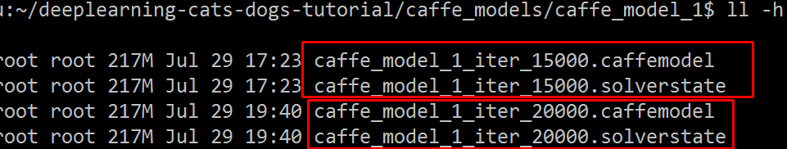
The solverstate file, as its name conveys, stores the state of the solver and not any information related to classification results. The model is saved as caffemodel file, which you can use to obtain classification results for your data. If you want to fine-tune your network you may use a pre-trained caffemodel file. This will save time as your network does not need to learn from scratch. But, in case your present training needs to be halted, due to a power cut or an unexpected reboot, you may resume your training form the previous snapshot of the solverstate.
我们在使用caffe训练过程中会生成.caffemodel和.solverstate文件，一个是模型文件，一个是中间状态文件（生成多少个取决于你自己设定的snapshot）。当训练过程中断，你想继续运行数据学习，此时只需要调用.solverstate文件即可。
使用方式代码，我使用的是.sh直接运行，配置和官方给的文件train_caffenet.sh差不多，稍微添加点内容就可以了。
./build/tools/caffe train \
--solver=examples/test/solver.prototxt --snapshot=examples/test/test_100000.solverstate

2.1 pycaffe cheatsheet

2.1.1
The pycaffe tests and this file are the main gateway to the python coding interface.
First of all, you would like to choose whether to use Caffe with CPU or GPU. It is sufficient to call caffe.set_mode_cpu() or caffe.set_mode_gpu(), respectively.

Net
The main class that the pycaffe interface exposes is the Net. It has two constructors:
net = caffe.Net('/path/prototxt/descriptor/file', caffe.TRAIN)
which simply create a Net (in this case using the Data Layer specified for training), or
net = caffe.Net('/path/prototxt/descriptor/file', '/path/caffemodel/weights/file', caffe.TEST)

which creates a Net and automatically loads the weights as saved in the provided caffemodel file - in this case using the Data Layer specified for testing.

A Net object has several attributes and methods. They can be found here. I will cite just the ones I use more often.

You can access the network blobs by means of Net.blobs. E.g.

data = net.blobs['data'].data
net.blobs['data'].data[...] = my_image
fc7_activations = net.blobs['fc7'].data
You can access the parameters (weights) too, in a similar way. E.g.

nice_edge_detectors = net.params['conv1'].data
higher_level_filter = net.params['fc7'].data

Ok, now it's time to actually feed the net with some data. So, you will use backward() and forward() methods. So, if you want to classify a single image

net.blobs['data'].data[...] = my_image
net.forward() # equivalent to net.forward_all()
softmax_probabilities = net.blobs['prob'].data
The backward() method is equivalent, if one is interested in computing gradients.

You can save the net weights to subsequently reuse them. It's just a matter of

net.save('/path/to/new/caffemodel/file')

Solver

The other core component exposed by pycaffe is the Solver. There are several types of solver, but I'm going to use only SGDSolver for the sake of clarity. It is needed in order to train a caffe model. You can instantiate the solver with

solver = caffe.SGDSolver('/path/to/solver/prototxt/file')
The Solver will encapsulate the network you are training and, if present, the network used for testing. Note that they are usually the same network, only with a different Data Layer. The networks are accessible with

training_net = solver.net
test_net = solver.test_nets[0] # more than one test net is supported
Then, you can perform a solver iteration, that is, a forward/backward pass with weight update, typing just

solver.step(1)
or run the solver until the last iteration, with

solver.solve()
Other features
https://stackoverflow.com/questions/32379878/cheat-sheet-for-caffe-pycaffe

2.1 lib introduce

2.1.1 LMDB
LMDB
Caffe使用LMDB来存放训练/测试用的数据集，以及使用网络提取出的feature（为了方便，以下还是统称数据集）。数据集的结构很简单，就是大量的矩阵/向量数据平铺开来。数据之间没有什么关联，数据内没有复杂的对象结构，就是向量和矩阵。既然数据并不复杂，Caffe就选择了LMDB这个简单的数据库来存放数据。

LMDB的全称是Lightning Memory-Mapped Database，闪电般的内存映射数据库。它文件结构简单，一个文件夹，里面一个数据文件，一个锁文件。数据随意复制，随意传输。它的访问简单，不需要运行单独的数据库管理进程，只要在访问数据的代码里引用LMDB库，访问时给文件路径即可。

图像数据集归根究底从图像文件而来。既然有ImageDataLayer可以直接读取图像文件，为什么还要用数据库来放数据集，增加读写的麻烦呢？我认为，Caffe引入数据库存放数据集，是为了减少IO开销。读取大量小文件的开销是非常大的，尤其是在机械硬盘上。LMDB的整个数据库放在一个文件里，避免了文件系统寻址的开销。LMDB使用内存映射的方式访问文件，使得文件内寻址的开销非常小，使用指针运算就能实现。数据库单文件还能减少数据集复制/传输过程的开销。一个几万，几十万文件的数据集，不管是直接复制，还是打包再解包，过程都无比漫长而痛苦。LMDB数据库只有一个文件，你的介质有多块，就能复制多快，不会因为文件多而慢如蜗牛。

2.1.1 LMDB

2.1 digits to train

2.1.1 LMDB
LMDB
Caffe使用LMDB

caffe framework

2.1 basic framewprk

2.1.1 blob
深度网络(net)是一个组合模型，它由许多相互连接的层（layers)组合而成。Caffe就是组建深度网络的这样一种工具，它按照一定的策略，一层一层的搭建出自己的模型。它将所有的信息数据定义为blobs，从而进行便利的操作和通讯。Blob是caffe框架中一种标准的数组，一种统一的内存接口，它详细描述了信息是如何存储的，以及如何在层之间通讯的。
Blobs封装了运行时的数据信息，提供了CPU和GPU的同步。从数学上来说, Blob就是一个N维数组。它是caffe中的数据操作基本单位，就像matlab中以矩阵为基本操作对象一样。只是矩阵是二维的，而Blob是N维的。N可以是2，3，4等等。对于图片数据来说，Blob可以表示为（N*C*H*W）这样一个4D数组。其中N表示图片的数量，C表示图片的通道数，H和W分别表示图片的高度和宽度。当然，除了图片数据，Blob也可以用于非图片数据。比如传统的多层感知机，就是比较简单的全连接网络，用2D的Blob，调用innerProduct层来计算就可以了。

Blob是：
对待处理数据带一层封装，用于在Caffe中通信传递。
也为CPU和GPU间提供同步能力
数学上，是一个N维的C风格的存储数组
总的来说，Caffe使用Blob来交流数据，其是Caffe中标准的数组与统一的内存接口，它是多功能的，在不同的应用场景具有不同的含义，如可以是：batches of images, model parameters, and derivatives for optimization等。

在模型中设定的参数，也是用Blob来表示和运算。它的维度会根据参数的类型不同而不同。比如：在一个卷积层中，输入一张3通道图片，有96个卷积核，每个核大小为11*11，因此这个Blob是96*3*11*11. 而在一个全连接层中，假设输入1024通道图片，输出1000个数据，则Blob为1000*1024

2.1.1 layer
层是网络模型的组成要素和计算的基本单位。层的类型比较多，如Data,Convolution,Pooling,ReLU,Softmax-loss,Accuracy等，一个层的定义大至如下图：
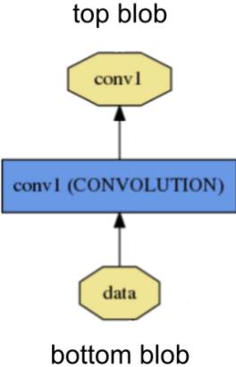
从bottom进行数据的输入 ，计算后，通过top进行输出。图中的黄色多边形表示输入输出的数据，蓝色矩形表示层。

每一种类型的层都定义了三种关键的计算：setup,forward and backword

setup: 层的建立和初始化，以及在整个模型中的连接初始化。

forward: 从bottom得到输入数据，进行计算，并将计算结果送到top，进行输出。

backward: 从层的输出端top得到数据的梯度，计算当前层的梯度，并将计算结果送到bottom,向前传递。

2.1.1 Net
就像搭积木一样，一个net由多个layer组合而成。

现给出 一个简单的2层神经网络的模型定义( 加上loss 层就变成三层了)，先给出这个网络的拓扑。
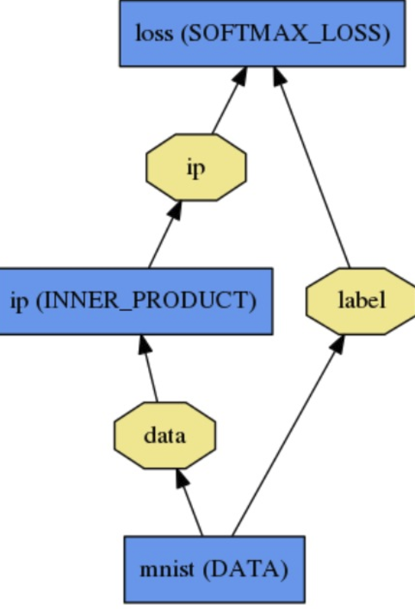
第一层：name为mnist, type为Data，没有输入（bottom)，只有两个输出（top),一个为data,一个为label
第二层：name为ip，type为InnerProduct, 输入数据data, 输出数据ip
第三层：name为loss, type为SoftmaxWithLoss，有两个输入，一个为ip,一个为label，有一个输出loss,没有画出来。
对应的配置文件prototxt就可以这样写：
name: "LogReg"  layer {  name: "mnist"  type: "Data"  top: "data"  top: "label"  data_param {  source: "input_leveldb"  batch_size: 64  }  } | layer {  name: "ip"  type: "InnerProduct"  bottom: "data"  top: "ip"  inner_product_param {  num_output: 2  }  } | layer {  name: "loss"  type: "SoftmaxWithLoss"  bottom: "ip"  bottom: "label"  top: "loss"  }
第一行将这个模型取名为LogReg, 然后是三个layer的定义，参数都比较简单，只列出必须的参数。具体的参数定义可参见本系列的前几篇文章。

2.1 config file

2.1.1 solver parameter
The solver orchestrates model optimization by coordinating the network’s forward inference and backward gradients to form parameter updates that attempt to improve the loss. The responsibilities of learning are divided between the Solver for overseeing the optimization and generating parameter updates and the Net for yielding loss and gradients.
The Caffe solvers are:
solver算是caffe的核心的核心，它协调着整个模型的运作。caffe程序运行必带的一个参数就是solver配置文件。运行代码一般为

# caffe train --solver=*_slover.prototxt
在Deep Learning中，往往loss function是非凸的，没有解析解，我们需要通过优化方法来求解。solver的主要作用就是交替调用前向（forward)算法和后向（backward)算法来更新参数，从而最小化loss，实际上就是一种迭代的优化算法。

到目前的版本，caffe提供了六种优化算法来求解最优参数，在solver配置文件中，通过设置type类型来选择
Stochastic Gradient Descent (type: "SGD"),
AdaDelta (type: "AdaDelta"),
Adaptive Gradient (type: "AdaGrad"),
Adam (type: "Adam"),
Nesterov’s Accelerated Gradient (type: "Nesterov") and
RMSprop (type: "RMSProp")

The solver

1.scaffolds the optimization bookkeeping and creates the training network for learning and test network(s) for evaluation.
2. iteratively optimizes by calling forward / backward and updating parameters
3. (periodically) evaluates the test networks
4. snapshots the model and solver state throughout the optimization

Solver的流程：
1. 设计好需要优化的对象，以及用于学习的训练网络和用于评估的测试网络。（通过调用另外一个配置文件prototxt来进行）
2. 通过forward和backward迭代的进行优化来跟新参数。
3. 定期的评价测试网络。 （可设定多少次训练后，进行一次测试）
4. 在优化过程中显示模型和solver的状态

where each iteration

calls network forward to compute the output and loss
calls network backward to compute the gradients
incorporates the gradients into parameter updates according to the solver method
updates the solver state according to learning rate, history, and method

在每一次的迭代过程中，solver做了这几步工作：
1、调用forward算法来计算最终的输出值，以及对应的loss
2、调用backward算法来计算每层的梯度
3、根据选用的slover方法，利用梯度进行参数更新
4、记录并保存每次迭代的学习率、快照，以及对应的状态。

接下来，我们先来看一个实例：
net: "examples/mnist/lenet_train_test.prototxt"
test_iter: 100
test_interval: 500
base_lr: 0.01
momentum: 0.9
type: SGD
weight_decay: 0.0005
lr_policy: "inv"
gamma: 0.0001
power: 0.75
display: 100
max_iter: 20000
snapshot: 5000
snapshot_prefix: "examples/mnist/lenet"
solver_mode: CPU

test_iter: 100
这个要与test layer中的batch_size结合起来理解。mnist数据中测试样本总数为10000，一次性执行全部数据效率很低，因此我们将测试数据分成几个批次来执行，每个批次的数量就是batch_size。假设我们设置batch_size为100，则需要迭代100次才能将10000个数据全部执行完。因此test_iter设置为100。执行完一次全部数据，称之为一个epoch

test_interval: 500
测试间隔。也就是每训练500次，才进行一次测试。

base_lr: 0.01
lr_policy: "inv"
gamma: 0.0001
power: 0.75
这四行可以放在一起理解，用于学习率的设置。只要是梯度下降法来求解优化，都会有一个学习率，也叫步长。base_lr用于设置基础学习率，在迭代的过程中，可以对基础学习率进行调整。怎么样进行调整，就是调整的策略，由lr_policy来设置。

lr_policy可以设置为下面这些值，相应的学习率的计算为：

- fixed: 保持base_lr不变.
- step: 如果设置为step,则还需要设置一个stepsize, 返回 base_lr * gamma ^ (floor(iter / stepsize)),其中iter表示当前的迭代次数
- exp: 返回base_lr * gamma ^ iter， iter为当前迭代次数
- inv: 如果设置为inv,还需要设置一个power, 返回base_lr * (1 + gamma * iter) ^ (- power)
- multistep: 如果设置为multistep,则还需要设置一个stepvalue。这个参数和step很相似，step是均匀等间隔变化，而multistep则是根据 stepvalue值变化
- poly: 学习率进行多项式误差, 返回 base_lr (1 - iter/max_iter) ^ (power)
- sigmoid: 学习率进行sigmod衰减，返回 base_lr ( 1/(1 + exp(-gamma * (iter - stepsize))))

momentum ：0.9
上一次梯度更新的权重，具体可参看下一篇文章。

type: SGD
优化算法选择。这一行可以省掉，因为默认值就是SGD。总共有六种方法可选择，在本文的开头已介绍。

weight_decay: 0.0005
权重衰减项，防止过拟合的一个参数。

display: 100
每训练100次，在屏幕上显示一次。如果设置为0，则不显示。

max_iter: 20000
最大迭代次数。这个数设置太小，会导致没有收敛，精确度很低。设置太大，会导致震荡，浪费时间。

snapshot: 5000
snapshot_prefix: "examples/mnist/lenet"
快照。将训练出来的model和solver状态进行保存，snapshot用于设置训练多少次后进行保存，默认为0，不保存。snapshot_prefix设置保存路径。
还可以设置snapshot_diff，是否保存梯度值，默认为false,不保存。

也可以设置snapshot_format，保存的类型。有两种选择：HDF5 和BINARYPROTO ，默认为BINARYPROTO
solver_mode: CPU
设置运行模式。默认为GPU,如果你没有GPU,则需要改成CPU,否则会出错。
注意：以上的所有参数都是可选参数，都有默认值。根据solver方法（type)的不同，还有一些其它的参数，在此不一一列举

Solver就是用来使loss最小化的优化方法。对于一个数据集D，需要优化的目标函数是整个数据集中所有数据loss的平均值
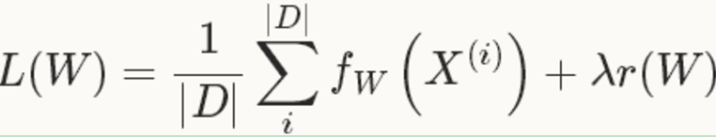
如果采用这种Loss 函数，迭代一次需要计算整个数据集，在数据集非常大的这情况下，这种方法的效率很低，这个也是我们熟知的梯度下降采用的方法。
在实际中，通过将整个数据集分成几批（batches), 每一批就是一个mini-batch，其数量（batch_size)为N<<|D|，此时的loss 函数为：
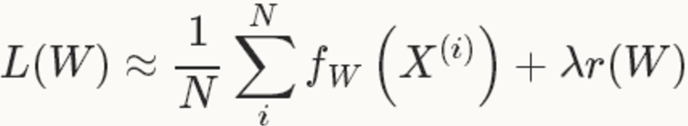
有了loss函数后，就可以迭代的求解loss和梯度来优化这个问题。在神经网络中，用forward pass来求解loss，用backward pass来求解梯度。
在caffe中，默认采用的Stochastic Gradient Descent（SGD）进行优化求解。后面几种方法也是基于梯度的优化方法（like SGD），因此本文只介绍一下SGD
SGD在通过负梯度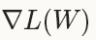和上一次的权重更新值V_{t}的线性组合来更新W，迭代公式如下：
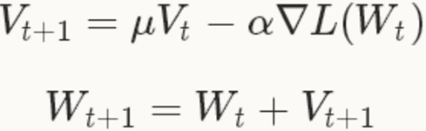
其中， 是负梯度的学习率(base_lr)，是上一次梯度值的权重（momentum），用来加权之前梯度方向对现在梯度下降方向的影响。这两个参数需要通过tuning来得到最好的结果，一般是根据经验设定的。如果你不知道如何设定这些参数，可以参考相关的论文。
在深度学习中使用SGD，比较好的初始化参数的策略是把学习率设为0.01左右（base_lr: 0.01)，在训练的过程中，如果loss开始出现稳定水平时，对学习率乘以一个常数因子（gamma），这样的过程重复多次。
对于momentum，一般取值在0.5--0.99之间。通常设为0.9，momentum可以让使用SGD的深度学习方法更加稳定以及快速。
关于更多的momentum，请参看Hinton的《A Practical Guide to Training Restricted Boltzmann Machines》。
base_lr: 0.01
lr_policy: "step"
gamma: 0.1
stepsize: 1000
max_iter: 3500
momentum: 0.9
lr_policy设置为step,则学习率的变化规则为 base_lr * gamma ^ (floor(iter / stepsize))
即前1000次迭代，学习率为0.01; 第1001-2000次迭代，学习率为0.001; 第2001-3000次迭代，学习率为0.00001，第3001-3500次迭代，学习率为10⁻⁵
上面的设置只能作为一种指导，它们不能保证在任何情况下都能得到最佳的结果，有时候这种方法甚至不work。如果学习的时候出现diverge（比如，你一开始就发现非常大或者NaN或者inf的loss值或者输出），此时你需要降低base_lr的值（比如，0.001），然后重新训练，这样的过程重复几次直到你找到可以work的base_lr
2、AdaDelta
AdaDelta是一种”鲁棒的学习率方法“，是基于梯度的优化方法（like SGD）
3、AdaGrad
自适应梯度（adaptive gradient）是基于梯度的优化方法（like SGD）

2.1.1 lr_mult和decay_mult
在caffe的prototxt定义中我们看到lr_mult和decay_mult
layer {
name: "conv3"
type: "Convolution"
bottom: "conv2"
top: "conv3"
param {
lr_mult: 1
decay_mult: 1
}
param {
lr_mult: 2
decay_mult: 0
}
convolution_param {
num_output: 32
kernel_size: 3
stride: 1
weight_filler {
type: "xavier"
}
bias_filler {
type: "constant"
value: 0
}
}
}
在caffe当中，除了全局设置的学习率lr和权重衰减项也就是weight_decay，每一个需要学习参数的layer都还有局部的加权值，分别是lr_mult和decay_mult，而对于卷积层的话，w和b都属于可以学习的参数，所以在学习更新中他们都有属于自己的lr_mult和decay_mult。

注：上面之所以有两次param 是因为weight和bias两个参数

caffe source code analysis

1.1 Blob

2.1.1 SyncedMemory
本文主要分析caffe中Blob内存管理类SyncedMemory，主要内容包括：
1. SyncedMemory和Blob的关系
2. SyncedMemory中的方法，如内存的分配、释放
3. SyncedMemory中内存的申请，是在数据访问时才分配而不是立马分配(通过enum SyncedHead状态实现)

### SyncedMemory和Blob的关系
Blob中的主要数据成员如下，实际是在SyncedMemory上做了一层包装：
template<typename Dtype>
class Blob{
protected:
shared_ptr<SyncedMemory> data_; //存储前向传递数据
shared_ptr<SyncedMemory> diff_; //存储反向传递梯度
vector<int> shape_; //参数维度
int count_; //Blob存储的元素个数（shape_所有元素乘积）
int capacity_;//当前Blob的元素个数（控制动态分配）
};
类图如下：
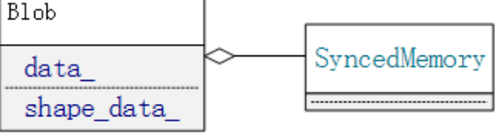

### SyncedMemory
SyncedMemory 的主要数据成员如下：
class SyncedMemory {
private:
void* cpu_ptr_;//内存指针
void* gpu_ptr_;//显存指针
size_t size_; //数据大小
SyncedHead head_;//当前数据状态
bool own_cpu_data_;
bool cpu_malloc_use_cuda_;
bool own_gpu_data_;
int gpu_device_;
};

1. SyncedMemory屏蔽了代码对不同硬件设备的内存分配的感知，同时隐藏了CPU和GPU之间的同步过程。
2. SyncedMemory采用“lazy”的模式，就是内存的实际申请时机是在第一次使用时进行的(通过枚举状态)。
首先看如下两个函数cpu_data， gpu_data获取cpu，gpu数据指针:
const void* SyncedMemory::cpu_data() {
to_cpu(); // 首先完成数据同步，第一次访问时会申请存储空间
return (const void*)cpu_ptr_;
}
const void* SyncedMemory::gpu_data() {
#ifndef CPU_ONLY
to_gpu();
return (const void*)gpu_ptr_;
#else
NO_GPU;
return NULL;
#endif
return nullptr;
}
以cpu_data为例, 如果数据尚未分配(通过如下枚举判断)，则分配数据，如果已经分配则什么也不做：
enum SyncedHead { UNINITIALIZED, HEAD_AT_CPU, HEAD_AT_GPU, SYNCED };

inline void SyncedMemory::to_cpu() {
switch (head_) {
case UNINITIALIZED://数据尚未分配
CaffeMallocHost(&cpu_ptr_, size_, &cpu_malloc_use_cuda_);
caffe_memset(size_, 0, cpu_ptr_);
head_ = HEAD_AT_CPU;//更新枚举状态
own_cpu_data_ = true;
break;
case HEAD_AT_GPU:
#ifndef CPU_ONLY
// ........
;
#else
NO_GPU;
#endif
break;
case HEAD_AT_CPU:
case SYNCED:
break;
}
}

SyncedMemory有如下接口，获取cpu中的数据指针(gpu同理)：
//获取CPU数据指针，不能改变数据内容
const void* cpu_data();
//获取CPU数据指针，可以改变数据内容
void* mutable_cpu_data();
Blob中调用:
// 调用SyncedMemory的数据访问函数cpu_data(),并返回内存指针
template <typename Dtype>
const Dtype* Blob<Dtype>::cpu_data() const {
CHECK(data_);
return (const Dtype*)data_->cpu_data();
}
template <typename Dtype>
Dtype* Blob<Dtype>::mutable_cpu_data() {
CHECK(data_);
return static_cast<Dtype*>(data_->mutable_cpu_data());
}

### 内存分配与释放
内存分配与释放由两个(不属于SyncedMemory类)的内联函数完成. 代码简单直观: 如果是CPU模式, 那么调用malloc和free来申请/释放内存, 否则调用CUDA的cudaMallocHost和cudaFreeHost来申请/释放显存.
inline void CaffeMallocHost(void** ptr, size_t size, bool* use_cuda) {
*ptr = malloc(size);
*use_cuda = false;
CHECK(*ptr) << "host allocation of size " << size << " failed";
}
inline void CaffeFreeHost(void* ptr, bool use_cuda) {
free(ptr);
}
参考：
https://www.jianshu.com/p/2e99bb0421c5
https://www.jianshu.com/p/b105578b214b

2.1.1 Blob
### overview
Blob 是Caffe作为数据传输的媒介，无论是网络权重参数，还是输入数据，都是转化为Blob数据结构来存储，网络，求解器等都是直接与此结构打交道的。

其直观的可以把它看成一个有4纬的结构体（包含数据和梯度），而实际上，它们只是一维的指针而已，其4维结构通过shape属性得以计算出来（根据C语言的数据顺序）。

### 成员变量
Blob中的主要数据成员如下，实际是在SyncedMemory上做了一层包装(SyncedMemory介绍见上一篇blog)：
protected:
shared_ptr<SyncedMemory> data_; //存储前向传递数据
shared_ptr<SyncedMemory> diff_; //存储反向传递梯度
shared_ptr<SyncedMemory> shape_data_;// 参数维度old version
vector<int> shape_; //参数维度
int count_; //Blob存储的元素个数（shape_所有元素乘积）
int capacity_;//当前Blob的元素个数（控制动态分配）

### 主要函数
主要分析如下几类函数：
- 构造函数, 以及Reshape函数()
2. 索引、返回N、C、H、W相关函数
3. gpu、cpu同步函数， 以及数据的获取
4. 简单的数据处理如scale_data对数据缩放(底层调用了cblas库的运算)

##### 1. 构造函数, 以及Reshape函数()
构造函数分类两种类型：
1. 默认的什么参数
2. 传入N、C、H、W构造，最终调用Reshape函数
Blob() //构造函数：初始化列表 {空函数体}
: data_(), diff_(), count_(0), capacity_(0) {}
// @brief Deprecated; use <code>Blob(const vector<int>& shape)</code>.
explicit Blob(const int num, const int channels, const int height,
const int width); //可以通过设置数据维度（N,C,H,W）初始化
// 也可以通过传入vector<int>直接传入维数
explicit Blob(const vector<int>& shape);

template <typename Dtype>
Blob<Dtype>::Blob(const int num, const int channels, const int height,
const int width)
// capacity_ must be initialized before calling Reshape
: capacity_(0) {
Reshape(num, channels, height, width);
}
template <typename Dtype>
Blob<Dtype>::Blob(const vector<int>& shape)
// capacity_ must be initialized before calling Reshape
: capacity_(0) {
Reshape(shape);
}
下面重点看下Reshape函数
template <typename Dtype>
void Blob<Dtype>::Reshape(const int num, const int channels, const int height,
const int width) {
vector<int> shape(4);
shape[0] = num;
shape[1] = channels;
shape[2] = height;
shape[3] = width;
Reshape(shape);
}

// 完成blob形状shape_的记录，大小count_的计算，合适大小capacity_存储的申请
template <typename Dtype>
void Blob<Dtype>::Reshape(const vector<int>& shape) {
CHECK_LE(shape.size(), kMaxBlobAxes);
count_ = 1;
shape_.resize(shape.size());
if (!shape_data_ || shape_data_->size() < shape.size() * sizeof(int)) {
shape_data_.reset(new SyncedMemory(shape.size() * sizeof(int)));
}
int* shape_data = static_cast<int*>(shape_data_->mutable_cpu_data());
for (int i = 0; i < shape.size(); ++i) {
CHECK_GE(shape[i], 0);
CHECK_LE(shape[i], INT_MAX / count_) << "blob size exceeds INT_MAX";
count_ *= shape[i];
shape_[i] = shape[i];
shape_data[i] = shape[i];
}
if (count_ > capacity_) {
capacity_ = count_;
// 只是构造了SyncedMemory对象，并未真正分配内存和显存
data_.reset(new SyncedMemory(capacity_ * sizeof(Dtype)));
// 真正分配是在第一次访问数据时
diff_.reset(new SyncedMemory(capacity_ * sizeof(Dtype)));
}
}
上面注意的是：shape_data_是历史版本的shape,
new SyncedMemory(shape.size() * sizeof(int)）并不分配实际的内存。shape_data_->mutable_cpu_data()获取实际的data，如果没有分配内存则分配。

void* SyncedMemory::mutable_cpu_data() {
to_cpu();
head_ = HEAD_AT_CPU;
return cpu_ptr_;
}
mutable_cpu_data，根据head_的枚举状态判断是否已经分配了内存。
注：Reshape函数除了被构造函数调用外，也常常作为一般的函数调用，例如对网络的输入的改变：
net_24.blobs['data'].reshape(10, 3, 24, 24)
##### 2. 索引、返回N、C、H、W相关函数
/// @brief Deprecated legacy shape accessor num: use shape(0) instead.
inline int num() const { return LegacyShape(0); }
/// @brief Deprecated legacy shape accessor channels: use shape(1) instead.
inline int channels() const { return LegacyShape(1); }
/// @brief Deprecated legacy shape accessor height: use shape(2) instead.
inline int height() const { return LegacyShape(2); }
/// @brief Deprecated legacy shape accessor width: use shape(3) instead.
inline int width() const { return LegacyShape(3); }

//计算物理偏移量，(n,c,h,w)的偏移量为((n∗C+c)∗H+h)∗W+w
inline int offset(const int n, const int c = 0, const int h = 0,
const int w = 0) const {
CHECK_GE(n, 0);
CHECK_LE(n, num());
CHECK_GE(channels(), 0);
CHECK_LE(c, channels());
CHECK_GE(height(), 0);
CHECK_LE(h, height());
CHECK_GE(width(), 0);
CHECK_LE(w, width());
return ((n * channels() + c) * height() + h) * width() + w;
}
计数 ：
//返回Blob维度数，对于维数(N,C,H,W)，返回N×C×H×W
inline int count() const { return count_; }
//对于维数(N,C,H,W)，count(0, 3)返回N×C×H
inline int count(int start_axis, int end_axis) const {
CHECK_LE(start_axis, end_axis);
CHECK_GE(start_axis, 0);
CHECK_GE(end_axis, 0);
CHECK_LE(start_axis, num_axes());
CHECK_LE(end_axis, num_axes());
int count = 1;
for (int i = start_axis; i < end_axis; ++i) {
count *= shape(i);
}
return count;
}

##### 3. gpu、cpu同步函数， 以及数据的获取
首先给出一个ReLULayer的前馈函数的示例(里面用到了Blob两个函数cpu_data， mutable_cpu_data一个获取可变的数据，一个不可变。)：
template <typename Dtype>
void ReLULayer<Dtype>::Forward_cpu(const vector<Blob<Dtype>*>& bottom,
const vector<Blob<Dtype>*>& top) {
// bottom_data don’t change
const Dtype* bottom_data = bottom[0]->cpu_data();
// top_data will change
Dtype* top_data = top[0]->mutable_cpu_data();
const int count = bottom[0]->count();
Dtype negative_slope = this->layer_param_.relu_param().negative_slope();
for (int i = 0; i < count; ++i) {
top_data[i] = std::max(bottom_data[i], Dtype(0))
+ negative_slope * std::min(bottom_data[i], Dtype(0));
}
}

// 调用SyncedMemory的数据访问函数cpu_data(),并返回内存指针
template <typename Dtype>
const Dtype* Blob<Dtype>::cpu_data() const {
CHECK(data_);
return (const Dtype*)data_->cpu_data();
}
template <typename Dtype>
Dtype* Blob<Dtype>::mutable_cpu_data() {
CHECK(data_);
return static_cast<Dtype*>(data_->mutable_cpu_data());
}
下面给出一些简单的示例：
// 假定数据在 CPU 上进行初始化，我们有一个 blob
const Dtype* foo;
Dtype* bar;
foo = blob.gpu_data(); // 数据从 CPU 复制到 GPU
foo = blob.cpu_data(); // 没有数据复制，两者都有最新的内容
bar = blob.mutable_gpu_data(); // 没有数据复制
// ... 一些操作 ...
bar = blob.mutable_gpu_data(); // 仍在 GPU，没有数据复制
foo = blob.cpu_data(); // 由于 GPU 修改了数值，数据从 GPU 复制到 CPU
foo = blob.gpu_data(); //没有数据复制，两者都有最新的内容
bar = blob.mutable_cpu_data(); // 依旧没有数据复制
bar = blob.mutable_gpu_data(); //数据从 CPU 复制到 GPU
bar = blob.mutable_cpu_data(); //数据从 GPU 复制到 CPU
##### 4. 简单的数据处理如scale_data对数据缩放(底层调用了cblas库的运算)
下面简单看下scale_data对data_乘上某个因子(主要是cpu的实现)：
data = mutable_cpu_data();//获取可变的CPU数据
caffe_scal(count_, scale_factor, data);//根据个数count_对data scale
template <typename Dtype>
void Blob<Dtype>::scale_data(Dtype scale_factor) { //对data_乘上某个因子
Dtype* data;
if (!data_) { return; }
switch (data_->head()) {
case SyncedMemory::HEAD_AT_CPU:
data = mutable_cpu_data();
caffe_scal(count_, scale_factor, data);
return;
case SyncedMemory::HEAD_AT_GPU:
case SyncedMemory::SYNCED:
// caffe_gpu_scal(count_, scale_factor, data);
return;
#else
NO_GPU;
#endif
case SyncedMemory::UNINITIALIZED:
return;
default:
LOG(FATAL) << "Unknown SyncedMemory head state: " << data_->head();
}
}
caffe_scal底层调用的是cblas的cblas_sscal函数(此处用了模板的特化)：
template <>
void caffe_scal<float>(const int N, const float alpha, float *X) {
cblas_sscal(N, alpha, X, 1);
}

1.1 TODO

2.1.1 参考

1.1

2.1.1 参考
Caffe Source Code Analysis
https://buptldy.github.io/2016/10/09/2016-10-09-Caffe_Code/

Caffe学习笔记6-Caffe结构简析（知乎同步）
http://yufeigan.github.io/2015/02/12/Caffe%E5%AD%A6%E4%B9%A0%E7%AC%94%E8%AE%B06-Caffe%E7%BB%93%E6%9E%84%E7%AE%80%E6%9E%90%EF%BC%88%E7%9F%A5%E4%B9%8E%E5%90%8C%E6%AD%A5%EF%BC%89/

Caffe_Code_Analysis
https://github.com/BUPTLdy/Caffe_Code_Analysis
E:\caffe_code

caffe源码解析-开篇
https://zhuanlan.zhihu.com/p/25127756

CNN only in native python & numpy
https://github.com/amsukdu/SimplePythonCNN

header only, dependency-free deep learning framework in C++14
https://github.com/tiny-dnn/tiny-dnn

下面这个有网页示例还可以
A scratch implementation of Convolutional Neural Network in Python using numpy only and validated over CIFAR-10 & MNIST Dataset
http://cnndigits.pythonanywhere.com/
https://github.com/zishansami102/CNN-from-Scratch

下面这个也可以
A convolutional neural network from scratch
https://github.com/dorajam/Convolutional-Network

下面这个系列blog写的很不错
Implementing Convolutional Neural Networks
https://deepnotes.io/implementing-cnn
https://github.com/parasdahal/deepnet

下面这个也还可以
In this article, CNN is created using only NumPy library. Just three layers are created which are convolution (conv for short), ReLU, and max pooling.
https://www.kdnuggets.com/2018/04/building-convolutional-neural-network-numpy-scratch.html

Convolutional neural networks with Python 3
https://github.com/integeruser/MNIST-cnn

2.1.1 参考
Caffe Source Code Analysis

reference cite

