chapter Lua & Torch 1
1.1 torch nn 1
1.1.1 define network 2
1.2 Transfer Function( sigmoid ReLU) 3
1.3 Serialization methods 4
1.4 Criterions 4
1.5 Missing details 4
1.6 Steps of Trainning 5
1.7 CIFAR-10 example 5
1.7.1 create .t7 file 5

chapter Lua & Torch

1.1 torch nn
th> torch.randn(3)  -0.3923  -0.5964  0.5535 | th> torch.ones(2, 3)  1 1 1  1 1 1

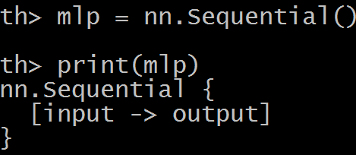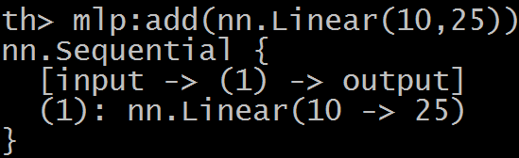
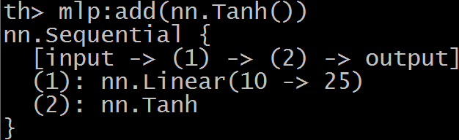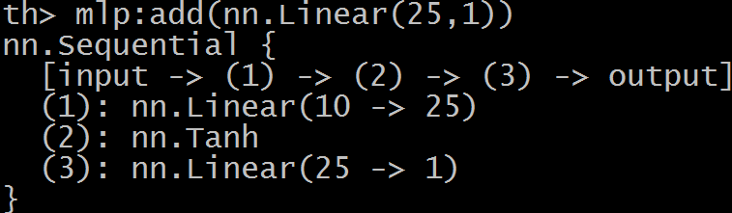
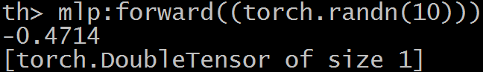

th> module = nn.Linear(10, 5) -- 10 inputs, 5 outputs
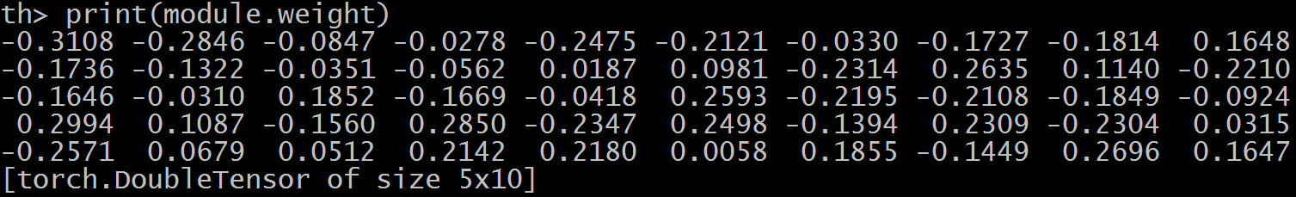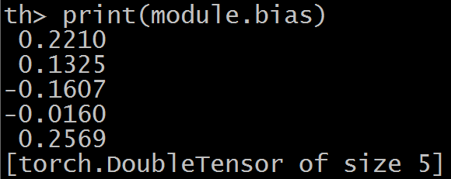
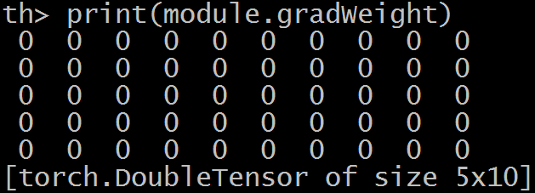
> torch.Tensor(2,2):fill(4)
4 4
4 4

1.1.1 define network
Modules are the bricks used to build neural networks. Each are themselves neural networks, but can be combined with other networks using containers to create complex neural networks
For example, look at this network that classfies digit images:
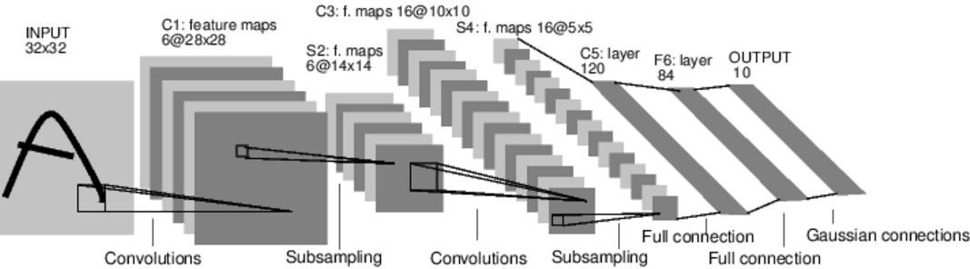
Such a network container is nn.Sequential which feeds the input through several layers.
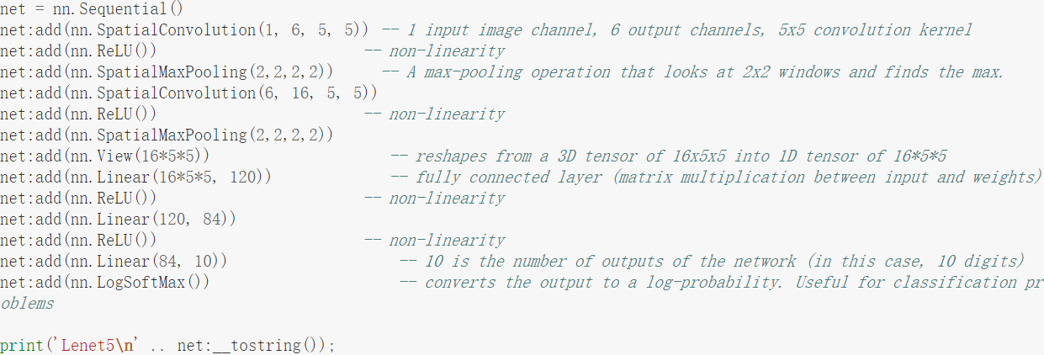
(介绍一下卷积函数：
module = nn.SpatialConvolution(nInputPlane, nOutputPlane, kW, kH, [dW],
[dH], [padW], [padH])
参数含义如下：
nInputPlane：输入的通道数
nOutputPlane：输出的通道数
kW x kH：定义卷积核的大小
[dW],[dH：分别为横向和纵向移动的步长，默认值为1
[padW]：宽度维度附加值，默认值为零，使用时推荐设置为(kW-1)/2。在卷积运算的维度不匹配时起作用，这儿不考虑]
[padH]：与padW类似，推荐设置为(kH-1)/2)

然后添加往卷基层添加卷积的操作以及激活函数ReLU
net:add(nn.ReLU())
加入新的池化Pooling层，在3x3的区域内寻找最大值作为该区域的值，横向和纵向的查找步长分别为3，如下所示。
介绍一下池化函数：
nn.SpatialMaxPooling(kW, kH, [dW], [dH], [padW], [padH])
参数的定义与卷积函数的定义一致，见上面)
将三维的Tensor转换成一维的Tensor,如下所示。
net:add(nn.View(16*5*5))-- reshapes from a 3D tensor of 16x5x5 into 1D tensor of 16*5*5

1.2 Transfer Function( sigmoid ReLU)
Transfer Function Layers
Transfer functions are normally used to introduce a non-linearity after a parameterized layer like Linear and SpatialConvolution. Non-linearities allows for dividing the problem space into more complex regions than what a simple logistic regressor would permit.
Applies the rectified linear unit (ReLU) function element-wise to the input Tensor, thus outputting a Tensor of the same dimension.
ii=torch.linspace(-3,3) -- generate [-3 , 3]
m=nn.ReLU()
oo=m:forward(ii)
go=torch.ones(100)
gi=m:backward(ii,go)
gnuplot.plot({'f(x)',ii,oo,'+-'},{'df/dx',ii,gi,'+-'})
gnuplot.grid(true)
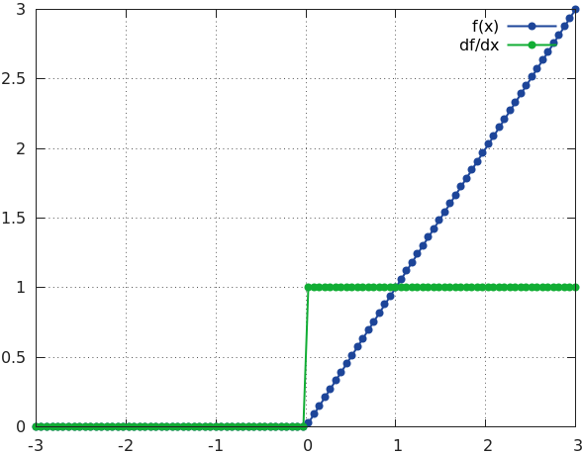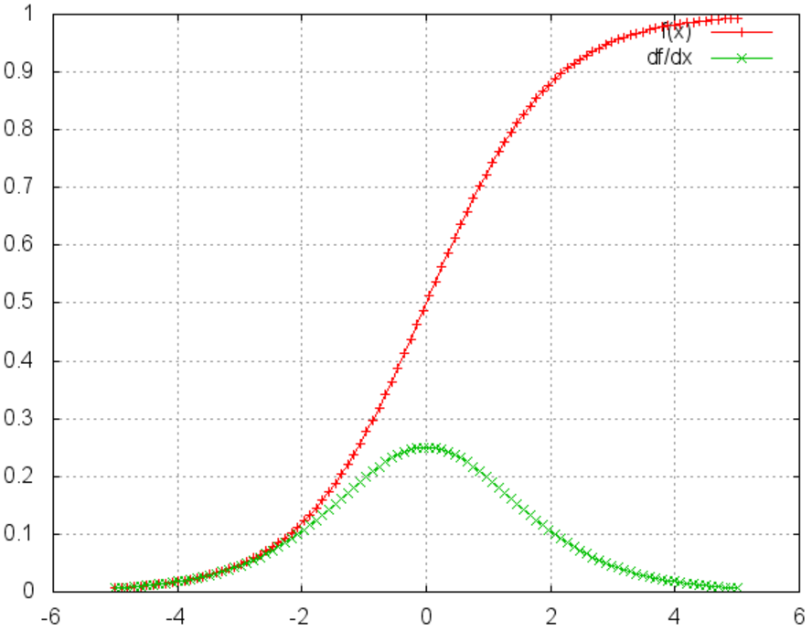
Every neural network module in torch has automatic differentiation. It has a :forward(input) function that computes the output for a given input, flowing the input through the network. and it has a :backward(input, gradient) function that will differentiate each neuron in the network w.r.t. the gradient that is passed in. This is done via the chain rule.

Applies the Sigmoid function element-wise to the input Tensor, thus outputting a Tensor of the same dimension.
Sigmoid is defined as f(x) = 1/(1+exp(-x))
ii=torch.linspace(-5,5)
m=nn.Sigmoid()
oo=m:forward(ii)
go=torch.ones(100)
gi=m:backward(ii,go)
gnuplot.plot({'f(x)',ii,oo,'+-'},{'df/dx',ii,gi,'+-'}) -- image in above right

other transfer functions like HardTanh、LogSoftMax

1.3 Serialization methods
These methods allow the user to save any serializable objects on disk and reload it later in its original state. In other words, it can perform a deep copy of an object into a given File.
Serializable objects are Torch objects having a read() and write() method. Lua objects such as table, number or string or pure Lua functions are also serializable.

1.4 Criterions
When you want a model to learn to do something, you give it feedback on how well it is doing. This function that computes an objective measure of the model's performance is called a loss function.
A typical loss function takes in the model's output and the groundtruth and computes a value that quantifies the model's performance.
Criterions are helpful to train a neural network. Given an input and a target, they compute a gradient according to a given loss function. AbsCriterion and MSECriterion are perfect for regression problems, while ClassNLLCriterion is the criterion of choice when dealing with classification.
The model then corrects itself to have a smaller loss.
In torch, loss functions are implemented just like neural network modules, and have automatic differentiation.
They have two functions - forward(input, target), backward(input, target)
For example:
criterion = nn.ClassNLLCriterion() -- a negative log-likelihood criterion for multi-class classification
criterion:forward(output, 3) -- let's say the groundtruth was class number: 3
gradients = criterion:backward(output, 3)
gradInput = net:backward(input, gradients)

1.5 Missing details
A neural network layer can have learnable parameters or not.
A convolution layer learns its convolution kernels to adapt to the input data and the problem being solved.
A max-pooling layer has no learnable parameters. It only finds the max of local windows (池化层没有学习参数)

A layer in torch which has learnable weights, will typically have fields .weight (and optionally, .bias)

m = nn.SpatialConvolution(1,3,2,2) -- learn 3 2x2 kernels
print(m.weight) -- initially, the weights are randomly initialized
print(m.bias) -- The operation in a convolution layer is: output = convolution(input,weight) + bias

There are also two other important fields in a learnable layer. The gradWeight and gradBias. The gradWeight accumulates the gradients w.r.t. each weight in the layer, and the gradBias, w.r.t. each bias in the layer.

Training the network
For the network to adjust itself, it typically does this operation (if you do Stochastic Gradient Descent):
weight = weight + learningRate * gradWeight [equation 1]
This update over time will adjust the network weights such that the output loss is decreasing.

1.6 Steps of Trainning
We now have 5 steps left to do in training our first torch neural network
- Load and normalize data
- Define Neural Network
- Define Loss function
- Train network on training data
- Test network on test data.

1.7 CIFAR-10 example

1.7.1 create .t7 file
load: Readed_t7 = torch.load('cifar10-train.t7')
print(Readed_t7)
{
data : ByteTensor - size: 10000x3x32x32
label : ByteTensor - size: 10000
}
print(Readed_t7.data[1][1]) => 输出一个 32*32的矩阵
print(Readed_t7.label[1]) => for example : 4
data = torch.Tensor(3,3,3):fill(1)
(1,.,.) =
1 1 1
1 1 1
1 1 1

(2,.,.) =
1 1 1
1 1 1
1 1 1

(3,.,.) =
1 1 1
1 1 1
1 1 1
[torch.DoubleTensor of size 3x3x3]

label=torch.Tensor(1):fill(1)

data_to_write = {data=data, label=label}
torch.save("/tmp/saved_data.t7", data_to_write)
testt7 = torch.load('/tmp/saved_data.t7.t7')
print(testt7)
{
data : DoubleTensor - size: 3x3x3
label : DoubleTensor - size: 1
}

=============load image and generate==================
require 'torchx';
--Read all your dataset (the chosen extension is png)
files = paths.indexdir("/Path/to/your/images/", 'png', true)
data1 = {}
for i=1,files:size() do
local img1 = image.load(files:filename(i),3)
table.insert(data1, img1)
end
--Create the table of label according to
label1 = {}
for i=1, #data1 do
if i <= number_of_images_of_the_first_class then
label1[i] = 1
else
label1[i] = 2
end
end
--Reshape the tables to Tensors
label = torch.Tensor(label1)
data = torch.Tensor(#data1,3,16,16)
for i=1, #data1 do
data[i] = data1[i]
end
--Create the table to save
Data_to_Write = { data = data, label = label }
--Save the table in the /tmp
torch.save("/tmp/Saved_Data.t7", Data_to_Write)
It should be possible to make a less hideous code but this one details all the steps and works with torch 7

