Numpy - 1 -
1.1 np array - 1 -
1.1.1 np.array vs list - 1 -
1.1.1 create array,shape(diagonal array) - 2 -
1.1.2 create numpy from file - 4 -
1.1.2 numpy.random.randn - 4 -
1.1.2 numpy.random.random_integers - 6 -
1.1.2 numpy.random.randint - 6 -
1.1.2 numpy.dot - 6 -
1.1.2 numpy broadcasting - 7 -
1.1.2 numpy.argmax - 10 -
1.1.5 np.argsort(arr) / arr.sort() - 11 -
1.1.3 numpy.mat vs np.array - 12 -
1.1.4 np.shuffle vs np.permute - 12 -
1.1.4 issues about array multiply - 13 -
1.1.4 list to array - 13 -
1.1.4 flatten - 13 -
1.1.4 empty_like/ones_like/zeros_like/ones - 14 -
1.1.5 get nth column - 15 -
1.1.5 iterate rows/column - 16 -
1.1.5 index arrays - 17 -
1.1.5 vstack/hstack vs append concatenate - 19 -
1.1.5 sum/reverse - 20 -
1.1.5 flip/fliplr/flipud/rot90 - 21 -
1.1.5 equal/close - 22 -
1.1.5 mean - 23 -
1.1.5 covariance - 23 -
1.1.5 add row(np.concatenate/append) - 23 -
1.1.5 sample rows(np.random.randint) - 27 -
1.1.5 random/np.random.choice - 27 -
1.1.5 random.seed - 29 -
1.1 numpy Scipy pandas difference - 30 -
1.1 practice usage - 30 -
1.1.1 euclidean distance - 30 -
1.1.1 create array,shape(diagonal array) - 31 -
sklearn - 32 -
1.1 basic plot - 32 -
1.1.1 metric accuracy score - 32 -
matplotlib - 33 -
1.1 basic plot - 33 -
1.1.5 plot orthogonal vector - 35 -
1.1 multiple figures - 35 -
1.1 subplots / plot mul - 37 -
1.1 scatter - 39 -
Scipy - 41 -
1.1 basic plot - 41 -
1.1.1 plot orthogonal vector - 41 -
1.1 practice example - 41 -
1.1.1 euclidean distance - 41 -

Numpy

np array

1.1.1 np.array vs list
Why NumPy instead of Python lists?
Is it worth my learning NumPy?

I have approximately 100 financial markets series, and I am going to create a cube array of 100x100x100 = 1 million cells. I will be regressing (3-variable) each x with each y and z, to fill the array with standard errors.
I have heard that for "large matrices" I should use NumPy as opposed to Python lists, for performance and scalability reasons. Thing is, I know Python lists and they seem to work for me.

Is the scale of the above problem worth moving to NumPy?

NumPy's arrays are more compact than Python lists -- a list of lists as you describe, in Python, would take at least 20 MB or so, while a NumPy 3D array with single-precision floats in the cells would fit in 4 MB. Access in reading and writing items is also faster with NumPy.

Maybe you don't care that much for just a million cells, but you definitely would for a billion cells -- neither approach would fit in a 32-bit architecture, but with 64-bit builds NumPy would get away with 4 GB or so, Python alone would need at least about 12 GB (lots of pointers which double in size) -- a much costlier piece of hardware!

The difference is mostly due to "indirectness" -- a Python list is an array of pointers to Python objects, at least 4 bytes per pointer plus 16 bytes for even the smallest Python object (4 for type pointer, 4 for reference count, 4 for value -- and the memory allocators rounds up to 16). A NumPy array is an array of uniform values -- single-precision numbers takes 4 bytes each, double-precision ones, 8 bytes. Less flexible, but you pay substantially for the flexibility of standard Python lists!

NumPy is not just more efficient; it is also more convenient. You get a lot of vector and matrix operations for free, which sometimes allow one to avoid unnecessary work. And they are also efficiently implemented.

For example, you could read your cube directly from a file into an array:

x = numpy.fromfile(file=open("data"), dtype=float).reshape((100, 100, 100))
Sum along the second dimension:

s = x.sum(axis=1)
Find which cells are above a threshold:

(x > 0.5).nonzero()
Remove every even-indexed slice along the third dimension:

x[:, :, ::2]
Also, many useful libraries work with NumPy arrays. For example, statistical analysis and visualization libraries.

Even if you don't have performance problems, learning NumPy is worth the effort.

1.1.1 create array,shape(diagonal array)
1. 创建二维数组 array() ：
set = array([[1., 2, ],[3., 4.],[5., 6.],[7., 9.]])
求数组的行数： set.shape[0] 4 求数组的列数： set.shape[1] 2
set.shape ：(4, 2) set.dtype：dtype('float64')

a = array(1,2,3,4) # 错误  a = array([1,2,3,4]) # 正确 | c = array( [ [1,2], [3,4] ], dtype=complex)  array([[ 1.+0.j, 2.+0.j], [ 3.+0.j, 4.+0.j]])

2 empty() 函数： a = empty([2, 2]) a
array([[ 2.01269048e-313, 4.44659081e-323],
[ 5.03965339e+223, 6.48588014e-310]])
b = empty([2, 2], dtype = int)
array([[19988563, 36534944], [ 2460004, 2460004]])

print 0.000000000000256 → 2.56e-13
3. eye（）
e1 = eye(2, 3, 0, dtype = int) | e2 = eye(3) | e3 = eye(3, dtype = int)
array([[1, 0, 0], [0, 1, 0]]) | array([[ 1., 0., 0.],  [ 0., 1., 0.],  [ 0., 0., 1.]]) | array([[1, 0, 0],  [0, 1, 0],  [0, 0, 1]])

e4 = eye(3, 1, dtype = int) | e5=eye(3, k=1, dtype= int) | e6=eye(3, k=-1,dtype= int)
array([[1],  [0],  [0]]) | array([[0, 1, 0],  [0, 0, 1],  [0, 0, 0]]) | array([[0, 0, 0],  [1, 0, 0],  [0, 1, 0]])

创建 方阵 identity（）
i1 = identity(3) | i2 = identity(3, dtype = int)
array([[ 1., 0., 0.],  [ 0., 1., 0.],  [ 0., 0., 1.]]) | array([[1, 0, 0],  [0, 1, 0],  [0, 0, 1]])

- 生成一个元素全为1的数组
要指定完整的shape（完整的行数和列数）的话：
o1 = ones(3) | o4 = ones( (2, 3), dtype = int)
array([ 1., 1., 1.]) | array([[1, 1, 1],  [1, 1, 1]])
6. zeros（） 全是0 的矩阵
z1 = zeros(3) | z2 = zeros((2, 3), dtype = int) | s = (3, 2) z4 = zeros(s)
array([ 0., 0., 0.])  z1.shape (3,) | array([[0, 0, 0],  [0, 0, 0]]) | array([[ 0., 0.],  [ 0., 0.],  [ 0., 0.]])
zz = zeros_like(z4)

NumPy提供一个类似arange的函数返回一个数列形式的数组:
以10开始，差值为5的等差数列。该函数不仅接受整数，还接受浮点参数：
arange(10, 30, 5) | arange(0,2,0.5) | numpy.linspace(-1, 0, 5)
array([10, 15, 20, 25]) | array([ 0. , 0.5,1. ,1.5]) | array([-1.,-0.75,-0.5, -0.25, 0. ])
当arange使用浮点数参数时，由于浮点数精度有限，通常无法预测获得的元素个数。因此，最好使用函数linspace去接收我们想要的元素个数来代替用range来指定步长。

a = arange(6) # 1d array | [0 1 2 3 4 5]
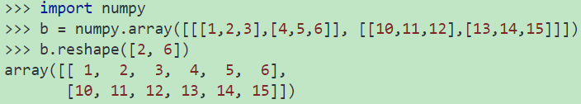
b = arange(12).reshape(4,3) # 2d array | c=arange(24).reshape(2,3,4) #3d array
[[ 0 1 2]  [ 3 4 5]  [ 6 7 8]  [ 9 10 11]] | [ [ [ 0 1 2 3]  [ 4 5 6 7]  [ 8 9 10 11] ]  [ [12 13 14 15]  [16 17 18 19]  [20 21 22 23]] ]

1.1.2 create numpy from file
def file_2np_arr():
"""txt file to numpy array"""
data_path = '../machine_learn/dataset/perception/dataset.txt'
x = np.loadtxt(data_path, dtype=float)
print x
# [ [ 1.1 2.2 0]
# [ 3.5 3.6 1]]

1.1.2 numpy.random.randn

numpy.random.randn(d0, d1, ..., dn)
Return a sample (or samples) from the “standard normal” distribution. randn generates an array of shape (d0, d1, ..., dn), filled with random floats if any of the d_i are floats, they are first converted to integers by truncation
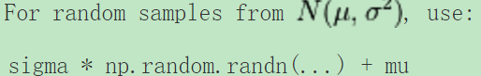
np.random.randn()
2.1923875335537315 #random
Two-by-four array of samples from N(3, 6.25):
2.5 * np.random.randn(2, 4) + 3
array([[-4.49401501, 4.00950034, -1.81814867, 7.29718677], #random
[ 0.39924804, 4.68456316, 4.99394529, 4.84057254]]) #random

sizes = [2, 3, 1]
for x, y in zip(sizes[:-1], sizes[1:]):
print 'x: ', x, ' y: ', y

print [np.random.randn(y, x)]
for x, y in zip(sizes[:-1], sizes[1:])]
x: 2 y: 3
x: 3 y: 1
[array([[ 0.10048464, -0.72051533],
[-0.0905854 , 1.65483025],
[-0.14572718, -1.11272223]]), array([[ 1.00388227, -0.84224117, 0.48437694]])]

random.random() 用于生成一个0到1的随机浮点数
import random random.random（）=》 0.3701787746508932
random.uniform(a,b)
用于生成一个指定范围内的随机浮点数，两个参数一个是上线，一个是下线。如：
random.uniform(10,20) 输出：16.878776709127855
random.randint(a,b)
用于生成指定范围内的整数，生成上线和下线之间的随机数，如：
random.randint(10,20) 输出：14
random.randrange([start], stop[, step])从指定范围内，按指定基数递增的集合中 获取一个随机数。如：
random.randrange(10, 100, 2)
结果相当于从[10, 12, 14, 16, … 96, 98]序列中获取一个随机数。
random.choice(sequence) 参数sequence表示一个有序类型。这里要说明 一下：sequence在python不是一种特定的类型，而是泛指一系列的类型。list, tuple, 字符串都属于sequence。如：
random.choice((“Tuple”,”List”, “Dict”)) 输出：List
random.shuffle(x[, random])用于将一个列表中的元素打乱,如：
x=[“Python”,”data”,”random”,”Mining”,”good”]
random.shuffle(x)
print x
random.sample(sequence, k)从指定序列中随机获取指定长度的片断。sample函数不会修改原有序列,如：
lists=[1,2,3,4,5,6,7,8,10]
a=random.sample(lists,3)
print a 输出：[4, 7, 5]

1.1.2 numpy.random.random_integers
Return random integers of type np.int from the “discrete uniform” distribution in the closed interval [low, high]. If high is None (the default), then results are from [1, low].

print np.random.random_integers(5)  # like 3 | arr = np.random.random_integers(12, size=(3, 4))  print arr  # [[ 2 9 7 6]  # [ 9 1 9 1]  # [ 8 6 11 5]]
d1=np.random.random_integers(1,6,10)
>>[1 6 1 4 2 6 5 1 5 4]
evenly-spaced

1.1.2 numpy.random.randint
numpy.random.randint(low, high=None, size=None, dtype='l')
Return random integers from low (inclusive) to high (exclusive). “half-open” interval [low, high)
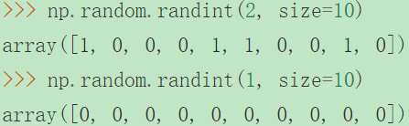 | 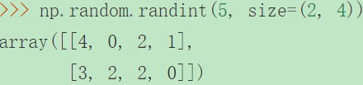

1.1.2 numpy.dot
numpy.dot(a, b, out=None)
Dot product of two arrays.For 2-D arrays it is equivalent to matrix multiplication, and for 1-D arrays to inner product of vectors (without complex conjugation). For N dimensions it is a sum product over the last axis of a and the second-to-last of b:
dot(a, b)[i,j,k,m] = sum(a[i,j,:] * b[k,:,m])
>>> np.dot(3, 4)
12
Neither argument is complex-conjugated:
>>> np.dot([2j, 3j], [2j, 3j])
(-13+0j)
For 2-D arrays it is the matrix product:
>>> a = [[1, 0], [0, 1]]  >>> b = [[4, 1], [2, 2]]  >>> np.dot(a, b)  array([[4, 1],  [2, 2]]) | >>> a=np.array([[1,2],[3,4]])  >>> b=np.array([[11,12],[13,14]])  >>> np.dot(a,b)  array([[37, 40],  [85, 92]])

arr1 = np.array([[1],  [2],  [3]])  arr2 = np.array([[2, 2, 2]]) # 2 [] 2-D array  print np.dot(arr1, arr2) | >[[2 2 2]  [4 4 4]  [6 6 6]]

1.1.2 numpy broadcasting
The term broadcasting describes how numpy treats arrays with different shapes during arithmetic operations. Subject to certain constraints, the smaller array is “broadcast” across the larger array so that they have compatible shapes.
Broadcasting provides a means of vectorizing array operations so that looping occurs in C instead of Python. It does this without making needless copies of data and usually leads to efficient algorithm implementations. There are, however, cases where broadcasting is a bad idea because it leads to inefficient use of memory that slows computation.
NumPy’s broadcasting rule relaxes this constraint when the arrays’ shapes meet certain constraints.
>>> a = np.array([1.0, 2.0, 3.0])  >>> b = np.array([2.0, 2.0, 2.0])  >>> a * b  array([ 2., 4., 6.]) | >>> a = np.array([1.0, 2.0, 3.0])  >>> b = 2.0  >>> a * b  array([ 2., 4., 6.])
The result is equivalent to the previous example where b was an array. We can think of the scalar b being stretched during the arithmetic operation into an array with the same shape as a.
The new elements in b are simply copies of the original scalar. The stretching analogy is only conceptual
NumPy is smart enough to use the original scalar value without actually making copies, so that broadcasting operations are as memory and computationally efficient as possible.
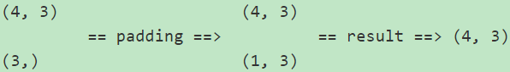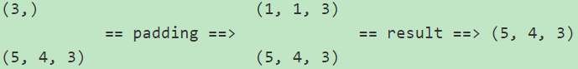
Finally, scalars are treated specially as 1-dimensional arrays with size 1:
In [93]: ones((4, 3)) + 1  array([[ 2., 2., 2.],  [ 2., 2., 2.],  [ 2., 2., 2.],  [ 2., 2., 2.]]) | b = np.broadcast(arr, 1)  print b.shape  >>>(3L, 4L)
def bc_demo_2():
a = np.array([1.0, 2.0, 3])
b = np.ones(3) * 2
print b
# [ 2. 2. 2.]
print a * b
# [ 2. 4. 6.]
b = 2
print a * b
# [ 2. 4. 6.]
x = np.arange(4).reshape(4, 1)
print x
# [[0]
# [1]
# [2]
# [3]]
y = np.ones(5)
print y
# [ 1. 1. 1. 1. 1.]
z = x + y
print z
# [[ 1. 1. 1. 1. 1.]
# [ 2. 2. 2. 2. 2.]
# [ 3. 3. 3. 3. 3.]
# [ 4. 4. 4. 4. 4.]]
print z.shape
# (4L, 5L)
The term broadcasting describes how numpy treats arrays with different shapes during arithmetic operations. Subject to certain constraints, the smaller array is “broadcast” across the larger array so that they have compatible shapes. Broadcasting provides a means of vectorizing array operations so that looping occurs in C instead of Python. It does this without making needless copies of data and usually leads to efficient algorithm implementations. There are, however, cases where broadcasting is a bad idea because it leads to inefficient use of memory that slows computation.
广播用以描述numpy中对两个形状不同的阵列进行数学计算的处理机制。较小的阵列“广播”到较大阵列相同的形状尺度上，使它们对等以可以进行数学计算。广播提供了一种向量化阵列的操作方式，因此Python不需要像C一样循环。广播操作不需要数据复制，通常执行效率非常高。然而，有时广播是个坏主意，可能会导致内存浪费以致计算减慢。

NumPy operations are usually done on pairs of arrays on an element-by-element basis. In the simplest case, the two arrays must have exactly the same shape, as in the following example:
Numpy操作通常由成对的阵列完成，阵列间逐个元素对元素地执行。最简单的情形是两个阵列有一样的形状，例如：
>>>
>>> a = np.array([1.0, 2.0, 3.0])
>>> b = np.array([2.0, 2.0, 2.0])
>>> a * b
array([ 2., 4., 6.])
NumPy’s broadcasting rule relaxes this constraint when the arrays’ shapes meet certain constraints. The simplest broadcasting example occurs when an array and a scalar value are combined in an operation:
Numpy的广播机制放宽了对阵列形状的限制。最简单的情形是一个阵列和一个尺度值相乘：
>>>
>>> a = np.array([1.0, 2.0, 3.0])
>>> b = 2.0
>>> a * b
array([ 2., 4., 6.])
The result is equivalent to the previous example where b was an array. We can think of the scalar b being stretchedduring the arithmetic operation into an array with the same shape as a. The new elements in b are simply copies of the original scalar. The stretching analogy is only conceptual. NumPy is smart enough to use the original scalar value without actually making copies, so that broadcasting operations are as memory and computationally efficient as possible.
上面两种结果是一样的，我们可以认为尺度值b在计算时被延展得和a一样的形状。延展后的b的每一个元素都是原来尺度值的复制。延展的类比只是一种概念性的。实际上，Numpy并不需要真的复制这些尺度值，所以广播运算在内存和计算效率上尽量高效。
The code in the second example is more efficient than that in the first because broadcasting moves less memory around during the multiplication (b is a scalar rather than an array).
上面的第二个例子比第一个更高效，因为广播在乘法计算时动用更少的内存。
When operating on two arrays, NumPy compares their shapes element-wise. It starts with the trailing dimensions, and works its way forward. Two dimensions are compatible when
they are equal, or one of them is 1
对两个阵进行操作时，NumPy逐元素地比较他们的形状，从后面的维度向前执行。当以下情形出现时，两个维度是兼容的：
1，它们相等 2，其中一个是1
Arrays do not need to have the same number of dimensions. For example, if you have a 256x256x3 array of RGB values, and you want to scale each color in the image by a different value, you can multiply the image by a one-dimensional array with 3 values. Lining up the sizes of the trailing axes of these arrays according to the broadcast rules, shows that they are compatible:
阵列不需要有相同的维度。例如，如果你有一个256x256x3的RGB阵列，你想要对每一种颜色加一个权重，你就可以乘以一个拥有3个元素的一维阵列。将两个阵列的各维度尺寸展开，从后往前匹配，如果满足了上面的两个条件，则这两个阵列是兼容的。

1.1.2 numpy.argmax
numpy.argmax(a, axis=None, out=None)
Returns the indices of the maximum values along an axis.
Parameters: | a : array_like  Input array.  axis : int, optional  By default, the index is into the flattened array, otherwise along the specified axis.  out : array, optional  If provided, the result will be inserted into this array. It should be of the appropriate shape and dtype.
Returns: | index_array : ndarray of ints  Array of indices into the array. It has the same shape as a.shape with the dimension along axis removed.
Notes
In case of multiple occurrences of the maximum values, the indices corresponding to the first occurrence are returned.
>>> a = np.arange(6).reshape(2,3)
>>> a
array([[0, 1, 2],
[3, 4, 5]])
>>> np.argmax(a)
5
>>> np.argmax(a, axis=0)
array([1, 1, 1])
>>> np.argmax(a, axis=1)
array([2, 2])
>>>
>>> b = np.arange(6)
>>> b[1] = 5
>>> b
array([0, 5, 2, 3, 4, 5])
>>> np.argmax(b) # Only the first occurrence is returned.
1

a = np.arange(6).reshape(2,3) print a
print np.argmax(a, axis=0) print np.argmax(a, axis=1)
a[1][2] = 3 ta = a.transpose() print ta
print np.argmax(ta, axis=0) print np.argmax(ta, axis=1)
[[0 1 2]
[3 4 5]]
[1 1 1]
[2 2]
[[0 3]
[1 4]
[2 3]]
[2 1]
[1 1 1]

1.1.5 np.argsort(arr) / arr.sort()
numpy.argsort(a, axis=-1, kind='quicksort', order=None)[source]
Returns the indices that would sort an array.
Perform an indirect sort along the given axis using the algorithm specified by the kind keyword
x = numpy.array([1.48,1.41,0.0,0.1])  print x.argsort()  >[2 3 1 0] | 2 is the index of 0.0.  3 is the index of 0.1.  1 is the index of 1.41.  0 is the index of 1.48.

arr = np.random.permutation(3 * 4).reshape(3, 4)  np.random.shuffle(arr)  print arr  arr_sort_idx = np.argsort(arr)  print arr_sort_idx | >>arr  [[ 7 11 8 10]  [ 5 2 9 0]  [ 3 1 4 6]] | >>arr_sort_idx  [[0 2 3 1]  [3 1 0 2]  [1 0 2 3]]
arr_sort_idx = np.argsort(arr) # default sort by row
arr_sort_idx = np.argsort(arr, axis=0) # sort by column

use argsort to sort by holistic column（The following example is common in PCA, in which we sort eigen vector by eigen value）
arr2 = np.random.randint(1, 10, size=(3, 3))  eig_val2, eig_vec2 = np.linalg.eig(arr2)  print eig_vec2 | [[-0.60334447 -0.39488112 -0.48786938]  [-0.64870621 0.9181712 -0.40655781]  [-0.46384879 0.03210224 0.77245985]]
print eig_val2 | [ 15.30073525 1.69926475 -4. ]
eig_val2_idx = np.argsort(eig_val2)  print eig_val2_idx | [2 1 0]
print eig_val2_idx[::-1] | [0 1 2]

print eig_vec2[:, eig_val2_idx] | [[-0.48786938 -0.39488112 -0.60334447]  [-0.40655781 0.9181712 -0.64870621]  [ 0.77245985 0.03210224 -0.46384879]]
print eig_vec2[:, eig_val2_idx[::-1]] | [[-0.60334447 -0.39488112 -0.48786938]  [-0.64870621 0.9181712 -0.40655781]  [-0.46384879 0.03210224 0.77245985]]

1.1.3 numpy array vs ndarray
What is the difference between ndarray and array in Numpy? And where can I find the implementations in the numpy source code?

Well, numpy.array is just a convenience function to create an ndarray, it is not a class itself.

You can also create an array using numpy.ndarray, but it is not the recommended way. From the docstring of numpy.ndarray:

Most of the meat of the implementation is in C code, here in multiarray, but you can start looking at the ndarray interfaces here:
numpy.array is a function that returns a numpy.ndarray. There is no object type numpy.array.

a = np.array([1, 2, 3])
print type(a)
# <type 'numpy.ndarray'>

1.1.3 numpy.mat vs np.array
a=np.mat('4 3; 2 1') | b=np.mat('1 2; 3 4') | print(a*b) # 矩阵相乘
[[4 3]  [2 1]] | [[1 2]  [3 4]] | [[13 20]  [ 5 8]]

class matrix(N.ndarray):
"""
matrix(data, dtype=None, copy=True)
Returns a matrix from an array-like object, or from a string of data.
A matrix is a specialized 2-D array that retains its 2-D nature
through operations. It has certain special operators, such as ``*``
(matrix multiplication) and ``**`` (matrix power).
Numpy matrices are strictly 2-dimensional, while numpy arrays (ndarrays) are N-dimensional.

Both matrix objects and ndarrays have .T to return the transpose, but matrix objects also have .H for the conjugate transpose, and .I for the inverse.
In contrast, numpy arrays consistently abide by the rule that operations are applied element-wise. Thus, if a and b are numpy arrays, then a*b is the array formed by multiplying the components element-wise:
c=np.array([[4, 3], [2, 1]]) | d=np.array([[1, 2], [3, 4]])
print(c*d)  [[4 6]  [6 4]] | 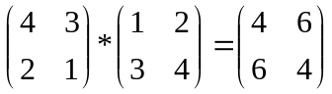
To obtain the result of matrix multiplication, you use np.dot :
print(np.dot(c,d))  [[13 20]  [ 5 8]] | print(a**2)  [[22 15]  [10 7]] | print(c**2)  [[16 9]  [ 4 1]]
Since a is a matrix, a**2 returns the matrix product a*a. Since c is an ndarray, c**2 returns an ndarray with each component squared element-wise.

np.array(arr) get a deep copy of ar
c=np.array([[4, 3], [2, 1]])  ccopy = np.array(c)  ccopy[0][0] = 0  print c, '\n', ccopy | [[4 3]  [2 1]]  [[0 3]  [2 1]]

1.1.4 1n array transpose
lst = [1, 2, 3]
arr = np.array(lst)
print arr.T
# [1 2 3]
arr_1 = np.matrix(lst)
print arr_1.T
# [[1]
# [2]
# [3]]
print np.mat(lst).T
# [[1]
# [2]
# [3]]
print np.array([lst]).T
# [[1]
# [2]
# [3]]

1.1.4 np.shuffle vs np.permute
numpy.random.shuffle(x)
Modify a sequence in-place by shuffling its contents.
This function only shuffles the array along the first axis of a multi-dimensional array. The order of sub-arrays is changed but their contents remains the same.
print np.arange(8)  arr = np.arange(8).reshape(2, 4)  print arr  print np.random.shuffle(arr), '\n', arr | >[0 1 2 3 4 5 6 7]  >[[0 1 2 3]  [4 5 6 7]]  >None #just modify the arr return none  >[[4 5 6 7] #do not modify sub-array  [0 1 2 3]]
print np.random.permutation(arr)
>[[4 5 6 7] # not none but a new deep copy of arr
[0 1 2 3]]

What is the difference between np.random.shuffle(x) and np.random.permutation(x)?
if passed an array, it will return a shuffled copy of the array; np.random.shuffle shuffles the array inplace
if passed an integer, it will return a shuffled range i.e. np.random.shuffle(np.arange(n))
If x is an integer, randomly permute np.arange(x). If x is an array, make a copy and shuffle the elements randomly.
print np.random.permutation(5)
>[2 1 3 4 0]

1.1.4 issues about array multiply
arr1 = np.array([[1], [2]])  arr2 = np.array([[3], [4]])  print arr1 * arr2 | >>>>  [[3]  [8]]

print np.dot(arr1.transpose(), arr2.transpose())
>>>ValueError: shapes (1,2) and (1,2) not aligned: 2 (dim 1) != 1 (dim 0)
print np.dot(arr1, arr2.transpose()) | >>>  [[3 4]  [6 8]]

arr1 = np.array([1, 2])  arr2 = np.array([3, 4])  print arr1 * arr2 | >>>[3 8]

1.1.4 list to array
tp, lst = (1, 2, 3), [[1, 2], [3, 4]]
print np.array(lst).shape | (2L, 2L)
print np.array(lst) | [[1 2]  [3 4]]
print np.asarray(lst) | [[1 2]  [3 4]]
print np.asarray(tp) | [1 2 3]

1.1.4 flatten
ndarray.flatten(order='C') Return a copy of the array collapsed into one dimension.
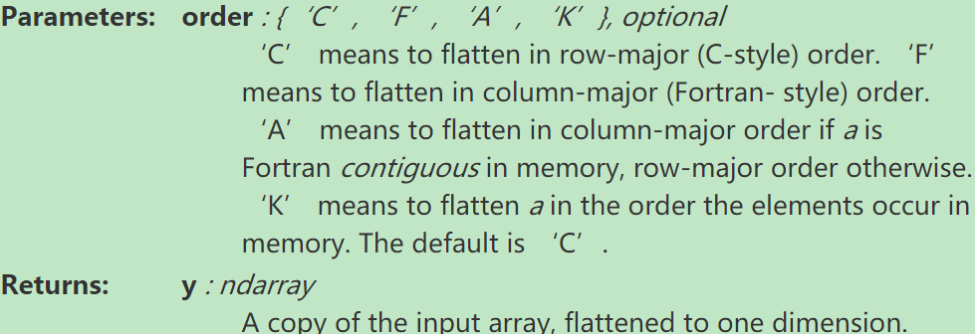
>>> a = np.array([[1,2], [3,4]])  >>> a.flatten()  array([1, 2, 3, 4]) | >>> a.flatten('F')  array([1, 3, 2, 4])

1.1.4 empty_like/ones_like/zeros_like/ones
numpy.empty_like
numpy.empty_like(a, dtype=None, order='K', subok=True)
Return a new array with the same shape and type as a given array.

Parameters:
a : array_like
The shape and data-type of a define these same attributes of the returned array

>>> a = ([1,2,3], [4,5,6]) # a is array-like
>>> np.empty_like(a)
array([[-107, -10, 3], #random
[ 0, 0, -1]])

def empty_test():
arr = np.array([[2.5, 3, 1], [1.1, -2, 3]])
print arr
print np.empty_like(arr)
print np.empty([2, 2])
# [[2.02554939e-316 2.50034710e-315]
# [1.97872580e-316 2.00283462e-316]]
print np.empty([2, 2], dtype=int)
# [[58157000 0]
# [58157064 0]]
def zero_test():
print np.zeros(5)
# [ 0. 0. 0. 0. 0.]
print np.zeros((5,), dtype=np.int)
# [0 0 0 0 0]
print np.zeros((2, 1))
# [[ 0.]
# [ 0.]]
x = np.arange(6).reshape((2, 3))
print np.zeros_like(x)
# [[0 0 0]
# [0 0 0]]

1.1.5 get nth column
alueError:
arr = np.arange(9).reshape((3, 3))
print arr  # [[0 1 2]  # [3 4 5]  # [6 7 8]] | arr_c2 = arr[:, [0, 2]] # arr_c2 deep copy from arr  print arr_c2  # [[0 2]  # [3 5]  # [6 8]]
arr_c2[:, [0]] = 9  print arr_c2  # [[9 2]  # [9 5]  # [9 8]] | print arr # no change, as we see this is deep copy
arr_c1 = arr[:, 0]  print arr_c1  [0 3 6] | arr_c11 = arr[:, [0]]  [[0]  [3]  [6]]
arr = np.arange(12).reshape(4, 3)  print arr  a_col = arr[:, 0]  print a_col  # [0 3 6 9]  print [a if a % 2 else 111 for a in arr[:, 0]]  # [111, 3, 111, 9] |  | print arr # no change  # [[ 0 1 2]  # [ 3 4 5]  # [ 6 7 8]  # [ 9 10 11]]

arr = np.arange(12).reshape(4, 3)  for i in xrange(arr.shape[0]):  if arr[i][0] % 2 == 0:  arr[i][0] = 111  print arr | [[111 1 2]  [ 3 4 5]  [111 7 8]  [ 9 10 11]]

arr = np.arange(12).reshape(4, 3)
print [arr[i][0] if arr[i][0] % 2 else 111 for i in xrange(arr.shape[0])]
[111, 3, 111, 9]

print arr
[[ 0 1 2]
[ 3 4 5]
[ 6 7 8]
[ 9 10 11]]

1.1.5 iterate rows/column
def iter_row_column():
arr = np.arange(6).reshape(2, 3)
print arr
# [[0 1 2]
# [3 4 5]]
for r in arr:
print r
# [0 1 2]
# [3 4 5]
for c in arr.T:
print c
# [0 3]
# [1 4]
# [2 5]
for c_idx in range(arr.shape[1]):
print arr[:, c_idx]
# [0 3]
# [1 4]
# [2 5]
def iter_sp_row():
arr = np.arange(8).reshape(4, 2)
print arr
# [[0 1]
# [2 3]
# [4 5]
# [6 7]]
lst_idx = [1, 3]
for idx in lst_idx:
print arr[idx]
# [2 3]
# [6 7]

1.1.5 index arrays
def single_idx():
arr = np.arange(6)
print arr
# [0 1 2 3 4 5]
print arr[1], arr[-1]
# 1 5
arr2 = np.arange(10)
print arr2
# [0 1 2 3 4 5 6 7 8 9]
print arr2[2: 5], arr2[:-7], arr2[1: 7: 2]
# [2 3 4] [0 1 2] [1 3 5]
b = arr2 > 7
print b
# [False False False False False False False False True True]
print arr2[b]
# [8 9]
def multidimen_idx():
arr = np.arange(6)
print arr
# [0 1 2 3 4 5]
arr.shape = (2, 3)
print arr
# [[0 1 2]
# [3 4 5]]
print arr[1, 1], arr[1, -1]
# 4 5
print arr[1], arr[1][1]
# [3 4 5] 4
arr2 = np.arange(35).reshape(5, 7)
print arr2
# [[ 0 1 2 3 4 5 6]
# [ 7 8 9 10 11 12 13]
# [14 15 16 17 18 19 20]
# [21 22 23 24 25 26 27]
# [28 29 30 31 32 33 34]]
print arr2[1:5:2]
# [[ 7 8 9 10 11 12 13]
# [21 22 23 24 25 26 27]]
# 1:5:2 means row 2, 4, ::3 means every 3 column
print arr2[1:5:2, ::3]
# [[ 7 10 13]
# [21 24 27]]
print arr2[np.array([0, 2, 4]), 1:3]
# [[ 1 2]
# [15 16]
# [29 30]]
print arr2[np.array([0, 2, 4]), np.array([0, 1, 2])]
# [ 0 15 30]
print arr2[np.array([0, 2, 4]), 1]
# [ 1 15 29]
b = arr2 > 20
print arr2[b]
# [21 22 23 24 25 26 27 28 29 30 31 32 33 34]
def n_dimension_arr():
arr = np.arange(30).reshape(2, 3, 5)
print arr
# [[[ 0 1 2 3 4]
# [ 5 6 7 8 9]
# [10 11 12 13 14]]
# [[15 16 17 18 19]
# [20 21 22 23 24]
# [25 26 27 28 29]]]
def assign_val():
arr = np.arange(10)
print arr
# [0 1 2 3 4 5 6 7 8 9]
arr[2:7] = 1
print arr
# [0 1 1 1 1 1 1 7 8 9]
arr[2:7] = range(5)
print arr
# [0 1 0 1 2 3 4 7 8 9]

1.1.5 vstack/hstack vs append concatenate
def v_h_column_stack():
print np.vstack(([1, 2, 3], [4, 5, 6]))
# [[1 2 3]
# [4 5 6]]
print np.column_stack(([1, 2, 3], [4, 5, 6]))
# [[1 4]
# [2 5]
# [3 6]]
print np.hstack(([1, 2, 3], [4, 5, 6]))
# [1 2 3 4 5 6]
print np.hstack(([[1], [2], [3]], [[4], [5], [6]]))
# equivalent to np.column_stack(([1, 2, 3], [4, 5, 6]))

when should i use hstack/vstack vs append vs concatenate vs column_stack
Simple question: what is the advantage of each of these methods. It seems that given the right parameters (and ndarray shapes) they all work seemingly equivalently. Do some work in place? have better performance? which functions should I use when?

If not here's a summary of their code:

vstack
concatenate([atleast_2d(_m) for _m in tup], 0)
i.e. turn all imputs in to 2d (or more) and concatenate on first

hstack
concatenate([atleast_1d(_m) for _m in tup], axis=<0 or 1>)

colstack
transform arrays with (if needed)
array(arr, copy=False, subok=True, ndmin=2).T

append
concatenate((asarray(arr), values), axis=axis)
In other words, they all work by tweaking the dimensions of the input arrays, and then concatenating on the right axis. They are just convenience functions.

In IPython you can look at the source code of a function by typing its name followed by ??. Taking a look at hstack we can see that it's actually just a wrapper around concatenate (similarly with vstack and column_stack):

np.hstack??
def hstack(tup):
...
arrs = [atleast_1d(_m) for _m in tup]
# As a special case, dimension 0 of 1-dimensional arrays is "horizontal"
if arrs[0].ndim == 1:
return _nx.concatenate(arrs, 0)
else:
return _nx.concatenate(arrs, 1)

1.1.5 sum/reverse
def arr_sum():
arr = np.arange(6).reshape((2, 3))
print arr
# [[0 1 2]
# [3 4 5]]
print arr.sum(axis=0)
# [3 5 7]
print arr.sum(axis=1)
# [ 3 12]
print arr > 1
# [[False False True]
# [ True True True]]
print arr[::-1]
# [[3 4 5]
# [0 1 2]]

1.1.5 flip/fliplr/flipud/rot90
numpy.flip(m, axis)
Reverse the order of elements in an array along the given axis.

The shape of the array is preserved, but the elements are reordered.
def flip_arr():
arr = np.arange(6).reshape(2, 3)
print arr
# [[0 1 2]
# [3 4 5]]
print np.fliplr(arr)
# [[2 1 0]
# [5 4 3]]
print arr[:, ::-1]
# [[2 1 0]
# [5 4 3]]
print np.flipud(arr)
# [[3 4 5]
# [0 1 2]]
print arr[::-1]
# [[3 4 5]
# [0 1 2]]
arr2 = np.arange(8).reshape((2, 2, 2))
print arr2
# [[[0 1]
# [2 3]]
#
# [[4 5]
# [6 7]]]

flipud Flip an array vertically (axis=0).
fliplr Flip an array horizontally (axis=1).
flipud Flip array in the up/down direction.
rot90 Rotate array counterclockwise.

numpy.fliplr(m)
Flip array in the left/right direction.
Flip the entries in each row in the left/right direction. Columns are preserved, but appear in a different order than before.

1.1.5 equal/close
def arr_equal():
ar1 = np.array([[1, 2], [3, 4]])
ar2 = np.array([[1, 2], [3, 4]])
ar3 = np.array([[1, 2], [3, 5]])
print np.array_equal(ar1, ar2)
# True
print np.array_equal(ar1, ar3)
# False
def arr_equiv():
ar1 = np.array([[1, 2], [3, 4]])
ar2 = np.array([[1, 2]])
ar3 = np.array([[1, 2], [1, 2]])
ar4 = np.array([1, 2])
print np.array_equiv(ar1, ar2)
# False
print np.array_equiv(ar1, ar4)
# False
print np.array_equiv(ar2, ar3)
# True
def arr_close():
ar1 = np.array([[1, 2], [3, 4]])
ar2 = np.array([[1.1, 2.1], [3.1, 4.1]])
ar3 = np.array([[1.00001, 2.00001], [3.00001, 4.00001]])
ar4 = np.array([[1.0001, 2.0001], [3.0001, 4.0001]])
print np.isclose(ar1, ar2)
# [[False False]
# [False False]]
print np.isclose(ar1, ar3)
# [[ True True]
# [ True True]]
print np.isclose(ar1, ar4)
# [[False False]
# [False False]]
print np.isclose(ar1, ar4, atol=1.e-4)
# [[ True True]
# [ True True]]
print np.allclose([1e10, 1e-7], [1.00001e10, 1e-8])
# False
print np.allclose([1e10, 1e-8], [1.00001e10, 1e-9])
# True

1.1.5 vectorize(operator element wise)
def my_fun(a, b):
if a >= b:
return a - b
else:
return a + b
def test_vectorize():
v_fun = np.vectorize(my_fun)
arr = np.arange(8).reshape(2, 4)
print arr
# [[0 1 2 3]
# [4 5 6 7]]
print v_fun(arr, 4)
# [[4 5 6 7]
# [0 1 2 3]]
squarer = lambda t: t ** 2
v_fun = np.vectorize(squarer)
print v_fun(arr)
# [[ 0 1 4 9]
# [16 25 36 49]]

1.1.5 unique/sum/where
def test_unique():
y = np.array([-1, -1, 1, 1, -1, -1, -1, 1, 1])
unique_y = np.unique(y)
print unique_y, unique_y.shape
# [-1 1] (2L,)
print np.equal(y, 1)
# [False False True True False False False True True]
for v in unique_y:
print np.sum(np.equal(y, v))
# 5, 4
print np.unique(y, return_index=True)
# (array([-1, 1]), array([0, 2], dtype=int64))
print np.unique(y, return_counts=True)
# (array([-1, 1]), array([5, 4], dtype=int64))
print np.unique(y, return_inverse=True)
# (array([-1, 1]), array([0, 0, 1, 1, 0, 0, 0, 1, 1], dtype=int64))
arr = np.array([1, 1, 1, 2, 2, 2, 5, 25, 1, 1])
u_arr, counts = np.unique(arr, return_counts=True)
print u_arr, counts
# [ 1 2 5 25] [5 3 1 1]
print np.asarray((u_arr, counts))
# [[ 1 2 5 25]
# [ 5 3 1 1]]
print np.asarray((u_arr, counts)).T
# [[ 1 5]
# [ 2 3]
# [ 5 1]
# [25 1]]
print np.array((u_arr, counts))
# [[ 1 2 5 25]
# [ 5 3 1 1]]

def test_sum():
arr = np.arange(24).reshape((2, 3, 4))
print arr
# [[[ 0 1 2 3]
# [ 4 5 6 7]
# [ 8 9 10 11]]
#
# [[12 13 14 15]
# [16 17 18 19]
# [20 21 22 23]]]
print arr[0, :, :]
# [[ 0 1 2 3]
# [ 4 5 6 7]
# [ 8 9 10 11]]
print arr[0::] # print arr
print arr[:, 1, :]
# [[ 4 5 6 7]
# [16 17 18 19]]
print arr[:, :, 2]
# [[ 2 6 10]
# [14 18 22]]
print arr.sum(1)
# [[12 15 18 21]
# [48 51 54 57]]
print arr[:, 0, :] + arr[:, 1, :] + arr[:, 2, :]
# [[12 15 18 21]
# [48 51 54 57]]
# arr.sum(0) => arr[0, :, :] + arr[1, :, :]
# arr.sum(1) => arr[:, 0, :] + arr[:, 1, :] + arr[:, 2, :]
# arr.sum(2) => arr[:, :, 0] + arr[:, :, 1] + arr[:, :, 2] + arr[:, :, 2]

def test_where():
arr = np.array([1, 2, 2, 5, 0])
print np.where(arr==2)
# (array([1, 2], dtype=int64),)
print len(np.where(arr==2))
# 1
arr2 = np.array([[1, 2, 3], [0, 5, 2]])
print arr2
# [[1 2 3]
# [0 5 2]]
arr2_con = np.where(arr2==2)
print arr2_con
# (array([0, 1], dtype=int64), array([1, 2], dtype=int64))
print len(arr2_con), np.size(arr2_con)
# 2, 4
a = np.arange(5, 10)
print a
# [5 6 7 8 9]
a_con = np.where(a < 8)
print a_con, np.size(a_con)
# (array([0, 1, 2], dtype=int64),) 3
print a[a_con]
# [5 6 7]
print len(a_con)
# 1
a_con = np.where(a < 8)
for item in a_con:
print item
# [0 1 2]
a = np.arange(4, 10).reshape(2, 3)
print a
# [[4 5 6]
# [7 8 9]]
print np.where(a > 7)
# (array([1, 1], dtype=int64), array([1, 2], dtype=int64))
print a[np.where(a > 7)]
# [8 9]
x = np.arange(9).reshape(3, 3)
print x
# [[0 1 2]
# [3 4 5]
# [6 7 8]]
print np.where(x > 3)
# (array([1, 1, 2, 2, 2], dtype=int64), array([1, 2, 0, 1, 2], dtype=int64))
print x[np.where(x > 3)]
# [4 5 6 7 8]
print np.where(x < 5, x, 0)
# [[0 1 2]
# [3 4 0]
# [0 0 0]]

1.1.5 all index of value
def get_all_idx_of_val():
lst = [1, 2, 1, 3, 1, 4]
val = 1
# print [idx if v == val for idx, v in enumerate(lst)]
print [idx for idx, v in enumerate(lst) if v == val]
# [0, 2, 4]
arr = np.array(lst)
print np.where(arr==val)
# (array([0, 2, 4], dtype=int64),)
print np.where(arr==val)[0]
# [0 2 4]

1.1.5 mean

def mean():
arr = np.arange(12).reshape((3, 4))
print arr
# [[ 0 1 2 3]
# [ 4 5 6 7]
# [ 8 9 10 11]]
mean_arr = np.mean(arr, axis=0)
print mean_arr
# [ 4. 5. 6. 7.]
print arr - mean_arr
# [[-4. -4. -4. -4.]
# [ 0. 0. 0. 0.]
# [ 4. 4. 4. 4.]]
print np.mean(arr)
# 5.5
print np.mean(arr, axis=1)
# [ 1.5 5.5 9.5]

1.1.5 covariance

1.1.5 add row(np.concatenate/append)
def add_row_2arr():
a1 = np.array([[0, 1, 2], [0, 2, 0]])
a2 = np.array([[1, 1, 1], [2, 2, 2], [3, 2, 0]])
print a2[:, 0]
# [1 2 3]
print [a2[:, 0] < 3]
# [array([ True, True, False], dtype=bool)]
print a2[a2[:, 0] < 3]
# [[1 1 1]
# [2 2 2]]
a1 = np.vstack((a1, a2[a2[:, 0] < 3]))
print a1
# [[0 1 2]
# [0 2 0]
# [1 1 1]
# [2 2 2]]
def add_row_2arr_v2():
a1 = np.array([[1, 2], [3, 4]])
a2 = np.array([[5, 6]])
print np.concatenate((a1, a2), axis=0)
# [[1 2]
# [3 4]
# [5 6]]
print np.concatenate((a1, a2.T), axis=1)
# [[1 2 5]
# [3 4 6]]
def add_row_2arr_v3():
print np.append([1, 2, 3], [[4, 5, 6], [7, 8, 9]])
# [1 2 3 4 5 6 7 8 9]
print np.append([[1, 2, 3], [4, 5, 6]], [[7, 8, 9]], axis=0)
# [[1 2 3]
# [4 5 6]
# [7 8 9]]
print np.append([[1, 2, 3], [4, 5, 6]], [[7], [8]], axis=1)
# [[1 2 3 7]
# [4 5 6 8]]

def dic_arr_append():
a1 = np.array([1, 2])
d = {1: a1}
# d[1].append([2, 3, 4])
# AttributeError: 'numpy.ndarray' object has no attribute 'append'
lst = [1, 2]
a1 = np.array([lst])
print a1
# [[1 2]]
d = {1: a1}
np.append(d[1], [2, 3])
print d
# {1: array([[1, 2]])}
print np.append(a1, [2, 3])
# [1 2 2 3]
print a1
# [[1 2]]
print np.append(a1, [[2, 3]])
# [1 2 2 3]
print np.append(a1, [[2, 3]], axis=0)
# [[1 2]
# [2 3]]
print a1
# [[1 2]]
# print np.append(a1, [2, 3], axis=0)
# ValueError: all the input arrays must have same number of dimensions
def dic_arr_concat():
lst = [1, 2]
a1 = np.array([lst])
print a1
# [[1 2]
# [2 3]]
d = {1: a1}
# np.concatenate((d[1], [2, 3]))
# ValueError: all the input arrays must have same number of dimensions
print np.concatenate((d[1], [[2, 3]]))
# [[1 2]
# [2 3]]
print d
# {1: array([[1, 2]])}
numpy.append
numpy.append(arr, values, axis=None)
Append values to the end of an array.

Parameters:
arr : array_like
Values are appended to a copy of this array.

Returns:
append : ndarray
A copy of arr with values appended to axis. Note that append does not occur in-place: a new array is allocated and filled. If axis is None, out is a flattened array.
Currently, I have some code like this

import numpy as np
ret = np.array([])
for i in range(100000):
tmp = get_input(i)
ret = np.append(ret, np.zeros(len(tmp)))
ret = np.append(ret, np.ones(fixed_length))

I think this code is not efficient as np.append needs to return a copy of the array instead of modify the ret in-place

Imagine a numpy array as occupying one contiguous block of memory. Now imagine other objects, say other numpy arrays, which are occupying the memory just to the left and right of our numpy array. There would be no room to append to or extend our numpy array. The underlying data in a numpy array always occupies a contiguous block of memory.

So any request to append to or extend our numpy array can only be satisfied by allocating a whole new larger block of memory, copying the old data into the new block and then appending or extending.

So:
It will not occur in-place.
It will not be efficient.

As the docs says,

Values are appended to a copy of this array.

So np.append creates a new list instead of modification of your original one. You have to write:

input_data = np.append(input_data, current_turn, axis = 0)
Example:

import numpy as np
my_array = np.array([1, 2, 3])
print(my_array)
# [1 2 3]
my_array = np.append(my_array, [4])
print(my_array)
# [1 2 3 4]

1.1.5 sample rows(np.random.randint)
def sample_rows():
arr1 = np.random.randint(5, size=(5, 3))
print arr1
# [[0 0 2]
# [1 2 0]
# [0 0 4]
# [3 3 4]
# [4 3 2]]
print arr1[[1, 2]]
# [[1 2 0]
# [0 0 4]]
idx = np.random.randint(5, size=2)
print idx
# [1 2]
print arr1[idx, :]
# [[1 2 0]
# [0 0 4]]
print arr1[idx, ]
# [[1 2 0]
# [0 0 4]]
print arr1[np.random.randint(arr1.shape[0], size=2), :]
# [[0 0 2]
# [4 3 2]]

1.1.5 random/np.random.choice
def random_int_arr():
print np.random.random_integers(5)
# like 3
arr = np.random.random_integers(12, size=(3, 4))
print arr
# [[ 2 9 7 6]
# [ 9 1 9 1]
# [ 8 6 11 5]]
d1 = np.random.random_integers(1, 6, 10)
print d1
# [6 4 5 2 4 1 1 5 6 2]
arr_f = 0.5 * (np.random.random_integers(12, size=(8, )) - 1)
print arr_f
# [ 5.5 2.5 2.5 1. 4. 4.5 5.5 3. ]
print np.random.randint(12, size=(3, 4))
# [[0 7 1 8]
# [7 1 1 2]
# [8 4 9 3]]
def sample_rows():
arr1 = np.random.randint(5, size=(5, 3))
print arr1
# [[0 0 2]
# [1 2 0]
# [0 0 4]
# [3 3 4]
# [4 3 2]]
print arr1[[1, 2]]
# [[1 2 0]
# [0 0 4]]
idx = np.random.randint(5, size=2)
print idx
# [1 2]
print arr1[idx, :]
# [[1 2 0]
# [0 0 4]]
print arr1[idx, ]
# [[1 2 0]
# [0 0 4]]
print arr1[np.random.randint(arr1.shape[0], size=2), :]
# [[0 0 2]
# [4 3 2]]
def choice_arr():
"""
numpy.random.choice(a, size=None, replace=True, p=None)
Generates a random sample from a given 1-D array
a : 1-D array-like or int
If an ndarray, a random sample is generated from its elements.
If an int, the random sample is generated as if a were np.arange(a)
"""
arr1 = np.arange(5)
print arr1
# [0 1 2 3 4]
print np.random.choice(arr1, 2)
# [4 0]
print np.random.choice(5, 2)
# [3 0]

1.1.5 random.seed

def ran_seed():
sd = 3
np.random.seed(sd)
print np.random.rand(4)
# [ 0.5507979 0.70814782 0.29090474 0.51082761]
print np.random.rand(4)
# [ 0.89294695 0.89629309 0.12558531 0.20724288]
np.random.seed(sd)
print np.random.rand(4)
# [ 0.5507979 0.70814782 0.29090474 0.51082761]
np.random.seed(sd)
arr = np.random.randint(5, size=(2, 3))
print arr
# [[2 0 1]
# [3 0 0]]
arr = np.random.randint(5, size=(2, 3))
print arr
# [[0 3 2]
# [3 1 1]]
np.random.seed(sd)
arr = np.random.randint(5, size=(2, 3))
print arr
# [[2 0 1]
# [3 0 0]]

If you want seemingly random numbers, do not set the seed. If you have code that uses random numbers that you want to debug, however, it can be very helpful to set the seed before each run so that the code does the same thing every time you run it.

To get the most random numbers for each run, call numpy.random.seed(). This will cause numpy to set the seed to a random number obtained from /dev/urandom or its Windows analog or, if neither of those is available, it will use the clock.

1.1 numpy Scipy pandas difference
Numpy：来存储和处理大型矩阵，比Python自身的嵌套列表（nested list structure)结构要高效的多，本身是由C语言开发。这个是很基础的扩展，其余的扩展都是以此为基础。数据结构为ndarray,一般有三种方式来创建。
- Python对象的转换通过类似工厂函数
- numpy内置函数生成：np.arange,np.linspace.....
- 从硬盘读取，loadtxt
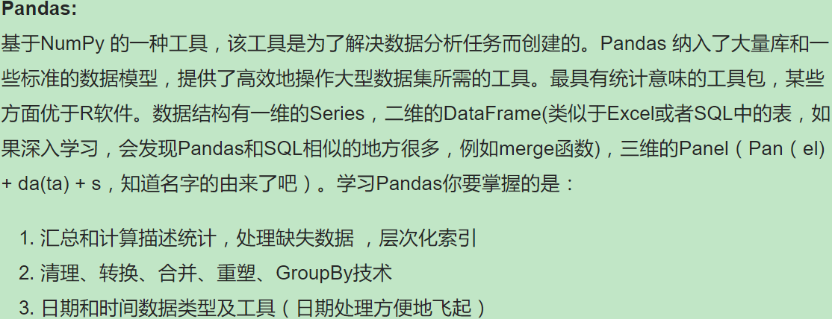
Matplotlib:
Python中最著名的绘图系统
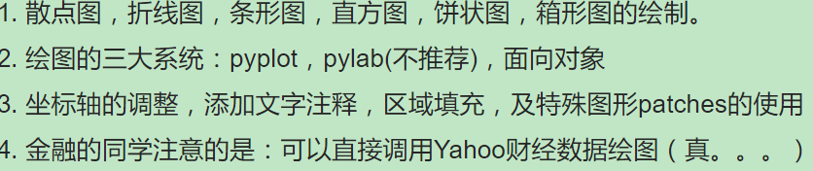
Scipy：方便、易于使用、专为科学和工程设计的Python工具包.它包括统计,优化,整合,线性代数模块,傅里叶变换,信号和图像处理,常微分方程求解器等等。基本可以代替Matlab，但是使用的话和数据处理的关系不大，数学系，或者工程系相对用的多一些。（略）
Scikit-learn：
关注机器学习的同学可以关注一下，很火的开源机器学习工具

1.1 practice usage

1.1.1 euclidean distance
def eu_distance():
a1 = [1, 2, 3]
a2 = [3, 4, 5]
from math import sqrt
print sqrt(sum((a - b)**2 for a, b in zip(a1, a2)))
# 3.46410161514

def np_sum():
a1 = np.array([1, 2, 3])
a2 = np.array([3, 4, 5])
print a1 - a2
# [-2 -2 -2]
print (a1 - a2)**2
# [4 4 4]
print np.sum(a1 - a2)
# -6
print np.sum((a1 - a2)**2)
# 12

def np_sqrt():
a1 = np.array([1, 4, 9])
print np.sqrt(a1)
# [ 1. 2. 3.]

def euclidean_distance_v2():
a1 = np.array([1, 2, 3])
a2 = np.array([3, 4, 5])
print np.sqrt(np.sum((a1 - a2)**2))
# 3.46410161514

def euclidean_distance_v3():
a1 = np.array([1, 2, 3])
a2 = np.array([3, 4, 5])
print np.linalg.norm(a1 - a2)
# 3.46410161514

1.1.1 create array,shape(diagonal array)

pandas

1.1 pandas object

1.1.1 pandas Series Object
At the very basic level, Pandas objects can be thought of as enhanced versions of NumPy structured arrays in which the rows and columns are identified with labels rather than simple integer indices.

def test_series_1():
data = pd.Series([0.25, 0.5, 0.75, 1])
print data
# 0 0.25
# 1 0.50
# 2 0.75
# 3 1.00
# dtype: float64
print data.values
# [ 0.25 0.5 0.75 1. ]
print data.index
# RangeIndex(start=0, stop=4, step=1)
print data[1:3]
# 1 0.50
# 2 0.75
# dtype: float64

while the NumPy array has an implicitly defined integer index used to access the values, the Pandas Series has an explicitly defined index associated with the values.

For example, the index need not be an integer, but can consist of values of any desired type. For example, if we wish, we can use strings as an index:
def test_series_2():
data = pd.Series([0.2, 0.4, 0.6], index=['a', 'b', 'c'])
print data
# a 0.2
# b 0.4
# c 0.6
# dtype: float64
print data['b'] # 0.4
print data[0:2]
# a 0.2
# b 0.4
# dtype: float64

We can even use noncontiguous or nonsequential indices:
data = pd.Series([0.25, 0.5, 0.75, 1.0],
index=[2, 5, 3, 7])
2 0.25
5 0.50
3 0.75
7 1.00
dtype: float64

Series as specialized dictionary
def test_series_3():
d_population = {'bj': 3000, 'sh': 2500, 'gz': 3000, 'sz': 2000}
population = pd.Series(d_population)
print population
# bj 3000
# gz 3000
# sh 2500
# sz 2000
# dtype: int64
print population['bj'] # 3000
print population['sh': 'sz']
# sh 2500
# sz 2000
# dtype: int64
print pd.Series({2: 'a', 1: 'b', 3: 'c'}, index=[3, 2])
# 3 c
# 2 a
# dtype: object

1.1.1 pandas DataFrame Object
Like the Series object discussed in the previous section, the DataFrame can be thought of either as a gener‐ alization of a NumPy array, or as a specialization of a Python dictionary. We’ll now take a look at each of these perspectives.
DataFrame as a generalized NumPy array
def test_data_frame_1():
data = [{'a': i, 'b': i * 2} for i in xrange(1, 4)]
print data
# [{'a': 1, 'b': 2}, {'a': 2, 'b': 4}, {'a': 3, 'b': 6}]
df = pd.DataFrame(data)
print df
# a b
# 0 1 2
# 1 2 4
# 2 3 6
print df['b']
# 0 2
# 1 4
# 2 6
# Name: b, dtype: int64

DataFrame as specialized dictionary

def test_data_frame_2():
d_population = {'bj': 3000, 'sh': 2500, 'gz': 3000, 'sz': 2000}
d_area = {'bj': 30, 'sh': 25, 'gz': 30, 'sz': 20}
states = pd.DataFrame({'population': d_population,
'area': d_area})
print states
# area population
# bj 30 3000
# gz 30 3000
# sh 25 2500
# sz 20 2000
print states.index
# Index([u'bj', u'gz', u'sh', u'sz'], dtype='object')
print states.columns
# Index([u'area', u'population'], dtype='object')
s_p = pd.Series(d_population)
s_a = pd.Series(d_area)
# equivalent to the above
print pd.DataFrame({'population': s_p,
'area': s_a})

From a list of dicts.
Even if some keys in the dictionary are missing, Pandas will fill them in with NaN (i.e., “not a number”) values:
def test_data_frame_3():
lst = [{'a': 1, 'b': 2}, {'b': 3, 'c': 4}]
print pd.DataFrame(lst)
# a b c
# 0 1.0 2 NaN
# 1 NaN 3 4.0

From a two-dimensional NumPy array. Given a two-dimensional array of data, we can
create a DataFrame with any specified column and index names. If omitted, an integer
index will be used for each:
def test_data_frame_4():
df = pd.DataFrame(np.arange(6).reshape(3, 2),
columns=['even', 'odd'],
index=['a', 'b', 'c'])
print df
# even odd
# a 0 1
# b 2 3
# c 4 5

1.1.1 pandas Index Object
This Index object is an interesting structure in itself, and it can be thought of either as an immutable array or as an ordered set (technically a multiset, as Index objects may contain repeated values). Those views have some interesting consequences in the operations available on Index objects.

def test_index_1():
idx = pd.Index([2, 3, 7, 5, 3])
print idx
# Int64Index([2, 3, 7, 5, 3], dtype='int64')
print idx[1]
# 3
print idx[::2]
# Int64Index([2, 7, 3], dtype='int64')
print idx.size, idx.shape, idx.ndim, idx.dtype
# 5 (5L,) 1 int64
One difference between Index objects and NumPy arrays is that indices are immuta‐
ble—that is, they cannot be modified via the normal means:
In[34]: ind[1] = 0
TypeError Traceback (most recent call last)
<ipython-input-34-40e631c82e8a> in <module>()
----> 1 ind[1] = 0

Index as ordered set
Pandas objects are designed to facilitate operations such as joins across datasets, which depend on many aspects of set arithmetic.

The Index object follows many of the conventions used by Python’s built-in set data structure, so that unions, intersec‐ tions, differences, and other combinations can be computed in a familiar way
def test_index_2():
idx_1 = pd.Index([1, 3, 5, 7, 9])
idx_2 = pd.Index([2, 3, 5, 7, 11])
print idx_1 & idx_2
# Int64Index([3, 5, 7], dtype='int64')
print idx_1 | idx_2
# Int64Index([1, 2, 3, 5, 7, 9, 11], dtype='int64')
print idx_1 ^ idx_2
# Int64Index([1, 2, 9, 11], dtype='int64')

1.1 Data indexing and Selection

1.1.1 Data Selection in Series
NumPy arrays indexing (e.g., arr[2, 1] ), slicing (e.g., arr[:, 1:5] ), masking (e.g., arr[arr > 0] ), fancy indexing (e.g., arr[0, [1, 5]] ), and combinations thereof (e.g., arr[:, [1, 5]] ). Here we’ll look at similar means of accessing and modifying values in Pandas Series and DataFrame objects. If you have used the NumPy patterns, the corresponding patterns in Pandas will feel very famil‐ iar, though there are a few quirks to be aware of.
def series_idx_1():
lst = np.linspace(0.25, 1, 4)
print lst
# [ 0.25 0.5 0.75 1. ]
data = pd.Series(lst, index=['a', 'b', 'c', 'd'])
print data
# a 0.25
# b 0.50
# c 0.75
# d 1.00
# dtype: float64
print data['b'] # 0.5
print 'a' in data # True
print data.keys()
# Index([u'a', u'b', u'c', u'd'], dtype='object')
print data.values
# [ 0.25 0.5 0.75 1. ]
print data.tolist()
# [0.25, 0.5, 0.75, 1.0]
# add 'e' to data
data['e'] = 1.25
print data
# a 0.25
# b 0.50
# c 0.75
# d 1.00
# e 1.25
# dtype: float64

Series as one-dimensional array
A Series builds on this dictionary-like interface and provides array-style item selec‐ tion via the same basic mechanisms as NumPy arrays—that is, slices, masking, and fancy indexing. Examples of these are as follows:
def series_idx_2():
lst = np.linspace(0.25, 1, 4)
data = pd.Series(lst, index=['a', 'b', 'c', 'd'])
print data['a': 'c'] # slicing by explicit index
# a 0.25
# b 0.50
# c 0.75
# dtype: float64
print data[0: 2] # slicing by implicit integer index
# a 0.25
# b 0.50
# dtype: float64
print data[(data > 0.3) & (data < 0.8)] # masking
# b 0.50
# c 0.75
# dtype: float64
data['e'] = 1.25
print data[['a', 'e']] # fancy indexing
# a 0.25
# e 1.25
# dtype: float64
Among these, slicing may be the source of the most confusion. Notice that when you are slicing with an explicit index (i.e., data['a':'c'] ), the final index is included in the slice, while when you’re slicing with an implicit index (i.e., data[0:2] ), the final index is excluded from the slice.

Indexers: loc, iloc, and ix
These slicing and indexing conventions can be a source of confusion. For example, if your Series has an explicit integer index, an indexing operation such as data[1] will use the explicit indices, while a slicing operation like data[1:3] will use the implicit Python-style index.

def series_idx_3():
data = pd.Series(['a', 'b', 'c'], index=[1, 3, 5])
print data
# 1 a
# 3 b
# 5 c
# dtype: object
# explicit index when indexing
print data[1] # a
# implicit index when slicing
print data[1: 3]
# 3 b
# 5 c
# dtype: object
# explicit index
print data.loc[1: 3]
# 1 a
# 3 b
# dtype: object
print data.loc[1]
# a
# implicit
print data.iloc[1: 3]
# 3 b
# 5 c
# dtype: object
print data.iloc[1]
# b

1.1.1 Data Selection in DataFrame
Recall that a DataFrame acts in many ways like a two-dimensional or structured array, and in other ways like a dictionary of Series structures sharing the same index. These analogies can be helpful to keep in mind as we explore data selection within this structure.
def test_df_idx_1():
d_population = {'bj': 3000, 'sh': 2500, 'gz': 3000, 'sz': 2000}
d_area = {'bj': 30, 'sh': 25, 'gz': 30, 'sz': 20}
data = pd.DataFrame({'pop': d_population, 'area': d_area})
print data['area']
# bj 30
# gz 30
# sh 25
# sz 20
# Name: area, dtype: int64
# print data['gz'] KeyError: 'gz'
print data.area # equivalent to the above data['area']
print data.area is data['area'] # True
data['density'] = data['pop'] / data['area']
print data
# area pop density
# bj 30 3000 100.0
# gz 30 3000 100.0
# sh 25 2500 100.0
# sz 20 2000 100.0
# raw underlying data array
print data.values
# [[ 30. 3000. 100.]
# [ 30. 3000. 100.]
# [ 25. 2500. 100.]
# [ 20. 2000. 100.]]
# accesses a row
print data.values[0]
# [ 30. 3000. 100.]
print data.T
# bj gz sh sz
# area 30.0 30.0 25.0 20.0
# pop 3000.0 3000.0 2500.0 2000.0
# density 100.0 100.0 100.0 100.0

Thus for array-style indexing, we need another convention. Here Pandas again uses the loc , iloc , and ix indexers mentioned earlier. Using the iloc indexer, we can index the underlying array as if it is a simple NumPy array (using the implicit Python-style index), but the DataFrame index and column labels are maintained in the result:

def test_df_idx_2():
d_population = {'bj': 3000, 'sh': 2500, 'gz': 3000, 'sz': 2000}
d_area = {'bj': 30, 'sh': 25, 'gz': 30, 'sz': 20}
data = pd.DataFrame({'pop': d_population, 'area': d_area})
data['density'] = data['pop'] / data['area']
print data
# area pop density
# bj 30 3000 100.0
# gz 30 3000 100.0
# sh 25 2500 100.0
# sz 20 2000 100.0
print data.iloc[1:3, 1:3]
# pop density
# gz 3000 100.0
# sh 2500 100.0
print data.iloc[0, :]
# area 30.0
# pop 3000.0
# density 100.0
# Name: bj, dtype: float64
print data.loc['gz':'sh', 'pop':'density']
# pop density
# gz 3000 100.0
# sh 2500 100.0
print data.loc[data.area > 25, ['area', 'density']]
# area density
# bj 30 100.0
# gz 30 100.0
print data.ix[:2, :'pop']
# area pop
# bj 30 3000
# gz 30 3000
print data.ix[:1, :'density']
# area pop density
# bj 30 3000 100.0
data.iloc[0, 2] = 9999
print data
# area pop density
# bj 30 3000 9999.0
# gz 30 3000 100.0
# sh 25 2500 100.0
# sz 20 2000 100.0

Additional indexing conventions
There are a couple extra indexing conventions that might seem at odds with the pre‐ ceding discussion, but nevertheless can be very useful in practice. First, while index‐ ing refers to columns, slicing refers to rows:

def test_df_idx_3():
d_population = {'bj': 3000, 'sh': 2500, 'gz': 3000, 'sz': 2000}
d_area = {'bj': 30, 'sh': 25, 'gz': 30, 'sz': 20}
data = pd.DataFrame({'pop': d_population, 'area': d_area})
data['density'] = data['pop'] / data['area']
print data
# area pop density
# bj 30 3000 100.0
# gz 30 3000 100.0
# sh 25 2500 100.0
# sz 20 2000 100.0
print data['bj': 'gz'] # can't use data['bj']
# area pop density
# bj 30 3000 100.0
# gz 30 3000 100.0
print data['bj': 'bj']
# area pop density
# bj 30 3000 100.0
print data[1: 2]
# area pop density
# gz 30 3000 100.0
# interpreted row-wise rather than column-wise:
print data[data.area < 25]
# area pop density
# sz 20 2000 100.0

1.1.1 rename columns
def rename_columns():
df = pd.DataFrame({"A": [1, 2, 3], "B": [4, 5, 6], "C": [7, 8, 9]})
print df
# A B C
# 0 1 4 7
# 1 2 5 8
# 2 3 6 9
# df = df.rename(columns={"A": "a"}, inplace=True)
df.rename(columns={"B": "b"}, inplace=True)
print df
# A b C
# 0 1 4 7
# 1 2 5 8
# 2 3 6 9
df.columns = list('abc')
print df
# a b c
# 0 1 4 7
# 1 2 5 8
# 2 3 6 9
df.columns.values[2] = 'C'
print df
# a b C
# 0 1 4 7
# 1 2 5 8
# 2 3 6 9

Use the df.rename() function and refer the columns to be renamed. Not all the columns have to be renamed:

df = df.rename(columns={'oldName1': 'newName1', 'oldName2': 'newName2'})
# Or rename the existing DataFrame (rather than creating a copy)
df.rename(columns={'oldName1': 'newName1', 'oldName2': 'newName2'}, inplace=True)

I'd like to change the column names in a DataFrame A where the original column names are:
['$a', '$b', '$c', '$d', '$e'] to ['a', 'b', 'c', 'd', 'e'].

df.rename(columns=lambda x: x[1:], inplace=True)

In [13]: df.columns
Out[13]: Index([u'a', u'b', u'c', u'd', u'e'], dtype=object)

df = df.rename(columns=lambda x: x.replace('$', ''))
OR
df.rename(columns=lambda x: x.replace('$', ''), inplace=True)

df.columns = ['a', 'b', 'c', 'd', 'e']
It will replace the existing names with the names you provide, in the order you provide.

You can also assign them by index like this:

df.columns.values[2] = 'c' #renames the 2nd column to 'c'

1.1.1 all column name
def df_feature_name():
lst = [{'a': 1, 'b': 2}, {'b': 3, 'c': 4}]
df = pd.DataFrame(lst)
print df
# a b c
# 0 1.0 2 NaN
# 1 NaN 3 4.0
print df.columns
# Index([u'a', u'b', u'c'], dtype='object')
print list(df.columns.values)
print df.columns.tolist()
print list(df)
# above three are the same ['a', 'b', 'c']

1.1 pandas operating data
One of the essential pieces of NumPy is the ability to perform quick element-wise operations, both with basic arithmetic (addition, subtraction, multiplication, etc.) and with more sophisticated operations (trigonometric functions, exponential and loga‐ rithmic functions, etc.). Pandas inherits much of this functionality from NumPy

Pandas includes a couple useful twists, however: for unary operations like negation and trigonometric functions, these ufuncs will preserve index and column labels in the output, and for binary operations such as addition and multiplication, Pandas will automatically align indices when passing the objects to the ufunc.

1.1.1 Ufuncs:Index preservation

def idx_align_series():
A = pd.Series([2, 4, 6], index=[0, 1, 2])
B = pd.Series([1, 3, 5], index=[1, 2, 3])
print A + B
# 0 NaN
# 1 5.0
# 2 9.0
# 3 NaN
# dtype: float64
print A.add(B, fill_value=0)
# 0 2.0
# 1 5.0
# 2 9.0
# 3 5.0
# dtype: float64

def idx_align_df():
rng = np.random.RandomState(42)
df1 = pd.DataFrame(rng.randint(0, 20, (2, 2)),
columns=list('AB'))
print df1
# A B
# 0 6 19
# 1 14 10
df2 = pd.DataFrame(rng.randint(0, 10, (3, 3)),
columns=list('BAC'))
print df2
# B A C
# 0 7 4 6
# 1 9 2 6
# 2 7 4 3
print df1 + df2
# A B C
# 0 10.0 26.0 NaN
# 1 16.0 19.0 NaN
# 2 NaN NaN NaN
fill = df1.stack().mean()
print fill
# 12.25
print df1.add(df2, fill_value=fill)
# A B C
# 0 10.00 26.00 18.25
# 1 16.00 19.00 18.25
# 2 16.25 19.25 15.25
print df1
# A B
# 0 6 19
# 1 14 10

1.1.1 Ufuncs: Operations Between DataFrame and Series
def row_col_ope():
rng = np.random.RandomState(42)
arr = rng.randint(10, size=(3, 4))
print arr
# [[6 3 7 4]
# [6 9 2 6]
# [7 4 3 7]]
print arr - arr[0]
# [[ 0 0 0 0]
# [ 0 6 -5 2]
# [ 1 1 -4 3]]
df = pd.DataFrame(arr, columns=list('QRST'))
print df - df.iloc[0]
# Q R S T
# 0 0 0 0 0
# 1 0 6 -5 2
# 2 1 1 -4 3
print df.subtract(df['R'], axis=0)
# Q R S T
# 0 3 0 4 1
# 1 -3 0 -7 -3
# 2 3 0 -1 3
print df # no change

1.1 feature to value

1.1.1 factorize
def factorize_1():
df = pd.DataFrame({"A": list('cbaa'),
"B": list('zyxz')})
print df
# A B
# 0 c z
# 1 b y
# 2 a x
# 3 a z
print df.apply(lambda col: pd.factorize(col, sort=True)[0])
# A B
# 0 2 2
# 1 1 1
# 2 0 0
# 3 0 2
print df.apply(lambda col: pd.factorize(col)[0])
# A B
# 0 0 0
# 1 1 1
# 2 2 2
# 3 2 0

1.1.1 count frequency
def count_1():
df = pd.DataFrame({'a': list('absba')})
print df.groupby('a')['a'].count()
# a
# a 2
# b 2
# s 1
print df['a'].value_counts()
# b 2
# a 2
# s 1
df['freq'] = df.groupby('a')['a'].transform('count')
print df
# a freq
# 0 a 2
# 1 b 2
# 2 s 1
# 3 b 2
# 4 a 2

1.1 process Missing data

1.1.1 pandas miss data
Detecting null values
Pandas data structures have two useful methods for detecting null data: isnull() and
notnull() . Either one will return a Boolean mask over the data. For example:
def miss_series():
data = pd.Series([1, np.nan, 'hello', None])
print data.isnull()
# 0 False
# 1 True
# 2 False
# 3 True
# dtype: bool
print data[data.notnull()]
# 0 1
# 2 hello
# dtype: object
print data.dropna()
# 0 1
# 2 hello
# dtype: object

But this drops some good data as well; you might rather be interested in dropping rows or columns with all NA values, or a majority of NA values. This can be specified through the how or thresh parameters, which allow fine control of the number of nulls to allow through.

The default is how='any' , such that any row or column (depending on the axis key‐ word) containing a null value will be dropped. You can also specify how='all' , which will only drop rows/columns that are all null values:
def miss_df():
df = pd.DataFrame([[1, np.nan, 2],
[2, 3, 5],
[np.nan, 4, 6]])
print df
# 0 1 2
# 0 1.0 NaN 2
# 1 2.0 3.0 5
# 2 NaN 4.0 6
print df.dropna()
# 0 1 2
# 1 2.0 3.0 5
print df.dropna(axis=1)
# 2
# 0 2
# 1 5
# 2 6
df[3] = np.nan
print df
# 0 1 2 3
# 0 1.0 NaN 2 NaN
# 1 2.0 3.0 5 NaN
# 2 NaN 4.0 6 NaN
print df.dropna(axis='columns', how='all')
# 0 1 2
# 0 1.0 NaN 2
# 1 2.0 3.0 5
# 2 NaN 4.0 6
print df.dropna(axis='rows', thresh=3)
# 0 1 2 3
# 1 2.0 3.0 5 NaN

drop based on value
def drop_specify():
data = {'name': ['Jason', 'Molly', 'Tina', 'Jake', 'Amy'],
'year': [2012, 2012, 2013, 2014, 2014],
'reports': [4, 24, 31, 2, 3]}
df = pd.DataFrame(data,
index=['Cochice', 'Pima', 'Santa Cruz', 'Maricopa', 'Yuma'])
print df
# name reports year
# Cochice Jason 4 2012
# Pima Molly 24 2012
# Santa Cruz Tina 31 2013
# Maricopa Jake 2 2014
# Yuma Amy 3 2014
print df.drop(['Cochice', 'Pima'])
# name reports year
# Santa Cruz Tina 31 2013
# Maricopa Jake 2 2014
# Yuma Amy 3 2014
print df.drop('reports', axis=1)
# name year
# Cochice Jason 2012
# Pima Molly 2012
# Santa Cruz Tina 2013
# Maricopa Jake 2014
# Yuma Amy 2014
print df[df.name != 'Tina']
print df.drop(df.index[2])
print df.drop(df.index[[2, 3]])

例如train_set中的缺失值全部是?，于是首先将其替换为nan，然后在dropna
train_nomissing = train_set.replace(' ?', np.nan).dropna()

1.1.1 fill null values
Filling null values
Sometimes rather than dropping NA values, you’d rather replace them with a valid value. This value might be a single number like zero, or it might be some sort of imputation or interpolation from the good values. You could do this in-place using the isnull() method as a mask, but because it is such a common operation Pandas provides the fillna() method, which returns a copy of the array with the null values replaced.

def fill_series():
data = pd.Series([1, np.nan, 2, None, 3], index=list('abcde'))
print data
# a 1.0
# b NaN
# c 2.0
# d NaN
# e 3.0
# dtype: float64
data.fillna(0)
print data
# a 1.0
# b NaN
# c 2.0
# d NaN
# e 3.0
# dtype: float64
# We can specify a forward-fill to propagate the previous value forward:
print data.fillna(method='ffill')
# a 1.0
# b 1.0
# c 2.0
# d 2.0
# e 3.0
# dtype: float64
# Or we can specify a back-fill to propagate the next values backward:
print data.fillna(method='bfill')
# a 1.0
# b 2.0
# c 2.0
# d 3.0
# e 3.0
# dtype: float64
For DataFrame s, the options are similar, but we can also specify an axis along which the fills take place:
def fill_df():
df = pd.DataFrame([[1, np.nan, 2],
[2, 3, 5],
[np.nan, 4, 6]])
df[3] = np.nan
print df
# 0 1 2 3
# 0 1.0 NaN 2 NaN
# 1 2.0 3.0 5 NaN
# 2 NaN 4.0 6 NaN
print df.fillna(method='ffill', axis=1)
# 0 1 2 3
# 0 1.0 1.0 2.0 2.0
# 1 2.0 3.0 5.0 5.0
# 2 NaN 4.0 6.0 6.0

Notice that if a previous value is not available during a forward fill, the NA value remains.

1.1 hierarchical indexing

1.1.1 multiply indexed series
A Multiply Indexed Series
Let’s start by considering how we might represent two-dimensional data within a one-dimensional Series . For concreteness, we will consider a series of data where each point has a character and numerical key.

下面是北上广的2000以及2010的房价(以城市和年份为key，房价为value)
def series_mul_idx_1():
city_year = [('bj', 2000), ('bj', 2010),
('gz', 2000), ('gz', 2010),
('sh', 2000), ('sh', 2010)]
price = [4000, 50000, 2000, 15000, 5000, 50000]
h_price = pd.Series(price, index=city_year)
print h_price
# (bj, 2000) 4000
# (bj, 2010) 50000
# (gz, 2000) 2000
# (gz, 2010) 15000
# (sh, 2000) 5000
# (sh, 2010) 50000
# dtype: int64

输出每个城市2000年房价:
# print year 2000 house price
print h_price[[i for i in h_price.index if i[1] == 2000]]
# (bj, 2000) 4000
# (gz, 2000) 2000
# (sh, 2000) 5000
# dtype: int64
This produces the desired result, but is not as clean (or as efficient for large datasets) as the slicing syntax we’ve grown to love in Pandas.
上面的方式不够清晰，性能也不够好，

1.1.1 pandas MultiIndex
The better way: Pandas MultiIndex
Fortunately, Pandas provides a better way. Our tuplebased indexing is essentially a rudimentary multi-index, and the Pandas MultiIndex type gives us the type of opera‐ tions we wish to have. We can create a multi-index from the tuples as follows:

# high efficient way
idx = pd.MultiIndex.from_tuples(city_year)
print idx
# MultiIndex(levels=[[u'bj', u'gz', u'sh'], [2000, 2010]],
# labels=[[0, 0, 1, 1, 2, 2], [0, 1, 0, 1, 0, 1]])

If we reindex our series with this MultiIndex , we see the hierarchical representation of the data:
h_price = h_price.reindex(idx)
print h_price
# bj 2000 4000
# 2010 50000
# gz 2000 2000
# 2010 15000
# sh 2000 5000
# 2010 50000

Now to access all data for which the second index is 2010, we can simply use the Pan‐ das slicing notation:
# print year 2000 house price
print h_price[:, 2000]
# bj 4000
# gz 2000
# sh 5000

1.1.1 MultiIndex as extra dimension
You might notice something else here: we could easily have stored the same data using a simple DataFrame with index and column labels. In fact, Pandas is built with this equivalence in mind. The unstack() method will quickly convert a multiply- indexed Series into a conventionally indexed DataFrame

# convert a multiply-indexed Series into a conventionally indexed DataFrame
h_prices_df = h_price.unstack()
print h_prices_df
# 2000 2010
# bj 4000 50000
# gz 2000 15000
# sh 5000 50000
Concretely, we might want to add another column of demographic data for each state at each year (say, population under 18); with a MultiIndex this is as easy as adding another col‐ umn to the DataFrame
# add lowest house price of each year
df_h_price = pd.DataFrame({'price': h_price,
'price_lowest': [2000, 20000, 1500, 8000, 2500, 25000]})
print df_h_price
# price price_lowest
# bj 2000 4000 2000
# 2010 50000 20000
# gz 2000 2000 1500
# 2010 15000 8000
# sh 2000 5000 2500
# 2010 50000 25000

# fraction of price_lowest/price
f_price = df_h_price['price_lowest'] / df_h_price['price']
print f_price.unstack()
# 2000 2010
# bj 0.50 0.400000
# gz 0.75 0.533333
# sh 0.50 0.500000

1.1.1 Methods of MultiIndex Creation
def df_multi_idx_1():
df = pd.DataFrame(np.random.rand(4, 2),
index=[['a', 'a', 'b', 'b'], [1, 2, 1, 2]],
columns=['data1', 'data2'])
print df
# data1 data2
# a 1 0.737537 0.102676
# 2 0.755261 0.715244
# b 1 0.411588 0.081071
# 2 0.915185 0.982820

1.1 Combining Datasets: Concat and Append

1.1.1 numpy concatenate example
def np_arr_concat():
x = [1, 2, 3]
y = [4, 5, 6]
z = [7, 8, 9]
print np.concatenate([x, y, z])
# [1 2 3 4 5 6 7 8 9]
x = [[1, 2],
[3, 4]]
print np.concatenate([x, x])
# [[1 2]
# [3 4]
# [1 2]
# [3 4]]

series/DataFrame concatenate
def series_concat():
ser1 = pd.Series(['A', 'B', 'C'], index=[1, 2, 3])
ser2 = pd.Series(['D', 'E', 'F'], index=[4, 5, 6])
print pd.concat([ser1, ser2])
# 1 A
# 2 B
# 3 C
# 4 D
# 5 E
# 6 F
# dtype: object

生成DataFrame
def make_df(cols, idx):
"""
make_df('ABC', range(3))
cols->ABC, idx -> [0, 1, 2]
return
A B C
0 A0 B0 C0
1 A1 B1 C1
2 A2 B2 C2
"""
data = {c:[str(c) + str(i) for i in idx] for c in cols}
return pd.DataFrame(data, idx)

def df_concat():
df1 = make_df('AB', [1, 2])
df2 = make_df('AB', [3, 4])
print df1
# A B
# 1 A1 B1
# 2 A2 B2
print df2
# A B
# 3 A3 B3
# 4 A4 B4
print pd.concat([df1, df2])
# A B
# 1 A1 B1
# 2 A2 B2
# 3 A3 B3
# 4 A4 B4
df3 = make_df('AB', [0, 1])
df4 = make_df('CD', [0, 1])
print df3
# A B
# 0 A0 B0
# 1 A1 B1
print df4
# C D
# 0 C0 D0
# 1 C1 D1
print pd.concat([df3, df4], axis=1)
# A B C D
# 0 A0 B0 C0 D0
# 1 A1 B1 C1 D1

Combining Datasets: Merge and Join
One essential feature offered by Pandas is its high-performance, in-memory join and merge operations. If you have ever worked with databases, you should be familiar with this type of data interaction. The main interface for this is the pd.merge func‐ tion, and we’ll see a few examples of how this can work in practice.

merge

def df_merge():
df1 = pd.DataFrame({'employee': ['Bob', 'Jake', 'Lisa', 'Sue'],
'group': ['Accounting', 'Engineering', 'Engineering', 'HR']})
df2 = pd.DataFrame({'employee': ['Lisa', 'Bob', 'Jake', 'Sue'],
'hire_date': [2004, 2008, 2012, 2014]})
print df1
# employee group
# 0 Bob Accounting
# 1 Jake Engineering
# 2 Lisa Engineering
# 3 Sue HR
print df2
# employee hire_date
# 0 Lisa 2004
# 1 Bob 2008
# 2 Jake 2012
# 3 Sue 2014

To combine this information into a single DataFrame , we can use the pd.merge() function:

Many-to-one joins are joins in which one of the two key columns contains duplicate entries. For the many-to-one case, the resulting DataFrame will preserve those dupli‐ cate entries as appropriate. Consider the following example of a many-to-one join:

print pd.merge(df1, df2)
# employee group hire_date
# 0 Bob Accounting 2008
# 1 Jake Engineering 2012
# 2 Lisa Engineering 2004
# 3 Sue HR 2014

Many-to-many joins
Many-to-many joins are a bit confusing conceptually, but are nevertheless well defined. If the key column in both the left and right array contains duplicates, then the result is a many-to-many merge.

def df_merge_2():
df1 = pd.DataFrame({'employee': ['Bob', 'Jake', 'Lisa', 'Sue'],
'group': ['Accounting', 'Engineering', 'Engineering', 'HR']})
df5 = pd.DataFrame({'group': ['Accounting', 'Accounting',
'Engineering', 'Engineering', 'HR', 'HR'],
'skills': ['math', 'spreadsheets', 'coding', 'linux',
'spreadsheets', 'organization']})
print pd.merge(df1, df5)
# employee group skills
# 0 Bob Accounting math
# 1 Bob Accounting spreadsheets
# 2 Jake Engineering coding
# 3 Jake Engineering linux
# 4 Lisa Engineering coding
# 5 Lisa Engineering linux
# 6 Sue HR spreadsheets
# 7 Sue HR organization

def df_merge_3():
df1 = pd.DataFrame({'employee': ['Bob', 'Jake', 'Lisa', 'Sue'],
'group': ['Accounting', 'Engineering', 'Engineering', 'HR']})
df3 = pd.DataFrame({'name': ['Bob', 'Jake', 'Lisa', 'Sue'],
'salary': [70000, 80000, 120000, 90000]})
print pd.merge(df1, df3, left_on="employee", right_on="name")
# employee group name salary
# 0 Bob Accounting Bob 70000
# 1 Jake Engineering Jake 80000
# 2 Lisa Engineering Lisa 120000
# 3 Sue HR Sue 90000

The result has a redundant column that we can drop if desired—for example, by using the drop() method of DataFrames:
print pd.merge(df1, df3, left_on="employee", right_on="name").drop('name', axis=1)
# employee group salary
# 0 Bob Accounting 70000
# 1 Jake Engineering 80000
# 2 Lisa Engineering 120000
# 3 Sue HR 90000

def df_merge_4():
df6 = pd.DataFrame({'name': ['Peter', 'Paul', 'Mary'],
'food': ['fish', 'beans', 'bread']},
columns=['name', 'food'])
df7 = pd.DataFrame({'name': ['Mary', 'Joseph'],
'drink': ['wine', 'beer']},
columns=['name', 'drink'])
print pd.merge(df6, df7)
# name food drink
# 0 Mary bread wine
The left join and right join return join over the left entries and right entries, respec‐ tively. For example:
print pd.merge(df6, df7, how='left')
# name food drink
# 0 Peter fish NaN
# 1 Paul beans NaN
# 2 Mary bread wine
# 3 Joseph NaN beer

Overlapping Column Names: The suffixes Keyword
Finally, you may end up in a case where your two input DataFrame s have conflicting column names. Consider this example:
def df_merge_5():
df8 = pd.DataFrame({'name': ['Bob', 'Jake', 'Lisa', 'Sue'],
'rank': [1, 2, 3, 4]})
df9 = pd.DataFrame({'name': ['Bob', 'Jake', 'Lisa', 'Sue'],
'rank': [3, 1, 4, 2]})
# Overlapping Column Names: The suffixes Keyword
print pd.merge(df8, df9, on="name")
# name rank_x rank_y
# 0 Bob 1 3
# 1 Jake 2 1
# 2 Lisa 3 4
# 3 Sue 4 2

Because the output would have two conflicting column names, the merge function automatically appends a suffix _x or _y to make the output columns unique. If these defaults are inappropriate, it is possible to specify a custom suffix using the suffixes keyword:

print pd.merge(df8, df9, on="name", suffixes=["_L", "_R"])
# name rank_L rank_R
# 0 Bob 1 3
# 1 Jake 2 1
# 2 Lisa 3 4
# 3 Sue 4 2

1.1.1 join
def join_1():
d1 = {'admit': [1, 0, 1, 0], 'gre': [1, 2, 3, 4]}
df1 = pd.DataFrame(d1)
print df1
# admit gre
# 0 1 1
# 1 0 2
# 2 1 3
# 3 0 4
d2 = {'gpa': [22, 44, 33, 11]}
df2 = pd.DataFrame(d2)
print df2
# gpa
# 0 22
# 1 44
# 2 33
# 3 11
print df1.join(df2)
# admit gre gpa
# 0 1 1 22
# 1 0 2 44
# 2 1 3 33
# 3 0 4 11

1.1.1 pandas

Aggregation and Grouping
An essential piece of analysis of large data is efficient summarization: computing aggregations like sum() , mean() , median() , min() , and max() , in which a single num‐ ber gives insight into the nature of a potentially large dataset.

1.1.1 sum/mean....

def series_demo():
rng = np.random.RandomState(42)
ser = pd.Series(rng.rand(5))
print ser
# 0 0.374540
# 1 0.950714
# 2 0.731994
# 3 0.598658
# 4 0.156019
# dtype: float64
print ser.sum()
# 2.8119
print ser.mean()
# 0.5623

def df_demo():
rng = np.random.RandomState(42)
df = pd.DataFrame({'A': rng.rand(5),
'B': rng.rand(5)})
print df
# A B
# 0 0.374540 0.155995
# 1 0.950714 0.058084
# 2 0.731994 0.866176
# 3 0.598658 0.601115
# 4 0.156019 0.708073
print df.mean()
# A 0.562385
# B 0.477888
# dtype: float64
print df.mean(axis='columns')
# 0 0.265267
# 1 0.504399
# 2 0.799085
# 3 0.599887
# 4 0.432046
# dtype: float64

def group_by_1():
df = pd.DataFrame({'key': ['A', 'B', 'C', 'A', 'B', 'C'],
'data': range(6)}, columns=['key', 'data'])
print df
# key data
# 0 A 0
# 1 B 1
# 2 C 2
# 3 A 3
# 4 B 4
# 5 C 5
print df.groupby('key').sum()
# key
# A 3
# B 5
# C 7

1.1.1 Aggregate, filter, transform, apply
The preceding discussion focused on aggregation for the combine operation, but there are more options available. In particular, GroupBy objects have aggregate() , filter() , transform() , and apply() methods that efficiently implement a variety of useful operations before combining the grouped data.

def agg_filter_trans_apply():
rng = np.random.RandomState(0)
df = pd.DataFrame({'key': ['A', 'B', 'C', 'A', 'B', 'C'],
'data1': range(6),
'data2': rng.randint(0, 10, 6)},
columns=['key', 'data1', 'data2'])
print df
# key data1 data2
# 0 A 0 5
# 1 B 1 0
# 2 C 2 3
# 3 A 3 3
# 4 B 4 7
# 5 C 5 9
print df.groupby('key').aggregate(['min', np.median, max])
# data1 data2
# min median max min median max
# key
# A 0 1.5 3 3 4.0 5
# B 1 2.5 4 0 3.5 7
# C 2 3.5 5 3 6.0 9

Another useful pattern is to pass a dictionary mapping column names to operations to be applied on that column:

print df.groupby('key').aggregate({'data1': 'min',
'data2': 'max'})
# data1 data2
# key
# A 0 5
# B 1 7
# C 2 9

Filtering. A filtering operation allows you to drop data based on the group proper‐ ties. For example, we might want to keep all groups in which the standard deviation is larger than some critical value:
print df.groupby('key').std()
# data1 data2
# key
# A 2.12132 1.414214
# B 2.12132 4.949747
# C 2.12132 4.242641

def filter_func(x):
return x['data2'].std() > 4

print df.groupby('key').filter(filter_func)
# key data1 data2
# 1 B 1 0
# 2 C 2 3
# 4 B 4 7
# 5 C 5 9

The filter() function should return a Boolean value specifying whether the group passes the filtering. Here because group A does not have a standard deviation greater than 4, it is dropped from the result.

Transformation. While aggregation must return a reduced version of the data, trans‐ formation can return some transformed version of the full data to recombine. For such a transformation, the output is the same shape as the input. A common example is to center the data by subtracting the group-wise mean:
print df.groupby('key').transform(lambda x: x - x.mean())
# data1 data2
# 0 -1.5 1.0
# 1 -1.5 -3.5
# 2 -1.5 -3.0
# 3 1.5 -1.0
# 4 1.5 3.5
# 5 1.5 3.0
The apply() method. The apply() method lets you apply an arbitrary function to the group results. The function should take a DataFrame , and return either a Pandas object (e.g., DataFrame , Series ) or a scalar; the combine operation will be tailored to the type of output returned.
def norm_by_data2(x):
# x is a DataFrame of group values
x['data1'] /= x['data2'].sum()
return x
def apply_1():
rng = np.random.RandomState(0)
df = pd.DataFrame({'key': ['A', 'B', 'C', 'A', 'B', 'C'],
'data1': range(6),
'data2': rng.randint(0, 10, 6)},
columns=['key', 'data1', 'data2'])
print df
# key data1 data2
# 0 A 0 5
# 1 B 1 0
# 2 C 2 3
# 3 A 3 3
# 4 B 4 7
# 5 C 5 9
print df.groupby('key').apply(norm_by_data2)
# key data1 data2
# 0 A 0.000000 5
# 1 B 0.142857 0
# 2 C 0.166667 3
# 3 A 0.375000 3
# 4 B 0.571429 7
# 5 C 0.416667 9

1.1.1 apply normalize some column
def apply_normalize():
rng = np.random.RandomState(0)
df = pd.DataFrame({'key': ['A', 'B', 'C', 'A'],
'data1': range(0, 4),
'data2': rng.randint(0, 10, 4)},
columns=['key', 'data1', 'data2'])
print df
# key data1 data2
# 0 A 0 5
# 1 B 1 0
# 2 C 2 3
# 3 A 3 3
cols_to_norm = ['data1']
f_norm = lambda x: (x - x.min()) / (x.max() - x.min())
df[cols_to_norm] = df[cols_to_norm].apply(f_norm)
print df
# key data1 data2
# 0 A 0.000000 5
# 1 B 0.333333 0
# 2 C 0.666667 3
# 3 A 1.000000 3

def apply_norm_all():
rng = np.random.RandomState(0)
df = pd.DataFrame({'data1': range(1, 5),
'data2': rng.randint(0, 10, 4)},
columns=['data1', 'data2'])
print df
# data1 data2
# 0 1 5
# 1 2 0
# 2 3 3
# 3 4 3
fun = lambda x: x / x.max()
df = df.apply(fun)
print df
# data1 data2
# 0 0.25 1.0
# 1 0.50 0.0
# 2 0.75 0.6
# 3 1.00 0.6

1.1 Pivot Tables

1.1.1 Pivot Tables by Hand
Pivot Tables
We have seen how the GroupBy abstraction lets us explore relationships within a data‐ set. A pivot table is a similar operation that is commonly seen in spreadsheets and other programs that operate on tabular data. The pivot table takes simple column- wise data as input, and groups the entries into a two-dimensional table that provides a multidimensional summarization of the data. The difference between pivot tables and GroupBy can sometimes cause confusion; it helps me to think of pivot tables as essentially a multidimensional version of GroupBy aggregation. That is, you split- apply-combine, but both the split and the combine happen across not a one- dimensional index, but across a two-dimensional grid

Pivot Tables by Hand
To start learning more about this data, we might begin by grouping it according to gender, survival status, or some combination thereof. If you have read the previous section, you might be tempted to apply a GroupBy operation—for example, let’s look at survival rate by gender:

def titanic_1():
titanic = sns.load_dataset('titanic')
print titanic.head()
# survived pclass sex age ......
# 0 0 male 22
# 1 1 1 female 38.0
# 2 1 3 female 26.0
# 3 1 1 female 35.0
# 4 0 3 male 35.0
print titanic.groupby('sex')[['survived']].mean()
# survived
# sex
# female 0.742038
# male 0.188908

This immediately gives us some insight: overall, three of every four females on board survived, while only one in five males survived!

This is useful, but we might like to go one step deeper and look at survival by both sex
and, say, class. Using the vocabulary of GroupBy , we might proceed using something
like this: we group by class and gender, select survival, apply a mean aggregate, com‐
bine the resulting groups, and then unstack the hierarchical index to reveal the hidden
multidimensionality. In code:
print titanic.groupby(['sex', 'class'])['survived'].aggregate('mean').unstack()
# class First Second Third
# sex
# female 0.968085 0.921053 0.500000
# male 0.368852 0.157407 0.135447

我们可以看到女性class为first的有0.968085的存活率

1.1.1 Pivot Table Syntax
Pivot Table Syntax
Here is the equivalent to the preceding operation using the pivot_table method of DataFrame s:
print titanic.pivot_table('survived', index='sex', columns='class')
# class First Second Third
# sex
# female 0.968085 0.921053 0.500000
# male 0.368852 0.157407 0.135447
This is eminently more readable than the GroupBy approach, and produces the same result. As you might expect of an early 20th-century transatlantic cruise, the survival gradient favors both women and higher classes. First-class women survived with near certainty (hi, Rose!), while only one in ten third-class men survived (sorry, Jack!).

1.1.1 Multilevel pivot tables
Just as in the GroupBy , the grouping in pivot tables can be specified with multiple lev‐ els, and via a number of options. For example, we might be interested in looking at age as a third dimension. We’ll bin the age using the pd.cut function:
age = pd.cut(titanic['age'], [0, 18, 80])
print titanic.pivot_table('survived', ['sex', age], 'class')
# class First Second Third
# sex age
# female (0, 18] 0.909091 1.000000 0.511628
# (18, 80] 0.972973 0.900000 0.423729
# male (0, 18] 0.800000 0.600000 0.215686
# (18, 80] 0.375000 0.071429 0.133663

1.1.1 Additional pivot table options
Additional pivot table options
The aggfunc keyword controls what type of aggregation is applied, which is a mean by default.

At times it’s useful to compute totals along each grouping. This can be done via the margins keyword:
print titanic.pivot_table('survived', index='sex', columns='class', margins=True)
# class First Second Third All
# sex
# female 0.968085 0.921053 0.500000 0.742038
# male 0.368852 0.157407 0.135447 0.188908
# All 0.629630 0.472826 0.242363 0.383838

1.1.1 Example: Birthrate Data
As a more interesting example, let’s take a look at the freely available data on births in the United States, provided by the Centers for Disease Control (CDC). This data can be found at https://raw.githubusercontent.com/jakevdp/data-CDCbirths/master/ births.csv (this dataset has been analyzed rather extensively by Andrew Gelman and his group; see, for example, this blog post):

Taking a look at the data, we see that it’s relatively simple—it contains the number of births grouped by date and gender:

def births_demo():
path = 'E:/python_code/births.csv'
births = pd.read_csv(path)
print births.head()
# year month day gender births
# 0 1969 1 1 F 4046
# 1 1969 1 1 M 4440
# 2 1969 1 2 F 4454
# 3 1969 1 2 M 4548
# 4 1969 1 3 F 4548

We can start to understand this data a bit more by using a pivot table. Let’s add a dec‐ ade column, and take a look at male and female births as a function of decade:
births['decade'] = 10 * (births['year'] // 10)
print births.pivot_table('births', index='decade', columns='gender', aggfunc='sum')
# gender F M
# decade
# 1960 1753634 1846572
# 1970 16263075 17121550
# 1980 18310351 19243452
# 1990 19479454 20420553
# 2000 18229309 19106428

births.pivot_table('births', index='year', columns='gender', aggfunc='sum').plot()
plt.ylabel('total births per year')
plt.show()
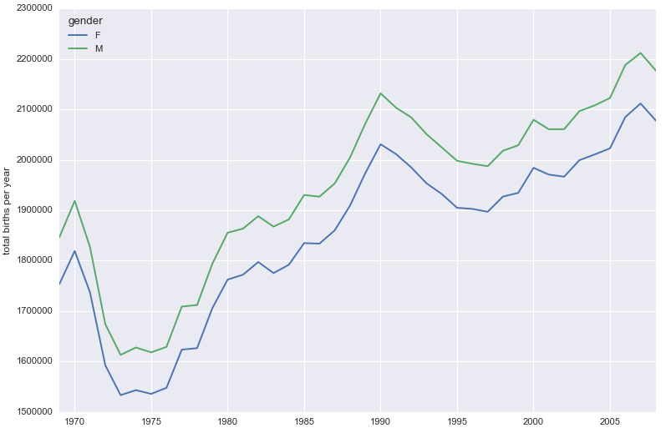

Finally, we can combine the day, month, and year to create a Date index. This allows us to quickly compute the weekday corresponding to each row:
# create a datetime index from the year, month, day
births.index = pd.to_datetime(10000 * births.year +
100 * births.month +
births.day, format='%Y%m%d')
births['dayofweek'] = births.index.dayofweek
births.pivot_table('births', index='dayofweek',
columns='decade', aggfunc='mean').plot()
plt.gca().set_xticklabels(['Mon', 'Tues', 'Wed', 'Thurs', 'Fri', 'Sat', 'Sun'])
plt.ylabel('mean births by day')
plt.show()
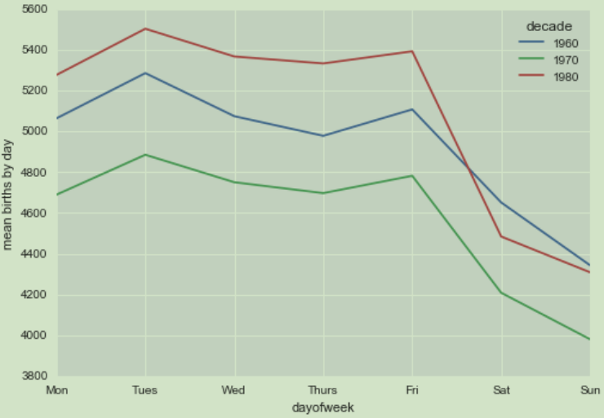
Apparently births are slightly less common on weekends than on weekdays!

1.1 Pandas String Operations
def series_str():
data = ['peter', 'Paul', None, 'MARY', 'gUIDO']
names = pd.Series(data)
print names.str.capitalize()
# 0 Peter
# 1 Paul
# 2 None
# 3 Mary
# 4 Guido
# dtype: object
print names.str.startswith('p')
# 0 True
# 1 False
# 2 None
# 3 False
# 4 False
# dtype: object

Methods using regular expressions
In addition, there are several methods that accept regular expressions to examine the content of each string element, and follow some of the API conventions of Python’s built-in re module
.........

Time Series
Pandas was developed in the context of financial modeling, so as you might expect, it contains a fairly extensive set of tools for working with dates, times, and time- indexed data.

1.1.1 numpy datetime
def np_dt():
date = np.array('2017-09-28', dtype=np.datetime64)
print date + np.arange(5)
# ['2017-09-28' '2017-09-29' '2017-09-30' '2017-10-01' '2017-10-02']

1.1.1 Pandas Time Series: Indexing by Time
Where the Pandas time series tools really become useful is when you begin to index data by timestamps. For example, we can construct a Series object that has time- indexed data:
def series_dt():
index = pd.DatetimeIndex(['2014-07-04', '2014-08-04',
'2015-07-04', '2015-08-04'])
data = pd.Series([0, 1, 2, 3], index=index)
print data
# 2014-07-04 0
# 2014-08-04 1
# 2015-07-04 2
# 2015-08-04 3
# dtype: int64

print data['2014-07-04':'2014-09-04']
# 2014-07-04 0
# 2014-08-04 1
# dtype: int64
There are additional special date-only indexing operations, such as passing a year to obtain a slice of all data from that year:
print data['2015']
# 2015-07-04 2
# 2015-08-04 3
# dtype: int64

1.1.1 Pandas Time Series Data Structures
For time stamps, Pandas provides the Timestamp type. As mentioned before, it is essentially a replacement for Python’s native datetime , but is based on the more efficient numpy.datetime64 data type. The associated index structure is DatetimeIndex

For time periods, Pandas provides the Period type. This encodes a fixed- frequency interval based on numpy.datetime64 . The associated index structure is PeriodIndex

For time deltas or durations, Pandas provides the Timedelta type. Timedelta is a more efficient replacement for Python’s native datetime.timedelta type, and is based on numpy.timedelta64 . The associated index structure is TimedeltaIndex

Any DatetimeIndex can be converted to a PeriodIndex with the to_period() func‐ tion with the addition of a frequency code; here we’ll use 'D' to indicate daily frequency:
def pd_time():
from datetime import datetime
dates = pd.to_datetime([datetime(2015, 7, 3), '4th of July, 2015',
'2015-Jul-6', '07-07-2015', '20150708'])
print dates
print dates.to_period('D')
# PeriodIndex(['2015-07-03', '2015-07-04', '2015-07-06', '2015-07-07',
# '2015-07-08'],
# dtype='int64', freq='D')

A TimedeltaIndex is created, for example, when one date is subtracted from another:
print dates - dates[0]
# TimedeltaIndex(['0 days', '1 days', '3 days',
# '4 days', '5 days'],
# dtype='timedelta64[ns]', freq=None)
Regular sequences: pd.date_range()
To make the creation of regular date sequences more convenient, Pandas offers a few functions for this purpose: pd.date_range() for timestamps, pd.period_range() for periods, and pd.timedelta_range() for time deltas. We’ve seen that Python’s range() and NumPy’s np.arange() turn a startpoint, endpoint, and optional stepsize into a sequence. Similarly, pd.date_range() accepts a start date, an end date, and an optional frequency code to create a regular sequence of dates. By default, the fre quency is one day:

print pd.date_range('2015-07-03', '2015-07-5')
# DatetimeIndex(['2015-07-03', '2015-07-04', '2015-07-05'],
# dtype='datetime64[ns]', freq='D')
Alternatively, the date range can be specified not with a start- and endpoint, but with a startpoint and a number of periods:
print pd.date_range('2015-07-03', periods=3)
# as above
You can modify the spacing by altering the freq argument, which defaults to D . For example, here we will construct a range of hourly timestamps:

print pd.date_range('2015-07-03', periods=3, freq='H')
# DatetimeIndex(['2015-07-03 00:00:00', '2015-07-03 01:00:00',
# '2015-07-03 02:00:00'],
# dtype='datetime64[ns]', freq='H')

Here are some monthly periods:
print pd.period_range('2015-07', periods=3, freq='M')
# PeriodIndex(['2015-07', '2015-08', '2015-09'],
# dtype='int64', freq='M')

1.1.1 Frequencies and Offsets
Fundamental to these Pandas time series tools is the concept of a frequency or date
offset. Just as we saw the D (day) and H (hour) codes previously, we can use such codes
to specify any desired frequency spacing.

For example, for a frequency of 2 hours 30 minutes, we can combine the hour ( H ) and
minute ( T ) codes as follows:

def pd_time_offset():
from pandas.tseries.offsets import BDay
print pd.timedelta_range(0, periods=3, freq="2H30T")
# TimedeltaIndex(['00:00:00', '02:30:00', '05:00:00'],
# dtype='timedelta64[ns]', freq='150T')
print pd.date_range('2015-07-01', periods=3, freq=BDay())
# DatetimeIndex(['2015-07-01', '2015-07-02', '2015-07-03'],
# dtype='datetime64[ns]', freq='B')

1.1.1 Resampling, Shifting, and Windowing
The ability to use dates and times as indices to intuitively organize and access data is an important piece of the Pandas time series tools. The benefits of indexed data in general (automatic alignment during operations, intuitive data slicing and access, etc.) still apply, and Pandas provides several additional time series–specific operations.

def pandas_datareader_1():
from pandas_datareader import data
goog = data.DataReader('GOOG', start='2004', end='2016',
data_source='google')
print goog.head()
goog = goog['Close']
goog.plot()
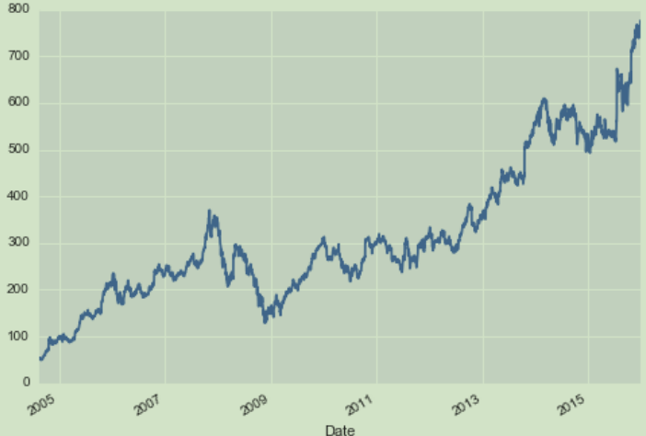

1.1 demo-categorical variable

1.1.1 Univariate Analysis
根据宝石的数据集，来可视化categorical variables
Visualise Categorical Variables in Python using Univariate Analysis
At this stage, we explore variables one by one. For categorical variables, we’ll use a frequency table to understand the distribution of each category. It is also used to highlight missing and outlier values.We can also read as a percentage of values under each category. It can be measured using two metrics, Count and Count% against each category. A bar chart can be used as visualisation.
https://github.com/tidyverse/ggplot2/blob/master/data-raw/diamonds.csv (数据集地址)
carat | cut | color | clarity | depth | table | price | x | y | z
0.23 | Ideal | E | SI2 | 61.5 | 55 | 326 | 3.95 | 3.98 | 2.43
0.21 | Premium | E | SI1 | 59.8 | 61 | 326 | 3.89 | 3.84 | 2.31
0.23 | Good | E | VS1 | 56.9 | 65 | 327 | 4.05 | 4.07 | 2.31
0.29 | Premium | I | VS2 | 62.4 | 58 | 334 | 4.2 | 4.23 | 2.63
0.31 | Good | J | SI2 | 63.3 | 58 | 335 | 4.34 | 4.35 | 2.75
0.24 | Very Good | J | VVS2 | 62.8 | 57 | 336 | 3.94 | 3.96 | 2.48
0.24 | Very Good | I | VVS1 | 62.3 | 57 | 336 | 3.95 | 3.98 | 2.47
0.26 | Very Good | H | SI1 | 61.9 | 55 | 337 | 4.07 | 4.11 | 2.53
0.22 | Fair | E | VS2 | 65.1 | 61 | 337 | 3.87 | 3.78 | 2.49

除了下面四个属性外其余的属性都是数值型
cut quality of the cut (Fair, Good, Very Good, Premium, Ideal)
color diamond colour, from J (worst) to D (best)
clarity a measurement of how clear the diamond is (I1 (worst), SI2, SI1, VS2, VS1, VVS2, VVS1, IF (best))
def load_data():
f_path = 'E:/python_code/tc_competition/diamond/diamonds.csv'
df_data = pd.read_csv(f_path)
print df_data.columns
输出所有的列名:
Index([u'carat', u'cut', u'color', u'clarity', u'depth', u'table', u'price',
u'x', u'y', u'z'],
dtype='object')
print df_data.describe()
输出统计信息(这里就不给出了，不会统计类别型的数据)

print df_data['clarity'].value_counts()
统计clarity每个类别的数量，输出如下:
SI1 13065
VS2 12258
SI2 9194
VS1 8171
VVS2 5066
VVS1 3655
IF 1790
I1 741
Name: clarity, dtype: int64

One-Way Tables统计图，快速知道数据的分布:Create frequency tables (also known as crosstabs) in pandas using the pd.crosstab() function.
my_tab = pd.crosstab(index=df_data["clarity"], # Make a crosstab
columns="count") # Name the count column
my_tab.plot.bar()
plt.show()
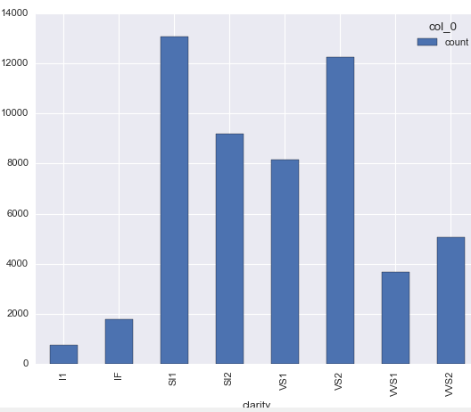

print my_tab.sum() # Sum the counts
Name: clarity, dtype: int64
col_0
count 53940
dtype: int64
print my_tab.shape # Check number of rows and cols
(8, 1)
print my_tab.iloc[1:7] # Slice rows 1-6
col_0 count
clarity
IF 1790
....
VVS1 3655
print my_tab / my_tab.sum()
col_0 count
clarity
I1 0.013737
IF 0.033185
.....
VVS2 0.093919

参考:
http://adataanalyst.com/data-analysis-resources/visualise-categorical-variables-in-python/

1.1.1 Bivariate Analysis
Visualise Categorical Variables in Python using Bivariate Analysis
Categorical & Continous: To find the relationship between categorical and continuous variables, we can use Boxplots
Boxplots are another type of univariate plot for summarising distributions of numeric data graphically. Let’s make a boxplot of carat using the pd.boxplot() function:
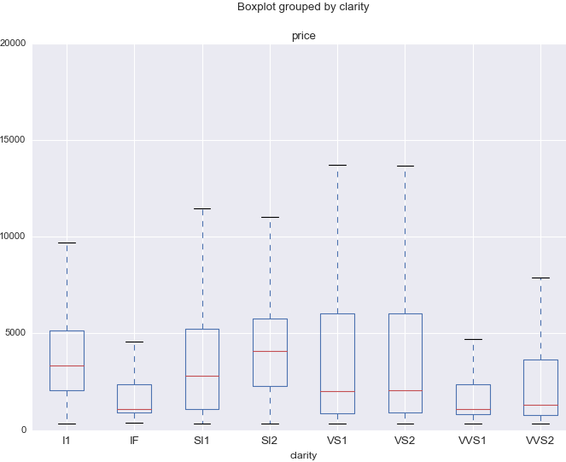
The boxplot above is curious: we’d expect diamonds with better clarity to fetch higher prices and yet diamonds on the highest end of the clarity spectrum (IF = internally flawless) actually have lower median prices than low clarity diamonds!

Categorical & Categorical: To find the relationship between two categorical variables, we can use following methods:

Two-way table: We can start analysing the relationship by creating a two-way table of count and count%. The rows represent the category of one variable and the columns represent the categories of the other variable. We show count or count% of observations available in each combination of row and column categories.

Stacked Column Chart: This method is more of a visual form of a Two-way table.

# two-way table
grouped = df_data.groupby(['cut', 'clarity'])
print grouped.size()
输出：
cut clarity
Fair I1 210
................................
VVS2 69
Good I1 96
.................
VVS2 286
Ideal I1 146
...................
VVS2 2606
Premium I1 205
IF 230
...
VVS2 870
Very Good I1 84
.........
VVS2 1235
dtype: int64

Two-Way Tables

Two-way frequency tables, also called contingency tables, are tables of counts with two dimensions where each dimension is a different variable. Two-way tables can give you insight into the relationship between two variables. To create a two-way table, pass two variables to the pd.crosstab() function instead of one:

clarity_color_table = pd.crosstab(index=df_data["clarity"],
columns=df_data["color"])
print clarity_color_table
color | D | E | F | G | H | I | J
clarity
I1 | 42 | 102 | 143 | 150 | 162 | 92 | 50
IF | 73 | 158 | 385 | 681 | 299 | 143 | 51
SI1 | 2083 | 2426 | 2131 | 1976 | 2275 | 1424 | 750
SI2 | 1370 | 1713 | 1609 | 1548 | 1563 | 912 | 479
VS1 | 705 | 1281 | 1364 | 2148 | 1169 | 962 | 542
VS2 | 1697 | 2470 | 2201 | 2347 | 1643 | 1169 | 731
VVS1 | 252 | 656 | 734 | 999 | 585 | 355 | 74
VVS2 | 553 | 991 | 975 | 1443 | 608 | 365 | 131
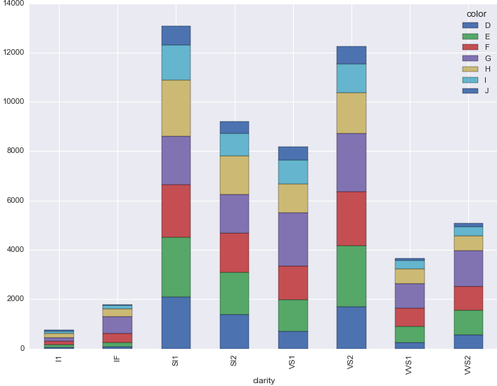

sklearn

1.1 metric

1.1.1 metric accuracy score
from sklearn.metrics import accuracy_score
def accuracy_score_demo():
y_pred = [0, 2, 1, 3]
y_true = [0, 1, 2, 3]
print accuracy_score(y_true, y_pred)
# 0.5

1.1.1 confusion_matrix
y_true = [0, 1, 0, 1, 1, 0, 1, 0, 1]
y_pred = [0, 0, 1, 0, 0, 0, 1, 1, 0]
print confusion_matrix(y_true, y_pred)
# [[2 2] 四个 0 两个被识别为了 0， 两个被识别为 1
# [4 1]] 五个 1 四个被识别为了 0， 一个被识别为 1

>>> from sklearn.metrics import confusion_matrix
>>> y_true = [2, 0, 2, 2, 0, 1]
>>> y_pred = [0, 0, 2, 2, 0, 2]
>>> confusion_matrix(y_true, y_pred)
array([[2, 0, 0],
[0, 0, 1],
[1, 0, 2]])

def classification_report_demo():
y_true = [0, 1, 2, 2, 0]
y_pred = [0, 0, 2, 1, 0]
target_names = ['class 0', 'class 1', 'class 2']
print classification_report(y_true, y_pred, target_names=target_names)
print confusion_matrix(y_true, y_pred)
# [[2 0 0]
# [1 0 0]
# [0 1 1]]

precision recall f1-score support

class 0 0.67 1.00 0.80 2
class 1 0.00 0.00 0.00 1
class 2 1.00 0.50 0.67 2

avg / total 0.67 0.60 0.59 5

1.1.1 cross_val_score

def svm_fit_test(X_train, X_test, Y_train, Y_test):
clf = svm.SVC(kernel='linear', C=1).fit(X_train, Y_train)
print clf.score(X_test, Y_test)
scores = cross_val_score(clf, X_train, Y_train)
print scores
0.6625
[ 0.68518519 0.68867925 0.68867925]

1.1 data split

1.1.1 KFlod
交叉验证法（crossvalidation）/k折交叉验证（k-fold cross validation）
方法：将数据集D划分为k个大小相似的互斥子集，即.每个子集Di都尽可能保持数据分布的一致性，即从D中通过分层采样得到。然后每次都用k-1个子集的并集作为训练集，余下的那个子集作为测试集；这样就可获得k组训练/测试集，从而可进行k次训练和测试，最终返回的是这k个测试结果的均值。
import numpy as np
from sklearn.model_selection import KFold
def kfold_1():
X = np.array([[3, 4, 0], [3, 2, 1], [5, 6, 0],
[1, 2, 1], [1, 5, 0], [7, 4, 1]])
kf = KFold(n_splits=4)
for train, test in kf.split(X):
print "=======train: %s" % X[train].tolist()
# print X[train]
print "=======test : %s" % X[test].tolist()
输出如下:(数据被分了四次，每次分为训练集，与测试集)
=======train: [[5, 6, 0], [1, 2, 1], [1, 5, 0], [7, 4, 1]]
=======test : [[3, 4, 0], [3, 2, 1]]

=======train: [[3, 4, 0], [3, 2, 1], [1, 5, 0], [7, 4, 1]]
=======test : [[5, 6, 0], [1, 2, 1]]

=======train: [[3, 4, 0], [3, 2, 1], [5, 6, 0], [1, 2, 1], [7, 4, 1]]
=======test : [[1, 5, 0]]

=======train: [[3, 4, 0], [3, 2, 1], [5, 6, 0], [1, 2, 1], [1, 5, 0]]
=======test : [[7, 4, 1]]

1.1 GridSearchCV

1.1.1 example 1/curve compare
def grid_search_cv_graph():
iris = datasets.load_digits()
X = iris.data
Y = iris.target
C_lst = [1, 10, 100, 1000]
gamma_lst = [1e-3, 1e-4]
parameters = {'C': C_lst, 'gamma': gamma_lst}
clf_ = svm.SVC()
clf = GridSearchCV(clf_, parameters, cv=2, n_jobs=-1)
clf.fit(X, Y)
print clf.best_params_
print clf.best_score_
scores = clf.cv_results_['mean_test_score']
print scores
scores = np.array(scores).reshape(len(C_lst), len(gamma_lst))
for ind, i in enumerate(C_lst):
plt.plot(gamma_lst, scores[ind], label='C: ' + str(i))
plt.legend()
plt.xlabel('Gamma')
plt.ylabel('Mean score')
plt.show()

{'C': 10, 'gamma': 0.001}
0.962715637173
[ 0.96048971 0.93600445 0.96271564 0.94546466 0.96271564 0.94657763
0.96271564 0.94657763]
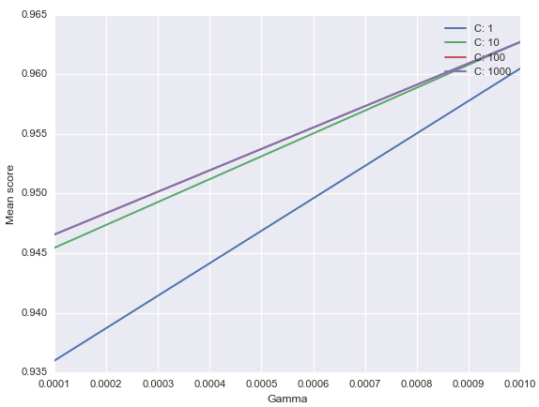

matplotlib

1.1 basic plot
import matplotlib.pyplot as plt  plt.plot([1,2,3,4])  plt.ylabel('some numbers')  plt.show() | 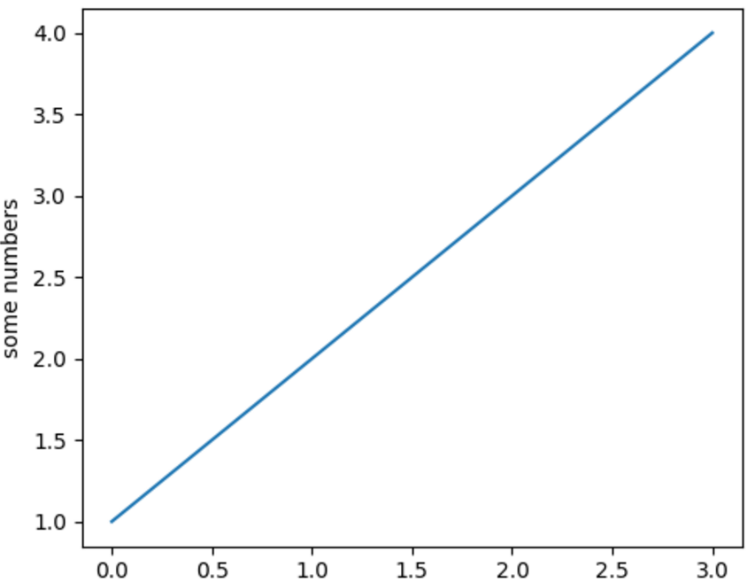
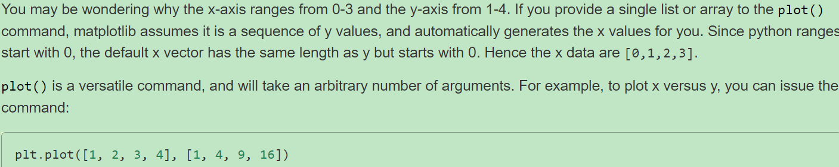
For every x, y pair of arguments, there is an optional third argument which is the format string that indicates the color and line type of the plot. The letters and symbols of the format string are from MATLAB, and you concatenate a color string with a line style string. The default format string is ‘b-‘, which is a solid blue line. For example, to plot the above with red circles, you would issue
import matplotlib.pyplot as plt  plt.plot([1,2,3,4], [1,4,9,16], 'ro')  plt.axis([0, 6, 0, 20])  plt.show() | 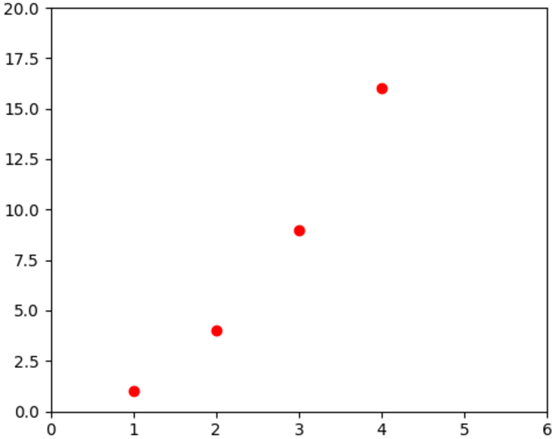
See the plot() documentation for a complete list of line styles and format strings. The axis() command in the example above takes a list of [xmin, xmax, ymin, ymax] and specifies the viewport of the axes.

If matplotlib were limited to working with lists, it would be fairly useless for numeric processing. Generally, you will use numpy arrays. In fact, all sequences are converted to numpy arrays internally. The example below illustrates a plotting several lines with different format styles in one command using arrays.

import numpy as np  import matplotlib.pyplot as plt  t = np.arange(0., 5., 0.2)  # red dashes, blue squares and green triangles  plt.plot(t, t, 'r--', t, t**2, 'bs', t, t**3, 'g^')  plt.show() | 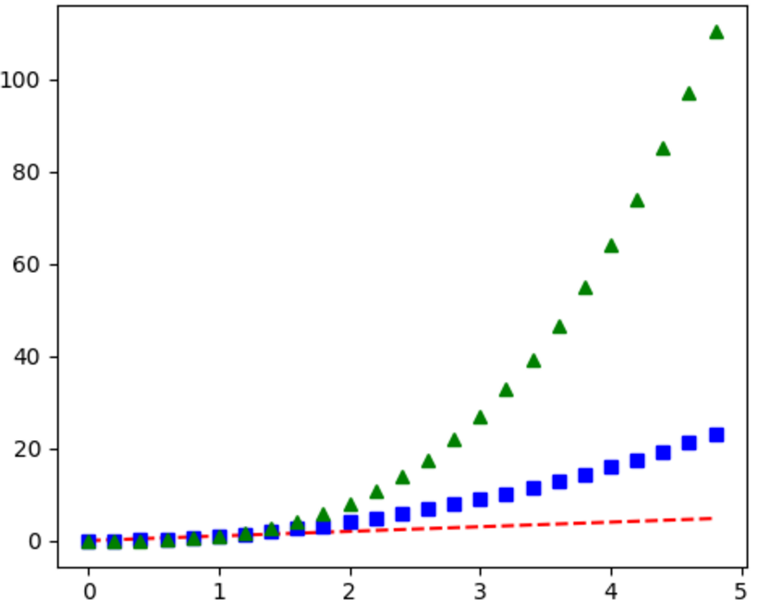
t = np.arange(0., 5., 0.2)
>>
[ 0. 0.2 0.4 0.6 0.8 1. 1.2 1.4 1.6 1.8 2. 2.2 2.4 2.6 2.8
3. 3.2 3.4 3.6 3.8 4. 4.2 4.4 4.6 4.8]

plt.plot([1,2,3,4],[1,4,9,16], linewidth=2.0) | plt.plot([0, 0], [0, 4], color='red', linewidth=3.0)  plt.axis([-1, 1, -4, 4])  plt.show()
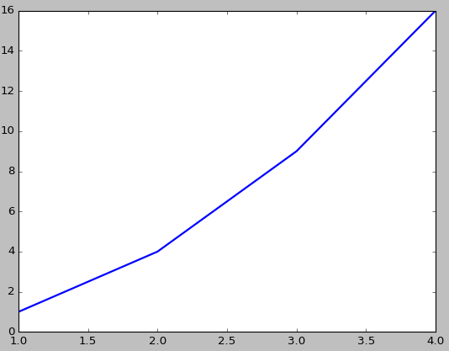 | 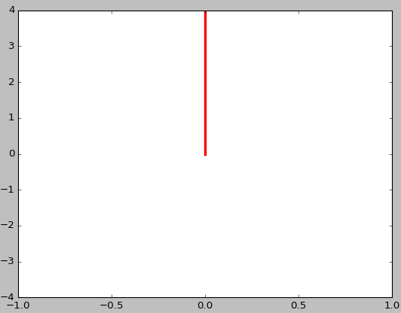
上面右边的那条红线，我们可以看出 plot(x, y)中x对应的是 x轴坐标，而y对应的是y轴的坐标。
lines = plt.plot([1,2,3,4],[1,4,9,16])  plt.setp(lines, color='r')  plt.show() | 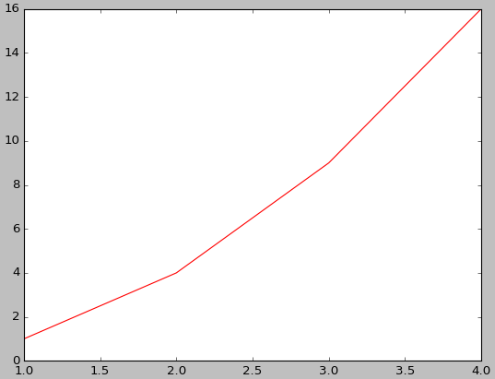

1.1.5 plot orthogonal vector
arr = np.array([[-0.85389096, -0.52045195],  [0.52045195, -0.85389096]])  v1_x, v2_x = [arr[:, 0][0], 0], [arr[:, 1][0], 0]  v1_y, v2_y = [arr[:, 0][1], 0], [arr[:, 1][1], 0]  plt.plot(v1_x, v1_y)  plt.plot(v2_x, v2_y)  # set the below bound,  # or the line won't seem orthogonal  plt.axis([-0.85389096, 0.52045195,  -0.85389096, 0.52045195])  plt.show() | 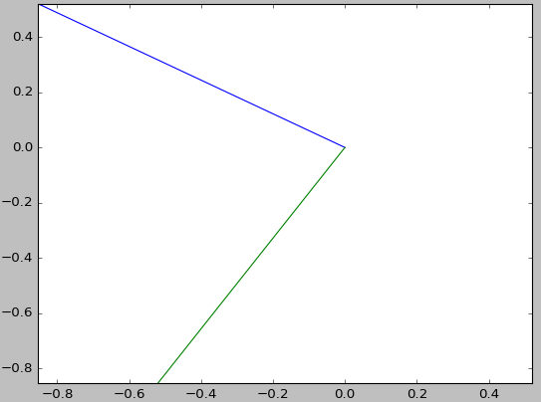
arr = np.array([[-0.85389096, -0.52045195],  [0.52045195, -0.85389096]])  v1_x, v2_x = [arr[:, 0][0], 0], [arr[:, 1][0], 0]  v1_y, v2_y = [arr[:, 0][1], 0], [arr[:, 1][1], 0]  plt.plot(v1_x, v1_y)  plt.plot(v2_x, v2_y)  plt.show() | 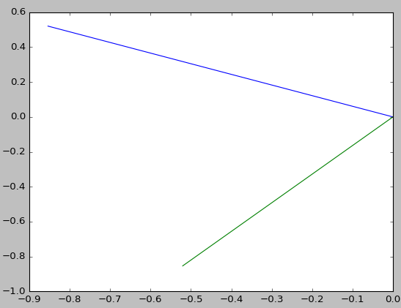
由上面我们可以看出，如果不设置对应的坐标范围，我们看不出两个向量正交(orthogonal)

1.1 multiple figures
plt.figure(1) # the first figure
plt.subplot(211) # the first subplot in the first figure
plt.plot([1, 2, 3])
plt.subplot(212) # the second subplot in the first figure
plt.plot([4, 5, 6, 7, 11])
plt.show()
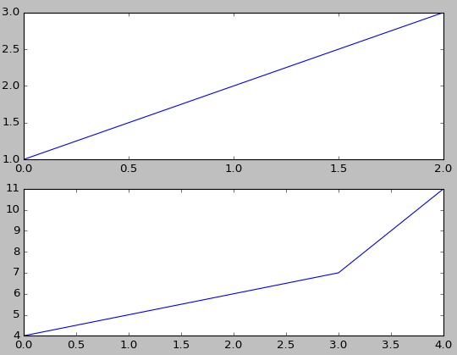
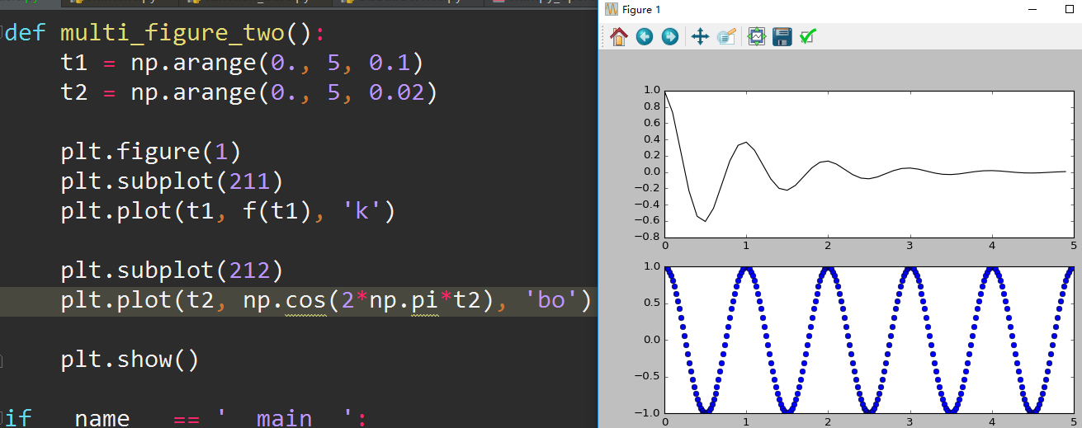
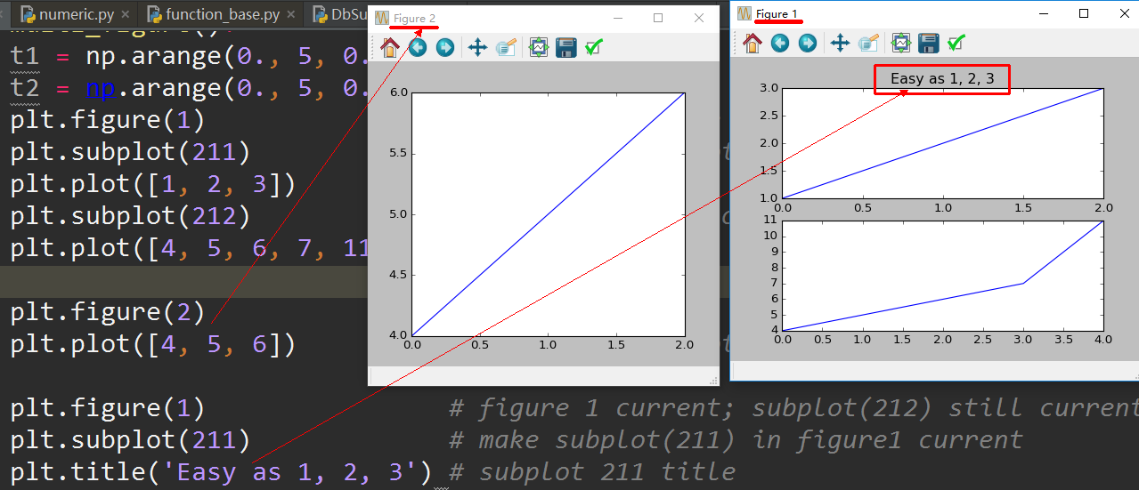

1.1 subplots / plot mul
left = 0.1  width = 0.8  ax1 = plt.axes([left, 0.5, width, 0.45])  ax2 = plt.axes([left, 0.3, width, 0.19])  ax3 = plt.axes([left, 0.2, width, 0.09], sharex=ax2)  ax4 = plt.axes([left, 0.1, width, 0.09], sharex=ax2)  # ticks at the top of the top plot  ax1.xaxis.tick_top()  # remove ticks for ax2 and ax3  ax2.xaxis.set_visible(False)  ax3.xaxis.set_visible(False)  # only put ticks on the bottom of ax4  ax4.xaxis.tick_bottom()  plt.show() | 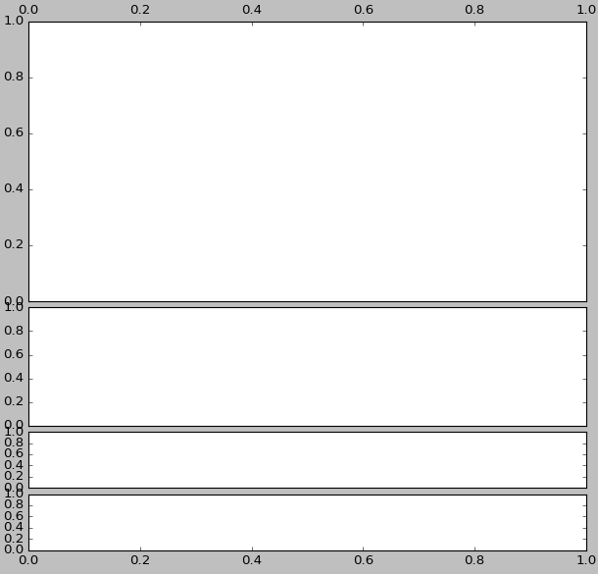

x = np.linspace(0, 2 * np.pi, 400)  y = np.sin(x ** 2)  # Just a figure and one subplot  f, ax = plt.subplots()  ax.plot(x, y)  ax.set_title('Simple plot')  plt.show() | 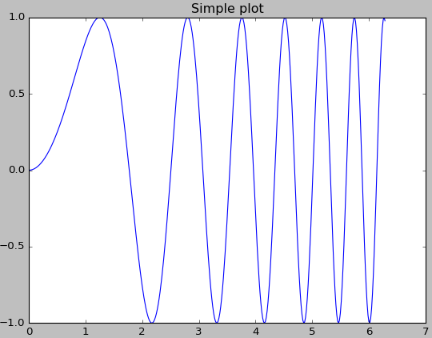

x = np.linspace(0, 2 * np.pi, 400)  y = np.sin(x ** 2)  f, ax_arr = plt.subplots(2, sharex=True)  ax_arr[0].plot(x, y)  ax_arr[0].set_title('sharing x axis')  ax_arr[1].scatter(x, y)  plt.show() | 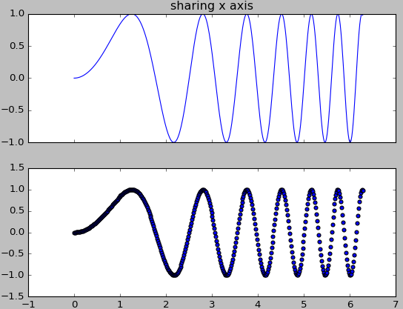

x = np.linspace(0, 2 * np.pi, 300)  y = np.sin(x ** 2)  f, (ax1, ax2) = plt.subplots(1, 2, sharey=True)  ax1.plot(x, y)  ax1.set_title('Sharing Y axis')  ax2.scatter(x, y)  plt.show() | 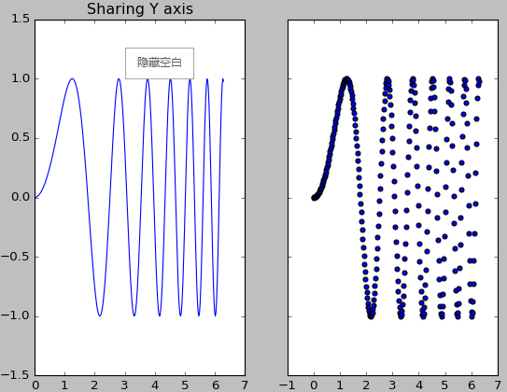

x = np.linspace(0, 2 * np.pi, 300)  y = np.sin(x ** 2)  f, (ax1, ax2, ax3)  = plt.subplots(3, sharex=True)  ax1.plot(x, y)  ax1.set_title('sharing x axis')  ax2.scatter(x, y)  x1 = [1, 2, 3, 4, 5, 6, 7]  y1 = [2.6, 3.6, 8.3, 56, 12.7, 8.9, 5.3]  # note y ranges hurge  ax3.scatter(x1, y1)  plt.show() | 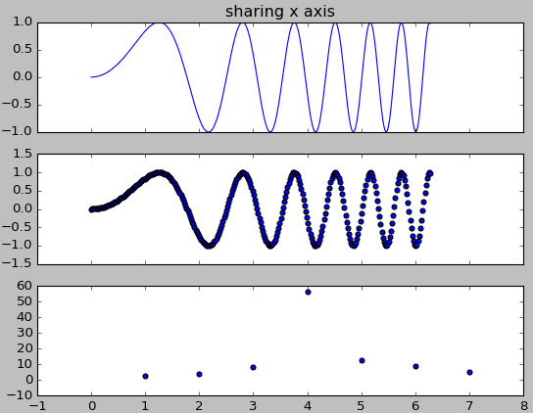

x = np.linspace(0, 2 * np.pi, 300)  y = np.sin(x ** 2)  f, ((ax1, ax2), (ax3, ax4)) =  plt.subplots(2, 2, sharex='col', sharey='row')  ax1.plot(x, y)  ax1.set_title('Sharing x per column, y per row')  ax2.scatter(x, y)  ax2.set_title('ax2')  ax3.plot(x, 2 * y ** 2 + 1, color='r')  ax3.set_title('ax3')  ax4.plot(x, 2 * y ** 2 + 1, color='b')  ax4.set_title('ax4') | 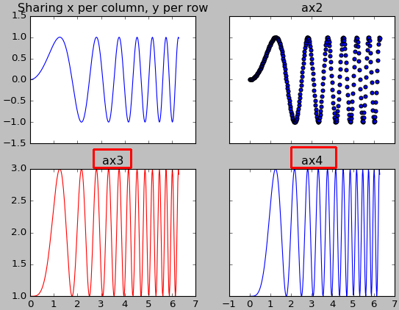

x = np.linspace(0, 2 * np.pi, 300)  y = np.sin(x ** 2)  f, ax_arr = plt.subplots(2, 2)  ax_arr[0, 0].plot(x, y)  ax_arr[0, 0].set_title('axis 0, 0')  ax_arr[0, 1].scatter(x, y)  ax_arr[0, 1].set_title('axis 0, 1')  ax_arr[1, 0].plot(x, y ** 2)  ax_arr[1, 0].set_title('axis 1, 0')  ax_arr[1, 1].scatter(x, y ** 2)  ax_arr[1, 1].set_title('axis 1, 1') | 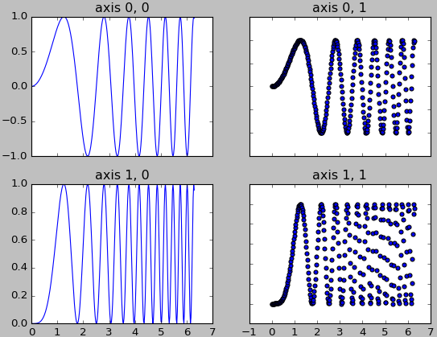
# for row 0, every element x axis hidden
plt.setp([ax.get_xticklabels() for ax in ax_arr[0, :]], visible=False)
# for column 1, every element y axis hidden
plt.setp([ax.get_yticklabels() for ax in ax_arr[:, 1]], visible=False)
plt.show()

multi plot compare

def plot_ret(results):
epochs = len(results['validation_0']['error'])
x_axis = range(0, epochs)
# plot log loss
fig, ax_arr = plt.subplots(2, sharex=True)
ax_arr[0].plot(x_axis, results['validation_0']['logloss'], label='Train')
ax_arr[0].plot(x_axis, results['validation_1']['logloss'], label='Test')
ax_arr[0].legend()
ax_arr[0].set_ylabel('Log Loss')
ax_arr[0].set_title('XGBoost Log Loss')
# plot classification error
# fig, ax = plt.subplots()
ax_arr[1].plot(x_axis, results['validation_0']['error'], label='Train')
ax_arr[1].plot(x_axis, results['validation_1']['error'], label='Test')
ax_arr[1].legend()
ax_arr[1].set_ylabel('Classification Error')
ax_arr[1].set_title('XGBoost Classification Error')
plt.show()
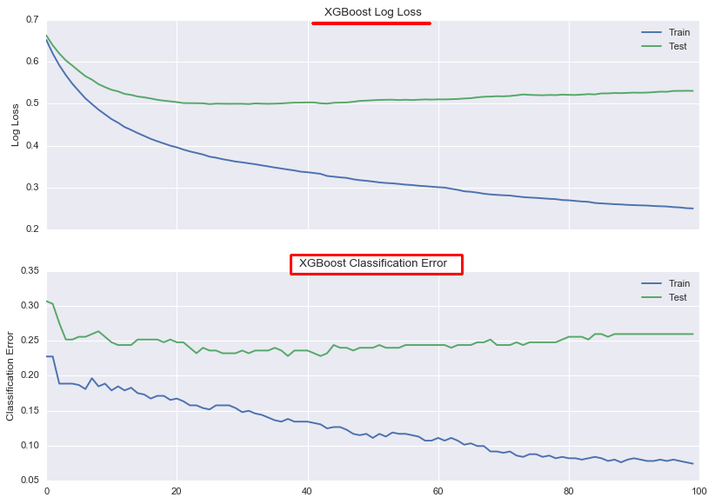
https://stackoverflow.com/questions/6963035/pyplot-axes-labels-for-subplots
https://stackoverflow.com/questions/16150819/common-xlabel-ylabel-for-matplotlib-subplots/26892326

1.1 scatter

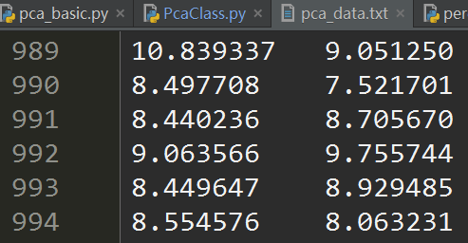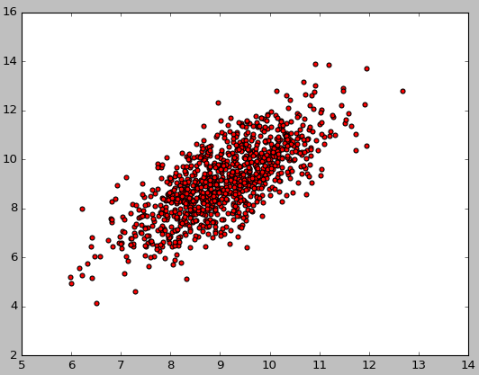
plt.scatter(data[:, 0], data[:, 1], c='r') # add c='r', or you will get error
plt.show()
# data[:, 0] means column 1, data[0] means row 1
def plot2D():  x=[1,2,3,4,5,6,7]  y=[2.6,3.6,8.3,56,12.7,8.9,5.3]  plt.plot(x,y)#画连线图  plt.scatter(x,y)#画散点图  plt.show() | 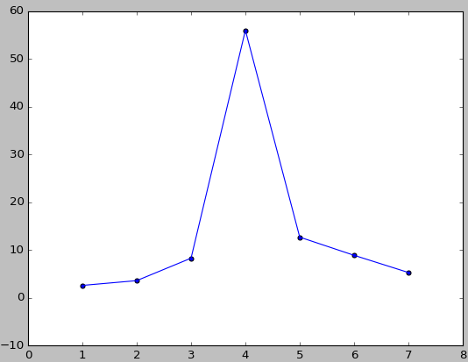

plt.figure(1)  plt.subplot(211)  plt.scatter(src_data[:, 0], src_data[:, 1], c='r')  plt.title('source data')  plt.subplot(212)  plt.scatter(sub_mean[:, 0], sub_mean[:, 1], c='r')  plt.title('sub_mean_data')  plt.show() | 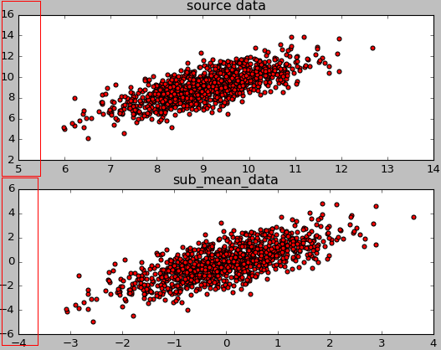

1.1 hist
import pandas as pd
import numpy as np
import matplotlib.pyplot as plt

# random data
df1 = pd.DataFrame(columns=['human_den','region'])
df1['human_den'] = np.random.rand(100)
df1['region'] = np.random.choice(['Northeast', 'South', 'Midwest'], size=100)

# set up figure & axes
fig, axes = plt.subplots(nrows=1, ncols=3, sharex=True, sharey=True)

# drop sharex, sharey, layout & add ax=axes
df1.hist(column='human_den',by='region', ax=axes)

# set title and axis labels
plt.suptitle('Your Title Here', x=0.5, y=1.05, ha='center', fontsize='xx-large')
fig.text(0.5, 0.04, 'common X', ha='center')
fig.text(0.04, 0.5, 'common Y', va='center', rotation='vertical')

Notice, the keyword arguments sharex, sharey, and layout are not assigned in df1.hist(), in favor of setting sharex, sharey, nrows and ncols in plt.subplots to achieve similar effects. The important element is assigning df.hist()'s keyword argument, ax, to the previously initialized axes object. The title can be set with suptitle.
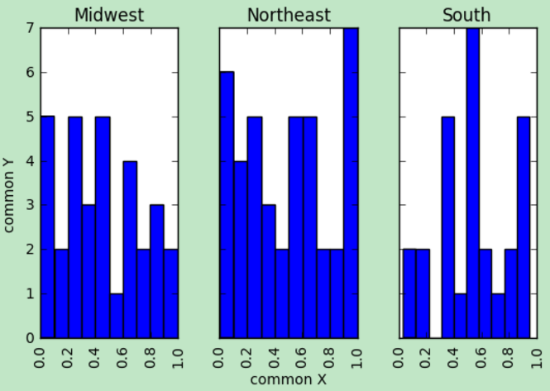

Scipy

1.1 basic plot

1.1.1 plot orthogonal vector

1.1 practice example

1.1.1 euclidean distance
from scipy.spatial import distance
import numpy as np
def eu_distance():
a1 = np.array([1, 2, 3])
a2 = np.array([3, 4, 5])
print distance.euclidean(a1, a2)
# 3.46410161514

