chapter 1 - 1 -
1.1 - 1 -
1.1.1 - 1 -

s2s

1.1 basic

1.1.1 使用简介/py示例
一、 DNS配置：
1. 接入生产环境：
DNS服务器已经配置了域名meta.yy.com

2. 接入测试环境：
配置 /etc/host:
175.6.25.61 meta.yy.com

[Note:] thrift通道服务端口：4001
http通道服务端口：8080

二、 S2sKey申请:
新服务上线，需先申请对应的 s2sKey(接入的安全认证,类似于ticket) ，可以到以下链接自行申请：
业务申请统一入口 ⇒ 添加s2s节点/查询s2s节点http://nb.service.yy.com/
申请如下（下面的仅仅测试示例）：
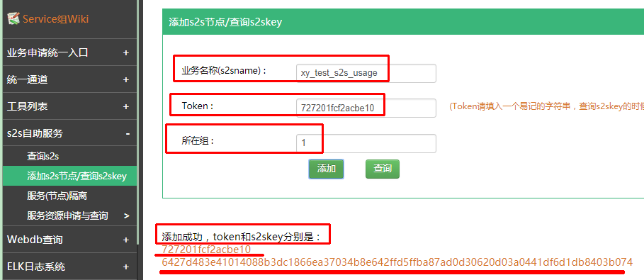
- 接口说明：

使用流程，下面给出py的http示例：

1./auth （向S2S验证身份，可以等价于web用户的登录，用户名密码）

a. 请求
POST请求, 格式如下:
POST /auth HTTP/1.1\r\n
Content-type :application/json;charset=UTF-8\r\n
Conten t-Length: xx\r\n [Note: xx泛指一个数值，下同]
/r/n
[ JSON编码的内容参数信息]
JSON编码带上以下的内容参数信息，如下例：
{"s2sname":"s2sdemo", "s2skey":"727201fcf2acbe10"}
key | value
s2sname | 服务名称
s2skey | 服务对应的key值，用于验证服务的合法性，需要预先申请

b. 响应
请求成功，JSON方式返回服务器生成的s2scookie:
HTTP/1.1 200 OK\r\n
Content-type :application/json;charset=UTF-8\r\n
Conten t-Length: xx\r\n
\r\n
{"s2scookie":”xxxxxxxx”}

请求失败, 返回相应的状态码，及错误描述信息:
HTTP/1.1 400 Bad Request\r\n
Content-type :text/plain;charset=UTF-8\r\n
Conten t-Length: 44\r\n
\r\n
auth failure, s2skey and s2sname are invalid
下面给出py代码：
S2S_COOKIE = ""
SVCID = -1
S2S_NAME = "xy_test_s2s_usage"
S2SKEY = "6427d483e41014088b3dc1866ea37034b8e642ffd5ff0441df6d1db8403b074"
headers = {"Content-type": "application/json;charset=UTF-8"}
def s2s_auth():
http_auth = httplib.HTTPConnection("meta.yy.com", 8080, timeout=30)
auth_data = {"s2sname":S2S_NAME, "s2skey":S2SKEY}
auth_params = json.dumps(auth_data)
http_auth.request("POST", "/auth", auth_params, headers)
auth_rsp = http_auth.getresponse()
auth_rsp_data = auth_rsp.read()
print "auth result: ", auth_rsp.status, auth_rsp.reason, auth_rsp_data
# auth result: 200 OK {"s2scookie":"E80300..............."}
auth_rsp_decoded = json.loads(auth_rsp_data)
print "auth_rsp_decoded: %s" % auth_rsp_decoded
# auth_rsp_decoded: {u's2scookie': u'E8030000110078795F......"}
if auth_rsp.status == 200:
S2S_COOKIE = auth_rsp_decoded['s2scookie']
http_auth.close()
return auth_rsp.status
上面程序运行成功了，返回cookie(运行成功后在运行程序任然返回相同的cookie因为，服务端肯定会有缓存cookie时间)

2./createMeta
a. 请求
POST请求，格式如下:
POST /createMeta HTTP/1.1\r\n
Content-type :application/json;charset=UTF-8\r\n
Conten t-Length: xx\r\n
/r/n
[ JSON编码的内容参数信息]
需要带上以下的内容参数信息，如下例:
{"s2sname":"s2sdemo", "s2scookie":"xxxxxxxx", "groupId": 64, "type": 4, "data": “xxxxxxxx”}
key | value
s2sname | 服务名称
s2scookie | 上次请求服务端返回的cookie
groupId | 服务所在的机房id
type | data的编解码方式
data | 服务信息，经base16编码后的字符串：  a. 服务信息经过订阅者与被订阅者协商的编解码协议编码后，生成二进制串;  b. 二进制串经base16编码转换成JSON可识别的字符串;
cookie,记录了会话的最新状态，每次请求(除authConnect外的请求)时，带上最新返回的cookie即可,否则服务端可能拒绝请求

b. 响应
请求成功, JSON 方式返回meta对应的全局惟一id和服务器生成的最新cookie:
HTTP/1.1 200 OK\r\n
Content-type :application/json;charset=UTF-8\r\n
Conten t-Length: xx\r\n
\r\n
{"s2scookie":"xxxxxxxx","serverId":488457215}
请求失败, 返回相应的状态码，及错误描述信息, 参考/auth
def create_meta():
global S2S_COOKIE
global SERVICE_ID
dt = "test"
dt = base64.b16encode(dt)
meta = {"s2sname":S2S_NAME,"s2scookie":S2S_COOKIE, "groupId": 63, "type": 4, "data": dt}
create_params = json.dumps(meta)
http_client = httplib.HTTPConnection("meta.yy.com", 8080, timeout=30)
http_client.request("POST", "/createMeta", create_params, headers)
create_rsp = http_client.getresponse()
create_rsp_data = create_rsp.read()
print "createMeta result:", create_rsp.status, create_rsp.reason, create_rsp_data
# createMeta result: 200 OK {"s2scookie":"E80300001100.....","serverId":141794623583}
decoded = json.loads(create_rsp_data)
if create_rsp.status == 200:
SERVICE_ID = decoded['serverId']
S2S_COOKIE = decoded['s2scookie']
http_client.close()
return create_rsp.status
上面的函数创建meta之后，就可以在web上面搜索到s2s的信息了:
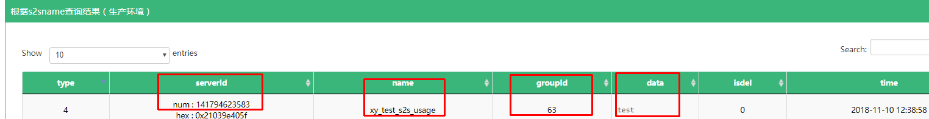

3.updateMeta
a. 请求
POST请求，格式如下：
POST /updateMeta HTTP/1.1\r\n
Content-type :application/json;charset=UTF-8\r\n
Conten t-Length: xx\r\n
/r/n
[ JSON编码的内容参数信息]
需要带上以下的内容参数信息:
{"s2scookie":"xxxxxxxxxx","data": “xxxx”, "serverId":xxx};
key | value
s2scookie | 服务器返回的最新cookie串
data | 更新后的服务注册信息二进制流经base16编码后的字符串
serverId | createMeta请求返回的serverId

b. 响应
请求成功, Json方式返回服务器最新生成的cookie
HTTP/1.1 200 OK\r\n
Content-type :application/json;charset=UTF-8\r\n
Conten t-Length: xx\r\n
\r\n
{"s2scookie":”xxxxxxxx”}
请求失败，返回相应的状态码，及错误描述信息,参考/auth

4./removeMeta
a. 请求
POST请求，格式如下:
POST /removeMeta HTTP/1.1\r\n
Content-type :application/json;charset=UTF-8\r\n
Conten t-Length: xx\r\n
/r/n
[ JSON编码的内容参数信息]
需要带上以下的内容参数信息:
{" S2scookie ":"xxxxxxxx", "serverId":xxx};
key | value
S2scookie | 上次请求返回的cookie
serverId | createMeta请求返回的serverId
代码如下：
def remove_meta():
global S2S_COOKIE
global SERVICE_ID
del_meta = {"s2scookie": S2S_COOKIE, "serverId": SERVICE_ID}
del_params = json.dumps(del_meta)
http_client = httplib.HTTPConnection("meta.yy.com", 8080, timeout=30)
http_client.request("POST", "/removeMeta", del_params, headers)
del_rsp = http_client.getresponse()
print "removeMeta result:", del_rsp.status, del_rsp.reason, del_rsp.read()
http_client.close()
b. 响应
请求成功, 无内容，简单回复
HTTP/1.1 200 OK\r\n

5./snapShot
a. 请求
POST请求，格式如下:
POST /snapShot HTTP/1.1\r\n
Content-type :application/json;charset=UTF-8\r\n
Conten t-Length: xx\r\n
/r/n
[ JSON编码的内容参数信息]
需要带上以下参数信息，如下:
{"s2scookie":"xxxxxxxx","conditions":[{'name':"s2sdemo", 'groupId':63}]}
key | value
s2scookie | 上次请求返回的s2scookie
conditions | 查询关注服务的条件过滤信息, 一个过滤条件由name, groupId, type组成(三者中的1~3个参数组成,and的关系)，多个过滤条件间是or的关系
b. 响应
请求成功, JSON 方式返回订部到的meta列表和s2scookie:
HTTP/1.1 200 OK\r\n
Content-type :application/json;charset=UTF-8\r\n
Conten t-Length: xxx\r\n
\r\n
[JSON编码的meta列表和s2scookie]
代码示例如下（其中groupid为机房信息）:
def print_meta(metas):
for meta in metas:
meta_data = meta['data']
data = binascii.unhexlify(meta_data)
print 'serverId = %d, name = %s, groupId =%d, type = %d, timeStamp = %d,
data = %s, status =%d\r' \
% (meta["serverId"], meta['name'], meta["groupId"], meta["type"],
meta["timestamp"], data, meta["status"])
def snap_shot():
global S2S_COOKIE
snap_data = {"s2scookie":S2S_COOKIE,
"conditions":[{'name': "xy_test_s2s_usage", 'groupId': 63}]}
params = json.dumps(snap_data)
http_client = httplib.HTTPConnection("meta.yy.com", 8080, timeout=30)
http_client.request("POST", "/snapShot", params, headers)
snap_rsp = http_client.getresponse()
print "snapShot result:", snap_rsp.status, snap_rsp.reason
snap_rsp_data = snap_rsp.read()
decoded = json.loads(snap_rsp_data)
print "snap_shot, decoded: " % decoded
metas = decoded['metas']
print_meta(metas)
# serverId = 1...3, name = xy_test_s2s_usage, groupId =63, type = 4,
timeStamp = 6...3, data = test, status =0
# serverId = 1...5, name = xy_test_s2s_usage, groupId =63, type = 4,
timeStamp = 6...9, data = new_xy, status =0
if snap_rsp.status == 200:
S2S_COOKIE = decoded['s2scookie']
return snap_rsp.status
获取订阅者的信息数据主要有groupId（机房信息）、data（数据，可以有不同的类型例如json，客户端和服务端可以协商）、type(就是数据的类型)。

1.1.1 c++ 示例

一、 DNS配置：
1. 接入生产环境：
DNS服务器已经配置了域名meta.yy.com

1.1

1.1.1

123
fsdf

