chapter1 get started 1
1.1 variable、operator 1
1.2 data type 1
1.2.1 numerical 1
1.2.2 string 1
1.2.3 tuple 3
1.2.4 list 4
1.2.5 dict 6
1.3 control flow 7
1.3.1 if-else 7
1.3.2 for 7
1.3.3 while 8
1.3.4 switch 8
1.3.4 a ? b:c ternary operator 8
1.4 function 9
1.4.1 define a function 9
1.4.2 Lambda expression 10
1.4.3 built-in function like range 10
1.5 deep/shallow copy 11
1.6 dir file path 12
1.6.2 read txt file(like nth row) 13
1.6.3 absolute relative path 14
1.6.3 sys.path import module 15
1.7 json 17
1.7.2 json unicode str 17
1.7 random 19
1.7 __init__, __all__ 20
1.7 string print format 20
1.7.1 basic formatting 21
1.7 getattr、setattr 21
1.7 yield、generator 22
chapter class 24
1.8 class 24
1.8.1 define a class 24
1.8.2 Inherit a class 25
1.8.3 supper() vs __init__() 26
1.8.4 classes extend object 27
1.8.5 class variable with or not self 27
1.8.6 difference between type() and isinstance 28
1.8.7 metaclass 28
1.8 date ( time datetime) 29
1.6 other trick 30
1.6.1 list to string vice verse 30
1.6.2 concatenate str and int 30
1.6.3 / decimal round 31
1.6.4 get filename without extension 31
1.6.5 add char in string 31
1.6.6 split string to list by nth 32
1.6.7 print trick 32
1.6.7 list itemwise do same function 32
1.6.7 zip enumerate multi list 32
1.6 encode/decode(utf8) 33
1.6.1 ASCII码 33
1.6.2 unicode 34
1.6.3 utf-8 34
1.6.3 GBK 35
1.6.4 py中文件编码 39
1.6.5 string类型 40
1.6.5 encode 40
1.6.5 decode 41
1.6.6 json中的应用 41
1.6 os 42
1.6.1 os.system() 43
1.6.2 os.system() 43
Chapter 2 thread process 45
1.6 thread 45
1.6.1 join 46
1.6.2 daemon vs non_daemon 46
1.6.1 Enumerating All Threads 48
1.6.1 Subclassing Thread 49
1.6.1 SubThread vs MainThread 49
1.6.1 Timer Thread 51
1.6.1 Signaling Between Threads 52
1.6.1 Thread Lock safe counter(Controlling Access to Resources) 53
1.6.1 Re-entrant Locks 54
1.6.1 线程退出问题 55
1.6.1 Synchronizing Threads Condition 56
1.6.1 Subclassing Thread 57
1.6.1 some question 58
1.6 multiprocessing 59
1.6.1 join 59
1.6.2 example 60
1.6 subprocess 60
1.6 log 63
1.6.1 log level 63
1.6.2 log FileHandler & Formatter 64
1.6.3 log level situation 65
1.6.4 Capture exceptions 2 file 66
1.6.5 get log from json 67
1.6.6 get log from yaml 69
1.6.7 log with multi thread 71
1.6.8 log with multi process 72
1.6.8 rotating file handler 72
1.6.8 multiple servers central log 72
Chapter 2 http web 73
Chapter 2 Numpy 错误！未定义书签。
1.1 np array 错误！未定义书签。
1.1.1 create array,shape(单位对角矩阵创建) 错误！未定义书签。
1.1.2 numpy.random.randn 错误！未定义书签。
1.1.2 numpy.dot 错误！未定义书签。
1.1.2 numpy.argmax 错误！未定义书签。
1.1.3 numpy.mat vs np.array 错误！未定义书签。
1.1.4 np.shuffle vs np.permute 错误！未定义书签。

chapter1 get started

1.1 variable、operator
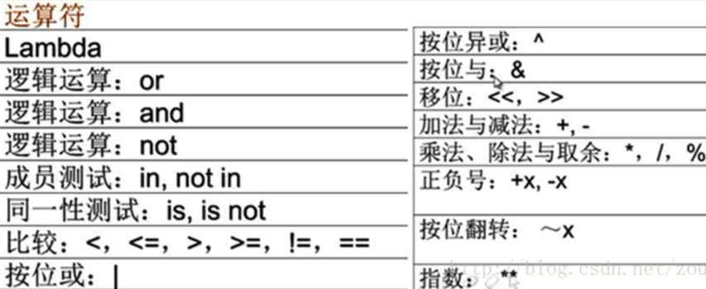

1.1.2 variable scope
I have a python code ,i need to get its value outside the for loop and if statements and use the variable further:
My code:
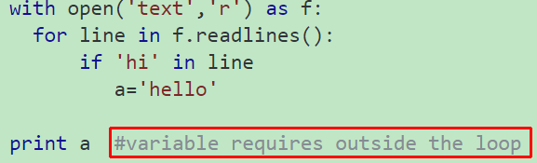
But i get Nameerror: 'a' is not defined

The error message means you never assigned to a (i.e. the if condition never evaluated to True).
To handle this more gracefully, you should assign a default value to a before the loop:

a = None
with open('test', 'r') as f:
...
You can then check if it's None after the loop:

if a is not None:
...

Heres the python code im having problems with:

for i in range (0,10):
if i==5:
i+=3
print i
I expected the output to be:  0 1 2 3 4 8 9 | however the interpreter spits out:  0 1 2 3 4 8 6 7 8 9

The for loop iterates over all the numbers in range(10), that is, [0,1,2,3,4,5,6,7,8,9].
That you change the current value of i has no effect on the next value in the range.
You can get the desired behavior with a while loop.

i = 0
while i < 10:
# do stuff and manipulate `i` as much as you like
if i==5:
i+=3

print i

# don't forget to increment `i` manually
i += 1

1.1.2 global
You can use a global variable in other functions by declaring it as global in each function that assigns to it:

globvar = 0

def set_globvar_to_one():
global globvar # Needed to modify global copy of globvar
globvar = 1

def print_globvar():
print(globvar) # No need for global declaration to read value of globvar

set_globvar_to_one()
print_globvar() # Prints 1
I imagine the reason for it is that, since global variables are so dangerous, Python wants to make sure that you really know that's what you're playing with by explicitly requiring the global keyword.

See other answers if you want to share a global variable across modules.

1.2 data type

1.2.1 numerical
通常的int, long,float,long等等都被支持。而且会看你的具体数字来定义变量的类型。
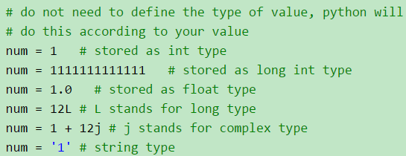

1.2.2 string
单引号，双引号和三引号都可以用来定义字符串。三引号可以定义特别格式的字符串。字符串作为一种序列类型，支持像Matlab一样的索引访问和切片访问。
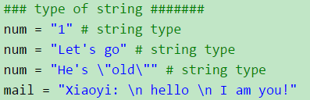
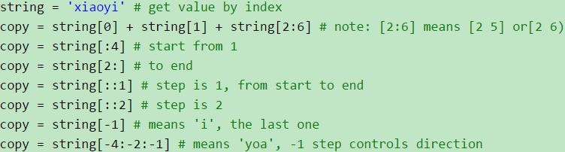
s为字符串
s.isalnum() 所有字符都是数字或者字母 s.isalpha() 所有字符都是字母
s.isdigit() 所有字符都是数字 s.islower() 所有字符都是小写
s.isupper() 所有字符都是大写 s.istitle() 所有单词都是首字母大写，像标题
s.isspace() 所有字符都是空白字符、 、、

判断是整数还是浮点数 a=123 b=123.123
isinstance(a,int) True | isinstance(b,float) True | isinstance(b,int) False
How to trim whitespace (including tabs)?
Whitespace on both sides:
s = " \t a string example\t "
s = s.strip()

Whitespace on the right side: >>>> s = s.rstrip()
Whitespace on the left side: >>>>>> s = s.lstrip()

As thedz points out, you can provide an argument to strip arbitrary characters to any of these functions like this:
s = s.strip(' \t\n\r')

tabs = " abcde fgh ijkl"
>>> print tabs.replace(" ", "")
abcdefghijkl

#how to trim a multi line string or a file
s=""" line one
\tline two\t
line three """

#line1 starts with a space, #2 starts and ends with a tab, #3 ends with a space.
s1=s.splitlines()
print s1
[' line one', '\tline two\t', 'line three ']

print [i.strip() for i in s1]
['line one', 'line two', 'line three']

def str_split():
s = 'python_worker_name&topSid_111_appid_111&topSid_222_appid_222'
print s[0:s.find('&')]
print s.split('&')
print s.split('&')[1:]
python_worker_name
['python_worker_name', 'topSid_111_appid_111', 'topSid_222_appid_222']
['topSid_111_appid_111', 'topSid_222_appid_222']

>>> x = 'Pear.good'
>>> y = x.replace('.good','')
>>> y
'Pear'
>>> x
'Pear.good'
.replace doesn't change the string, it returns a copy of the string with the replacement. You can't change the string directly because strings are immutable.

set1={'Apple.good','Orange.good','Pear.bad','Pear.good','Banana.bad','Potato.bad'}

Strings are immutable. string.replace creates a new string. This is stated in the documentation:

Return a copy of string s with all occurrences of substring old replaced by new. ...
new_set = {x.replace('.good', '').replace('.bad', '') for x in set1}

url = 'bear fish.com'
if url.endswith('.com'):
url = url[:-4]
print url
bear fish

1.2.3 tuple
元组tuple用()来定义。相当于一个可以存储不同类型数据的一个数组。可以用索引来访问，但需要注意的一点是，里面的元素不能被修改。
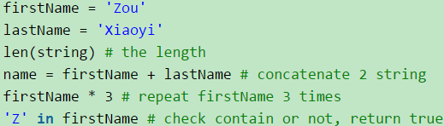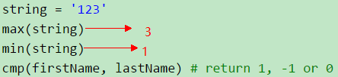
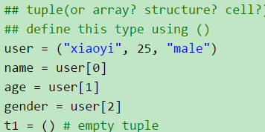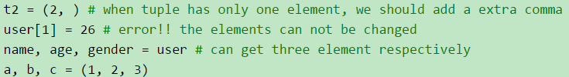
def leftShift(tup, n): #this method not so pythonic
length = len(tup)
if length != 0:
n = n % length
else:
return tuple()
return tup[n:] + tup[0:n]
def tuple_shift_left(tup, n):  if not tup or not n:  return tup  n %= len(tup)  return tup[n:] + tup[:n] | print tuple_shift_left(tp, 1)  # (2, 3, 4, 1)  print tuple_shift_left(tp, 5)  # (2, 3, 4, 1)

1.2.4 list
列表list用[]来定义。它和元组的功能一样，不同的一点是，里面的元素可以修改。List是一个类，支持很多该类定义的方法，这些方法可以用来对list进行操作。
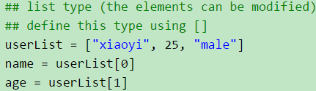
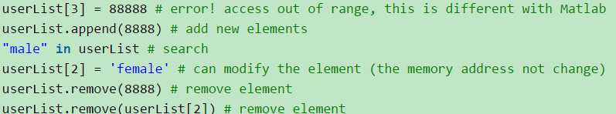
len(userList) #输出长度
Create an empty list in python with certain size
l = [None] * 3
>>> [None, None, None]
>>> def display():
return [x**2 for x in range(9)]

>>> print display()
[0, 1, 4, 9, 16, 25, 36, 49, 64]
print [None for a in xrange(3)]  >>> [None, None, None] | print range(5)  >>> [0, 1, 2, 3, 4]

Works well for non-reference types like numbers. Unfortunately if you want to create a list-of-lists you will run into referencing errors. Example in Python 2.7.6:
>>> a = [[]]*10
>>> a
[[], [], [], [], [], [], [], [], [], []]
>>> a[0].append(0)
>>> a
[[0], [0], [0], [0], [0], [0], [0], [0], [0], [0]]
As you can see, each element is pointing to the same list object. To get around this, you can create a method that will initialize each position to a different object reference.
def init_list_of_objects(size):
list_of_objects = list()
for i in range(0,size):
list_of_objects.append( list() ) #different object reference each time
return list_of_objects
>>> a = init_list_of_objects(10)
>>> a
[[], [], [], [], [], [], [], [], [], []]
>>> a[0].append(0)
>>> a
[[0], [], [], [], [], [], [], [], [], []]
There is likely a default, built-in python way of doing this (instead of writing a function), but I'm not sure what it is. Would be happy to be corrected!

def create_list_repeated_n_times():
# generate list with 10 0
lst_i = [0 for i in xrange(10)]
print lst_i
# [0, 0, 0, 0, 0, 0, 0, 0, 0, 0]
lst_i_2 = [0] * 3
print lst_i_2
# [0, 0, 0]
lst_d = [lst_i_2] * 3
print lst_d
# [[0, 0, 0], [0, 0, 0], [0, 0, 0]]
lst_d[0].append(0)
print lst_d
# [[0, 0, 0, 0], [0, 0, 0, 0], [0, 0, 0, 0]]

bl = [2, 3, 4]
print [recursion(a) for a in bl]
>>>[2, 6, 24]
lst = [1, 2, 3, 4]  n = 2  print lst[n:] + lst[:n]  # [3, 4, 1, 2] | n = 1  print lst[n:] + lst[:n]  # [2, 3, 4, 1] | lst = [1, 2, 3, 4]  lst.append(lst.pop(0))  print lst  # [2, 3, 4, 1]
range(stop) -> list of integers
range(start, stop[, step]) -> list of integers
Return a list containing an arithmetic progression of integers.
range(i, j) returns [i, i+1, i+2, ..., j-1]; start (!) defaults to 0.
When step is given, it specifies the increment (or decrement).
For example, range(4) returns [0, 1, 2, 3]. The end point is omitted!
These are exactly the valid indices for a list of 4 elements.

You can also use this syntax (L[start:stop:step]):
mylist = [1,2,3,4,5,6,7,8,9,10]  for i in mylist[::2]:  print i,  # prints 1 3 5 7 9 | for i in mylist[1::2]:  print i,  # prints 2 4 6 8 10

for i in lst[1::2]:  print i  # 2 4 6 8 10 | lst = [1, 2, 3, 4, 5, 6]  print lst[::-1]  # [6, 5, 4, 3, 2, 1] | print lst[::-2]  # [6, 4, 2]
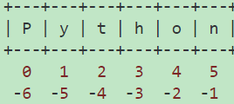
lst[start:stop:step]
is step is minus, firstly we reverse the lst and then get the lst by step

lst = [1, 2, 3, 4, 5, 6, 7]  # =======================  # [1, 2, 3, 4, 5, 6, 7]  # 0 1 2 3 4 5 6  # -7 -6 -5 -4 -3 -2 -1  print lst[-7:-1]  # [1, 2, 3, 4, 5, 6]  print lst[-7:0]  # []  print lst[-7:]  # [1, 2, 3, 4, 5, 6, 7]  print lst[-5:-2]  # [3, 4, 5] | print lst[:-1]  # [1, 2, 3, 4, 5, 6]  print lst[:-3]  # [1, 2, 3, 4]  print lst[:-3:-1]  # [7, 6]  print lst[:-3:1]  # [1, 2, 3, 4]  print lst[:3:-1]  # [7, 6, 5]  print lst[:-1:-1]  # []  print lst[:-2:-1]  # [7]
[a:b:c]
len = length of string, tuple or list
c -- default is +1. The sign of c indicates forward or backward, absolute value of c indicates steps. Default is forward with step size 1. Positive means forward, negative means backward.
a -- When c is positive or blank, default is 0. When c is negative, default is -1.
b -- When c is positive or blank, default is len. When c is negative, default is -(len+1).

def clear_lst():
# method to clear a list
a = [1, 2, 3]
b = a
a = []
print a # []
print b # [1, 2, 3]
a = [1, 2, 3]
b = a
del a[:] # equivalent to del a[0:len(a)]
print a # []
print b # []

def eu_distance():
a1 = [1, 2, 3]
a2 = [3, 4, 5]
from math import sqrt
print sqrt(sum((a - b)**2 for a, b in zip(a1, a2)))
# 3.46410161514

def lst_tuple_column():
lst_tp = [('33', 1), ('88', 2), ('22', 3), ('44', 4)]
# 2 column
print [x[1] for x in lst_tp]
# [1, 2, 3, 4]
print sum(x[1] for x in lst_tp)
# 10
from operator import itemgetter
print map(itemgetter(1), lst_tp)
# [1, 2, 3, 4]
print map(lambda x: x[1], lst_tp)
# [1, 2, 3, 4]
print dict(lst_tp).keys()
# ['33', '88', '44', '22']
print dict(lst_tp).values()
# [1, 2, 4, 3]

How can I count the occurrences of a list item in Python?

def lst_counter():
print [1, 2, 3, 4, 1, 4, 1].count(1)
# 3
from collections import Counter
z = ['blue', 'red', 'blue', 'yellow', 'blue', 'red']
print Counter(z)
# Counter({'blue': 3, 'red': 2, 'yellow': 1})
lst = ["a", "b", "b"]
print [[x, lst.count(x)] for x in set(lst)]
# [['a', 1], ['b', 2]]
print dict((x, lst.count(x)) for x in set(lst))
# {'a': 1, 'b': 2}
print dict((i, lst.count(i)) for i in lst)
# {'a': 1, 'b': 2}

def get_max_val_idx():
lst = [1, 7, 3, 5, 6]
max_val = max(lst)
print max_val
# 7
max_idx = lst.index(max_val)
print max_idx
# 1
import operator
index, value = max(enumerate(lst), key=operator.itemgetter(1))
print index, value
# 1 7

def get_all_idx_of_val():
lst = [1, 2, 1, 3, 1, 4]
val = 1
# print [idx if v == val for idx, v in enumerate(lst)]
print [idx for idx, v in enumerate(lst) if v == val]
# [0, 2, 4]
import numpy as np
arr = np.array(lst)
print np.where(arr==val)
# (array([0, 2, 4], dtype=int64),)
print np.where(arr==val)[0]
# [0 2 4]
sorting, by the difference in two elements of a tuple(根据list tupple 的差来排序)
def max_activity():
s = [1, 3, 0, 5, 3, 5, 6, 8, 8, 2]
e = [4, 5, 6, 7, 4, 6, 9, 10, 11, 5]
tp_lst = zip(s, e)
print tp_lst
# [(1, 4), (3, 5), (0, 6), (5, 7), (3, 4), (5, 6), (6, 9), (8, 10), (8, 11), (2, 5)]
tp_lst.sort(key=lambda t: t[1] - t[0])
print tp_lst
# [(3, 4), (5, 6), (3, 5), (5, 7), (8, 10), (1, 4), (6, 9), (8, 11), (2, 5), (0, 6)]
lst = sorted(zip(s, e), key=lambda t: t[1]-t[0])
print lst
# [(3, 4), (5, 6), (3, 5), (5, 7), (8, 10), (1, 4), (6, 9), (8, 11), (2, 5), (0, 6)]
print sorted(zip(s, e), key=lambda t: t[1]-t[0], reverse=True)
# [(0, 6), (1, 4), (6, 9), (8, 11), (2, 5), (3, 5), (5, 7), (8, 10), (3, 4), (5, 6)]

def test_print():
tp_lst = [(0, 1), (2, 3), (4, 5)]
for item in tp_lst: print item
print "->".join([str(item) for item in tp_lst])
# (0, 1)->(2, 3)->(4, 5)

遍历list删除元素
def remove_item_while_iter():
lst = [1, 1, 0, 2, 0, 0, 8, 3, 0]
print filter(lambda x: x != 0, lst)//实际上是复制新的list
# [1, 1, 2, 8, 3]
print [x for x in lst if x != 0]
# [1, 1, 2, 8, 3]
for item in lst[:]://每次复制新的list
if item == 0:
lst.remove(item)
print lst
# [1, 1, 2, 8, 3]
lst = [1, 1, 0, 2, 0, 0, 8, 3, 0]
while 0 in lst:
lst.remove(0)
print lst
# [1, 1, 2, 8, 3]

def test_print():
tp_lst = [(0, 1), (2, 3), (4, 5)]
for item in tp_lst: print item
print "->".join([str(item) for item in tp_lst])
# (0, 1)->(2, 3)->(4, 5)
# 输出list中打一个大于指定值(例如0.7)的index
def test_find_cond():
lst = [0.5, 0.3, 0.9, 0.8]
print filter(lambda x: x[1] > .7, enumerate(lst))
# [(2, 0.9), (3, 0.8)]
print next(x[0] for x in enumerate(lst) if x[1] > 0.7)
# 2
print [n for n, i in enumerate(lst) if i > 0.7][0]
# 2

tuple list sum:
def test_lst_sum():
lst = [1, 3, 5]
print sum(lst) # 9
print sum(lst[1:]) # 8
print sum(lst[5:]) # 0
print sum(lst[5:-1]) # 0
print sum(lst[1: -1]) # 3
lst_tp = [('33', 1), ('88', 2), ('22', 3), ('44', 4)]
print sum(x[1] for x in lst_tp[1:]) # 9

# =======================
# [1, 2, 3, 4, 5, 6, 7]
# 0 1 2 3 4 5 6
# -7 -6 -5 -4 -3 -2 -1

print lst[:-3:-1]
# [7, 6]
print lst[:-3:1]
# [1, 2, 3, 4]
# is step is minus, firstly we reverse the lst and then get the lst by step
print lst[:3:-1]
# [7, 6, 5]

def lst_idx_reverse():
lst = [3, 4, 2, 1]
print lst[1:]
# [4, 2, 1]
print lst[1: 4]
# [4, 2, 1]
print lst[1: 4: -1]
# [] not [1, 2, 4]
print lst[1: 4][::-1]
# [1, 2, 4]
print lst[3: 0: -1]
# [1, 2, 4]
print lst[2: 0: -1]
# [1, 2, 4]

1.2.4 set
Sets are constructed from a sequence (or some other iterable object). Since sets cannot have duplicated, there are usually used to build sequence of unique items (e.g., set of identifiers).

def define_set():
"""2 ways of defining set"""
set_1 = set([1, 2, 3])
print type(set_1)
print set_1
set_2 = {2, 3, 2}
print type(set_2)
# <type 'set'>
print set_2
# set([2, 3])

a = set((1, 2, 3, 4))
b = set([3, 4, 5, 6])
print a | b # Union
# {1, 2, 3, 4, 5, 6}
print a & b # Intersection
# {3, 4}
print a < b # Subset
# False
print a - b # Difference
# {1, 2}
print a ^ b # Symmetric Difference
# {1, 2, 5, 6}

def set_lst():
s1 = {1, 2, 3}
lst_1 = []
# set to list
lst_1 += s1

def dict_key_to_set():
d = {'111': 1, 'aaa': 111}
s1 = set(d.keys())
print s1
# set(['111', 'aaa'])

def set_diff():
s1 = {1, 3}
s2 = {1, 2, 4}
print s1 - s2
print s1.difference(s2)
# set([3])

1.2.5 dict
字典dictionary用{}来定义。它的优点是定义像key-value这种键值对的结构，就像struct结构体的功能一样。它也支持字典类支持的方法进行创建和操作。
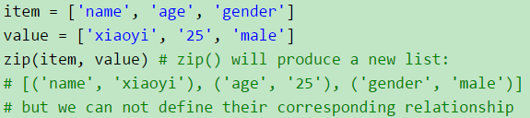
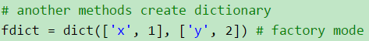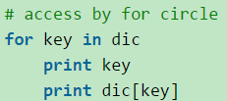

def iter_dict_remove():
"""remove item in dict while iteration it"""
d_info = {'aa': -1, 'bb': 0, 'cc': 1, 'dd': 2}
for k, v in d_info.items():
print k, v
if v < 0:
del d_info[k]
print 'after del'
for key in d_info.iterkeys():
print key, d_info[key]
if __name__ == '__main__':
iter_dict_remove()
s_lst={}
s_lst['worker_1'] = [1, 2, 3]
s_lst['worker_2'] = [1, 2, 3]
s_lst['worker_2'] = [1, 2, 3]
print s_lst

aa -1
cc 1
dd 2
bb 0
after del
cc 1
dd 2
bb 0
{'worker_2': [1, 2, 3], 'worker_1': [1, 2, 3]}

iteration dict sorted by key

def iter_dic_sort():
d_info = {'33': 33, '88': 88, '22': 22, '44': 44}
for k in sorted(d_info):
print k, d_info[k]
22 22
33 33
44 44
88 88

How to sort a dictionary by value?
def dict_sort_by_value():
dic_num = {'first': 11, 'second': 2, 'third': 33, 'Fourth': 4}
# print all the keys
print dic_num.keys()
print list(dic_num)
# ['second', 'Fourth', 'third', 'first']
# print all the sorted keys
print sorted(dic_num)
# ['Fourth', 'first', 'second', 'third']
print sorted(dic_num, key=str.lower)
# ['first', 'Fourth', 'second', 'third']
# print sorted values
print sorted(dic_num.values())
# [2, 4, 11, 33]
# sorted by value
sorted_val = sorted(dic_num.items(), key=operator.itemgetter(1))
# [('second', 2), ('Fourth', 4), ('first', 11), ('third', 33)]
print sorted_val
# sorted by key
sorted_key = sorted(dic_num.items(), key=operator.itemgetter(0))
print sorted_key
# [('Fourth', 4), ('first', 11), ('second', 2), ('third', 33)]

def sum_dic_val():
d_info = {'33': 1, '88': 2, '22': 3, '44': 4}
print sum(d_info.values())
# 10

def dict_pop():
dic_k_lst = {'11': {1, 2}, 'ab': [3], 'cd': [0, -1, 2]}
s1 = dic_k_lst['11']
print s1
# set([1, 2])
# del dic_k_lst['11']
dic_k_lst.pop('11')
print s1
# set([1, 2])
print dic_k_lst
# {'ab': [3], 'cd': [0, -1, 2]}

def dic_probability():
p = {1: {1: 0.1, 2: 0.3}, 2: {1: 0.1, 2: 0.3}}
# {1: {1: 0.1, 2: 0.3}, 2: {1: 0.1, 2: 0.3}}
print p[2], p[2][2]
# {1: 0.1, 2: 0.3} 0.3

1.3 control flow

1.3.1 if-else
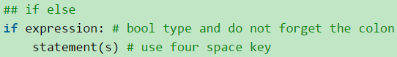
b = 0
b = None
# if b is not zero not None(like -1, 1) it will print
if b:
print '%s not zero not None' % b

1.3.2 for
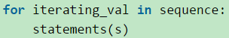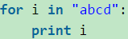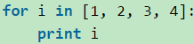
print range(5) →→→→ [0, 1, 2, 3, 4]
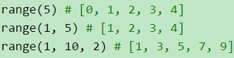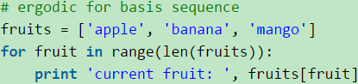
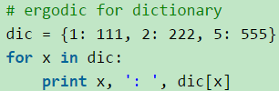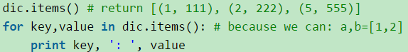
x = [2, 3, 4] y = [4, 5]
z = [v + w for v in x for w in y] #[6, 7, 7, 8, 8, 9]
s = '1234567890'
print [s[k: k+3] for k in range(0, len(s), 3)] #['123', '456', '789', '0']

1.3.3 while
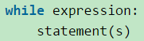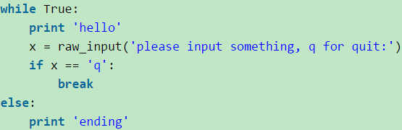

1.3.3 emulate do while
def shell_sort(seq):
LEN = len(seq)

jump = LEN # step
condition = True

while condition:
jump = (jump - 1) / 2 + 1
for i in xrange(jump, LEN):
j = i
while j >= jump and seq[j - jump] > seq[j]:
seq[j - jump], seq[j] = seq[j], seq[j - jump]
j -= jump
# emulate do while
condition = True if jump > 1 else False

Here's a very simple way to emulate a do-while loop:
condition = True
while condition:
# loop body here
condition = test_loop_condition()
# end of loop

1.3.4 switch
其实Python并没有提供switch结构，但我们可以通过字典和函数轻松的进行构造。
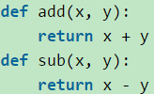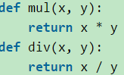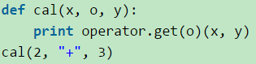
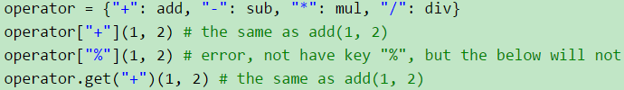

1.3.4 a ? b:c ternary operator
a, b = 1, 2  print True if a > b else False  >>>False | if conditionX:  print('yes')  else:  print('nah')
a, b = 1, 2  print True if a > b else False  >>>False | print('yes') if conditionX else print('nah')

Conditional expressions (sometimes called a “ternary operator”) have the lowest priority of all Python operations.
The expression x if C else y first evaluates the condition, C (not x); if C is true, x is evaluated and its value is returned; otherwise, y is evaluated and its value is returned.

1.4 except

1.4.1
Catch multiple exceptions in one line (except block)
An except clause may name multiple exceptions as a parenthesized tuple, for example

except (IDontLikeYouException, YouAreBeingMeanException) as e:
pass

Separating the exception from the variable with a comma will still work in Python 2.6 and 2.7, but is now deprecated and does not work in Python 3; now you should be using as.

If you frequently use a large number of exceptions, you can pre-define a tuple, so you don't have to re-type them many times.

#This example code is a technique I use in a library that connects with websites to gather data

ConnectErrs = (URLError, SSLError, SocketTimeoutError, BadStatusLine, ConnectionResetError)

def connect(url, data):
#do connection and return some data
return(received_data)

def some_function(var_a, var_b, ...):
try: o = connect(url, data)
except ConnectErrs as e:

1.4 function

1.4.1 define a function
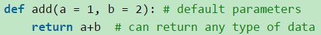
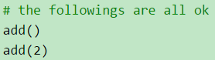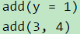
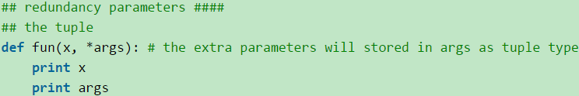
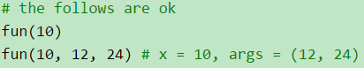
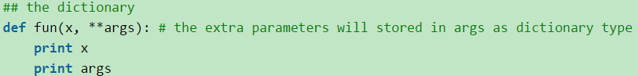
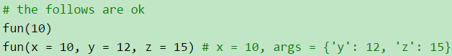
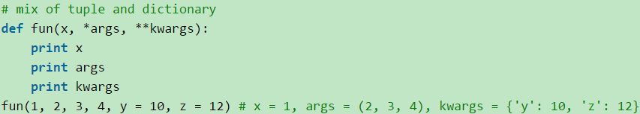
def fdict(**kwargs):
print kwargs
a, b = '1', '2'  fdict(a, b) | fdict(a = 1, b = 2)
File "E:/python_code/find-books/sin/arctan.py", line 58, in <module>  fdict(a, b)  TypeError: fdict() takes exactly 0 arguments (2 given) | =>{'a': 1, 'b': 2}  fdict()  =>{}

1.4.2 pass kwargs/xargs
You can use **kwargs to let your functions take an arbitrary number of keyword arguments ("kwargs" means "keyword arguments")
def print_keyword_args(**kwargs):
# kwargs is a dict of the keyword args passed to the function
for key, value in kwargs.iteritems():
print "%s = %s" % (key, value)
def test_print_keyword_args():
print_keyword_args(first_name="John", last_name="Doe")
# first_name = John
# last_name = Doe
dic_args = {'first_name': 'Bobby', 'last_name': 'Smith'}
# print_keyword_args(dic_args)
# TypeError: print_keyword_args() takes exactly 0 arguments (1 given)
print_keyword_args(**dic_args)
# first_name = Bobby
# last_name = Smith

func(a=1, b=2, c=3) is the same as args = {'a': 1, 'b': 2, 'c':3} func(**args)

def print_everything(*args):
for count, thing in enumerate(args):
print '{0} -> {1}'.format(count, thing)
def test_print_everything():
print_everything('apple', 'banana', 'cabbage')
# 0->apple
# 1->banana
# 2->cabbage

def func(required_arg, *args, **kwargs):
# required_arg is a positional-only parameter.
print required_arg
# args is a tuple of positional arguments,
# because the parameter name has * prepended.
if args: # If args is not empty.
print args
# kwargs is a dictionary of keyword arguments,
# because the parameter name has ** prepended.
if kwargs: # If kwargs is not empty.
print kwargs
def test_func():
func("required argument")
# required argument
func("required argument", 1, 2, '3')
# required argument
# (1, 2, '3')
func("required argument", 1, 2, '3', keyword1=4, keyword2="foo")
# required argument
# (1, 2, '3')
# {'keyword2': 'foo', 'keyword1': 4}
# func()
# TypeError: func() takes at least 1 argument (0 given)

1.4.2 kwargs default value
kwargs returns a dictionary, but what is the best way to set default values, or is there one? Should I just access it as a dictionary? Use get function?
# kwargs default value
class ExampleClass:
def __init__(self, **kwargs):
self.val = kwargs['val']
self.val2 = kwargs.get('val2')
self.val3 = kwargs.get('val3', 'default_val3')
self.val4 = kwargs.pop('val4', 'default_val4')
A simple question, but one that I can't find good resources on. People do it different ways in code that I've seen and it's hard to know what to use.

You can pass a default value to get() for keys that are not in the dictionary:

self.val2 = kwargs.get('val2',"default value")
However, if you plan on using a particular argument with a particular default value, why not use named arguments in the first place?

def __init__(self, val2="default value", **kwargs):

def default_kwargs(**kwargs):
options = {
'option1': 'default_value1',
'option2': 'default_value2',
'option3': 'default_value3', }
options.update(kwargs)
print options
def test_default_kwargs():
default_kwargs()
# {'option2': 'default_value2', 'option3': 'default_value3', 'option1': 'default_value1'}
default_kwargs(option1='new_value1', option3='new_value3')
# {'option2': 'default_value2', 'option3': 'new_value3', 'option1': 'new_value1'}

1.4.2 function in function
def heap_sort(seq):
def fun_in():
print '123'
fun_in()

1.4.2 Lambda expression
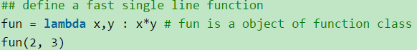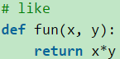
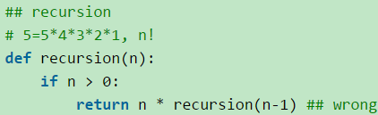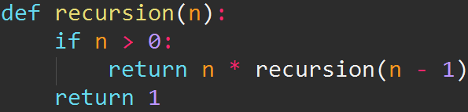
print recursion(5)
TypeError: unsupported operand type(s) for *: 'int' and 'NoneType'（改成右边的就OK）
def mul(x, y):
return x * y
numList = range(1, 5)
reduce(mul, numList) # 5! = 120
reduce(lambda x,y : x*y, numList) # 5! = 120, the advantage of lambda function avoid defining a function
numList = [1, 2, 6, 7]
print filter(lambda x : x % 2 == 0, numList) #[2, 6]
print [x for x in numList if x % 2 == 0] # the same as above
map(lambda x : x * 2 + 10, numList)
print [x * 2 + 10 for x in numList] # the same as above

1.4.3 built-in function like range
- isinstance # test type
- numList = [1, 2]
- if type(numList) == type([]):
- print "It is a list"
- if isinstance(numList, list): # the same as above, return true
- print "It is a list"
- for i in range(1, 10001) # will create a 10000 list, and cost memory
- for i in xrange(1, 10001)# do not create such a list, no memory is cost
- ## some basic functions about string
- str = 'hello world'
- str.capitalize() # 'Hello World', first letter transfer to big
- str.replace("hello", "good") # 'good world'
- ip = "192.168.1.123"
- ip.split('.') # return ['192', '168', '1', '123']
- help(str.split)
- import string
- str = 'hello world'
- string.replace(str, "hello", "good") # 'good world'

- ## some basic functions about sequence
- len, max, min
- # filter(function or none, sequence)
- def fun(x):
- if x > 5:
- return True
- numList = [1, 2, 6, 7]
- filter(fun, numList) # get [6, 7], if fun return True, retain the element, otherwise delete it
- filter(lambda x : x % 2 == 0, numList)
- # zip()
- name = ["me", "you"]
- age = [25, 26]
- tel = ["123", "234"]
- zip(name, age, tel) # return a list: [('me', 25, '123'), ('you', 26, '234')]
- # map()
- map(None, name, age, tel) # also return a list: [('me', 25, '123'), ('you', 26, '234')]
- test = ["hello1", "hello2", "hello3"]
- zip(name, age, tel, test) # return [('me', 25, '123', 'hello1'), ('you', 26, '234', 'hello2')]
- n = [i for i in xrange(20)]
- print [n[k: k + 5] for k in xrange(0, 20, 5)]
- >[[0, 1, 2, 3, 4], [5, 6, 7, 8, 9], [10, 11, 12, 13, 14], [15, 16, 17, 18, 19]]

1.4.3 if __name__ == ‘__main__’
if __name__ == '__main__':

一开始也没弄懂，这句话是什么意思。在StackOverflow中找到了答案。

大致翻一下：
当Python解释器，读py文件,它会执行它发现的所有代码。在执行代码之前，它会定义一些变量。例如，如果这个py文件就是主程序，它会设置__name__变量为"__main__"。如果这个py被引入到别的模块，__name__会被设置为该模块的名字。
举个栗子： 创建一个test.py文件：

if __name__ == '__main__':
print '自己主动执行'
else:
print '我被别的模块引入'

执行下$ python test.py会输出自己主动执行
直接在命令行中输入python随后输入import test，会输出：我被别的模块引入。

1.4.3 map/filter/reduce....
def to_upper(item):
return item.upper()
def map_demo():
name_lst = ['xy', 'bear fish', 'jay']
name_len = map(len, name_lst)
print name_len
# [2, 9, 3]
name_upper = map(to_upper, name_lst)
print name_upper
# ['XY', 'BEAR FISH', 'JAY']
a = [1, 2, 3, 4]
b = [17, 12, 11, 10]
c = [-1, -4, 5, 9]
print map(lambda x, y: x + y, a, b)
# [18, 14, 14, 14]
print map(lambda x, y, z: x + y + z, a, b, c)
# [17, 10, 19, 23]

squares = map(lambda x:x * x, range(4))
print squares
# [0, 1, 4, 9]

((((1+2)+3)+4)+5) ）
def reduce_demo():
lst = range(1, 6)
print lst # [1, 2, 3, 4, 5]
sum = reduce(lambda x, y: x + y, lst)
print sum # 15

def filter_demo():
lst = range(0, 11)
odd_lst = filter(lambda x: x % 2, lst)
print odd_lst # [1, 3, 5, 7, 9]
average = reduce(lambda x, y: x + y, odd_lst) / len(odd_lst)
print average # 5

>>> fib = [0,1,1,2,3,5,8,13,21,34,55]
>>> result = filter(lambda x: x % 2, fib)
>>> print result
[1, 1, 3, 5, 13, 21, 55]
>>> result = filter(lambda x: x % 2 == 0, fib)
>>> print result
[0, 2, 8, 34]

The function reduce(func, seq) continually applies the function func() to the sequence seq. It returns a single value.

If seq = [ s1, s2, s3, ... , sn ], calling reduce(func, seq) works like this:

At first the first two elements of seq will be applied to func, i.e. func(s1,s2) The list on which reduce() works looks now like this: [ func(s1, s2), s3, ... , sn ]

In the next step func will be applied on the previous result and the third element of the list, i.e. func(func(s1, s2),s3)
The list looks like this now: [ func(func(s1, s2),s3), ... , sn ]

Continue like this until just one element is left and return this element as the result of reduce()

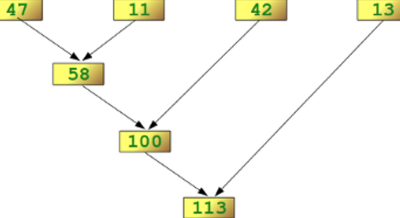

1.4.3 operator
import operator
def cmp_fun():
a, b = 5, 3
print operator.le(a, b)
# False
print operator.gt(a, b)
# True
def lst_ope():
lst = [1, 2, 3]
print operator.indexOf(lst, 2)
# 1
lst1 = [1, 2, 3, 2]
print operator.countOf(lst1, 2)
# 2
def cal_ope():
lst1 = [0, 1, 2, 3]
lst2 = [10, 20, 30, 40]
print map(operator.mul, lst1, lst2)
# [0, 20, 60, 120]
print sum(map(operator.mul, lst1, lst2))
# 200
a, b = 1, 3
print operator.iadd(a, b)
# 4
def item_ope():
s = ['h', 'e', 'l', 'l', 'o']
print operator.getitem(s, 1)
# e
print operator.itemgetter(1, 4)(s)
# ('e', 'o')
inventory = [('apple', 3), ('banana', 2), ('pear', 5), ('orange', 1)]
get_count = operator.itemgetter(1)
print map(get_count, inventory)
# [3, 2, 5, 1]
print sorted(inventory, key=get_count)
# [('orange', 1), ('banana', 2), ('apple', 3), ('pear', 5)]
def reduce_ope():
a = [2, 3, 4, 5]
print reduce(lambda x, y: x + y, a)
# 14
print reduce(operator.add, a)
# 14

1.4.3 functional programe
我们先用一个最简单的例子来说明一下什么是函数式编程。
先看一个非函数式的例子： 函数式的
int cnt;  void increment(){  cnt++;  } | int increment(int cnt){  return cnt+1;  }
你可能会觉得这个例子太普通了。是的，这个例子就是函数式编程的准则：不依赖于外部的数据，而且也不改变外部数据的值，而是返回一个新的值给你。

def inc(x):  def inc_x(y):  return x + y  return inc_x | def test_inc():  inc2 = inc(2)  inc5 = inc(5)  print inc2(5) # 7  print inc5(5) # 10

我们可以看到上面那个例子inc()函数返回了另一个函数incx()，于是我们可以用inc()函数来构造各种版本的inc函数，比如：inc2()和inc5()。这个技术其实就是上面所说的Currying技术。从这个技术上，你可能体会到函数式编程的理念：把函数当成变量来用，关注于描述问题而不是怎么实现，这样可以让代码更易读。

Map & Reduce
在函数式编程中，我们不应该用循环迭代的方式，我们应该用更为高级的方法，如下所示的Python代码
def to_upper(item):
return item.upper()
def map_demo():
name_lst = ['xy', 'bear fish', 'jay']
name_len = map(len, name_lst)
print name_len
# [2, 9, 3]
name_upper = map(to_upper, name_lst)
print name_upper
# ['XY', 'BEAR FISH', 'JAY']
a = [1, 2, 3, 4]
b = [17, 12, 11, 10]
c = [-1, -4, 5, 9]
print map(lambda x, y: x + y, a, b)
# [18, 14, 14, 14]
print map(lambda x, y, z: x + y + z, a, b, c)
# [17, 10, 19, 23]

你可以看到这样的代码很易读，因为，这样的代码是在描述要干什么，而不是怎么干。
下面，我们看看描述实现方法的过程式编程是怎么玩的（看上去是不是不如函数式的清晰？）：
name_up = []
for i in range(len(name_lst)):
name_up.append(name_lst[i].upper())
print name_up
# ['XY', 'BEAR FISH', 'JAY']
对于map我们别忘了lambda表达式：你可以简单地理解为这是一个inline的匿名函数。下面的lambda表达式相当于：def func(x): return x*x
squares = map(lambda x:x * x, range(4))
print squares
# [0, 1, 4, 9]

我们再来看看reduce怎么玩？（下面的lambda表达式中有两个参数，也就是说每次从列表中取两个值，计算结果后把这个值再放回去，下面的表达式相当于：((((1+2)+3)+4)+5) ）
def reduce_demo():
lst = range(1, 6)
print lst # [1, 2, 3, 4, 5]
sum = reduce(lambda x, y: x + y, lst)
print sum # 15

Python中的除了map和reduce外，还有一些别的如filter, find, all, any的函数做辅助（其它函数式的语言也有），可以让你的代码更简洁，更易读。 我们再来看一个比较复杂的例子：计算数组中正数的平均值
def cal_aver():
lst = range(0, 11)
positive_num_cnt = 0
positive_num_sum = 0
for i in range(len(lst)):
if lst[i] > 0:
positive_num_cnt += 1
positive_num_sum += lst[i]
average = 0
if positive_num_cnt > 0:
average = positive_num_sum / positive_num_cnt
print average # 5
如果用函数式编程，这个例子可以写成这样：
def filter_demo():
lst = range(0, 11)
odd_lst = filter(lambda x: x % 2, lst)
print odd_lst # [1, 3, 5, 7, 9]
average = reduce(lambda x, y: x + y, odd_lst) / len(odd_lst)
print average # 5

C++11玩的法：
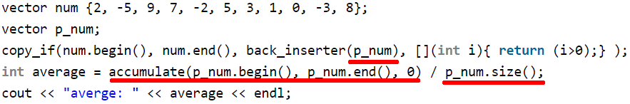
我们可以看到，函数式编程有如下好处：

1）代码更简单了。
2）数据集，操作，返回值都放到了一起。
3）你在读代码的时候，没有了循环体，于是就可以少了些临时变量，以及变量倒来倒去逻辑。
4）你的代码变成了在描述你要干什么，而不是怎么去干。

1.4.3 @ annotation(decorator)
所谓修饰工作就是想给现有的模块加上一些小装饰（一些小功能，这些小功能可能好多模块都会用到），但又不让这个小装饰（小功能）侵入到原有的模块中的代码里去。

Python 的 Decorator在使用上和Java/C#的Annotation很相似，就是在方法名前面加一个@XXX注解来为这个方法装饰一些东西。但是，Java/C#的Annotation也很让人望而却步，太TMD的复杂了，你要玩它，你需要了解一堆Annotation的类库文档，让人感觉就是在学另外一门语言。

而Python使用了一种相对于Decorator Pattern和Annotation来说非常优雅的方法，这种方法不需要你去掌握什么复杂的OO模型或是Annotation的各种类库规定，完全就是语言层面的玩法：一种函数式编程的技巧。
def hello(fn):
def wrapper():
print "hello, %s" % fn.__name__
fn()
print 'bye, %s' % fn.__name__
return wrapper

@hello
def foo():
print 'I am foo'
# hello, foo
# I am foo
# bye, foo
示例2：fn没有被执行
def do_nothing(fn):  def wrapper():  print 'do not exe fn'  return wrapper | @do_nothing  def foo_nothing():  print 'I am foo_nothing'  # do not exe fn

你可以看到如下的东西：
1）函数foo前面有个@hello的“注解”，hello就是我们前面定义的函数hello
2）在hello函数中，其需要一个fn的参数（这就用来做回调的函数）
3）hello函数中返回了一个inner函数wrapper，这个wrapper函数回调了传进来的fn，并在回调前后加了两条语句。

Decorator 的本质
对于Python的这个@注解语法糖- Syntactic Sugar 来说，当你在用某个@decorator来修饰某个函数func时，如下所示:

@decorator
def func():
pass

其解释器会解释成下面这样的语句： func = decorator(func)
尼玛，这不就是把一个函数当参数传到另一个函数中，然后再回调吗？是的，但是，我们需要注意，那里还有一个赋值语句，把decorator这个函数的返回值赋值回了原来的func。
@hello
def foo():
print "i am foo"
被解释成了： foo = hello(foo)
知道这点本质，当你看到有多个decorator或是带参数的decorator，你也就不会害怕了。
比如：多个decorator
@decorator_one
@decorator_two
def func():
pass

相当于：
func = decorator_one(decorator_two(func))

比如：带参数的decorator：
@decorator(arg1, arg2)
def func():
pass
func = decorator(arg1,arg2)(func)
@do_nothing
@hello
def foo_nested():
print 'I am foo_nested'
输出: do not exe fn

@hello
@do_nothing
def foo_nested_v2():
print 'I am foo_nested_v2'
hello, wrapper
do not exe fn
bye, wrapper

1.5 deep/shallow copy
- ##############################
- ### memory operation
- ## 浅拷贝：对引用对象的拷贝（只拷贝父对象）
- ## 深拷贝：对对象资源的拷贝

- a = [1, 2, 3]
- b = a # id(a) == id (b), 同一个标签，相当于引用
- a.append(4) # a = [1, 2, 3, 4], and b also change to = [1, 2, 3, 4]

- import copy
- a = [1, 2, ['a', 'b']] # 二元列表
- c = copy.copy(a) # id(c) != id(a)
- a.append('d') # a = [1, 2, ['a', 'b'], 'd'] but c keeps not changed
- # 但只属于浅拷贝，只拷贝父对象
- # 所以 id(a[0]) == id(c[0])，也就是说对a追加的元素不影响c，
- # 但修改a被拷贝的数据后，c的对应数据也会改变，因为拷贝不会改变元素的地址
- a[2].append('d') # will change c, too
- a[1] = 3 # will change c, too
- # 深拷贝
- d = copy.deepcopy(a) # 全部拷贝，至此恩断义绝，两者各走
- # 各的阳关道和独木桥，以后毫无瓜葛

1.6 dir file path and import question
1读取文件中所有的文件名
print os.listdir(IMG_DIR) #['1.jpg', '2.jpg']

import glob
print glob.glob("/home/adam/*.txt")

If you want just files, you could either filter this down using os.path:
from os import listdir
from os.path import isfile, join
onlyfiles = [f for f in listdir(mypath) if isfile(join(mypath, f))]
If you'd like, you can open and read the contents, or focus only on files with the extension ".dat" like in the code below:
for f in full_file_paths:
if f.endswith(".dat"):
print f

- 目录不存在则创建目录
# Create a directory and any missing ancestor directories.
# If the directory already exists, do nothing.
from distutils.dir_util import mkpath
mkpath("test")
Try the os.path.exists function
if not os.path.exists(dir):
os.mkdir(dir)
I would personally recommend that you use os.path.isdir() to test instead of os.path.exists().
>>> os.path.exists('/tmp/dirname')
True
>>> os.path.exists('/tmp/dirname/filename.etc')
True
>>> os.path.isdir('/tmp/dirname/filename.etc')
False
>>> os.path.isdir('/tmp/fakedirname')
False

1.6.2 read txt file(like nth row)
In Python 2.6 or later:  with open("file") as fp:  for i, line in enumerate(fp):  if i == 25:  # 26th line  elif i == 29:  # 30th line  elif i > 29:  break | f=open('filename')  lines=f.readlines()  print lines[25]  print lines[29]  or:  lines=[25, 29]  i=0  f=open('filename')  for line in f:  if i in lines:  print i  i+=1
A fast and compact approach could be:

def picklines(thefile, whatlines):
return [x for i, x in enumerate(thefile) if i in whatlines]

this accepts any open file-like object thefile (leaving up to the caller whether it should be opened from a disk file, or via e.g a socket, or other file-like stream) and a set of zero-based line indices whatlines, and returns a list, with low memory footprint and reasonable speed. If the number of lines to be returned is huge, you might prefer a generator:

def yieldlines(thefile, whatlines):
return (x for i, x in enumerate(thefile) if i in whatlines)
which is basically only good for looping upon -- note that the only difference comes from using rounded rather than square parentheses in the return statement, making a list comprehension and a generator expression respectively.
Further note that despite the mention of "lines" and "file" these functions are much, much more general -- they'll work on any iterable, be it an open file or any other, returning a list (or generator) of items based on their progressive item-numbers. So, I'd suggest using more appropriately general names;-).
import linecache
linecache.getline('Sample.txt', Number_of_Line)

if you want line 7
line = open("file.txt", "r").readlines()[7]

1.6.4 download file from url
for example download mp3 from url:

def download_file(f_name, url):
mp3file = urllib2.urlopen(url)
with open(f_name, 'wb') as output:
output.write(mp3file.read())

The disadvantage of this solution is, that the entire file is loaded into ram before saved to disk, just something to keep in mind if using this for large files on a small system like a router with limited ram

def dw_load_v2(f_name, url):
mp3file = urllib2.urlopen(url)
with open(f_name, 'wb') as output:
while True:
data = mp3file.read(4096)
if data:
output.write(data)
else:
break

1.6.3 absolute relative path
"Current working directory is %s" % os.getcwd()

How do I import a python module given its relative path?
dirFoo\
Foo.py
dirBar\
Bar.py

Foo wishes to include Bar, but restructuring the folder hierarchy is not an option.

1.Be sure that dirBar has the __init__.py file -- this makes a directory into a Python package.
2.import sys
sys.path.append( <path to dirFoo> )
import Bar

3.import os, sys
lib_path = os.path.abspath(os.path.join('..', '..', '..', 'lib'))
sys.path.append(lib_path)

import mymodule

print os.path.join('H', 'work', 'lib')
=>H\work\lib

Given a path such as "mydir/myfile.txt", how do I find the absolute filepath relative to the current working directory in Python?
print os.path.abspath("mydir/myfile.txt")
=>E:\python_code\scrape_yy\utils\mydir\myfile.txt
print os.path.abspath("")  => E:\python_code\scrape_yy\utils | print os.path.abspath("../")  =>E:\python_code\scrape_yy
Strictly taken, a module is a single python file, while a package is a folder containing python files, accompanied by a (can be empty) file named __init__.py, to tell python it is a package to import modules from.
By default, Python looks for its modules and packages in $PYTHONPATH.
To find out what is included in $PYTHONPATH, run the following code in python
import sys
print(sys.path)
>>>>['E:\\python_code\\scrape_yy\\utils', 'E:\\python_code\\scrape_yy', 'D:\\Anaconda2\\python27.zip', 'D:\\Anaconda2\\DLLs', 'D:\\Anaconda2\\lib', 'D:\\Anaconda2\\lib\\plat-win', 'D:\\Anaconda2\\lib\\lib-tk','D:\\Anaconda2\\lib\\.7.egg']

Question
How do you append directories to your Python path?

Answer
Your path (i.e. the list of directories Python goes through to search for modules and files) is stored in the path attribute of the sys module. Since path is a list, you can use the append method to add new directories to the path.
For instance, to add the directory /home/me/mypy to the path, just do:

import sys
sys.path.append("/home/me/mypy")

1.6.3 sys.path import module
项目的目录结构如下所示：问题在于，当我在目录scrape_yy下时倒入不了utils，即无法 import utils .其中utils中有__init__.py文件。
|-- config  |-- log  |-- scrape_yy  | |-- config  | |-- run_config  | |-- spiders  | `-- test  `-- utils | 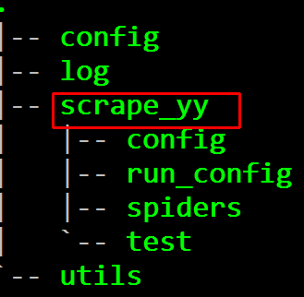
解决一：
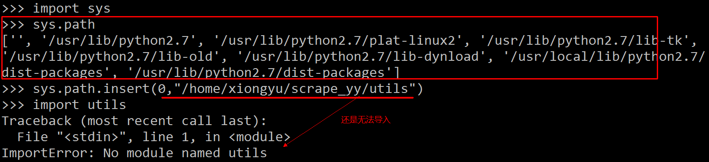
下面这样就可以了sys.path.insert(0,”/home/xiongyu/scrape_yy”) 包的上一层目录
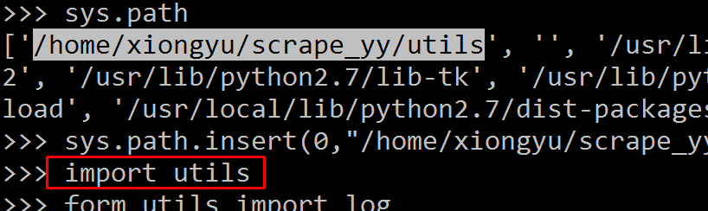
解决二：export PYTHONPATH=$PYTHONPATH:/home/xiongyu/scrape_yy
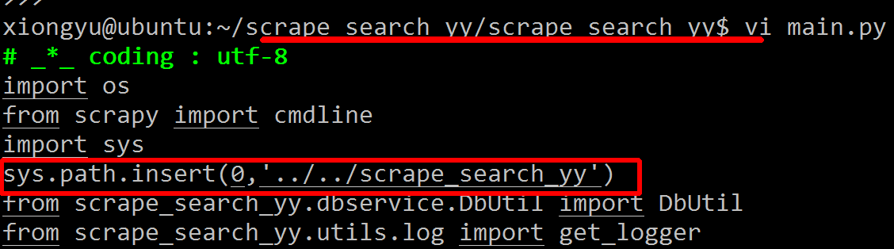
最上面加上项目的最高路径，就没有import问题了

1.6.4 import module problem
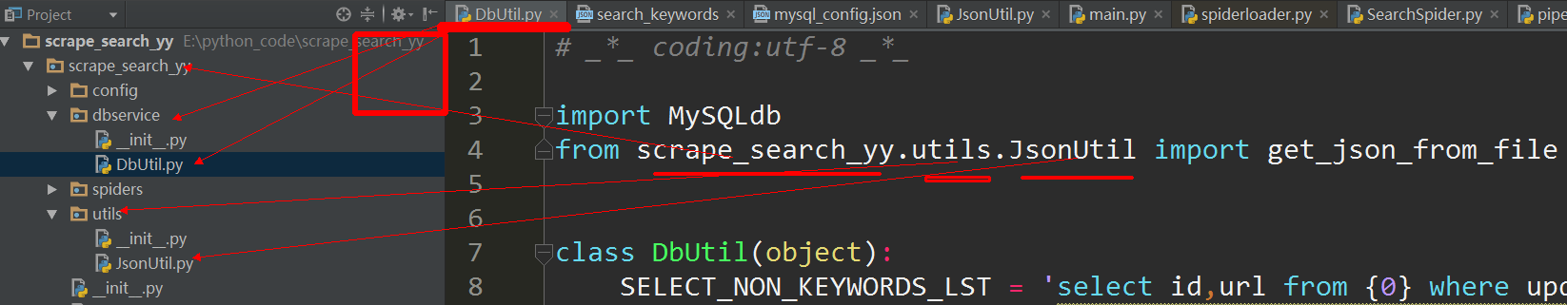

This is solved 100%:
app/
main.py
settings/
local_setings.py

Import settings/local_setting.py in app/main.py:

main.py:

import sys
sys.path.insert(0, "../settings")
try:
from local_settings import *
except ImportError:
print('No Import')

1.7 json
The json library can parse JSON from strings or files. The library parses JSON into a Python dictionary or list. It can also convert Python dictionaries or lists into JSON strings.
json_string = '{"first_name": "Guido", "last_name":"Rossum"}'
parsed_json = json.loads(json_string)
print parsed_json
print json.dumps(parsed_json, indent=2, sort_keys=True)#convert to JSON:
print type(json.dumps(parsed_json)) # 2 json , is really str in python
>{u'first_name': u'Guido', u'last_name': u'Rossum'}
>{
"first_name": "Guido",
"last_name": "Rossum"
}
<type 'str'>

file = '../config/neteasy.json'
with open(file) as json_file_data:
data = json.load(json_file_data)
print type(data)
print data['rank']['url']
print json.dumps(data, indent=4, sort_keys=True)
<type 'dict'>
http://news.163.com/rank/
{
"rank": {
"url": "http://news.163.com/rank/",
"xpath": {
"time": "",
"title": "",
"url": ""
}
},
"size": 1
}

1.7.2 json unicode str
json_string = '{"first_name": "Guido", "last_name":"Rossum"}'
parsed_json = json.loads(json_string)
print parsed_json
print type(parsed_json)
>>>>>>
{u'first_name': u'Guido', u'last_name': u'Rossum'}
<type 'dict'>
可见转化后的json里面的字符串全部是unicode，现在想办法把其全部转化为str

def byteify(input):
if isinstance(input, dict):
return {byteify(key): byteify(value)
for key, value in input.iteritems()}
elif isinstance(input, list):
return [byteify(element) for element in input]
elif isinstance(input, unicode):
return input.encode('utf-8')
else:
return input

print byteify(parsed_json)
{'first_name': 'Guido', 'last_name': 'Rossum'}

方法二：
json_string = '{"first_name": "Guido", "last_name":"Rossum"}'
import yaml
print yaml.safe_load(json_string)
print type(yaml.safe_load(json_string))
>>>>>
{'first_name': 'Guido', 'last_name': 'Rossum'}
<type 'dict'>
http://stackoverflow.com/questions/956867/how-to-get-string-objects-instead-of-unicode-ones-from-json-in-python

1.7.2 json dump to file
js_data = {"0": [], "1": [], "2": []}
for item in lst:
id, value = str(item[0]), item[1]
js_data[id].append(value)

with codecs.open('../config/search_keywords.json', 'w', encoding='utf-8') as fp:
# json.dump(js_data, fp)
fp.write(json.dumps(js_data, indent=4, sort_keys = True, ensure_ascii=False))
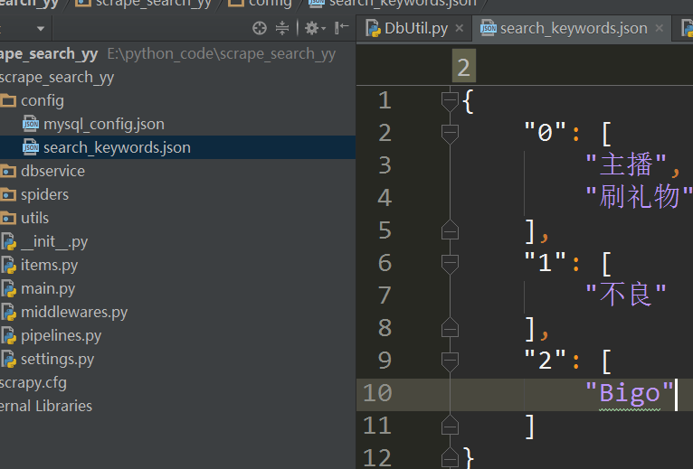
with open('data.txt', 'w') as outfile:
json.dump(jsonData, outfile, sort_keys = True, indent = 4,
ensure_ascii = False)
if we use the method above the json file result is unicode not normal chinese words.

1.7 random
# python random from list
- import random
- foo = ['a', 'b', 'c', 'd', 'e']
- print(random.choice(foo))
foo = ['a', 'b', 'c', 'd', 'e']
from random import randrange
random_index = randrange(0,len(foo))
print foo[random_index]

If you want to randomly select more than one item from a list, or select an item from a set, I'd recommend using random.sample instead.
import random
group_of_items = {1, 2, 3, 4} # a sequence or set will work here.
num_to_select = 2 # set the number to select here.
list_of_random_items = random.sample(group_of_items, num_to_select)
first_random_item = list_of_random_items[0]
second_random_item = list_of_random_items[1]

foo = ['a', 'b', 'c', 'd', 'e']
randomindex = random.randint(0,len(foo)-1)
print (foo[randomindex])

generate random list ,like containing 500 int nums from (0, 79999)
y_lst = random.sample(range(80000), 500)

1.7.1 random.seed
>>> import random  >>> random.seed(9001)  >>> random.randint(1, 10)  1  >>> random.randint(1, 10)  3  >>> random.randint(1, 10)  6  >>> random.randint(1, 10) | >>> random.seed(9001)  >>> random.randint(1, 10)  1  >>> random.seed(9001)  >>> random.randint(1, 10)  1  >>> random.seed(9001)  >>> random.randint(1, 10)  1  >>> random.seed(9002)  >>> random.randint(1, 10)  3

def generate_random_num_str(length):
return ''.join(random.choice(string.letters) for i in range(length))
def get_random_int():
# n -> [0, 10]
n =random.randint(0, 10)
print n
def rand_range():
print random.randrange(1, 100)
# like 23
print random.randrange(0, 100, 10)
# 20
print random.randrange(0, 100, 10)
# 90
def random_seed():
sd = 3
random.seed(sd)
print "Random number with seed 10 : ", random.random()
# It will generate same random number(do random.seed(sd) every time before)
random.seed(sd)
print "Random number with seed 10 : ", random.random()
# It will generate same random number
random.seed(sd)
print "Random number with seed 10 : ", random.random()
if __name__ == '__main__':
# print random.choice(string.letters)
# f
# print generate_random_num_str(5)
# bjSQU

1.7 __init__, __all__
I have been using Python more and more, and I keep seeing the variable __all__ set in different __init__.py files. Can someone explain what this does?
when __all__ is used. It is a list of strings defining what symbols in a module will be exported when from <module> import * is used on the module.

For example, the following code in a foo.py explicitly exports the symbols bar and baz:
__all__ = ['bar', 'baz']
waz = 5
bar = 10
def baz(): return 'baz'
These symbols can then be imported like so:

from foo import *

print bar
print baz

# The following will trigger an exception, as "waz" is not exported by the module
print waz

If the __all__ above is commented out, this code will then execute to completion, as the default behaviour of import * is to import all symbols that do not begin with an underscore, from the given namespace.
NOTE: __all__ affects the from <module> import * behavior only. Members that are not mentioned in __all__ are still accessible from outside the module and can be imported with from <module> import <member>.

1.7 string print format

1.7.1 """ " ' difference
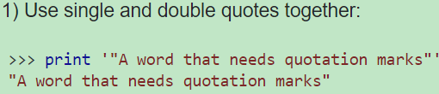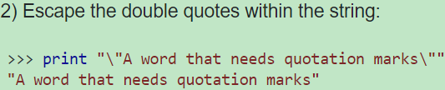
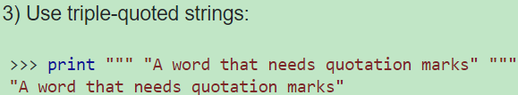

1.7.1 basic formatting
query = 'select url from {0} where ....'  query1 = 'select url from %s where ....'  print query.format('table')  print query1 % 'table' | >>>>  select url from table where ....  select url from table where ....

print '%s %s' % ('one', 'two')  print '{} {}'.format('one', 'two')  print '{1} {0}'.format('one', 'two') | one two  one two  two one

def test_format():
html = '''<li>{a}</li><li>{b}</li>'''
value = {'a':123, 'b':"abc"}
print html.format(**value)

>>>>>
<li>123</li><li>abc</li>

1.7 getattr、setattr
Objects in Python can have attributes (actually, every object has built-in attributes -- data attributes and methods (functions are values, i.e. objects, too) to work with those).
For example you have an object person, that has several attributes: name, gender, etc.You access these attributes (be it methods or data objects) usually writing: person.name, person.gender, person.the_method(), etc.
But what if you don't know the attribute's name at the time you write the program?

For me, getattr is easiest to explain this way:
It allows you to call methods based on the contents of a string instead of typing the method name.
For example, you cannot do this: | However, you CAN do this:
obj = MyObject()  for x in ['foo', 'bar']:  obj.x() | obj = MyObject()  for x in ['foo', 'bar']:  getattr(obj, x)()
because x is not of the type "builtin", but "str".

It allows you to dynamically connect with objects based on your input. I've found it useful when dealing with custom objects and modules.
A pretty common use case for getattr is mapping data to functions.
For instance, in a web framework like Django or Pylons, getattr makes it straightforward to map a web request's URL to the function that's going to handle it. If you look under the hood of Pylons's routing, for instance, you'll see that (by default, at least) it chops up a request's URL, like:
http://www.example.com/customers/list
into "customers" and "list". Then it searches for a controller class named CustomerController. Assuming it finds the class, it creates an instance of the class and then uses getattr to get its list method. It then calls that method, passing it the request as an argument.
The source code from
BaseHTTPRequestHandler(SocketServer.StreamRequestHandler)
mname = 'do_' + self.command #(for example self.command=GET )

if not hasattr(self, mname):
self.send_error(501, "Unsupported method (%r)" % self.command)
return
method = getattr(self, mname)
method()
self.wfile.flush()

def do_GET(self): #correspond to the mnname
self.send_response(200)
self.send_header("Content-type", "text/html")
self.send_header("Content-Length", str(len(self.Page)))
self.end_headers()
self.wfile.write(self.Page)

1.7 yield、generator
print xrange(1, 5)  >>> xrange(1, 5) | print range(1, 5)  >>>> [1, 2, 3, 4]

def makeRange(n):  # return 0,1,2,...,n-1  i = 0  while i < n:  yield i  i += 1 | print makeRange(5)  print makeRange(5)  >>>>>>  <generator object makeRange at 0x00000000037CB480>

x = iter(makeRange(2))  print next(x) >>0  print next(x) >>1  print next(x) >>Traceback (most recent call last):........StopIteration | li = list(makeRange(2)) >>  printli >> [0, 1]  li = list(range(2))  print li >> [0, 1]

When you request an iterator from a list, it creates a new iterator. However, when you request an iterator from an iterator (which you would rarely do), it just gives you a copy of itself.
Thus, in the unlikely event that you are failing to do something like this...
> x = myRange(5)  > list(x)  [0, 1, 2, 3, 4] | > list(x)  []
... then remember that a generator is an iterator; that is, it is one-time-use. If you want to reuse it, you should call myRange(...) again. If you need to use the result twice, convert the result to a list and store it in a variable x = list(myRange(5)).
class It(object):
def __init__(self):
self.count = -1

def __iter__(self):
return self

def next(self):
self.count += 1
if self.count < 4:
return self.count
else:
raise StopIterationit = It()
for item in it:
print item
it = It()
try:
while 1:
print it.next()
except StopIteration as msg:
print msg
>>0
1
2
3
#the above 2 act samely
For more insight as to what's happening behind the scenes, the for loop can be rewritten to this(the above while loop):
def f123():  yield 1  yield 2  yield 3 | for item in f123():  print item | >>>  1  2  3
hasattr(f123(), '__iter__') # that's an iterable
>>>True
Instead of yield statements, if you had three return statements in f123() only the first would get executed, and the function would exit. But f123() is no ordinary function. When f123() is called, it does not return any of the values in the yield statements! It returns a generator object. Also, the function does not really exit - it goes into a suspended state. When the for loop tries to loop over the generator object, the function resumes from its suspended state at the very next line after the yield it previously returned from, executes the next line of code, in this case a yield statement, and returns that as the next item. This happens until the function exits, at which point the generator raises StopIteration, and the loop exits.
What does the yield keyword do in Python?
Answer Outline/Summary
A function with yield, when called, returns a Generator.
Generators are iterators because they implement the iterator protocol, so you can iterate over them.
A generator can also be sent information, making it conceptually a coroutine.

Generators
Generators are iterators, but you can only iterate over them once. It’s because they do not store all the values in memory, they generate the values on the fly:
def f_135():
yield 1
yield 3
yield 5
def demo_1():
for val in f_135():
print val
# 1 3 5
generator = f_135()
print next(generator)
# 1
print next(generator)
# 3
print next(generator)
# 5
def fibonacci(n):
cur = 1
pre = 0
count = 0
while count < n:
yield cur
cur, pre = cur + pre, cur
count += 1
def demo_fib():
ge_fib = fibonacci(10)
for i in ge_fib:
print i, ", "
# 1 , 1 , 2 , 3 , 5 , 8 , 13 , 21 , 34 , 55
ge_fib = fibonacci(5)
print next(ge_fib)
# 1
print next(ge_fib)
# 1
def read_file(f_path='__init__.py'):
# read 60 bytes once
bt_once = 60
with open(f_path, 'rb') as fmp3:
data = fmp3.read(bt_once)
while data:
yield data
data = fmp3.read(bt_once)
def demo_read_file():
for txt in read_file():
print txt
# # coding:utf-8
# if __name__ == '__main__':
# pass

https://jeffknupp.com/blog/2013/04/07/improve-your-python-yield-and-generators-explained/

chapter class

1.8 class

1.8.1 define a class
class Pet(object): # object is the supperclass if non, just -> class Pet:
def __init__(self, name, species):
self.name = name
self.species = species

def getName(self):
return self.name

def getSpecies(self):
return self.species

def __str__(self): # pet = Pet() print pet (so you can print instance to str)
return "%s is a %s" % (self.name, self.species)

1.8.2 Inherit a class
Sometimes just defining a single class (like Pet) is not enough. For example, some pets are dogs and most dogs like to chase cats

class Dog(Pet):

def __init__(self, name, chases_cats):
Pet.__init__(self, name, "Dog")
self.chases_cats = chases_cats

def chasesCats(self):
return self.chases_cats

We want to specify that all Dogs have species "Dog", and also whether or not the dog likes to chase cats. To do this, we need to define our own initialization function (recall that this is known as overriding). We also need to call the parent class initialization function, though, because we still want the name and species fields to be initialized. If we did not have line 4, then we could still call the methods getName and getSpecies. However, because Pet.__init__ was never called, the name and species fields were never created, so calling getName or getSpecies would throw an error.

A Closer Look at Inheritance
Let’s examine the difference between Dog and Pet.

>>> from pets import Pet, Dog
>>> mister_pet = Pet("Mister", "Dog")
>>> mister_dog = Dog("Mister", True)

The function used below, isinstance, is a special function that checs to see if an instance is an instance of a certain type of class. Here we can see that mister_pet is an instance of Pet, but not Dog, while mister_dog is an instance of both Pet and Dog:
>>> isinstance(mister_pet, Pet)
True
>>> isinstance(mister_pet, Dog)
False
>>> isinstance(mister_dog, Pet)
True
>>> isinstance(mister_dog, Dog)
True
super() lets you avoid referring to the base class explicitly, which can be nice. But the main advantage comes with multiple inheritance, where all sorts of fun stuff can happen. See the standard docs on super if you haven't already.
class b:  def b1(self):  print 'bbb'  def d1(self):  self.b1() | class d(b):  def b1(self): #override b1 in b  print 'ddd'  d = d()  d.d1()  >>>> ddd

1.8.3 supper() vs __init__()
class ChildA(Base):  def __init__(self):  Base.__init__(self) | class ChildB(Base):  def __init__(self):  super(ChildB, self).__init__()

ChildA()  ChildB()  #Super has no side effects  Base = ChildB  Base()  #works as expected | Base = ChildA  Base()  #gets into infinite recursion.
class Base(object):
def __init__(self):
print "Base created"

The primary difference in this code is that you get a layer of indirection in the __init__ with super, which references the parent class.
In ChildA, which doesn't use super, if you want to swap Base for another base, you'll need to change the reference to Base in the __init__ as well as any other methods that have this usage. Whereas in ChildB you only need to swap the parent class once e.g.:
class ChildB(DifferentBase):
def __init__(self):
super(ChildB, self).__init__()

This means that the use of super can make your code more maintainable when you have child classes referencing methods of their parents directly, most likely because they have overridden those methods themselves.

If we don’t call the base class init function explicitly in the subclass, it won’t be called by default.
class Base(object):  def __init__(self):  print 'base' | class ChildA(Base):  def __init__(self):  # Base.__init__(self)  print 'ChildA' | ChildA()  >>>>ChildA

1.8.4 classes extend object
class Foo():  def a(self):  print "hello" | class Foo(object):  def a(self):  print "hello"
Should all Python classes extend object? Are there any potential problems with not extending object?

In Python 2, not inheriting from object will create an old-style class, which, amongst other effects, causes type to give different results:
>>> class Foo: pass
...
>>> type(Foo())
<type 'instance'>
vs.

>>> class Bar(object): pass
...
>>> type(Bar())
<class '__main__.Bar'>

Finally, old-style classes have disappeared in Python 3, and inheritance from object has become implicit. So, always prefer new style classes unless you need backward compat with old software.

1.8.5 class variable with or not self
How do these 2 classes differ?
class A:  x = []  def add(self):  self.x.append(1) | class B:  def __init__(self):  self.x = []  def add(self):  self.x.append(1)

- x is a class variable. B's self.x is an instance variable., i.e. A's x is shared between instances (对于A类x相当于静态变量，B x为类的一般变量)
x = A()  y = A()  x.add()  y.add()  print "A's x:",x.x | x = B()  y = B()  x.add()  y.add()  print "B's x:",x.x
>>>A's x: [1, 1] | >>>B's x: [1]

1.8.6 difference between type() and isinstance
Here's why isinstance is better than type:
class Vehicle:  pass | class Truck(Vehicle):  pass

in this case, a truck object is a Vehicle, but you'll get this:

isinstance(Vehicle(), Vehicle) # returns True
type(Vehicle()) == Vehicle # returns True
isinstance(Truck(), Vehicle) # returns True
type(Truck()) == Vehicle # returns False, and this probably won't be what you want.
it will handle subclasses properly. In fact, your example can be written even more easily because isinstance()'s second parameter may be a tuple:

if isinstance(v, (Vehicle, Truck)):
do_something_else()

1.8.7 metaclass
A metaclass is the class of a class. Like a class defines how an instance of the class behaves, a metaclass defines how a class behaves. A class is an instance of a metaclass.
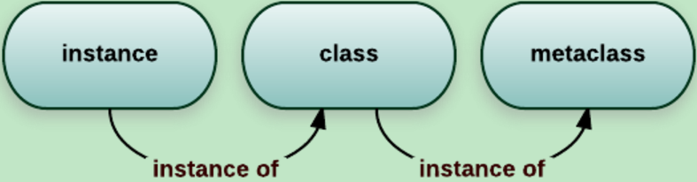

chapter

1.8 date ( time datetime)
Getting current time in python using time module
## 24 hour format ##  time.strftime("%H:%M:%S")  =>15:48:24 | ## 12 hour format ##  time.strftime("%I:%M:%S")  =>03:48:24
## dd/mm/yyyy format  print (time.strftime("%d.%m.%Y"))  =>21.02.2017 | print (time.strftime("%d.%m.%Y-%H:%M:%S"))  =>21.02.2017-15:48:24
s = '02' print int(s) =>2
print "Current date & time " + time.strftime("%c")
=>Current date & time 02/21/17 15:55:34
## Only date representation
print "Current date " + time.strftime("%x")
=>Current date 02/21/17
## Only time representation
print "Current time " + time.strftime("%X")
=>Current time 15:55:34

Get the current date and time in Python using datetime module
import datetime

i = datetime.datetime.now()
print ("Current date & time = %s" % i)
print ("dd/mm/yyyy format = %s/%s/%s" % (i.day, i.month, i.year) )
print ("hh:mm:ss format = %s:%s:%s" % (i.hour, i.month, i.second) )

print type(i)
print i.strftime('%Y/%m/%d %H:%M:%S')
print type(i.strftime('%Y/%m/%d %H:%M:%S'))

=>Current date & time = 2017-02-21 16:01:23.026000
=>dd/mm/yyyy format = 21/2/2017
=>hh:mm:ss format = 16:2:23

=><type 'datetime.datetime'>
=>2017/02/21 16:05:57
=><type 'str'>

1.6 other trick

1.6.1 list to string vice verse
convert a list into a string in python
list = [how,are,you] to a string "how are you"
The spaces are important, i don't want to get howareyou as I have with
my attempt so far of using "".join(list)
1. " ".join(my_list) you need to join with a space not an empty string
2. For non-strings (such as an array of ints) this may be better:
" ".join(str(item) for item in my_list)

1.6.2 concatenate str and int
things = 5 print("You have " + things + " things.")
TypeError: cannot concatenate 'str' and 'int' objects.The problem here is that the + operator has (at least) two different meanings in Python: for numeric types, it means "add the numbers together":
>>> 1 + 2 3
and for sequence types, it means "concatenate the sequences":
>>> [1, 2, 3] + [4, 5, 6] [1, 2, 3, 4, 5, 6]
As a rule, Python doesn't implicitly convert objects from one type to another in order to make operations "make sense", because that would be confusing: for instance, you might think that '3' + 5 should mean '35', but someone else might think it should mean 8 or even '8'.
Similarly, Python won't let you concatenate two different types of sequence:
Because of this, you need to do the conversion explicitly,whether what you want is concatenation or addition:
>>> 'Total: ' + str(123) 'Total: 123'
>>> int('456') + 789 1245

1.6.3 / decimal round
divide two numbers in Python 2.7 and get the result with decimals
"/" is integer division in python 2 so it is going to round to a whole number.
If you would like a decimal returned, just change the type of one of the inputs to float:
float(20)/15 #1.33333333
Use the built-in function round():
round(1.2345,2) >>> 1.23 round(1.5145,2) >>> 1.51
round(1.679,2) >>> 1.68
Or built-in function format():
format(1.2345, '.2f') >>> '1.23' format(1.679, '.2f') >>> '1.68'

1.6.4 get filename without extension
fullPath = 'C:\Windows\Fonts\simhei.TTF'
base = os.path.basename(fullPath)
os.path.splitext(base)[0]

1.6.4 get all files in directory
from os import listdir
from os.path import isfile, join
import glob, os

files = [f for f in listdir(dir)]
# like ['1.jpg', '10.jpg', '2.jpg', 'dir']

files = [f for f in listdir(dir) if isfile(join(dir, f))]
# doesn't contain directory
# like ['1.jpg', '10.jpg', '2.jpg']
files = [join(dir, f) for f in listdir(dir) if isfile(join(dir, f))]
# like ['E:/img\\1.jpg', 'E:/img\\10.jpg', 'E:/img\\2.jpg']

files = [f for f in listdir(dir) if f.endswith('.jpg')]
# like ['1.jpg', '10.jpg', '2.jpg']

files = glob.glob(dir + '/*.jpg')
# like ['E:/img\\1.jpg', 'E:/img\\10.jpg', 'E:/img\\2.jpg']
os.chdir(dir)
files = glob.glob('*.jpg')
# like ['1.jpg', '10.jpg', '2.jpg']

1.6.5 add char in string
I can use to insert a value in a certain position of a string?
Something like this: "3655879ACB6" then in position 4 add "-" to become "3655-879ACB6"
create a new string that has the inserted character:
>>> s[:4] + '-' + s[4:] '3558-79ACB6'

1.6.6 split string to list by nth
def str_to_strlist_by_nth(str, nth):
return [str[i:i + nth] for i in range(0, len(str), nth)]
s = '1234567890'
print [s[k: k+3] for k in range(0, len(s), 3)] #['123', '456', '789', '0']
print '01.02.2017'.split('.')
print [int(s) for s in '01.02.2017'.split('.')]
->['01', '02', '2017']
->[1, 2, 2017]

1.6.7 print trick
cnt = 123
print 'image-%09d' % cnt #image-000000123
cnt = 123
print 'image-%9d' % cnt #image- 123

1.6.7 two list to dict
keys = ['a', 'b', 'c']  values = [1, 2, 3]  dictionary = dict(zip(keys, values))  print(dictionary)  {'a': 1, 'b': 2, 'c': 3} | import itertools  keys = ('name', 'age', 'food')  values = ('Monty', 42, 'spam')  adict = dict(itertools.izip(keys,values))  >>> adict  {'food': 'spam', 'age': 42, 'name': 'Monty'}  It's also more economical in memory  consumption compared to zip.
new_dict = {k: v for k, v in zip(keys, values)}

1.6.7 list itemwise do same function if-else
suqare = lambda x : x * x  bl = [2, 3, 4]  print [suqare(a) for a in bl]  >>> [4, 9, 16] | the following code,chang the even num to 111  print a_col  # [0 3 6 9]  print [a if a % 2 else 111 for a in arr[:, 0]]  # [111, 3, 111, 9]

1.6.7 modify entry during for loop
for item in lst:  print item  item += '1'  #only temp variable item change not lst | a = [1, 3, 5]  b = a  a[:] = [x + 2 for x in a]  print a # [3, 5, 7]  print b # [3, 5, 7]
Since the loop below only modifies elements already seen, it would be considered acceptable:

a = ['a',' b', 'c ', ' d ']
for i, s in enumerate(a):
a[i] = s.strip()
print a # ['a', 'b', 'c', 'd']
Which is different from:
a[:] = [s.strip() for s in a]
in that it doesn't require the creation of a temporary list and an assignment of it to replace the original, although it does require more indexing operations.

1.6.7 loop backwards xrange
for i in range(100, -1, -1)  and some slightly longer (and slower) solution:  for i in reversed(range(101))  for i in range(101)[::-1] | range(10, 0, -1)  Which gives  [10, 9, 8, 7, 6, 5, 4, 3, 2, 1]

for i in range(5, 7):  print i  # 5, 6 | for i in range(5, -1):  print i  # output nothing | for i in range(5, -1, -1):  print i  # 5 4 3 2 1 0

1.6.7 zip enumerate multi list/last n elements
How to get last items of a list in Python?
>>> a = [1, 2, 3, 4, 5, 6, 7, 8, 9, 10, 11, 12]
>>> a[-9:]
[4, 5, 6, 7, 8, 9, 10, 11, 12]
Here is how to iterate over two lists and their indices using enumerate together with zip:
al, bl, cl = [1, 2, 3], [2, 3, 4], [5, 6, 7]  print zip(al, bl, cl) | a, b = ['a1', 'a2', 'a3'], ['b1', 'b2', 'b3']  for i, (a, b) in enumerate(zip(a, b)):  print i, a, b
>>> [(1, 2, 5), (2, 3, 6), (3, 4, 7)] | > 0 a1 b1  1 a2 b2  2 a3 b3
yields the exact same result as above, but is faster and uses less memory.

from itertools import izip, count
a, b = ['a1', 'a2', 'a3'], ['b1', 'b2', 'b3']
for i, a, b in izip(count(), a, b):
print i, a, b

Accessing the index in Python 'for' loops
How do I access the index itself for a list like the following?
al = ['a1', 'a2', 'a3']
Using an additional state variable, such as an index variable (which you would normally use in languages such as C or PHP), is considered non-pythonic.
The better option is to use the built-in function enumerate(), available in both Python 2 and 3:
for idx, val in enumerate(al):  print(idx, val) | for idx, val in enumerate(a, start=1):  print idx, ':', val
0 : a1  1 : a2  2 : a3 | 1 : a1  2 : a2  3 : a3
for i in range(len(al)):
print i, al[i]
ints = [1, 2, 3, 4, 5]  [ (ix, ints[ix]) for ix in range(len(ints))]  >>> [(0, 1), (1, 2), (2, 3), (3, 4), (4, 5)] | int_list = [8, 23, 45, 12, 78]  for index in enumerate(int_list):  print index  (0, 8)  (1, 23)  (2, 45)

1.6 encode/decode(utf8)

1.6.1 ASCII码
我们知道，在计算机内部，所有的信息最终都表示为一个二进制的字符串。每一个二进制位（bit）有0和1两种状态因此八个二进制位就可以组合出256种状态，这被称为一个字节（byte）上个世纪60年代，美国制定了一套字符编码，对英语字符与二进制位之间的关系，做了统一规定这被称为ASCII码，一直沿用至今ASCII码一共规定了128个字符的编码，比如空格"SPACE"是32（二进制00100000），大写的字母A是65（二进制01000001）。这128个符号（包括32个不能打印出来的控制符号），只占用了一个字节的后面7位，最前面的1位统一规定为0。
非ASCII编码（由来的原因）
英语用128个符号编码就够了，但是用来表示其他语言，128个符号是不够的。
byte n.字节；8位元组
address byte 地址字节 error byte错误字节 byte offset字节偏移
encode vt.编码；译码
We should encode the message for security reasons.
为了确保安全，我们应该对信息进行编码
decode v.解码；译解；译码
The Lab Activity will help students decode a waveform.
实验活动将帮助学生解码一道波形
automatic decode system 自动解码系统

1.6.2 unicode
(问题)世界上存在着多种编码方式，同一个二进制数字可以被解释成不同的符号因此，要想打开一个文本文件，就必须知道它的编码方式，否则用错误的编码方式解读，就会出现乱码。
(由来)可以想象，如果有一种编码，将世界上所有的符号都纳入其中。每一个符号都给予一个独一无二的编码，那么乱码问题就会消失。这就是Unicode，就像它的名字都表示的，这是一种所有符号的编码。
Unicode只是一个符号集：它只规定了符号的二进制代码，却没有规定这个二进制代码应该如何存储。比如，汉字"严"的unicode是十六进制数4E25，转换成二进制数足足有15位（100111000100101），也就是说这个符号的表示至少需要2个字节。表示其他更大的符号，可能需要3个字节或者4个字节，甚至更多。

这里就有两个严重的问题，
第一个问题是，如何才能区别Unicode和ASCII？计算机怎么知道三个字节表示一个符号，而不是分别表示三个符号呢？
第二个问题是，我们已经知道，英文字母只用一个字节表示就够了，如果Unicode统一规定，每个符号用三个或四个字节表示，那么每个英文字母前都必然有二到三个字节是0，这对于存储来说是极大的浪费，文本文件的大小会因此大出二三倍，这是无法接受的。
它们造成的结果是：
- 出现了Unicode的多种存储方式，也就是说有许多种不同的二进制格式，可以用来表示Unicode。
- Unicode在很长一段时间内无法推广，直到互联网的出现。

1.6.3 utf-8
互联网的普及，强烈要求出现一种统一的编码方式。UTF-8就是在互联网上使用最广的一种Unicode的实现方式。其他实现方式还包括UTF-16（字符用两个字节或四个字节表示）和UTF-32（字符用四个字节表示），不过在互联网上基本不用重复一遍，这里的关系是，UTF-8是Unicode的实现方式之一。
UTF-8最大的一个特点，就是它是一种变长的编码方式。它可以使用1~4个字节表示一个符号，根据不同的符号而变化字节长度。
UTF-8的编码规则很简单，只有二条：
1）对于单字节的符号，字节的第一位设为0，后面7位为这个符号的unicode码。因此对于英语字母，UTF-8编码和ASCII码是相同的。
2）对于n字节的符号（n>1），第一个字节的前n位都设为1，第n+1位设为0，后面字节的前两位一律设为10。剩下的没有提及的二进制位，全部为这个符号的unicode码。
下面，还是以汉字"严"为例，演示如何实现UTF-8编码。
已知"严"的unicode是4E25（100111000100101），根据上表，可以发现4E25处在第三行的范围内（0000 0800-0000 FFFF），因此"严"的UTF-8编码需要三个字节，即格式是"1110xxxx 10xxxxxx 10xxxxxx"。从"严"的最后一个二进制位开始，依次从后向前填入格式中的x，多出的位补0。这样就得到了，"严"的UTF-8编码是"11100100 10111000 10100101"，转换成十六进制就是E4B8A5。
6. Unicode与UTF-8之间的转换
通过上例子，可以看到"严"的Unicode码是4E25，UTF-8编码是E4B8A5，两者是不一样的。
utf-8是 unicode的一种实现方式，unicode、gbk、gb2312是编码字符集.

1.6.3 GBK
GBK是国家标准GB2312基础上扩容后兼容GB2312的标准。GBK的文字编码是用双字节来表示的，即不论中、英文字符均使用双字节来表示，为了区分中文，将其最高位都设定成1。GBK包含全部中文字符，是国家编码，通用性比UTF8差，不过UTF8占用的数据库比GBD大。
GBK、GB2312等与UTF8之间都必须通过Unicode编码才能相互转换
简单来说，unicode，gbk和大五码就是编码的值，而utf-8,uft-16之类就是这个值的表现形式．而前面那三种编码是一兼容的，同一个汉字，那三个码值是完全不一样的．如＂汉＂的uncode值与gbk就是不一样的，假设uncode为a040，gbk为b030，而uft-8码，就是把那个值表现的形式．utf-8码完全只针对uncode来组织的，如果ＧＢＫ要转ＵＴＦ－８必须先转uncode码，再转utf-8就ＯＫ了．

GBK就是在保存你的帖子的时候，一个汉字占用两个字节。。外国人看会出现乱码，此为我中华为自己汉字编码而形成之解决方案。
UTF8就是在保存你的帖子的时候，一个汉字占用3个字节。。但是外国人看的话不会乱码，此为西人为了解决多字节字符而形成之解决方案。
ASCII(ISO-8859-1)是鼻祖，最简单的方式，字节高位为0
GB2312、GBK、GB18030，这几个是中文编码方式，并向下兼容。GB2312包含7000多个汉字和字符，GBK包含21000多个，GB18030更厉害，到了27000多个。他们都是用2个字节来表示一个汉字。跟ascii是怎么区分的呢？如果高字节的高位为1（也就是高字节大于127），就表示是汉字，低字节并无明显特征。
Unicode是统一编码，它建立了一个全世界统一的码表。世界上的所有文字，在这张码表中都是唯一的。
UTF－8是Unicode的一种存储、传输方式。它将整个Unicode码表分为3部分。
0000 - 007F 这部分是最初的ascii部分，按原始的存储方式，即0xxxxxxx。
0080 - 07FF 这部分存储为110xxxxx 10xxxxxx
0800 - FFFF 这部分存储为1110xxxx 10xxxxxx 10xxxxxx
因此，一个汉字究竟被存储为什么，就需要：先查unicode码表，然后根据在码表的位置进行计算。例如：“电”字，在码表中是3575，计算成utf8就是E794B5，而在GB2312的码表中为B5E7
UTF－8的好处：兼容ASCII，存储英文文件都是单字节，文件小。当然，当以存中文为主时就变成了3字节编码了，比GB系列还大！如何标明一个文件是utf8格式呢？这个标记是可选的：EF BB BF。比如，用windows自带的记事本创建一个utf8格式的文件，就会加上这个标记。但是，如果用ultraedit创建utf8文件，并不会加上这个标记。这个标记有个术语，叫做BOM（Byte Order Mark）。不带BOM的utf8文件和GB2312文件怎么区分呢？我也不知道。唯一能想到的办法就是：先用一种试，如果出现乱码，就用另一种再试GBK的中文编码是双字节来表示的，英文编码是用ASC||码表示的，既用单字节表示。但GBK编码表中也有英文字符的双字节表示形式，所以英文字母可以有2中GBK表示方式。为区分中文，将其最高位都定成1。英文单字节最高位都为0。当用GBK解码时，若高字节最高位为0，则用ASC||码表解码；若高字节最高位为1，则用GBK编码表解码

1.6.4 base64
为什么要使用base64编码，有哪些情景需求？
计算机中任何数据都是按ascii码存储的，而ascii码的128～255之间的值是不可见字符而在网络上交换数据时，比如说从A地传到B地，往往要经过多个路由设备，由于不同的设备对字符的处理方式有一些不同，这样那些不可见字符就有可能被处理错误，这是不利于传输的。所以就先把数据先做一个Base64编码，统统变成可见字符，这样出错的可能性就大降低了。
有些情况下传输不可见字符不方便。比如一个纯文本协议，二进制中可能会出现被当做控制字符处理的部分。这样引起传输失败有时在一些特殊应用的场合，大多数消息是纯文本的，偶尔需要用这条纯文本通道传一张图片之类的情况发生的时候，就会用到base64。

应用场景：
- 如果细心的话，会发现百度云盘共享的时候，用的就是Base64。举个例子，前几天有个朋友给我发送一个视频，给的链接是这样的（后面四位略去）：http://pan.baidu.com/s/1gdH****
- 对于一些简单图片，通常会选择将图片内容直接内嵌在页面中，避免不必要的外部资源加载，增大页面加载时间，但是图片数据是二进制数据，该怎么嵌入呢？绝大多数现代浏览器都支持一种名为 Data URLs 的特性，允许使用Base64对图片或其他文件的二进制数据进行编码，将其作为文本字符串嵌入网页中。以百度搜索首页为例，其中语音搜索的图标是个背景图片，其内容以 Data URLs 形式直接写在css中，这个css内容又直接嵌在HTML页面中，如下图所示：
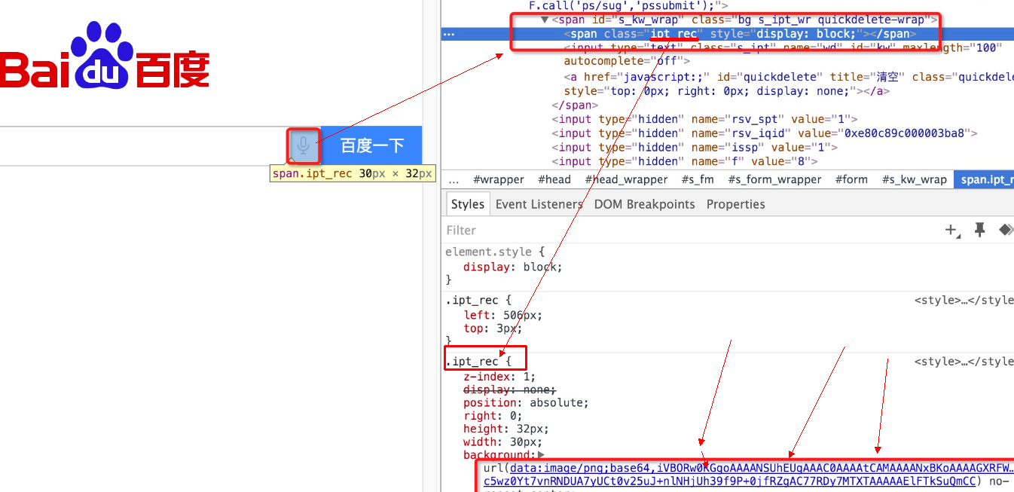
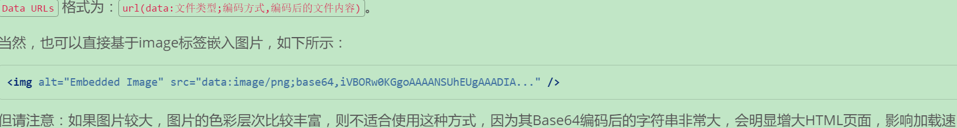
MIME（多用途互联网邮件扩展）
我们的电子邮件系统，一般是使用SMTP（简单邮件传输协议）将邮件从客户端发往服务器端，邮件客户端使用POP3（邮局协议，第3版本）或IMAP（交互邮件访问协议）从服务器端获取邮件。
SMTP协议一开始是基于纯ASCII文本的，对于二进制文件（比如邮件附件中的图像、声音等）的处理并不好，所以后来新增MIME标准来编码二进制文件，使其能够通过SMTP协议传输
举例来说，我给自己发封邮件，正文为空，带一个名为hello.txt的附件，内容为 您好！世界！。导出邮件源码，其关键部分如下图所示：
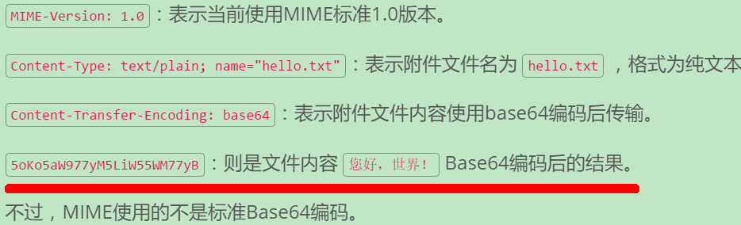
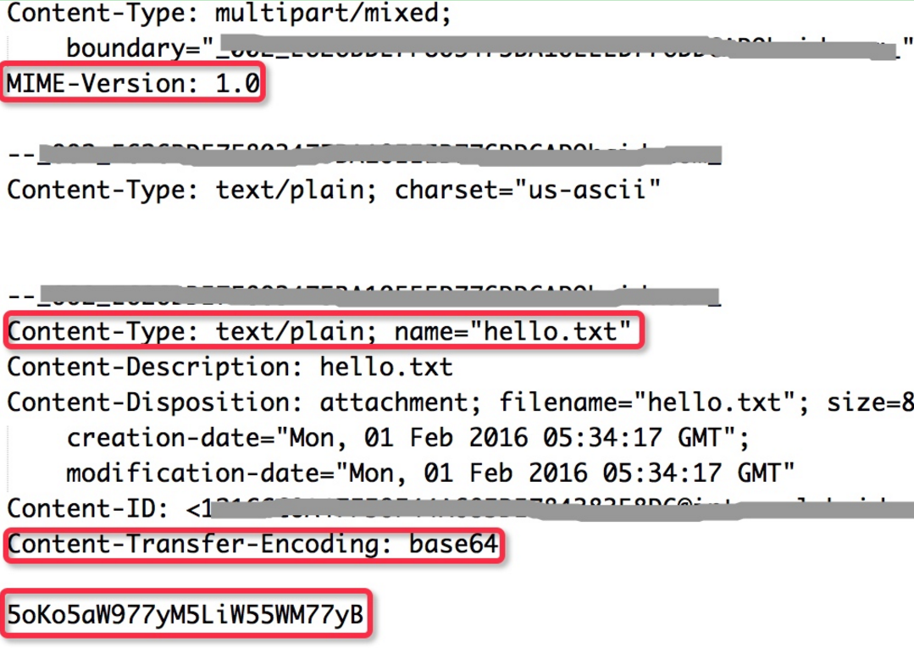
Base64编码原理
所谓Base64，就是说选出64个字符----小写字母a-z、大写字母A-Z、数字0-9、符号"+"、"/"（再加上作为垫字的"="，实际上是65个字符）----作为一个基本字符集(同理有Base32、Base16编码)。然后，其他所有符号都转换成这个字符集中的字符

具体来说，转换方式可以分为四步
第一步，将每三个字节作为一组，一共是24个二进制位。
第二步，将这24个二进制位分为四组，每个组有6个二进制位。
第三步，在每组前面加两个00，扩展成32个二进制位，即四个字节。
第四步，根据下表，得到扩展后的每个字节的对应符号，这就是Base64的编码值。
Base64将三个字节转化成四个字节，因此Base64编码后的文本，会比原文本大出三分之一左右
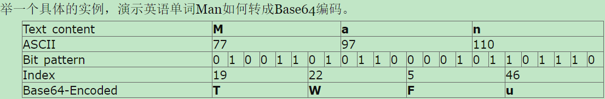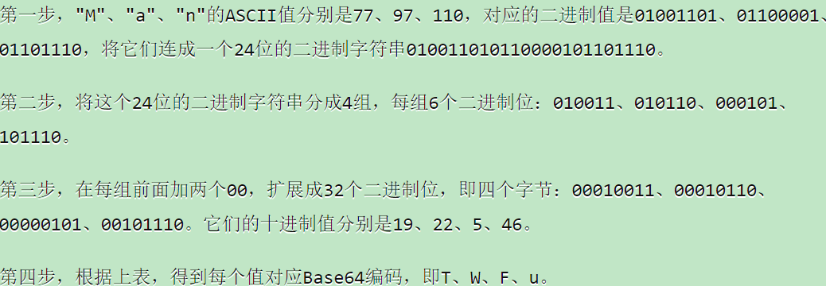
因此，Man的Base64编码就是TWFu。

如果字节数不足三，则这样处理：
a）二个字节的情况：将这二个字节的一共16个二进制位，按照上面的规则，转成三组，最后一组除了前面加两个0以外，后面也要加两个0。这样得到一个三位的Base64编码，再在末尾补上一个"="号。
比如，"Ma"这个字符串是两个字节，可以转化成三组00010011、00010110、00010000以后，对应Base64值分别为T、W、E，再补上一个"="号，因此"Ma"的Base64编码就是TWE=。

b）一个字节的情况：将这一个字节的8个二进制位，按照上面的规则转成二组，最后一组除了前面加二个0以外，后面再加4个0。这样得到一个二位的Base64编码，再在末尾补上两个"="号。
比如，"M"这个字母是一个字节，可以转化为二组00010011、00010000，对应的Base64值分别为T、Q，再补上二个"="号，因此"M"的Base64编码就是TQ==。

再举一个中文的例子，汉字"严"如何转化成Base64编码？
这里需要注意，汉字本身可以有多种编码，比如gb2312、utf-8、gbk等等，每一种编码的Base64对应值都不一样。下面的例子以utf-8为例。
首先，"严"的utf-8编码为E4B8A5，写成二进制就是三字节的"11100100 10111000 10100101"。将这个24位的二进制字符串，按照第3节中的规则，转换成四组一共32位的二进制值"00111001 00001011 00100010 00100101"，相应的十进制数为57、11、34、37，它们对应的Base64值就为5、L、i、l。
所以，汉字"严"（utf-8编码）的Base64值就是5Lil。

1.6.4 py中文件编码
Python 默认脚本文件都是 ANSCII 编码的，当文件 中有非 ANSCII 编码范围内的字符的时候就要使用"编码指示"来修正一个 module 的定义中，如果.py文件中包含中文字符（严格的说是含有非anscii字符），则需要在第一行或第二行指定编码声明：
# -*- coding=utf-8 -*-

例如下面的代码：
"""
# -*- coding: utf-8 -*-
"""
def str_related(s):
keywords = ['直播', '主播', 'yy', '斗鱼', '映客', '花椒']

程序报错：SyntaxError: Non-ASCII character '\xe7'
取消注释：# -*- coding: utf-8 -*-
就没有问题了

1.6.5 string类型
先说一下python中的字符串类型，在python中有两种字符串类型，分别是 str 和 unicode，他们都是basestring的派生类；
- str类型是一个包含Characters represent (at least) 8-bit bytes的序列；
- unicode 的每个 unit 是一个 unicode obj;
也就是说在读取一个文件的内容，或者从网络上读取到内容时，保持的对象为str类型；如果想把一个str转换成特定编码类型，需要把str转为Unicode,然后从unicode转为特定的编码类型如：utf-8、gb2312等。
How do I check if a string is unicode or ascii?
def whatisthis(s):
if isinstance(s, str):
print "ordinary string"
elif isinstance(s, unicode):
print "unicode string"
else:
print "not a string"

Just do : type(s)
One will say unicode, the other will say str.
Or do you mean you have a str, and you are trying to figure out if it is encoded using ASCII or UTF-8 or something else? In that case, try this:
s.decode('ascii')
if it raises an exception, the string is not 100% ASCII.

1.6.5 encode
unicode 转为 gb2312,utf-8等,使用 encode(encoding)

s = u'中国'
s_gb = s.encode('gb2312') #unicode --> gb2312
print type(s_gb)
>>> <type 'str'>
s_u = (s_gb.decode('gb2312')).encode('utf-8') # gb2312 --> unicode--> utf-8
print s_u, s
>>> 中国 中国

s = u'中国'
s_gb = s.encode('gb2312')
s_gb = s_gb.decode('gb2312')
print s_gb, type(s_gb)
>>> 中国 <type 'unicode'>

s = '中国' #s按照上面的utf-8编码,而非'unicode'，故而报错
s_gb = s.encode('gb2312')
UnicodeDecodeError: 'ascii' codec can't decode byte 0xe4 in position 0: ordinal not in range(128)

1.6.5 decode
utf-8,GBK转换为 unicode 使用 unicode(s,encoding) 或者 s.decode(encoding), 其中encoding为是本身的编码格式。

# -*- coding: utf-8 -*-

s = '中国'.decode('utf-8') #s按照上面的utf-8编码
print type(s), type(unicode(s))
>>> <type 'unicode'> <type 'unicode'>

s = '中国'
print type(s) #s按照上面的utf-8编码但依然是str类型
>>> <type 'str'>
s = u'中国' #指定s为unicode类型
print type(s)
>>> <type 'unicode'>

1.6.6 json中的应用
例如，一下json file
{
"scrape_list":["我的shxwcb", "sina_hotnews", "sina_society", "sina_pic",
"news173", "sina_tech"]
}
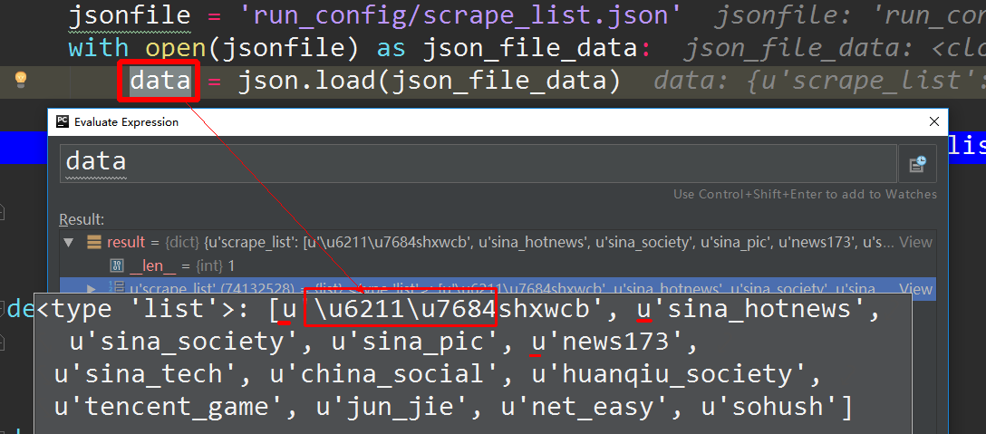
可以看到：
- json导入到的数据全部是一unicode形式编码
- 对于英文直接显示，而中文 则是 \u(unicode 值)
所以在使用的过程中对于每个encode('utf-8')转化为utf-8的str
ret_lst = [item.encode('utf-8') for item in data['scrape_list']]

1.6.7 utf8 vs utf8mb4
MySQL在5.5.3之后增加了这个utf8mb4的编码，mb4就是most bytes 4的意思，专门用来兼容四字节的unicode。好在utf8mb4是utf8的超集，除了将编码改为utf8mb4外不需要做其他转换。当然，为了节省空间，一般情况下使用utf8也就够了。
Since now-a-days we don't need support only for storing language characters but also symbols, newly introduced emojis and so on
utf8mb4 handles Emoji and some Chinese characters that are missing from utf8. There are other, less common, characters.

1.6.7 utf8 vs utf16 utf32
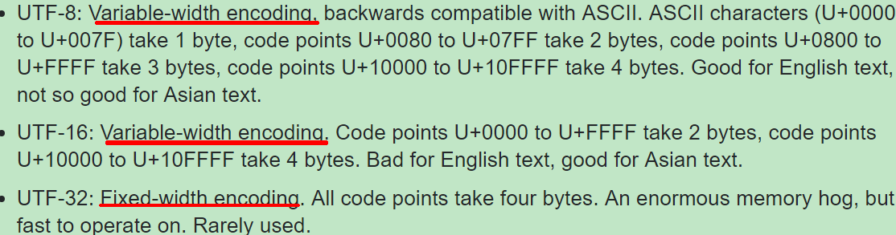
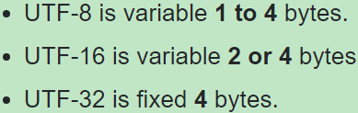

1.6 os
The OS module in Python provides a way of using operating system dependent
functionality.
The functions that the OS module provides allows you to interface with theunderlying operating system that Python is running on – be that Windows, Mac orLinux.
You can find important information about your location or about the process.
#Returns the current working directory. os.getcwd()
Return the real group id of the current process. os.getgid()
Return the current process’s user id. os.getuid()

Return a list of the entries in the directory given by path. os.listdir(path)
Create a directory named path with numeric mode mode. os.mkdir(path)

1.6.1 os.system()
os.system("some_command with args") passes the command and arguments to your system's shell. This is nice because you can actually run multiple commands at once in this manner and set up pipes and input/output redirection.
For example:
os.system("some_command < input_file | another_command > output_file")
However, while this is convenient, you have to manually handle the escaping of shell characters such as spaces, etc. On the other hand, this also lets you run commands which are simply shell commands and not actually external programs.
>>> import os  >>> os.system("pwd")  /home/xiongyu | import os  cmd = 'ls -al'  os.system(cmd) | os.system('history')  >>>error  BASH built-in commands

def do_scrape_task2():
web_list = get_spider_list()
for web in web_list:
# os.system(get_execmd(web))
print 'scrape from %s:' % web
os.system('scrapy crawl %s' % web)

if __name__ == '__main__':
while True:
jsonfile = 'run_config/run_config.json'
with open(jsonfile) as json_file_data:
data = json.load(json_file_data)

minute = data['minute']

do_scrape_task2()

print 'scrape all now sleeping %d minutes' % minute
time.sleep(60 * minute)

1.6.2 os.system()
stream = os.popen("some_command with args") will do the same thing as os.system except that it gives you a file-like object that you can use to access standard input/output for that process. There are 3 other variants of popen that all handle the i/o slightly differently. If you pass everything as a string, then your command is passed to the shell; if you pass them as a list then you don't need to worry about escaping anything.
The Popen class of the subprocess module. This is intended as a replacement for os.popen but has the downside of being slightly more complicated by virtue of being so comprehensive. For example, you'd say:
print subprocess.Popen("echo Hello, shell=True, stdout=subprocess.PIPE)
.stdout.read()

print subprocess.Popen("echo %s " % user_input, stdout=PIPE).stdout.read()
and imagine that the user enters "my mama didnt love me && rm -rf /".

Difference between subprocess.Popen and os.system

If you check out the subprocess section of the Python docs, you'll notice there is an example of how to replace os.system() with subprocess.Popen():

sts = os.system("mycmd" + " myarg")
...does the same thing as...

sts = Popen("mycmd" + " myarg", shell=True).wait()
The "improved" code looks more complicated, but it's better because once you know subprocess.Popen(), you don't need anything else. subprocess.Popen() replaces several other tools (os.system() is just one of those) that were scattered throughout three other Python modules.

If it helps, think of subprocess.Popen() as a very flexible os.system().

subprocess.Popen() is strict superset of os.system().

The popen() function opens a process by creating a pipe, forking, and invoking the shell.
If you are thinking, which one to use, then use subprocess definitely because you you have all facilities for execution, plus additional control over the process.

Chapter 2 thread process

1.6 thread

1.6.1 python GIL
最近在看Python的多线程，经常我们会听到老手说：“Python下多线程是鸡肋，推荐使用多进程！”，但是为什么这么说呢？
首先强调背景：
1. GIL是什么？
GIL的全称是Global Interpreter Lock(全局解释器锁)，来源是python设计之初的考虑，为了数据安全所做的决定。
GIL 的作用通俗来讲就是，同一时刻一个解释进程只有一行 bytecode 在执行

2. 每个CPU在同一时间只能执行一个线程
在单核CPU下的多线程其实都只是并发，不是并行，并发和并行从宏观上来讲都是同时处理多路请求的概念。但并发和并行又有区别，并行是指两个或者多个事件在同一时刻发生；而并发是指两个或多个事件在同一时间间隔内发生。
在Python多线程下，每个线程的执行方式：

获取GIL
执行代码直到sleep或者是python虚拟机将其挂起。
释放GIL

可见，某个线程想要执行，必须先拿到GIL，我们可以把GIL看作是“通行证”，并且在一个python进程中，GIL只有一个。拿不到通行证的线程，就不允许进入CPU执行。
在Python2.x里，GIL的释放逻辑是当前线程遇见IO操作或者ticks计数达到100（ticks可以看作是Python自身的一个计数器，专门作用于GIL，每次释放后归零，这个计数可以通过 sys.setcheckinterval 来调整），进行释放。
而每次释放GIL锁，线程进行锁竞争、切换线程，会消耗资源。并且由于GIL锁存在，python里一个进程永远只能同时执行一个线程(拿到GIL的线程才能执行)，这就是为什么在多核CPU上，python的多线程效率并不高。

那么是不是python的多线程就完全没用了呢？
CPU密集型代码(各种循环处理、计数等等)，在这种情况下，由于计算工作多，ticks计数很快就会达到阈值，然后触发GIL的释放与再竞争（多个线程来回切换当然是需要消耗资源的），所以python下的多线程对CPU密集型代码并不友好。

IO密集型代码(文件处理、网络爬虫等)，多线程能够有效提升效率(单线程下有IO操作会进行IO等待，造成不必要的时间浪费，而开启多线程能在线程A等待时，自动切换到线程B，可以不浪费CPU的资源，从而能提升程序执行效率)。所以python的多线程对IO密集型代码比较友好。

请注意：多核多线程比单核多线程更差，原因是单核下的多线程，每次释放GIL，唤醒的那个线程都能获取到GIL锁，所以能够无缝执行，但多核下，CPU0释放GIL后，其他CPU上的线程都会进行竞争，但GIL可能会马上又被CPU0拿到，导致其他几个CPU上被唤醒后的线程会醒着等待到切换时间后又进入待调度状态，这样会造成线程颠簸(thrashing)，导致效率更低。

每个进程有各自独立的GIL，互不干扰，这样就可以真正意义上的并行执行，所以在python中，多进程的执行效率优于多线程(仅仅针对多核CPU而言)
import time
import threading
def profile(func):
def wrapper(*args, **kwargs):
start = time.time()
func(*args, **kwargs)
end = time.time()
print 'COST: {}'.format(end - start)
return wrapper
def fib(n):
if n <= 2:
return 1
return fib(n-1) + fib(n-2)
@profile
def nothread():
fib(35)
fib(35)
@profile
def hasthread():
for i in range(2):
t = threading.Thread(target=fib, args=(35,))
t.start()
main_thread = threading.currentThread()
for t in threading.enumerate():
if t is main_thread:
continue
t.join()
if __name__ == '__main__':
nothread()
# COST: 16.8039999008
hasthread()
# COST: 42.8039999008

这种情况还不如不用多线程！
GIL是必须的，这是Python设计的问题：Python解释器是非线程安全的。这意味着当从线程内尝试安全的访问Python对象的时候将有一个全局的强制锁。 在任何时候，仅仅一个单一的线程能够获取Python对象或者C API。每100个字节的Python指令解释器将重新获取锁，这（潜在的）阻塞了I/O操作。因为锁，CPU密集型的代码使用线程库时，不会获得性能的提高
那是不是由于GIL的存在，多线程库就是个「鸡肋」呢？当然不是。事实上我们平时会接触非常多的和网络通信或者数据输入/输出相关的程序，比如网络爬虫、文本处理等等。这时候由于网络情况和I/O的性能的限制，Python解释器会等待读写数据的函数调用返回，这个时候就可以利用多线程库提高并发效率了。

1.6.1 python thread safe
我们知道python代码经过编译成字节码指令，然后python虚拟机按照指令进行执行，这里每一条指令都是原子操作不会被中断，可以看到i+=1这条语句被划分为4条指令被执行。取出i变量的值入栈→→将被加数1入栈→→取出2个数相加结果再入栈→→结果出栈。因为是要累加。我们当然需要累加的第一步加入的值是上一个累加的结果。可是在多线程不加锁的情况下每一条指令被执行完毕后都有可能去执行另外一个线程的指令。这就会造成第一步加入的值有可能和另外一个线程是一样的，于是悲剧发生了

同步机制
Python线程包含多种同步机制:
1. Semaphore（信号量）

在多线程编程中，为了防止不同的线程同时对一个公用的资源（比如全部变量）进行修改，需要进行同时访问的数量（通常是1）。信号量同步基于内部计数器，每调用一次acquire()，计数器减1；每调用一次release()，计数器加1.当计数器为0时，acquire()调用被阻塞。

import time
from random import random
from threading import Thread, Semaphore
sema = Semaphore(3)
def foo(tid):
with sema:
print '{} acquire sema'.format(tid)
wt = random() * 2
time.sleep(wt)
print '{} release sema'.format(tid)
threads = []
for i in range(5):
t = Thread(target=foo, args=(i,))
threads.append(t)
t.start()
for t in threads:
t.join()
0 acquire sema
1 acquire sema
2 acquire sema
0 release sema3 acquire sema

2 release sema
4 acquire sema
3 release sema
1 release sema
4 release sema

2. Lock（锁）
Lock也可以叫做互斥锁，其实相当于信号量为1。
3. RLock（可重入锁）
acquire() 能够不被阻塞的被同一个线程调用多次。但是要注意的是release()需要调用与acquire()相同的次数才能释放锁。

1.6.1 with
with 语句适用于对资源进行访问的场合，确保不管使用过程中是否发生异常都会执行必要的“清理”操作，释放资源，比如文件使用后自动关闭／线程中锁的自动获取和释放等。
问题引出, 如下代码：
file = open("１.txt")
data = file.read()
file.close()
上面代码存在２个问题：
（１）文件读取发生异常，但没有进行任何处理；
（２）可能忘记关闭文件句柄；

改进
try:
do something
except:
do something
finally:
f.close()

虽然这段代码运行良好，但比较冗长。
而使用with的话，能够减少冗长，还能自动处理上下文环境产生的异常。如下面代码：

with open("１.txt") as file:
data = file.read()

with 工作原理

（１）紧跟with后面的语句被求值后，返回对象的“–enter–()”方法被调用，这个方法的返回值将被赋值给as后面的变量；
（２）当with后面的代码块全部被执行完之后，将调用前面返回对象的“–exit–()”方法。
with工作原理代码示例：
class Sample(object):
def __enter__(self):
print 'in __enter__'
return "Foo"
def __exit__(self, exc_type, exc_val, exc_tb):
print 'in __exit__'
def get_sample():
return Sample()
def test_with():
with get_sample() as sp:
print 'Sample: ', sp
if __name__ == '__main__':
test_with()
in __enter__
Sample: Foo
in __exit__

可以看到，整个运行过程如下：
（１）enter()方法被执行；
（２）enter()方法的返回值，在这个例子中是”Foo”，赋值给变量sample；
（３）执行代码块，打印sample变量的值为”Foo”；
（４）exit()方法被调用；

class Sample():
def __enter__(self):
print('in enter')
return self
def __exit__(self, exc_type, exc_val, exc_tb):
print "type: ", exc_type
print "val: ", exc_val
print "tb: ", exc_tb
def do_something(self):
bar = 1 / 0
return bar + 10
with Sample() as sample:
sample.do_something()
程序输出结果：

in enter
Traceback (most recent call last):
type: <type 'exceptions.ZeroDivisionError'>
val: integer division or modulo by zero
File "/home/user/cltdevelop/Code/TF_Practice_2017_06_06/with_test.py", line 36, in <module>
tb: <traceback object at 0x7f9e13fc6050>
sample.do_something()
File "/home/user/cltdevelop/Code/TF_Practice_2017_06_06/with_test.py", line 32, in do_something
bar = 1 / 0
ZeroDivisionError: integer division or modulo by zero

Process finished with exit code 1

总结

实际上，在with后面的代码块抛出异常时，exit()方法被执行。开发库时，清理资源，关闭文件等操作，都可以放在exit()方法中。
总之，with-as表达式极大的简化了每次写finally的工作，这对代码的优雅性是有极大帮助的。
如果有多项，可以这样写：

With open('1.txt') as f1, open('2.txt') as f2:
do something

1.6.1 thread safe list/set

class LockedSet(set):
"""A set where add(), remove(), and 'in' operator are thread-safe"""
def __init__(self, *args, **kwargs):
self._lock = Lock()
super(LockedSet, self).__init__(*args, **kwargs)
def add(self, elem):
with self._lock:
super(LockedSet, self).add(elem)
def remove(self, elem):
with self._lock:
super(LockedSet, self).remove(elem)
def __contains__(self, elem):
with self._lock:
super(LockedSet, self).__contains__(elem)

def locked_method(method):
"""Method decorator. Requires a lock object at self._lock"""
def newmethod(self, *args, **kwargs):
with self._lock:
return method(self, *args, **kwargs)
return newmethod
class DecoratorLockedSet(set):
def __init__(self, *args, **kwargs):
self._lock = Lock()
super(DecoratorLockedSet, self).__init__(*args, **kwargs)
@locked_method
def add(self, *args, **kwargs):
return super(DecoratorLockedSet, self).add(args, kwargs)
@locked_method
def remove(self, *args, **kwargs):
return super(DecoratorLockedSet, self).remove(args, kwargs)

1.6.1 join

1.6.2 daemon vs non_daemon
Some threads do background tasks, like sending keepalive packets, or performing periodic garbage collection, or whatever. These are only useful when the main program is running, and it's okay to kill them off once the other, non-daemon, threads have exited.
Without daemon threads, you'd have to keep track of them, and tell them to exit, before your program can completely quit. By setting them as daemon threads, you can let them run and forget about them, and when your program quits, any daemon threads are killed automatically.

Let's say you're making some kind of dashboard widget. As part of this, you want it to display the unread message count in your email box. So you make a little thread that will:
- Connect to the mail server and ask how many unread messages you have.
- Signal the GUI with the updated count.
- Sleep for a little while.
When your widget starts up, it would create this thread, designate it a daemon, and start it. Because it's a daemon, you don't have to think about it; when your widget exits, the thread will stop automatically.
下面给出一个daemon 与 non daemon线程的区别
class HelloThread extends Thread  {  public void run()  {  for ( ; ; )  {  System.out.println("hello");  sleep(1000);  }  }  } | public class RegularThreader  {  public static void main(String[] args)  {  Thread hello = new HelloThread();  hello.start();  System.out.println("Sorry, I must be leaving");  }  }
输出：Sorry, I must be leaving
hello
hello......一直输出hello
可以看出：non daemon线程会一直阻塞进程
public class MainThread {
public static void main(String[] args) throws InterruptedException {
Thread hello = new HelloWorld();
hello.setDaemon(true);
hello.start();
System.out.println("Sorry, I must be leaving");
}
}
输出：Sorry, I must be leaving
然后程序就完全退出了，可见daemon线程不会阻塞当前进程
public class MainThread {
public static void main(String[] args) throws InterruptedException {
Thread hello = new HelloWorld();
hello.setDaemon(true);
hello.start();
System.out.println("Sorry, I must be leaving");
hello.join(1000*5);
}
}
输出：Sorry, I must be leaving
hello.... 5秒后程序退出
然后程序就完全退出了，可见daemon线程不会阻塞当前进程
当在主线程中对daemon线程加了 .join之后，daemon线程就相当于non_daemon
A classic example of a daemon thread is the garbage collector thread found in many Java Virtual Machines. It needs to run continuously while any other threads are running, but should not prevent the program from exiting. When the program exits, there is no more need for a garbage collector.
from threading import Thread
import time

class ThreadA(Thread):
def run(self):
print 'T1: sleeping...'
time.sleep(4)
print 'T1: raising...'
raise RuntimeError('bye')

class ThreadB(Thread):
def __init__(self):
Thread.__init__(self)
self.daemon = True
def run(self):
while True:
x = raw_input('T2: enter some input: ')
print 'GOT:', x

t1 = ThreadA()
t2 = ThreadB()
t1.start()
t2.start()
t1.join() # wait for t1 to finish/raise
print 'done'
Since ThreadB is daemonic, we don't have to explicitly make it stop, nor to join it. When the main thread exits, it exits as well.

1.6.1 Enumerating All Threads
It is not necessary to retain an explicit handle to all of the daemon threads in order to ensure they have completed before exiting the main process. enumerate() returns a list of active Thread instances. The list includes the current thread, and since joining the current thread is not allowed (it introduces a deadlock situation), it must be skipped.

def worker():
"""thread worker function"""
pause = random.randint(1,5)
logging.debug('sleeping %s', pause)
time.sleep(pause)
logging.debug('ending')

def mul_worker():
mt = threading.currentThread()
logging.debug('current thread %s', mt.getName())
for i in range(3):
t = threading.Thread(target=worker)
t.setDaemon(True)
t.start()

if __name__ == '__main__':
# =============================
mt = threading.currentThread()
logging.debug('current thread %s', mt.getName())
mul_worker() >>>> still main thread
for t in threading.enumerate():
if t is mt:
continue

logging.debug('joing %s', t.getName())
t.join()

(MainThread) current thread MainThread
(MainThread) current thread MainThread
(Thread-1 ) sleeping 2
(Thread-2 ) sleeping 1
(Thread-3 ) sleeping 2
(MainThread) joing Thread-1
(Thread-2 ) ending
(Thread-1 ) ending
(MainThread) joing Thread-2
(MainThread) joing Thread-3
(Thread-3 ) ending

Process finished with exit code 0

1.6.1 Subclassing Thread
At start-up, a Thread does some basic initialization and then calls its run() method, which calls the target function passed to the constructor. To create a subclass of Thread, override run() to do whatever is necessary.
class MyThread(threading.Thread):  def run(self):  logging.debug('running')  return | t = MyThread()

1.6.1 SubThread vs MainThread
when will main thread exit in python
def worker():
"""thread worker function"""
print 'Worker'
# time.sleep(10000)
return

threads = []
for i in range(5):
t = threading.Thread(target=worker)
threads.append(t)
t.start()

print "main Exit"

and sometime the result is this:>>>>>>>>>>>>
Worker
Worker
Worker
Worker
main Exit
Worker
So I want to ask when will main thread exit in python after it starts several thread?

The main thread will exit whenever it is finished executing all the code in your script that is not started in a separate thread.
Since the t.start() will start the thread and then return to the main thread, the main thread will simply continue to execute until it reaches the bottom of your script and then exit.
Since you started the other threads in a non-daemon mode, they will continue running until they are finished.
If you wanted the main thread to not exit until all the threads have finished, you should explicitly join them to the main thread. The join will cause the thread calling join to wait until the the thread being joined is finished.

class ThreadA(Thread):
def __init__(self, mt):
Thread.__init__(self)
self.mt = mt

def run(self):
print 'T1: sleeping...'
time.sleep(4)
print 'current thread is ', self.isAlive()
print 'main thread is ', self.mt.isAlive()
print 'T1: raising...'

if __name__ == '__main__':
mt = threading.currentThread()
ta = ThreadA(mt)
ta.start()
logging.debug('main end')

>>>
T1: sleeping...
(MainThread) main end
current thread is True
main thread is False
T1: raising...
由此可见main_thread 已经退出了

1.6.1 Timer Thread
定时器线程
One example of a reason to subclass Thread is provided by Timer, also included in threading. A Timer starts its work after a delay, and can be canceled at any point within that delay time period.
def worker():
pause = random.randint(1, 5)
logging.debug('sleeping %s', pause)
time.sleep(pause)
logging.debug('ending')

if __name__ == '__main__':
# =============================
t1 = threading.Timer(3, worker)
t1.setName('t1')
# t1.setDaemon(True)
t1.start()
t1.cancel()
print 'done'

done

Process finished with exit code 0
由此可见，Timer线程和一般线程使用，的主要区别在于，前者在start之后不会立马运行而是等待指定的时间.

1.6.1 Signaling Between Threads
Although the point of using multiple threads is to spin separate operations off to run concurrently, there are times when it is important to be able to synchronize the operations in two or more threads. A simple way to communicate between threads is using Event objects. An Event manages an internal flag that callers can either set() or clear(). Other threads can wait() for the flag to be set(), effectively blocking progress until allowed to continue.

def out_input(e, t):
time_wait = 10
last_time = current_time = time.time()

while (current_time - last_time) < time_wait:
event_is_set = e.wait(t)
logging.debug('event set is %s', event_is_set)
if event_is_set:
print 'thank you for feedback'
last_time = current_time = time.time()
e.clear()

else:
print 'do other work'
current_time = time.time()

print 'time out'
def get_input(e):
input = ''
while input !='q':
input = raw_input('please input your name: ')
e.set()

if __name__ == '__main__':
# =============================
e = threading.Event()
get_t = Thread(target=get_input, args=(e,))
get_t.start()
out_t = Thread(target=out_input, args=(e,2))
out_t.start()
logging.debug('Waiting before calling Event.set()')
time.sleep(3)
e.set()
logging.debug('Event is set')

The wait() method takes an argument representing the number of seconds to wait for the event before timing out. It returns a boolean indicating whether or not the event is set, so the caller knows why wait() returned. The isSet() method can be used separately on the event without fear of blocking.

1.6.1 Thread Lock safe counter(Controlling Access to Resources)
Are Python built-in containers thread-safe?

You need to implement your own locking for all shared variables that will be modified in Python.

By the way, I don't know if you know this, but locking is very easy in Python - create a threading.lock object, and then you can acquire/release it like this:

import threading
list1Lock = threading.Lock()

with list1Lock:
# change or read from the list here
# continue doing other stuff (the lock is released when you leave the with block)
# 添加到现有的订阅list里面
with self._sub_uid_lst_lock:
self._sub_uid_lst.add(strip_prefix)

In addition to synchronizing the operations of threads, it is also important to be able to control access to shared resources to prevent corruption or missed data. Python’s built-in data structures (lists, dictionaries, etc.) are thread-safe as a side-effect of having atomic byte-codes for manipulating them (the GIL is not released in the middle of an update). Other data structures implemented in Python, or simpler types like integers and floats, don’t have that protection. To guard against simultaneous access to an object, use a Lock object.
class Counter(object):
def __init__(self, start=0):
self.lock = threading.Lock()
self.val = start

def increment(self):
logging.debug('wanting for block')
try:
self.lock.acquire()
self.val += 1
logging.debug('now counter %s', self.val)
finally:
self.lock.release()

def worker_c(c):
for i in xrange(0, 2):
wait_time = random.randint(0, 5)
logging.debug('now sleeping %s', wait_time)
time.sleep(wait_time)
c.increment()

if __name__ == '__main__':
c = Counter()
for i in xrange(0, 3):
t = Thread(target=worker_c, args=(c,))
t.start()
# t.join()
logging.debug('counter all bey')
# t.join() | t.join() #主线程在这里阻塞了，所以所有的线程顺序执行
>>>>(Thread-1 ) now sleeping 5  (Thread-2 ) now sleeping 5  (MainThread) counter all bey  (Thread-3 ) now sleeping 5  (Thread-1 ) wanting for block  (Thread-1 ) now counter 1  (Thread-1 ) now sleeping 4  (Thread-2 ) wanting for block  (Thread-2 ) now counter 2  (Thread-2 ) now sleeping 0  (Thread-2 ) wanting for block  (Thread-2 ) now counter 3  (Thread-3 ) wanting for block  (Thread-3 ) now counter 4  (Thread-3 ) now sleeping 2  (Thread-3 ) wanting for block  (Thread-3 ) now counter 5  (Thread-1 ) wanting for block  (Thread-1 ) now counter 6  由此可见，main thread 在其他线程前退出了。 | (Thread-1 ) now sleeping 5  (Thread-1 ) wanting for block  (Thread-1 ) now counter 1  (Thread-1 ) now sleeping 1  (Thread-1 ) wanting for block  (Thread-1 ) now counter 2  (Thread-2 ) now sleeping 0  (Thread-2 ) wanting for block  (Thread-2 ) now counter 3  (Thread-2 ) now sleeping 0  (Thread-2 ) wanting for block  (Thread-2 ) now counter 4  (Thread-3 ) now sleeping 4  (Thread-3 ) wanting for block  (Thread-3 ) now counter 5  (Thread-3 ) now sleeping 0  (Thread-3 ) wanting for block  (Thread-3 ) now counter 6  (MainThread) counter all bey
因此一般情况下：子线程全部开启之后在join，代码如下
for i in range(2):
t = threading.Thread(target=worker, args=(counter,))
t.start()

logging.debug('Waiting for worker threads')
main_thread = threading.currentThread()
for t in threading.enumerate():
if t is not main_thread:
t.join() #子线程全部开启之后在join
logging.debug('Counter: %d', counter.value)

1.6.1 Re-entrant Locks
Normal Lock objects cannot be acquired more than once, even by the same thread. This can introduce undesirable side-effects if a lock is accessed by more than one function in the same call chain.
lock = threading.Lock()  print 'First try :', lock.acquire()  print 'Second try:', lock.acquire(0)  >>>>  First try : True  Second try: False | lock = threading.Lock()  print 'First try :', lock.acquire()  print 'Second try:', lock.acquire()  >>>  First try : True  Second try: #block
In a situation where separate code from the same thread needs to “re-acquire” the lock, use an RLock instead.

lock = threading.RLock()
print 'First try :', lock.acquire()
print 'Second try:', lock.acquire(0)
>>>
First try : True
Second try: 1

Using with removes the need to explicitly acquire and release the lock.
def worker_with(lock):
with lock:
logging.debug('Lock acquired via with')

def worker_no_with(lock):
lock.acquire()
try:
logging.debug('Lock acquired directly')
finally:
lock.release()

lock = threading.Lock()
w = threading.Thread(target=worker_with, args=(lock,))
nw = threading.Thread(target=worker_no_with, args=(lock,))
w.start()
nw.start()
>>>
(Thread-1 ) Lock acquired via with
(Thread-2 ) Lock acquired directly
The two functions worker_with() and worker_no_with() manage the lock in equivalent ways.

1.6.1 线程退出问题
对于程序来说，如果主进程在子进程还未结束时就已经退出，那么Linux内核会将子进程的父进程ID改为1（也就是init进程），当子进程结束后会由init进程来回收该子进程。
那如果是把进程换成线程的话，会怎么样呢？假设主线程在子线程结束前就已经退出，子线程会发生什么？
在一些论坛上看到许多人说子线程也会跟着退出，其实这是错误的，原因在于他们混淆了线程退出和进程退出概念。实际的答案是主线程退出后子线程的状态依赖于它所在的进程，如果进程没有退出的话子线程依然正常运转。如果进程退出了，那么它所有的线程都会退出，所以子线程也就退出了。

先来看一个主线程先退出的例子：
#include <pthread.h>
#include <unistd.h>

#include <stdio.h>

void* func(void* arg)
{
pthread_t main_tid = *static_cast<pthread_t*>(arg);
pthread_cancel(main_tid);
while (true)
{
//printf("child loops\n");
}
return NULL;
}

int main(int argc, char* argv[])
{
pthread_t main_tid = pthread_self();
pthread_t tid = 0;
pthread_create(&tid, NULL, func, &main_tid);
while (true)
{
printf("main loops\n");
}
sleep(1);
printf("main exit\n");
return 0;
}

1.6.1 Synchronizing Threads Condition
In addition to using Events, another way of synchronizing threads is through using a Condition object. Because the Condition uses a Lock, it can be tied to a shared resource. This allows threads to wait for the resource to be updated. In this example, the consumer() threads wait() for the Condition to be set before continuing. The producer() thread is responsible for setting the condition and notifying the other threads that they can continue.

def comsume_con(cond):
logging.debug('now start for consume')
with cond:
logging.debug('now wait for condition')
cond.wait()
logging.debug('resource is available')

def produce_con(cond):
logging.debug('now start for produce')
with cond:
logging.debug('making resource available')
cond.notifyAll()

if __name__ == '__main__':
# =============================
cond = threading.Condition()
c1 = Thread(name='c1', target=comsume_con, args=(cond,))
c2 = Thread(name='c2', target=comsume_con, args=(cond,))
p = Thread(name='p1', target=produce_con, args=(cond,))
c1.start()
c2.start()
time.sleep(5)
p.start()
>>>>>
(c1 ) now start for consume
(c1 ) now wait for condition
(c2 ) now start for consume
(c2 ) now wait for condition
(p1 ) now start for produce
(p1 ) making resource available
(c1 ) resource is available
(c2 ) resource is available

1.6.1 Subclassing Thread

1.6.1 some question
Q1:In Pthreads, when we create multiple threads inside the main function, does all the created threads become a worker thread for the main thread? or each thread is a manager thread by itself?
There's no Pthreads designated thread that manages all the other worker threads. Typically, main thread is used for that job. But nothing prevents you from choosing another thread to manage all the threads. Main thread can also participate in the the "work" as a worker.
each thread is a manager thread by itself?
A thread is an independent entity within a process. Usually, they all "co-ordinate" with each other to accomplish a common goal.
When you create a thread, you can call it a "worker" if you want. The thread doesn't care how people think about it. It runs the same whether you call it a "worker", "manager", or "moose" for all it matters.

Q2:I have two threads: the main thread and a thread generated from the main thread.When the main thread exits, will the whole program terminate?
No : Java programs terminate when all non-daemon threads finish.
The documentation states:
When a Java Virtual Machine starts up, there is usually a single non-daemon thread (which typically calls the method named main of some designated class). The Java Virtual Machine continues to execute threads until either of the following occurs:
1. The exit method of class Runtime has been called and the security manager has permitted the exit operation to take place.
2.All threads that are not daemon threads have died, either by returning from the call to the run method or by throwing an exception that propagates beyond the run method.

There is no notion of a parent-child relationship between threads. Once the two threads are running they're basically peers. Main thread can exit while other thread still running.

Java has no real concept of "child" threads. When you start a thread it inherits the daemon and priority from the "parent" but that's the end of the parent/child relationship.

1.6.1 Queue
The Queue module implements multi-producer, multi-consumer queues. It is especially useful in threaded programming when information must be exchanged safely between multiple threads. The Queue class in this module implements all the required locking semantics.

The module implements three types of queue, which differ only in the order in which the entries are retrieved. In a FIFO queue, the first tasks added are the first retrieved. In a LIFO queue, the most recently added entry is the first retrieved (operating like a stack). With a priority queue, the entries are kept sorted (using the heapq module) and the lowest valued entry is retrieved first.

The Queue module defines the following classes and exceptions:
class Queue.Queue(maxsize=0)
Constructor for a FIFO queue. maxsize is an integer that sets the upperbound limit on the number of items that can be placed in the queue. Insertion will block once this size has been reached, until queue items are consumed. If maxsize is less than or equal to zero, the queue size is infinite.
class Queue.LifoQueue(maxsize=0)
class Queue.PriorityQueue(maxsize=0)

exception Queue.Empty
Exception raised when non-blocking get() (or get_nowait()) is called on a Queue object which is empty.

exception Queue.Full
Exception raised when non-blocking put() (or put_nowait()) is called on a Queue object which is full.

1.6 multiprocessing

1.6.1 join
Without the join(), the main process can complete before the child process does. I'm not sure under what circumstances that leads to zombieism.
The main purpose of join() is to ensure that a child process has completed before the main process does anything that depends on the work of the child process.
The etymology of join() is that it's the opposite of fork, which is the common term in Unix-family operating systems for creating child processes. A single process "forks" into several, then "joins" back into one.

1.6.2 example
def f(n):
sleep_time = random.randint(1, 5)
print 'process %s sleep %s s' % (n, sleep_time)
time.sleep(sleep_time)
print n*n

def do_multiprocess():
for i in xrange(5):
p = Process(target=f, args=[i,])
p.start()

if __name__ == '__main__':
do_multiprocess()
>>>>
process 0 sleep 5 s  process 1 sleep 4 s  process 2 sleep 1 s  process 4 sleep 4 s  process 3 sleep 2 s | 4  9  1  16  0

1.6.1 multiprocessing.dummy
from multiprocessing import Pool
from multiprocessing.dummy import Pool as ThreadPool

multiprocessing.dummy 模块与 multiprocessing 模块的区别： dummy 模块是多线程，而 multiprocessing 是多进程， api 都是通用的。 所有可以很方便将代码在多线程和多进程之间切换
Dummy is an exact clone of the multiprocessing module. The only difference is that, whereas multiprocessing works with processes, the dummy module uses threads (which come with all the usual Python limitations). So anything that applies to one, applies to the other. It makes it extremely easy to hop back and forth between the two. Which is especially great for exploratory programming when you’re not quite sure if some framework call is IO or CPU bound.

1.6 subprocess
subprocess包主要功能是执行外部的命令和程序。比如说，我需要使用wget下载文件。我在Python中调用wget程序。从这个意义上来说，subprocess的功能与shell类似。
subprocess以及常用的封装函数
当我们运行python的时候，我们都是在创建并运行一个进程。正如我们在Linux进程基础中介绍的那样，一个进程可以fork一个子进程，并让这个子进程exec另外一个程序。在Python中，我们通过标准库中的subprocess包来fork一个子进程，并运行一个外部的程序
subprocess包中定义有数个创建子进程的函数，这些函数分别以不同的方式创建子进程，所以我们可以根据需要来从中选取一个使用。另外subprocess还提供了一些管理标准流(standard stream)和管道(pipe)的工具，从而在进程间使用文本通信。
使用subprocess包中的函数创建子进程的时候，要注意:
1) 在创建子进程之后，父进程是否暂停，并等待子进程运行。
2) 函数返回什么
3) 当returncode不为0时，父进程如何处理。

subprocess.call()
父进程等待子进程完成
返回退出信息(returncode，相当于exit code，见Linux进程基础)

subprocess.check_call()
父进程等待子进程完成
返回0
检查退出信息，如果returncode不为0，则举出错误subprocess.CalledProcessError，该对象包含有returncode属性，可用try...except...来检查(见Python错误处理)。

subprocess.check_output()
父进程等待子进程完成
返回子进程向标准输出的输出结果
检查退出信息，如果returncode不为0，则举出错误subprocess.CalledProcessError，该对象包含有returncode属性和output属性，output属性为标准输出的输出结果，可用try...except...来检查。

这三个函数的使用方法相类似，我们以subprocess.call()来说明:
import subprocess
rc = subprocess.call(["ls","-l"])
我们将程序名(ls)和所带的参数(-l)一起放在一个表中传递给subprocess.call()

Popen()
实际上，我们上面的三个函数都是基于Popen()的封装(wrapper)。这些封装的目的在于让我们容易使用子进程。当我们想要更个性化我们的需求的时候，就要转向Popen类，该类生成的对象用来代表子进程。
与上面的封装不同，Popen对象创建后，主程序不会自动等待子进程完成。我们必须调用对象的wait()方法，父进程才会等待 (也就是阻塞block)：
import subprocess
child = subprocess.Popen(["ping","-c","5","www.google.com"])
print("parent process")
从运行结果中看到，父进程在开启子进程之后并没有等待child的完成，而是直接运行print。
对比等待的情况:
import subprocess
child = subprocess.Popen(["ping","-c","5","www.google.com"])
child.wait()
print("parent process")

此外，你还可以在父进程中对子进程进行其它操作，比如我们上面例子中的child对象:

child.poll() # 检查子进程状态
child.kill() # 终止子进程
child.send_signal() # 向子进程发送信号
child.terminate() # 终止子进程

子进程的PID存储在child.pid
子进程的文本流控制
(沿用child子进程) 子进程的标准输入，标准输出和标准错误也可以通过如下属性表示:
child.stdin
child.stdout
child.stderr
我们可以在Popen()建立子进程的时候改变标准输入、标准输出和标准错误，并可以利用subprocess.PIPE将多个子进程的输入和输出连接在一起，构成管道(pipe):
import subprocess
child1 = subprocess.Popen(["ls","-l"], stdout=subprocess.PIPE)
child2 = subprocess.Popen(["wc"], stdin=child1.stdout,stdout=subprocess.PIPE)
out = child2.communicate()
print(out)

subprocess.PIPE实际上为文本流提供一个缓存区。child1的stdout将文本输出到缓存区，随后child2的stdin从该PIPE中将文本读取走。child2的输出文本也被存放在PIPE中，直到communicate()方法从PIPE中读取出PIPE中的文本。
要注意的是，communicate()是Popen对象的一个方法，该方法会阻塞父进程，直到子进程完成。
我们还可以利用communicate()方法来使用PIPE给子进程输入:

import subprocess
child = subprocess.Popen(["cat"], stdin=subprocess.PIPE)
child.communicate("vamei")
我们启动子进程之后，cat会等待输入，直到我们用communicate()输入"vamei"。通过使用subprocess包，我们可以运行外部程序。这极大的拓展了Python的功能。如果你已经了解了操作系统的某些应用，你可以从Python中直接调用该应用(而不是完全依赖Python)，并将应用的结果输出给Python，并让Python继续处理。shell的功能(比如利用文本流连接各个应用)，就可以在Python中实现。
subprocess.call, subprocess.check_call(), subprocess.check_output()
subprocess.Popen(), subprocess.PIPE
Popen.wait(), Popen.communicate()

Chapter log

1.6 log

1.6.1 log level
Level | When it’s used
DEBUG | Detailed information, typically of interest only when diagnosing problems.
INFO | Confirmation that things are working as expected.
WARNING | An indication that something unexpected happened, or indicative of some problem in the near future (e.g. ‘disk space low’). The software is still working as expected.
ERROR | Due to a more serious problem, the software has not been able to perform some function.
CRITICAL | A serious error, indicating that the program itself may be unable to continue running
import logging
def basic():
logging.basicConfig(level=logging.INFO)
logger = logging.getLogger(__name__)
logger.info('start reading database')

records = {"name":"xiongyu", "age":25}
logger.debug('records:%s', records)
logger.error('records:%s', records)
logger.info('finishing records')

if __name__ == '__main__':
basic()
>>>>>>
INFO:__main__:start reading database
ERROR:__main__:records:{'age': 25, 'name': 'xiongyu'}
INFO:__main__:finishing records

可以看到，log级别低于指定级别的将不会输出。
把上述代码中的basic()函数中的logging.basicConfig(level=logging.INFO)注释掉，输出：
No handlers could be found for logger "__main__"

或者依然注释掉basic()函数中的logging.basicConfig(level=logging.INFO)在main中加入
logging.basicConfig(level=logging.DEBUG)
logger = logging.getLogger(__name__)
代码依旧会正常的输出

1.6.2 log FileHandler & Formatter
- FileHandler 决定日志文件的输出(如重定向到文件)
一个logger可以有多个FileHandler
- Formatter 日志的输出格式，例如使得默认就追加日期。

def handler_fun():
logger = logging.getLogger(__name__)
logger.setLevel(logging.INFO)

handler = logging.FileHandler('hello.log')
handler.setLevel(logging.INFO)

format = logging.Formatter('%(asctime)s - %(name)s - %(levelname)s - %(message)s')
handler.setFormatter(format)

# add the handlers to the logger
logger.addHandler(handler)
logger.info('hello xy')

if __name__ == '__main__':
handler_fun()

结果：console中没有任何输出，而是在文件的结构下，自动的生成了hello.log文件，运行代码多次，日志文件会自动追加。
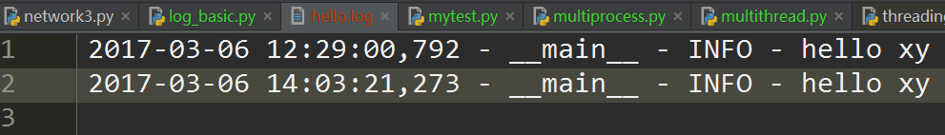
There are different handlers, you can also send records to you mailbox or even a to a remote server. You can also write your own custom logging handler.

1.6.3 log level situation
With flexibility of the logging module, you can write logging record everywhere with proper level and configure them later.
In most cases, you don’t want to read too much details in the log file. Therefore, debug level is only enabled when you are debugging. I use debug level only for detail debugging information, especially when the data is big or the frequency is high, such as records of algorithm internal state changes in a for-loop.

def complex_algorithm(items):
for i, item in enumerate(items):
# do some complex algorithm computation
logger.debug('%s iteration, item=%s', i, item)

I use info level for routines, for example, handling requests or server state changed.

def handle_request(request):
logger.info('Handling request %s', request)
# handle request here
result = 'result'
logger.info('Return result: %s', result)

def start_service():
logger.info('Starting service at port %s ...', port)
service.start()
logger.info('Service is started')

I use warning when it is important, but not an error, for example, when a user attempts to login with wrong password or connection is slow.

def authenticate(user_name, password, ip_address):
if user_name != USER_NAME and password != PASSWORD:
logger.warn('Login attempt to %s from IP %s', user_name, ip_address)
return False
# do authentication here

I use error level when something is wrong, for example, an exception is thrown, IO operation failure or connectivity issue.

def get_user_by_id(user_id):
user = db.read_user(user_id)
if user is None:
logger.error('Cannot find user with user_id=%s', user_id)
return user
return user

I seldom use critical, you can use it when something really bad happen, for example, out of memory, disk is full or a nuclear meltdown (Hope that will not happen :S).

1.6.4 Capture exceptions 2 file
Capture exceptions and record them with traceback
It is always a good practice to record when something goes wrong, but it won’t be helpful if there is no traceback. You should capture exceptions and record them with traceback. Following is an example:

下面的例子中logger来自1.6.2

try:
open('/path/to/does/not/exist', 'rb')
except (SystemExit, KeyboardInterrupt):
raise
except Exception, e:
logger.error('Failed to open file', exc_info=True)

By calling logger methods with exc_info=True parameter, traceback is dumped to the logger. As you can see the result
>>>>>>>>>to file
ERROR:__main__:Failed to open file
Traceback (most recent call last):
File "example.py", line 6, in <module>
open('/path/to/does/not/exist', 'rb')
IOError: [Errno 2] No such file or directory: '/path/to/does/not/exist'
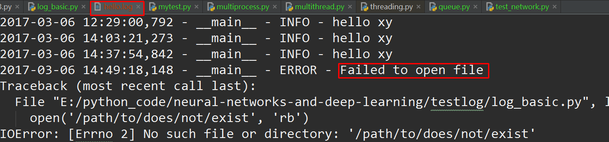

1.6.5 get log from json
logging.json file
{
"version": 1,
"disable_existing_loggers": false,
"formatters": {
"simple": {
"format": "%(asctime)s - %(name)s - %(levelname)s - %(message)s"
}
},

"handlers": {
"console": {
"class": "logging.StreamHandler",
"level": "DEBUG",
"formatter": "simple",
"stream": "ext://sys.stdout"
},

"info_file_handler": {
"class": "logging.handlers.RotatingFileHandler",
"level": "INFO",
"formatter": "simple",
"filename": "info.log",
"maxBytes": 10485760,
"backupCount": 20,
"encoding": "utf8"
},

"error_file_handler": {
"class": "logging.handlers.RotatingFileHandler",
"level": "ERROR",
"formatter": "simple",
"filename": "errors.log",
"maxBytes": 10485760,
"backupCount": 20,
"encoding": "utf8"
}
},

"loggers": {
"my_module": {
"level": "ERROR",
"handlers": ["console"],
"propagate": "no"
}
},

"root": {
"level": "INFO",
"handlers": ["console", "info_file_handler", "error_file_handler"]
}
}

import json
import os
import logging.config

def setup_logging(default_path = 'logging.json',
default_level = logging.INFO,
env_key = 'LOG_CFG'):

path = default_path
env_key = 'LOG_CFG'
value = os.getenv(env_key)
if value:
path = value
if os.path.exists(path):
with open(path, 'rt') as f:
config = json.load(f)
logging.config.dictConfig(config)
else:
logging.basicConfig(level=default_level)

if __name__=='__main__':
setup_logging()
logger = logging.getLogger('loggers')#get logger from json
logger.info('test')
logger.error('error')
logger = logging.getLogger('root')
logger.info('test')
运行代码会自动生成
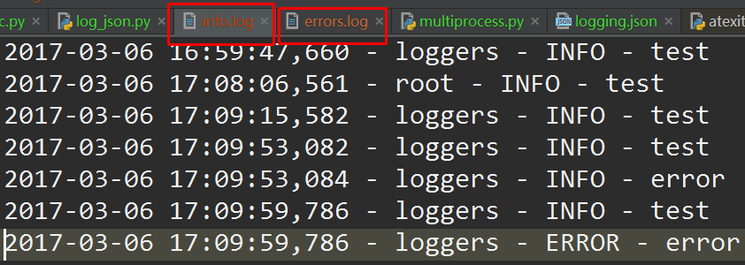
修改一下formatters格式
"formatters": {
"simple": {
"class": "logging.Formatter",
"datefmt": "%Y-%m-%d %H:%M:%S",
"format": "%(asctime)s - %(name)s - %(levelname)s - %(message)s"
}
}
时间输出的格式就没有那么繁琐了
2017-03-06 17:35:38 - loggers - INFO - test
或者
formatter = logging.Formatter("%(asctime)s;%(levelname)s;%(message)s",
"%Y-%m-%d %H:%M:%S")

1.6.6 get log from yaml
One advantage of using JSON configuration is that the json is a standard library, you don’t need to install it. But personally, I prefer YAML. It’s very clear to read and easy to write. You can also load the YAML configuration with following recipes
logging.yaml
---
version: 1
disable_existing_loggers: False
formatters:
simple:
format: "%(asctime)s - %(name)s - %(levelname)s - %(message)s"

handlers:
console:
class: logging.StreamHandler
level: DEBUG
formatter: simple
stream: ext://sys.stdout

info_file_handler:
class: logging.handlers.RotatingFileHandler
level: INFO
formatter: simple
filename: info.log
maxBytes: 10485760 # 10MB
backupCount: 20
encoding: utf8

error_file_handler:
class: logging.handlers.RotatingFileHandler
level: ERROR
formatter: simple
filename: errors.log
maxBytes: 10485760 # 10MB
backupCount: 20
encoding: utf8

loggers:
my_module:
level: ERROR
handlers: [console]
propagate: no

root:
level: INFO
handlers: [console, info_file_handler, error_file_handler]
...

import os
import logging.config
import yaml

def setup_logging(
default_path='logging.yaml',
default_level=logging.INFO,
env_key='LOG_CFG'
):
"""Setup logging configuration

"""
path = default_path
value = os.getenv(env_key, None)
if value:
path = value
if os.path.exists(path):
with open(path, 'rt') as f:
config = yaml.safe_load(f.read())
logging.config.dictConfig(config)
else:
logging.basicConfig(level=default_level)
https://fangpenlin.com/posts/2012/08/26/good-logging-practice-in-python/

1.6.7 log with multi thread
def f(n):
logger = logging.getLogger('main')
sleep_time = random.randint(1, 5)
logger.info('process %s sleep %s s' % (n, sleep_time))
time.sleep(sleep_time)
logger.info('process %s result %s s' % (n, n*n))

def do_multithread():
for i in xrange(5):
t = Thread(target=f, args=(i,))
t.start()

if __name__ == '__main__':
logger = logging.getLogger('main')
format = "%(asctime)s [%(levelname)-8s] %(message)s"
handler = logging.StreamHandler()
handler.setFormatter(logging.Formatter(format, datefmt="%Y-%m-%d %H:%M:%S"))
handler.setLevel(logging.DEBUG)
logger.addHandler(handler)
logger.setLevel(logging.DEBUG) #这个必须设置，否则，回继承root log
logger.info('main')
do_multithread()

>>>>>>
2017-03-06 16:18:12 [INFO ] main
2017-03-06 16:18:12 [INFO ] process 0 sleep 1 s
2017-03-06 16:18:12 [INFO ] process 1 sleep 2 s
2017-03-06 16:18:12 [INFO ] process 2 sleep 1 s
2017-03-06 16:18:12 [INFO ] process 3 sleep 4 s
2017-03-06 16:18:12 [INFO ] process 4 sleep 5 s
2017-03-06 16:18:13 [INFO ] process 0 result 0 s
2017-03-06 16:18:13 [INFO ] process 2 result 4 s
2017-03-06 16:18:14 [INFO ] process 1 result 1 s
2017-03-06 16:18:16 [INFO ] process 3 result 9 s
2017-03-06 16:18:17 [INFO ] process 4 result 16 s

由此可见logger被多个线程共享，通过logging.getLogger(name)即可以被其他线程调用。
注意：logger.setLevel(logging.DEBUG) #这个必须设置，否则，会继承root log
的级别WARNING
下一节对比一下多进程中的情况

1.6.8 log with multi process
def do_multiprocess():
for i in xrange(5):
p = Process(target=f, args=[i,])
p.start()

其余代码不变，发现没有任何输出。可见logger不被多进程共享的

1.6.8 rotating file handler
If you use FileHandler for writing logs, the size of log file will grow with time. Someday, it will occupy all of your disk. In order to avoid that situation, you should use RotatingFileHandler instead of FileHandler in production environment.

1.6.8 multiple servers central log
Setup a central log server when you have multiple servers
When you have multiple servers and different log files. You can setup a central log system to collect all important (warning and error messages in most cases). Then you can monitor it easily and notice what’s wrong in your system.
I’m glad that Python logging library is nicely designed, and the best part is that it is a standard library, you don’t have to choose. It is flexible, you can write your own handlers and filters. There are also third-party handlers such as ZeroMQ logging handler provided by pyzmq, it allows you to send logging messages through a zmq socket.

1.6 error about log

1.6.8 python logUnicodeDecodeError
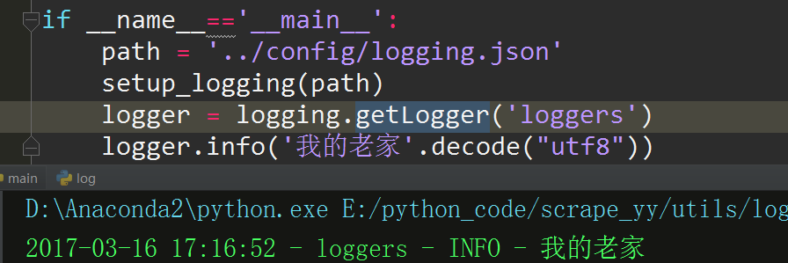

Chapter 2 http web
- 见java_web_note

1.1 http client request
def get_ret_from_http(url):
url = """http://127.0.0.1:9325/short/check?url=http%403_3.jpg&serial=ab"""
ret = requests.get(url)
print ret.content
# eg. result: {"error":false,"resultMap":{"check_ret":1},"success":true}

1.1 http encode(quote)
def url_quote():
raw_url = 'http://bs2-audiorec.oss-cn-shanghai.aliyuncs.com/e98f81fb526061e92a26eda17955c219.pcm'
url = urllib.quote(raw_url)
print url
# http%3A//bs2-audiorec.oss-cn-shanghai.aliyuncs.com/e98f81fb526061e92a26eda17955c219.pcm
print urllib.unquote(url)
# http://bs2-audiorec.oss-cn-shanghai.aliyuncs.com/e98f81fb526061e92a26eda17955c219.pcm
print urllib.quote("河=&源")
# %E6%B2%B3%E6%BA%90

Python进行URL解码

import urllib
rawurl = "%E6%B2%B3%E6%BA%90"
url = urllib.unquote(rawurl)
print url # 河源

问题扩展
urllib.unquote()目的是对url编码进行解码，与该函数对应的是编码函数urllib.quote()

>>> import urllib
>>> urllib.quote("河源")
'%E6%B2%B3%E6%BA%90

URL为何要编码、解码？

通常如果一样东西需要编码，说明这样东西并不适合传输。原因多种多样，如Size过大，包含隐私数据。对于Url来说，之所以要进行编码，是因为Url中有些字符会引起歧义。
例如，Url参数字符串中使用key=value键值对这样的形式来传参，键值对之间以&符号分隔，如/s?q=abc&ie=utf-8。如果你的value字符串中包含了=或者&，那么势必会造成接收Url的服务器解析错误，因此必须将引起歧义的&和=符号进行转义，也就是对其进行编码。

又如，Url的编码格式采用的是ASCII码，而不是Unicode，这也就是说你不能在Url中包含任何非ASCII字符，例如中文。否则如果客户端浏览器和服务端浏览器支持的字符集不同的情况下，中文可能会造成问题。

def req_with_para():
d_para = {"name": "xy", "age": 21}
print requests.get('http://xy.com', params=d_para)
# ordered name-value pairs
d_sorted_para = [("age", 21), ("name", "xy")]
print requests.get('http://xy.com', params=d_sorted_para)
def url_encode_v1():
f = {'eventName': 'myEvent', 'eventDescription': '飞龙在天'}
print urllib.urlencode(f)
# eventName=myEvent&eventDescription=%E9%A3%9E%E9%BE%99%E5%9C%A8%E5%A4%A9
def url_encode_v2():
d_para = {"name": "xy熊大", "age": 21}
print '&'.join('%s=%s' % (k, v) for k, v in d_para.iteritems())
# age=21&name=xy熊大
print '&'.join('%s=%s' % (k, urllib.quote(str(v))) for k, v in d_para.iteritems())
# age=21&name=xy%E7%86%8A%E5%A4%A7
base_url = 'xy.com/'
url = 'http://%s?%s' % (base_url, '&'.join('%s=%s' % (k, urllib.quote(str(v))) for k, v in d_para.iteritems()))
print url
# http://xy.com/?age=21&name=xy%E7%86%8A%E5%A4%A7
print urllib.unquote(url)
# http://xy.com/?age=21&name=xy熊大

1.6 restful Flask

1.6.1 ASCII码

Chapter 2 MySQLdb

1.1 query update
{
"host":"127.0.0.1","user":"root","pwd":"xy123",
"db":"test","port":8066,
"tb_yynews":"tb_test1",
"tb_keyword":"tb_test2"
}

class DbUtil(object):
SELECT_NON_KEYWORDS_LST = 'select id where date is null'
SELECT_KEYWORDS = 'select keyword_type, keyword from {0}'
UPDATE_KEYWORDS = " update tb_ck set keyword= %s where id = %s "
path = 'config/logging.json'
log = get_logger(path)

def __init__(self, config = '../config/mysql_config.json'):
self.config_db(config)

def config_db(self, filename):
data = get_json_from_file(filename)

host = data['host']
user = data['user']
pwd = data['pwd']
db = data['db']
port = data['port']

self.tb_yynews = data['tb_yynews']
self.tb_keyword = data['tb_keyword']
self.conn = MySQLdb.connect(host=host, port=port, user=user, passwd=pwd, db=db, charset="utf8", use_unicode=True)
self.cursor = self.conn.cursor()

def query_non_keywords_lst(self):
try:
query = self.SELECT_NON.format(self.tb_yynews)
self.cursor.execute(query)

# for row in self.cursor:
# print row
# print self.cursor.fetchall()
# return [(row[0], row[1].encode('utf-8')for row in self.cursor]
return [(row[0], row[1], row[2]) for row in self.cursor]

except MySQLdb.Error, e:
print "error %d: %s" % (e.args[0], e.args[1])

def query_keywords(self):
"""
get all the keyword and its type
:return like list of tuple [(1,'直播'),(0,'yy')]:
"""
try:
query = self.SELECT_KEYWORDS.format(self.tb_keyword)
self.cursor.execute(query)
return [(row[0], row[1]) for row in self.cursor]
except MySQLdb.Error, e:
print "error %d: %s" % (e.args[0], e.args[1])

def update_keywords(self, k1, k2, k3, id):
try:
now = time.strftime("%Y-%m-%d %H:%M:%S")
# update = self.UPDATE_KEYWORDS.format(k1, k2, k3, now, id)
# self.cursor.execute(update)

self.cursor.execute(self.UPDATE_KEYWORDS, (k1, k2, k3, now, id))
self.conn.commit()

except MySQLdb.Error, e:
print "error %d: %s" % (e.args[0], e.args[1])

if __name__ == '__main__':
db = DbUtil()
# db.update_keywords()
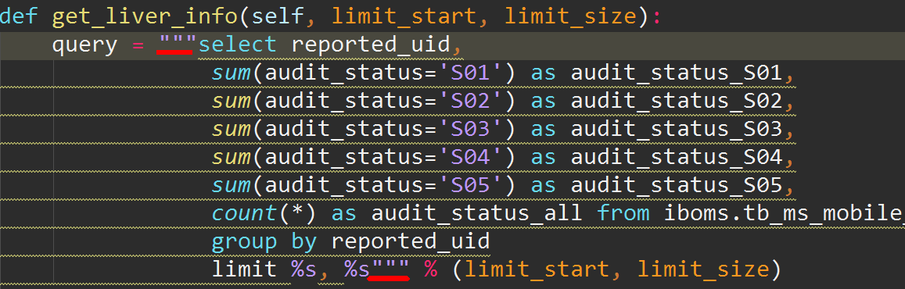

1.1.1 insert multiple lines
How to use python mysqldb to insert many rows at once
c.executemany("insert into T (F1,F2) values (%s, %s)",
[('a','b'),('c','d')])

1.1.1 insert ignore duplicate entries
How to avoid duplicate entries in a MySQL database without throwing an error
I am using the Python-MySQL (MySQLdb) library to insert values into a database. I want to avoid duplicate entries from being inserted into the database, so I have added the unique constraint to that column in MySQL. I am checking for duplicates in the title column. In my Python script, I am using the following statement:
cursor.execute ("""INSERT INTO `database` (title, introduction) VALUES (%s, %s)""", (title, pure_introduction))

Now when a duplicate entry is added to the database, it will produce an error. I do not want an error message to appear; I just want that if a duplicate entry is found then it should simply not enter that value into the database. How do I do this?
solution 1:
You can utilize the INSERT IGNORE syntax to suppress this type of error.
If you use the IGNORE keyword, errors that occur while executing the INSERT statement are ignored. For example, without IGNORE, a row that duplicates an existing UNIQUE index or PRIMARY KEY value in the table causes a duplicate-key error and the statement is aborted. With IGNORE, the row is discarded and no error occurs. Ignored errors may generate warnings instead, although duplicate-key errors do not.
In your case, the query would become:
INSERT IGNORE INTO `database` (title, introduction) VALUES (%s, %s)
solution 2:
Aside from what @Andy suggested (which should really be posted as an answer), you can also catch the exception in Python and silence it:
try:
cursor.execute ("""INSERT INTO `database` (title, introduction) VALUES (%s, %s)""", (title, pure_introduction))
except MySQLdb.IntegrityError:
pass # or may be at least log?

1.2 sqlalchemy
anaconda install:conda install -c anaconda sqlalchemy=1.1.6
所谓ORM（Object Relational Mapping），就是建立其由Python类到数据库表的映射关系：一个Python实例(instance)对应数据库中的一行(row)。这种映射包含两层含义，一是实现对象和与之关联的的行的状态同步，二是将涉及数据库的查询操作，表达为Python类的相互关系。

1.2.1 python logUnicodeDecodeError

Chapter interv

1.1 object

1.2.1 object is

Chapter setup

1.1 sqlalchemy
123

