chapter 1

1.1

1.1.1 SO_REUSEPORT
SO_REUSEPORT
Linux kernel 3.9 came with an interesting feature: ability to bind multiple listening sockets to the same port on the same host, by unrelated processes or threads. The socket option is called SO_REUSEPORT
Let's see an example. Here is a Python program that sets SO_REUSEPORT option on the listening socket. Besides that it's a normal echo server. We are printing PID after a client connect to see which process accepted a connection. Note also that I defined the SO_REUSEPORT constant by hand, because even the newest Python (3.3.2) lacks it's definition in the socket module.

import socket
import os

SO_REUSEPORT = 15

s = socket.socket(socket.AF_INET, socket.SOCK_STREAM)
s.setsockopt(socket.SOL_SOCKET, SO_REUSEPORT, 1)
s.bind(('', 10000))
s.listen(1)
while True:
conn, addr = s.accept()
print('Connected to {}'.format(os.getpid()))
data = conn.recv(1024)
conn.send(data)
conn.close()
Let's now spawn two servers and talk to them using nc as a client:

$ python server.py&
[1] 12649
$ python server.py&
[2] 12650
$ echo data | nc localhost 10000
Connected to 12649
data
$ echo data | nc localhost 10000
Connected to 12650
data

Linux3.9加入了SO_REUSEPORT选项。只要所有socket（包括第一个）在绑定地址前设置了这个选项，两个或多个，TCP或UDP，监听（服务器）或非监听（客户）socket就可以被绑定在完全相同的地址端口组合下。同时，为了防止端口劫持（port hijacking），还有一个特别的限制：所有试图绑定在相同的地址端口组合的socket必须属于拥有相同用户ID的进程。所以一个用户无法从另一个用户那里“偷窃”端口。
除此之外，对于设置了SO_REUSEPORT选项的socket，Linux kernel还会执行一些别的系统所没有的特别的操作：对于绑定于同一地址端口组合上的UDP socket，kernel尝试在它们之间平均分配收到的数据包；对于绑定于同一地址端口组合上的TCP监听socket，kernel尝试在它们之间平均分配收到的连接请求（调用accept()方法所得到的请求）。这意味着相比于其他允许地址复用但随机将收到的数据包或者连接请求分配给连接在同一地址端口组合上的socket的系统而言，linux尝试了进行流量分配上的优化。比如一个简单的服务器进程的几个不同实例可以方便地使用SO_REUSEPORT来实现一个简单的负载均衡，而且这个负载均衡有kernel负责， 对程序来说完全免费！

1.1.1 epoll_create1 vs epoll_create
1.创建epoll fd函数

int epoll_create(int size);
epoll_create()创建一个epoll的事例，通知内核需要监听size个fd。size指的并不是最大的后备存储设备，而是衡量内核内部结构大小的一个提示。当创建成功后，会占用一个fd，所以记得在使用完之后调用close()，否则fd可能会被耗尽。

Note:自从Linux2.6.8版本以后，size值其实是没什么用的，不过要大于0，因为内核可以动态的分配大小，所以不需要size这个提示了。

创建还有另外一个函数

int epoll_create1(int flag);
这个函数是在linux 2.6.27中加入的，当你在看陈硕的muduo时可以看到这个函数，其实它和epoll_create差不多，不同的是epoll_create1函数的参数是flag，当flag是0时，表示和epoll_create函数完全一样，不需要size的提示了。

当flag = EPOLL_CLOEXEC，创建的epfd会设置FD_CLOEXEC

当flag = EPOLL_NONBLOCK，创建的epfd会设置为非阻塞

一般用法都是使用EPOLL_CLOEXEC.

Note:关于FD_CLOEXEC，现在网上好多都说的有点问题，我翻阅了一些资料，请教了一些人，大约明白它的意思了。

它是fd的一个标识说明，用来设置文件close-on-exec状态的。当close-on-exec状态为0时，调用exec时，fd不会被关闭；状态非零时则会被关闭，这样做可以防止fd泄露给执行exec后的进程。关于exec的用法，大家可以去自己查阅下，或者直接man exec

epoll_create系统调用的入口：

SYSCALL_DEFINE1(epoll_create, int, size)
{
if (size <= 0)
return -EINVAL;

return sys_epoll_create1(0);
}
根据man文档，自从linux 2.6.8开始epoll_create的参数就被忽略了，仅需传入大于0的值即可（从上面实现源码第3-4行亦可知）。
epoll_create实质调用了自linux 2.6.27新增的epoll_create1调用，传入flag标记为0。

1.1.1 std::enable_shared_from_this/shared_from_this
struct TcpConn: public std::enable_shared_from_this<TcpConn>, private noncopyable {...}

void TcpConn::close() {
if (channel_) {
TcpConnPtr con = shared_from_this();
getBase()->safeCall(
[con]{ if (con->channel_) con->channel_->close(); }
);
}
}

See also in the section “TcpConn createConnect”

basic class

1.1 poller

1.1.1 poller(poll/epoll)
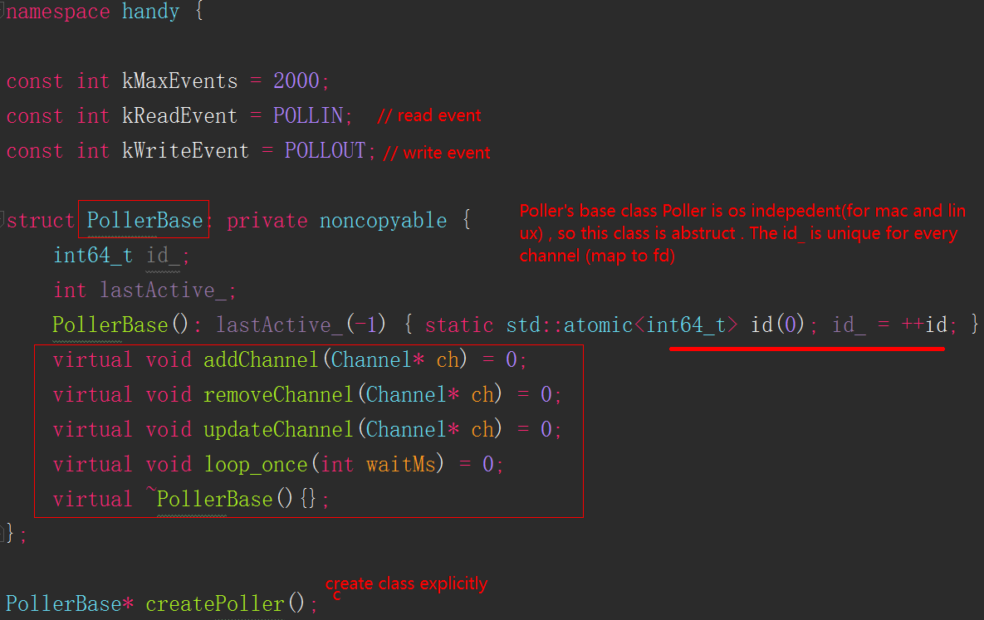
#ifdef OS_LINUX
#include <sys/epoll.h>
#elif defined(OS_MACOSX)
#include <sys/event.h>
#else
#error "platform unsupported"
#endif

namespace handy {
#ifdef OS_LINUX
struct PollerEpoll : public PollerBase{...........}
PollerBase* createPoller() { return new PollerEpoll(); }

#elif defined(OS_MACOSX)
struct PollerKqueue : public PollerBase {...........}
PollerBase* createPoller() { return new PollerKqueue(); }

#endif
}

lastActive_ = epoll_wait(fd_, activeEvs_, kMaxEvents, waitMs);
create by other function
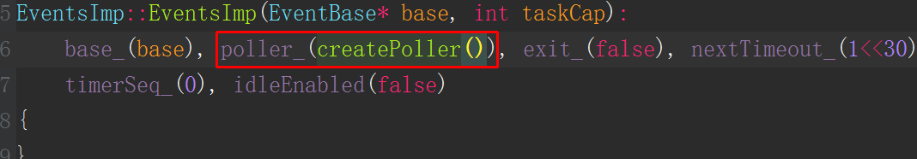
struct PollerEpoll : public PollerBase{
int fd_;
std::set<Channel*> liveChannels_;
//for epoll selected active events
struct epoll_event activeEvs_[kMaxEvents];
PollerEpoll();
~PollerEpoll();
void addChannel(Channel* ch) override;
void removeChannel(Channel* ch) override;
void updateChannel(Channel* ch) override;
void loop_once(int waitMs) override;
};

lastActive_ = epoll_wait(fd_, activeEvs_, kMaxEvents, waitMs);

PollerEpoll::PollerEpoll(){
fd_ = epoll_create1(EPOLL_CLOEXEC);
fatalif(fd_<0, "epoll_create error %d %s", errno, strerror(errno));
info("poller epoll %d created", fd_);
}

PollerEpoll::~PollerEpoll() {
info("destroying poller %d", fd_);
while (liveChannels_.size()) { // how to ensure thread safe
(*liveChannels_.begin())->close();
}
::close(fd_);
info("poller %d destroyed", fd_);
}

void PollerEpoll::addChannel(Channel* ch) {
struct epoll_event ev;
memset(&ev, 0, sizeof(ev));
ev.events = ch->events();
ev.data.ptr = ch;
trace("adding channel .fd..events..epoll", (long long)ch->id(), ch->fd(), ev.events, fd_);
int r = epoll_ctl(fd_, EPOLL_CTL_ADD, ch->fd(), &ev);
fatalif(r, "epoll_ctl add failed %d %s", errno, strerror(errno));
liveChannels_.insert(ch); // how to ensure thread safe
}
void PollerEpoll::updateChannel(Channel* ch) {
struct epoll_event ev;
memset(&ev, 0, sizeof(ev));
ev.events = ch->events();
ev.data.ptr = ch;
trace("modifying channel ...fd ...events read %d write %d epoll %d",
(long long)ch->id(), ch->fd(), ev.events & POLLIN, ev.events & POLLOUT, fd_);
int r = epoll_ctl(fd_, EPOLL_CTL_MOD, ch->fd(), &ev);
fatalif(r, "epoll_ctl mod failed %d %s", errno, strerror(errno));
}

issue:
- Is there a need to create a new epoll_event, just find ch by id, and then epoll_ctl?
- still thread safe?

void PollerEpoll::removeChannel(Channel* ch) {
trace("deleting channel %lld fd %d epoll %d", (long long)ch->id(), ch->fd(), fd_);
liveChannels_.erase(ch);
for (int i = lastActive_; i >= 0; i --) { // remove from epoll_wait active
if (ch == activeEvs_[i].data.ptr) {
activeEvs_[i].data.ptr = NULL;
break;
}
}
}

void PollerEpoll::loop_once(int waitMs) {
int64_t ticks = util::timeMilli();
lastActive_ = epoll_wait(fd_, activeEvs_, kMaxEvents, waitMs);
int64_t used = util::timeMilli()-ticks;
trace("epoll wait %d return %d errno %d used %lld millsecond",
waitMs, lastActive_, errno, (long long)used);
fatalif(lastActive_ == -1 && errno != EINTR, "epoll error..%s", errno, strerror(errno));
while (--lastActive_ >= 0) {
int i = lastActive_;
Channel* ch = (Channel*)activeEvs_[i].data.ptr;
int events = activeEvs_[i].events;
if (ch) {
if (events & (kReadEvent | POLLERR)) {
trace("channel %lld fd %d handle read", (long long)ch->id(), ch->fd());
ch->handleRead();
} else if (events & kWriteEvent) {
trace("channel %lld fd %d handle write", (long long)ch->id(), ch->fd());
ch->handleWrite();
} else {
fatal("unexpected poller events");
}
}
}
}

loop_once usage

void EventsImp::loop() {
while (!exit_)
loop_once(10000);
.....
}
struct EventsImp {
void loop_once(int waitMs) { poller_->loop_once(std::min(waitMs, nextTimeout_));
handleTimeouts(); }
....
}
void EventBase::loop_once(int waitMs) { imp_->loop_once(waitMs); }

1.1.1 channel
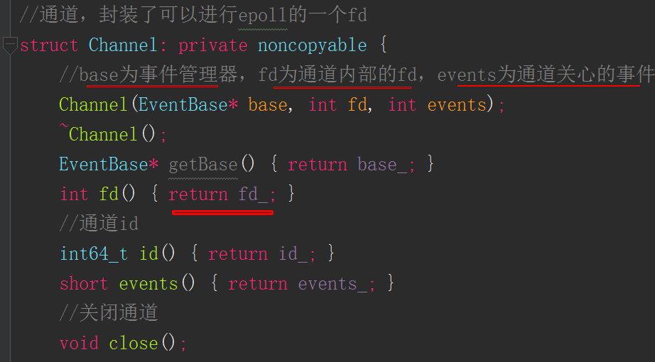
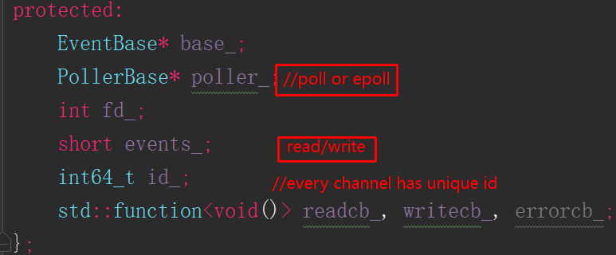

1.1 TcpConn

1.1.1 TcpConn
//see this usage in section "examples->codec-cli.cc" , 2099->port,
//3000->time out
TcpConnPtr con = TcpConn::createConnection(&base, "127.0.0.1", 2099, 3000);

TcpConn has two static create function, one for client to establish connect to server, another for server to get create a connect to client.
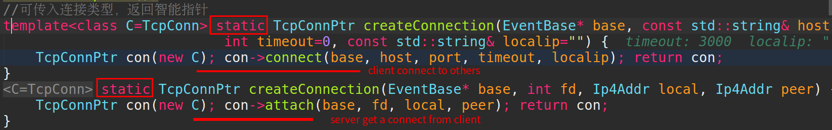

void TcpConn::connect(......) {
.....
destHost_ = host; //check for con is client or server
...
connectTimeout_ = timeout;
connectedTime_ = util::timeMilli();
Ip4Addr addr(host, port);
int fd = socket(AF_INET, SOCK_STREAM, 0);
fatalif(fd<0, "socket failed %d %s", ....);
net::setNonBlock(fd);
int t = util::addFdFlag(fd, FD_CLOEXEC);
....
int r = 0;
if (localip.size()) {
Ip4Addr addr(localip, 0);
r = ::bind(fd,.....);
error("bind to %s failed error %d %s",........);
}
if (r == 0) {
r = ::connect(fd, .......);
if (r != 0 && errno != EINPROGRESS) {
error("connect to %s error %d %s", .....);
}
}

sockaddr_in local;
socklen_t alen = sizeof(local);
if (r == 0) {
r = getsockname(fd, (sockaddr *) &local, &alen);
if (r < 0) {
error("getsockname failed %d %s", ......);
}
}
state_ = State::Handshaking;
attach(base, fd, Ip4Addr(local), addr);
if (timeout) {
TcpConnPtr con = shared_from_this();
//within timeout, if con state is still handshaking,then close
timeoutId_ = base->runAfter(timeout, [con] {
if (con->getState() == Handshaking) {
con->channel_->close();
}
});
}
}

void TcpConn::attach(EventBase* base, int fd, Ip4Addr local, Ip4Addr peer)
{
fatalif((destPort_<=0 && state_ != State::Invalid) || (destPort_>=0 && state_ != State::Handshaking),
"you should use a new TcpConn to attach. state: %d", state_);
base_ = base;
state_ = State::Handshaking;
local_ = local;
peer_ = peer;
delete channel_;
channel_ = new Channel(base, fd, kWriteEvent|kReadEvent);
trace("tcp constructed %s - %s fd: %d",
local_.toString().c_str(),
peer_.toString().c_str(),
fd);
TcpConnPtr con = shared_from_this();
con->channel_->onRead([=] { con->handleRead(con); });
con->channel_->onWrite([=] { con->handleWrite(con); });
}

Logging output:

poller.cpp:41 poller epoll 3 created //base epoll
event_base.cpp:130 wakeup pipe created 4 5 //pipe line
poller.cpp:58 adding channel 1 fd 4 events 1 epoll 3 //pipe read
poller.cpp:58 adding channel 2 fd 6 events 5 epoll 3 // TcpConn channel
conn.cpp:27 tcp constructed 0.0.0.0:25600 - 127.0.0.1:2099 fd: 6

Some of debug process
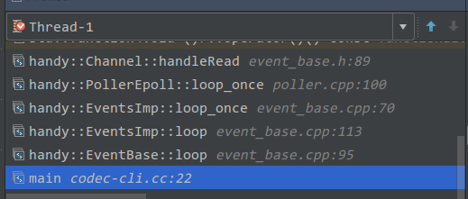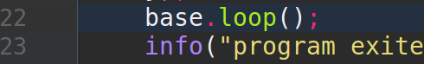
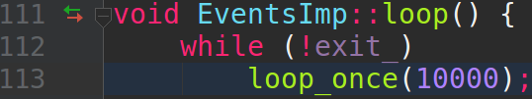
void EventsImp::loop() {
while (!exit_)
loop_once(10000);
timerReps_.clear(); timers_.clear(); idleConns_.clear();
//重连的连接无法通过channel清理，因此单独清理
for (auto recon: reconnectConns_) {
recon->cleanup(recon);
}
loop_once(0);
}
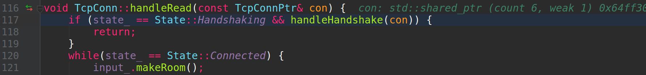

1.1 EventBase

1.1.1 EventBase demo
Firstly I give a demo of the EventBase usage:

EventBase base;
Signal::signal(SIGINT, [&]{ base.exit(); });
info("program begin");
// only run once
base.runAfter(200, [](){
info("a task in runAfter 200ms");
});
// run after 100ms, and repeat every 1000ms
base.runAfter(100, [](){
info("a task in runAfter 100ms interval 1000ms");
}, 1000);
TimerId id = base.runAt(time(NULL)*1000+300, [](){
info("a task in runAt now+300 interval 500ms");
}, 500);
base.runAfter(2000, [&](){
info("cancel task of interval 500ms");
base.cancel(id);
});
base.runAfter(3000, [&](){
base.exit();
});
base.loop();

Logging out put:

poller.cpp:41 poller epoll 3 created
timer.cc:7 program begin
timer.cc:15 a task in runAt now+300 interval 500ms
timer.cc:12 a task in runAfter 100ms interval 1000ms
timer.cc:9 a task in runAfter 200ms
timer.cc:15 a task in runAt now+300 interval 500ms
timer.cc:15 a task in runAt now+300 interval 500ms
timer.cc:12 a task in runAfter 100ms interval 1000ms
timer.cc:15 a task in runAt now+300 interval 500ms
timer.cc:18 cancel task of interval 500ms
timer.cc:12 a task in runAfter 100ms interval 1000ms
poller.cpp:45 destroying poller 3
poller.cpp:50 poller 3 destroyed

base.runAfter(200, [](){
info("a task in runAfter 200ms");
});

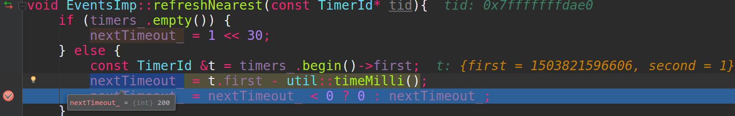

Let’s give another example. If one task execute too long, the next task, may not run at the specified time.

base.runAfter(200, [](){
info("a task in runAfter 200ms, now I will sleep 5000ms");
std::this_thread::sleep_for(std::chrono::milliseconds(5000));
info("now I wake up");
});
//this task doesn’t run after 250ms, but after 5000ms
base.runAfter(250, [](){
info("a task in runAfter 250ms");
});

2017/08/27-16:55:20.090240 6651 timer.cc:12 a task in runAfter 200ms, now I will sleep 5000ms
2017/08/27-16:55:25.090399 6651 timer.cc:14 now I wake up
2017/08/27-16:55:25.090454 6651 timer.cc:18 a task in runAfter 250ms

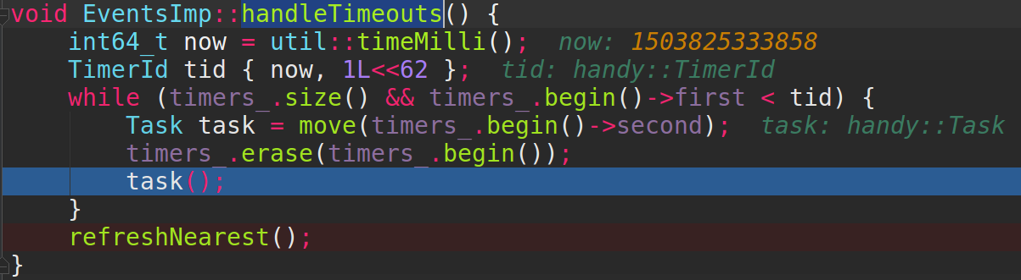
After handle timeout, and the refresh Nearest, the nextTimeout_ is 0, so if one task consumes long than the next task time out, the next task won’t be executed accurately.
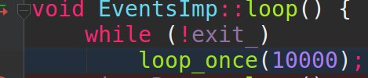

1.1.1 EventBase repeat time out
Let’s see a demo, a task will run after 10000ms, and repeat run at a interval of 1000ms

base.runAfter(10000, [](){
info("a task in runAfter 10000ms interval 1000ms, now I will sleep 5000ms");
std::this_thread::sleep_for(std::chrono::milliseconds(5000));
info("Now I wake up");
}, 1000);

Log output as below:

2017/08/27-18:51:39.531537 timer.cc:9 program begin
2017/08/27-18:51:49.541640 timer.cc:22 a task in runAfter 10000ms interval 1000ms, now I will sleep 5000ms
2017/08/27-18:51:54.541755 timer.cc:24 Now I wake up
2017/08/27-18:51:54.541784 timer.cc:22 a task in runAfter 10000ms interval 1000ms, now I will sleep 5000ms
2017/08/27-18:51:59.541908 timer.cc:24 Now I wake up
2017/08/27-18:51:59.541936 timer.cc:22 a task in runAfter 10000ms interval 1000ms, now I will sleep 5000ms
2017/08/27-18:52:04.542102 timer.cc:24 Now I wake up

We can see that, if the execute time of task is longer than the task, the task won’t run at the next interval time.

Here is the key class, and code snippet

struct TimerRepeatable {
int64_t at; //current timer timeout timestamp
int64_t interval;
TimerId timerid;
Task cb;
};
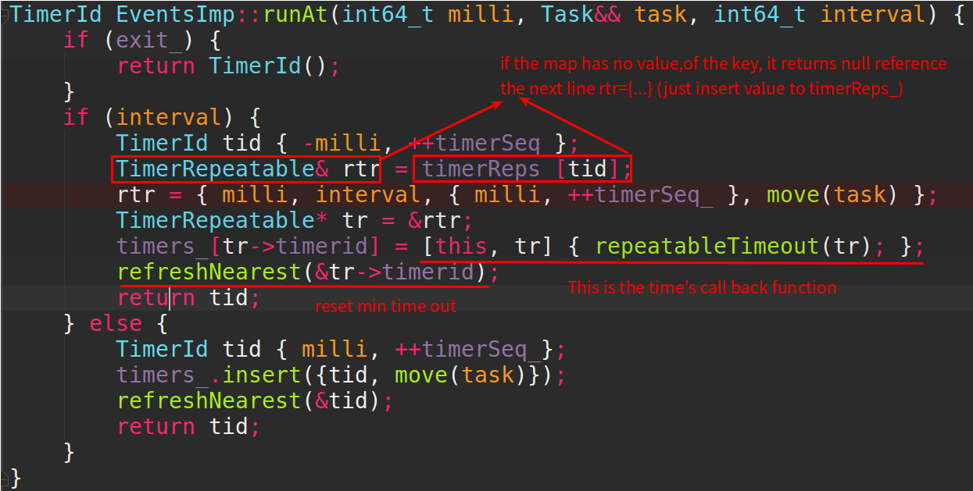
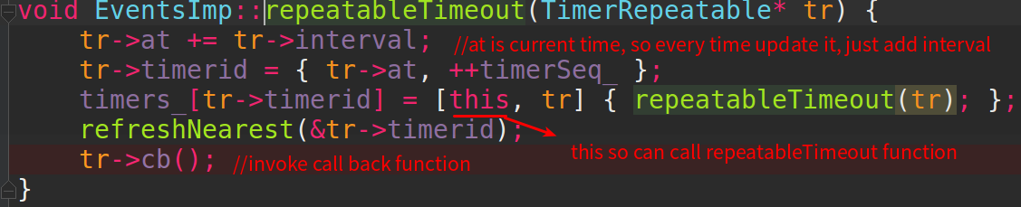
We can see that every time invoke runAt function, we refresh nearest function to update minimum time out, so the task will be executed in specified time.
For repeating execute it, we insert the package the task function and every time invoke it we update the timer’s id, and refresh nearest and the minimum time out, then invoke the call back function.

1.1.1 TimerId/
typedef std::pair<int64_t, int64_t> TimerId;
typedef std::function<void()> Task;

struct EventsImp {
......
std::atomic<int64_t> timerSeq_;
std::map<TimerId, Task> timers_;
......
}

TimerId EventsImp::runAt(int64_t milli, Task&& task, int64_t interval) {
.....
if (interval) {
TimerId tid { -milli, ++timerSeq_};
TimerRepeatable& rtr = timerReps_[tid];
rtr = { milli, interval, { milli, ++timerSeq_ }, move(task) };
TimerRepeatable* tr = &rtr;
timers_[tr->timerid] = [this, tr] { repeatableTimeout(tr); };
refreshNearest(&tr->timerid);
return tid;
}//(interval=0)only run once, no intervel repate
else{
TimerId tid { milli, ++timerSeq_};
timers_.insert({tid, move(task)});
refreshNearest(&tid);
return tid;
}
}
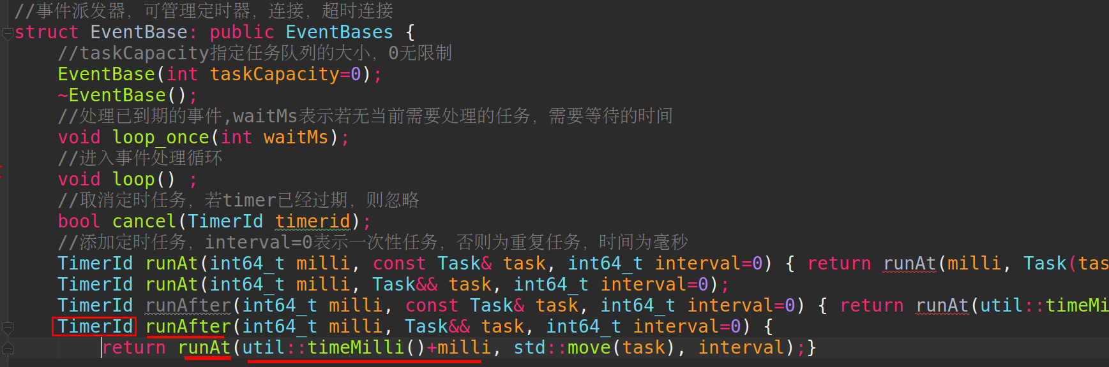

Demo analysis

1.1 examples->codec-cli.cc

1.1.1 no server only client(reconnect)
int main(int argc, const char* argv[]) {
setloglevel("TRACE");
EventBase base;
Signal::signal(SIGINT, [&]{ base.exit(); });
//connect to 127.0.0.1 port 2099, time out 3000ms
TcpConnPtr con = TcpConn::createConnection(&base, "127.0.0.1", 2099, 3000);
//reconnect time interval 3000ms
con->setReconnectInterval(3000);
con->onMsg(new LengthCodec, [](const TcpConnPtr& con, Slice msg) {
info("recv msg: %.*s", (int)msg.size(), msg.data());
});
con->onState([=](const TcpConnPtr& con) {
info("onState called state: %d", con->getState());
if (con->getState() == TcpConn::Connected) {
con->sendMsg("hello");
}
});
base.loop();
info("program exited");
}

Let’s see if we don’t start server, how the client performs

INFO handy/poller.cc:39 poller epoll 3 created

TRACE handy/event_base.cc:130 wakeup pipe created 4 5

TRACE handy/poller.cc:56 adding channel 1 fd 4 events 1 epoll 3

TRACE handy/poller.cc:56 adding channel 2 fd 6 events 5 epoll 3

1.1.1 CLion cmake build libhandy_lib.a
Navigate ->Run ->Build
