chapter 1 2
1.1 dir & file 2
1.1.1 create new file 2
1.1.2 locate file 2
1.1.2 delete file 2
1.1.2 upload download file 2
1.1.2 file size 2
1.1.2 back to last dir 3
1.1.2 move rename 3
1.1.2 clear file content not delete it 3
1.1.2 tree dir structure 3
1.1 ubuntu sys 4
1.1.1 sys version 4
1.1.1 change to root 4
1.1 process port 4
1.1.1 port in use kill process 4
1.1.1 run process background 4
1.1 read file 4
1.1.1 tail 4
1.1.1 vi file line count 4
1.1.1 less 5
1.1 zip unzip tar file 6
1.1 run install 6
1.1.1 soft/hard link ln 6
1.1.1 source 6
1.1.1 export 6
1.1.1 make ./configure make install 6
1.1.1 ldconfig 7
chapter vim 7

chapter 1

1.1 dir & file

1.1.1 create new file
创建文件
> newfile (如果存在的话会空文件覆盖原有的)
touch newfile

1.1.2 locate/find file
查看文件的位置
locate tesseract | grep so

locate is fast but bases its results on a local database that needs to be updated for it to find a recent result. Command updatedb is usually run daily by cron to update the default database.

This means that the database locate searches wasn't updated after the file was created on the system. So, let's update the database, which can be done using the updatedb command. Here's how you do that: sudo updatedb
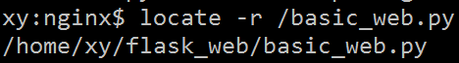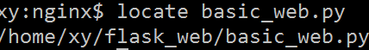
Display only the Count
To get the count of number of matching entry, use locate -c as shown below.
$ locate -c httpd.conf
3

Ignore Case in Locate Output
The locate command by default is configured to accept the file name in a case sensitive manner. In order to make the results case insensitive, we can use the -i option :
locate -i new.txt
/tmp/NEW.txt
/tmp/new.txt

find is real time so does not depend on a local database. Being real time it is also slower than locate.

1.1.2 find command
在运行一个非常消耗资源的find命令时，很多人都倾向于把它放在后台执行，因为遍历一个大的文件系统可能会花费很长的时间
find命令的一般形式为；
find pathname -options [-print -exec -ok ...]
find / -name "filename"
目的：在根目录“/”开始搜被称为filename的文件，“filename”文件名可以包含通配符（*，？）

I have one file name as "process.txt" in my system.
Did you try: find . -name "process.txt" This will search the current directory for a file called process.txt
find / -name process.txt
Run updatedb as root, then locate process.txt

Regular files only
$ find . -name 'my*' -type f

Search all directories
$ find / -name myfile -type f -print
This searches every directory for a regular file whose name is myfile and prints it to the screen.

1.1.2 find directory by name
find / -xdev 2>/dev/null -name "nginx"
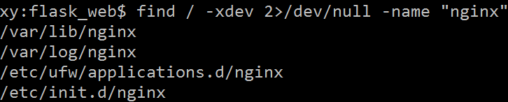

1.1.2 exec / find

1.1.2 delete file
删除文件 rm -f filename
example：
rm -f 2.mp3 blabla.mp3 rm -f {2,blabla}.mp3
rm -f *.mp3 It will remove all files ending with .mp3
rm -r dir 递归的删除整个目录里面的内容

1.1.2 upload download file
上传大文件的时候稳定点
rz -bey
下载一个文件 sz filename
下载多个文件 sz filename1 filename2
下载dir目录下的所有文件，不包含dir下的文件夹 sz dir/*
下载文件存放位置在securtCRT中设置，位于：
英文版 options — session options — X/Y/Zmodem。

1.1.2 file size
查看文件 ls 以M的方式显示大小
ls -l --block-size=M
ls -lh human readable file sizes, long format
ls -lhS sort by size
sudo aptget instaLl lua5.2

1.1.2 back to last dir
cd - 命令回到之前的目录

1.1.2 move rename
How do I rename a directory via the command line

have got the directory /home/user/oldname and I want to rename it to
/home/user/newname. How can I do this in a terminal?

mv /home/user/oldname /home/user/newname

For who trying to move folder, on ubuntu using putty just use the following command:
sudo mv /fromPath/ /toPath/
for exemple:
sudo mv /root/folder1 /home/folder2/
"/" in the end :this mean you are going to move folder1 inside folder2
else you gonna get "no such file or directory"

1.1.2 (cp -a dir dir)copy directory
I want to copy a directory from one place to another via the command line

The -a flag is probably what you are looking for:
cp -a /path/from /path/to
The -a flag turns on recursive behaviour (which can also be done with the -R flag), and will also attempt to preserve metadata such as file ownership, permissions, timestamps, links, etc.

sudo cp -R Source_Folder Destination_Folder
This command can also be used to copy files, by just removing the "-R" which is used to copy the recursive structure of internal folders (if there are any in the Source_Folder path that we mentioned.)
One more example:
sudo cp -R /var/www/* /home/test_user/

1.1.2 clear file content not delete it
clear log file （清空log文件而不删除文件）
> error.log
truncate -s 0 /path/to/error.log

1.1.2 tree dir structure
tree ( 查看项目的目录结构) sudo apt-get install tree

tree
tree /path/to/directory
tree [options]
tree [options] /path/to/directory
The -a option should be passed to see all files.
By default tree does not print hidden files (those beginning with a dot ‘.’).

To list directories only, run:
tree -d

etc
|-- abrt
| |-- abrt-action-save-package-data.conf
| |-- abrt.conf
| |-- gpg_keys
| `-- plugins
| |-- CCpp.conf
| `-- python.conf

1.1.2 list hidden files
ls -a list all files

ls -ld .?*

Will only list hidden files .

Explain :

-l use a long listing format

-d, --directory
list directory entries instead of contents, and do not derefer‐
ence symbolic links

.?* will only state hidden files

ls -d .!(|.)

1.1.2 ln -s dir
use the ln command to do symbolic links.

ln -s <real folder> <link folder>
in this example, you will create link folder that will actually contain what real folder have, and if you save something to link folder it will actually save it into real folder

You can verify the link with the command ls -l which will show an arrow to where the link points.

Note that the folder containing the link must exist, so you would have to create it first.

So in your situation, the commands that you are looking for are

sudo mkdir /Applications/XAMPP/virtual_dir
sudo ln -s /var/www/thumb /Applications/XAMPP/virtual_dir
Again, you can verify that the link was actually made with

ls -l /Applications/XAMPP/virtual_dir

ln -s [source_folder] [link_location]
This will create a link named like source folder, but you can rename the link. This way you can quickly switch content of folder.

link_dir/
real_dir/
/link_dir$ ln -s ../real_dir/* .

/link_dir$ ll
total 8
drwxrwxr-x 2 adminroot adminroot 4096 Aug 17 12:15 ./
drwxrwxr-x 4 adminroot adminroot 4096 Aug 17 12:12 ../
lrwxrwxrwx 1 adminroot adminroot 17 Aug 17 12:15 1.jpg -> ../real_dir/1.jpg
lrwxrwxrwx 1 adminroot adminroot 17 Aug 17 12:15 2.jpg -> ../real_dir/2.jpg

/link_dir$ echo 'hello'>> 1.jpg

/link_dir$ cat 1.jpg
hello

cat ../real_dir/1.jpg
hello

/link_dir$ > 3.jpg

/link_dir$ ll
total 8
drwxrwxr-x 2 adminroot adminroot 4096 Aug 17 12:18 ./
drwxrwxr-x 4 adminroot adminroot 4096 Aug 17 12:12 ../
lrwxrwxrwx 1 adminroot adminroot 17 Aug 17 12:15 1.jpg -> ../real_dir/1.jpg
lrwxrwxrwx 1 adminroot adminroot 17 Aug 17 12:15 2.jpg -> ../real_dir/2.jpg
-rw-rw-r-- 1 adminroot adminroot 0 Aug 17 12:18 3.jpg

ll ../real_dir/
total 12
drwxrwxr-x 2 adminroot adminroot 4096 Aug 17 12:11 ./
drwxrwxr-x 4 adminroot adminroot 4096 Aug 17 12:12 ../
-rw-rw-r-- 1 adminroot adminroot 6 Aug 17 12:17 1.jpg
-rw-rw-r-- 1 adminroot adminroot 0 Aug 17 12:11 2.jpg

1.1.2 (test -f )command to check file exists
test -f filename && echo "File exists"

1.1.2 batch rename extension
How do I rename the extension for a batch of files?
In a directory, I have a bunch of *.html files.
I'd like to rename them all to *.txt
I use the bash shell.

for file in *.html; do
mv "$file" "`basename "$file" .html`.txt"
done

EDIT: As pointed out in the comments, this does not work for filenames with spaces in them without proper quoting (now added above). When working purely on your own files that you know do not have spaces in the filenames this will work but whenever you write something that may be reused at a later time, do not skip proper quoting.

if using bash, no need for external commands like sed, basename, rename, expr...etc

for file in *.html
do
mv "$file" "${file%.html}.txt"
done

rename 's/\.html$/\.txt/' *.html
does exactly what you want.

1.1.2 argument list too long
Argument list too long error for rm, cp, mv commands

for f in *.pdf; do rm "$f"; done
for f in *.pdf; do rm $f; done

echo *.png | xargs -n 2 rm -f
echo *.jpg | xargs -n 2 rename 's/\.jpg$/\.png/' *.jpg

1.1.2 default echo files
images/ad_train# echo *.png
- png 2.png

directly in *.JPEG this defaultly denotes all .JPEG files
for file in *.JPEG; do mv "$file" "${file%.jpg}.JPEG"; done;

for f in *.zip; do sudo unzip -j $f;done #unzip all the zip files

1.1 ubuntu sys

1.1.1 sys/kernel version
lsb_release -a
uname -a for all information regarding the kernel version,

uname -r for the exact kernel version
lsb_release -afor all information related to the Ubuntu version,

lsb_release -r for the exact version
sudo fdisk -l for partition information with all details.

1.1.1 32bit or 64bit
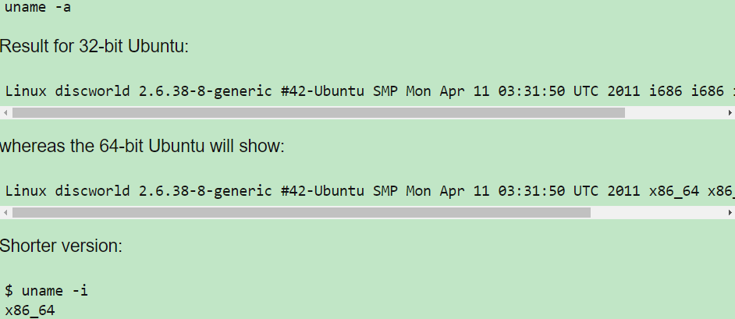

1.1.1 change to root/sudo -i
sudo -i 切换到 root运行 ，exit退出返回到之前的用户

1.1.1 sys memory
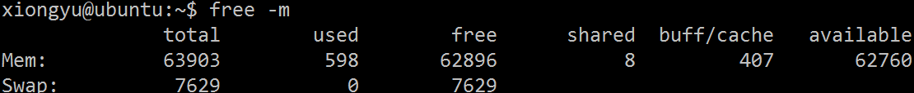
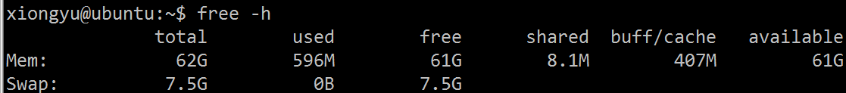
cat /proc/meminfo
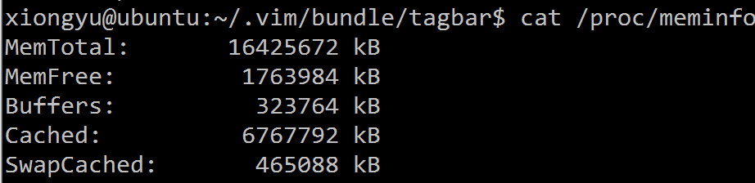
This will convert any kB lines to MB:
awk '$3=="kB"{$2=$2/1024;$3="MB"} 1' /proc/meminfo | column -t
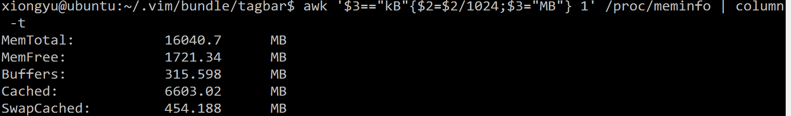
This version converts to gigabytes:
awk '$3=="kB"{$2=$2/1024**2;$3="GB";} 1' /proc/meminfo | column -t
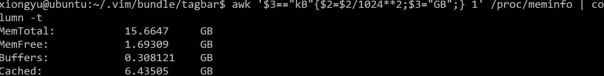
For completeness, this will convert to MB or GB as appropriate:
awk '$3=="kB"{if ($2>1024**2){$2=$2/1024**2;$3="GB";} else if ($2>1024){$2=$2/1024;$3="MB";}
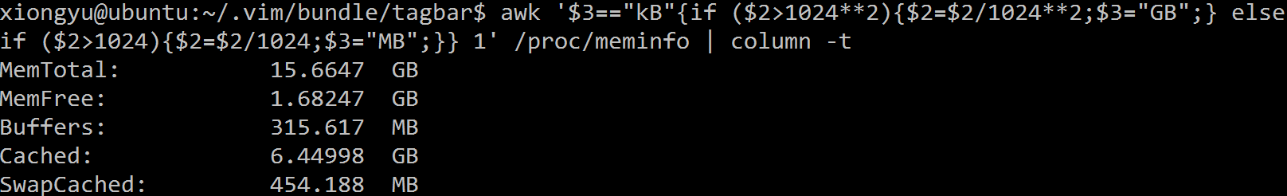

1.1.1 ulimit (some para about sys like file max)
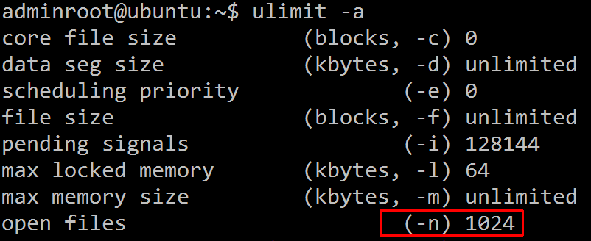

1.1.1 change sys time
You can set the system date with this command:
sudo date --set="2015-09-30 10:05:59.990"

1.1.1 timestamp to datetime
date -d @1278999698 +'%Y-%m-%d %H:%M:%S' Where the number behind @ is is the number in seconds
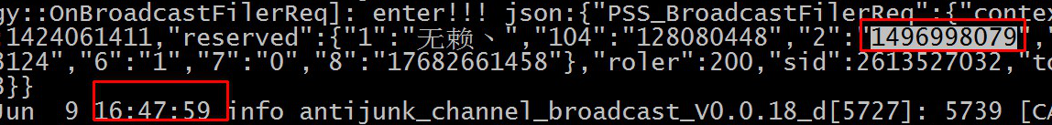

1.1.1 navidia info
Nvidia cards, type
nvidia-smi -q

nvidia-smi -q | grep 'GPU 0000'
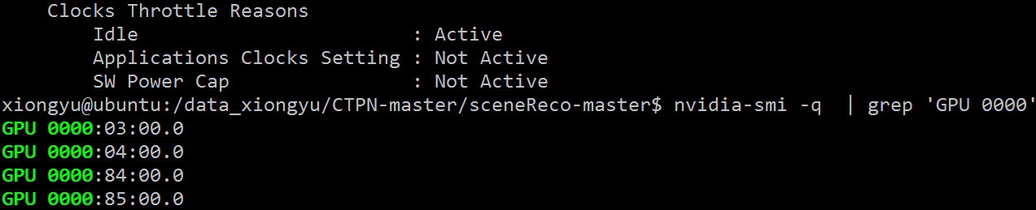
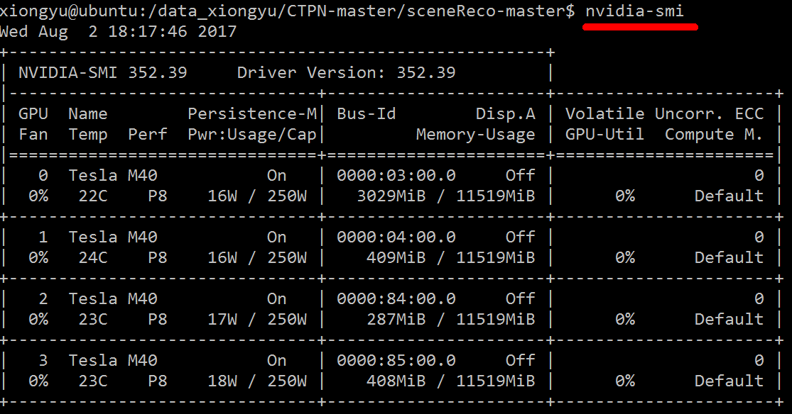
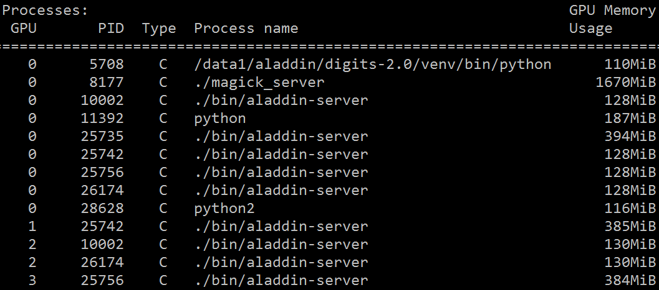

1.1 process port

1.1.1 lsof port in use kill process
sudo lsof -t -i:9001
sudo kill $(sudo lsof -t -i:9001) //kill the process
fuser -n tcp -k 9001 //kill the process

1.1.1 nohub run process background
nohub (run process as a background process)
eg1. nohup ./yourscript &
eg2. nohup python main.py &

What's the difference between nohup and ampersand
myprocess.out & would run the process in background using a subshell. If the current shell is terminated (say by logout), all subshells are also terminated so the background process would also be terminated. The nohup command ignores the HUP signal and thus even if the current shell is terminated, the subshell and the myprocess.out would continue to run in the background. Another difference is that & alone doesn't redirect the stdout/stderr so if there are any output or error, those are displayed on the terminal. nohup on the other hand redirect the stdout/stderr to nohup.out or $HOME/nohup.out.

1.1.1 command ; || && $？
(1) cmd1 ;cmd2 ;cmd3 ( ; 不考虑命令的相关性，连续的执行命令)
(2) cmd1 && cmd2 (如果cmd1执行完毕且正确（$?=0）,则执行cmd2。cmd1错误则cmd2不执行)
(3) cmd1 || cmd2 (如果cmd1 执行完毕且正确（$?=0）,则不执行 cmd2，否则执行cmd2)
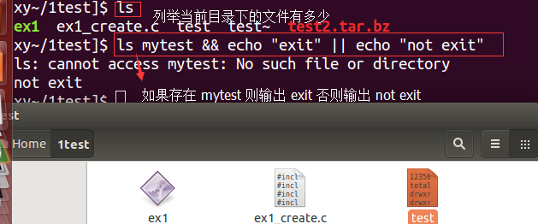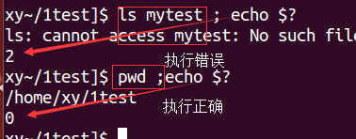

1.1.1 ps process
进程的查看： ps [-aux] [-ljf] (其中 -a 代表将所有的进程显示出来 -u 代表有效用户组的信息显示出来 -x通常和 a结合输出完整的信息 -l 详细的输出PID 的信息)
例如： ps -l (仅查看自己的bash 相关的进程)
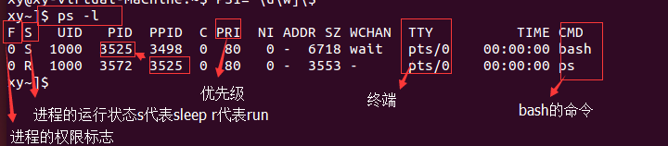
ps -aux
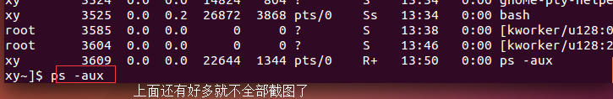
You can use
ps -ax | grep application name
If your searching for firefox type in terminal like ps -ax | grep firefox, it shows the process id of corresponding application. You can stop that application by kill command if process id=1317,
kill -9 1317
2. Display process by user
To filter the processes by the owning user use the "-u" option followed by the username. Multiple usernames can be provided separated by a comma.
下例中-f则会输出更加详细的详细，如程序是这样运行的，例如下面的
python main.py
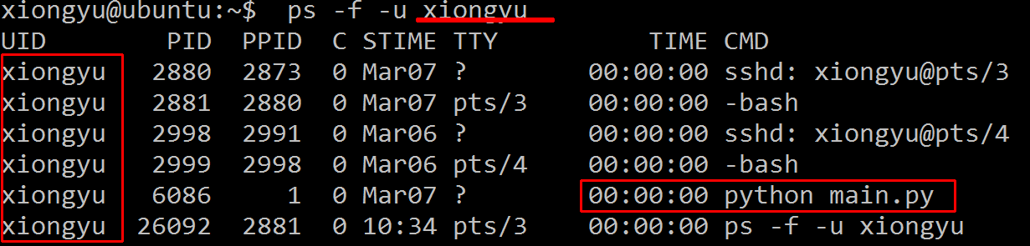
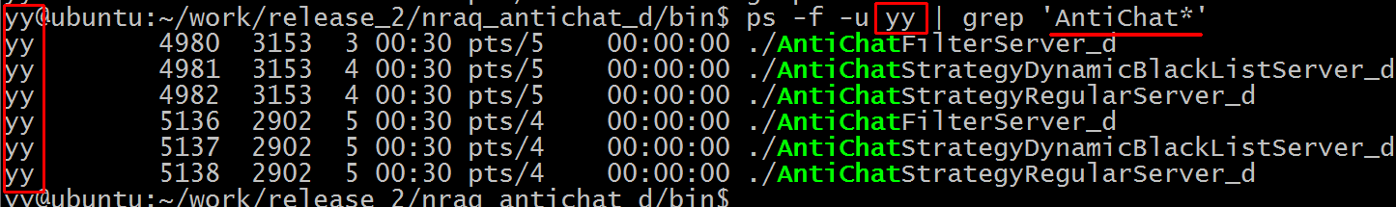
3. Show process by name or process id
To display processes by process id, use the "-p" option and provides the process ids separated by comma.
$ ps -f -p 3150,7298,6544
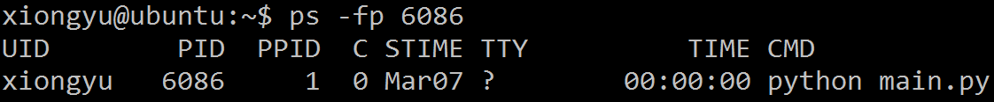
ps -fC apache2
To search the processes by their name or command use the "-C" option followed by the search term.
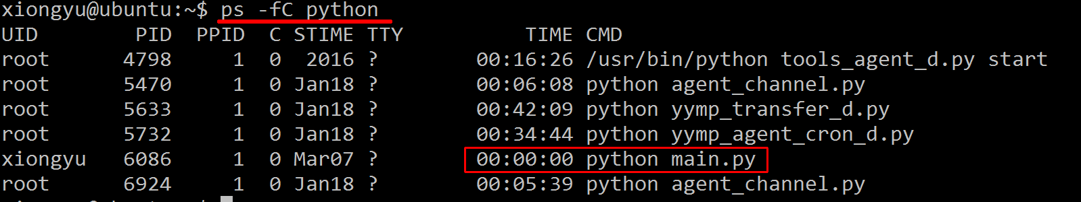
The "-C" must be provided with the exact process name and it cannot actually search with a partial name or wildcard. To search the process list more flexibly, the usual grep command has to be used
ps -ef | grep python
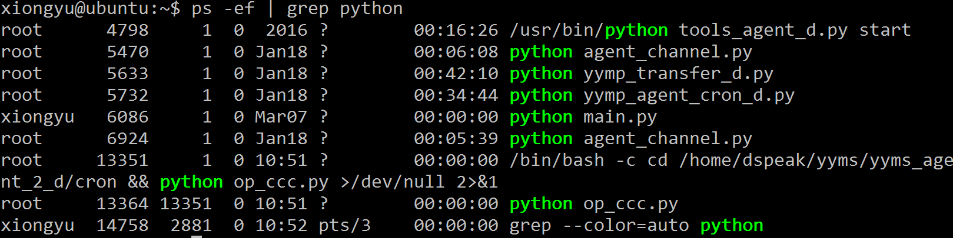
4. Sort process by cpu or memory usage
System administrators often want to find out processes that are consuming lots of memory or CPU. The sort option will sort the process list based on a particular field or parameter.
Multiple fields can be specified with the "--sort" option separated by a comma. Additionally the fields can be prefixed with a "-" or "+" symbol indicating descending or ascending sort respectively. There are lots of parameters on which the process list can be sorted. Check the man page for the complete list.
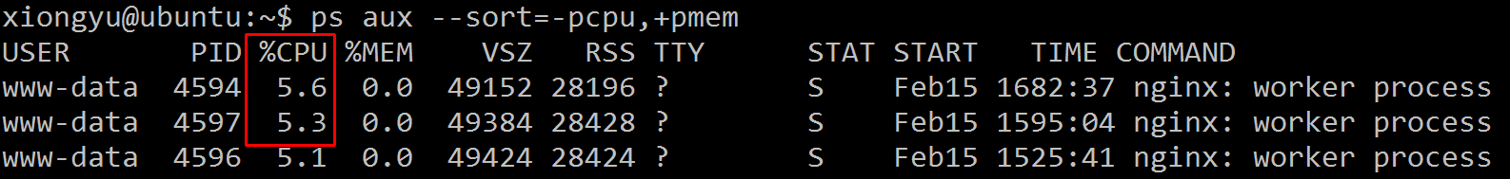
Display the top 5 processes consuming most of the cpu.
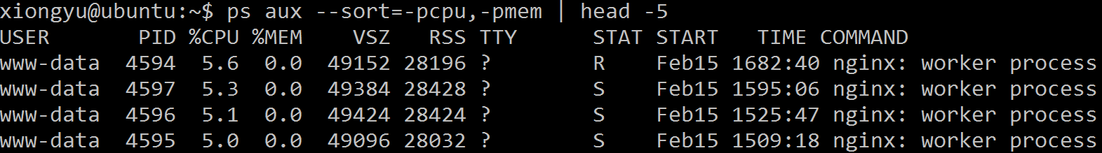
Show processes in a hierarchy
ps -ae --forest
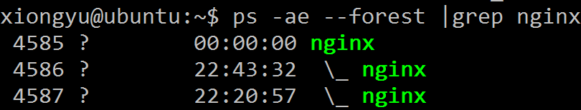
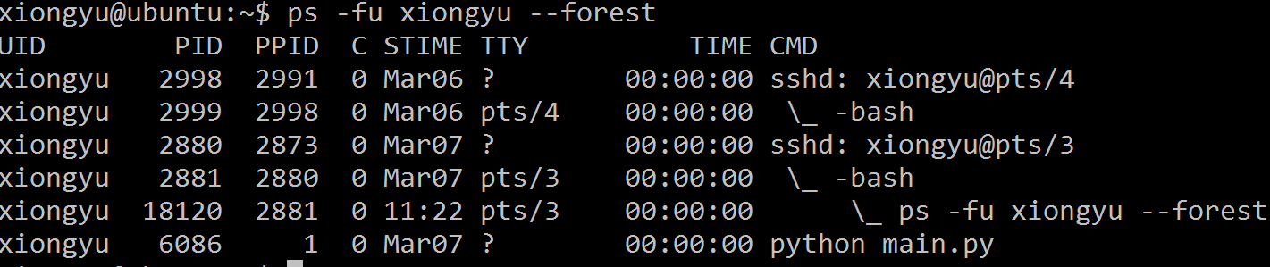
7. Display threads of a process
The "-L" option will display the threads along with the processes. It can be used to display all threads of a particular process or all processes.
The following command shall display all the threads owned by the process with id 3150.
$ ps -p 3150 -L
8. Change the columns to display
The ps command can be configured to show a selected list of columns only.
The following command shows only the pid, username, cpu, memory and command columns.
ps -e -o pid,uname,pcpu,pmem,comm
It is possible to rename the column labels
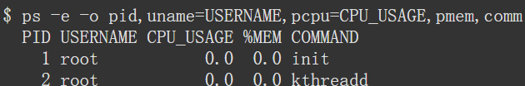
9. Display elapsed time of processes
The elapsed time indicates, how long the process has been running for. The column for elapsed time is not shown by default, and has to be brought in using the "-o" option
$ ps -e -o pid,comm,etime
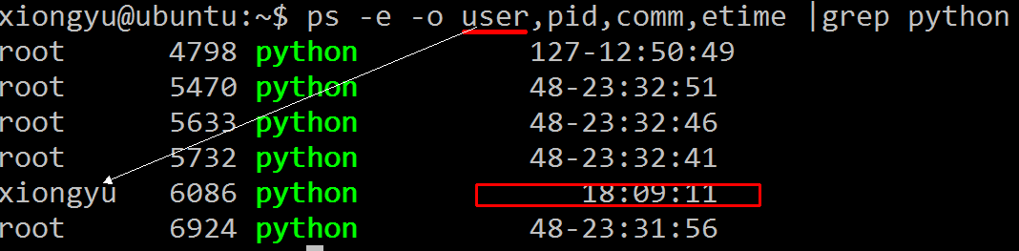
Run ps in dynamic mode
As mentioned in the beginning, the ps command only produces a snapshot of processes, meaning the information produced is static. In case you want the command to be run in a way that makes sure the output gets updated periodically, then you can pass your ps command as an argument to the watch command.
watch -n 2 'ps -aef | grep firefox'
So the above command will make sure that the output of the ps -aef | grep firefox command gets updated after every 2 seconds.
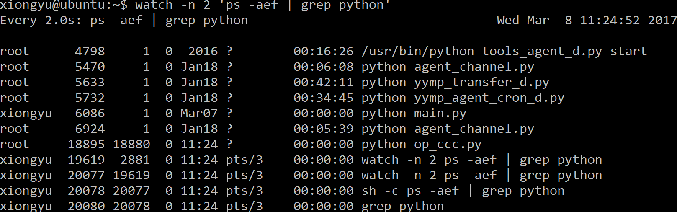
http://www.binarytides.com/linux-ps-command/

1.1.1 process start time
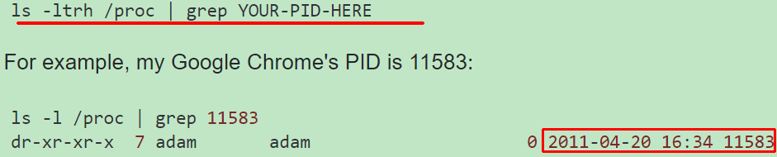

1.1.1 top process
top : 动态的查看进程的变化 top [-d 数字] / top [-bnp]
其中（-d 后面接秒数 整个进程的界面更新的秒数 默认的为 5 ,-p 可接进程号查看指定进程）
例子（1） 2秒为单位查看进程的动态变化
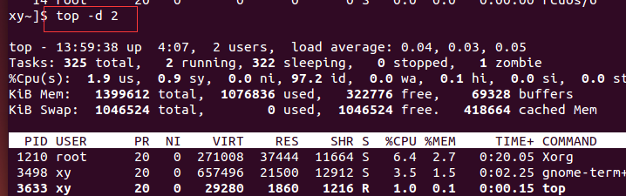
例子（2） 对指定的进程进行检测
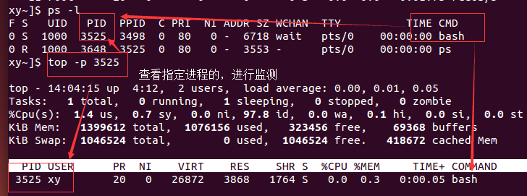
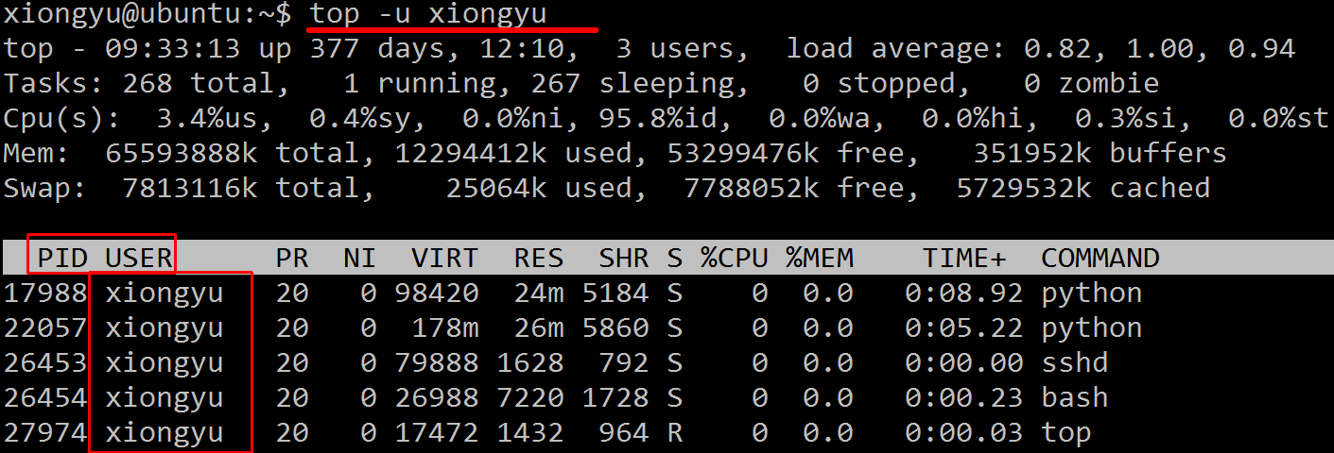

1.1.1 top parameter meaning
统计信息区前五行是系统整体的统计信息。第一行是任务队列信息，同 uptime 命令的执行结果。其内容如下：

01:06:48 当前时间
up 1:22 系统运行时间，格式为时:分
1 user 当前登录用户数
load average: 0.06, 0.60, 0.48 系统负载，即任务队列的平均长度。三个数值分别为 1分钟、5分钟、15分钟前到现在的平均值。

total 进程总数
running 正在运行的进程数 sleeping 睡眠的进程数 stopped 停止的进程数 zombie 僵尸进程数
Cpu(s):
0.3% us 用户空间占用CPU百分比 1.0% sy 内核空间占用CPU百分比
0.0% ni 用户进程空间内改变过优先级的进程占用CPU百分比
98.7% id 空闲CPU百分比 0.0% wa 等待输入输出的CPU时间百分比
0.0%hi：硬件CPU中断占用百分比 0.0%si：软中断占用百分比 0.0%st：虚拟机占用百分比

top //每隔5秒显式所有进程的资源占用情况
top -d 2 //每隔2秒显式所有进程的资源占用情况
top -c //每隔5秒显式进程的资源占用情况，并显示进程的命令行参数(默认只有进程名)
top -p 12345 -p 6789//每隔5秒显示pid是12345和pid是6789的两个进程的资源占用情况
top -d 2 -c -p 123456 //每隔2秒显示pid是12345的进程的资源使用情况，并显式该进程启动的命令行参数

1.1.1 kill process
杀掉指定的进程 kill -s 9 pid
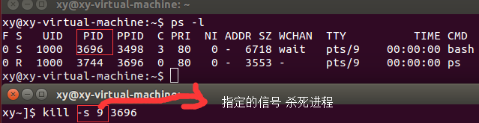

1.1.1 (pkill)kill process by pattern name
From man 1 pkill

-f The pattern is normally only matched against the process name.
When -f is set, the full command line is used.
Which means, for example, if we see these lines in ps aux:

apache 24268 0.0 2.6 388152 27116 ? S Jun13 0:10 /usr/sbin/httpd
apache 24272 0.0 2.6 387944 27104 ? S Jun13 0:09 /usr/sbin/httpd
apache 24319 0.0 2.6 387884 27316 ? S Jun15 0:04 /usr/sbin/httpd
We can kill them all using the pkill -f option:

pkill -f httpd

1. Kill Command – Kill the process by specifying its PID
Example: Kill the firefox process.
ps -ef | grep firefox
1986 ? Sl 7:22 /usr/lib/firefox-3.5.3/firefox
$ kill -9 1986

2. Killall Command – Kill processes by name
Instead of specifying a process by its PID, you can specify the name of the process. If more than one process runs with that name, all of them will be killed.
Example: Kill all the firefox processes
killall -9 firefox

3. Pkill Command – Send signal to the process based on its name
You can send signal to any process by specifying the full name or partial name. So there is no need for you to find out the PID of the process to send the signal.

1.1.1 xargs
xargs command is designed to construct argument lists and invoke other utility. xargs reads items from the standard input or pipes, delimited by blanks or newlines, and executes the command one or more times with any initial-arguments followed by items read from standard input. Blank lines on the standard input are ignored.
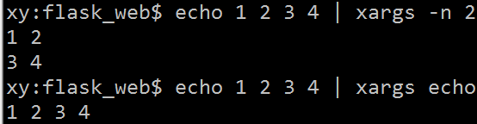
Xargs Example 1- with and without xargs
in this example of xargs command we will see how output changes with use of xargs command in unix or Linux. Here is the output of find command without xargs first and than with xargs, you can clearly see that multiline output is converted into single line:
devuser@system:/etc find . -name "*bash*"
./bash.bashrc
./bash.bash_logout

devuser@system:/etc find . -name "*bash*" | xargs
./bash.bashrc ./bash.bash_logout ./defaults/etc/bash.bashrc
Xargs Example 2 – xargs and grep
Another common use fo unix xargs command is to first find the files and then look for specific keyword on that file using grep command. here is an example of xargs command that does it
find . -name "*.java" | xargs grep "Stock"
This will first find all java files from current directory or below and than on each java file look for word "Stocks"if you have your development environment setup in Linux or unix this is a great tool to find function references or class references on java files.

Xargs Example 3 – delete temporary file using find and xargs
Another common example of xargs command in unix is removing temporary files from system.
find /tmp -name "*.tmp" | xargs rm
This will remove all .tmp file from /tmp or below directory. xargs in unix is very fast as compared to deleting single file at a time which can also be done by using find command alone

1.1.1 free memory
例子（4） free : 查看内存的使用情况
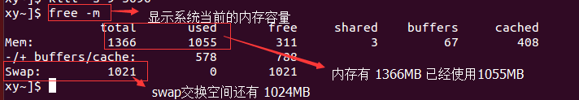

1.1.1 fg & job
工作管理相关 ：如我们在bash 环境下输入某个命令（解压缩，则必须等到解压缩完成后才能够进行bash的命令使用，那么怎么样使在输入解压缩的同时还可以，输入其他的命令控制呢？办法就是让解压缩在后台运行即可，这样我们就可以使用bash 做其他的事情了）
- 命令 & (在命令的后面加上 & 即可以将该命令丢到后台执行)
- 查看当前的后台工作状态 jobs [-lrs] (-l 列出job number 以及PID ，-r 正在运行的程序 -s 后台暂停的程序)
(3) fg %jobnumber (将后台的程序拿到前台运行 fg: foreground )
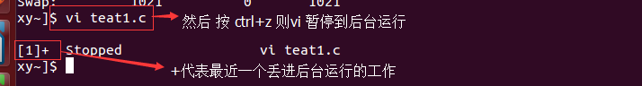

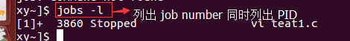
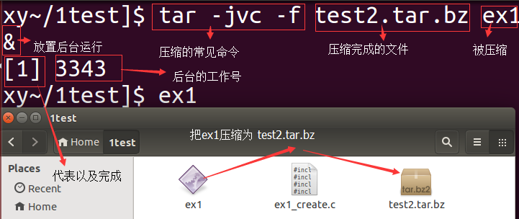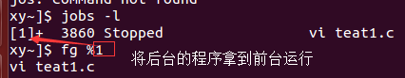

1.1.1 ‘pgrep x’ or ‘ps aux | grep x’
Why does “ps aux | grep x” give better results than “pgrep x”?
I've just tried the following command on my Ubuntu, it doesn't show a thing:
pgrep php5
shouldn't it return the process id of php5(which the following command just does)?: ps aux | grep php5
So,what's the difference between these two commands?
ps aux includes the full command line (path and parameters), while pgrep only looks at the first 15 characters of the executable's names
That means that grepping ps aux output will match anything that occurs in the path or the parameters of a process' binary: e.g. `
ps aux | grep php5 will match /usr/share/php5/i-am-a-perl-script.pl
but pgrep php5 won't
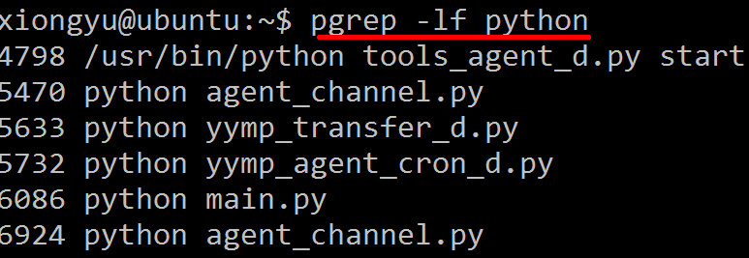
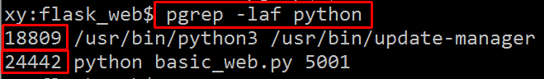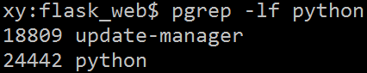

1.1.1 grep(kill process)
When I check list of processes and 'grep' out those that are interesting for me, the grep itself is also included in the results. For example, to list terminals:

$ ps aux | grep terminal

user 2064 0.0 0.6 181452 26460 ? Sl Feb13 5:41 gnome-terminal --working-directory=..
user 2979 0.0 0.0 4192 796 pts/3 S+ 11:07 0:00 grep --color=auto terminal

Normally I use ps aux | grep something | grep -v grep to get rid of the last entry... but it is not elegant :)
Do you have a more elegant hack to solve this issue (apart of wrapping all the command into a separate script, which is also not bad)

The usual trick is this:
ps aux | grep '[t]erminal'
This will match lines containing terminal, which grep '[t]erminal' does not! It also works on many flavours of Unix.
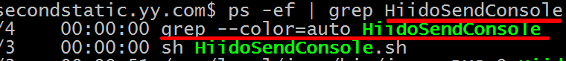

1.1 read file

1.1.1 tail
View a log file in Linux dynamically
tail -f log.txt

1.1.1 vi file line count
vi file line count
:echo line('$')
The simplest way is to press ctrl-g, which will reveal the filename,
current line, the line count

1.1.1 less
less命令查看 log 文件
less file.log 打开了文件从第一行开始，若想移到最后一行 shift+g ctrl+b往前一页一页翻页查看
j - 向前移动一行
k - 向后移动一行
G - 移动到最后一行
g - 移动到第一行
ctrl + F - 向前移动一屏
ctrl + B - 向后移动一屏
q / ZZ - 退出 less 命令
模仿 tail -f Press F
向下10行 10j – 10
向上10行 10k
CTRL+G – show the current file name along with line, byte and percentage statistics.

向前搜索In forward: /keyword
向后搜索In backward: ?keyword
n - continue searching for your pattern in the same direction
N - continue searching for your pattern in the opposite direction
&pattern – display only the matching lines, not all. &keyword

ESC-/pattern
Same as "/*".
ESC-?pattern
Same as "?*".
n Repeat previous search
N Repeat previous search, but in the reverse direction.
ESC-n Repeat previous search
ESC-N Repeat previous search, but in the reverse direction and crossing file boundaries.

history | less -Ip 'lsof' （查看含有 'lsof' 命令）

-i or --ignore-case
-I or --IGNORE-CASE Like -i, but searches ignore case even if the pattern contains uppercase letters.

1.1.1 head
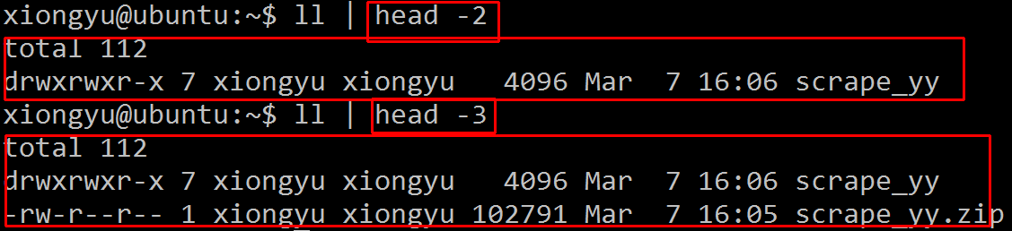
Head prints the first N number of data of the given input. By default, it prints first 10 lines of each given file.
1. Print the first N number of lines
To view the first N number of lines, pass the file name as an argument with -n option as shown below.
$ head -n 5 flavours.txt
2. Print N number of lines by specifying N with –
You don’t even need to pass the -n option as an argument, simply specify the N number of lines followed by ‘-‘ as shown below.
$ head -4 flavours.txt
3. Print all but not the last N lines
By placing ‘-‘ in front of the number with -n option, it prints all the lines of each file but not the last N lines as shown below,
$ head -n -5 flavours.txt
Print the N number of bytes
You can use the -c option to print the N number of bytes from the initial part of file.
$ head -c 5 flavours.txt
Ubuntu
Passing Output of Other command to Head Input
You may pass the output of other commands to the head command via pipe as shown below,
$ ls | head

1.1.1 cat/tac/rev/paste
1. Display the contents of a file
When you pass the filename as an argument to cat, it displays the contents of the file as shown below.

Copy File Content
Redirection symbols in unix plays an important role in processing the standard file descriptor contents. Using it, you can copy the contents of one file into another as shown below.
$ cat program.pl >backup_prgm.pl

Concatenate Contents of Multiple Files
Through cat command, you will be able to concatenate contents of more than one file into a new file.
For example, the codes from program.pl and program2.pl gets combined into a new file all_pgrm.pl.
$ cat program.pl program2.pl >all_pgrm.pl

Display Line numbers
To display the contents of a file with the line number in front of each line, use option -n. The following example, prints the line number for the lines from program.pl,
$ cat -n program.pl

Display File Content in Reverse
tac is the reverse of cat. As you can imagine, tac will just display the contents of a file in reverse order (lines from bottom is displayed first).

rev command – Reverse the order of characters in every line

3. paste command – Merge file lines

Paste the line1 of file1, file2, .. fileN into the line1 of the output. It will repeat the same for all lines. Each file’s line will be delimited by tab.
Paste output:

$ paste f1 f2 f3
f1-line1<tab>f2-line1<tab>f3-line1
f1-line2<tab>f2-line2<tab>f3-line2
cat emp-number.txt  100  200  300 | cat emp-firstname.txt  Emma  Alex  Madison | cat emp-lastname.txt  Thomas  Jason  Randy
paste emp-number.txt emp-firstname.txt emp-lastname.txt
100 Emma Thomas
200 Alex Jason
300 Madison Randy

1.1.1 tee > (redirect output)
二数据流重定向（可以将要输出到屏幕上面的数据重定向到文件）
标准输入（stdin）: 代码为0，使用<或<<
标准输出（stdout）: 代码为 1 使用 > 或 >> （>覆盖源文件的内容 >>在文件中追加）
标准错误输出（stderr）: 代码为 2 使用 > 或 >>
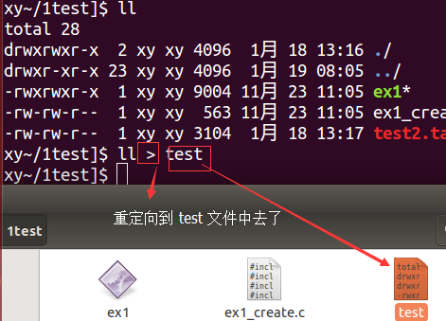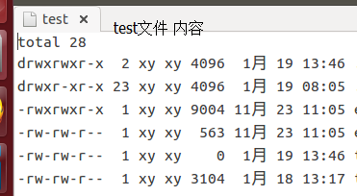
上面的如果 test中原本有数据则会被覆盖，如果想以追加的方式输出到test中则: ll >> test
上面讲的是 standard output 如果是 standard error output 呢？ 2> 与 2>> 。>在前面无数字的情况下默认的是 standard output 。1> : 覆盖的方式将正确的数据输出到指定的文件。 1>> 以累加的方式。 2> : 以覆盖的方式将错误的数据输出到文件或设备。2>> : 以累加的方式。
例子：将 ./ex1 这个程序的正确的和错误输出到同一个文件outfile 则
./ex1 > outfile 2>&1 或者 ./ex1 &> outfile

How do I save terminal output to a file?
Yes it is possible, just redirect the output to a file:

The standard output stream will be redirected to the file only, it will not be visible in the terminal. If the file already exists, it gets overwritten.
command >> output.txt
utput stream will be redirected to the file only

command 2> output.txt
The standard error stream will be redirected to the file only, it will not be visible in the terminal. If the file already exists, it gets overwritten.
command 2>> output.txt
The standard error stream will be redirected to the file only, it will not be visible in the terminal. If the file already exists, the new data will get appended to the end of the file.

command &> output.txt
Both the standard output and standard error stream will be redirected to the file only, nothing will be visible in the terminal. If the file already exists, it gets overwritten.
command &>> output.txt
Both the standard output and standard error stream will be redirected to the file appended to the end of the file..

command | tee output.txt

The standard output stream will be copied to the file, it will still be visible in the terminal. If the file already exists, it gets overwritten.
command | tee -a output.txt

The standard output stream will be copied to the file, it will still be visible in the terminal. If the file already exists, the new data will get appended to the end of the file

command |& tee output.txt

Both the standard output and standard error streams will be copied to the file while still being visible in the terminal. If the file already exists, it gets overwritten.
command |& tee -a output.txt

Both the standard output and standard error streams will be copied to the file while still being visible in the terminal. If the file already exists, the new data will get appended to the end of the file.

1.1.1 /dev/null
Technically /dev/null is defined as a null device. Anything written to it is lost forever. If you read the wiki description of /dev/null, you will get to know lots of jargons/metaphors written/referred by UNIX techies a lot. In this article, we will concentrate on the importance of /dev/null, why it is there, and how to use it.
Importance
When things written to it are lost forever, then why do we need it? This is a valid questions, but we need /dev/null/ to lose information. That's correct, to explain let's take an example:

Example 1:

Suppose, you want to list all files of directory /var/tmp/ having word "foo" in its content. To achieve the task, we will write something as:

]$ grep -l foo /var/tmp/*
/var/tmp/storagedata
/var/tmp/storagedata.0
grep: /var/tmp/td.log: Permission denied
So we got two files having word "foo"; but we also an annoying error message which was part of STDERR. We were not interested in any error message, and we wanted to see only those files which I am permitted to read. So, how do I get rid of this error message? Luckily newer version of grep provides a silent option "-s", using which we can get rid of this message. But what if I am working on a traditional system, having traditional grep? What if the system command is not having the silent option? The solution is given below:

Capturing STDOUT only

Using newer grep:
]$ grep -ls foo /var/tmp/*
/var/tmp/storagedata
/var/tmp/storagedata.0

Using traditional grep:
]$ grep -l foo /var/tmp/* 2>/dev/null
/var/tmp/storagedata
/var/tmp/storagedata.0

In general using any system command :
]$ cmd 2>/dev/null
Most of you should have captured the importance of /dev/null by now. In simple words, by using "2>/dev/null", we are asking the shell to redirect the STDERR to /dev/null. This is very useful when we execute system command through a program and expect to get only the STDOUT.

There may also be a case, when we are only interested to see the error message (STDERR), and are not at all interested in STDOUT. To get STDERR, and to discard the STDOUT we will redirect the STDERR to STDOUT and will redirect the STDOUT to /dev/null; as given below:
Capturing STDERR only

]$ cmd 2>&1 1>/dev/null

the blew command pp which is wrong command, so it has error msg, we can redirect the error msg to /dev/null
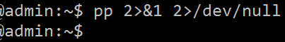
Let’s clear the file contents $ cat /dev/null > file.txt

1.1 zip unzip tar file
压缩，解压缩
1. .zip文件
zip -r archive_name.zip directory_to_compress （compress to zip）
unzip archive_name.zip (decompress)

My version of unzip has a -j option to not create any directory.
unzip -j /path/to/file.zip

for f in *.zip; do sudo unzip -j $f;done #unzip all the zip files

2. .tar 文件
tar -cvf archive_name.tar directory_to_compress
tar -xvf archive_name.tar.gz (解包)
3. .tar.gz 文件
tar -zcvf archive_name.tar.gz directory_to_compress
tar -zxvf archive_name.tar.gz

1.1 run install

1.1.1 soft/hard link ln
ln -s file1 file2 软链接
ln file1 file2 硬链接

1.1.1 source
source . 命令 （通常用于重新执行刚修改的初始化文件）
source ~/.bashrc (环境变量)

The problem is that source is a bash build-in command (not a program - like ls or grep). I think one approach is to login as root and then execute the source command.
sudo -s
source /etc/bash.bashrc

1.1.1 export
export (导入环境变量)
export PATH=$PATH:/home/xy/caffe/python

# These instructions are for bash
$ echo $SHELL
/bin/bash

# Check the current value of your envvar
$ echo $CAFFE_ROOT

# Add the envvar to ~/.profile so it will load automatically when you login
$ echo "export CAFFE_ROOT=/home/username/caffe/" >> ~/.profile

# Load the new configuration
$ source ~/.profile

# Check the new envvar value
$ echo $CAFFE_ROOT
/home/username/caffe/

1.1.1 command not found
sudo vi ~/.bashrc

the end of the file, add
export PATH="/data/services/torch/install/bin:$PATH"
then source ~/.bashrc

1.1.1 make ./configure make install
1、configure，configure是一个shell脚本，它可以自动设定源程序以符合各种不同平台
上Unix系统的特性这一步一般用来生成 Makefile，为下一步的编译做准备，你可以通过在
configure 后加上参数来对安装进行控制，比如代码:./configure –prefix=/usr意思是将
该软件安装在 /usr 下面，执行文件就会安装在 /usr/bin

2、make，这一步就是编译，大多数的源代码包都经过这一步进行编译

3、make insatll这条命令来进行安装

4、make clean：清除编译产生的可执行文件及目标文件(object file，*.o)。

1.1.1 ldconfig
ldconfig （是一个动态链接库管理命令）
1、往/lib和/usr/lib里面加东西，是不用修改/etc/ld.so.conf的，
但是完了之后要调一下ldconfig，不然这个library会找不到
2、ldconfig 命令的用途,主要是在默认搜寻目录(/lib和/usr/lib)以及动态
库配置文件/etc/ld.so.conf内所列的目录下,搜索出可共享的动态 链接库(格式如前介绍,lib*.so*),

1.1.1 use anaconda’s python instead of standard /usr/lib/python
export PATH="/usr/local/texlive/2014/bin/x86_64-linux:$PATH"
export PATH="$HOME/anaconda/bin:$PATH"
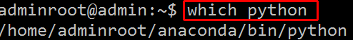

1.1.1 change default python version
$ ls /usr/bin/python*
/usr/bin/python /usr/bin/python2 /usr/bin/python2.7 /usr/bin/python3 /usr/bin/python3.4

To check what is your default python version execute:
$ python --version
Python 2.7.8

Change python version on per user basis

To change a python version on per user basis you simply create an alias within user's home directory. Open ~/.bashrc file and add new alias to change your default python executable:
alias python='/usr/bin/python3.4'

Once you make the above change, re-login or source your .bashrc file:
$ . ~/.bashrc
Check your default python version:
$ python --version
Python 3.4.2

Change python version system-wide

To change python version system-wide we can use update-alternatives command. Logged in as a root user, first list all available python alternatives:
# update-alternatives --list python
update-alternatives: error: no alternatives for python

The above error message means that no python alternatives has been recognized by update-alternatives command. For this reason we need to update our alternatives table and include both python2.7 and python3.4:
# update-alternatives --install /usr/bin/python python /usr/bin/python2.7 1
update-alternatives: using /usr/bin/python2.7 to provide /usr/bin/python (python) in auto mode
# update-alternatives --install /usr/bin/python python /usr/bin/python3.4 2
update-alternatives: using /usr/bin/python3.4 to provide /usr/bin/python (python) in auto mode
# update-alternatives --list python
/usr/bin/python2.7
/usr/bin/python3.4

1.1.1 .so not found
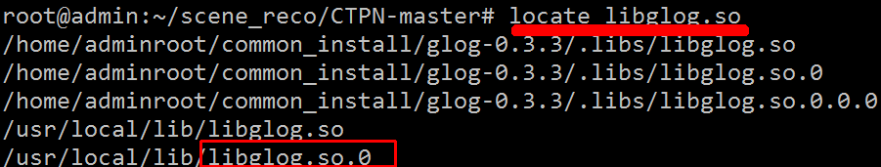

1.1.1 pip install *.whl
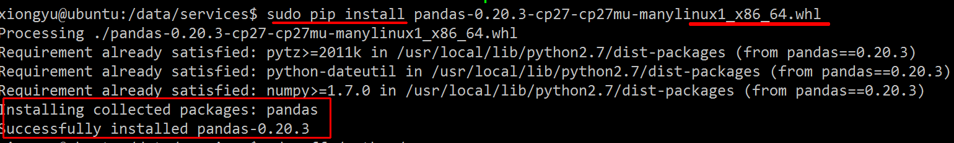

1.1.1 /usr/bin/ld can’t find
/usr/bin/ld: cannot find -lxxx问题总结
linux下编译应用程序常常会出现如下错误：
/usr/bin/ld: cannot find -lxxx
意思是编译过程找不到对应库文件。其中，-lxxx表示链接库文件 libxxx.so。
注：有时候，由于库文件是编译过程临时生成的，如果前面出错也会导致出现这种情况，下面针对的是由于本机系统环境缺失而引起的。。
一般出现这种错误有以下几种原因：
1.系统缺乏对应的库文件；
2.版本不对应；
3.库文件的链接错误；
4.库文件路径设置问题。
对应第一第二种情况，可以通过下载安装lib来解决，ubuntu大多数可以直接通过apt-get来安装：
apt-get install libxxx-dev
一般遇到这种问题笔者第一时间也是会去检查系统是否已安装该lib或者是否已选择正确版本（只是习惯问题），如果还是不能解决问题，那么，引起错误的原因不是链接错误就是库文件路径问题了。
通过find或者locate指令定位到链接文件，查看链接文件是否正确的指向了我们希望的lib，如果不是，用 ln -sf */libxxx.so.x */libxxx.so 指令修改它。

1.1 network

1.1.1 tcpdump
用简单的话来定义tcpdump，就是：dump the traffic on a network，根据使用者的定义对网络上的数据包进行截获的包分析工具。 tcpdump可以将网络中传送的数据包的“头”完全截获下来提供分析。它支持针对网络层、协议、主机、网络或端口的过滤，并提供and、or、not等逻辑语句来帮助你去掉无用的信息。
监视指定网络接口的数据包
tcpdump -i eth1
如果不指定网卡，默认tcpdump只会监视第一个网络接口，一般是eth0，下面的例子都没有指定网络接口
也可以指定ip,例如截获所有210.27.48.1 的主机收到的和发出的所有的数据包

tcpdump host 210.27.48.1

1.1.1 nc
DESCRIPTION
The nc (or netcat) utility is used for just about anything under the sun involving TCP or UDP. It can open TCP connections, send UDP packets, listen on arbitrary TCP and UDP ports, do port scanning, and deal with both IPv4 and IPv6. U

CLIENT/SERVER MODEL
port [s] can be single integers or ranges. Ranges are in the form nn-mm. In general, a destination port must be specified, unless the -U option is given (in which case a socket must be specified).
It is quite simple to build a very basic client/server model using nc. On one console, start nc listening on a specific port for a connection. For example:
$ nc -l 1234
nc is now listening on port 1234 for a connection. On a second console (or a second machine), connect to the machine and port being listened on:
$ nc 127.0.0.1 1234
There should now be a connection between the ports. Anything typed at the second console will be concatenated to the first, and vice-versa. After the connection has been set up, nc does not really care which side is being used as a 'server' and which side is being used as a 'client'. The connection may be terminated using an EOF ('^D').
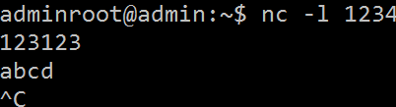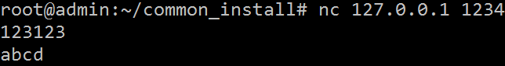

DATA TRANSFER
The example in the previous section can be expanded to build a basic data transfer model. Any information input into one end of the connection will be output to the other end, and input and output can be easily captured in order to emulate file transfer.
Start by using nc to listen on a specific port, with output captured into a file:
$ nc -l 1234 > filename.out
Using a second machine, connect to the listening nc process, feeding it the file which is to be transferred:

$ nc host.example.com 1234 < filename.in
After the file has been transferred, the connection will close automatically.

This utility can be used for creating TCP/UDP connections and investigating them. The biggest use of this utility is in the scripts where we need to deal with TCP/UDP sockets.
The flag -4 or -6 specifies that netcat utility should use which type of addresses. -4 forces nc to use IPV4 address while -6 forces nc to use IPV6 address.
Server :
$ nc -4 -l 2389
Client :
$ nc -4 localhost 2389
$ netstat | grep 2389
tcp 0 0 localhost:2389 localhost:50851 ESTABLISHED
tcp 0 0 localhost:50851 localhost:2389 ESTABLISHED

1.1.1 wget/curl(http request)
You can try wget with -p option:

wget -p http://site.com
It will tell you how long it takes to download each element and the return codes for each request.
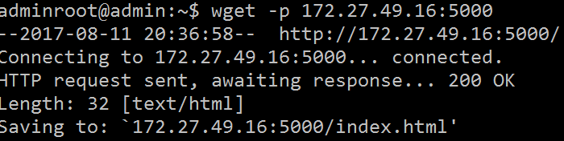
Linux provides a nice little command which makes our lives a lot easier.
GET:
with JSON:
curl -i -H "Accept: application/json" -H "Content-Type: application/json" http://hostname/resource
POST:
For posting data:
curl --data "param1=value1&param2=value2" http://hostname/resource
For file upload:
curl --form "fileupload=@filename.txt" http://hostname/resource
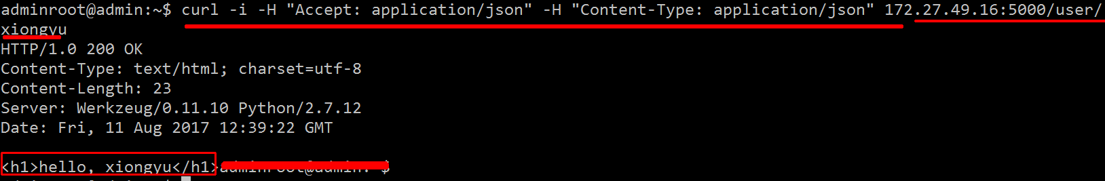

1.1 awk/grep/sed

1.1.1 awk
Awk Introduction and Printing Operations

Awk is a programming language which allows easy manipulation of structured data and the generation of formatted reports. Awk stands for the names of its authors “Aho, Weinberger, and Kernighan”

The Awk is mostly used for pattern scanning and processing. It searches one or more files to see if they contain lines that matches with the specified patterns and then perform associated actions.

Some of the key features of Awk are:

Awk views a text file as records and fields.
- Like common programming language, Awk has variables, conditionals and loops
- Awk has arithmetic and string operators.
- Awk can generate formatted reports

Awk reads from a file or from its standard input, and outputs to its standard output. Awk does not get along with non-text files.

Syntax:

awk '/search pattern1/ {Actions}
/search pattern2/ {Actions}' file

$cat employee.txt
100 Thomas Manager Sales $5,000
200 Jason Developer Technology $5,500
300 Sanjay Sysadmin Technology $7,000

Awk Example 1. Default behavior of Awk
By default Awk prints every line from the file.
$ awk '{print;}' employee.txt
100 Thomas Manager Sales $5,000
200 Jason Developer Technology $5,500
300 Sanjay Sysadmin Technology $7,000

In the above example pattern is not given. So the actions are applicable to all the lines.
Action print with out any argument prints the whole line by default. So it prints all the
lines of the file with out fail. Actions has to be enclosed with in the braces.

Awk Example 2. Print the lines which matches with the pattern.

$ awk '/Thomas/
> /Sanjay/' employee.txt
100 Thomas Manager Sales $5,000
300 Sanjay Sysadmin Technology $7,000

In the above example it prints all the line which matches with the ‘Thomas’ or ‘Nisha’. It has two patterns. Awk accepts any number of patterns, but each set (patterns and its corresponding actions) has to be separated by newline.
Awk Example 3. Print only specific field.

Awk has number of built in variables. For each record i.e line, it splits the record delimited by whitespace character by default and stores it in the $n variables. If the line has 4 words, it will be stored in $1, $2, $3 and $4. $0 represents whole line. NF is a built in variable which represents total number of fields in a record.
$ awk '{print $2,$5;}' employee.txt  Thomas $5,000  Jason $5,500  Sanjay $7,000 | $ awk '{print $2,$NF;}' employee.txt  Thomas $5,000  Jason $5,500  Sanjay $7,000

Awk Example 4. Initialization and Final Action
Awk has two important patterns which are specified by the keyword called BEGIN and END.Syntax:
BEGIN { Actions}
{ACTION} # Action for everyline in a file
END { Actions }

# is for comments in Awk
Actions specified in the BEGIN section will be executed before starts reading the lines from the input.
END actions will be performed after completing the reading and processing the lines from the input.
$ awk 'BEGIN {print "Name\tDesignation\tDepartment\tSalary";}
> {print $2,"\t",$3,"\t",$4,"\t",$NF;}
> END{print "\n--------------";
> }' employee.txt
Name Designation Department Salary
Thomas Manager Sales $5,000
Jason Developer Technology $5,500
Sanjay Sysadmin Technology $7,000
--------------

In the above example, first field ($1) is employee id. So if $1 is greater than 200, then just do the default print action to print the whole line.
Awk Example 5. Find the employees who has employee id greater than 200

$ awk '$1 >200' employee.txt
300 Sanjay Sysadmin Technology $7,000

Awk Example 6. Print the list of employees in Technology department
Now department name is available as a fourth field, so need to check if $4 matches with the string “Technology”, if yes print the line.
$ awk '$4 ~/Technology/' employee.txt
200 Jason Developer Technology $5,500
300 Sanjay Sysadmin Technology $7,000

Awk Example 7. Print number of employees in Technology department
The below example, checks if the department is Technology, if it is yes, in the Action, just increment the count variable, which was initialized with zero in the BEGIN section.

$ awk 'BEGIN { count=0;}
$4 ~ /Technology/ { count++; }
END { print "Number of employees in Technology Dept =",count;}' employee.txt
Number of employees in Tehcnology Dept = 3

Awk Example 7. if .awk file
The
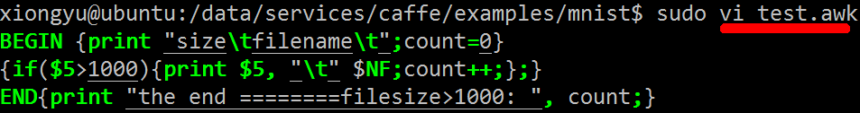
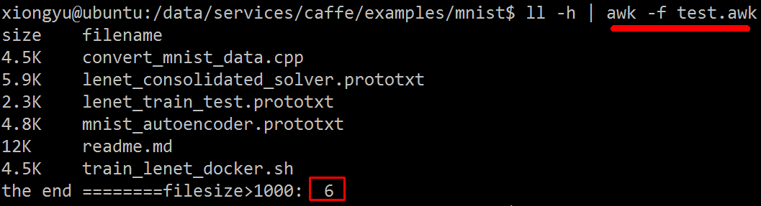
Syntax:

if (conditional-expression)  action | if (conditional-expression)  {  action1;  action2;  } | if (conditional-expression)  action1  else  action2
Awk also has conditional operator i.e ternary operator ( ?: ) whose feature is similar to the awk If Else Statement.Syntax:
conditional-expression ? action1 : action2 ;

$cat student-marks
Jones 2143 78 84 77
RinRao 2122 38 37

1. Awk If Example: Check all the marks are exist

$ awk '{
if ($3 =="" || $4 == "" || $5 == "")
print "Some score for the student",$1,"is missing";'
}' student-marks
Some score for the student RinRao is missing

2. Awk If Else Example: Generate Pass/Fail Report based on Student marks in each subject

$ awk '{
if ($3 >=50 && $4 >= 50 && $5 >= 50)
print $0,"=>","Pass";
else
print $0,"=>","Fail";
}' student-marks

Jones 2143 78 84 77 => Pass
RinRao 2122 38 37 => Fail

3. Awk If Else If Example: Find the average and grade for every student

$ cat grade.awk
{
total=$3+$4+$5;
avg=total/3;
if ( avg >= 90 ) grade="A";
else if ( avg >= 80) grade ="B";
else if (avg >= 70) grade ="C";
else grade="D";

print $0,"=>",grade;
}
$ awk -f grade.awk student-marks
Jones 2143 78 84 77 => C
RinRao 2122 38 37 => D

awk print column $3 if $2==a specific value?
If you're looking for a particular string, put quotes around it:
awk '$1 == "findtext" {print $3}'
Otherwise, awk will assume it's a variable name.
This method uses regexp, it should work:
awk '$2 ~ /findtext/ {print $3}' <infile>
Depending on the AWK implementation are you using == is ok or not.

Have you tried ~?. For example, if you want $1 to be "hello":

awk '$1 ~ /^hello$/{ print $3; }' <infile>
^ means $1 start, and $ is $1 end.
awk: 好用的数据处理工具 （相对于sed用于一行的处理，awk则是 将一行分成段来处理。）
awkz中的每一行的字段都有变量的别名，$1,$2......。上面的例子，root是$1。192.169.1.100
在第三列故而是$3。$0代表一整行的以上
awk 的内置变量: NF: 每一行$0拥有的字段总数， NR：目前awk处理的是第几行 FS：目前的分割符，默认的是空格键
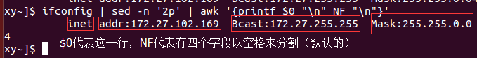
awk 的逻辑运算符：>,<,==,!=,>=,<=。
以下例子：awk提取指定的列，提取ifconfig中的IP，提取工龄>=3的。

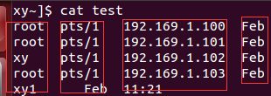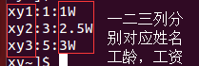
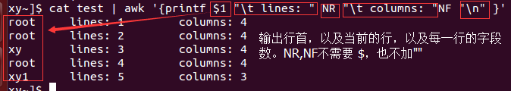
下面是找出工龄三年以上的姓名以及工资 （图见上面的右图）
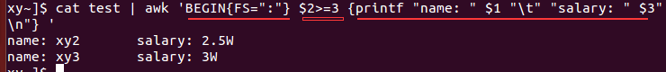
下面是统计计算输出每个人的总金额并输出 表格见页顶的右图
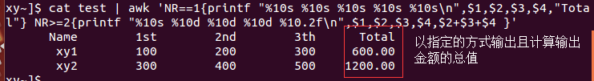
总结下awk：awk ‘ 条件类型1{动作1} 条件类型2{动作2}...’ filename。
awk 主要是将一行分成数个’字段’ 来处理，其内置变量为NF,NR,$n,FS(分别是每一行拥有的字段数，当前第几行，$n代表第几个字段，FS是分隔符主要用于如何提取$n)。
总结下grep: 主要是以行为单位查找字符串（包括指定的查找，查找一定范围，重复）
（1）指定的查找 grep ‘the’ test （2）反向选择 grep -v ‘the’ test
（2）集合查找 grep ‘t[ae]st’ test (查tast,test)。grep ‘[^a-z]oo’ test (查找oo前面不能是a-z)
(3) 行首grep ‘^the’ test (以the开头的行) grep ‘^[^the]’ test(不以the开头的行)
行尾 grep ‘\.$’ test (以 . 结尾的行)
（4）任意一字符 . (一定要有任意一个字符)和重复字符 *(重复前一个0到无穷次)
例如：grep ‘g..d’ test (g d之间必须要有两个字符)
又如：g g 之间必须一个o且全部是o 。grep ‘goo*g’ test。 g g之间2到5个o ，grep ‘go\{2,5\}g’ test 。两个以上的o ，Grep ‘go\{2,\}g’ test。
总结下sed: 指定行的新增，删除，查找替换，显示。部分字符串的查找替换（删除）。直接修改源文件的内容。

1.1.1 awk practice
awk_test.txt  2.gu Qxy 23  4.gui Qxr 21  1.guT QWS 18 | awk '{print $1, $2}' awk_test.txt  2.gu Qxy  4.gui Qxr  1.guT QWS
# . as sperator  awk -F'[.]' '{print $1, $2}' awk_test.txt  2 gu Qxy 23  4 gui Qxr 21  1 guT QWS 18 | # . ‘ ’ space as sperator  awk -F'[. ]' '{print $1, $2}' awk_test.txt  2 gu  4 gui  1 guT
-F ‘[]’ multiple char as sperator
awk_test.txt  10,15-10-2014,abc  20,12-10-2014,bcd  10,09-10-2014,def | awk '{print $1;}' awk_test.txt  10,15-10-2014,abc  20,12-10-2014,bcd  10,09-10-2014,def
awk -F'[,]' '{print $1, $2, $3;}' awk_test.txt
awk -F, '{print $1, $2, $3;}' awk_test.txt # equivalent to the above
10 15-10-2014 abc
20 12-10-2014 bcd
10 09-10-2014 def

awk to print unique lines based on column field:
awk -F, '!seen[$1]++' awk_test.txt
10,15-10-2014,abc
20,12-10-2014,bcd

sort -u -t, -k1,1 awk_test.txt
10,15-10-2014,abc
20,12-10-2014,bcd

Using awk to sum the values of a column, based on the values of another column
I am trying to sum certain numbers in a column using awk. I would like to sum just column 3 of the "smiths" to get a total of 212. I can sum the whole column using awk
smiths|Login|2
olivert|Login|10
denniss|Payroll|100
smiths|Time|200
smiths|Logout|10

awk -F '|' '$1 ~ /smiths/ {sum += $3} END {print sum}' inputfilename

Note that since you're not really using a regex here, just a specific value, you could just as easily use:
awk -F '|' '$1 == "smiths" {sum += $3} END {print sum}' inputfilename

Very good so far. All you need to do is add a selector before the block to add the sum. Here we check that the first argument contains only "smiths":
awk 'BEGIN {FS = "|"} ; $1 ~ /^smiths$/ {sum+=$3} END {print sum}'
You could shorten this a bit by specifying the field separator as an option. In awk it's generally a good idea to initialize variables on the command line:

awk -F'|' '$1 ~ /^smiths$/ {sum+=$3} END {print sum}'

Another approach is to use awk associative arrays, more info here. This line produces the desired output:

awk -F '|' '{a[$1] += $3} END{print a["smiths"]}' filename.txt
As a side effect, the array stores all other values:

awk -F '|' '{a[$1] += $3} END{for (i in a) print i, a[i]}' filename.txt
Output:

smiths 212
denniss 100
olivert 10

How can I replace a newline (\n) using sed?
gnu sed has an option -z for null separated records (lines). If you know your file has no nulls you can just:
sed -z 's/\n/ /g'
Who needs sed? Here is the bash way:

cat test.txt | while read line; do echo -n "$line "; done
echo "108.166.104.204 108.166.105.47 108.166.56.241"
| awk '{for(i=1;i<=NF;i++){print "[ndbd]";print "HostName="$i;}}'
[ndbd]
HostName=108.166.104.204
[ndbd]
HostName=108.166.105.47
[ndbd]
HostName=108.166.56.241

1.1.1 grep
下面先讲解下 grep的用法 grep [-A] [-B] ‘搜索的字符串’ filename
其中 -A：后面可以加数字，为after的意思,除了该行外，后续的N行也被行出来
其中 -B：后面可以加数字，为before的意思,除了该行外，前面的N行也被行出来
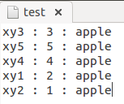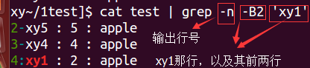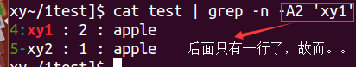
例（1）：查找特定的字符串 （下面查找 ‘the’）
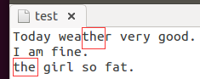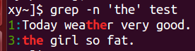
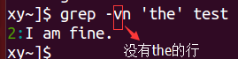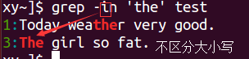
例（2）：利用中括号 [ ] 查找集合字符串
（1）下面查找 test 和 taste 这两个单词，发现 他们有共同的 ‘t?st’ 存在
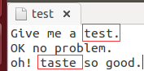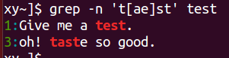

（2）我们想要查找含有 ‘oo’但是前面不能是 ’g’ 的 可以在集合字符的反向选择[^]
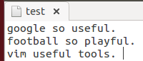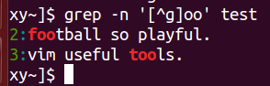
(3) ‘oo’ 前面不能含有小写的字母 可以 ‘[^ac...z]oo’ 这样麻烦改成’[^a-z]oo’,或者’[^[:lower:]]oo’
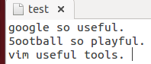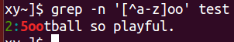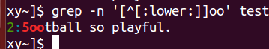
又如查找含有数字的行 ：grep -n ‘[0-9]’ test或者 grep -n ‘[[:digit:]]’ test
例（3）：行首与行尾 及字符 ^$
(1) 上面的例子中我们查找含有’the’的行，如果我们想要查询’the’ 只在行首的怎么办？
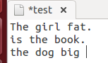 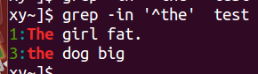 -i 不区分大小写
（2）找出开头是小写的 grep -n ‘^[a-z]’ test
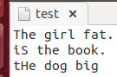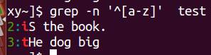
比较可以发现 ^ 在中括号 [ ] 内部和外部意义不一样，在内部代表方向选择，外部代表定位行首
（3）查找出行尾以小数点 . 结束的行
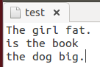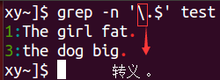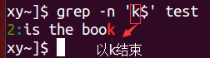
（4）查找 空白行
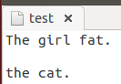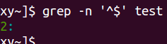
例（4）：任一字符 . 与重复字符 *。
(1) 查找 g??d 的字符串 ，即共四个字符开头 g 结尾 d . 代表0个或者1个字符
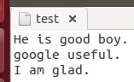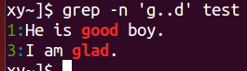
(2) 查找 g...d 的字符串 ，gd之间至少含有两个oo以上 ooo*而不是 oo*
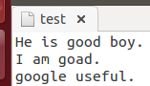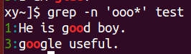
（3）如果g g之间 至少一个o 如 gog,goog,goooodg
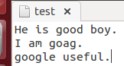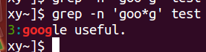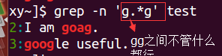
(4) 两个oo 2到5个o
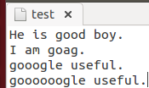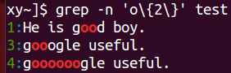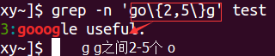
基础正则表达式字符
^word | 意义:待查找的字符串 word 在行首 。范例：查找行首为 # 的那一行并列出行号  grep -n ‘^#’ test
word$ | 意义:待查找的字符串 word 在行尾 。范例：查找行尾为 ！ 的那一行并列出行号  grep -n ‘！$’ test
\ | 意义：转义字符
* | 意义：重复零个到无穷个的前一字符。范例：查找含有 es,ess,esss等字符串，因为*可以是0个且*为重复前一个字符，故而*之前必须紧接前一个字符  grep -n ‘ess*’ test
[ list ] | 意义:从字符集合查找出想要选取的字符 。范例：查找含有 gg或者gd 的那一行。例如  a[afe]y 代表 aay,afy,aey之一 。 grep -n ‘g[gd]’ test
[ n1-n2 ] | 意义 : 字符范围集合的之一。例如 grep ‘[0-9]’ test 含有数字的即可
[ ^list ] | 意义:在字符串集合找到不要的字符串或范围
\{n,m\} | 意义：连续n到m个RE字符，若为b\{n\}则为联系的n个b,若为b\{n,\}连续的n个以上的b。例如 g与g之间2到3个o的存在goog或者gooog : grep ‘go\{2,3\}g’ test

1. Search for the given string in a single file
The basic usage of grep command is to search for a specific string in the specified file as shown below.
Syntax: grep "literal_string" filename

$ grep "this" demo_file
this line is the 1st lower case line in this file.
Two lines above this line is empty.

2. Checking for the given string in multiple files.
Syntax: grep "string" FILE_PATTERN

This is also a basic usage of grep command. For this example, let us copy the demo_file to demo_file1. The grep output will also include the file name in front of the line that matched the specific pattern as shown below. When the Linux shell sees the meta character, it does the expansion and gives all the files as input to grep.

$ cp demo_file demo_file1
$ grep "this" demo_*

demo_file:this line is the 1st lower case line in this file.
demo_file1:this line is the 1st lower case line in this file.

3. Case insensitive search using grep -i
Syntax: grep -i "string" FILE

4. Match regular expression in files

Syntax: grep "REGEX" filename

This is a very powerful feature, if you can use use regular expression effectively. In the following example, it searches for all the pattern that starts with “lines” and ends with “empty” with anything in-between. i.e To search “lines[anything in-between]empty” in the demo_file.

$ grep "lines.*empty" demo_file
Two lines above this line is empty.

5. Checking for full words, not for sub-strings using grep -w

If you want to search for a word, and to avoid it to match the substrings use -w option. Just doing out a normal search will show out all the lines.
The following example is the regular grep where it is searching for “is”. When you search for “is”, without any option it will show out “is”, “his”, “this” and everything which has the substring “is”.

$ grep -i "is" demo_file
THIS LINE IS THE 1ST UPPER CASE LINE IN THIS FILE.
This Line Has All Its First Character Of The Word With Upper Case.

$ grep -iw "is" demo_file
THIS LINE IS THE 1ST UPPER CASE LINE IN THIS FILE.

7. Highlighting the search using GREP_OPTIONS
As grep prints out lines from the file by the pattern / string you had given, if you wanted it to highlight which part matches the line, then you need to follow the following way.
$ export GREP_OPTIONS='--color=auto' GREP_COLOR='100;8'

8. Searching in all files recursively using grep -r
When you want to search in all the files under the current directory and its sub directory. -r option is the one which you need to use. The following example will look for the string “ramesh” in all the files in the current directory and all it’s subdirectory.
$ grep -r "ramesh" *

11. Counting the number of matches using grep -c
When you want to count that how many lines matches the given pattern/string, then use the option -c.
Syntax: grep -c "pattern" filename

$ grep -c "go" demo_text
6

When you want do find out how many lines that does not match the pattern
$ grep -v -c this demo_file
4

12. Display only the file names which matches the given pattern using grep -l

If you want the grep to show out only the file names which matched the given pattern, use the -l (lower-case L) option.
When you give multiple files to the grep as input, it displays the names of file which contains the text that matches the pattern, will be very handy when you try to find some notes in your whole directory structure

$ grep -l this demo_*
demo_file
demo_file1

13. Show only the matched string

By default grep will show the line which matches the given pattern/string, but if you want the grep to show out only the matched string of the pattern then use the -o option.
It might not be that much useful when you give the string straight forward. But it becomes very useful when you give a regex pattern and trying to see what it matches as

$ grep -o "is.*line" demo_file
is line is the 1st lower case line
is line
is is the last line

15. Show line number while displaying the output using grep -n

To show the line number of file with the line matched. It does 1-based line numbering for each file. Use -n option to utilize this feature.

$ grep -n "go" demo_text
5: * e - go to the end of the current word.
6: * E - go to the end of the current WORD.

Grep OR Operator
Use any one of the following 4 methods for grep OR. I prefer method number 3 mentioned below for grep OR operator
1. Grep OR Using \|
If you use the grep command without any option, you need to use \| to separate multiple patterns for the or condition.

grep 'pattern1\|pattern2' filename
For example, grep either Tech or Sales from the employee.txt file. Without the back slash in front of the pipe, the following will not work.

$ grep 'Tech\|Sales' employee.txt
100 Thomas Manager Sales $5,000
200 Jason Developer Technology $5,500

2. Grep OR Using -E
grep -E option is for extended regexp. If you use the grep command with -E option, you just need to use | to separate multiple patterns for the or condition.
grep -E 'pattern1|pattern2' filename

For example, grep either Tech or Sales from the employee.txt file. Just use the | to separate multiple OR patterns.

$ grep -E 'Tech|Sales' employee.txt
100 Thomas Manager Sales $5,000
200 Jason Developer Technology $5,500

3. Grep OR Using egrep
egrep is exactly same as ‘grep -E’. So, use egrep (without any option) and separate multiple patterns for the or condition.

egrep 'pattern1|pattern2' filename

For example, grep either Tech or Sales from the employee.txt file. Just use the | to separate multiple OR patterns.

$ egrep 'Tech|Sales' employee.txt
100 Thomas Manager Sales $5,000
200 Jason Developer Technology $5,500

4. Grep OR Using grep -e
Using grep -e option you can pass only one parameter. Use multiple -e option in a single command to use multiple patterns for the or condition.

grep -e pattern1 -e pattern2 filename
For example, grep either Tech or Sales from the employee.txt file. Use multiple -e option with grep for the multiple OR patterns.

$ grep -e Tech -e Sales employee.txt
100 Thomas Manager Sales $5,000
200 Jason Developer Technology $5,500

Grep AND

5. Grep AND using -E ‘pattern1.*pattern2’

There is no AND operator in grep. But, you can simulate AND using grep -E option.
grep -E 'pattern1.*pattern2' filename
grep -E 'pattern1.*pattern2|pattern2.*pattern1' filename
The following example will grep all the lines that contain both “Dev” and “Tech” in it (in the same order).

$ grep -E 'Dev.*Tech' employee.txt
200 Jason Developer Technology $5,500

The following example will grep all the lines that contain both “Manager” and “Sales” in it (in any order).

$ grep -E 'Manager.*Sales|Sales.*Manager' employee.txt

6. Grep AND using Multiple grep command

You can also use multiple grep command separated by pipe to simulate AND scenario.

grep -E 'pattern1' filename | grep -E 'pattern2'

7. Grep NOT using grep -v
Using grep -v you can simulate the NOT conditions. -v option is for invert match. i.e It matches all the lines except the given pattern.

grep -v 'pattern1' filename

Example 6. Word boundary (\b)
\b is to match for a word boundary. \b matches any character(s) at the beginning (\bxx) and/or end (xx\b) of a word, thus \bthe\b will find the but not thet, but \bthe will find they.

# grep -i "\bthe\b" comments
If the Line starts with single hash symbol,

Example 10. Valid IP address
The following grep command matches only valid IP address.
egrep '\b(25[0-5]|2[0-4][0-9]|[01]?[0-9][0-9]?\.){3}(25[0-5]|2[0-4][0-9]|[01]?[0-9][0-9]?)' input
15.12.141.121

1.1.1 sed
we feel it's important to point out what exactly is it that sed does, because "stream editor" may not ring too many bells. sed takes the input text, does the specified operations on every line (unless otherwise specified) and prints the modified text. The specified operations can be append, insert, delete or substitute.
1. Viewing a range of lines of a document
Tools such as head and tail allow us to view the bottom or the top of a file. What if we need to view a section in the middle? The following sed one-liner will return lines 5 through 10 from myfile.txt:

# sed -n '5,10p' myfile.txt
2. Viewing the entire file except a given range
On the other hand, it’s possible that you want to print the entire file except a certain range. To exclude lines 20 through 35 from myfile.txt, do:

# sed '20,35d' myfile.txt

3. Viewing non-consecutive lines and ranges
It’s possible that you’re interested in set of non-consecutive lines, or in more than one range. Let’s display lines 5-7 and 10-13 from myfile.txt:

# sed -n -e '5,7p' -e '10,13p' myfile.txt
4. Replacing words or characters (basic substitution)
To replace every instance of the word version with story in myfile.txt, do:

# sed 's/version/story/g' myfile.txt
Additionally, you may want to consider using gi instead of g in order to ignore character case:

# sed 's/version/story/gi' myfile.txt
To replace multiple blank spaces with a single space, we will use the output of ip route show and a pipeline:

# ip route show | sed 's/ */ /g'

5. Replacing words or characters inside a range
If you’re interested in replacing words only within a line range (30 through 40, for example), you can do:

# sed '30,40 s/version/story/g' myfile.txt
Of course, you can indicate a single line through its corresponding number instead of a range.

6. Using regular expressions (advanced substitution) – I
Sometimes configuration files are loaded with comments. While this is certainly useful, it may be helpful to display only the configuration directives sometimes if you want to view them all at a glance.

To remove empty lines or those beginning with # from the Apache configuration file, do:

# sed '/^#\|^$\| *#/d' httpd.conf
The caret sign followed by the number sign (^#) indicates the beginning of a line, whereas ^$ represents blank lines. The vertical bars indicate boolean operations, whereas the backward slash is used to escape the vertical bars.

In this particular case, the Apache configuration file has lines with #’s not at the beginning of some lines, so *# is used to remove those as well.

7. Using regular expressions (advanced substitution) – II
To replace a word beginning with uppercase or lowercase with another word, we can also use sed. To illustrate, let’s replace the word zip or Zip with rar in myfile.txt:

# sed 's/[Zz]ip/rar/g' myfile.txt

8. Viewing lines containing with a given pattern
Another use of sed consists in printing the lines from a file that match a given regular expression. For example, we may be interested in viewing the authorization and authentication activities that took place on July 2, as per the /var/log/secure log in a CentOS 7 server.

In this case, the pattern to search for is Jul 1 at the beginning of each line:

# sed -n '/^Jul 1/ p' /var/log/secure

1.1.1 cut
Cut command in unix (or linux) is used to select sections of text from each line of files. You can use the cut command to select fields or columns from a line by specifying a delimiter or you can select a portion of text by specifying the range or characters. Basically the cut command slices a line and extracts the text.
Unix Cut Command Example
> cat file.txt
unix or linux os
is unix good os
is linux good os

1. Write a unix/linux cut command to print characters by position?

The cut command can be used to print characters in a line by specifying the position of the characters. To print the characters in a line, use the -c option in cut command

cut -c4 file.txt
x
u
l

The above cut command prints the fourth character in each line of the file. You can print more than one character at a time by specifying the character positions in a comma separated list as shown in the below example

cut -c4,6 file.txt
xo
ui
ln

2.Write a unix/linux cut command to print characters by range?

You can print a range of characters in a line by specifying the start and end position of the characters.

cut -c4-7 file.txt
x or
unix
linu

The above cut command prints the characters from fourth position to the seventh position in each line. To print the first six characters in a line, omit the start position and specify only the end position.

cut -c-6 file.txt
unix o
is uni
is lin

3.Write a unix/linux cut command to print the fields using the delimiter?

You can use the cut command just as awk command to extract the fields in a file using a delimiter. The -d option in cut command can be used to specify the delimiter and -f option is used to specify the field position.

cut -d' ' -f2 file.txt
or
unix
linux
This command prints the second field in each line by treating the space as delimiter. You can print more than one field by specifying the position of the fields in a comma delimited list.

cut -d' ' -f2,3 file.txt
or linux
unix good
linux good

4. Write a unix/linux cut command to display range of fields?

You can print a range of fields by specifying the start and end position.

cut -d' ' -f1-3 file.txt

The above command prints the first, second and third fields. To print the first three fields, you can ignore the start position and specify only the end position.

cut -d' ' -f-3 file.txt

To print the fields from second fields to last field, you can omit the last field position.

cut -d' ' -f2- file.txt

cut -d':' -f1 /etc/passwd

1.1.1 tr
How do I combine all lines in a text file into a single line?
tr as you used it should work and is the simplest -- you just need to output to another file. If you use the input file as output, the result is an empty file as you observed;

cat myfile.txt | tr -d '\n' > oneline.txt
You need to remember some editors terminate a line with \r\n. For that case, use
cat myfile | tr -d '\r\n'

Here it is. It's another solution and simple easy.
echo $(cat Input.txt) > Output.txt
replace ‘\n’ to space ‘ ’
tr abbreviated as translate or transliterate. It takes as parameters two sets of characters, and replaces occurrences of the characters in the first set with the corresponding elements from the other set i.e. it is used to translate characters.
tr command syntax

tr [options] "set1" "set2"
echo something | tr "set1" "set2"

How do I use tr command under Linux / UNIX?
Translate the word ‘linux’ to upper-case:

$ echo 'linux' | tr "[:lower:]" "[:upper:]"
$ echo 'linux' | tr "a-z" "A-Z"
$ echo 'I LovE linuX. one is better Than 2' | tr "a-z" "A-Z"

Output:
LINUX
LINUX
I LOVE LINUX. ONE IS BETTER THAN 2

Shell scripting example
In the following example you will get confirmation before deleting the file. If the user responds in lower case, the tr command will do nothing, but if the user responds in upper case, the character will be changed to lower case. This will ensure that even if user responds with YES, YeS, YEs etc; script should remove file:

#!/bin/bash
echo -n "Enter file name : "
read myfile
echo -n "Are you sure ( yes or no ) ? "
read confirmation
confirmation="$(echo ${confirmation} | tr 'A-Z' 'a-z')"
if [ "$confirmation" == "yes" ]; then
[ -f $myfile ] && /bin/rm $myfile || echo "Error - file $myfile not found"
else
: # do nothing
fi

Remove all non-printable characters from myfile.txt
$ tr -cd "[:print:]" < myfile.txt

5. Delete specified characters using -d option
tr can also be used to remove particular characters using -d option.

$ echo "the geek stuff" | tr -d 't'
he geek suff
To remove all the digits from the string, use

$ echo "my username is 432234" | tr -d [:digit:]
my username is

How to search for a compliment of a pattern

To search for a compliment of a pattern use the -c option. Searching for a compliment means searching for the inverse of the set specified. In the following example any character that is not ‘a’ is matched and translated to ‘z’.

echo abcdefghijklmnop | tr -c 'a' 'z'
azzzzzzzzzzzzzzzz

echo abcdefghijklmnop | tr 'a' 'z'
zbcdefghijklmnop

Searching for a compliment pattern can effectively be used to pull out patterns from text. In the following example the -c option is combined with the -d delete option to extract a phone number.

echo 'Phone: 01234 567890' | tr -cd '[:digit:]'
01234567890

How to squeeze repeating characters
To squeeze repeat occurrences of characters specified in a set use the -s option. This removes repeated instances of a character. In the following example a string with too many spaces is squeezed to remove them.

echo 'too many spaces here' | tr -s '[:space:]'
too many spaces here

How to truncate a search pattern
To truncate the first set to the second set use the -t option. By default tr will repeat the last character of the second set if the first and second sets are different lengths. Consider the following example.

echo 'the cat in the hat' | tr 'abcdefgh' '123'
t33 31t in t33 31t

1.1 sort

1.1.1 sort
sort [-fbmnrtuk] [file or stdin] 下面说下其中几个参数的意思。
-f：忽略大小写，-b：忽略前面的空格，-n使用纯数字排序 -t: 分隔符默认的是 Tab ,-k:区间
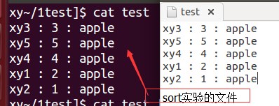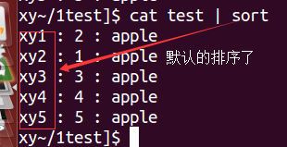
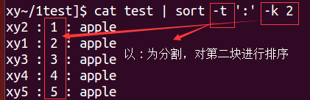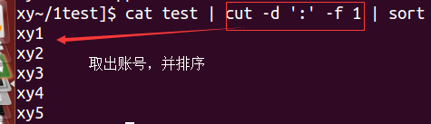
awk_test.txt  10,15-10-2014,abc  20,12-10-2014,bcd  10,09-10-2014,def | sort -u -t, -k1,1 awk_test.txt  10,15-10-2014,abc  20,12-10-2014,bcd
sort -u -t, -k1,1 file
-u for unique
-t, so comma is the delimiter
-k1,1 for the key field 1

Sort Command Syntax: $ sort [-options]
For example, here is a test file:

ll | sort -k 5 -n
(sort file by size, -n for sort by numeric, -k 5 choose the size column)
sort -n -k 2 -u train.txt (get the unique calssify num)

And, here is what you get when sort command is executed on this file without any option. It sorts lines in test file and displays sorted output.
$ cat test  zzz  aaa  AAA | $ sort test  aaa  AAA  zzz

1. Perform Numeric Sort using -n option
If we want to sort on numeric value, then we can use -n or –numeric-sort option.
Create the following test file for this example:

The following sort command sorts lines in test file on numeric value in first word of line and displays sorted output.
$ cat test  22 zzz  33 sss  11 qqq | $ sort -n test  11 qqq  22 zzz  33 sss

2. Sort Human Readable Numbers using -h option
If we want to sort on human readable numbers (e.g., 2K 1M 1G), then we can use -h or –human-numeric-sort option.
Create the following test file for this example:

The following sort command sorts human readable numbers (i.e 1K = 1 Thousand, 1M = 1 Million, 1G = 1 Giga, 1T = 1 Tera) in test file and displays sorted output.
$ cat test  2M  1G  1K | $ sort -h test  1K  2M  1G

3. Sort Months of an Year using -M option
If we want to sort in the order of months of year, then we can use -M or –month-sort option.
Create the following test file for this example:
$ cat test  sept  aug  jan | $ sort -M test  jan  aug  sept

The following sort command sorts lines in test file as per month order. Note, lines in file should contain at least 3 character name of month name at start of line (e.g. jan, feb, mar).
4. Check if Content is Already Sorted using -c option
If we want to check data in text file is sorted or not, then we can use -c or –check, –check=diagnose-first option.
Create the following test file for this example:
$ cat test
2
5
1

The following sort command checks whether text file data is sorted or not. If it is not, then it shows first occurrence with line number and disordered value.
$ sort -c test
sort: test:3: disorder: 1

5. Reverse the Output and Check for Uniqueness using -r and -u options

If we want to get sorted output in reverse order, then we can use -r or –reverse option. If file contains duplicate lines, then to get unique lines in sorted output, “-u” option can be used.

Create the following test file for this example:

$ cat test  5  1  4  4 | $ sort -r test  5  4  4  1 | $ sort -r -u test  5  4  1

The following sort command sorts lines in test file in reverse order and displays sorted output.
The following sort command sorts lines in test file in reverse order and removes duplicate lines from sorted output.

6. Selectively Sort the Content, Customize delimiter, Write output to a file using -k, -t, -o options
If we want to sort on the column or word position in lines of text file, then “-k” option can be used. If we each word in each line of file is separated by delimiter except ‘space’, then we can specify delimiter using “-t” option. We can get sorted output in any specified output file (using “-o” option) instead of displaying output on standard output.
Create the following test file for this example:
$ cat test
aa aa zz
aa aa ff
aa aa tt

The following sort command sorts lines in test file on the 3rd word of each line and displays sorted output.

$ sort -k3 test
aa aa ff
aa aa tt
aa aa zz

$ cat test
aa|5a|zz
aa|2a|ff
aa|1a|tt

Here, several options are used altogether. In test file, words in each line are separated by delimiter ‘|’. It sorts lines in test file on the 2nd word of each line on the basis of numeric value and stores sorted output into specified output file.
$ sort -n -t'|' -k2 test -o outfile

The contents of output file are shown below.
$ cat outfile
aa|1a|tt
aa|2a|ff
aa|5a|zz

1.1.1 uniq
One point you want to say is that it only works if the duplicate lines are next to one another.
So I always have to sort the file then pass it to uniq like this
cat filename | sort | uniq
Without the sort, a file that has this will not work as expected
aa
bb
aa
bb

Uniq command is helpful to remove or detect duplicate entries in a file.
The following test file is used in some of the example to understand how uniq command works.
$ cat test
aa
aa
bb
bb
bb
xx
1. Basic Usage
Syntax: $ uniq [-options]
For example, when uniq command is run without any option, it removes duplicate lines and displays unique lines as shown below.
$ uniq test
aa
bb
xx

2. Count Number of Occurrences using -c option
This option is to count occurrence of lines in file.
$ uniq -c test
2 aa
3 bb
1 xx

3. Print only Duplicate Lines using -d option
This option is to print only duplicate repeated lines in file. As you see below, this didn’t display the line “xx”, as it is not duplicate in the test file.
$ uniq -d test
aa
bb

The above example displayed all the duplicate lines, but only once. But, this -D option will print all duplicate lines in file. For example, line “aa” was there twice in the test file, so the following uniq command displayed the line “aa” twice in this output.
$ uniq -D test
aa
aa
bb
bb
bb

4. Print only Unique Lines using -u option
This option is to print only unique lines in file.
$ uniq -u test
xx

5. Limit Comparison to ‘N’ characters using -w option
This option restricts comparison to first specified ‘N’ characters only. For this example, use the following test2 input file.
$ cat test2
hi Linux
hi LinuxU
hi LinuxUnix
hi Unix
The following uniq command using option ‘w’ is compares the first 8 characters of lines in file, and then using ‘c’ option prints number of occurrences of lines of file.

$ uniq -c -w 8 testNew
3 hi Linux
1 hi Unix

The following uniq command using option ‘w’ is compares first 8 characters of lines in file, and then using ‘D’ option prints all duplicate lines of file.

$ uniq -D -w 8 testNew
hi Linux
hi LinuxU
hi LinuxUnix

6. Avoid Comparing first ‘N’ Characters using -s option
This option skips comparison of first specified ‘N’ characters. For this example, use the following test3 input file.

$ cat test3
aabb
xxbb
bbc
bbd
The following uniq command using option ‘s’ skips comparing first 2 characters of lines in file, and then using ‘D’ option prints all duplicate lines of file.
Here, starting 2 characters i.e. ‘aa’ in 1st line and ‘’xx’ in 2nd line would not be compared and then next 2 characters ‘bb’ in both lines are same so would be shown as duplicated lines.

$ uniq -D -s 2 test3
aabb
xxbb

7. Avoid Comparing first ‘N’ Fields using -f option

This option skips comparison of first specified ‘N’ fields of lines in file.

$ cat test2
hi hello Linux
hi friend Linux
hi hello LinuxUnix
The following uniq command using option ‘f’ skips comparing first 2 fields of lines in file, and then using ‘D’ option prints all duplicate lines of file.

Here, starting 2 fields i.e. ‘hi hello’ in 1st line and ‘hi friend’ in 2nd line would not be compared and then next field ‘Linux’ in both lines are same so would be shown as duplicated lines.

$ uniq -D -f 2 test2
hi hello Linux
hi friend Linux

1.1 variable

1.1.1 for

1.1.1 example sz variable
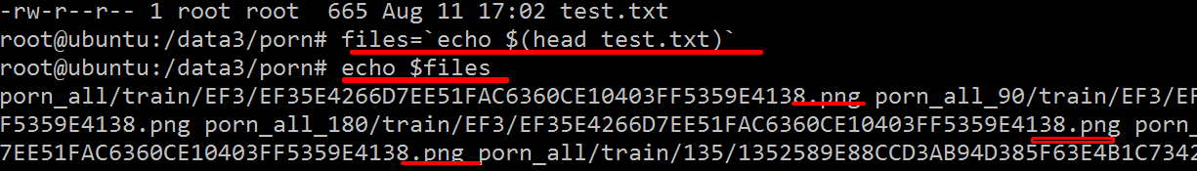
sudo rz $files (send all files to win10)

1.1.1 environment variable
To set variable only for current shell:
VARNAME="my value"

To set an environment variable once, use the export command in the prompt, not in a shell script:
$ export THEVAR=/example
The variable will be set for the rest of the shell session or until unset.
To set it for current shell and all processes started from current shell:
export VARNAME="my value" # shorter, less portable version

To set an environment variable everytime, use the export command in the .bashrc file (or the appropriate initialization file for your shell).

To set an environment variable from a script, use the export command in the script, and then source the script. If you execute the script it will not work.

To set it permanently for all future bash sessions add such line to your .bashrc file in your $HOME directory.

To set it permanently, and system wide (all users, all processes) add set variable in /etc/environment:
gksudo gedit /etc/environment

If you are doing things via script, one easy way to set environment variable permanently is put below statement in your script,

if [[ ! -d "$MyVar" ]]; then
export MyVar="abc"
echo 'export MyVar="abc"' >> ~/.bashrc
fi
If you need to evaluage expressions like pwd, you can use this, for example,

echo "export EIGEN_ROOT=\"$(pwd)/eigen\"" >> ~/.bashrc

1.1.1 ldd / LD_LIBRARY_PATH
The LD_LIBRARY_PATH environment variable contains a colon separated list of paths that the linker uses to resolve library dependencies of ELF executables at run-time. These paths will be given priority over the standard library paths /lib and /usr/lib. The standard paths will still be searched, but only after the list of paths in LD_LIBRARY_PATH has been exhausted.
The best way to use LD_LIBRARY_PATH is to set it on the command line or script immediately before executing the program. This way you can keep the new LD_LIBRARY_PATH isolated from the rest of your system.

$ export LD_LIBRARY_PATH="/list/of/library/paths:/another/path"
$ ./program

In general it is not a good practice to have LD_LIBRARY_PATH permanently set in your environment. This could lead to unintended side effects as programs can link to unintended libraries producing strange results or unexpectedly crashing. There is also the possibility introducing potential security threats.

A common case for setting LD_LIBRARY_PATH is when you have an application that requires dynamic libraries which were not installed in the standard library locations.
You can check if the linker can locate all the required libraries by running the ldd command.
$ ldd ~/myprogram

librt.so.1 =&gt; /lib/librt.so.1 (0x00002b4eca08e000)
libc.so.6 =&gt; /lib/libc.so.6 (0x00002b4eca49f000)
libpthread.so.0 =&gt; /lib/libpthread.so.0 (0x00002b4eca7df000)
/lib64/ld-linux-x86-64.so.2 (0x00002b4ec9e72000)
libmylib.so.1 =&gt; not found

Let’s assume this library exists here “~/myprogdir/lib/libmylib.so.1”. We have to set LD_LIBRARY_PATH to include this path for the application to successfully run.
$ export LD_LIBRARY_PATH="~/myprogdir/lib/:$LD_LIBRARY_PATH"
$ ldd ~/myprogram

librt.so.1 =&gt; /lib/librt.so.1 (0x00002b4eca08e000)
libc.so.6 =&gt; /lib/libc.so.6 (0x00002b4eca49f000)
libpthread.so.0 =&gt; /lib/libpthread.so.0 (0x00002b4eca7df000)
/lib64/ld-linux-x86-64.so.2 (0x00002b4ec9e72000)
libmylib.so.1 =&gt; ~/myprogdir/lib/libmylib.so.1 (0x00002b4eca9fa000)

The linker has now found all the required libraries.

ldd caffe | sed -n '23,25p'
/lib64/ld-linux-x86-64.so.2 (0x00007ffb3d41b000)
libsz.so.2 => /usr/lib/x86_64-linux-gnu/libsz.so.2 (0x00007ffb395d5000)
libdl.so.2 => /lib/x86_64-linux-gnu/libdl.so.2 (0x00007ffb393d1000)

chapter vim

1.1 vi search

1.1.1
To find a word in Vi/Vim, simply type the / or ? key, followed by the word you're searching for.
Once found, you can press the n key to go directly to the next occurrence of the word.
Vi/Vim also allows you to launch a search on the word over which your cursor is positioned. To do this, place the cursor over the term, and then press * or # to look it up.

The most useful shortcut in vim, IMHO, is the * key.
Put the cursor on a word and hit the * key and you will jump to the next instance of that word.
The # key does the same but jumps to the previous instance of the word.
Truly a time saver.

It is n for next and N for previous.
And if you use reverse search with ? (e.g ?cake) instead of /, it is the other way round.

:set hlsearch
To remove the highlight of the previous search:
:nohlsearch

1.1 go to line when open the file

1.1.1 vi +3 test.txt
Go to the 143rd line of file  $ vim +143 filename.txt | Go to the first match of the specified  $ vim +/search-term filename.txt
Open the file in read only mode.
$ vim -R /etc/passwd

1.1.1 line operator
1. move row to nth row
You can move a line, or a block of lines, with the :m command. Examples:
:m 12 move current line to after line 12
:m 0 move current line to before first line
:m $ move current line to after last line

:m 'a move current line to after line with mark a (see using marks)
:m 'a-1 move current line to before line with mark a

move a block of lines
:5,7m 21 move lines 5, 6 and 7 to after line 21
:5,7m 0 move lines 5, 6 and 7 to before first line
:5,7m $ move lines 5, 6 and 7 to after last line
:.,.+4m 21 move 5 lines starting at current line to after line 21

2. go to nth row
G（移动到文件最后一行）/nG（移动到文件第n行）

0(移动到行首)/$(移动到行尾)

u（撤销）
i/I （光标所在的位置进行插入字符）

a/A (光标所在的下一个位置插入)

o/O (光标所在行的下一行开始插入)

