chapter 1 - 1 -
1.1 vector inner product,distance and orthogonal - 1 -
1.1.1 - 1 -

Credit Card Fraud Detection

1.1 description

1.1.1 describe question
项目背景
数据集包含由欧洲持卡人于2013年9月使用信用卡进行交的数据。此数据集显示两天内发生的交易，其中284,807笔交易中有492笔被盗刷。数据集非常不平衡，积极的类（被盗刷）占所有交易的0.172％。
它只包含作为PCA转换结果的数字输入变量。不幸的是，由于保密问题，我们无法提供有关数据的原始功能和更多背景信息。特征V1，V2，... V28是使用PCA获得的主要组件，没有用PCA转换的唯一特征是“时间”和“量”。特征'时间'包含数据集中每个事务和第一个事务之间经过的秒数。特征“金额”是交易金额，此特征可用于实例依赖的成本认知学习。特征'类'是响应变量，如果发生被盗刷，则取值1，否则为0。

1 场景解析（算法选择）
1）首先，我们拿到的数据是持卡人两天内的信用卡交易数据，这份数据包含很多维度，要解决的问题是预测持卡人是否会发生信用卡被盗刷。信用卡持卡人是否会发生被盗刷只有两种可能，发生被盗刷或不发生被盗刷。又因为这份数据是打标好的（字段Class是目标列），也就是说它是一个监督学习的场景。于是，我们判定信用卡持卡人是否会发生被盗刷是一个二元分类问题，意味着可以通过二分类相关的算法来找到具体的解决办法，本项目选用的算法是逻辑斯蒂回归（Logistic Regression）
2）分析数据：数据是结构化数据 ，不需要做特征抽象。特征V1至V28是经过PCA处理，而特征Time和Amount的数据规格与其他特征差别较大，需要对其做特征缩放，将特征缩放至同一个规格。在数据质量方面 ，没有出现乱码或空字符的数据，可以确定字段Class为目标列，其他列为特征列
3）这份数据是全部打标好的数据，可以通过交叉验证的方法对训练集生成的模型进行评估。70%的数据进行训练，30%的数据进行预测和评估

1.1.1 describe question

1.1 cited

1.1.1

https://www.kaggle.com/dalpozz/creditcardfraud

https://www.kaggle.com/dalpozz/creditcardfraud

下面这个准确率很高
https://www.kaggle.com/krishna541/creditcardfraud

graduate check

1.1 description

1.1.1 load data
辨别不同的因素对研究生录取的影响。
数据集中的前三列可作为预测变量(predictor variables)：
gpa
gre 分数
rank 表示本科生母校的声望
第四列 admit则是二分类目标变量(binary target variable)，它表明考生最终是否被录用
def get_data():
f_path = "./dataset/UCLA_dataset.csv"
df = pd.read_csv(f_path)
print df.head()
admit gre gpa rank
0 0 380 3.61 3
1 1 660 3.67 3
2 1 800 4.00 1
3 1 640 3.19 4
4 0 520 2.93 4
重命名'rank'列，因为dataframe中有个方法名也为'rank'
df.rename(columns={"rank": "prestige"}, inplace=True)
print df.head()
return df
admit gre gpa prestige
0 0 380 3.61 3
1 1 660 3.67 3
2 1 800 4.00 1
3 1 640 3.19 4
4 0 520 2.93 4

1.1.1 summary statistic & Looking data
We can use the pandas function describe to give us a summarized view of everything--describe is analogous to summary in R. There's also function for calculating the standard deviation, std. I've included it here to be consistent UCLA's tutorial, but the standard deviation is also included in describe.
A feature I really like in pandas is the pivot_table/crosstab aggregations. crosstab makes it really easy to do multidimensional frequency tables (sort of like table in R).
def statistic_data(df):
print df.describe()
admit gre gpa prestige
count 400.000000 400.000000 400.000000 400.00000
mean 0.317500 587.700000 3.389900 2.48500
std 0.466087 115.516536 0.380567 0.94446
min 0.000000 220.000000 2.260000 1.00000
25% 0.000000 520.000000 3.130000 2.00000
50% 0.000000 580.000000 3.395000 2.00000
75% 1.000000 660.000000 3.670000 3.00000
max 1.000000 800.000000 4.000000 4.00000
print df.std()
admit 0.466087
gre 115.516536
gpa 0.380567
prestige 0.944460
dtype: float64
print pd.crosstab(df['admit'], df['prestige'], rownames=['admit'])
prestige 1 2 3 4
admit
0 28 97 93 55
1 33 54 28 12
df.hist()
pl.show()
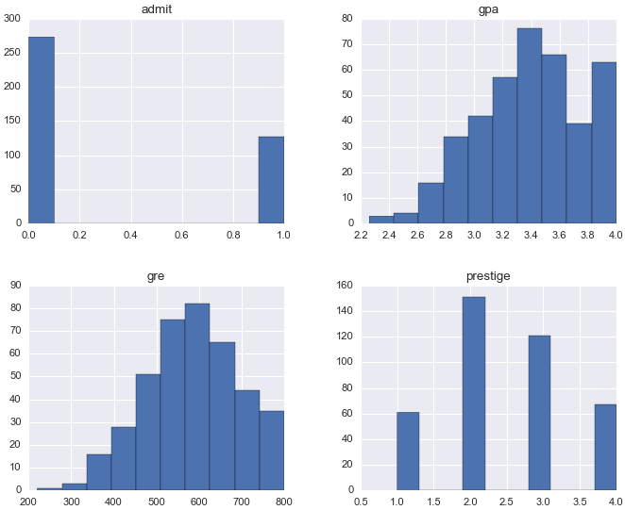

查看gre不同时，’admit’的情况：
# 没有被录取的
no_admits = df[df.admit == 0]
print no_admits.shape
# 没有被录取的学生gre统计信息
print no_admits.gre.describe()
# 被录取的
admits = df[df.admit == 1]
print admits.shape
# 被录取的学生gre统计信息
print admits.gre.describe()
输出如下:
# 没被录取的公273个，平均分573.18 | # 被录取公127个，平均分618.89
(273, 4)  count 273.000000  mean 573.186813  std 115.830243  min 220.000000  25% 500.000000  50% 580.000000  75% 660.000000  max 800.000000  Name: gre, dtype: float64 | (127, 4)  count 127.000000  mean 618.897638  std 108.884884  min 300.000000  25% 540.000000  50% 620.000000  75% 680.000000  max 800.000000  Name: gre, dtype: float64
由此可见gre分数越高，越容易被录取。下面看下直方图:
f, (ax1, ax2) = plt.subplots(2, 1, sharex=True)
f.suptitle('gre per by class')
bins = 20
ax1.hist(no_admits.gre, bins=bins)
ax1.set_title('no_admits')
ax2.hist(admits.gre, bins=bins)
ax2.set_title('admits')
plt.xlabel('gre')
plt.ylabel('Number of gre')
plt.show()
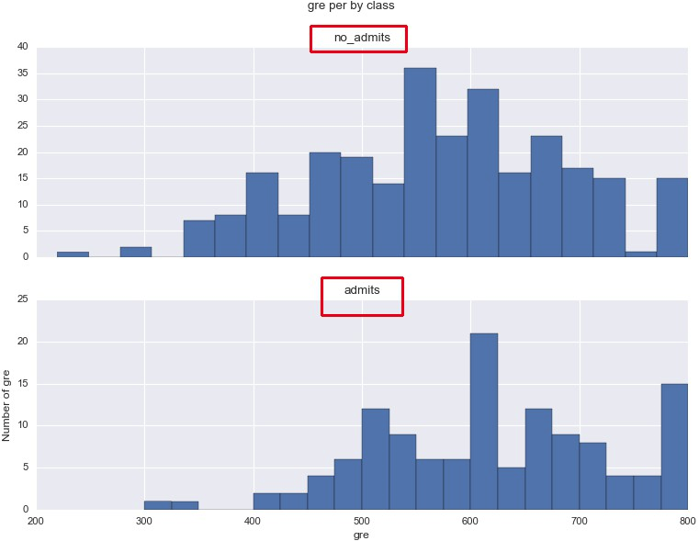

1.1 data process

1.1.1 dummy variables
pandas gives you a great deal of control over how categorical variables are represented. We're going dummify the "prestige" column using get_dummies.

get_dummies creates a new DataFrame with binary indicator variables for each category/option in the column specified. In this case, prestige has four levels: 1, 2, 3 and 4 (1 being most prestigious). When we call get_dummies, we get a dataframe with four columns, each of which describes one of those levels.
def process_df(df):
dummy_ranks = pd.get_dummies(df['prestige'], prefix='prestige')
print dummy_ranks.tail()
prestige_1 prestige_2 prestige_3 prestige_4
395 0.0 1.0 0.0 0.0
396 0.0 0.0 1.0 0.0
397 0.0 1.0 0.0 0.0
398 0.0 1.0 0.0 0.0
399 0.0 0.0 1.0 0.0

# create a clean data frame for the regression
cols_to_keep = ['admit', 'gre', 'gpa']
data = df[cols_to_keep].join(dummy_ranks.ix[:, 'prestige_2':])
print data.tail()
admit gre gpa prestige_2 prestige_3 prestige_4
395 0 620 4.00 1.0 0.0 0.0
396 0 560 3.04 0.0 1.0 0.0
397 0 460 2.63 1.0 0.0 0.0
398 0 700 3.65 1.0 0.0 0.0
399 0 600 3.89 0.0 1.0 0.0

1.1.1 split data train test
def split_train_test(df):
X = df.ix[:, 1:]
Y = df.admit
X_train, X_test, Y_train, Y_test = train_test_split(X, Y,
test_size=0.2, random_state=40)
return X_train, X_test, Y_train, Y_test

1.1.1 normalize column
考虑吧gre, gpa两列数据归一化(对于同样的train, test数据，对于逻辑回归模型，不归一化的数据精度更高)
def process_df_norm(df):
dummy_ranks = pd.get_dummies(df['prestige'], prefix='prestige')
cols_to_keep = ['admit', 'gre', 'gpa']
df = df[cols_to_keep].join(dummy_ranks.ix[:, 'prestige_2':])
cols_norm = ['gre', 'gpa']
f_norm = lambda x: (x - x.min()) / (x.max() - x.min())
df[cols_norm] = df[cols_norm].apply(f_norm)
print df.tail()
return df
admit gre gpa prestige_2 prestige_3 prestige_4
395 0 0.689655 1.000000 1.0 0.0 0.0
396 0 0.586207 0.448276 0.0 1.0 0.0
397 0 0.413793 0.212644 1.0 0.0 0.0
398 0 0.827586 0.798851 1.0 0.0 0.0
399 0 0.655172 0.936782 0.0 1.0 0.0

train & test

1.1.1 print accuracy/confusion_matrix
def print_cm_accuracy(Y_true, Y_pred):
cnf_matrix = confusion_matrix(Y_true, Y_pred)
print cnf_matrix
accuracy_percent = accuracy_score(Y_true, Y_pred)
print "accuracy is: %s%s" % (accuracy_percent * 100, '%')

1.1.1 LogisticRegression
def lr_fit_test(X_train, X_test, Y_train, Y_test):
lr = LogisticRegression()
# lr = LogisticRegression(C=1.0, class_weight=None, dual=False, fit_intercept=True,
# intercept_scaling=1, penalty='l2', random_state=None, tol=0.0001)
lr.fit(X_train, Y_train)
Y_pred = lr.predict(X_test)
print_cm_accuracy(Y_test, Y_pred)
输出如下:
[[53 0]
[23 4]]
accuracy is: 71.25%
- 上面的：lr参数发现C=1.0时准确率最高
- 数据归一化之后，准确率竟然下降了1.25%

1.1.1 RandomForestClassifier
下面给出随机森林的训练以及预测
def rfc_fit_test(X_train, X_test, Y_train, Y_test):
rf = RandomForestClassifier(n_jobs=4)
rf.fit(X_train, Y_train)
Y_pred = rf.predict(X_test)
print_cm_accuracy(Y_test, Y_pred)
输出:
[[46 7]
[17 10]]
accuracy is: 70.0%

相同的数据集，随机森林的精度较低（逻辑回归为71.25%）

下面看下数据归一化后的准确率:(原有的基础上面下降了)
[[48 5]
[20 7]]
accuracy is: 68.75%

1.1.1 KNeighborsClassifier
下面给出K近邻的不同K值是准确度，以及数据是否归一化的对比:
def knn_fit_test(X_train, X_test, Y_train, Y_test):
ks = [1, 3, 5, 7]
for k in ks:
print 'KNeighborsClassifier k is %s' % k
knn = KNeighborsClassifier(n_neighbors=k)
knn.fit(X_train, Y_train)
Y_pred = knn.predict(X_test)
print_cm_accuracy(Y_test, Y_pred)

数据不归一化:
KNeighborsClassifier k is 1
[[41 12]
[15 12]]
accuracy is: 66.25%
KNeighborsClassifier k is 3
[[44 9]
[17 10]]
accuracy is: 67.5%
KNeighborsClassifier k is 5
[[47 6]
[17 10]]
accuracy is: 71.25%
KNeighborsClassifier k is 7
[[47 6]
[20 7]]
accuracy is: 67.5%
==========================================
数据归一化:
KNeighborsClassifier k is 1
[[41 12]
[15 12]]
accuracy is: 66.25%
KNeighborsClassifier k is 3
[[44 9]
[14 13]]
accuracy is: 71.25%
KNeighborsClassifier k is 5
[[44 9]
[15 12]]
accuracy is: 70.0%
KNeighborsClassifier k is 7
[[46 7]
[17 10]]
accuracy is: 70.0%

1.1 cited
来源(Englsih)
http://blog.yhat.com/posts/logistic-regression-python-rodeo.html
chinese
http://www.powerxing.com/logistic-regression-in-python/

Resource List

1.1
Tencent_Social_Ads
第一届腾讯社交广告高校算法大赛(全国14名)
https://github.com/freelzy/Tencent_Social_Ads

1.1 ali_tainci
https://tianchi.aliyun.com/competition/gameList.htm?spm=5176.100153.0.0.3fe4c06dG1eO91
[天池竞赛系列]IJCAI-17 口碑商家客流量预测冠军思路
http://blog.csdn.net/bryan__/article/details/77435245?spm=5176.9876270.0.0.43ff8f33UfHIko

xgboost
https://github.com/dmlc/xgboost
Scalable, Portable and Distributed Gradient Boosting (GBDT, GBRT or GBM) Library, for Python, R, Java, Scala, C++ and more. Runs on single machine, Hadoop, Spark, Flink and DataFlow

Introduction to Boosted Trees
http://xgboost.apachecn.org/en/latest/model.html English
http://xgboost.apachecn.org/cn/latest/model.html chinese

1.1 interv

数据挖掘岗面试总结
http://blog.csdn.net/bryan__/article/details/52672912

他人的数据挖掘面试题-经验
http://blog.csdn.net/MAGANG255/article/details/52278621

