basic

1.1 variable

1.1.1 read variable from prompt

1.1.1 read variable awk
read -p "input the class num: " class
class_num=`awk '$2=='$class' {class_num+=1;} END {print class_num}' train.txt`
echo "$class sample size is: $class_num"

you can use the shell variables inside awk. There are a bunch of ways of doing it, but my favorite is to define a variable with the -v flag:
$ echo | awk -v my_var=4 '{print "My var is " my_var}'
My var is 4

ust pass the environment variable as parameter to the -v flag. For example, if you have this variable:
$ VAR=3
$ echo $VAR
3
Use it this way:

$ echo | awk -v env_var="$VAR" '{print "The value of VAR is " env_var}'
The value of VAR is 3
Of course, you can give the same name, but the $ will not be necessary:

$ echo | awk -v VAR="$VAR" '{print "The value of VAR is " VAR}'
The value of VAR is 3

awk -v col=1 '{print $col}' train.txt | head -1
train/4C0/4C0B77F76A1C58DE372F984AA8A807BEFF04F63A.png

1.1.1 variable divide
The default shell on most Linux distributions is Bash. In Bash, variables must use a dollar sign prefix for parameter expansion. For example:
x=20
y=5
expr $x / $y

Of course, Bash also has arithmetic operators and a special arithmetic expansion syntax, so there's no need to invoke the expr binary as a separate process. You can let the shell do all the work like this:
x=20; y=5
z=$((x / y))

1.1.1 str concat
var=$var$name

1.1.1 ` ` / $()
for line in `head sub_model.csv`;do echo $line;done
../test_data/50049/5020231.jpg,1
../test_data/50049/5020274.jpg,1

What's the difference between $(stuff) and `stuff`?

There are two syntaxes for command substitution: with dollar-parentheses and with backticks. Running top -p $(pidof init) and top -p `pidof init` gives the same output. Are these two ways of doing the same thing, or are there differences?

The old-style backquotes ` ` do treat backslashes and nesting a bit different. The new-style $() interprets everything in between ( ) as a command.

echo $(uname | $(echo cat))
Linux

echo `uname | `echo cat``
bash: command substitution: line 2: syntax error: unexpected end of file
echo cat

works if the nested backquotes are escaped:

echo `uname | \`echo cat\``
Linux

The new-style $() applies to all POSIX-conformant shells.
As mouviciel pointed out, old-style ` ` might be necessary for older shells.

Apart from the technical point of view, the old-style ` ` has also a visual disadvantage:

Hard to notice: I like $(program) better than `program`
Easily confused with a single quote: '`'`''`''`'`''`'

Obvious difference I observe is that you cannot nest backticks while you can nest $(). Maybe both exist for legacy reasons. Similarly, the . and source commands are synonyms.

1.1 common variable

1.1.1 ./ vs sh
Given that script:

#!/bin/bash
#Simple array
array=(1 2 3 4 5)

echo ${array[*]}
and assuming:

It's in a file in your current directory named array.sh;
You've done chmod +x array.sh;
You have a sufficiently new version of bash installed in /bin/bash (you report that you have 4.3.8, which is certainly new enough); and
You execute it correctly
then that should work without any problem.

If you execute the script by typing

./array.sh
the system will pay attention to the #!/bin/bash line and execute the script using /bin/bash.

If you execute it by typing something like:

sh ./array.sh
then it will execute it using /bin/sh. On Ubuntu, /bin/sh is typically a symbolic link to /bin/dash, a Bourne-like shell that doesn't support arrays. That will give you exactly the error message that you report.

When you use ./scriptname.sh it executes with /bin/bash as in the first line with #!. But when you use sh scriptname.sh it executes sh, not bash.

The sh shell has no syntax to create arrays, but Bash has the syntax you used.

1.1.1 $?/$$
(1) cmd1 ;cmd2 ;cmd3 ( ; 不考虑命令的相关性，连续的执行命令)
(2) cmd1 && cmd2 (如果cmd1执行完毕且正确（$?=0）,则执行cmd2。cmd1错误则cmd2不执行)
(3) cmd1 || cmd2 (如果cmd1 执行完毕且正确（$?=0）,则不执行 cmd2，否则执行cmd2)
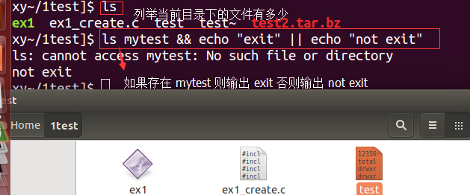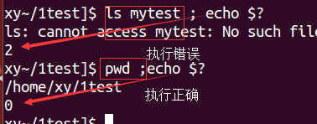
First print the PID of the current shell:
$ echo $$
25009

print_something () {
echo Hello $1
return 5
}
print_something Mars
print_something Jupiter
echo The previous function has a return value of $?

Line 11 - Remember that the variable $? contains the return status of the previously run command or function.
./return_status_example.sh
Hello Mars
Hello Jupiter
The previous function has a return value of 5

Typically a return status of 0 indicates that everything went successfully. A non zero value indicates an error occurred.

Shell Built-in Variables:

$0 #Name of this shell script itself.
$1 #Value of first command line parameter (similarly $2, $3, etc)
$# #In a shell script, the number of command line parameters.
$* #All of the command line parameters.
$- #Options given to the shell.
$? #Return the exit status of the last command.
$$ #Process id of script (really id of the shell running the script)

1.1.1 date format in shell log
xiongyu@ubuntu:~/search_start_sh$ tail restart_scrape.log
2017-08-25 21:10:09 scrape_yy_news_main.py got down, now I will restart it

some of my shell contents is as below
log_file="restart_scrape.log"
TIMESTAMP=`date "+%Y-%m-%d %H:%M:%S"`
echo "$TIMESTAMP $search_py_file got down, now I will restart it" | tee -a $log_file

1.1.1 PWD(current dir in shell)(pwd in command)
echo "Now I am in $PWD"
if you use $pwd, it won’t show the current directory

The PWD variable is defined by POSIX and will work on all POSIX-compliant shells:
PWD
Set by the shell and by the cd utility. In the shell the value shall be initialized from the environment as follows.

1.1 for loop

1.1.1 seq
adminroot@admin:~$ seq 4
1
2
3
4
adminroot@admin:~$ seq 5 | { while read num; do x+=$num; done; echo $x; }
12345

1.1.1 for loop
END=5
for ((i=1;i<=END;i++)); do
echo $i
done
# ==> outputs 1 2 3 4 5 on separate lines
$ a="0"; for i in $(seq 3); do a="$a$i"; echo "$i | $a"; done
1 | 01
2 | 012
3 | 0123
kent$ echo "108.166.104.204 108.166.105.47 108.166.56.241"|awk '{for(i=1;i<=NF;i++){print "[ndbd]";print "HostName="$i;print ""}}'
[ndbd]
HostName=108.166.104.204

[ndbd]
HostName=108.166.105.47

[ndbd]
HostName=108.166.56.241

If you want to iterate over an array variable, you need to specify the whole array:

ip_ndbd=(108.166.104.204 108.166.105.47 108.166.56.241)

ip_temp=""
for ip in ${ip_ndbd[*]}
do
ip_temp+="\n\[ndbd\]\nHostname=$ip\n"
done

The for ((expr1;expr2;expr3)); construct works just like for (expr1;expr2;expr3) in C and similar languages, and like other ((expr)) cases, Bash treats them as arithmetic.
limit=4
i=1; while [ $i -le $limit ]; do  echo $i  i=$(($i + 1))  done | for i in $(seq 1 $limit); do  echo $i  done

1.1.1 for loop by step
for i in `seq 0 3 8`;do echo $i;done;  0  3  6 | #!/bin/bash  for i in $(seq 1 2 10)  do  echo "skip by 2 value $i"  done

for (( COUNTER=0; COUNTER<=10; COUNTER+=2 )); do  echo $COUNTER  done | for {0..10..2}; do  ..  done

Bash 4's brace expansion has a step feature:
for i in `seq 1 $step $class_num`  do  echo "skip by $step $i"  done | skip by 2398 1  skip by 2398 2399  skip by 2398 4797  skip by 2398 7195
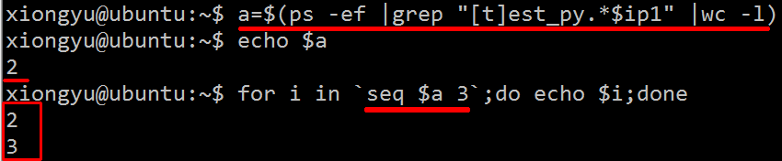

1.1.1 for files operaor
for f in *.pdf; do rm "$f"; done

if using bash, no need for external commands like sed, basename, rename, expr...etc

for file in *.html
do
mv "$file" "${file%.html}.txt"
done

for f in *.pdf
do
rm $f
done

files=(*.pdf)
for((I=0;I<${#files[*]};I+=1000)); do rm -f ${files[@]:I:1000}; done
This way it will erase in batches of 1000 files per step.
for f in *.zip; do sudo unzip -j $f;done #unzip all the zip files

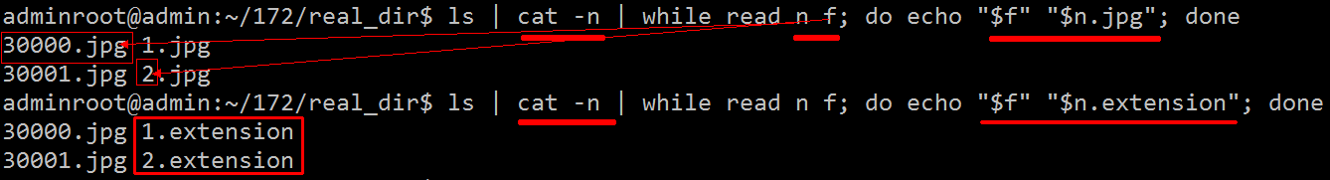
Renaming files in a folder to sequential numbers
I want to rename the files in a directory to sequential numbers. Based on creation date of the files.
For Example sadf.jpg to 0001.jpg, wrjr3.jpg to 0002.jpg

a=1
for i in *.jpg; do
new=$(printf "%04d.jpg" "$a") #04 pad to length of 4
mv -i -- "$i" "$new"
let a=a+1
done

using the -i flag prevents automatically overwriting existing files.

find -name '*.jpg' \ # find jpegs
| awk 'BEGIN{ a=0 }{ printf "mv \"%s\" %04d.jpg\n", $0, a++ }' # build mv command
| bash # run that command

split -l 200000 filename
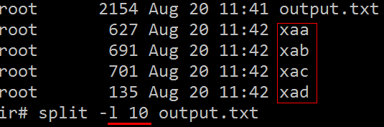

only output the even row(all 2 row, so output the 2th row)
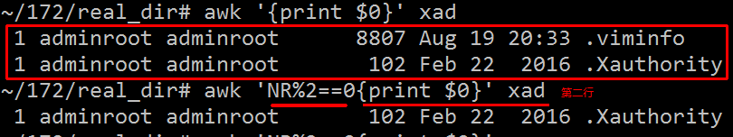
awk -v c=1 'NR%10==0 {++c}{print $0 > c".txt"}' output.txt
1.txt 2.txt 3.txt 4.txt

real_dir# for f in *.txt;do awk -v f="$f" '{line_num+=1}END{print f": line->"line_num}' $f;done
1.txt: line->9
2.txt: line->10
3.txt: line->10
4.txt: line->3

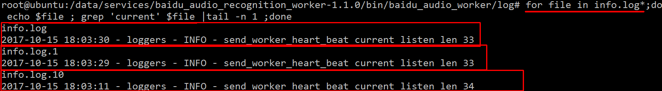
for file in info.log*;do echo $file ; grep 'current' $file |tail -n 1 ;done

output as below

info.log
2017-10-15 18:03:30 - loggers - INFO - send_worker_heart_beat current listen len 33
info.log.1
2017-10-15 18:03:29 - loggers - INFO - send_worker_heart_beat current listen len 33
info.log.2
2017-10-15 18:03:11 - loggers - INFO - send_worker_heart_beat current listen len 34
info.log.3

1.1.1 to do
https://ryanstutorials.net/bash-scripting-tutorial/bash-loops.php

1.1 while

1.1.1 while read(batch rename files)
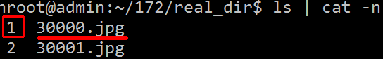
read n f (n f splited by space not ,)
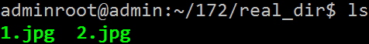

1.1.1 while IFS=’,’ read split ,
head -5 sub_model_.csv | while read line num; do echo $line "->" $num;done

../test_data/50049/5020231.jpg,1 ->
../test_data/50049/5020274.jpg,1 ->
../test_data/50049/5020289.jpg,1 ->
../test_data/10092/10090248.jpg,1 ->

head -5 sub_model.csv | while IFS=',' read line num; do echo $line "->" $num;done
../test_data/50049/5020231.jpg -> 1
../test_data/50049/5020274.jpg -> 1
../test_data/50049/5020289.jpg -> 1
../test_data/10092/10090248.jpg -> 1

Internal Variable

$IFS
internal field separator
This variable determines how Bash recognizes fields, or word boundaries, when it interprets character strings.

for line in `head sub_model.csv`;do echo $line;done
../test_data/50049/5020231.jpg,1
../test_data/50049/5020274.jpg,1

1.1.1 while loop infinitely
while :
do
# loop infinitely
done

But I just don't understand the use of : here. Wouldn't it be better to use:

while true
do
# loop infinitely
done

: [arguments] No effect; the command does nothing beyond expanding arguments and performing any specified redirections. A zero exit code is returned.
As this returns always zero therefore is is similar to be used as true

The colon is a built-in command that does nothing, but returns 0 (success). Thus, it's shorter (and faster) than calling an actual command to do the same thing.

1.1 case/esac
Case statement: Here is an example that looks for a match with one of the characters a, b, c. If $1 fails to match these, it always matches the * case. A case statement can also use more advanced pattern matching.

case "$1" in
a) cmd1 ;;
b) cmd2 ;;
c) cmd3 ;;
*) cmd4 ;;
esac

1.1 array

1.1.1 basic usage
xiongyu@ubuntu:~/asd$ for f in [a b c]; do echo $f;done
[a
b
c]

xiongyu@ubuntu:~/asd$ for f in "a b c"; do echo $f;done
a b c

xiongyu@ubuntu:~/asd$ numbers="a b c"
xiongyu@ubuntu:~/asd$ for f in `echo $numbers`; do echo $f;done
a
b
c
1. Declaring an Array and Assigning values

In bash, array is created automatically when a variable is used in the format like,

name[index]=value
name is any name for an array
index could be any number or expression that must evaluate to a number greater than or equal to zero.You can declare an explicit array using declare -a arrayname.

Unix[0]='Debian'
Unix[1]='Red hat'
Unix[2]='Ubuntu'

echo ${Unix[1]}
Red hat

To access an element from an array use curly brackets like ${name[index]}.

2. Initializing an array during declaration
Syntax:
declare -a arrayname=(element1 element2 element3)
declare -a Unix=('Debian' 'Red hat' 'Red hat' 'Suse' 'Fedora');

3. Print the Whole Bash Array
There are different ways to print the whole elements of the array. If the index number is @ or *
echo ${Unix[@]}
echo ${Unix[*]}
4. Length of the Bash Array
${#arrayname[@]} gives you the length of the array.

5. Length of the nth Element in an Array

${#arrayname[n]}

6. Extraction by offset and length for an array
The following example shows the way to extract 2 elements starting from the position 3 from an array called Unix.
Unix=('Debian' 'Red hat' 'Ubuntu' 'Suse' 'Fedora' 'UTS' 'OpenLinux');
echo ${Unix[@]:3:2}
Suse Fedora
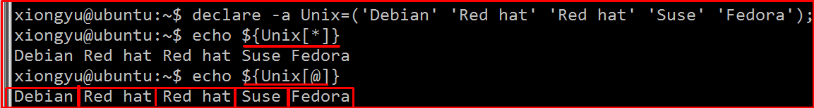

7. Extraction with offset and length, for a particular element of an array

To extract only first four elements from an array element . For example, Ubuntu which is located at the second index of an array, you can use offset and length for a particular element of an array.

Unix=('Debian' 'Red hat' 'Ubuntu' 'Suse' 'Fedora' 'UTS' 'OpenLinux');
echo ${Unix[2]:0:4}
Ubun

8. Search and Replace in an array elements

The following example, searches for Ubuntu in an array elements, and replace the same with the word ‘SCO Unix’.
Unix=('Debian' 'Red hat' 'Ubuntu' 'Suse' 'Fedora' 'UTS' 'OpenLinux');
echo ${Unix[@]/Ubuntu/SCO Unix}
Debian Red hat SCO Unix Suse Fedora UTS OpenLinux

9. Add an element to an existing Bash Array

The following example shows the way to add an element to the existing array.
Unix=('Debian' 'Red hat' );
Unix=("${Unix[@]}" "AIX")

echo ${Unix[2]}
AIX

9. Since bash3, elements can also be appended to an array with “+=”:

Unix+=( “AIX” “HP-UX” )

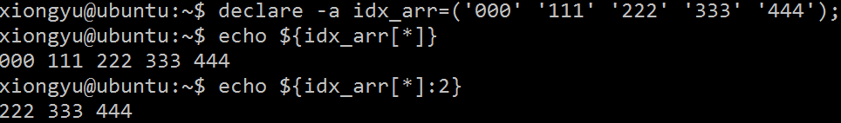
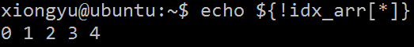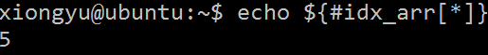
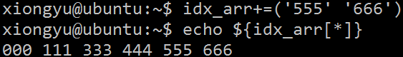
10. Remove an Element from an Array

unset is used to remove an element from an array.unset will have the same effect as assigning null to an element.

Unix=('Debian' 'Red hat' 'Ubuntu' 'Suse' 'Fedora' 'UTS' 'OpenLinux');
unset Unix[3]
echo ${Unix[3]}

The above script will just print null which is the value available in the 3rd index. The following example shows one of the way to remove an element completely from an array.

Unix=('Debian' 'Red hat' 'Ubuntu' 'Suse' 'Fedora' 'UTS' 'OpenLinux');
pos=3
Unix=(${Unix[@]:0:$pos} ${Unix[@]:$(($pos + 1))})
echo ${Unix[@]}

Debian Red hat Ubuntu Fedora UTS OpenLinux

In this example, ${Unix[@]:0:$pos} will give you 3 elements starting from 0th index i.e 0,1,2 and ${Unix[@]:4} will give the elements from 4th index to the last index. And merge both the above output. This is one of the workaround to remove an element from an array.

11. Remove Bash Array Elements using Patterns

In the search condition you can give the patterns, and stores the remaining element to an another array as shown below.

$ cat arraymanip.sh
#!/bin/bash
declare -a Unix=('Debian' 'Red hat' 'Ubuntu' 'Suse' 'Fedora');
declare -a patter=( ${Unix[@]/Red*/} )
echo ${patter[@]}

$ ./arraymanip.sh
Debian Ubuntu Suse Fedora
The above example removes the elements which has the patter Red*.

12. Copying an Array

Expand the array elements and store that into a new array as shown below.

#!/bin/bash
Unix=('Debian' 'Red hat' 'Ubuntu' 'Suse' 'Fedora' 'UTS' 'OpenLinux');
Linux=("${Unix[@]}")

13. Concatenation of two Bash Arrays

Expand the elements of the two arrays and assign it to the new array.

$cat arraymanip.sh
#!/bin/bash
Unix=('Debian' 'Red hat' 'Ubuntu' 'Suse' 'Fedora' 'UTS' 'OpenLinux');
Shell=('bash' 'csh' 'jsh' 'rsh' 'ksh' 'rc' 'tcsh');

UnixShell=("${Unix[@]}" "${Shell[@]}")

14. Deleting an Entire Array
unset is used to delete an entire array.

UnixShell=("${Unix[@]}" "${Shell[@]}")
unset UnixShell

15. Load Content of a File into an Array
You can load the content of the file line by line into an array.

filecontent=( `cat "logfile" `)

(associative array)check index exists
Shell Associative Array
bashi没有原生的对于类似hash table的支持，不像perl或python.
下标数组元素是通过数组下标（数组下标可以是算术表达式，其结果必须是一个整数）来访问的，但是这种访问方式在表达某些关联性很强的数据时会存在限制。
shell 提供了另外一种数组，其可以使用任意的字符串作为下标（不必是整数）来访问数组元素。这种数组叫做关联数组（associative array）。
关联数组的下标和值称为键值对，它们是一一对应的关系。在关联数组中，键是唯一的，值可以不唯一。

定义关联数组
shell 的关联数组和 shell 的下标数组在定义和使用上完全一样，只是在索引上有区别。
需要注意的是，在使用关联数组之前，需要使用命令 declare -A array 进行显示声明。

declare -A phone
phone=([jim]=135 [tom]=136 [lucy]=158)
#display all elements  echo ${array[@]}  echo ${array[@]:0} | #display all elements except first one  echo ${array[@]:1}  #display elements in a range  echo ${array[@]:1:4}

And for associative array, you could use the same:

$ unset array
$ declare -A array
xiongyu@ubuntu:~$ declare -A arr  xiongyu@ubuntu:~$ arr["key1"]="red"  xiongyu@ubuntu:~$ arr["key2"]="black"  xiongyu@ubuntu:~$ arr["key3"]="blue"  xiongyu@ubuntu:~$ echo ${arr[@]}  blue black red  xiongyu@ubuntu:~$ echo ${!arr[@]}  key3 key2 key1 | xiongyu@ubuntu:~$ arr_1["aa"]="aa"  xiongyu@ubuntu:~$ arr_1["bb"]="bb"  xiongyu@ubuntu:~$ echo ${!arr_1[@]}  0  xiongyu@ubuntu:~$ echo ${arr_1[@]}  bb

$ array=()
$ array[12]="red"
$ array[51]="black"
$ array[129]="blue"

$ echo ${array[@]}
red black blue

$ echo ${!array[@]}
12 51 129

$ echo "${#array[@]}"
3

$ printf "%s\n" ${!array[@]}|grep -q ^51$ && echo 51 exist
51 exist

$ printf "%s\n" ${!array[@]}|grep -q ^52$ && echo 52 exist
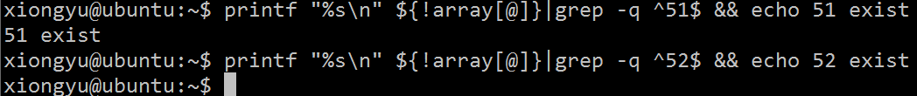

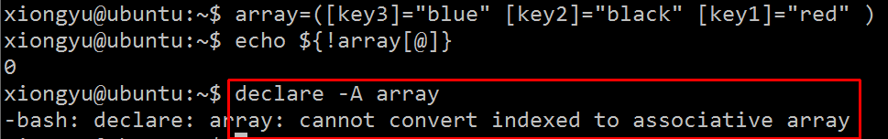
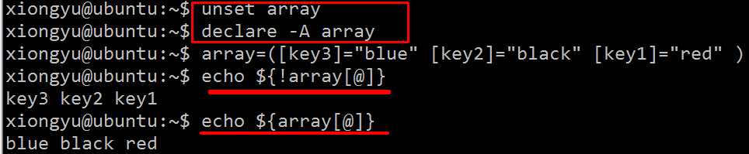
The straightforward way is to iterate with a loop :

var=ab
for item in "${array[@]}"; do
[[ $var == "$item" ]] && echo "$var present in the array"
done

-v varname
True if the shell variable varname is set (has been assigned a value).
example:

declare -A foo
foo[bar]="this is bar"
foo[baz]=""
if [[ -v "foo[bar]" ]] ; then
echo "foo[bar] is set"
fi
if [[ -v "foo[baz]" ]] ; then
echo "foo[baz] is set"
fi
if [[ -v "foo[quux]" ]] ; then
echo "foo[quux] is set"
fi
This will show that both foo[bar] and foo[baz] are set (even though the latter is set to an empty value) and foo[quux] is not.

for key in "${!isp_ip[@]}"
do
echo " sudo exe $key ${isp_ip[$key]}"
done

isp_ip key is 1 2 32
isp_ip val is 221.228.107.250 103.229.149.248 112.25.251.249

sudo exe 1 221.228.107.250
sudo exe 2 103.229.149.248
sudo exe 32 112.25.251.249

How to iterate over associative arrays in Bash
Based on an associative array in a Bash script, I need to iterate over it to get the key and value.

#!/bin/bash

declare -A array
array[foo]=bar
array[bar]=foo

The keys are accessed using an exclamation point: ${!array[@]}, the values are accessed using ${array[@]}.

You can iterate over the key/value pairs like this:

for i in "${!array[@]}"
do
echo "key : $i"
echo "value: ${array[$i]}"
done

Note the use of quotes around the variable in the for statement (plus the use of @ instead of *). This is necessary in case any keys include spaces.

1.1 wildcards
Whenever we refer to a path we may also use wildcards in that path to turn it into a set of files or directories.

Here is the basic set of wildcards:

* - represents zero or more characters
? - represents a single character
[] - represents a range of characters
As a basic first example we will introduce the *. In the example below we will list every entry beginning with a b.

xiongyu@ubuntu: ls
barry.txt blah.txt bob example.png firstfile foo1 foo2
foo3 frog.png secondfile thirdfile video.mpeg

ls b*
barry.txt blah.txt bob

In this example we are looking for each file whose second letter is i. As you can see, the pattern can be built up using several wildcards.

xiongyu@ubuntu: ls ?i*
firstfile video.mpeg

Or how about every file with a three letter extension. Note that video.mpeg is not matched as the path name must match the given pattern exactly.

xiongyu@ubuntu: ls *.???
barry.txt blah.txt example.png frog.png

And finally the range operator ( [ ] ). Unlike the previous 2 wildcards which specified any character, the range operator allows you to limit to a subset of characters. In this example we are looking for every file whose name either begins with a s or v

xiongyu@ubuntu: ls [sv]*
secondfile video.mpeg

With ranges we may also include a set by using a hyphen. So for example if we wanted to find every file whose name includes a digit in it we could do the following:

xiongyu@ubuntu: ls *[0-9]*
foo1 foo2 foo3

We may also reverse a range using the caret ( ^ ) which means look for any character which is not one of the following.
xiongyu@ubuntu: ls [^a-k]*
secondfile thirdfile video.mpeg

Find the file type of every file in a directory.
xiongyu@ubuntu:file /home/ryan/*
bin: directory
Documents: directory
frog.png: PNG image data
public_html: directory
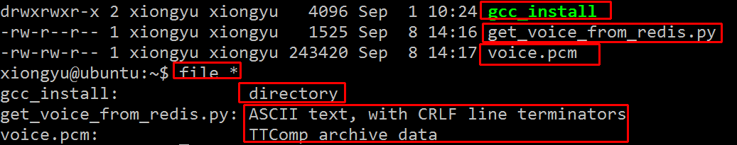

Move all files of type either jpg or png (image files) into another directory.
xiongyu@ubuntu: mv public_html/*.??g public_html/images/

https://ryanstutorials.net/linuxtutorial/wildcards.php

1.1 define function

1.1.1 basic
in the section “restart process->1.1.1” has function usage

#!/bin/bash
# Basic function
print_something () {
echo Hello I am a function
}
print_something
print_something

./function_example.sh
Hello I am a function
Hello I am a function

Passing Arguments

It is often the case that we would like the function to process some data for us. We may send data to the function in a similar way to passing command line arguments to a script. We supply the arguments directly after the function name. Within the function they are accessible as $1, $2, etc.

print_something () {
echo Hello $1
}
print_something Mars
print_something Jupiter

./arguments_example.sh
Hello Mars
Hello Jupiter

Return Values
Most other programming languages have the concept of a return value for functions, a means for the function to send data back to the original calling location. Bash functions don't allow us to do this. They do however allow us to set a return status. Similar to how a program or command exits with an exit status which indicates whether it succeeded or not. We use the keyword return to indicate a return status.

print_something () {
echo Hello $1
return 5
}
print_something Mars
print_something Jupiter
echo The previous function has a return value of $?

Line 11 - Remember that the variable $? contains the return status of the previously run command or function.
./return_status_example.sh
Hello Mars
Hello Jupiter
The previous function has a return value of 5

Typically a return status of 0 indicates that everything went successfully. A non zero value indicates an error occurred.

$# -> para size, $*: all paras
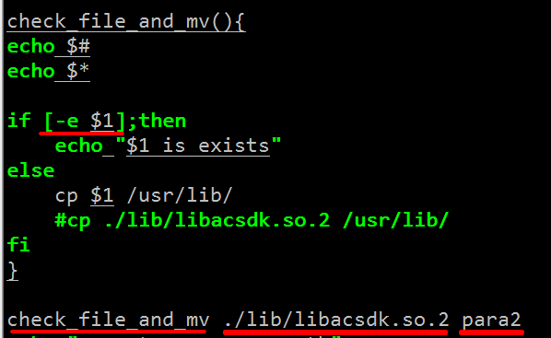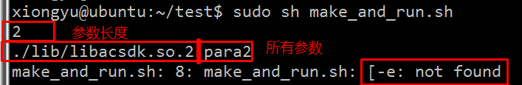
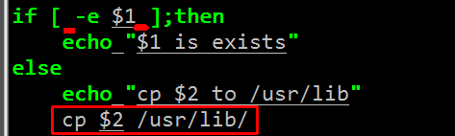 if [ check ]记得判断加上空格
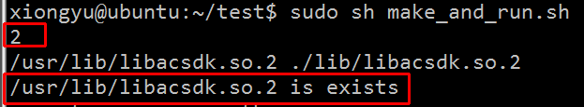

1.1.1 local variable(variable scope)
All variables declared inside a function will be shared with the calling environment.
All variables declared local will not be shared.
Example code
xiongyu@ubuntu:~$ cat tmp_sh.sh  #!/bin/bash  f(){  echo funtion starts  local willNotExists="It still does!"  DoesNotExists="It still does!"  echo funcion ends  }  echo $DoesNotExists #Should print empty line  echo $WillNotExists #Should print empty line  f #Call the function  echo $DoesNotExists #Should print It still does!  echo $WillNotExists #Should print empty line  DoesNotExists="new value"  echo $DoesNotExists | funtion starts  funcion ends  It still does!  new value

1.1.1 return val
#/bin/sh/  TIMESTAMP(){  echo "1111"  echo $(date "+%Y-%m-%d %H:%M:%S")  # date "+%Y-%m-%d %H:%M:%S"  }  echo "$(TIMESTAMP) ==="  sleep 1  echo "$(TIMESTAMP) ===" | xiongyu@ubuntu:~$ sh tmp_sh.sh  1111  2017-08-28 18:14:44 ===  1111  2017-08-28 18:14:45 ===
all the echo string in function will be returned as string
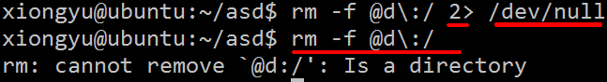

xiongyu@ubuntu:~/asd$ cat test.sh
#!/bin/bash
testMkdir(){
retval=""
if mkdir $1:
then # directory did not exist, but was created successfully
echo >&2 "successfully mkdir: $1"
retval="true"
else
echo >&2 "cannot mkdir $1"
retval="false"
fi
echo "$retval"
}
d="9)23f&#!@"
retval=$(testMkdir $d)
echo "now echo ret======================"
echo $retval

xiongyu@ubuntu:~/asd$ sh test.sh
mkdir: cannot create directory `9)23f&#!@:': File exists
cannot mkdir 9)23f&#!@
now echo ret======================
false

2. return exit status

lockdir="somedir"
testlock(){
if mkdir "$lockdir"
then # directory did not exist, but was created successfully
echo >&2 "successfully acquired lock: $lockdir"
retval=0
else
echo >&2 "cannot acquire lock, giving up on $lockdir"
retval=1
fi
return "$retval"
}

- share variable

1.1.1 if func (prompt y/n)condition
xiongyu@ubuntu:~/asd$ vi test.sh  #!/bin/bash  promptyn(){  while :  do  read -p "$1 " yn  case $yn in  [Yy]* ) return 0;;  [nN]* ) return 1;;  * ) echo "please input right choice";;  esac  done  }  #yn=$(promptyn "is the sky blue?")  #echo $yn  if promptyn "is the sky blue?";  then  echo "yes"  else  echo "no"  fi | xiongyu@ubuntu:~/asd$ sh test.sh  is the sky blue? asd  please input right choice  is the sky blue? wer  please input right choice  is the sky blue? yellow  yes
比较奇怪的是函数return 0结果却是echo yes.

Return Values
Most other programming languages have the concept of a return value for functions, a means for the function to send data back to the original calling location. Bash functions don't allow us to do this. They do however allow us to set a return status. Similar to how a program or command exits with an exit status which indicates whether it succeeded or not. We use the keyword return to indicate a return status.

print_something () {
echo Hello $1
return 5
}
print_something Mars
print_something Jupiter
echo The previous function has a return value of $?

Line 11 - Remember that the variable $? contains the return status of the previously run command or function.
./return_status_example.sh
Hello Mars
Hello Jupiter
The previous function has a return value of 5

Typically a return status of 0 indicates that everything went successfully. A non zero value indicates an error occurred.

1.1.1 multiple lines comments
There is no block comment on shell script.

Using vi (yes, vi) you can easily comment from line n to m

<ESC>
:10,100s/^/#/
(that reads, from line 10 to 100 substitute line start (^) with a # sign.)

and un comment with

<ESC>
:10,100s/^#//
(that reads, from line 10 to 100 substitute line start (^) followed by # with noting //.)

vi is almost universal anywhere where there is /bin/sh.

I have recently started studying shell script and I'd like to be able to comment out a set of lines in a shell script. I mean like it is in case of C/Java :

/* comment1
comment2
comment3
*/`

Use : ' to open and ' to close.

For example:

: '
This is a
very neat comment
in bash
'

1.1 evvironment variable

1.1.1 export variable
if [[ ! -d "$MyVar" ]]; then
export MyVar="abc"
echo 'export MyVar="abc"' >> ~/.bashrc
fi
If you need to evaluage expressions like pwd, you can use this, for example,

1.1 common use function

1.1.1 sleep s/minutes/hours
The syntax is as follows for gnu/bash sleep command:

sleep NUMBER[SUFFIX]
Where SUFFIX may be:
s for seconds (the default) m for minutes. h for hours. d for days.

Examples
To sleep for 5 seconds, use: sleep 5
To sleep for 2 minutes, use: sleep 2m
To sleep for 3 hours, use: sleep 3h
To sleep for 5 days, use: sleep 5d

1.1.1 set -e(exit shell if any command failed)
Good practices:

#!/bin/bash #Explicitly tell shell this is a bash script
set -e #Exit as soon as any line in the bash script fails
set -x #Prints each command executed (prefix with ++)
set -ex #Do both (for good practice)

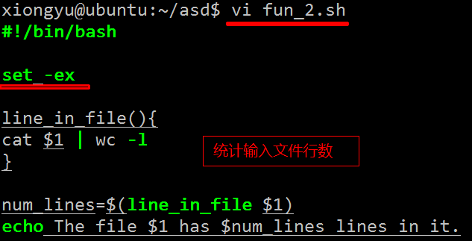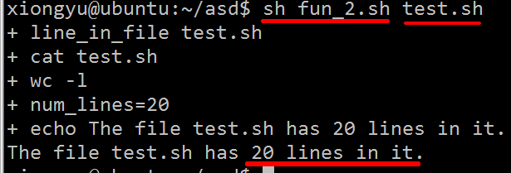
If remove the line ‘set -ex’ in the file ‘fun_2.sh’, then just print

1.1.1 printf
printf
In format prinft can have format specifiers, escape sequences or ordinary characters. When it comes to arguments it is usually text we would like to print to standard output stream. Let’s start with something simple from a bash shell command line:

$printf “hello printf”
hello printf$

Not the different behaviour in comparison to echo command. No new line had been printed out as it it in case of when using default setting of echo command. To print a new line we need to supply printf with format string with escape sequence \n ( new line ):

$ printf "%s\n" "hello printf"
hello printf

The format string is applied to each argument:

$ printf "%s\n" "hello printf" "in" "bash script"
hello printf
in
bash script

Format specifiers

As you could seen in the previous simple examples we have used %s as a format specifier. The most commonly used printf specifiers are %s, %b, %d, %x and %f . The specifiers are replaced by a corresponding arguments. See the following example:

$ printf "%s\t%s\n" "1" "2 3" "4" "5"
1 2 3
4 5

$ printf "%.1f\n" 255 0xff
255.0
255.0

Formatting to three places with preceding with 0:

for i in $( seq 1 4 ); do printf "%03d\t" "$i"; done
001 002 003 004
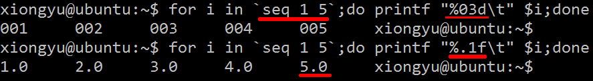

common use

1.1 checking files(is file/dir/readable)
Checking files:

-r file #Check if file is readable.
-w file #Check if file is writable.
-x file #Check if we have execute access to file.
-f file #Check if file is an ordinary file (not a directory, a device file, etc.)
-s file #Check if file has size greater than 0.
-d file #Check if file is a directory.
-e file #Check if file exists. Is true even if file is a directory.
Example:

if [ -s file ]
then
#such and such
fi

check if file is the same.
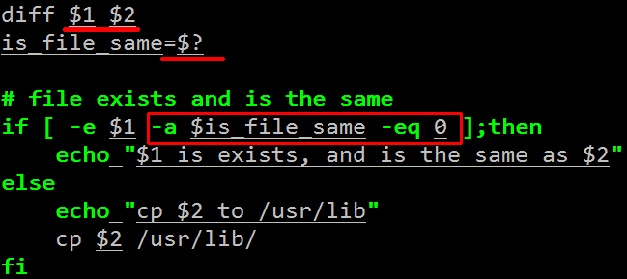

1.1 checking string
Checking strings:

s1 = s2 #Check if s1 equals s2.
s1 != s2 #Check if s1 is not equal to s2.
-z s1 #Check if s1 has size 0.
-n s1 #Check if s2 has nonzero size.
s1 #Check if s1 is not the empty string.
Example:

if [ $myvar = "hello" ] ; then
echo "We have a match"
fi

1.1 checking numbers
Note that a shell variable could contain a string that represents a number. If you want to check the numerical value use one of the following:

n1 -eq n2 #Check to see if n1 equals n2.
n1 -ne n2 #Check to see if n1 is not equal to n2.
n1 -lt n2 #Check to see if n1 < n2.
n1 -le n2 #Check to see if n1 <= n2.
n1 -gt n2 #Check to see if n1 > n2.
n1 -ge n2 #Check to see if n1 >= n2.

Example:

if [ $# -gt 1 ]
then
echo "ERROR: should have 0 or 1 command-line parameters"
fi

1.1 Boolean operators(or and not)
Boolean operators:

! #not
-a #and
-o #or
Example:

if [ $num -lt 10 -o $num -gt 100 ]
then
echo "Number $num is out of range"
elif [ ! -w $filename ]
then
echo "Cannot write to $filename"
fi
Note that ifs can be nested. For example:

if [ $myvar = "y" ]
then
echo "Enter count of number of items"
read num
if [ $num -le 0 ]
then
echo "Invalid count of $num was given"
else
#... do whatever ...
fi

practice demo

1.1 batch sz files

1.1.1 read/awk/str concat space
#!/bin/sh
read -p "input the class num: " class
class_num=`awk '$2=='$class' {class_num+=1;} END {print class_num}' train.txt`
echo "$class sample size is: $class_num"

read -p "input the num of how many samples you wants to download: " download_num
step=$((class_num / download_num))
echo "step size is $step"
# all_files-> a.jpg b.jpg c.jpg
all_files=`awk -v c="$class" '$2==c {print $1} ' train.txt `
d_f=" "
count=0
for i in $all_files
do
count=$(($count+1))
if [ $count -eq $step ]
then
count=0
d_f="$d_f $i" #there is a space between two variable
fi
done
echo "after for loop, the end of sz"
cd /data5/light/storm_1_1/images
sudo sz $d_f
cd -

head -2 train.txt
train/4C0/4C0B77F76A1C58DE372F984AA8A807BEFF04F63A.png 0
train/4C0/4C0A77546E80894F8F89EE8D7AB8C7E159A99193.png

tail -2 train.txt
train/64f/64fc3277521ff37177cbb43329b891dcb8f01203.png 27
train/9C9/9C999B0A7FBEA214C3C8546549447A9902151ACB.png 16
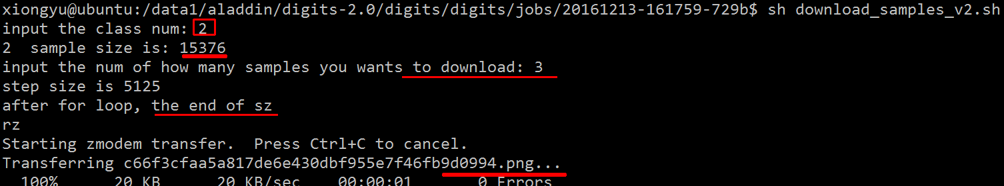

if the download size is too big, the bash will show error parameters too long, so in the above loop we can add batch size sz:
batch_size=100
batch_count=0

if [ $batch_count -eq $batch_size ]
then
echo "batch: $batch_count "
cd /data5/light/storm_1_1/images
sudo sz $d_f
cd -
d_f=" "
batch_count=0
fi

1.1.1 python lib install(with proxy)
pip.conf
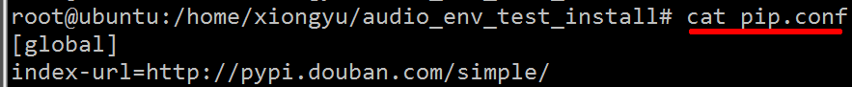
[global]
index-url=http://pypi.douban.com/simple/

cd /root/
mkdir .pip
cd -
sudo cp pip.conf ~/.pip/pip.conf
sudo apt-get update
echo "python pip"
sudo apt-get -y install python-pip
pip install --upgrade pip
# clear the cached locations
hash -r
echo "install pillow"
sudo pip install --upgrade pillow --trusted-host pypi.douban.com --trusted-host pypi.douban.com
sudo apt-get -y install libtiff4-dev libjpeg8-dev zlib1g-dev libfreetype6-dev liblcms2-dev libwebp-dev tcl8.5-dev tk8.5-dev python-tk
echo "install baidu-aip"
sudo pip install baidu-aip --trusted-host pypi.douban.com --trusted-host pypi.douban.com
echo "install redis"
sudo pip install redis --trusted-host pypi.douban.com --trusted-host pypi.douban.com
echo "install oss2 "
sudo pip install oss2 --trusted-host pypi.douban.com --trusted-host pypi.douban.com
echo "install mysqldb "
sudo apt-get install python2.7-mysqldb
python baidu_voice.py

1.1 restart process

1.1.1 log(date format) $PWD/nohup/while
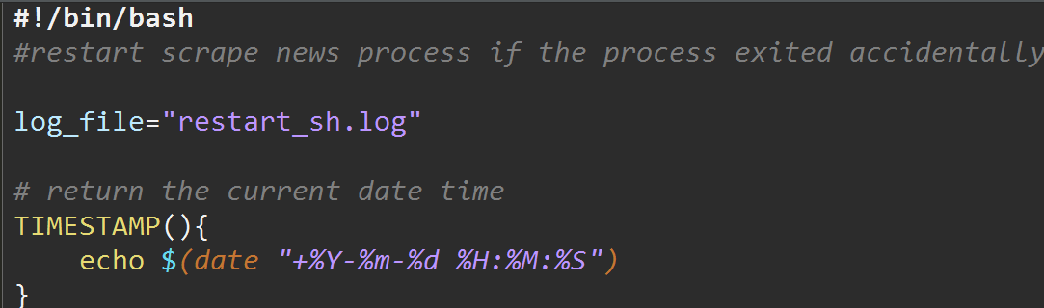
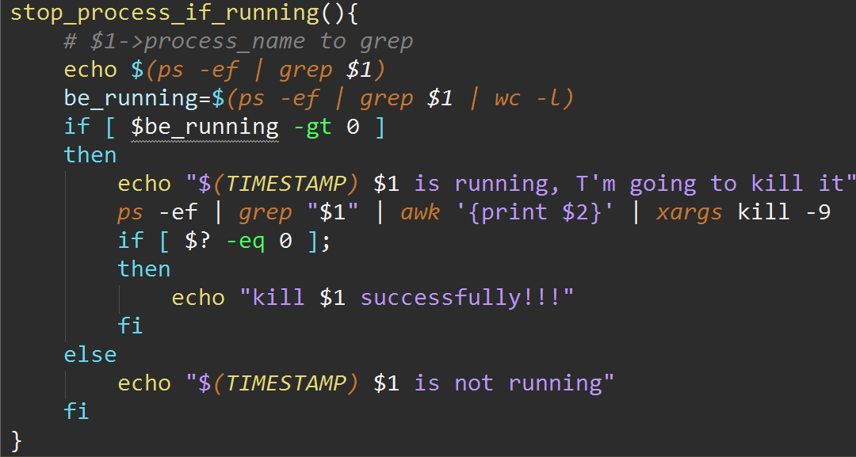
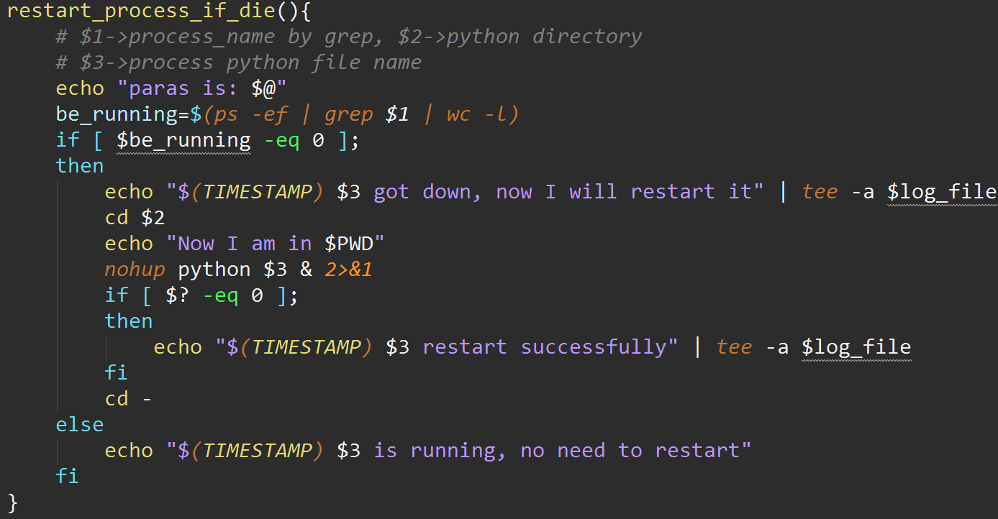
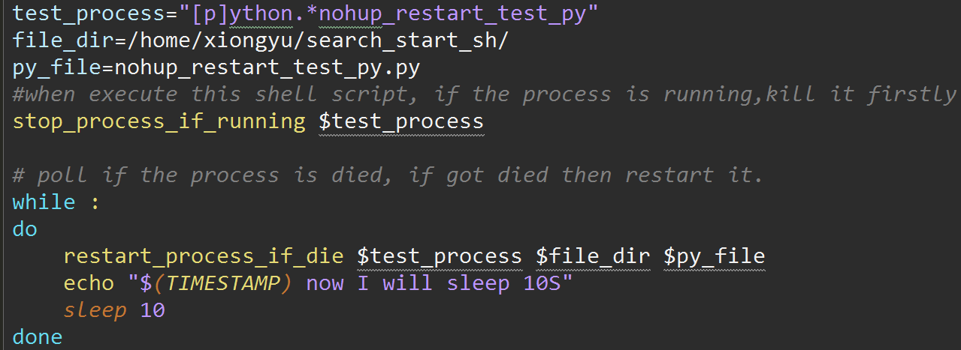

1.1.1 $?(set -e) bash fail function
Best practice to use $? in bash?
Let's have a example:
We have a linear script and I we would like to know that all the command was executed ok. Do you think it is ok to call a small function (let's call it "did_it_work"), to check the error code and break if it's not.

#!/bin/bash

function did_it_work {
code=$1
if [ "$code" -ne "0" ]
then
echo "Error failure: code $code "
exit 1
fi
}

dir=some/path
mkdir -p $dir  did_it_work $? | cd $dir  did_it_work $?

One common way is:

die() {
echo "$*" 1>&2
exit 1
}
then you use it like this:

mkdir -p some/path || die "mkdir failed with status $?"
Or if you want it to include the exit status, you could change it to:

die() {
echo "FATAL ERROR: $* (status $?)" 1>&2
exit 1
}
and then using it is a bit easier:

mkdir -p some/path || die "mkdir failed"
Just in case you haven't seen command1 || command2 before, it runs command1, and if command1 fails, it runs command2.

xiongyu@ubuntu:~/asd$ vi test.sh  die(){  echo "$*" 1>&2  exit 1  }  aa || die "aa failed $?" | xiongyu@ubuntu:~/asd$ sh test.sh  test.sh: 6: test.sh: aa: not found  aa failed 127
echo "$*" 1>&2 -> echo "$*" (the output is same)

If you really want to exit on an error and are using Bash, then you should also consider set -e. From help set:

-e Exit immediately if a command exits with a non-zero status.
This of course doesn't give you the flexibility of a did_it_work() function, but it is an easy way to make sure your bash script stops on an error without adding lots of calls to your new function.

1.1 restart process by count

1.1.1 pass parameter
根据程序名以及参数，确保启动多少个程序实例：
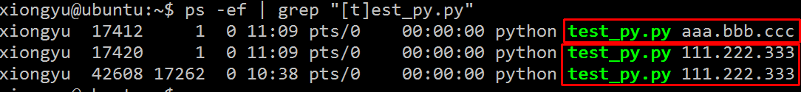
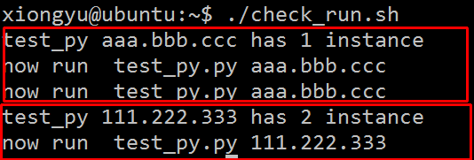
执行shell之后每次程序启动了三个实例
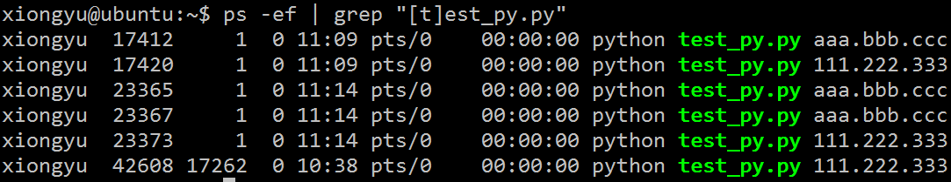
#!/bin/bash
process_check_run(){
ready_run_count=$(ps -ef | grep "[t]est_py.*$1" |wc -l)
echo "test_py $1 has $ready_run_count instance"
for (( i=$ready_run_count;i<3;i++ ));
do
echo "now run test_py.py $1"
python test_py.py $1&
sleep 3
done
}
process_check_run aaa.bbb.ccc
process_check_run 111.222.333

# 检查已近启动的程序数量，确保启动三个
process_check_run(){
ready_run_count=$(ps -ef | grep "$APP_NAME" | grep -v grep | grep "$1"|wc -l)
echo "$APP_NAME $1 has $ready_run_count instance"
for (( i=$ready_run_count;i<3;i++ ));
do
echo "now run $APP_NAME $1 $2 21.22.84.17 40 &"
nohup ./$APP_NAME $1 $2 21.22.84.17 40 >/dev/null 2>&1 &
sleep 3
done
}
echo "now check and start dianxin"
# $CTL_IP发布系统内置环境变量
process_check_run $CTL_IP 1
echo "now check and start liantong"
process_check_run $CNC_IP 2
echo "now check and start yidong"
process_check_run $MOB_IP 32

1.1.1 exec script when startup
How to run a script at the start up of Ubuntu?

sudo -s and the command prompt will change to '#' indicating that the terminal session has root privileges.
Alternative #1: Add commands to /etc/rc.local
vi /etc/rc.local

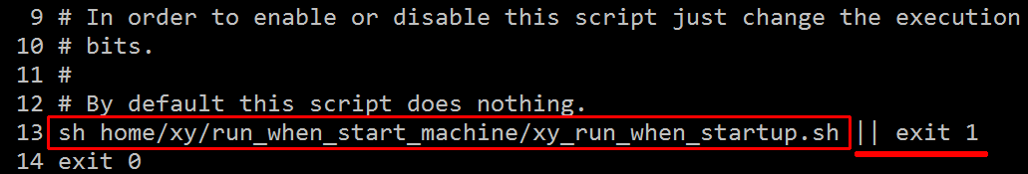

cat xy_run_when_startup.sh （注意路径，否则rc.local中用的是当前路径）
#!bin/bash
nohup sh /home/xy/test_nohup_run.sh >/dev/null 2>&1 &
exit 0

不能使用”nohup sh test_nohup_run.sh >/dev/null 2>&1 & ”

cat test_nohup_run.sh
#!bash/bin/
log_file="info.log"
TIMESTAMP(){
echo $(date "+%Y-%m-%d %H:%M:%S")
}
while :
do
echo "$(TIMESTAMP) do check" | tee -a $log_file
sleep 10
done

一定要注意：
1. chmod 755 * 使得shell可以执行
2. 路径问题，日志的输出，默认的是在当前目录下
如果这样执行 sh ./run_when_start_machine/test_nohup_run.sh
则日志最终输出在，当前目录下，而不是当前的脚本目录下。

1.1 batch sz files

1.1.1 read/awk/str concat space
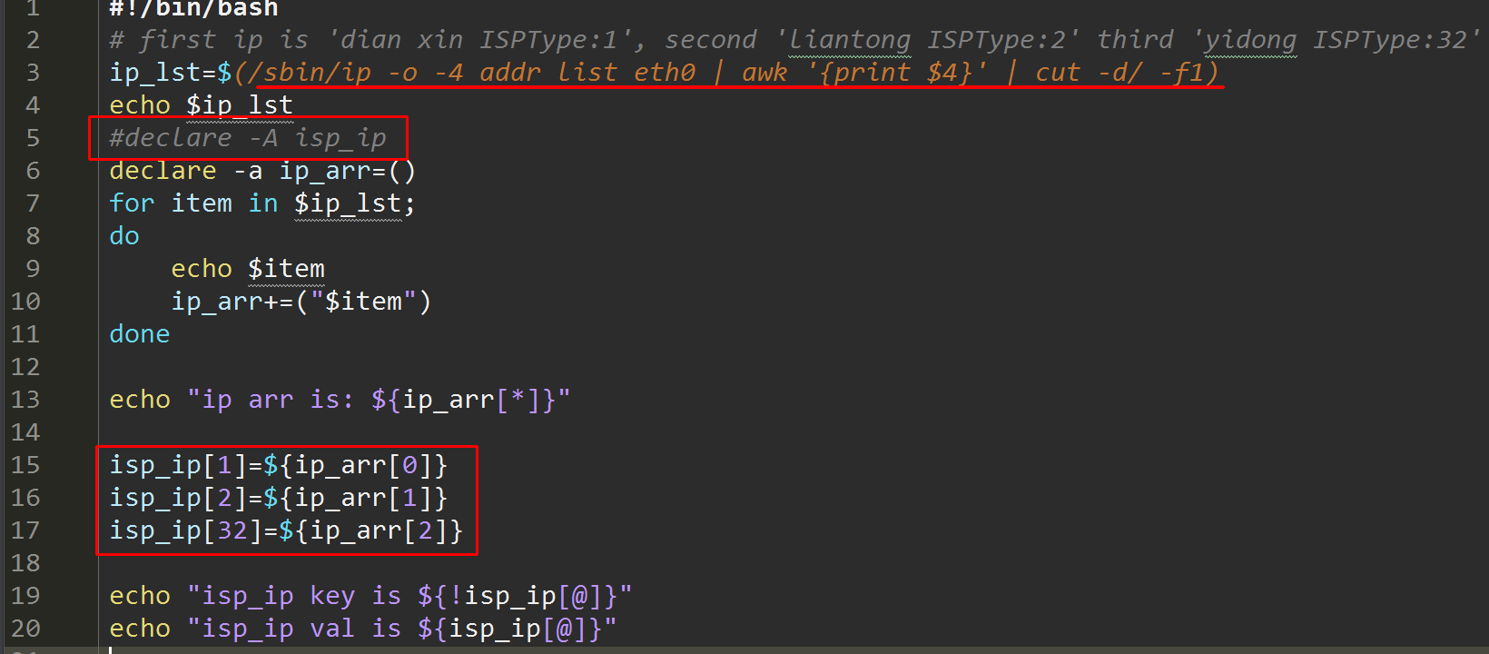

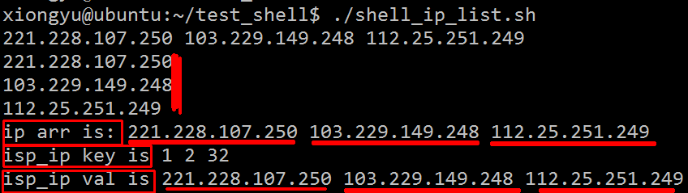
#!/bin/bash
# first ip is 'dian xin ISPType:1', second 'liantong ISPType:2' third 'yidong ISPType:32'
ip_lst=$(/sbin/ip -o -4 addr list eth0 | awk '{print $4}' | cut -d/ -f1)
echo $ip_lst
#declare -A isp_ip
declare -a ip_arr=()
for item in $ip_lst;
do
echo $item
ip_arr+=("$item")
done

echo "ip arr is: ${ip_arr[*]}"

isp_ip[1]=${ip_arr[0]}
isp_ip[2]=${ip_arr[1]}
isp_ip[32]=${ip_arr[2]}

echo "isp_ip key is ${!isp_ip[@]}"
echo "isp_ip val is ${isp_ip[@]}"

1.1 start process num by CPU count

1.1.1 count CPU

#!/bin/bash
cpu_num=$(nproc --all)
echo $cpu_num
count=15
per_count=4
if [ $cpu_num -lt 30 ]
then
count=30
per_count=10
fi
test_fun(){
echo $count, $per_count
for(( i=8;i<$per_count;i++ ))
do
echo $i
done
}
test_fun

