chapter 1-table column 2
1.1 table property 2
1.1.1 create table 2
1.1.1 see how table is created 2
1.1.1 rename table 3
1.1 database property 3
1.1.1 create database 3
1.1.1 drop database 3
1.1.1 use specified database 3
1.1 connect to database 3
1.1 column property 4
1.1.1 modify column property 4
1.1.1 see column property 4
1.1.1 show all column property 4
1.1.1 rename column add comment 4
1.1.1 add column 5
1.1.1 drop column 5
1.1.1 column default value 5
1.1 index 5
1.1.1 show all index 5
1.1.1 add unique index 5
1.1.1 add index 6
1.1.1 index VS key 6
1.1.1 add multiple index 6
1.1.1 add primary key 6
chapter 2-query 7
1.1 select 7
1.1.1 select null empty 7
1.1 group 8
1.1.1 group by 1 8
1.1 update 8
1.1.1 update 8
1.1 insert 9
1.1.1 insert into table directly 9
1.1.1 insert into table by other table 9
1.1.1 insert ignore duplicate error& solve 9
1.1 distinct 9
chapter 3-useful function 10
1.1 about math 10
1.1.1 round 10
1.1.1 floor 11
chapter 4- other quesion 11
1.1 about math 11

chapter 1-table column

1.1 table property

1.1.1 create table
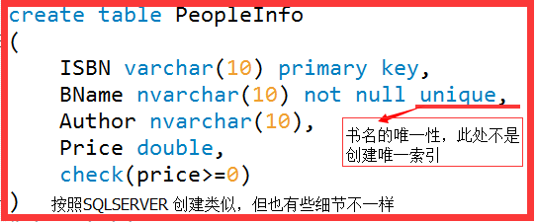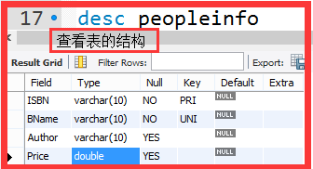
create table tb_scrape_yy(
id int(10) auto_increment not null primary key,
`url` varchar(255) not null,
`title` varchar(400) not null,
`scrape_date` datetime not null,
`web_src` varchar(256) DEFAULT null,
`ex1` varchar(256) DEFAULT null,
UNIQUE KEY `url_UNIQUE` (`url`)
)ENGINE=InnoDB AUTO_INCREMENT=0 DEFAULT CHARSET=utf8;

1.1.1 create table(by other) like A1 as A2
So you do:
CREATE TABLE New_Users LIKE Old_Users;
Then you insert with
INSERT INTO New_Users SELECT * FROM Old_Users

create table blog_copy like springdemo.blog;
select * from springdemo.blog_copy;
insert into blog_copy select * from blog;

1.1.1 (show create table tb)see how table is created
show create table tbname;
SHOW create table db.tb_mobile_report;
CREATE TABLE `tb_mobile_report` (
`id` int(12) NOT NULL AUTO_INCREMENT,
`reported_sid` varchar(128) DEFAULT NULL COMMENT '直播间ID或频道ID',
`reported_ssid` varchar(128) DEFAULT NULL COMMENT '子频道ID',
URL,@符号分割',
) ENGINE=InnoDB AUTO_INCREMENT=1 DEFAULT CHARSET=utf8

1.1.1 (desc tb)see table field property
desc springdemo.tb_auto_update_2;
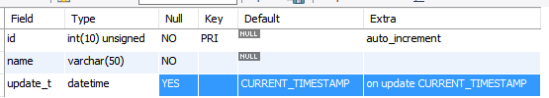

1.1.1 rename table
alter table peopleinfo rename BookInfo
DROP TABLE 表名;

1.1.1 show all tables in database
mysql> USE test;  Database changed  mysql> SHOW TABLES; | SHOW TABLES IN db_name

1.1.1 delete(truncate) all rows in table
set sql_safe_updates=0;  delete from tableName; | truncate table tb_name;

drop table tablename;
After this, it's gone. No more table. No more data.
Use this when you don't need that table any more.
truncate table tablename;
After this, the table is empty, and (importantly) auto-incrementing keys are reset to 1. It's quite literally like having a brand new table.
Use this when you just want an empty table. It's faster than DELETE because it simply deletes all data. DELETE will scan the table to generate a count of rows that were affected.
delete from tablename;
This lets you filter which rows to delete based on an optional WHERE clause.
Use this when you want to delete specific records, eg: DELETE FROM tablename WHERE username = 'joe'

1.1 database property

1.1.1 create database
create database sudu; //建立库sudu

1.1.1 drop database
drop database if exists school; //如果存在sudu则删除

1.1.1 use specified/show database
use school; //打开库sudu
show databases; //show all databases;

1.1 connect to database
连接MYSQL
格式： mysql -h主机地址 -u用户名 -p db_name
1、 连接到本机上的MYSQL
mysql -u root -p
(本机的本地测试密码为xiongyu)

2、连接到远程主机上的MYSQL。假设远程主机的IP为：110.110.110.110，
用户名为root,密码为abcd123。则键入以下命 令：
mysql -h 110.110.110.110 -u root -p db_name;(注:u与root之间可以不用加空格，其它也一样)

3、 退出MYSQL命令： exit (回车)
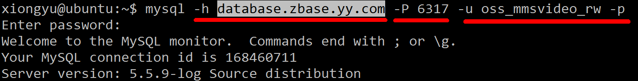

1.1 partition

1.1.1 create table by day
背景：现有任务每天需要插入 几千万的数据到表中，我们可以考虑每天建立一个表。例如:
CREATE TABLE tb_2017_11_01 (
`id` bigint(20) NOT NULL AUTO_INCREMENT,
`create_time` datetime not NULL
.......
)

但是这么做会有如下缺点：
- 假设现在要查询几天的数据，还得查询多张表，最终合并查询结果，这一点十分麻烦。
- 当然了一天一张表，维护起来也是麻烦

这时可以是用一张月表，每一天的数据一个分区表，而分区表对于用户是透明的。

方便起见先创建按照天分区的表:

CREATE TABLE `audio_rec_ret_2017_11` (
`id` bigint(20) NOT NULL AUTO_INCREMENT,
`ftime` datetime NOT NULL,
PRIMARY KEY (`id`,`ftime`),
KEY `ftime_idx` (`ftime`)
) ENGINE=InnoDB AUTO_INCREMENT=1 DEFAULT CHARSET=utf8
PARTITION BY RANGE (TO_DAYS(ftime))
(PARTITION p20171101 VALUES LESS THAN (737000) ENGINE = InnoDB,
PARTITION p20171102 VALUES LESS THAN (737001) ENGINE = InnoDB,
PARTITION p20171103 VALUES LESS THAN (737002) ENGINE = InnoDB,
...................
PARTITION p20171129 VALUES LESS THAN (737028) ENGINE = InnoDB,
PARTITION p20171130 VALUES LESS THAN (737029) ENGINE = InnoDB)

insert into springdemo.audio_rec_ret_2017_11(ftime)
values('2017-11-1 10:10:10'),
('2017-11-2 10:10:10'),
('2017-11-3 10:10:10'),
('2017-11-4 10:10:10'),
('2017-11-5 10:10:10'),
('2017-11-6 10:10:10');

看下我们的查询结果：
explain partitions
select * from springdemo.audio_rec_ret_2017_11
where ftime between '2017-11-4 0:0:0' and '2017-11-5 23:59:59';
可以看到只遍历了，两个分区表，只扫描了2行，而不是扫描所有的行。

Mysql支持水平分区，并不支持垂直分区;
水平分区：指将同一表中不同行的记录分配到不同的物理文件中；
垂直分区：指将同一表中不同列的记录分配到不同的物理文件中；
其中CSV、FEDORATED、MERGE等引擎不支持分区，MYISAM、InnoDB、NDB等引擎支持分区

分区表
主要提供如下的特性，或者适合如此场景：

1. 数据量非常大， 或者只有表中最后的部分有热点数据，其他均为历史数据
2. 分区表数据更容易维护，可以对独立的分区删除等操作
3.分区表的数据可以分布在不同的物理设备上，从而高效地利用多个硬件设备。
可以避免一些特殊瓶颈，比如InnoDB的单个索引的互斥访问
- 可以备份和恢复独立的分区

MySQL有4种分区类型:
1.RANGE 分区 - 连续区间的分区 - 基于属于一个给定连续区间的列值，把多行分配给分区；
2.LIST 分区 - 离散区间的分区 - 类似于按RANGE分区，区别在于LIST分区是基于列值匹配一个离散值集合中的某个值来进行选择；
3.HASH 分区 - 平均分区 - 基于用户定义的表达式的返回值来进行选择的分区，该表达式使用将要插入到表中的这些行的列值进行计算，这个函数可以包含MySQL中有效的、产生非负整数值的任何表达式；
4.KEY 分区 - Key分区 - 类似于按HASH分区，区别在于KEY分区只支持计算一列或多列，且MySQL服务器提供其自身的哈希函数；

3.【Range分区】创建分区表(range多列分区)，并测试
create table tb3(
id int unsigned not null auto_increment comment '主键',
username varchar(32) comment '用户名',
sid int unsigned comment '学号',
age int unsigned comment '年龄',
primary key(id,sid,age) comment '分区字段sid,age必须包含在主键字段内'
)engine=MyISAM default charset=utf8
partition by range columns(sid,age)
(
partition p01 values less than(5,8) comment 'sid<5,age<8',
partition p02 values less than(10,15) comment 'sid<10,age<15',
partition p03 values less than(maxvalue,maxvalue) comment '其它值'
);
我们甚至可以建立一个小于1天的临时分区，即一天内按时间段进行分区存储，如：
CREATE TABLE t2 (
dt datetime
)ENGINE=MyISAM DEFAULT CHARSET=utf8
PARTITION BY RANGE (to_seconds(dt))
(
PARTITION p01 VALUES LESS THAN (to_seconds('2009-11-30 08:00:00')) ,
PARTITION p02 VALUES LESS THAN (to_seconds('2009-11-30 16:00:00')) ,
PARTITION p03 VALUES LESS THAN (to_seconds('2009-12-01 00:00:00')) ,
PARTITION p04 VALUES LESS THAN (to_seconds('2009-12-01 08:00:00')) ,
PARTITION p05 VALUES LESS THAN (to_seconds('2009-12-01 16:00:00')) ,
PARTITION p06 VALUES LESS THAN (MAXVALUE)
);

List分区

是用IN来做列值匹配的集合。 比如可以按照地区来分为东西南北几个区：
PARTITION BY LIST(store_id)
PARTITION pNorth VALUES IN (3,5,6,9,17),
PARTITION pEast VALUES IN (1,2,10,11,19,20),
PARTITION pWest VALUES IN (4,12,13,14,18),
PARTITION pCentral VALUES IN (7,8,15,16)
);
这种如果插入语句不在IN中，则会插入失败
def tb_partition_sql():
"""
mysql partition table by day in month
:return:
"""
sql = """PARTITION p%s VALUES LESS THAN (TO_DAYS('%s')) ENGINE = InnoDB,"""
d1 = datetime.date(2017, 12, 1)
d2 = datetime.date(2017, 12, 31)
days = [d1 + datetime.timedelta(days=x) for x in range((d2-d1).days + 2)]
# print len(days)
for i in xrange(len(days) - 1):
s1 = days[i].strftime('%Y%m%d')
s2 = days[i + 1].strftime('%Y-%m-%d')
print sql % (s1, s2)
# PARTITION p20171201 VALUES LESS THAN (TO_DAYS('2017-12-02')) ENGINE = InnoDB,
# ...........
# PARTITION p20171231 VALUES LESS THAN (TO_DAYS('2018-01-01')) ENGINE = InnoDB,

http://www.cnblogs.com/martinzhang/p/3467232.html
https://yq.aliyun.com/articles/31799

1.1 column property

1.1.1 modify column property
修改表的列属性 alter table <表名> modify <列> <数据类型>
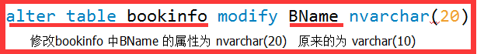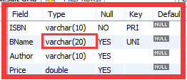

1.1.1 see column property
查看列的属性(查看表的列的属性)
describe table_name column_name describe tb_ms_video_day_20161123 uid;

describe springdemo.blog title;

1.1.1 show all column property
show fields from springdemo.blog;
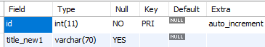

1.1.1 rename column add comment
修改表的字段名 alter table <表名> change<旧列名> <新列名> <数据类型>

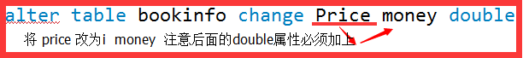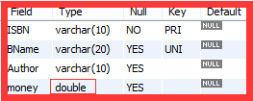
注意：数据在数据库中的存储和数据类型有很大的关系，故而不要随便改数据类型
alter table springdemo.blog change title title_new nvarchar(60) comment '修改啦';

1.1.1 add column
添加列(字段)(其实可以指定位置的，这里就省略了)
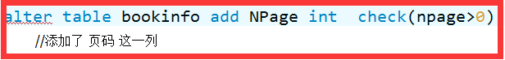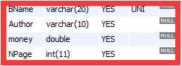
同事添加索引
alter table springdemo.tb_ms_audit_user_info
add mal_report int default 0
comment '恶意举报的次数', add index(mal_report);

1.1.1 drop column
删除字段 : alter table <表名> drop <列名>

1.1.1 column default value
alter table tablename alter column drop default; (若本身存在默认值，则先删除)
alter table tablename alter column set default 't5';(若本身不存在则可以直接设定)

1.1 index

1.1.1 show all index
show index from springdemo.blog;
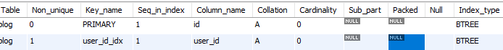

1.1.1 add unique index
创建唯一索引
alter table aladdin.tb_al_storm_model_predict_result add unique index
`unique_idsrc_caffeversion` (`id_src`, `caffe_version`)

1.1.1 add index
ALTER TABLE `table` ADD INDEX `index_name` (`col1`,`col2`)
ALTER TABLE `table` ADD INDEX `product_id` (`product_id`)
SELECT * FROM table WHERE product_id = '1';
Never compare integer to strings in mysql. If id is int = remove the quotes.

alter table springdemo.tb_ms_audit_user_info
add mal_report int default 0
comment '恶意举报的次数',add index(mal_report);

1.1.1 index VS key
What are differences between Index v.s. Key in MySQL

CREATE TABLE tasks (
task_id INT UNSIGNED NOT NULL AUTO_INCREMENT,
INDEX parent (parent_id),
....
However I found a code using KEY instead of INDEX as following.

...
KEY order_date (order_date)
...

There's no difference. They are synonyms.
From the CREATE TABLE manual entry:
KEY is normally a synonym for INDEX. The key attribute PRIMARY KEY can also be specified as just KEY when given in a column definition. This was implemented for compatibility with other database systems.

1.1.1 add multiple index
多列索引
ALTER TABLE `table_name` ADD INDEX index_name ( `column1`, `column2`, `column3` )

1.1.1 add primary key
ALTER TABLE `table_name` ADD PRIMARY KEY ( `column` )

chapter 2-query

1.1 select

1.1.1 select null empty
A common error when working with NULL is to assume that it is not possible to insert a zero or an empty string into a column defined as NOT NULL, but this is not the case. These are in fact values, whereas NULL means “not having a value.” You can test this easily enough by using IS [NOT] NULL as shown:
mysql> SELECT 0 IS NULL, 0 IS NOT NULL, '' IS NULL, '' IS NOT NULL;
+-----------+---------------+------------+----------------+
| 0 IS NULL | 0 IS NOT NULL | '' IS NULL | '' IS NOT NULL |
+-----------+---------------+------------+----------------+
| 0 | 1 | 0 | 1 |
+-----------+---------------+------------+----------------+

This will select all rows where some_col is NULL or '' (empty string)
SELECT * FROM table WHERE some_col IS NULL OR some_col = '';
To check if field is NULL use IS NULL, IS NOT NULL operators.

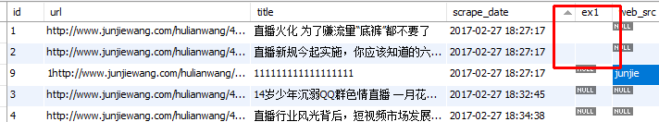
As to table tb_yylive_news，the default value of ex1 is null, then we do the follow update operator.

set sql_safe_updates=0; update springdemo.tb_yylive_news set ex1='' where id=1;
update springdemo.tb_yylive_news set ex1=' ' where id=2;

Then we query from the table:
SELECT * FROM springdemo.tb_yylive_news where ex1 is not null;
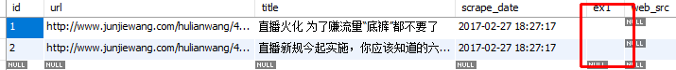
We can see that:the above set ex1=' ' and ex1='' are not null.

method 1:
A shorter way to write the condition:
WHERE some_col > ''
Since null > '' produces unknown, this has the effect of filtering out both null and empty strings.
SELECT * FROM springdemo.tb_yylive_news where ex1 > '';
method 2:
I hate messy fields in my databases. If the column might be a blank string or null, I'd rather fix this before doing the select each time, like this:

UPDATE MyTable SET MyColumn=NULL WHERE MyColumn='';
SELECT * FROM MyTable WHERE MyColumn IS NULL

This keeps the data tidy, as long as you don't specifically need to differentiate between NULL and empty for some reason.

1.1.1 select limit offset
SELECT * FROM springdemo.user;
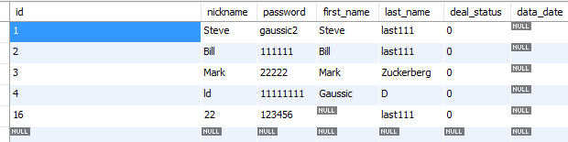
SELECT * FROM springdemo.user limit 0, 2;
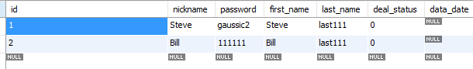
SELECT * FROM springdemo.user limit 1, 2;
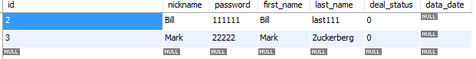
SELECT * FROM springdemo.user limit 2;
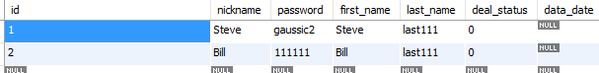
as we see “ limit a, b “ a means start point , begining with 0, b denotes length
if “limit a” return 0-a

SELECT * FROM springdemo.user limit 2 offset 0;
equivalent to “ SELECT * FROM springdemo.user limit 0, 2; ”
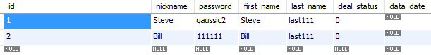
SELECT * FROM springdemo.user limit 2 offset 1;
equivalent to “ SELECT * FROM springdemo.user limit 1, 2; ”
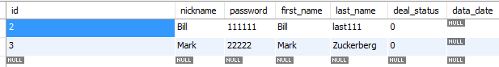

1.1 group

1.1.1 group by 1
select floor(id/10)*10 as bin_floor, count(*)  from springdemo.tb_yylive_news  group by 1  order by 1 desc; | 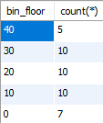
select floor(id/10)*10 as bin_floor, count(*)  from springdemo.tb_yylive_news  group by 1  order by 1; | 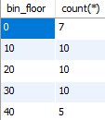

1.1.1 group by date question
select count(*), date_format(news_date, '%Y-%m-%d') AS `month_logged`
from detect.tb_ck_hot_news where keyword_warn = ''
group by month_logged;
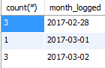
select count(*), date_format(news_date, '%Y-%m-%d') AS `month_logged`
from detect.tb_ck_hot_news where keyword_warn = '' and news_date between '2017-03-20' and '2017-03-23'
group by month_logged;
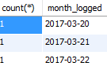
SELECT day(create_time), count(*) as 总举报量 from tb  where create_time>='2017-06-14 00:00:00'  and create_time<='2017-06-22 00:00:00'  group by day(create_time)  ; | 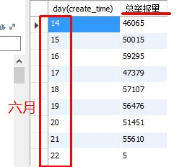

select DATE_FORMAT(create_time, '%Y-%m-%d') as d,  sum(audit_status in('S01', 'S02')) as 人审核量,  sum(1) as 总举报量  from zbase.tb_ms_mobile_report  where create_time>='2017-03-1 0:00:00'  and create_time<='2017-03-15 23:59:59'  group by d; | 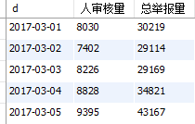

1.1.1 Unknown column alias
You cannot access the alias directly by name.
One solution is to wrap the query with the aliases in a subquery, and then refer to the alias names in an outer query:
select tb.d,  tb.all_num as 违规uid总数,  tb.distinct_num as 唯一违规uid总数,  (tb.all_num-tb.distinct_num) as 重复uid总数  from  (select DATE_FORMAT(time, '%Y-%m-%d') as d,  sum(1) as all_num,  count(distinct(uid)) as distinct_num  from tb_ms  where time>='2017-6-17 0:00:00'  and time<='2017-06-21 23:59:59' and status='S'  group by d) as tb; | 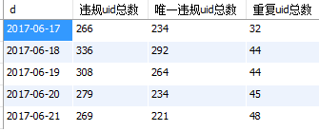

1.1.1 column equal multi values
select name from table `where value IN ('123','234','134');
select name from table `where value IN='123';

1.1 sum (succinct ways equal to group )
select  sum(audit_status='S02') as audit_status_S02,  sum(audit_status='S01') as audit_status_S01  from springdemo.tb_ms_mobile_report_test  where reported_uid='957063158'; | 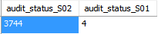
 | efficently

select
sum(audit_status='S02') as audit_status_S02,
sum(audit_status='S01') as audit_status_S01
from springdemo.tb_ms_mobile_report_test
where reported_uid=957063158;

time consume
note: the type of reported_uid is varchar, if we check it by int as below, the time consume is heavy.
Database = CARS, Table = TYPES, Column1 = LICENSE, Column2 = COLOR
If using MySQL you can simplify further:
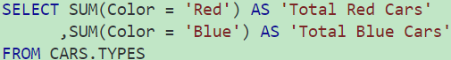
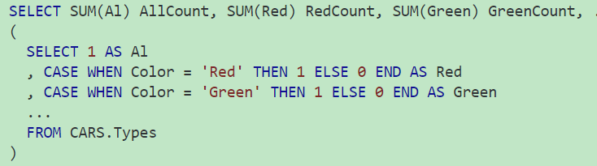
the below example is more complicate

select reported_uid,
sum(audit_status='S01') as audit_status_S01,
sum(audit_status='S02') as audit_status_S02,
sum(audit_status='S03') as audit_status_S03,
sum(audit_status='S04') as audit_status_S04,
sum(audit_status='S05') as audit_status_S05,
count(*) as audit_status_all
from iboms.tb_ms_mobile_report_test
group by reported_uid;

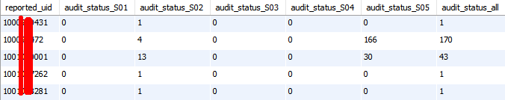
compare this question to `1.1 inner left join on`

1.1 update

1.1.1 update
mysql 某列的值赋值给另外一列
set sql_safe_updates=0;
update springdemo.users set pwd=nickname where id=id;

1.1.1 sample batch update
How to bulk update mysql data with one query?
is there any way to simplify it to one query?
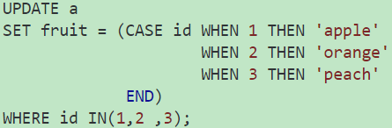

1.1 insert

1.1.1 insert into table directly
INSERT INTO 表名 VALUES ("hyq","M");
insert into teacher values('','allen','飞数科技1','2005-10-10');

1.1.1 insert into table by other table
用一张表中的数据更新另外一张表
INSERT INTO tb_al_sample (biz_id,sample_path)
SELECT 3,FILE FROM idcard_image WHERE FILE IS NOT NULL;

1.1.1 insert ignore duplicate error& solve
How to avoid duplicate entries in a MySQL database without throwing an error
I am using the Python-MySQL (MySQLdb) library to insert values into a database. I want to avoid duplicate entries from being inserted into the database, so I have added the unique constraint to that column in MySQL. I am checking for duplicates in the title column. In my Python script, I am using the following statement:
cursor.execute ("""INSERT INTO `database` (title, introduction) VALUES (%s, %s)""", (title, pure_introduction))

You can utilize the INSERT IGNORE syntax to suppress this type of error.
If you use the IGNORE keyword, errors that occur while executing the INSERT statement are ignored. For example, without IGNORE, a row that duplicates an existing UNIQUE index or PRIMARY KEY value in the table causes a duplicate-key error and the statement is aborted. With IGNORE, the row is discarded and no error occurs. Ignored errors may generate warnings instead, although duplicate-key errors do not.
In your case, the query would become:
insert ignore into `database` (title, introduction) VALUES (%s, %s)

1.1 distinct
For example ,we want to count num of users which have unique uid.
select count(distinct(uid)) from test.tb_user;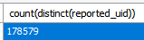

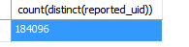
SELECT COUNT(DISTINCT column_name) FROM table_name;
select COUNT(*) column_name FROM (SELECT DISTINCT column_name);
select count(*) from  (select distinct reported_uid from iboms.tb_ms_mobile_report_test)  as tb; | 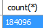

select count(distinct reported_uid)  from iboms.tb_ms_mobile_report_test; | 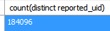

1.1 delete
DELETE FROM tb_name where ....;

1.1 inner, left join on（full outer join not supported by mysql）
Note : To ensure you can get all the data, make sure the most data is in the left.

select tb_S01.reported_uid, tb_S02.liver_status_S02_num, tb_S01.liver_status_S01_num,
tb_S03.liver_status_S03_num, tb_S04.liver_status_S04_num, tb_all.liver_all_num
from
(select reported_uid, count(*) as liver_status_S02_num
from springdemo.tb_ms_mobile_report_test where audit_status='S02'
group by reported_uid
order by liver_status_S02_num desc) as tb_S02
inner join
................................................................as tb_S01
on tb_S01.reported_uid = tb_S02.reported_uid
inner join
(select reported_uid, count(*) as liver_all_num
from springdemo.tb_ms_mobile_report_test
group by reported_uid
order by liver_all_num desc) as tb_all
on tb_all.reported_uid = tb_S02.reported_uid
inner join
...................... tb_S03
on tb_S03.reported_uid = tb_all.reported_uid
inner join
(select reported_uid, count(*) as liver_status_S04_num
from springdemo.tb_ms_mobile_report_test where audit_status='S04'
group by reported_uid
order by liver_status_S04_num desc) as tb_S04
on tb_S04.reported_uid = tb_S03.reported_uid
order by tb_S02.liver_status_S02_num desc;
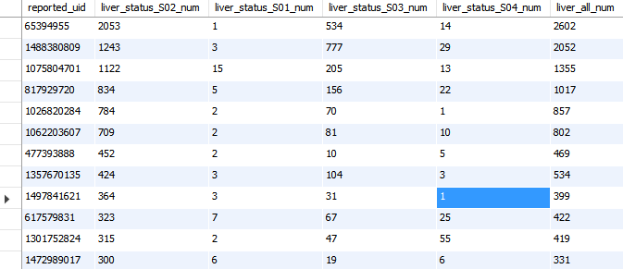
only return 33 rows, but there are more than 10W rows, the reason is that inner join returns the intersections of two table.
if we change inner join to left join,we can get the below results:
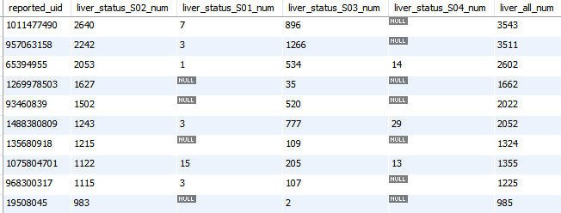
as we see all the results, returned.

if we use where condition, we may get nothing,and is very time consuming.
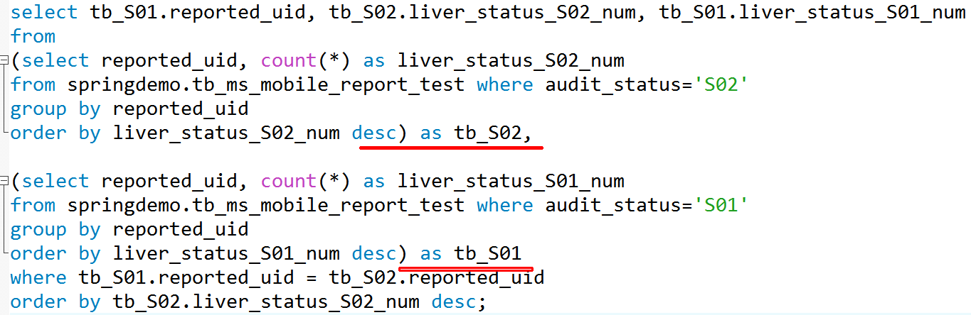
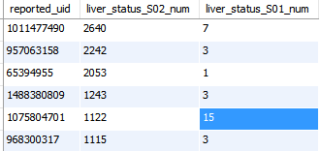
as we see,the results is smaller than 10W

left join 的时候要注意大集合的数据表在最左边，还有就是，其他的条件都是等于on最多的那张表。

select tb_vio_all.reported_uid, tb_vio_all.num_violation_all,
......................
from
(select reported_uid, count(*) as num_violation_all
from springdemo.tb_ms_mobile_report_test
group by reported_uid
order by num_violation_all desc) as tb_vio_all
left join
......................as tb_vio_0
on tb_vio_0.reported_uid=tb_vio_all.reported_uid
left join
...................... as tb_vio_1
on tb_vio_1.reported_uid=tb_vio_all.reported_uid
left join
...................... as tb_vio_2
on tb_vio_2.reported_uid=tb_vio_all.reported_uid
left join
......................as tb_vio_4
on tb_vio_4.reported_uid=tb_vio_all.reported_uid
left join
......................as tb_vio_null
on tb_vio_null.reported_uid=tb_vio_all.reported_uid
order by tb_vio_all.num_violation_all desc;
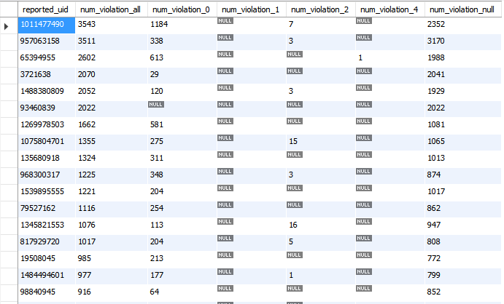
add
`if(liver_status_S02_num is null,0,liver_status_S02_num) as liver_status_S02_num,`
then NULL -> 0

a simple way by sum in 1.1 sum

chapter 3-useful function

1.1 about math

1.1.1 round
select round(3.14),round(3.54);
select round(3.16, 1),round(3.54, 1);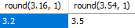
I am looking for a ROUND() type function that would allow me to round numbers to 1 decimal place but also to the nearest 0.5.
To illustrate:  19.425 => 19.5  19.124 => 19.0 | Similarly:  12.654 => 12.5  12.845 => 13.0
As vissi said, to get the result you want you'll need 2 round statements. (To get to 1 decimal place)
SELECT ROUND(ROUND(19.425 * 2) / 2, 1) #19.5
SELECT ROUND(ROUND(19.124 * 2) / 2, 1) #19.0
SELECT ROUND(ROUND(12.654 * 2) / 2, 1) #12.5
SELECT ROUND(ROUND(12.845 * 2) / 2, 1) #13.0

1.1.1 floor

1.1 if - case when

1.1.1 if - case when
MySQL Update field of set IF NULL or other value
I think that's it's possible for you to do this using an IF statement. The IF statement takes 3 parameters when you're using it: the expression, value if true, value if false
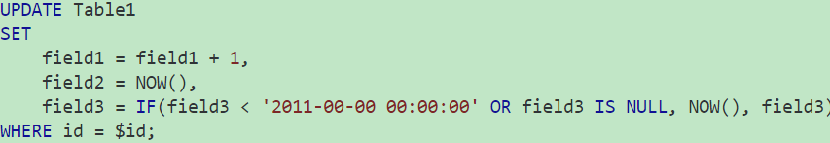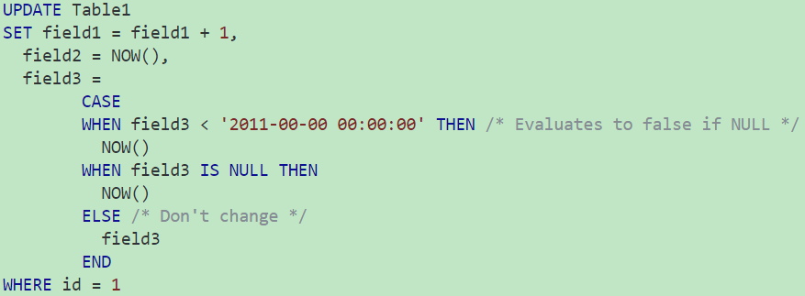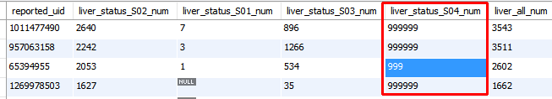

1.1 ifnull / coalesec
The main difference between the two is that IFNULL function takes two arguments and returns the first one if it's not NULL or the second if the first one is NULL.

COALESCE function can take two or more parameters and returns the first non-NULL parameter, or NULL if all parameters are null, for example:

SELECT IFNULL('some value', 'some other value');
-> returns 'some value'

SELECT IFNULL(NULL,'some other value');
-> returns 'some other value'

SELECT COALESCE(NULL, 'some other value');
-> returns 'some other value' - equivalent of the IFNULL function

SELECT COALESCE(NULL, 'some value', 'some other value');
-> returns 'some value'

SELECT COALESCE(NULL, NULL, NULL, NULL, 'first non-null value');
-> returns 'first non-null value'

SELECT city_name, IFNULL(property_count, 0) FROM cities
SELECT COALESCE(count(id),0) as totalRec

chapter 4- data type

int

1.1.1 int vs int(3)
Difference between “int” and “int(3)” data types in my sql
I define a table with a field name "id" and the data type is "int(2)". I inserted the value to the field "id" as "123456".This is accepted and stored. So what is the use of giving the range.
For INT and other numeric types that attribute only specifies the display width.
The (2) doesn't define the size of the integer. It's just number of digits to display in some tools

1.1.1 int vs unsigned int
What's the difference in int(11) and int(11) UNSIGNED?
An UNSIGNED type cannot be negative, but on the other hand it has twice as large a range for the positive integers. The types TINYINT, SMALLINT, MEDIUMINT, INT and BIGINT all have signed and unsigned versions.

For INT the ranges are defined as follows:

Type Storage Min Max
INT 4 -2147483648 2147483647
INT UNSIGNED 4 0 4294967295

INT goes from -2147483648 to +2147483647
UNSIGNED INT goes from 0 to 4294967295

the 11 between the braces has no effect on the number, just how it's displayed.

1.1 date interval / format
select date_format('2017-03-21 13:33:59', '%Y-%m-%d') AS date_day;
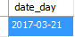
SELECT weekofyear('2017-03-21 13:33:59'),month('2017-03-21 13:33:59'),
weekofyear('2017-01-5 13:33:59'),month('2017-01-5 13:33:59');
select current_date(),current_time(),current_timestamp();


I'm using MySQL and I have the following table:
| clicks | int |
| period | date |
I want to be able to generate reports like this, where periods are done in the last 4 weeks:
| period | clicks |
| 1/7 - 7/5 | 1000 |
or in the last 3 months:
| period | clicks |
| July | .... |
SELECT
MONTH(`date`) AS period,
SUM(clicks) AS clicks
FROM `tablename`
WHERE `date` >= CURDATE() - INTERVAL 3 MONTH
GROUP BY period
SELECT
WEEKOFYEAR(`date`) AS period,
SUM(clicks) AS clicks
FROM `tablename`
WHERE `date` >= CURDATE() - INTERVAL 4 WEEK
GROUP BY period

1.1.1 30 mins ago
SQL Timestamp Where clause 30 mins ago
How can I see if a time stamp was from >= 30 mins ago? Sorry if I am not descriptive enough but idk what else to say.
unix_timestamp()-1800<=$THE_TIME_STAMP

select * from tbl where
timestampdiff(minute, tbl.`date_time_field`, now()) >= 30

SELECT * FROM table_name where
timestamp_field < DATE_ADD(CURRENT_TIMESTAMP(), INTERVAL -30 MINUTE);

SELECT ext_par FROM tb_text where
audit_time > DATE_ADD(CURRENT_TIMESTAMP(), INTERVAL -30 MINUTE)

SELECT username FROM online
WHERE time > NOW() - INTERVAL 15 MINUTE

1.1.1 set default time/auto update time
create table tb_auto_update(
id int unsigned auto_increment,
name varchar(50) not null,
update_t datetime on update current_timestamp,
primary key(id)
)engine=Innodb default charset=utf8;

insert into springdemo.tb_auto_update(name) values('xy1'),('xy2');
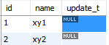
update springdemo.tb_auto_update set name='xx' where id=1;
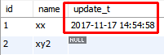
插入的时候update_t是null,但是更新的时候，时间自动为当时的时间了。

update_t datetime default current_timestamp on update current_timestamp,

给时间默认值，然后加上on update完美解决。

desc springdemo.tb_auto_update_2;

chapter 5- other quesion

1.1 lost connection
set global max_allowed_packet=67108864;

1.1 mysql Workbench lost connection
