HuangsHotelReservationSystem - Premier Hotel Reservation Application Design Document

Revision History
Date | Revision | Author | Description | Document Tracking
01.19.18 | 1.0 | Zhi Huang

Contents
1 Introduction 4
1.1 Intent 4
1.2 High Level Requirements 4
1.2.1 Registration 4
1.2.2 Authentication 5
1.2.3 Profile 5
1.2.4 Product Selection 5
1.2.5 Payments 5
1.2.6 Checkout 5
1.2.7 Return Processing 6
1.2.8 Administration 6
1.2.9 Key Technology Standards 6
1.2.10 Future Enhancements 6
2 HotelReservationSystem Use Cases 8
2.1 Intent 8
2.2 Customer Interacting Use Cases 8
2.2.1 Use Case Diagram 8
3 Service layer diagram 10
3.1 Intent 10
3.2 Service Layer diagram 10
4 Fully Dressed Use Case 10
3.1 Intent 10
3.2 Authenticate Customer Use Case 10
5 Summary 12

Introduction

Intent
This document details the requirements of the Hotel Reservation System application along with a fully dressed use cases. Document al also includes design details of the HuangsHotelReservationSystem Application.

High Level Requirements
HuangsHotelReservationSystem is a fictitious room rental business that servers high-end customer for luxury summer vacation. Room type includes Single, Double, Triple, Queen, King, Double-Double, Studio, Master Suite and Adjacent rooms will be offered in the beginning of the program.

Based on marketing studies from US news travel, the 22 best places to visit in the USA will host this business, which includes New York City, Philadelphia, Honolulu – Oahu, Maui, San Francisco, Grand Canyon, Sonoma, Washington, D.C, New Orleans, San Diego, Kauai, Hawaii, Breckenridge, Boston, Miami, Los Angeles, Charleston, Yosemite, Seattle, Asheville NC, Park City and Denver.

During the pilot phase of this application, it will be built as windows based thick clients used by central reservation system (CRS). In this phase, all orders will be placed via CRSs. This implies that vacancy checking, rental rate info, number of beds, size of bed, view of the room, customer information, payment information etc will only be conveyed by the CRS.

Future implementation will make the application web enabled; customer will be able to reserve their favorite room online and process payment online.

Given the clientele involved, this business will be highly active on the social networking sites such as Twitter, Facebook and Yammer. Software integration to these sites will be scheduled after the completion of the pilot phase.

hotel reservation use cases

Intent
This section lists the various uses cases pertained to customer interaction with the system.

Customer Interacting Use Cases

Following are the customer interacting use cases by priority:

Room Reservation

Check Room availability

Customer login

Manage Profile

Payment Processing

Checkout

Use Case Diagram

Following figure depicts the use case diagram associated with the customer as the main actor.
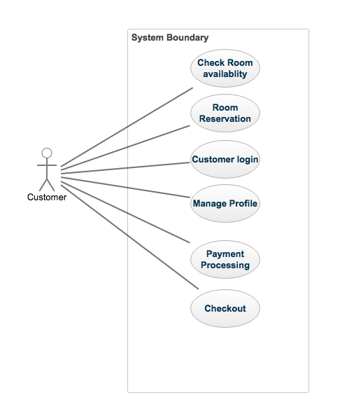

Figure 2-1 HotelReservationSystem Customer Interacting Use Cases

Service layer diagram

Intent
This section details the architecture of Service layer and Business layer of the application

Service layer diagram
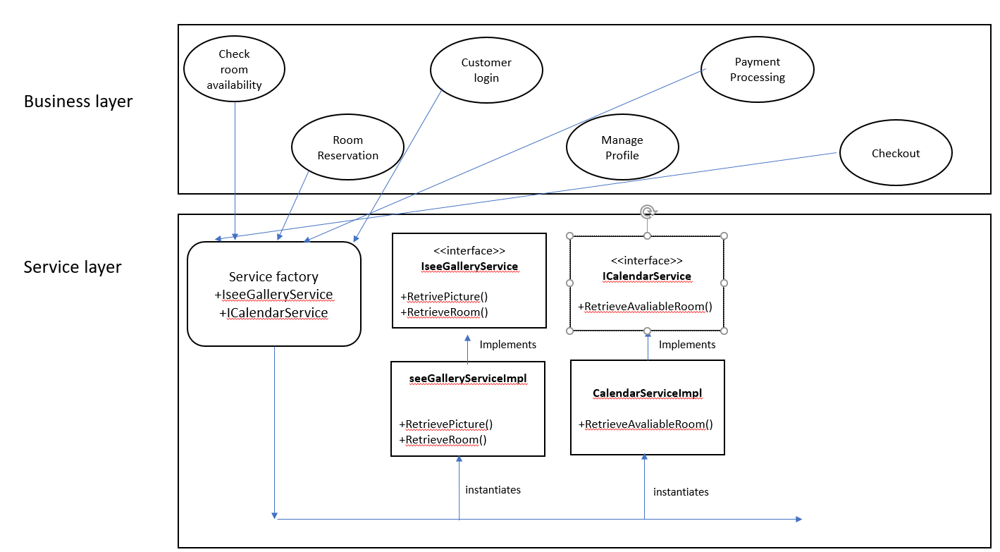

Fully Dressed Use Case

Intent
These sections document two fully dressed use cases for Register Customer and Check Room availability.

Check Room Availability Use Case

Primary Actor: Customer

Assumptions:
- Customer already exists as an active HuangsHotelReservation customer

Stakeholders:
- HuangsHotelReservation wants to ensure a registered customer is accessing the application to obtain the room availability.

Pre-conditions:
- The customer has successfully logged into HuangsHotelReservation system.

Post-conditions (Success Guarantee):
- Customer is successfully checking the room availability within the application (In the windows based application, this is performed by the CRS).

Flow of Events:
- Customer is prompted to either enter their userName and password to gain access to the HuangsHotel application functions(See Customer login use case for more details).

ALT FLOW 1.A1 Customer know exactly which room they will book
  - See Room Reservation use case for steps to reserve a room
  - See Payment processing use cases for steps to make a payment

- Customer does not know exactly what room style they want
System/UI Requirements
  - After customer successfully login, they can select to see some galleries of the room structure and views of different rooms.
  - Customer select the room type they wants

ALT FLOW 2.A1 Keep hitting next to see more galleries

- After customer successfully selects a room type, there is a blank field for customer to fill in the desired date.
  - The room availability will automatically show up.

ALT FLOW 3.A1 If the selected date does not have an available selected room type, it will take customer back step 2 of this flow.

  - Customer can reserve the room now, see Room Reservation use case for steps to reserve a room
  - See Payment processing use cases for steps to make a payment

Room Reservation Use Case

Primary Actor: Customer

Assumptions:
- Customer already picked a desired room to live

Stakeholders:
- HuangsHotelReservation wants to ensure a registered customer is accessing the application to make a room reservation.

Pre-conditions:
- Customer already able to log into HuangsHotelReservation System and ready to reserve a room

Post-conditions (Success Guarantee):
- Customer is successfully reserve the room within the application (In the windows based application, this is performed by the CRS).

Flow of Events:
- Customer is prompted to enter their duration to stay in the HuangsHotel.
- Applications checks the duration for format validity (See requirement below.)
  - Duration must be a positive integer
  - Duration must be less than a month

- After customer finished entering the duration of their stays, customer is presented with their room style, rate of the room, duration of the room, checkin and checkout time of the room, and complementary service available.
Examples:
“Room type: Single Rate of the room: $1000/Night

Duration: 1 days Checkin time: 1/1/2018
Checkout time: 1/2/2018
Complementary service:
Free wifi, free breakfast, free coeffe, free massage
Wifi password: welcome2Huangs

Total: $1000”
- If customer is okay with reservation, customer can continue with the reservation.
ALT FLOW 1.A1 Customer is not satisfied with the reservation; they can edit the current page to tweak the details.

ALT FLOW 1.A2 Customer is not satisfied with the reservation; they can go back to the galleries and select a different room style with different rate. Go back to step 1 of this flow.

- Customer can will be prompt for payment information, see payment processing use case for more details.

Summary

This document details the requirements, highlights use cases and flushes out two fully dressed use cases of the HuangsHotelReservation application

- End -

