Week 3 Programming assignment includes the following changes in my application:

In src:

Service class ServiceFacotry.java created

Service class ICalendarService.java created

Service class CalendarServiceImpl.java created

Service class IseeGalleryService.java created

Service class seeGalleryServiceImpl.java created

In test:

Domain test class AvailableRoomtest.java created

Service test class AllTests.java created

Service test class CalendarServiceImpltest.jav created

Service test class ServiceFactoryTest.java created

Service test class seeGalleryServiceImpltest.java created

Previous week Corrections:

Added missing AvailableRoom test case.

Execution result:

No compiler error:

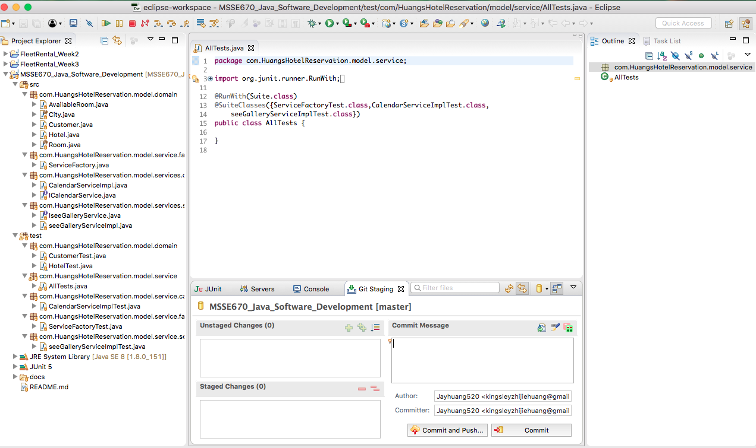

Execution of the test suite:

