# Execution comments from HW1

1. Packages edited:
2. com.huangshotelreservation.model.business:
   1. HuangsHotelReservationManager.java
   2. ManagerSuperType.java
3. com.huangshotelreservation.model.services:
   1. CalendarServiceImpl.java
   2. PropertyManager.java
   3. SeeGalleryServiceImpl.java
4. com.huangshotelreservation.presentation:
   1. MainUI.java
   2. Log4JInit.java(Added)
5. com.huangshotelreservation.view
   1. MainJFrameController.java
   2. ReserveRoomJFrameController.java
   3. SeeGalleryJFrameController.java
   4. Log4j.properties added
6. Log4j.properties added
7. Config folder added:
   1. HuangsHotelReservation.txt added
   2. application.properties added
   3. log4j.properties added

Edit most of the class to use log4j logging instead of System.out.println(). Added the log4j properties to allow the java project to run with log4j.

MainUI:

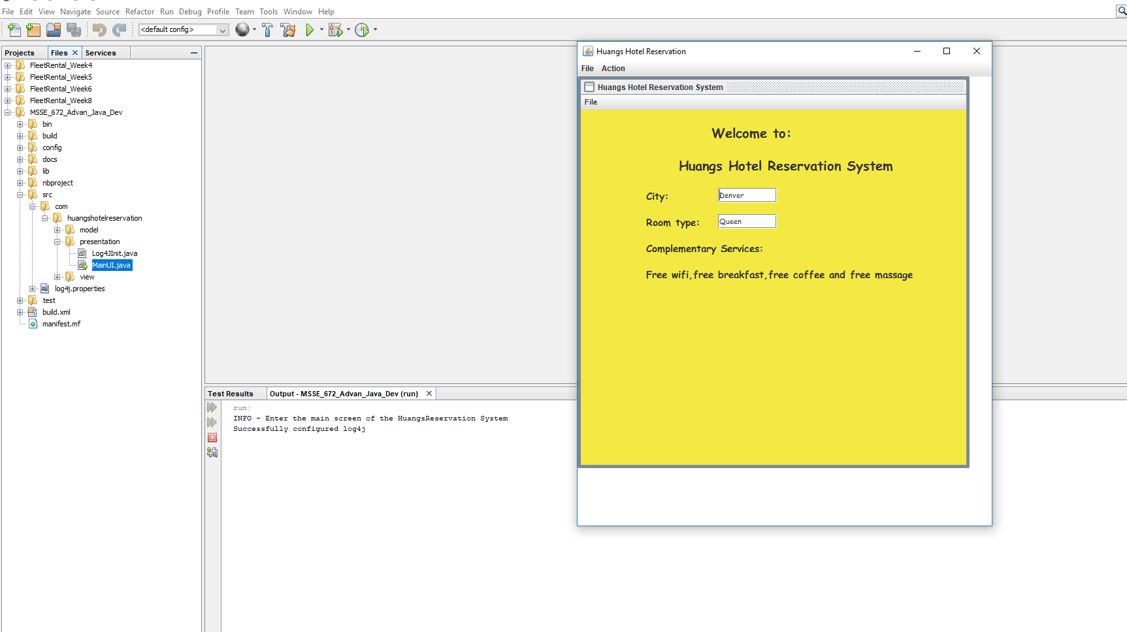

SeeGallery Service:

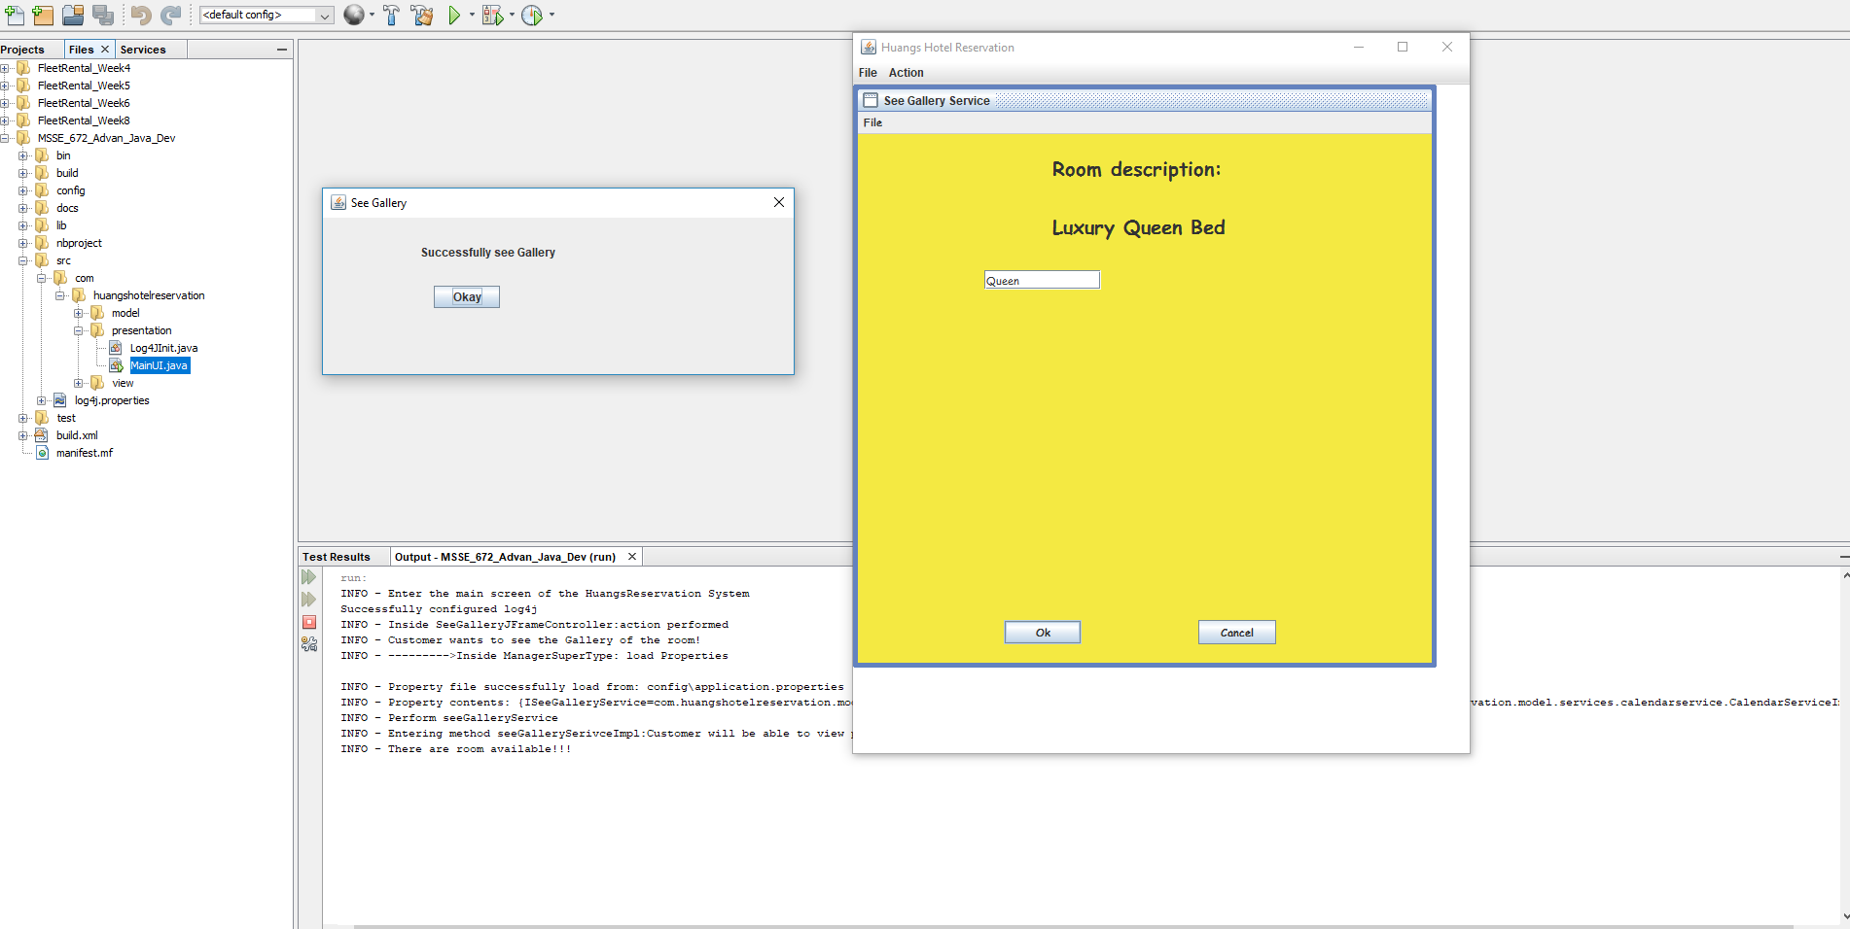

CalendarService:

