# Execution comments from HW1 unit testing

1. Files added:
   1. application.properties
   2. log4j.properties
2. com.huangshotelreservation.model.services:
   1. ServiceFactoryTest.java edited
   2. CalendarServiceImplTest.java edited

ApplicationTestSuite:

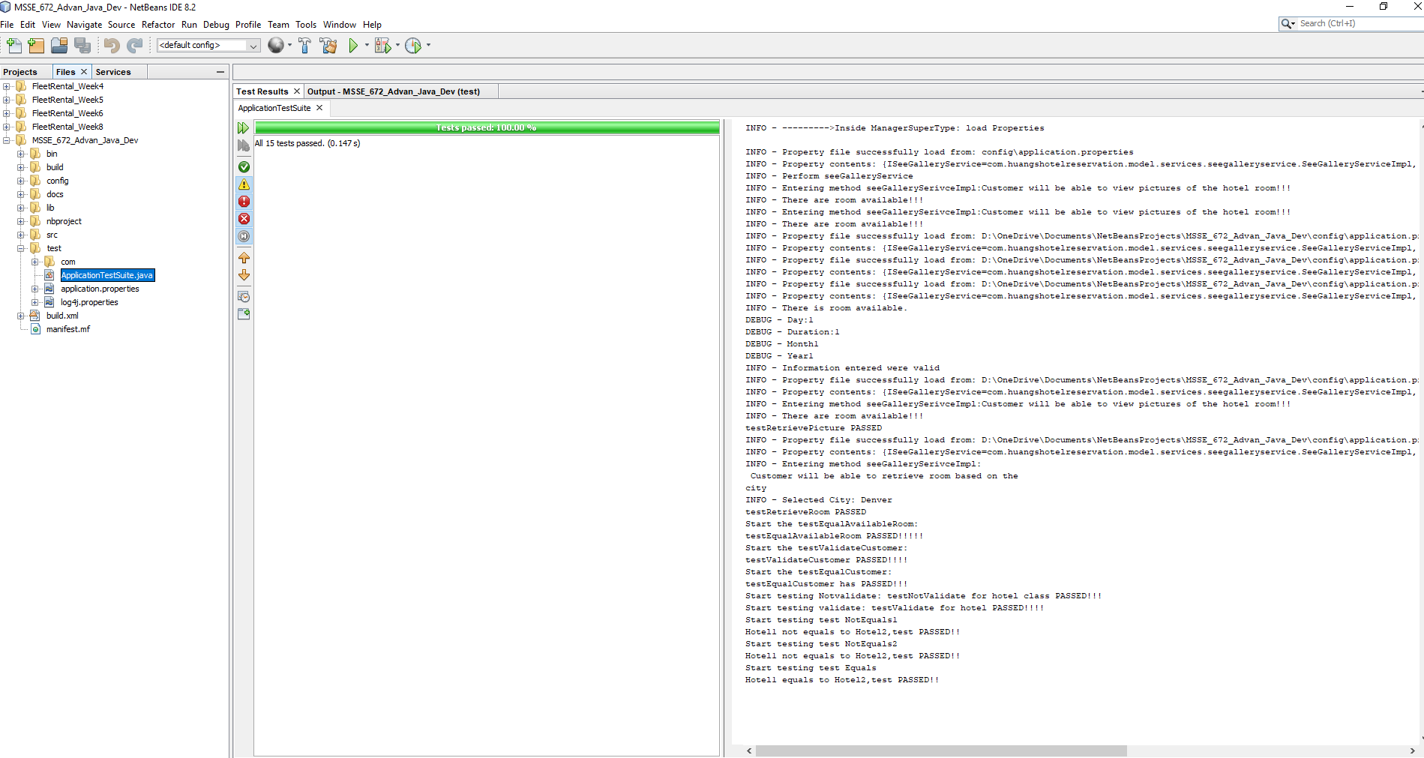

BusinessTest:

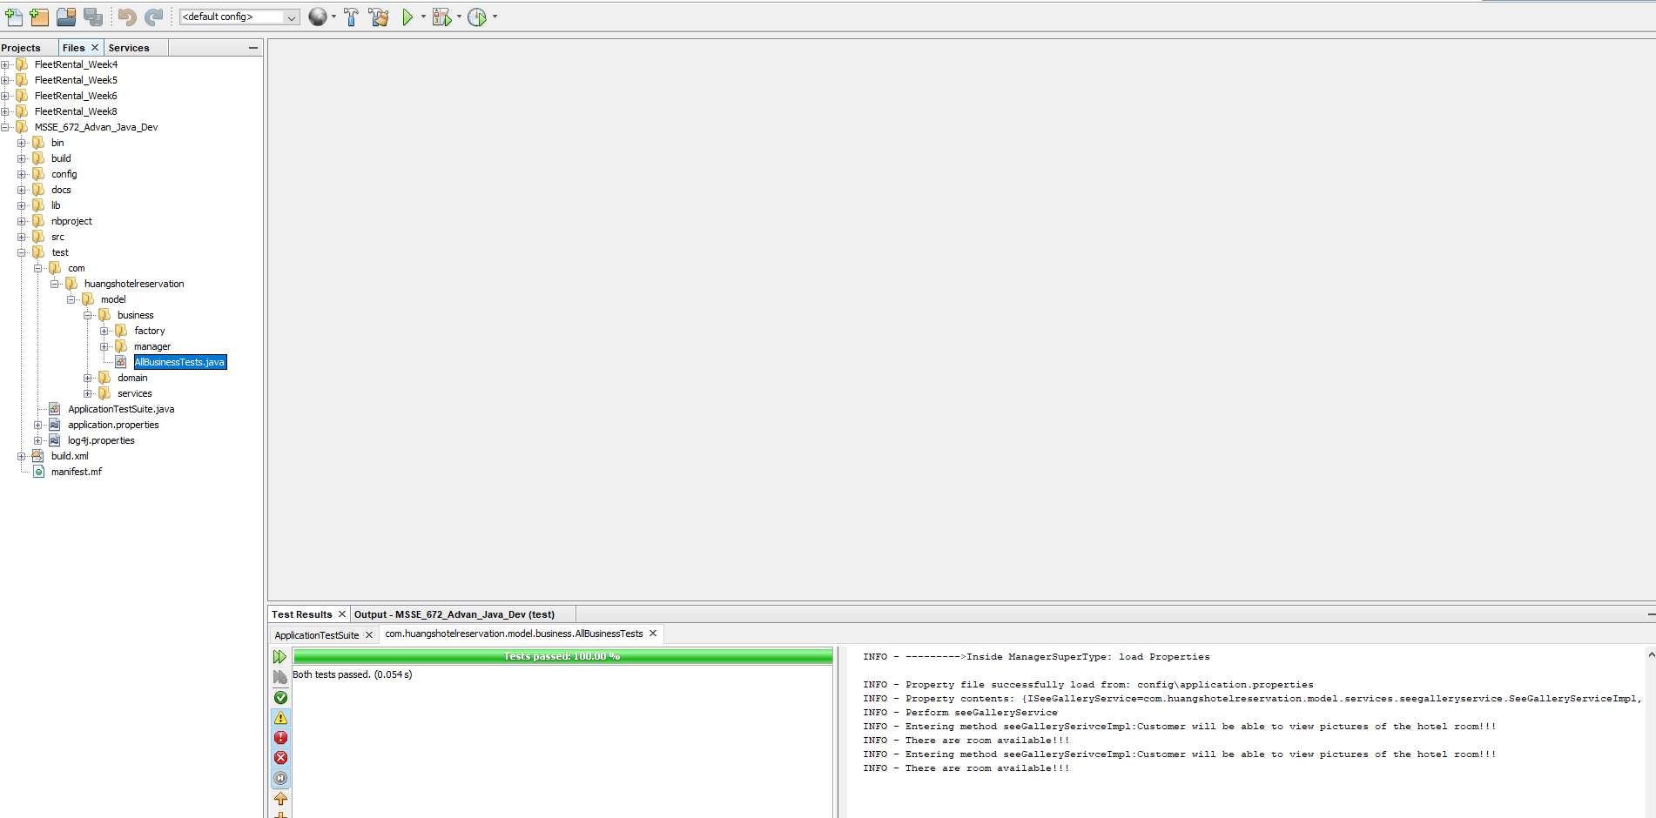

DomainTest:

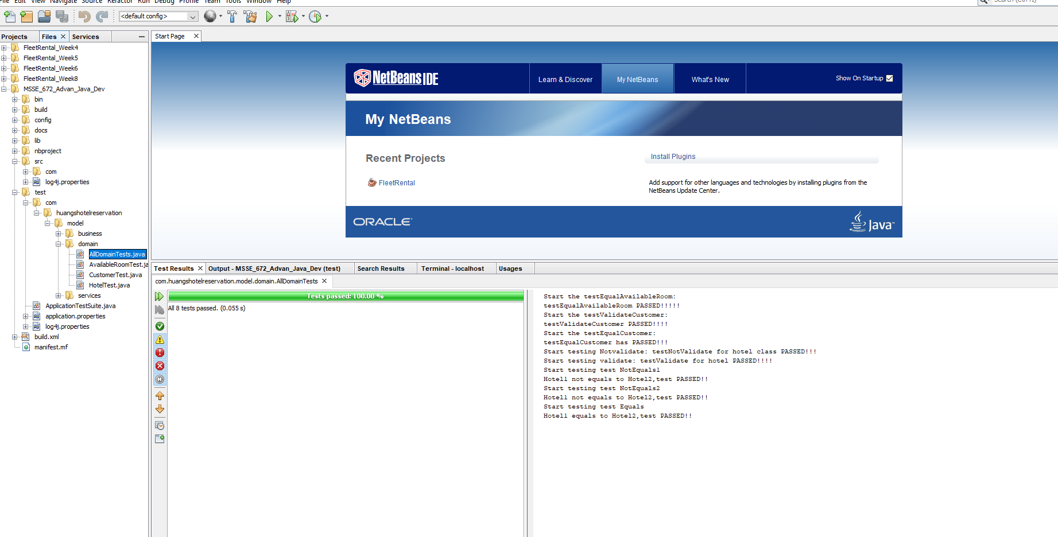

Service test:

