# Execution comments from HW2

1. Refactor presentation folder to view folder
   1. MainUI.java moved from com.huangshotelreservation.presentation to com.huangshotelreservation.view.mainjframe
   2. Log4JInit.java moved from com.huangshotelreservation.presentation to com.huangshotelreservation.view

Run the application, everything still working. Collection and generics are already implemented during the Course MSSE 670. No additional code needed.

MainUI:

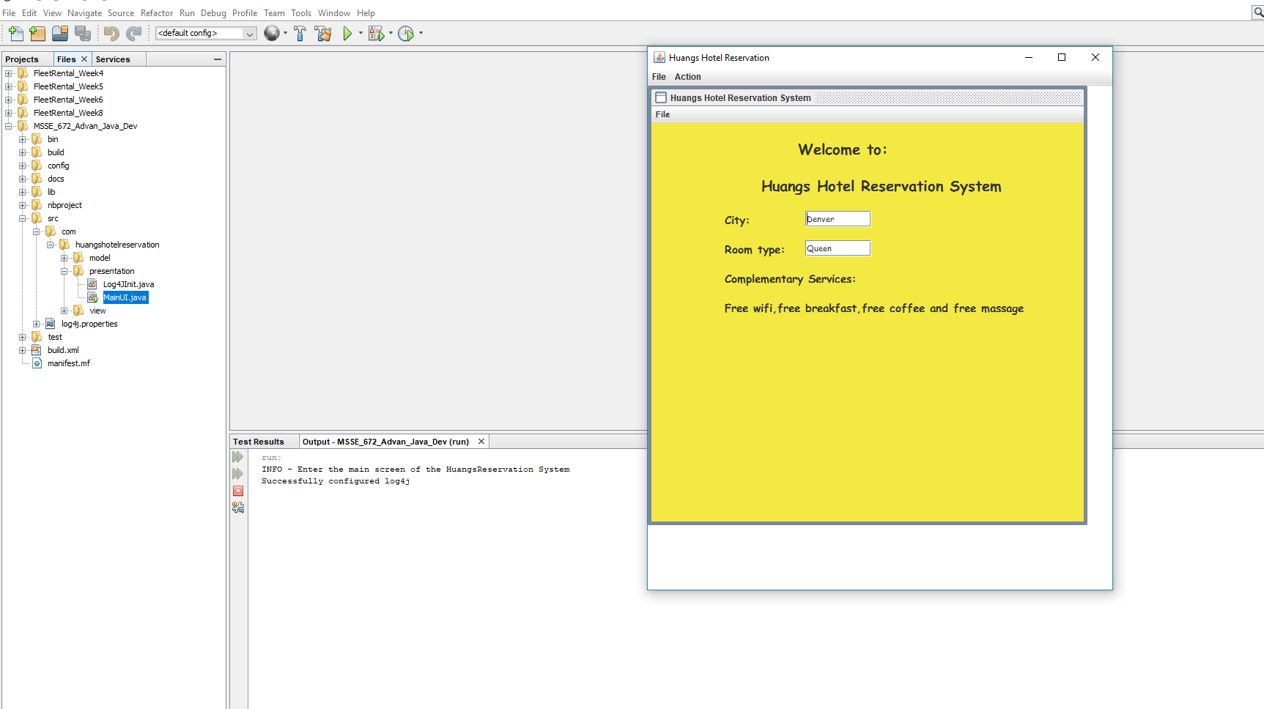

SeeGallery Service:

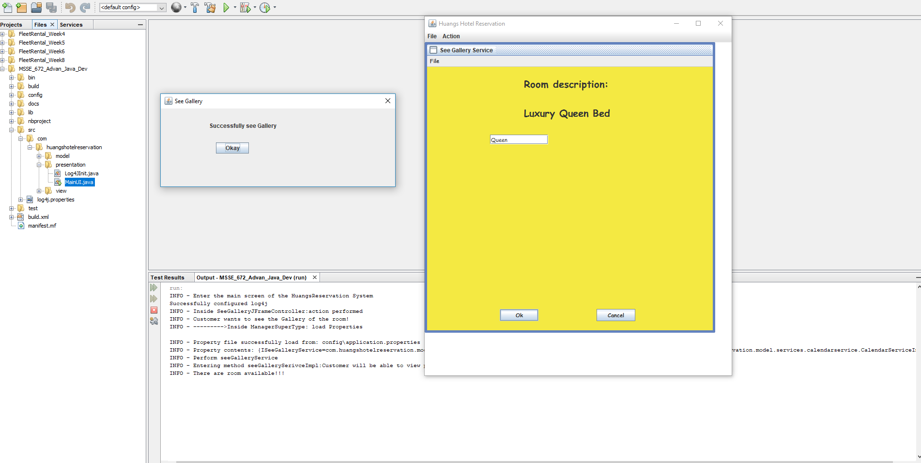

CalendarService:

