运行test.py
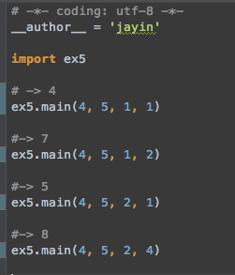

运行结果
100
[2, 4]
165
[0, 3, 4]

