运行test.py
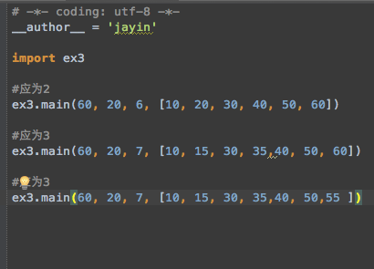

运行结果:

2
[20, 40, 60]
3
[10, 30, 40, 60]
3
[10, 30, 40, 60]

