AI Research Paper Explainer
End-to-End Build Guide — v0 + GitHub + Claude Code
Stack: Next.js 16 (App Router) · TypeScript · Vercel AI SDK · @ai-sdk/anthropic (Claude Opus 4.8) · unpdf · Tailwind / shadcn-ui
This guide documents the full workflow used to build the application: generating a UI with v0, wiring it to Claude through the Vercel AI SDK, adding features, and the setup/debugging steps required to actually run it. Steps marked NEW were added to complete the original outline.

Workflow at a Glance
- Step 1 — Generate the base UI with v0
- Step 2 — Connect to GitHub and clone the repo
- Step 3 — Environment & dependencies (NEW)
- Step 4 — Implement the backend with Claude Code (Vercel AI SDK)
- Step 5 — Run & verify the app (NEW)
- Step 6 — Fix the file-upload dropzone bug (NEW)
- Step 7 — Add 'Explain Like Different Personas'
- Step 8 — Convert analysis generation to streaming
- Step 9 — Deployment (NEW, optional)

Step 1 — Generate the Base UI with v0
Open v0 (v0.app) and use the following prompt to scaffold the application.
v0 prompt:
Build a modern AI-powered Research Paper Explainer.
Features: Upload PDF paper; Chat with paper; Generate summary; Key Contributions section; Methodology section; Limitations section; Future Work section.
Design: Modern SaaS dashboard; Clean academic style; Dark mode support; Responsive layout.
Include: Upload area; Summary cards; Chat interface; Citation panel. Basic app version ready to use.
Result: a working Next.js front end with all UI components, but with placeholder / non-functional backend logic.

Step 2 — Connect to GitHub and Clone the Repo
- In v0, connect the project to GitHub and push it to a new repository.
- Clone the repository locally:
git clone https://github.com/<your-username>/ai-research-explainer.git
cd ai-research-explainer

Step 3 — Environment & Dependencies (NEW)
This step is required before anything can run and was missing from the original outline. The app calls the Anthropic API, so it needs a key.
- Create an Anthropic API key at console.anthropic.com (Settings → API Keys).
- Create your local environment file from the template:
cp .env.example .env.local
- Add your key to .env.local (it is git-ignored, so it will not be committed):
ANTHROPIC_API_KEY=sk-ant-...
- Install dependencies (requires Node.js 20+ for Next.js 16):
npm install
Note: the Claude Code step below adds two packages to package.json — @ai-sdk/anthropic (the official Anthropic provider for the Vercel AI SDK) and unpdf (serverless PDF text extraction). Re-run npm install if you pull changes that modify package.json.

Step 4 — Implement the Backend with Claude Code
Open the cloned project in Claude Code and run the following prompt.
Claude Code prompt:
This is a Next.js application generated by v0. I want users to upload a research paper PDF and receive: 1. Executive Summary 2. Key Contributions 3. Methodology 4. Limitations 5. Future Work.
Implement: PDF upload endpoint; PDF text extraction; Claude API integration; Structured output generation; Connect the generated UI to the backend; Error handling; Loading states. Use the Vercel AI SDK and TypeScript.
What this produced:
- app/api/analyze/route.ts — multipart PDF upload endpoint (validates type, size, empty files).
- lib/pdf.ts — server-side text extraction with unpdf, detecting scanned/image-only PDFs.
- Structured output via the Vercel AI SDK (Zod schema) against model claude-opus-4-8.
- app/api/chat/route.ts — 'chat with the paper' endpoint using the same provider.
- Front end wired to send the file and render Summary, Key Contributions, Methodology, Limitations, Future Work, and Citations.
- Error handling (config/validation/extraction/rate-limit) and loading states.
Design choice: the official @ai-sdk/anthropic provider is used (driven by ANTHROPIC_API_KEY) so the app calls the Claude API directly, rather than routing through a gateway.

Step 5 — Run & Verify the App (NEW)
- Start the development server:
npm run dev
- Open http://localhost:3000.
- Upload a text-based research-paper PDF (under 20 MB) and confirm the analysis sections populate.
- Optionally build for production to catch type/bundle issues:
npm run build

Step 6 — Fix the File-Upload Dropzone Bug (NEW)
On first run the upload control did nothing when clicked. Two real bugs in components/upload-area.tsx were found and fixed:
- Click loop: the hidden file <input> was a child of the clickable <div>, so calling input.click() dispatched a click that bubbled back to the div's onClick and re-triggered .click() — the browser defends against this by refusing to open the dialog.
- Silent MIME rejection: the client rejected any PDF whose file.type was empty or non-standard (common on drag-drop and across OS/browser combos) with no feedback — stricter than the server.
Fix:
- Wrap the <input> in a native <label>, so clicking opens the dialog natively (no JS .click(), no bubbling loop, keyboard-accessible).
- Accept a PDF by extension or MIME type (accept="application/pdf,.pdf" plus a .pdf name check) and show a toast on non-PDF files.
- Reset the input value on click so the same file can be re-selected after an error.
Lesson: a v0-generated dropzone using a programmatic .click() on a nested input is a common footgun; prefer a <label>-wrapped input.

Step 7 — Add 'Explain Like Different Personas'
Add audience-specific explanation buttons.
Feature spec / Claude Code prompt:
Add an 'Explain like a persona' feature. Buttons: Researcher, Product Manager, Executive, Student. When clicked, Claude receives a request such as 'Explain this paper for a product manager' and returns a tailored explanation.
What this produced:
- app/api/explain/route.ts — a streaming endpoint with a distinct system prompt per persona (audience, focus, tone, jargon level).
- components/persona-explainer.tsx — the four persona buttons rendered in a new 'Explain' tab, streaming the response with loading and error states.

Step 8 — Convert Analysis Generation to Streaming
Claude Code prompt:
Convert all analysis generation to streaming responses using the Vercel AI SDK.
What this produced:
- Server: /api/analyze switched from generateObject to streamObject (Vercel AI SDK), returning a streamed response.
- Client: reads the stream and uses parsePartialJson to reveal each section as it parses.
- UI: the audience now sees progressive status — 'Generating Summary…', 'Generating Contributions…', 'Generating Methodology…' — each section filling in as Claude produces it.
Trade-off: because the response is a stream (HTTP 200 once it starts), a mid-stream model error cannot change the status code — it is logged server-side and surfaced to the client via a completion check. Pre-stream errors (upload, extraction, config, rate limit) still return precise codes.

Step 9 — Deployment (NEW, optional)
- Push your changes to GitHub.
- Import the repository into Vercel (or your host of choice).
- Set the ANTHROPIC_API_KEY environment variable in the host's project settings.
- Deploy. The /api/analyze, /api/chat, and /api/explain routes run as server functions (Node.js runtime).

Appendix — Project Structure & Troubleshooting
Key files:
- app/api/analyze/route.ts — PDF upload + extraction + streamed structured analysis
- app/api/chat/route.ts — chat with the paper
- app/api/explain/route.ts — persona explanations (streaming)
- lib/pdf.ts — PDF text extraction (unpdf)
- components/upload-area.tsx — dropzone (label-based)
- components/analysis-view.tsx — progressive section cards
- components/persona-explainer.tsx — persona buttons + output
Common issues:
- 'Server is not configured… Set ANTHROPIC_API_KEY' — key missing; restart dev server after editing .env.local.
- 'Could not extract enough text… scanned or image-only' — the PDF has no text layer (needs OCR); use a text-based PDF.
- Upload does nothing — hard-refresh (Cmd+Shift+R); if still stuck, stop the server, delete the .next folder, and re-run npm run dev.
- 401 invalid x-api-key in the terminal — bad/placeholder key in .env.local.

Frontend Demo :
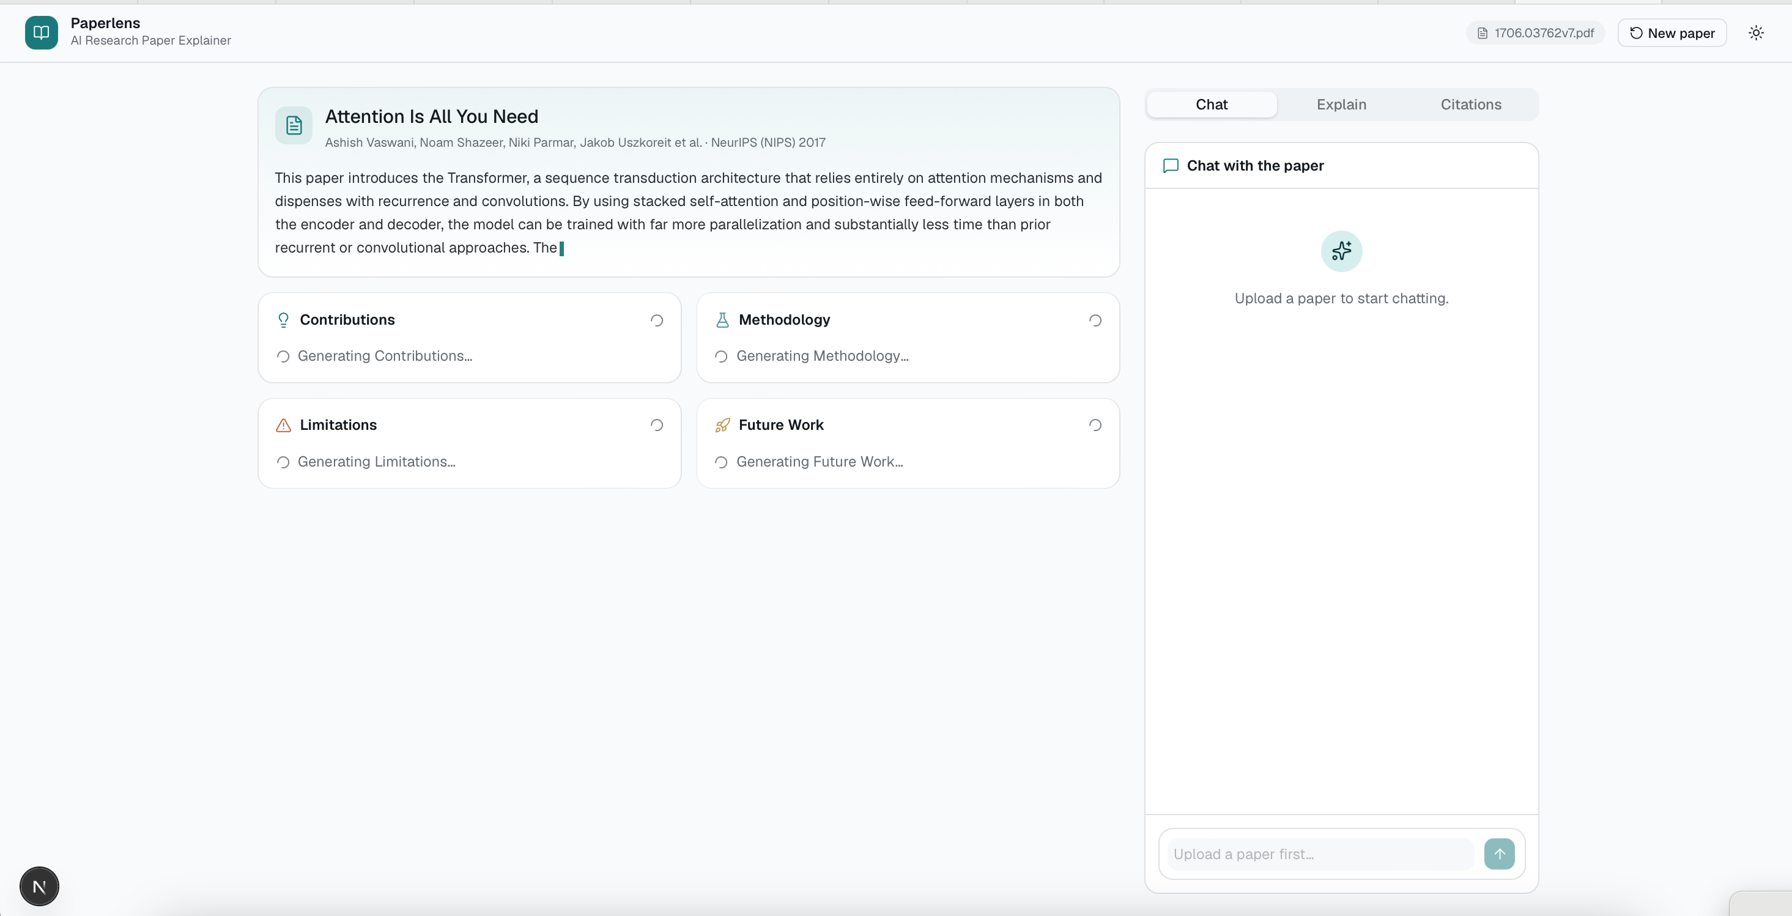
Upload the research paper
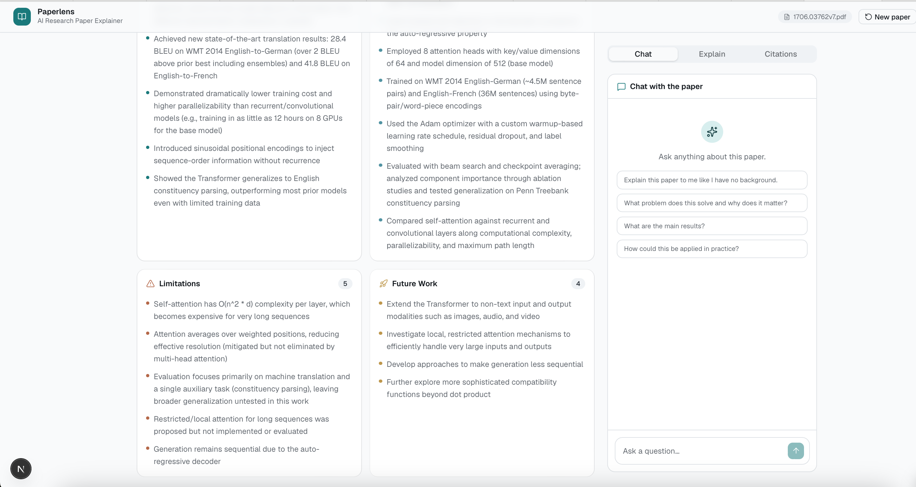
Chat about the paper
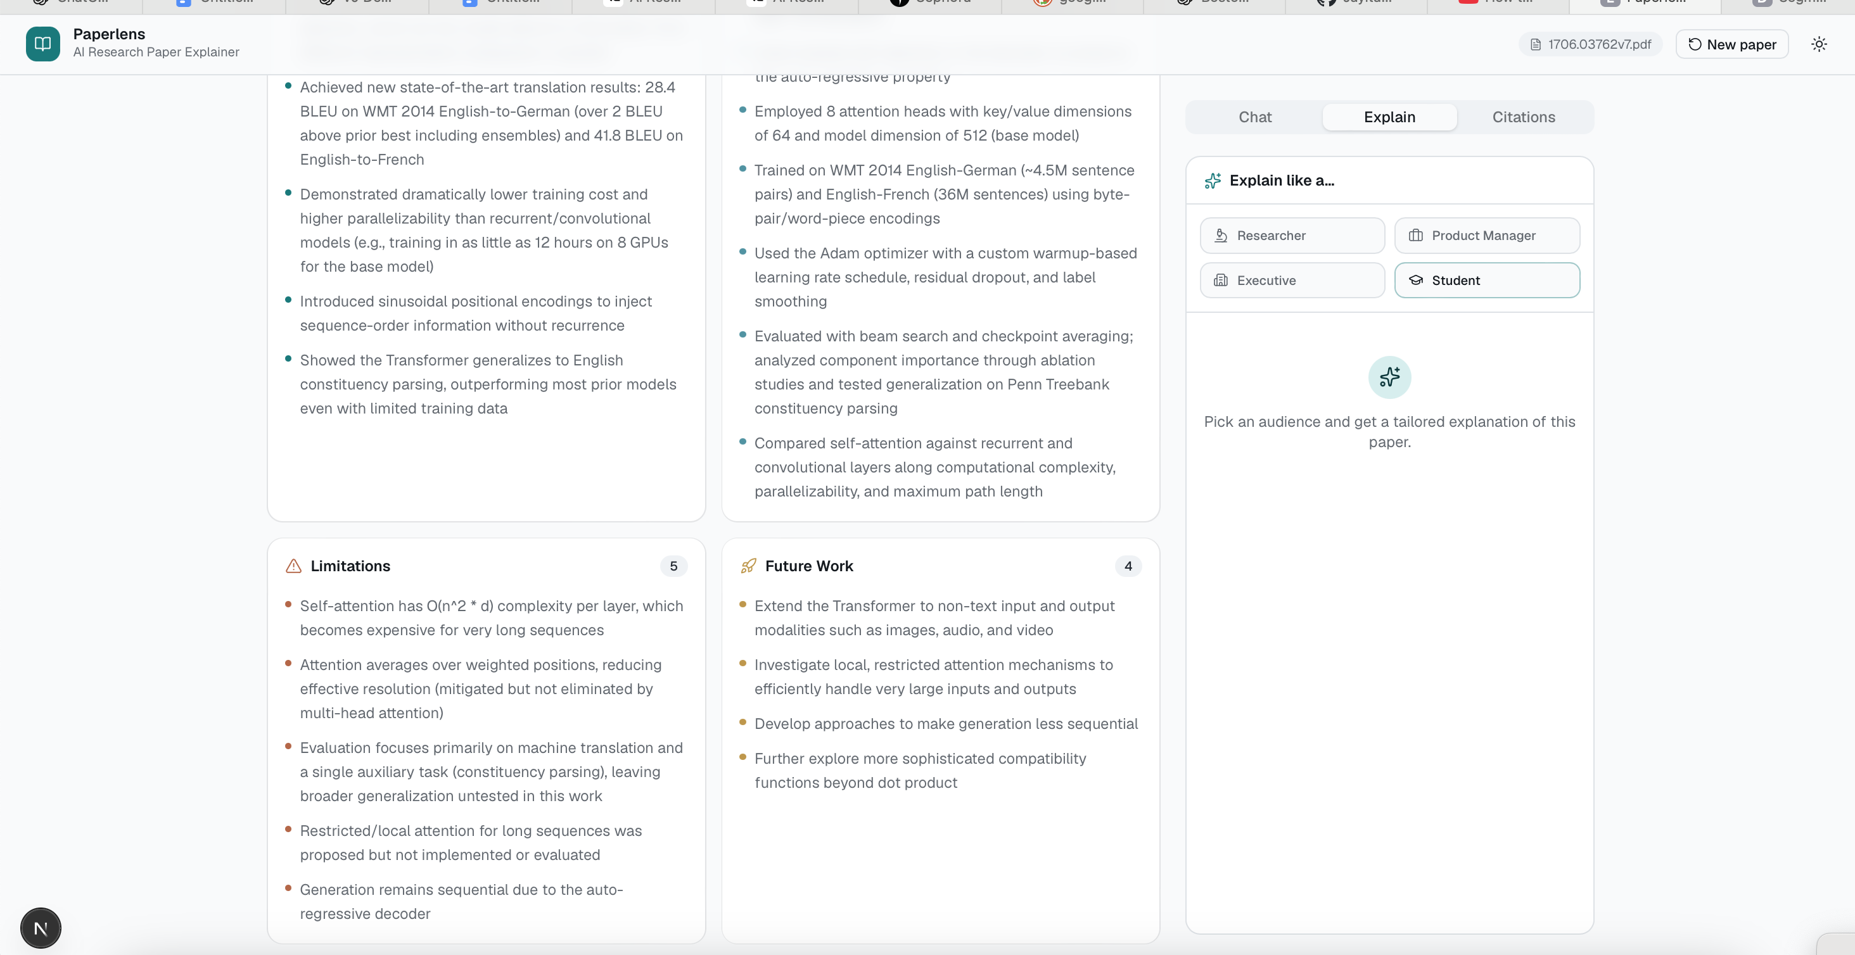
Or select a persona like student and accordingly get the explanation
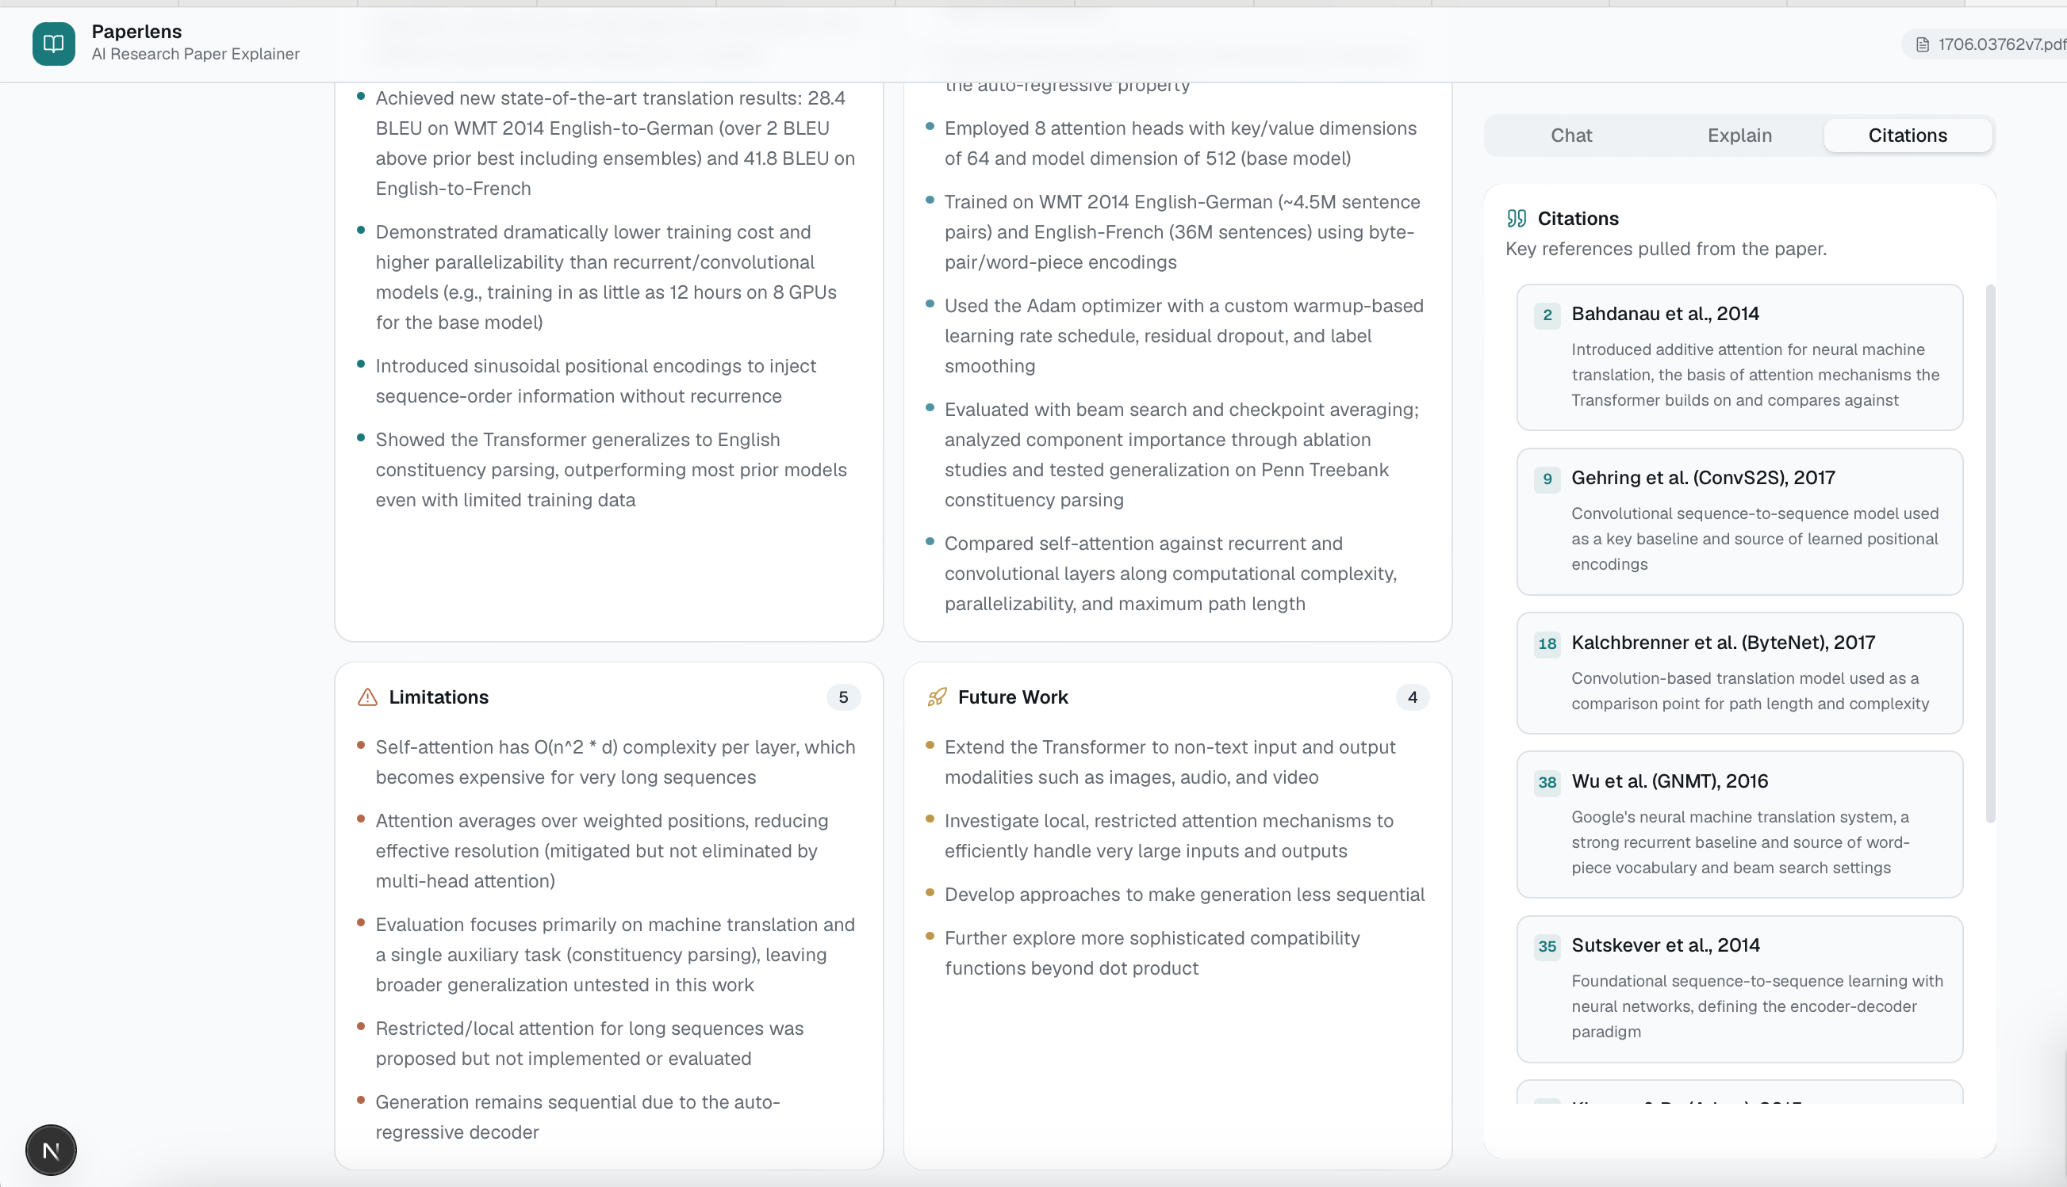

Check citations.

