1. How to define PT option 1 & PT option 2
2. Average Marginal Effect table:
3. Do we need to keep lower and upper limit values? Is it okay if we just keep the mean values?

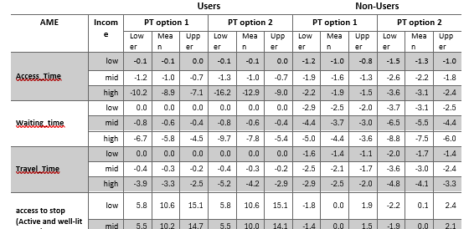

1. Can we compare across different variables by income group for one category?

That is, for users, if we consider high income group can we compare these values and say high income group have more sensitivity to access time and access to stop than travel time or other safety variables.

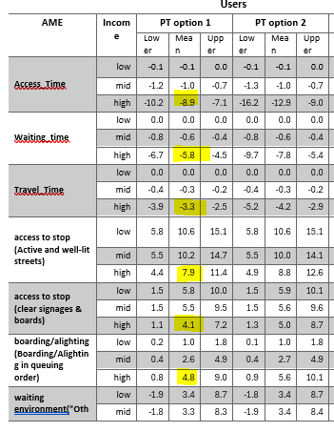

1. Among non-users, AME values show minimal variation across income groups, unlike the user group, what does this imply?
2. Income category for non-users and users are different right? The low income in users and low income nonusers are of different income range?

If it is same, can we compare income category sensitivity between users and non-users?

If it is different don’t we need to specify the income range for different category for users and non users?

|  |
| --- |
|  |

1. Is it right to say non users in all income category are most sensitive to on board safety and safety during boarding alighting than travel time change while users , low and middle income groups are not that sensitive to time , they are more sensitive to safety interventions