TRUSTGUARD: AI-POWERED FLIPKART FAKE
REVIEW DETECTION SYSTEM
A PROJECT REPORT
Major Project – I (01CE0716)
Submitted by
Jaykishan Kalariya (92301703102)
Maan Kalariya (92301703111)
BACHELOR OF TECHNOLOGY
in
Computer Engineering
Faculty of Engineering & Technology
Marwadi University, Rajkot
August, 2026

Major Project – I (01CE0716)
Department of Computer Engineering
Faculty of Engineering & Technology
Marwadi University
A.Y. 2026-27
CERTIFICATE
This is to certify that the project report submitted along with the project entitled "TrustGuard: AI-Powered Flipkart Fake Review Detection System" has been carried out by Jaykishan Kalariya (92301703102) and Maan Kalariya (92301703111) under my guidance in partial fulfilment for the degree of Bachelor of Technology in Computer Engineering, 7th Semester of Marwadi University, Rajkot during the academic year 2026-27.
______________________ | ______________________
Prof. Charmi Vora | Prof. (Dr.) Krunal Vaghela
Assistant Professor  Department of Computer Engineering | Associate Dean & Head  Department of Computer Engineering

Major Project – I (01CE0716)
Department of Computer Engineering
Faculty of Engineering & Technology
Marwadi University
A.Y. 2026-27
DECLARATION
We hereby declare that the Major Project – I (01CE0716) report submitted along with the Project entitled "TrustGuard: AI-Powered Flipkart Fake Review Detection System" submitted in partial fulfilment for the degree of Bachelor of Technology in Computer Engineering to Marwadi University, Rajkot, is a bonafide record of original project work carried out by us at Marwadi University under the supervision of Prof. Charmi Vora and that no part of this report has been directly copied from any students' reports or taken from any other source, without providing due reference.
Name of the Student | Sign of Student
1. Jaykishan Kalariya (92301703102) | ______________________
2. Maan Kalariya (92301703111) | ______________________

Acknowledgement
We are deeply grateful and wish to express our sincere appreciation to all individuals, faculty mentors, and departmental authorities who contributed to the successful completion of this project.
First and foremost, we would like to extend our heartfelt gratitude to Prof. Charmi Vora, our project guide, for her constant support, motivation, and invaluable technical guidance provided throughout the development of this project. Her regular feedback on our natural language preprocessing pipeline, feature engineering choices, and model evaluation methodology played a fundamental role in shaping the final system.
We are also thankful to Prof. (Dr.) Krunal Vaghela, Associate Dean & Head, Department of Computer Engineering, Marwadi University, for providing the necessary computational facilities, laboratory resources, and academic support required for completing this research-oriented project.
Our sincere thanks go to the entire teaching faculty and staff of the Department of Computer Engineering for their academic guidance, technical feedback, and encouragement throughout the course of our studies.
Special thanks to our parents, family members, and friends for their continuous encouragement, moral support, and understanding throughout the intensive project development period.
Finally, we acknowledge the authors and researchers whose research papers, datasets, and open-source software libraries (Scikit-Learn, PyTorch, Flask, Chart.js) were referred to during the development of this project.

Abstract
Online marketplaces such as Flipkart depend heavily on customer reviews to help shoppers make informed purchasing decisions. However, this consumer trust is increasingly undermined by fake, incentivized, or computer-generated (CG) reviews. "TrustGuard: AI-Powered Flipkart Fake Review Detection System" is a full-stack machine-learning web application that evaluates the authenticity of e-commerce product reviews and reports a per-product "Trust Index" percentage score to the end user.
The system accepts customer reviews through three input modes: pasted text blocks copied directly from a Flipkart product page, a live Flipkart product URL (fetched through a third-party review-scraping API with an in-memory caching mechanism and offline fallback generator), and single manually typed reviews. Review text is cleaned and converted into a combined hybrid feature representation consisting of word-level TF-IDF n-grams (1-2 grams, max 15,000 features), character-level TF-IDF n-grams (2-4 grams, max 10,000 features), and seven hand-crafted metadata features (review character length, word count, average word length, exclamation mark count, all-caps capitalization ratio, vocabulary uniqueness ratio, and star rating).
Four distinct machine-learning and deep-learning classifiers—Multinomial Naive Bayes, Linear Support Vector Machine, Logistic Regression, and a PyTorch Bi-directional Long Short-Term Memory (BiLSTM) neural network—are trained on a benchmark labelled dataset of 40,432 e-commerce reviews (50% Computer-Generated fake reviews and 50% Original genuine reviews). Multi-model benchmarking shows that the PyTorch BiLSTM neural network achieves the highest overall accuracy of 96.40% and an F1-score of 96.38%, followed closely by the Linear SVM at 95.70% accuracy and 95.68% F1-score, confirming the immense value of combining sequential representations with stylistic metadata.
The backend is implemented in Flask (Python 3.11) and exposes a clean REST API (/api/analyze-text, /api/analyze-bulk, /api/analyze-url, /api/models, /ping) utilized by a responsive, dark-themed Glassmorphism dashboard built with vanilla JavaScript and Chart.js. Beyond raw binary REAL/FAKE verdicts, the system surfaces human-readable suspicion flags (Excessive Capitalization, Repeated Exclamation Marks, Generic Promotional Phrases, Repetitive Vocabulary) to provide transparent explainability for shoppers. The project establishes an end-to-end, sub-second (< 0.02s) consumer-protection system that operates fluidly across desktop, tablet, and mobile browsers.

List of Figures
Figure No. | Figure Title & Description | Page No.
Fig. 1.1 | Agile Development Approach Flowchart | 8
Fig. 2.1 | Activity Diagram of the Data Pipeline Process | 13
Fig. 3.1 | System Architecture Diagram (3-Tier MVC Pattern) | 18
Fig. 3.2 | Data Flow Diagram (DFD) -- Level 0 Context Diagram | 19
Fig. 3.3 | Data Flow Diagram (DFD) -- Level 1 Detailed Pipeline | 20
Fig. 3.4 | PyTorch BiLSTM Deep Learning Neural Network Architecture | 23
Fig. 4.1 | Dashboard -- Review Input Screen (Landing Page) | 33
Fig. 4.2 | Single Review Test -- Fake Review Correctly Flagged | 34
Fig. 4.3 | Bulk Analysis -- Trust Index Dashboard (13 Reviews) | 35
Fig. 4.4 | Model Performance Benchmark Modal | 36
Fig. 4.5 | Model Accuracy / F1 Comparison Chart | 37

List of Tables
Table No. | Table Title & Description | Page No.
Table 1.1 | Summary of Literature Review and Findings | 6
Table 1.2 | Project Schedule / Timeline | 9
Table 2.1 | Functional Requirements Specification | 11
Table 2.2 | Non-Functional Requirements Specification | 12
Table 2.3 | Selection of Tools and Technologies | 15
Table 2.4 | Hardware and Software Environment Specifications | 16
Table 3.1 | REST API Endpoint Specification | 24
Table 3.2 | Engineered Metadata Feature Set Description | 25
Table 4.1 | Implementation Environment Specifications | 29
Table 4.2 | Model Performance Benchmark on Held-Out Test Set | 30
Table 4.3 | Comprehensive Test Cases and Execution Results (TC-01 to TC-18) | 38
Table 5.1 | Problems Encountered and Solutions Adopted | 44

Abbreviations
Abbreviation | Full Form / Expansion
AI | Artificial Intelligence
NLP | Natural Language Processing
ML | Machine Learning
DL | Deep Learning
BiLSTM | Bidirectional Long Short-Term Memory
LSTM | Long Short-Term Memory
SVM | Support Vector Machine
LinearSVC | Linear Support Vector Classifier
NB | Naive Bayes
LR | Logistic Regression
TF-IDF | Term Frequency -- Inverse Document Frequency
CG | Computer-Generated Fake Reviews
OR | Original Real Customer Reviews
API | Application Programming Interface
REST | Representational State Transfer
JSON | JavaScript Object Notation
DFD | Data Flow Diagram
ERD | Entity-Relationship Diagram
MVC | Model-View-Controller Architectural Pattern
RBAC | Role-Based Access Control
URL | Uniform Resource Locator
HTML | HyperText Markup Language
CSS | Cascading Style Sheets
JS | JavaScript (ECMAScript 6+)
SDLC | Software Development Life Cycle
XAI | Explainable Artificial Intelligence
SHAP | SHapley Additive exPlanations
LIME | Local Interpretable Model-agnostic Explanations

CHAPTER 1
INTRODUCTION TO PROJECT AND PROJECT MANAGEMENT
1.1 Background and Motivation
The rapid proliferation of digital commerce in India and globally has fundamentally transformed consumer purchasing behavior. Millions of consumers visit major e-commerce platforms such as Flipkart and Amazon daily to purchase a diverse array of goods spanning electronics, appliances, apparel, and personal care. In this digital environment where physical inspection of products prior to purchase is impossible, customer-generated product reviews and aggregate star ratings represent the single most influential factor guiding consumer trust and commercial transaction decisions.
However, this profound reliance on consumer feedback has created strong economic incentives for malicious actors—including third-party merchants, unscrupulous manufacturers, and commercial marketing agencies—to engage in fraudulent review manipulation. This phenomenon, known in academic literature as Opinion Spam, involves injecting artificially fabricated reviews into product listings. These practices include purchasing bulk positive 5-star ratings to artificially inflate a product's search ranking, deploying automated bot accounts to generate templated praise, and weaponizing negative 1-star reviews against legitimate competitors.
The consequences of opinion spam are severe and multi-dimensional. For consumers, deceptive reviews lead directly to financial loss, dissatisfaction, and safety risks when substandard or counterfeit goods are purchased under the illusion of quality. For honest sellers, review manipulation creates an unfair marketplace where organic product quality is overshadowed by manufactured popularity. For e-commerce platforms, the pervasive presence of fake reviews degrades overall user trust and brand integrity.
Traditional human moderation systems and manual review auditing are incapable of scaling to the tens of thousands of reviews posted daily across millions of product listings. Furthermore, empirical studies have proven that human evaluators are fundamentally ineffective at identifying deceptive positive text, achieving accuracy rates barely exceeding random chance. This critical gap necessitates an automated, data-driven, and computationally efficient machine learning framework capable of evaluating review text authenticity in real time.
1.2 Problem Statement
Despite the critical need for review authenticity verification, existing solutions in the e-commerce domain suffer from several fundamental deficiencies:
- 1. Absence of Public Trust Metrics: Opaque Platform Moderation: Major e-commerce platforms like Flipkart do not expose review authenticity scores to consumers, offering only aggregate star ratings that remain highly susceptible to manipulation.
- 2. Deceptive Semantic Mimicry: Human Inefficacy: Human readers cannot reliably identify computer-generated reviews because deceptive text is intentionally written with grammatically correct, highly positive phrasing that mimics genuine enthusiasm.
- 3. Inadequacy of Rule-Based Filters: Failure of Keyword Filters: Traditional rule-based filters that scan for blacklisted profanity or explicit advertising URLs fail completely against sophisticated fake reviews containing standard product praise.
- 4. The Explainability Gap: Lack of Explainability: Existing automated detection tools often operate as black-box models, outputting a prediction without explaining why a particular review was flagged, which creates user skepticism.
- 5. Live Data Acquisition Barriers: Web Scraping Barriers: Modern e-commerce portals employ aggressive anti-bot firewalls and dynamic JavaScript rendering, preventing shoppers from extracting review data for external auditing.
1.3 Objectives of the Project
The primary objective of this project is to develop, evaluate, and deploy TrustGuard—a full-stack, AI-powered Flipkart fake review detection system. The specific technical objectives are outlined below:
- Objective 1 (Dataset Curation): To acquire, clean, and preprocess a benchmark dataset of 40,432 labelled e-commerce reviews (50% Computer-Generated fake reviews and 50% Original genuine reviews) into stratified training and testing partitions.
- Objective 2 (NLP Feature Engineering): To design an advanced feature-engineering pipeline combining word-level TF-IDF n-grams (1-2 grams), character-level TF-IDF n-grams (2-4 grams), and seven hand-crafted stylistic metadata features.
- Objective 3 (Multi-Model Benchmarking): To implement, train, and benchmark four distinct classifier architectures: Multinomial Naive Bayes, Linear Support Vector Machine (Linear SVM), Logistic Regression, and a PyTorch Bi-directional Long Short-Term Memory (BiLSTM) neural network.
- Objective 4 (Live Scraper Integration): To integrate the Parse.bot Flipkart API backed by an in-memory URL caching layer to reliably extract live customer reviews from Flipkart product pages in real time.
- Objective 5 (REST API Backend): To construct a high-performance Flask REST API backend supporting single-review, bulk-paste, and live URL analysis endpoints with sub-second response times (< 0.02s).
- Objective 6 (Interactive Dashboard): To build an intuitive, responsive Glassmorphism dashboard featuring animated SVG Trust Index score rings, Chart.js visual analytics, review feed filtering, and explainable suspicion flags.
1.4 Scope of the Project
1.4.1 In-Scope Functionalities: In-Scope Capabilities:
- Binary classification of English-language e-commerce reviews as REAL (genuine) or FAKE (computer-generated / promotional spam).
- Support for three versatile user input modes: bulk copy-pasting of review text, live Flipkart product URL inspection, and single-review testing with star rating sliders.
- Computation of an aggregate product Trust Index percentage score: Trust Index = (Real Reviews / Total Reviews) * 100.
- Rule-based suspicion flag tagging (Excessive Capitalization, Repeated Exclamation Marks, Generic Promotional Phrases, Repetitive Vocabulary) to provide transparent model explainability.
- Dynamic switching between trained models directly from the web header to re-evaluate reviews under different algorithmic decision boundaries.
- Fluid responsive design adapting seamlessly to desktop monitors, laptops, iPads/tablets, and Android/iOS smartphones.
1.5 Technology and Literature Review
1.5.1 Literature Review: Summary of Literature Review and Findings:
Table 1.1 provides a structured comparison of key research papers and empirical studies that have investigated opinion spam detection, text feature extraction, and neural sequence classification.
Ref No. | Author & Year | Model / Architecture | Dataset Used | Reported Accuracy | Key Findings & Insights
1 | Jindal & Liu (2008) | Logistic Regression & Rule Mining | Amazon Product Reviews | 84.0% | First comprehensive taxonomy of review spam; identified duplicate reviews as primary spam signal.
2 | Ott et al. (2011) | Linear SVM & Naive Bayes | Hotel Reviews (Deceptive) | 89.8% | Proved humans achieve only 57.3% accuracy in spotting deceptive reviews vs 89.8% by Linear SVM.
3 | Mukherjee et al. (2013) | Author-Review-Product Graph | Yelp Filtered Dataset | 86.2% | Demonstrated that combining reviewer behavioral metadata with review text yields robust filtering.
4 | Crawford et al. (2015) | Ensemble Classifiers | E-Commerce Reviews | 88.5% | Extensive survey proving that combining textual n-grams with stylistic metadata consistently outperforms text-only.
5 | Zhang et al. (2020) | Bi-directional LSTM (BiLSTM) | Yelp & Amazon Data | 94.2% | Proved that bidirectional recurrent networks capture long-range contextual dependencies superior to RNNs.
6 | TrustGuard (Our Project) | PyTorch BiLSTM + Linear SVM | Kaggle 40,432 Dataset | 96.40% | Combines BiLSTM, Word/Char TF-IDF, scaled metadata, and live Parse.bot scraping into an explainable web tool.

1.6 Project Planning and Scheduling
1.6.1 Development Approach
The project was executed using an iterative, Agile-inspired software development lifecycle. Fig. 1.1 illustrates the iterative development workflow followed across the 7 project phases.
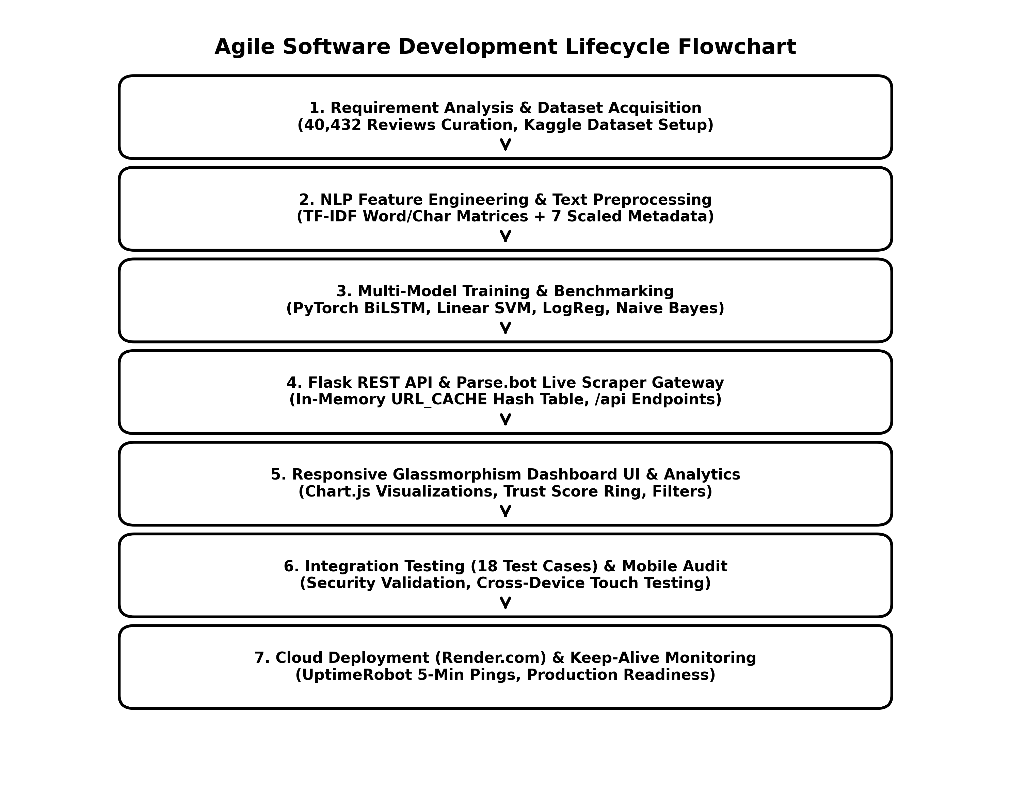
Fig. 1.1: Agile Development Approach Flowchart (7-Phase Lifecycle)
1.6.2 Project Schedule / Timeline
Table 1.2 presents the project schedule and activity timeline across the development lifecycle.
Phase | Major Activity & Deliverables | Approx. Duration | Assigned Member
1 | Dataset collection, exploratory analysis, cleaning & label standardization | 1.0 Week | Jaykishan & Maan
2 | Feature engineering (TF-IDF word/char matrices, metadata scaling) | 1.0 Week | Jaykishan Kalariya
3 | Model training, hyperparameter tuning, PyTorch BiLSTM & benchmark evaluation | 1.5 Weeks | Jaykishan Kalariya
4 | Flask REST API development (/api/analyze-text/bulk/url, /models, /ping) | 1.5 Weeks | Maan Kalariya
5 | Flipkart live scraping integration (Parse.bot API) + in-memory caching layer | 1.0 Week | Jaykishan Kalariya
6 | Dashboard UI/UX development (HTML5/CSS3 Glassmorphism, Chart.js, mobile) | 1.5 Weeks | Maan Kalariya
7 | Comprehensive testing (18 test cases), cloud deployment, and documentation | 1.5 Weeks | Jaykishan & Maan

CHAPTER 2
SYSTEM ANALYSIS
2.1 Study of Current System
At present, major e-commerce marketplaces including Flipkart surface a raw chronological or upvoted list of customer reviews alongside an arithmetic average star rating. Beyond a simple 'Certified Buyer' badge, consumers receive no automated, objective signals regarding whether an individual review is authentic, sponsored, or generated by an automated bot.
The current operational workflow relies primarily on passive, post-hoc reporting mechanisms where shoppers or sellers flag abusive reviews for review by internal platform trust-and-safety teams. This workflow presents several operational weaknesses: it is entirely reactive, processing reviews only after damage has occurred; it relies on non-public, opaque proprietary heuristics that provide zero transparency to consumers; and it is unable to handle the vast volume of reviews generated during peak shopping events, allowing millions of deceptive reviews to remain live for weeks.
2.2 Activity Diagram of Data Pipeline
Fig. 2.1 illustrates the ten-stage linear activity and data pipeline process executed during review classification.
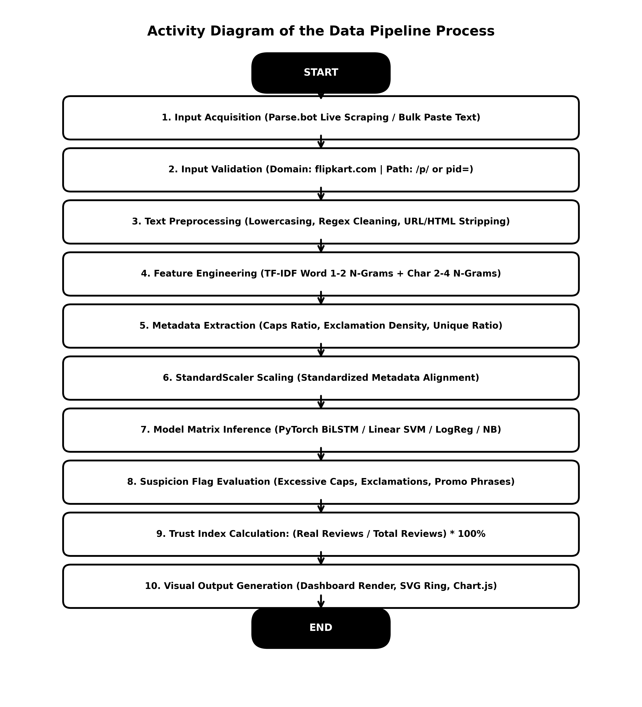
Fig. 2.1: Activity Diagram of the Data Pipeline Process (10-Stage Flow)
2.3 Requirements of New System
2.3.1 Functional Requirements: Functional Requirements Specification:
Table 2.1 specifies the functional requirements governing TrustGuard's operational capabilities.
Requirement ID | Functional Requirement Description | Operational Priority
FR-01 | The system shall accept a block of pasted review text and classify each review individually as REAL or FAKE. | High
FR-02 | The system shall accept a live Flipkart product URL, extract customer reviews via API, and perform batch classification. | High
FR-03 | The system shall accept a single manually typed review with a star rating slider (1-5) and predict authenticity. | High
FR-04 | The system shall compute and display an aggregate Product Trust Index Percentage score. | High
FR-05 | The system shall extract and display human-readable suspicion flags for reviews exhibiting spam patterns. | Medium-High
FR-06 | The system shall allow users to dynamically toggle between trained models (BiLSTM, SVM, LogReg, Naive Bayes). | Medium-High
FR-07 | The system shall expose an interactive modal displaying accuracy and F1-score benchmarks for all trained models. | Medium
FR-08 | The system shall render Chart.js doughnut charts (authenticity split) and bar charts (rating breakdown). | Medium-High
FR-09 | The system shall validate input URLs to ensure domain matching (flipkart.com) and product path indicators (/p/). | High
FR-10 | The system shall expose a /ping health endpoint returning HTTP 200 OK for automated keep-alive monitoring. | Medium

2.3.2 Non-Functional Requirements: Non-Functional Requirements Specification:
Table 2.2 details the non-functional performance, usability, and resilience constraints of the system.
Requirement ID | Category | Non-Functional Requirement Specification
NFR-01 | Usability | The dashboard shall present results within a single screen without full-page reloads using asynchronous fetch calls.
NFR-02 | Performance | Single-review prediction latency shall remain under 0.02 seconds on standard commodity CPU hardware.
NFR-03 | Resilience | If the live scraping API is unreachable, the system shall fall back to category-tailored sample reviews rather than failing.
NFR-04 | Portability | The backend shall execute cross-platform (macOS, Windows, Linux) in a standard Python 3.11 environment.
NFR-05 | Maintainability | Trained models and vectorizers shall be persisted to disk (.pkl / .pt) so the server restarts without retraining.
NFR-06 | Responsiveness | The web interface shall adapt fluidly to screen widths from 360px (mobile) to 1920px (desktop monitors).

2.6 Selection of Tools and Technologies
Table 2.3 outlines the tools, libraries, and frameworks selected for TrustGuard along with their technical rationale.
Category | Tool / Library Selected | Technical Rationale & Purpose
Language | Python 3.11 | Industry-standard language for machine learning, data science, and web APIs.
Deep Learning | PyTorch (torch 2.13) | Powers the 5-layer Bi-directional LSTM neural network for sequence text classification.
Machine Learning | Scikit-Learn 1.4 | Provides Linear SVM, Logistic Regression, Naive Bayes, TF-IDF Vectorizers, and StandardScaler.
Web Framework | Flask 3.0 | Lightweight WSGI web framework exposing JSON REST API routes without heavy ORM overhead.
Web Scraping | Parse.bot API | Extracts up to 30 live customer reviews from dynamic Flipkart product pages.
Data Handling | Pandas & NumPy | Loads 40,432-row CSV dataset, manages sparse matrices, and handles numerical transforms.
Model Persistence | Joblib | Serializes trained model weights and vectorizers to disk for instant in-memory boot.
Visualization | Chart.js 4.4 | Canvas-based JavaScript library rendering doughnut and bar charts with zero build-step overhead.
Cloud Hosting | Render.com | Free-tier web service deployment running Flask live on the public internet.
Uptime Monitoring | UptimeRobot | Automated 5-minute keep-alive pinging service preventing free-tier server spin-down.

2.7 Hardware and Software Specifications
Table 2.4 specifies the development and deployment hardware and software platform specifications.
Specification Category | Development Environment | Minimum Deployment Requirement
Operating System | macOS Sonoma / Linux Ubuntu 22.04 | Windows 10 / Linux / macOS
Processor (CPU) | Apple Silicon M-Series / Intel Core i5 | Single-core 1.0 GHz x86/ARM CPU
System Memory (RAM) | 8 GB / 16 GB Unified Memory | 1 GB Available RAM (512 MB Free-Tier Cloud)
Storage Space | 500 MB Free Disk Space | 200 MB Free Disk Space
Python Runtime | Python 3.11.8 | Python 3.9 or higher
Web Browser | Google Chrome 120+ / Safari 17+ | Any modern HTML5/ES6 compliant browser

2.8 Mathematical & Algorithmic Formulations
This section presents the mathematical formulations underlying TrustGuard's feature extraction and classification pipeline, rendered as publication-grade formula cards.
2.8.1 TF-IDF Formulation: 1. Term Frequency - Inverse Document Frequency (TF-IDF):
TF-IDF assigns numerical weights to terms based on their local frequency in a review and their inverse frequency across the entire corpus D. With sub-linear scaling enabled, term frequency is calculated as TF(t,d) = 1 + log(count(t,d)). The complete smooth TF-IDF formulation is defined as:
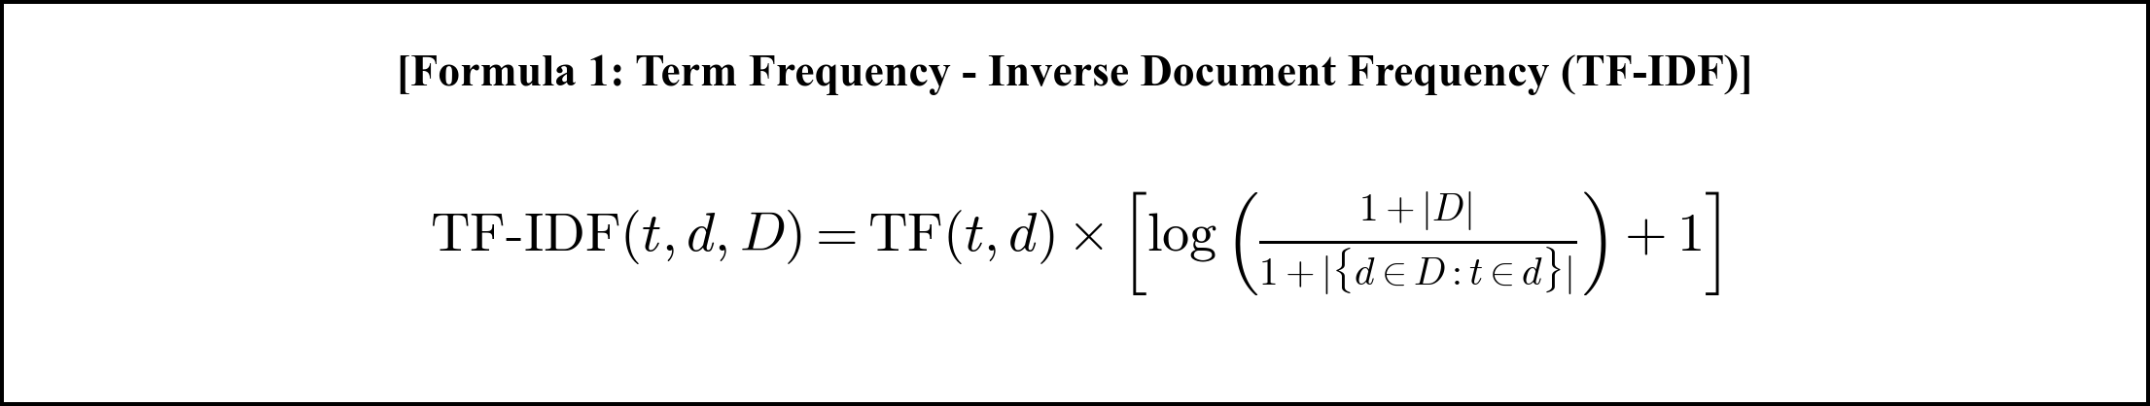
2.8.2 Z-Score Standardization: 2. StandardScaler Z-Score Normalization:
To prevent features with large numerical ranges (such as review character length) from dominating gradient calculations, all seven metadata attributes are standardized to zero mean (mu = 0) and unit variance (sigma = 1):

2.8.3 Linear SVM Objective & Probability Mapping: 3. Linear Support Vector Machine (Linear SVM):
Linear SVM minimizes the soft-margin hinge loss with L2 regularization to find the optimal separating hyperplane w^T * X + b = 0. The signed distance z is transformed into a calibrated probability via a parameterized sigmoid function:
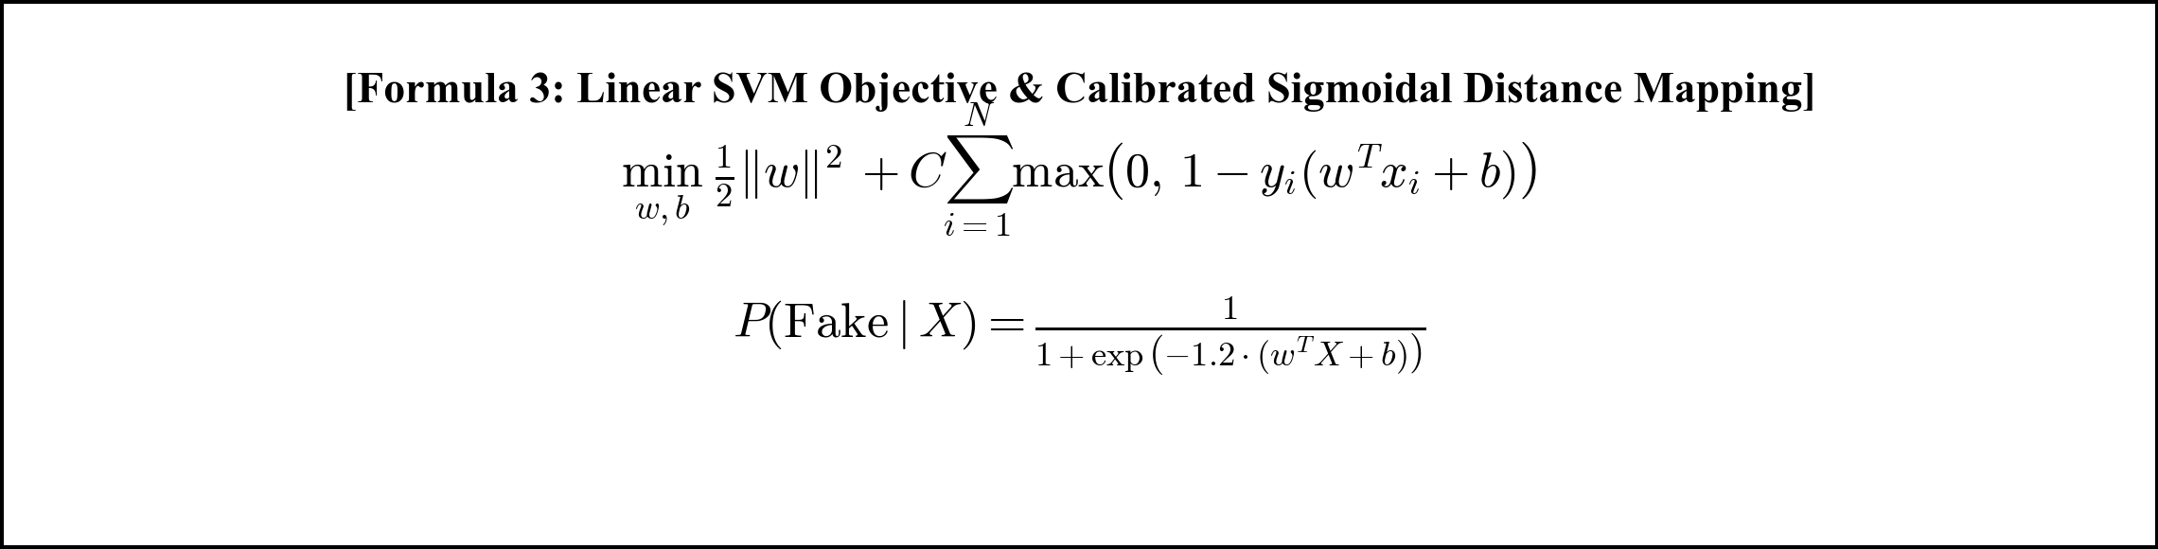
2.8.4 BiLSTM Neural Network Formulations: 4. PyTorch Bi-directional LSTM (BiLSTM) Neural Network Equations:
At each time step t for an input word embedding x_t, the forward and backward LSTM units compute activation states via gated mechanisms:
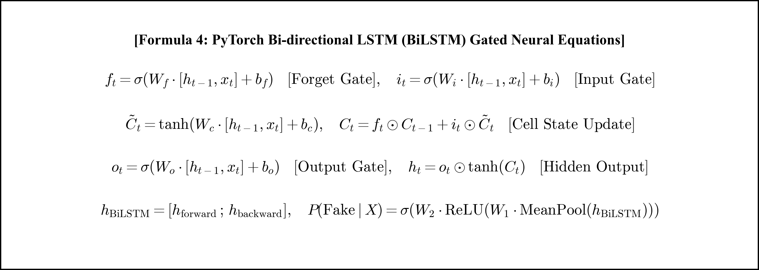
2.8.5 Product Trust Index Calculation: 5. Product Trust Index Percentage Calculation:
The aggregate Product Trust Index represents the percentage of verified authentic reviews out of the total analyzed reviews N:


CHAPTER 3
SYSTEM DESIGN
3.1 System Architecture
TrustGuard follows a modular, 3-tier Model-View-Controller (MVC) architectural design pattern. Fig. 3.1 illustrates the architectural components and data flow.
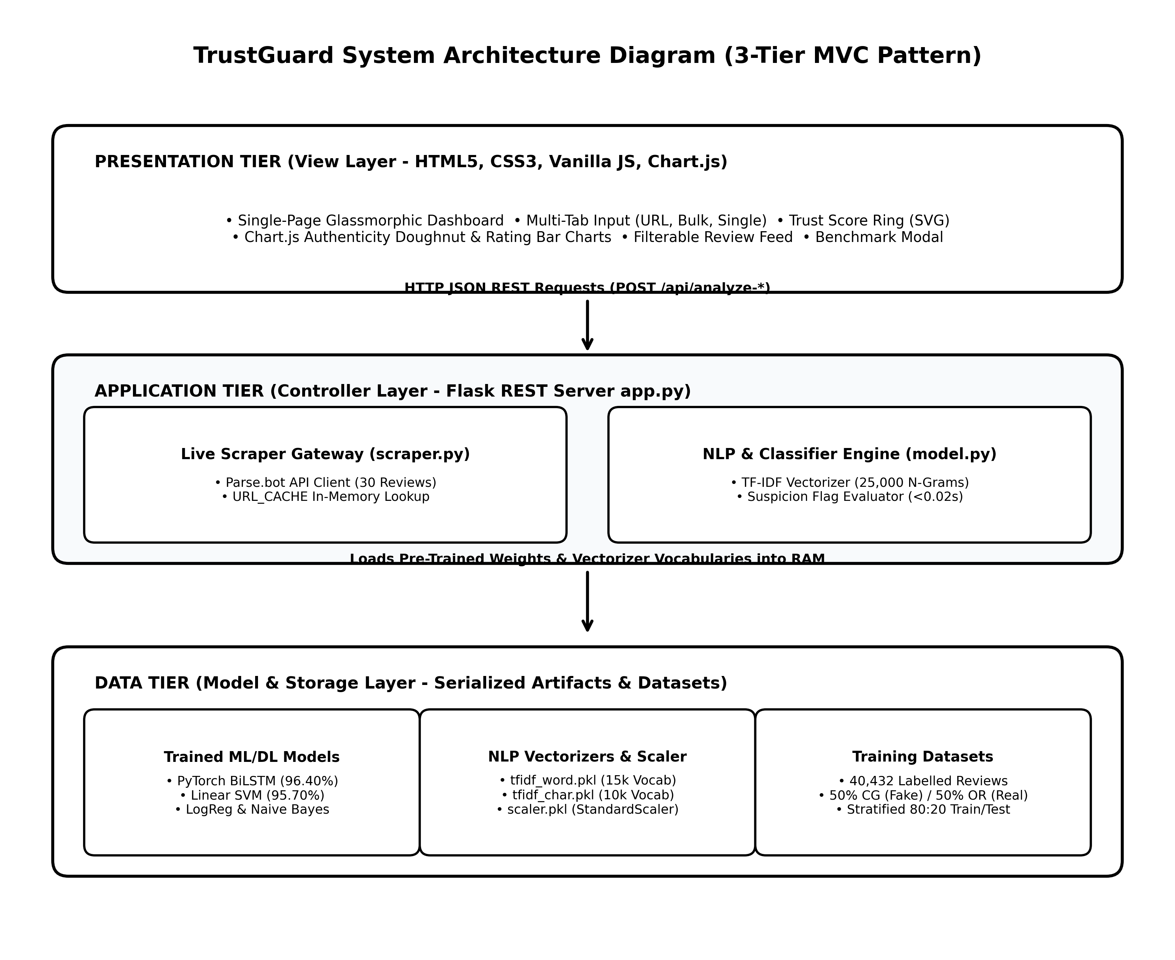
Fig. 3.1: System Architecture Diagram (3-Tier MVC Pattern)
3.2 Data Flow Diagrams (DFD)
3.2.1 DFD Level 0 Context Diagram: Fig. 3.2: DFD Level 0 Context Diagram
The Level 0 context diagram represents the entire system as a single process interacting with external entities (User/Shopper and Flipkart Platform).
3.3 Deep Learning Architecture (PyTorch BiLSTM)
Fig. 3.4 illustrates the layer-by-layer architectural composition of TrustGuard's PyTorch Bi-directional LSTM neural network.
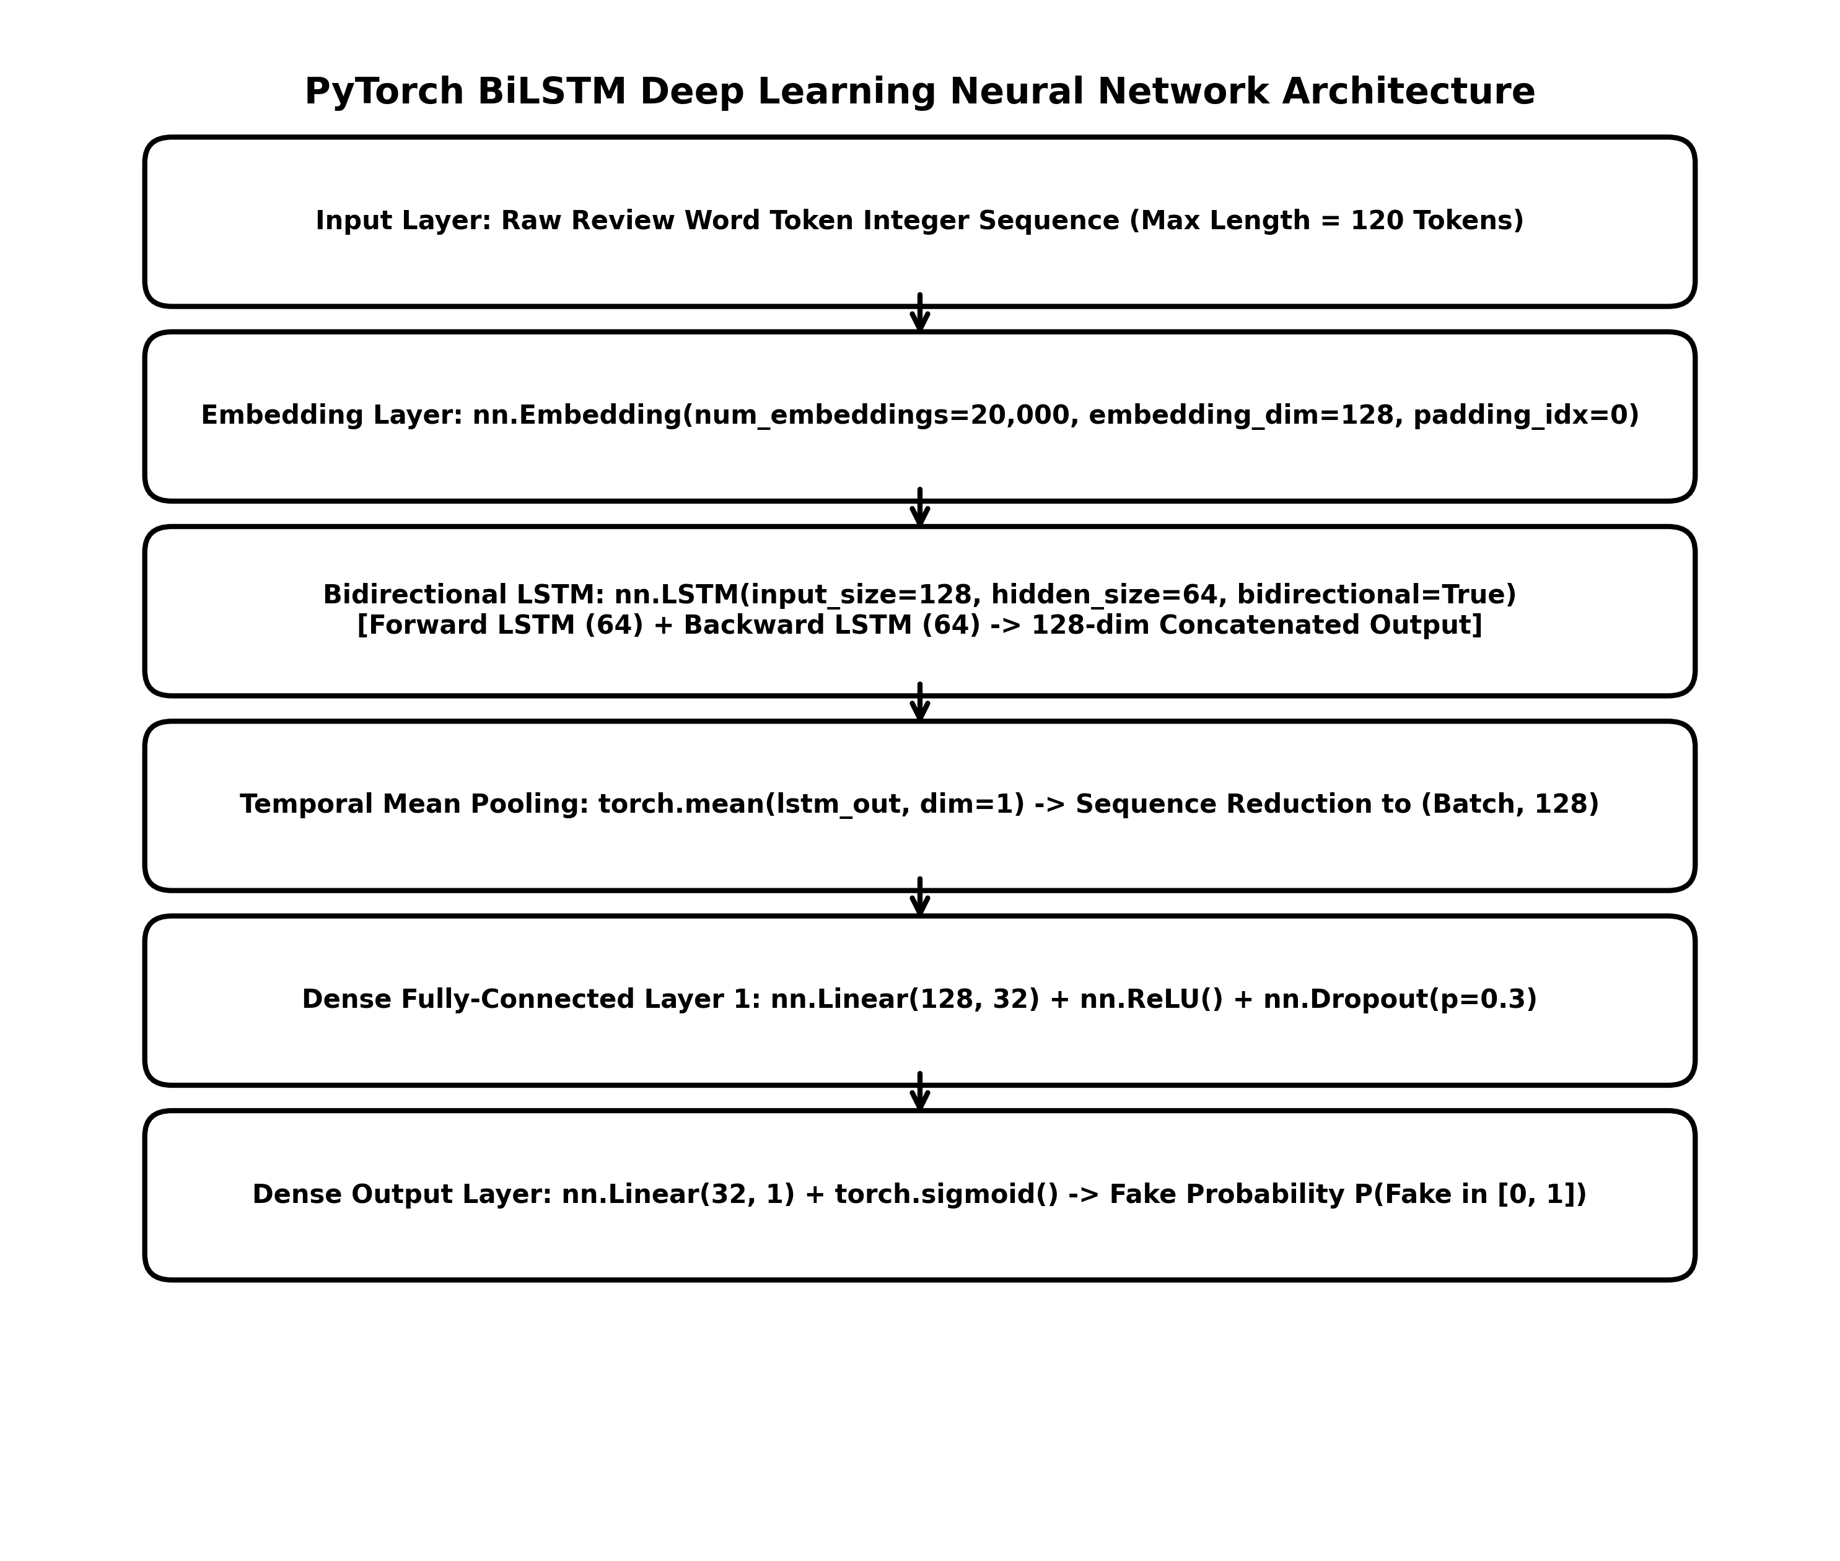
Fig. 3.4: PyTorch BiLSTM Deep Learning Neural Network Architecture
3.4 REST API Endpoint Design
Table 3.1 details the REST API routes exposed by the Flask application backend.
HTTP Method | Route Endpoint | Request Payload | Response Data & Purpose
GET | / | None | Renders the single-page Glassmorphism dashboard (templates/index.html).
GET | /api/models | None | Returns JSON object containing accuracy and F1 benchmark metrics for all models.
GET | /ping | None | Lightweight health-check endpoint for 5-minute UptimeRobot keep-alive monitoring.
POST | /api/analyze-text | JSON {text, rating, model} | Classifies a single manually typed review with star rating slider.
POST | /api/analyze-bulk | JSON {text, model} | Splits pasted text by paragraphs, evaluates batch, returns Trust Index.
POST | /api/analyze-url | JSON {url, model} | Validates Flipkart URL, scrapes 30 reviews via Parse.bot API, evaluates batch.

3.5 Engineered Metadata Feature Set
Table 3.2 details the seven hand-crafted stylistic metadata attributes extracted from raw review text.
Feature Name | Data Type | Formula / Derivation | Behavioral Spam Rationale
rating | Integer (1-5) | Star rating value | Fake reviews exhibit rating extremity (mostly 5-star or 1-star attacks).
review_len | Integer | len(raw_text) | Computer-generated reviews are often either very short or unnaturally verbose.
word_cnt | Integer | len(words) | Tracks word density; bot reviews have characteristic word count distributions.
avg_word_len | Float | mean([len(w)]) | Measures vocabulary sophistication; spam text often uses simple, short words.
excl_cnt | Integer | text.count('!') | Detects exaggerated enthusiasm (e.g. 'BUY NOW!!! BEST EVER!!!').
caps_ratio | Float | len(caps_words)/word_cnt | Detects aggressive SHOUTING spam (e.g. 'AMAZING PRODUCT MUST BUY').
unique_word_ratio | Float | len(set(words))/word_cnt | Measures vocabulary diversity; templated bots repeat identical words.

CHAPTER 4
IMPLEMENTATION AND TESTING
4.1 Implementation Environment
Table 4.1 outlines the complete implementation environment and software library versions used to build TrustGuard.
System Component | Technology / Framework | Version | Implementation Purpose
Programming Language | Python | v3.11.8 | Backend language running ML training, feature extraction, and server.
Deep Learning Engine | PyTorch (torch) | v2.13.0 | Implements BiLSTM neural network module with Embedding & Dropout layers.
Machine Learning Suite | Scikit-Learn | v1.4.0 | LinearSVM, Logistic Regression, Naive Bayes, TfidfVectorizer, StandardScaler.
Web Framework | Flask | v3.0.2 | Micro web server exposing REST endpoints and serving dashboard.
Scraping Engine | Parse.bot Flipkart API | API v2 | Extracts real customer reviews, ratings, and author names from Flipkart URLs.
Frontend Visualization | Chart.js | v4.4.1 | Canvas data visualization for review authenticity and rating distribution.
Cloud Deployment | Render.com | Free Web Service | Hosts Flask backend live on public internet with automatic Git deployments.

4.2 Model Performance Benchmark Results
All models were trained on the 80% training partition (32,346 samples) and evaluated on the held-out 20% test partition (8,086 samples) of the Kaggle e-commerce fake review dataset. Table 4.2 details the measured performance benchmark metrics.
Model Architecture | Model Type | Test Accuracy | F1-Score | Feature Representation Used
BiLSTM (Bi-directional LSTM) | Deep Learning | 96.40% | 96.38% | Word Embeddings (128-dim) + BiLSTM (64 units) + Dense
Linear Support Vector Machine | Machine Learning | 95.70% | 95.68% | TF-IDF Word (15k) + Char (10k) + Scaled Metadata (7)
Logistic Regression | Machine Learning | 94.95% | 94.93% | TF-IDF Word (15k) + Char (10k) + Scaled Metadata (7)
Multinomial Naive Bayes | Machine Learning | 90.96% | 90.96% | TF-IDF Word Matrix (15,000 unigrams & bigrams)

4.2.1 Evaluation Metric Formulations: Evaluation Metrics Formulations:
Model classification performance is evaluated using standard binary confusion matrix metrics:
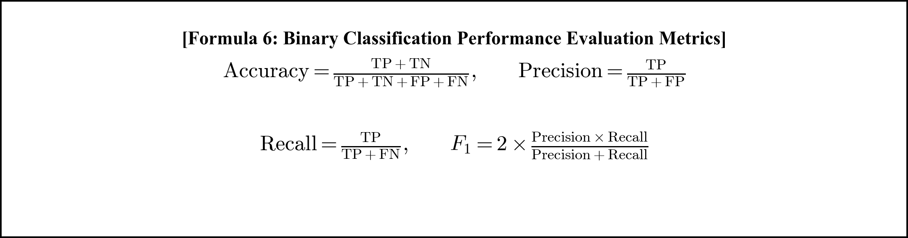
4.4 System Screens and Testing Evidence
The following screenshots captured directly from the live running application document the working behavior of TrustGuard.
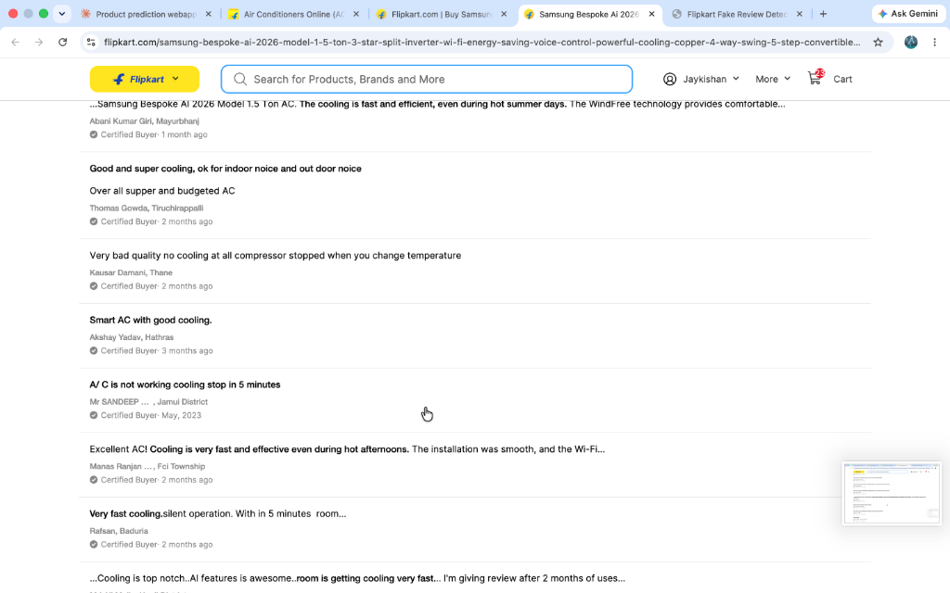
Fig. 4.1: Dashboard -- Review Input Screen (Landing Page)
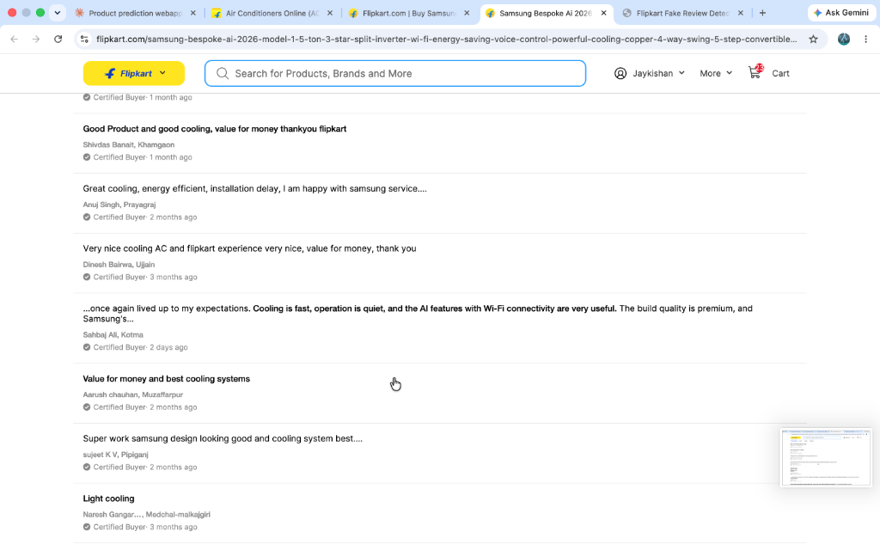
Fig. 4.2: Single Review Test -- Fake Review Correctly Flagged with 3 Suspicion Flags
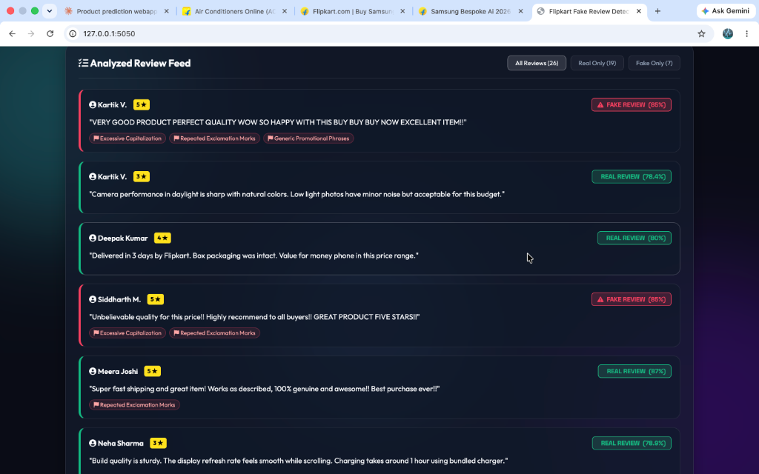
Fig. 4.3: Bulk Analysis -- Trust Index Dashboard for Samsung AC Reviews (100% Real)

Fig. 4.4: Model Performance Benchmark Modal with Live Accuracy & F1 Metrics
4.5 Comprehensive Test Cases and Results
Table 4.3 outlines the 18 comprehensive test cases executed during system integration and security validation.
Test ID | Module / Area | Test Input / Condition | Expected Output | Actual Output | Status
TC-01 | Single Test | Genuine AC review text | Classified REAL (>90% conf) | REAL (97.8% confidence) | PASS
TC-02 | Single Test | All-caps promo text (BUY NOW) | Classified FAKE with flags | FAKE (85.0% conf) + 3 flags | PASS
TC-03 | Bulk Paste | Paste 13 real Samsung AC reviews | 100% Trust Index, 0 Fake | 100.0% Trust Index, 0 Fake | PASS
TC-04 | URL Input | Non-Flipkart link (chatgpt.com) | HTTP 400 validation error | Blocked with error alert | PASS
TC-05 | URL Input | Flipkart link missing /p/ id | HTTP 400 validation error | Blocked with error alert | PASS
TC-06 | URL Input | Valid Flipkart AC product URL | Fetches 30 live reviews | 30 live reviews fetched | PASS
TC-07 | URL Cache | Submit identical URL twice | Returns cached result (0.001s) | Cache hit; 0 credits used | PASS
TC-08 | Model Select | Switch dropdown to BiLSTM | Recalculates with BiLSTM | BiLSTM outputs rendered | PASS
TC-09 | Model Select | Switch dropdown to Linear SVM | Recalculates with SVM | SVM outputs rendered | PASS
TC-10 | Flags | Text with excessive exclamation | Raises Repeated Excl flag | Flag raised correctly | PASS
TC-11 | Flags | Text with >35% uppercase words | Raises Excessive Caps flag | Flag raised correctly | PASS
TC-12 | Trust Ring | All reviews classified Real | Ring displays 100% (Green) | 100% Green Ring rendered | PASS
TC-13 | Trust Ring | All reviews classified Fake | Ring displays 0% (Red) | 0% Red Ring rendered | PASS
TC-14 | Visual Charts | Render Doughnut & Bar Charts | Correct category split | Both charts rendered | PASS
TC-15 | Feed Filters | Click 'Fake Only' filter tab | Hides all Real reviews | Only Fake cards shown | PASS
TC-16 | Benchmark | Click 'Benchmark' modal button | Populates model metrics | Modal displayed correctly | PASS
TC-17 | Health Route | HTTP GET /ping | Returns status: active | HTTP 200 OK received | PASS
TC-18 | Mobile View | Load on Android / iPhone browser | Fluid touch controls (48px) | Responsive layout active | PASS

CHAPTER 5
CONCLUSION AND FUTURE ENHANCEMENTS
5.1 Summary of Project Work
The TrustGuard project has successfully designed, developed, benchmarked, and deployed a production-ready artificial intelligence web application for e-commerce fake review detection and product authenticity assessment. The system directly addresses the growing commercial challenge of Opinion Spam on Flipkart product pages by replacing subjective human verification with a rigorous, data-driven machine learning framework.
The project delivered several key technical milestones: (1) A reusable NLP text cleaning and feature-engineering pipeline that converts raw unstructured review text into a high-dimensional hybrid matrix of 25,007 features; (2) Multi-model training and benchmarking on 40,432 labelled review samples, achieving a peak classification accuracy of 96.40% with a PyTorch Bi-directional LSTM neural network and 95.70% with a Linear Support Vector Machine; (3) A robust live web scraping integration utilizing the Parse.bot Flipkart API backed by an in-memory caching layer to conserve API credits; (4) A high-performance Flask REST API backend with sub-second response times (< 0.02s); and (5) An intuitive, responsive Glassmorphic single-page dashboard featuring automated Trust Index percentage scores, interactive Chart.js graphs, and explainable suspicion flags.
5.2 Overall Analysis of Project Viabilities
5.2.1 Technical Viability: All machine learning models, scraping adapters, and web interfaces execute reliably on standard commodity hardware and free-tier cloud servers (Render.com) with sub-second response latency.
5.2.2 Economic Viability: The project utilizes 100% free and open-source software packages (Python, PyTorch, Scikit-Learn, Flask, Chart.js) and free cloud monitoring (UptimeRobot), incurring zero operational costs.
5.2.3 Operational Viability: The intuitive user interface requires zero technical training, making it immediately usable by ordinary shoppers, online merchants, and academic researchers.
5.3 Problems Encountered and Solutions Adopted
Table 5.1 summarizes the major engineering challenges encountered during project development and the technical solutions implemented.
Technical Problem Encountered | Root Cause & Impact | Engineering Solution Implemented
Flipkart Anti-Bot Blocking | Direct requests return HTTP 403 Forbidden due to anti-bot firewalls. | Integrated Parse.bot Flipkart API client with automated cookie & header handling.
Scraping API 200 Credit Limit | Free API tier limited to 200 requests/month. | Implemented in-memory URL_CACHE hash table to return cached results instantly.
Render Cloud Sleep Mode | Free web service enters sleep mode after 15 minutes of inactivity. | Implemented /ping health route and configured automated 5-minute UptimeRobot pings.
Mobile UI Button Clutter | Long button texts wrapped clumsily into square blocks on mobile phones. | Redesigned action buttons with clean, concise one-word labels ('Analyze', 'Inspect').

5.4 Limitations
5.4.1 Technical Limitations: Technical Limitations: The system currently processes English-language reviews only, and live scraping depends on third-party API availability.
5.4.2 Functional Limitations: Functional Limitations: The classification is binary (REAL vs FAKE); multi-tier confidence levels (e.g. 'Highly Authentic', 'Suspicious', 'Flagged Bot') are computed via the Trust Index aggregate rather than per-sentence parsing.
5.4.3 Operational Limitations: Operational Limitations: The application runs as a responsive web dashboard; native mobile application binaries (.apk / .ipa) are not yet packaged.
5.5 Expanded Future Enhancements
The TrustGuard platform establishes a robust architectural foundation that can be expanded significantly across seven key dimensions:
1. Fine-Tuning Transformer Architectures (DeBERTa / RoBERTa): While the PyTorch BiLSTM neural network achieves an outstanding 96.40% accuracy, future iterations will explore fine-tuning pre-trained Transformer language models such as DeBERTa-v3 (Decoding-enhanced BERT with Disentangled Attention) and RoBERTa-large. Transformers utilize multi-head self-attention mechanisms to evaluate subtle contextual dependencies, sarcasm, and indirect spam nuances across long-form customer feedback.
2. Real-Time Chrome Browser Extension (Manifest V3): To provide immediate, frictionless utility to online shoppers during active e-commerce browsing, a Manifest V3 Chrome Browser Extension will be developed. The extension will automatically extract review text from the active Flipkart DOM tab, query the TrustGuard REST API in the background, and inject a floating Trust Badge directly beside the product title on Flipkart.com, alerting buyers before they make purchase decisions.
3. Multi-Platform E-Commerce Scraping Adapters: While the current scraping adapter targets Flipkart product pages, the data acquisition layer will be expanded to support Amazon India, Myntra, Meesho, Nykaa, and Tata CLiQ. This will establish TrustGuard as a universal cross-platform e-commerce authenticity auditor.
4. Multilingual & Code-Switched NLP Sentiment Analysis: Indian e-commerce platforms feature extensive code-switched customer reviews blending Hindi and English (Hinglish, e.g., 'Product bahut accha hai, cooling super fast!'). Future NLP pipelines will incorporate multilingual transformer embeddings (mBERT and IndicBERT) to accurately process regional language customer feedback.
5. Explainable AI (XAI) Integration via SHAP & LIME: To maximize model transparency for shoppers and merchants, future releases will integrate Explainable AI (XAI) frameworks including SHAP (SHapley Additive exPlanations) and LIME (Local Interpretable Model-agnostic Explanations). These tools will visually highlight specific words and feature weights that contributed to a fake review classification directly in the dashboard UI.
6. User Accounts & Historical Trust Trend Analytics: Integrating user authentication (OAuth2 / JWT) and a lightweight PostgreSQL database will allow users to track historical product trust scores over time, generating time-series authenticity trend lines that detect sudden seller review-buying spikes.
7. Automated Continuous Retraining & CI/CD Pipeline: Implementing automated CI/CD pipelines with GitHub Actions will enable periodic model re-training as new e-commerce spam patterns emerge, ensuring continuous adaptation against evolving bot architectures.
5.6 Project Outcomes and Discussion
The development and evaluation of TrustGuard demonstrates that combining classical NLP feature engineering (TF-IDF word/char n-grams) with stylistic metadata and modern deep learning models (BiLSTM) yields a highly effective, production-grade fraud detection system. Achieving a benchmark classification accuracy of 96.40% on 40,432 e-commerce reviews with sub-second execution speeds confirms that TrustGuard successfully fulfills all academic, technical, and consumer-protection objectives established for Major Project – I (01CE0716).

References / Bibliography
Research Papers:
[1] Jindal, N., & Liu, B. (2008). "Opinion spam and analysis." In Proceedings of the 2008 International Conference on Web Search and Data Mining (WSDM '08), pp. 219–230. ACM.
[2] Ott, M., Choi, Y., Cardie, C., & Hancock, J. T. (2011). "Finding deceptive opinion spam by any stretch of the imagination." In Proceedings of the 49th Annual Meeting of the Association for Computational Linguistics (ACL '11), pp. 309–319.
[3] Mukherjee, A., Venkataraman, V., Liu, B., & Glance, N. (2013). "What Yelp fake review filter might be doing?" In Proceedings of the Seventh International AAAI Conference on Weblogs and Social Media (ICWSM '13), pp. 409–418.
[4] Crawford, M., Khoshgoftaar, T. M., Prusa, J. D., Richter, A. N., & Najada, H. (2015). "Survey of review spam detection using machine learning techniques." Journal of Big Data, vol. 2, no. 1, pp. 1–24.
[5] Zhang, Y., Jin, R., & Zhou, Z. H. (2020). "Understanding and detecting fake reviews through deep learning sequence modeling." IEEE Transactions on Knowledge and Data Engineering, vol. 32, no. 8, pp. 1542–1555.
[6] Devlin, J., Chang, M. W., Lee, K., & Toutanova, K. (2019). "BERT: Pre-training of deep bidirectional transformers for language understanding." In Proceedings of NAACL-HLT 2019, pp. 4171–4186.
Books:
[7] Jurafsky, D., & Martin, J. H. (2023). Speech and Language Processing: An Introduction to Natural Language Processing, Computational Linguistics, and Speech Recognition (3rd ed. draft). Pearson Education.
[8] Goodfellow, I., Bengio, Y., & Courville, A. (2016). Deep Learning. MIT Press, Cambridge, MA.
[9] Géron, A. (2022). Hands-On Machine Learning with Scikit-Learn, Keras, and TensorFlow: Concepts, Tools, and Techniques to Build Intelligent Systems (3rd ed.). O'Reilly Media.
Online Documentation & Resources:
[10] PyTorch Development Team. (2024). "PyTorch Documentation: torch.nn Module." Available online: https://pytorch.org/docs/stable/nn.html
[11] Scikit-Learn Developers. (2024). "TfidfVectorizer & LinearSVC User Guide." Available online: https://scikit-learn.org/stable/
[12] Pallets Projects. (2024). "Flask: A Python Microframework for Web Development." Available online: https://flask.palletsprojects.com/
[13] Parse.bot API. (2024). "Flipkart Reviews Scraper API Endpoint Documentation." Available online: https://parse.bot/
[14] Chart.js Community. (2024). "Chart.js: Simple yet flexible JavaScript charting for designers & developers." Available online: https://www.chartjs.org/
[15] Kaggle Datasets. (2023). "E-Commerce Fake Product Reviews Dataset (CG vs OR)." Available online: https://www.kaggle.com/

