N01540305

Jaykumar Patel

Solution:

ArrayList Add Functionality:

Code Snippet:

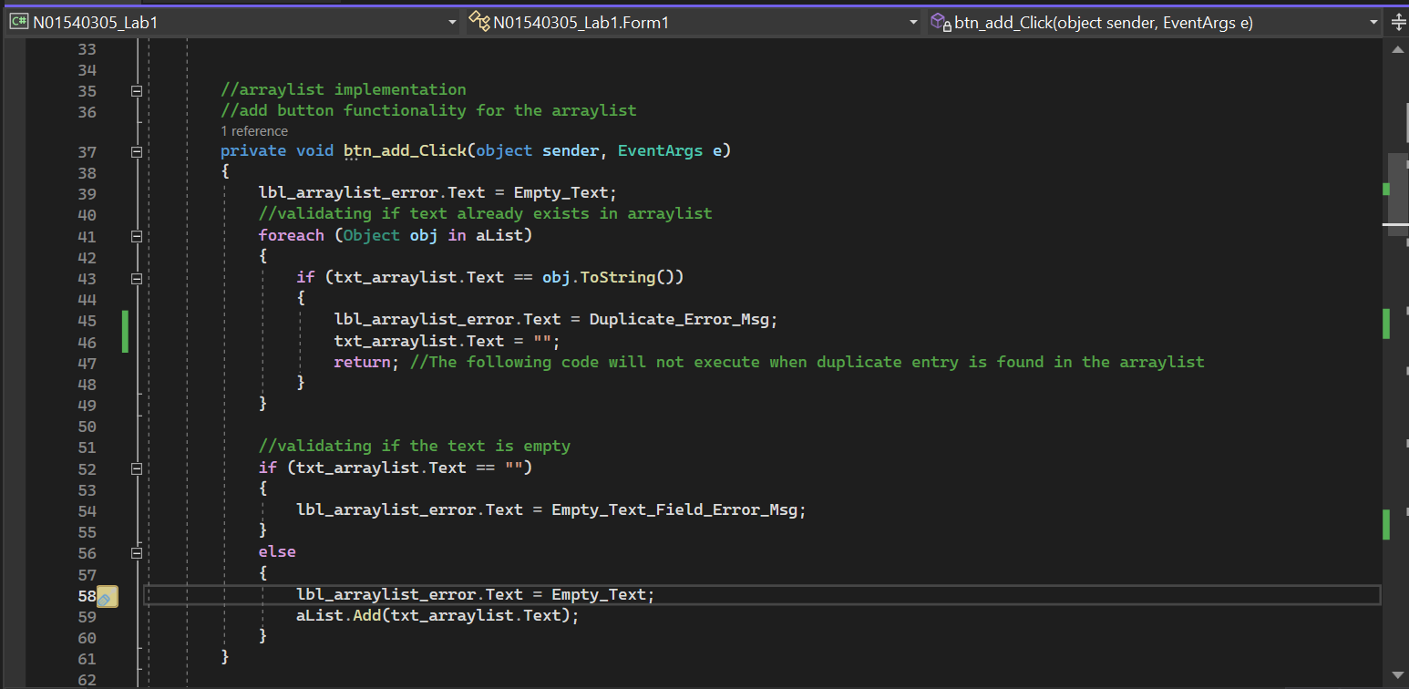

Code execution:

Trying to add empty string, results in an error:

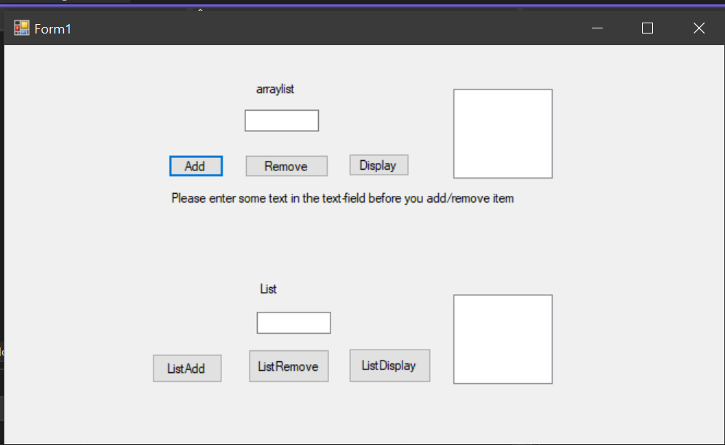

New text enters successfully:

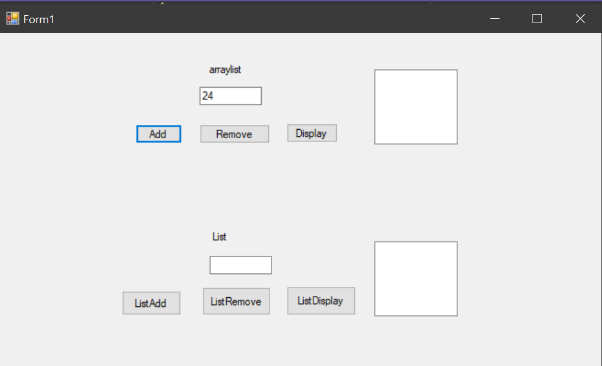

Does not accept repetitive text:

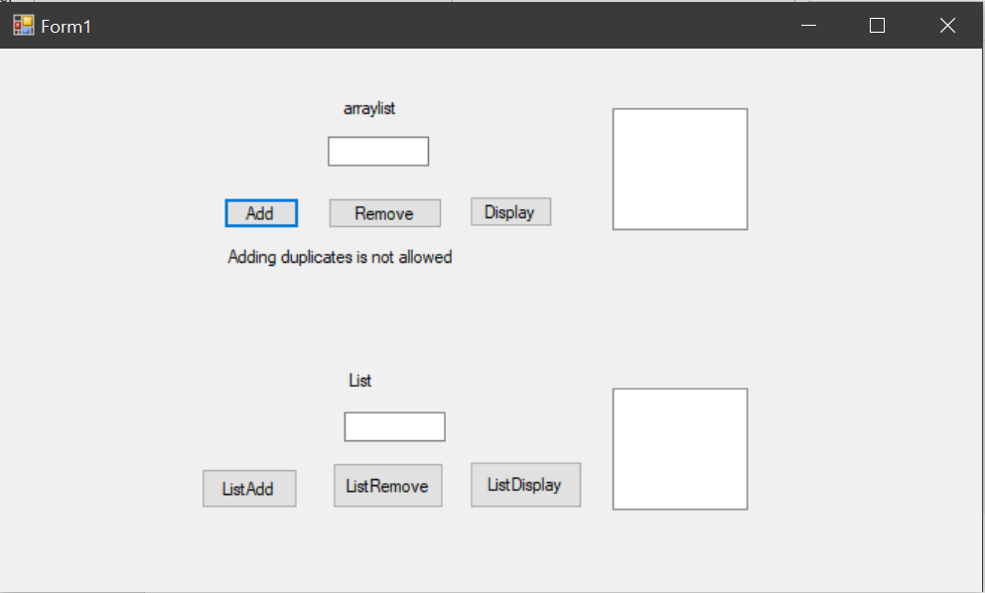

ArrayList remove functionality:

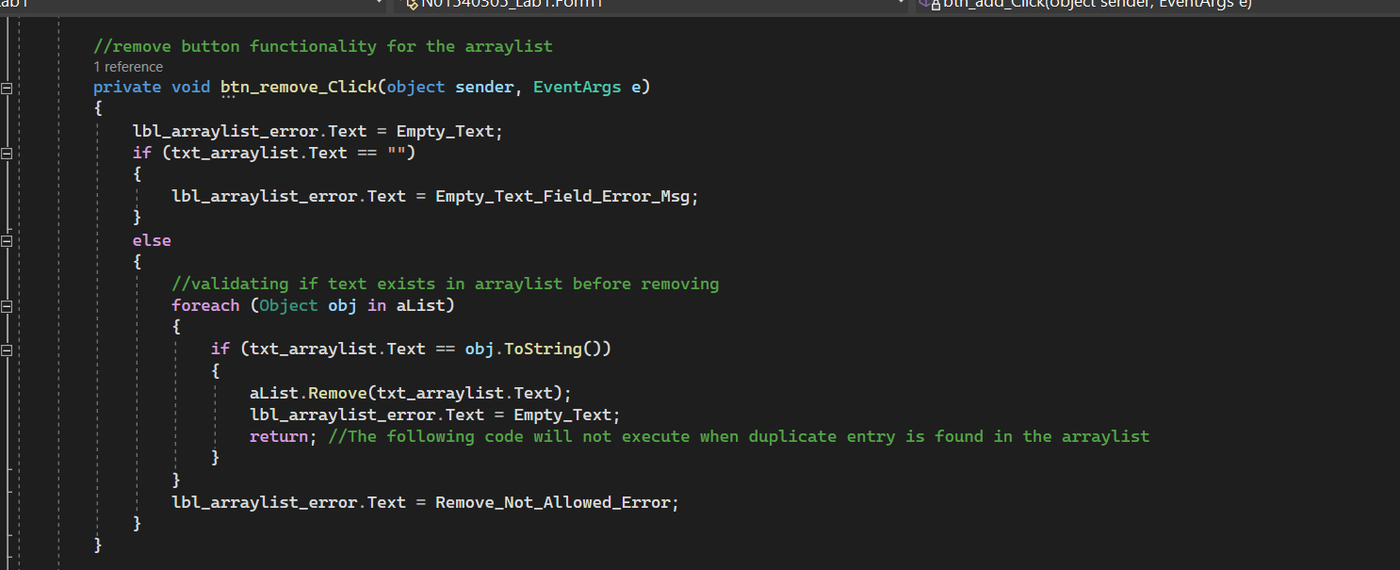

Remove throws error if text field is empty:

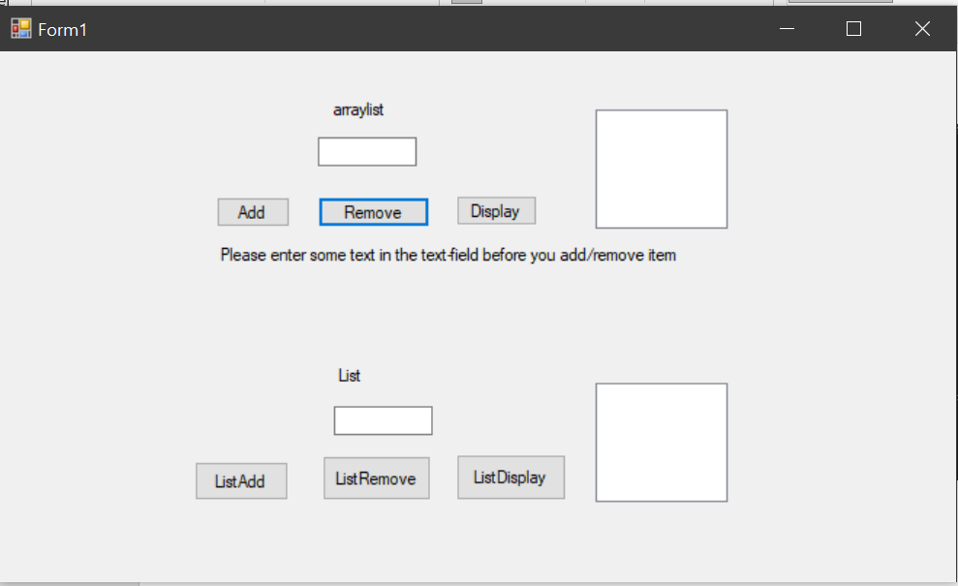

Remove will only remove if object is found in arraylist, otherwise it will throw an error:

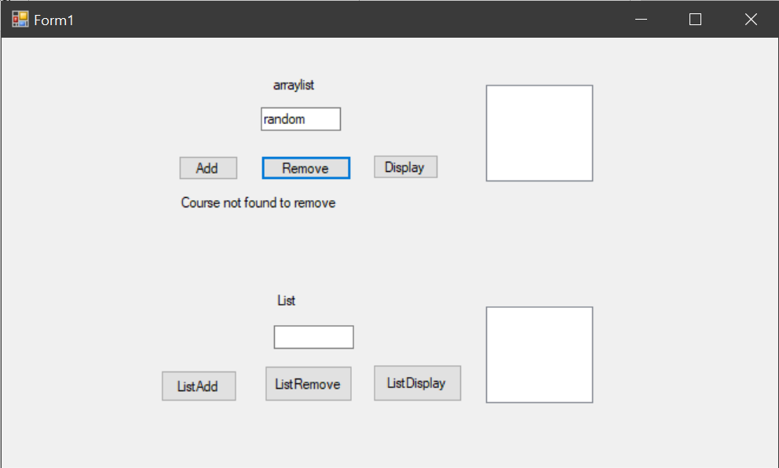

Arraylist display operation:

Code:

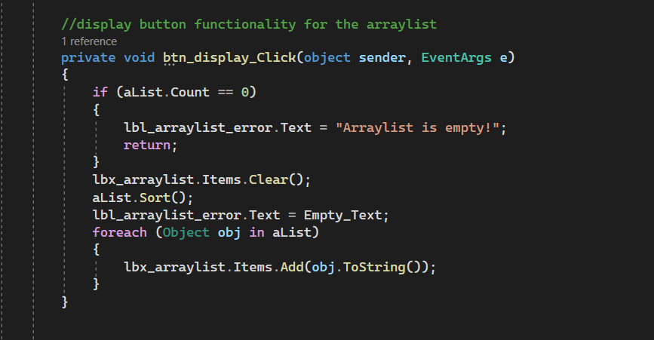

Sorted display:

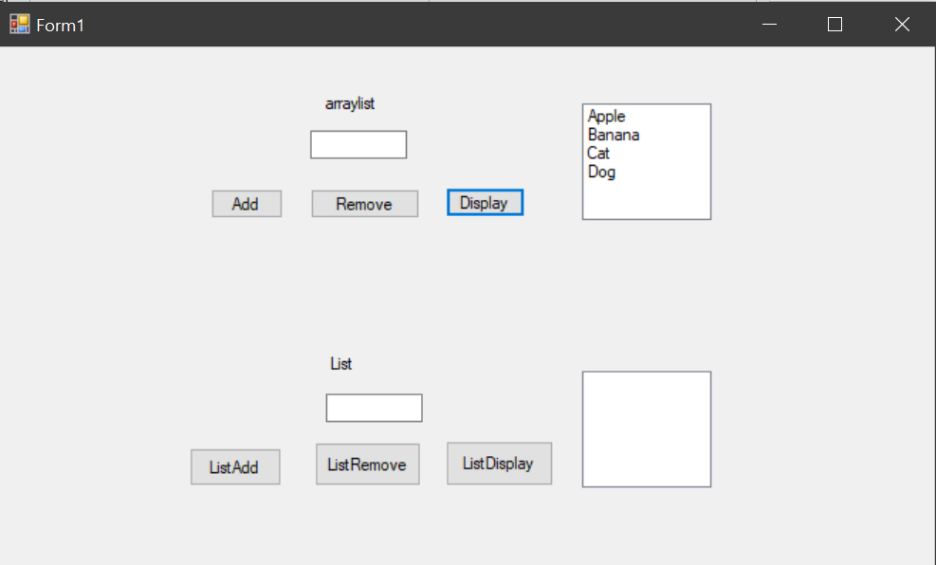

Similar things are expected in the list

Code snippets of add, remove and display are as follows:

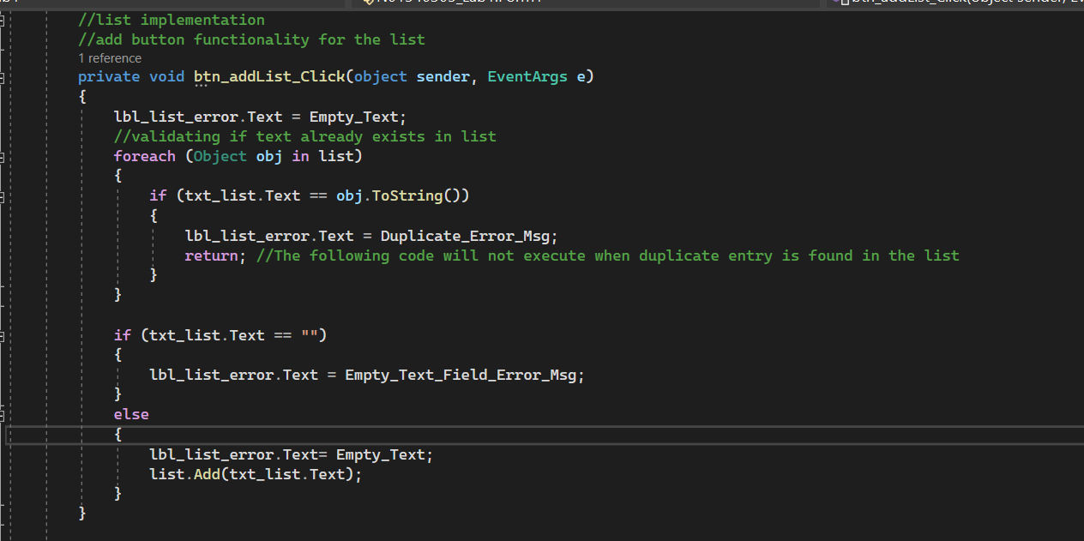

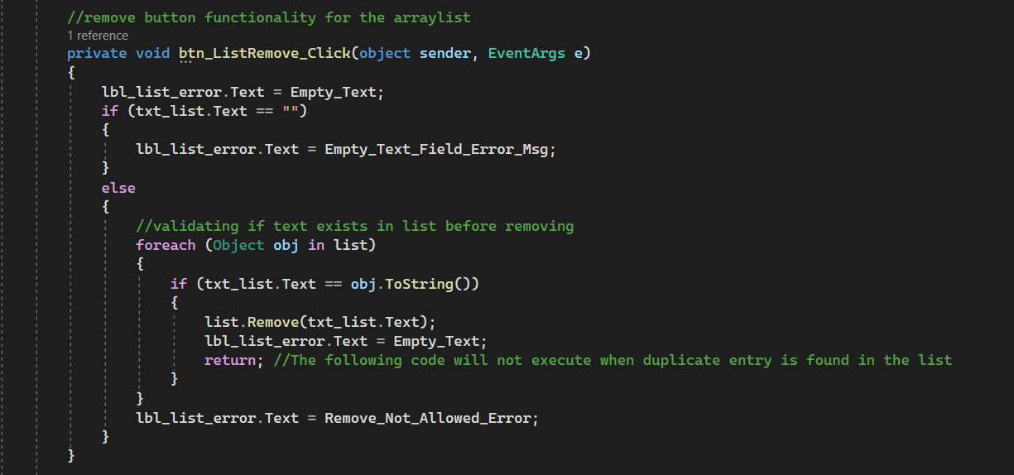

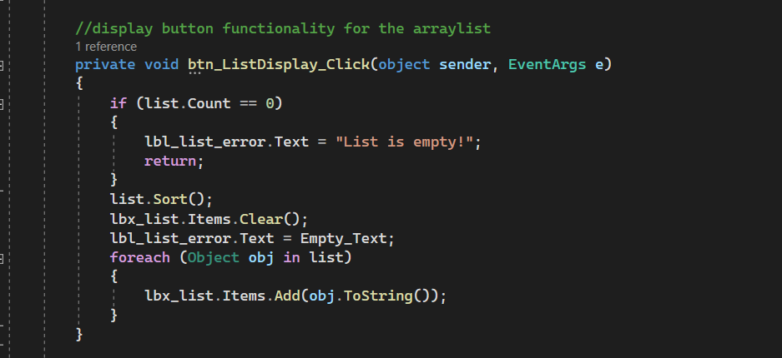

Execution is almost similar to arraylist