Cover Sheet for Coursework

Surname (in CAPITALS): GREEN
First name (in CAPITALS): JAYLA
Email ID: JG574

I acknowledge that this is an assessed piece of coursework. I have completed the Academic Integrity training course ADX178 on Blackboard and understand the University’s policy on plagiarism:
https://le.ac.uk/policies/regulations/senate-regulations/senate-regulation-11/academic

I hereby declare that all work submitted is my own and has been created solely by me, except where clearly stated otherwise within the text

Date: 11/01/2026 Signature: J GREEN

Please give a summary of your submission in the table below:

Category: Web Application (Web Application / Mobile iOS App / Android App)
Your choice of language and framework: JavaScript (React frontend, Node.js/Express backend with Firebase services)

Section | Sub-tasks | A: achieved  P: partially implemented  N: not attempt
Task 1  Voter | register | A
Task 1  Voter | login | A
Task 1  Voter | voter page | A
Task 1  Election Commission | login | A
Task 1  Election Commission | create and manage referendum | A
Task 1  Election Commission | visualise results | B
Task 2  REST API | 2.1 | A
Task 2  REST API | 2.2 | A
Bonus

Note: You are not required to implement every feature listed in the functional specification. However, you are encouraged to complete as much as possible. Your coursework will be assessed based on factors such as complexity, functionality quality, and the overall effort demonstrated.

Please attach at least TWO screenshots below:

Voter dashboard
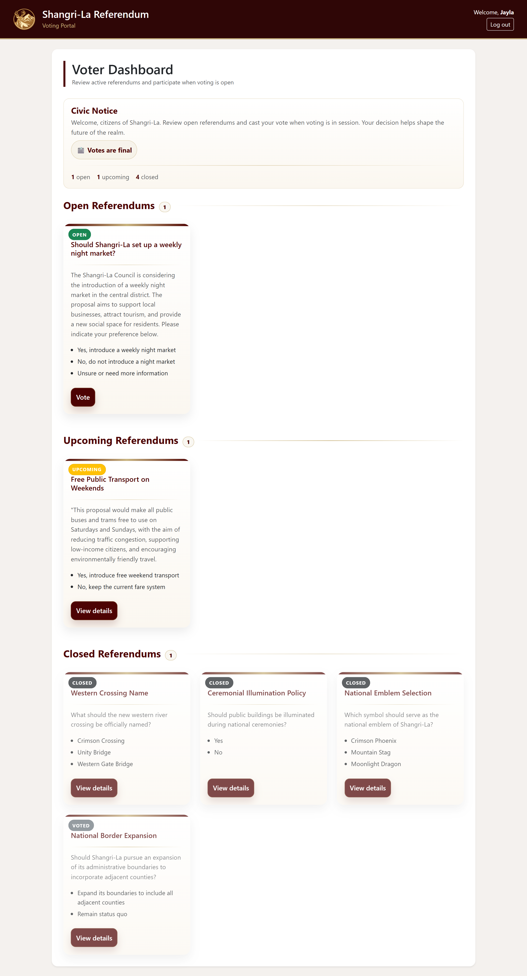

Election Commission dashboard
