Mood Board

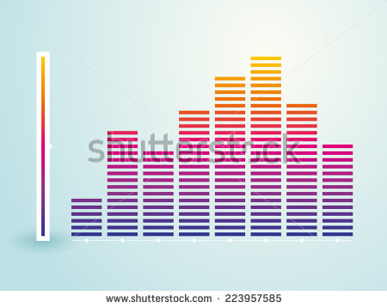

The bar graph inspired the bar graph structure in my production and the colors inspired a way of separation by attributes besides the bars themselves.

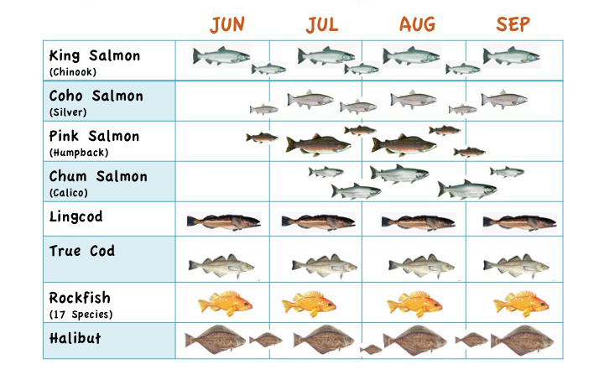

This graph inspired a horizontal layout of the information because of how many data points must be displayed. In order to make them all fit they must be displayed this way.

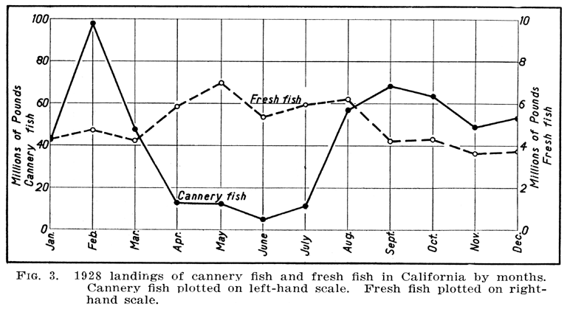

This graph inspired the overlapping technique for the platform graph.

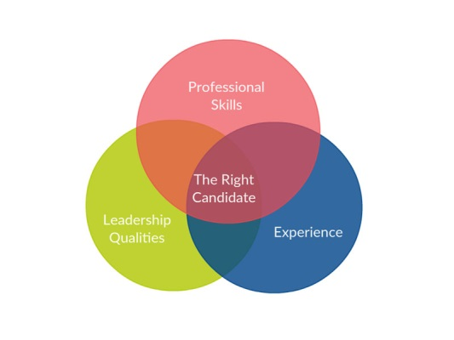

After looking at the ven-diagram I knew I had too many data points to use this graph successfully but it influenced the way I grouped items in the data set.

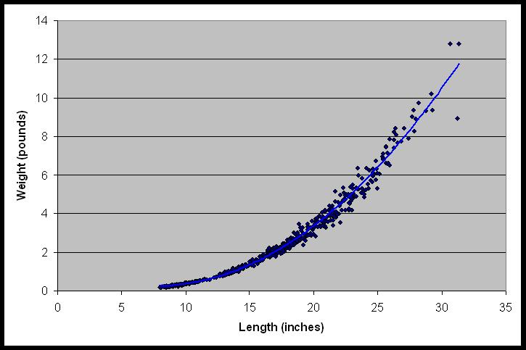

This graphs clearly ascending and descending characteristics

Influenced the way I graphed the APR for the data set.

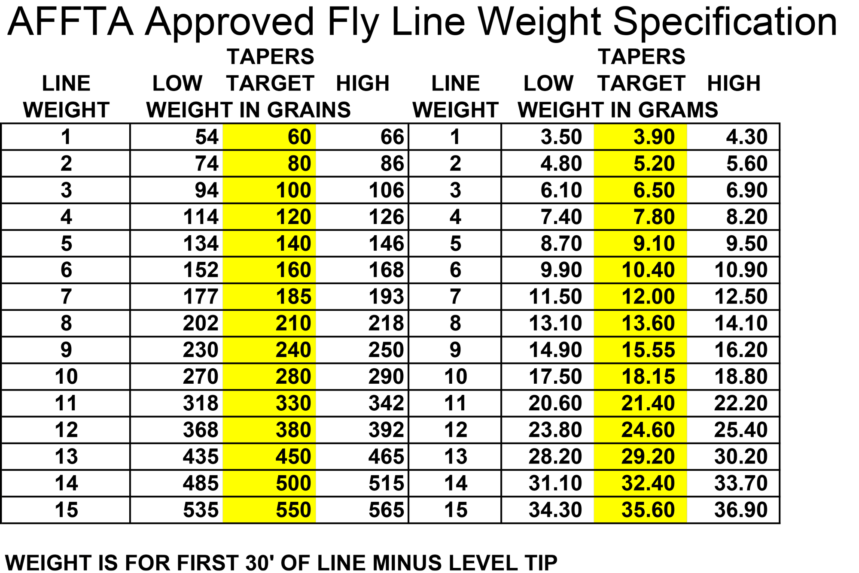

This graph showed me how too much data and not enough lines will make for a confusing make of a graph so I made sure not to use too many numbers to represent data in the graph

Sketches

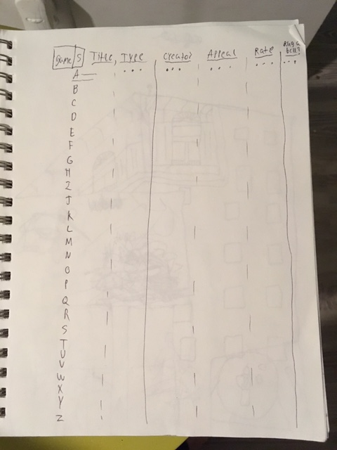

My first vertical horizontal sketch for visualizing data.

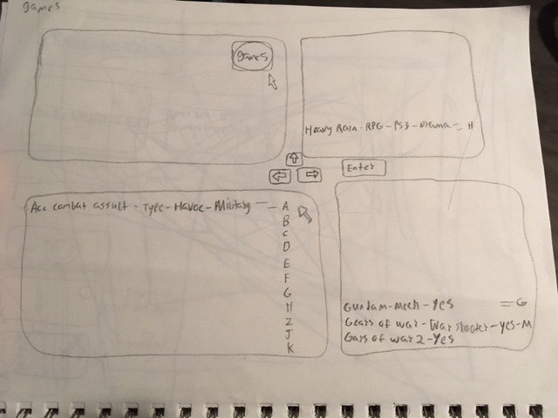

A more in depth program for visualizing data. I abandoned this program once I was informed that the program need not be so advanced to read input strings of data from the user.

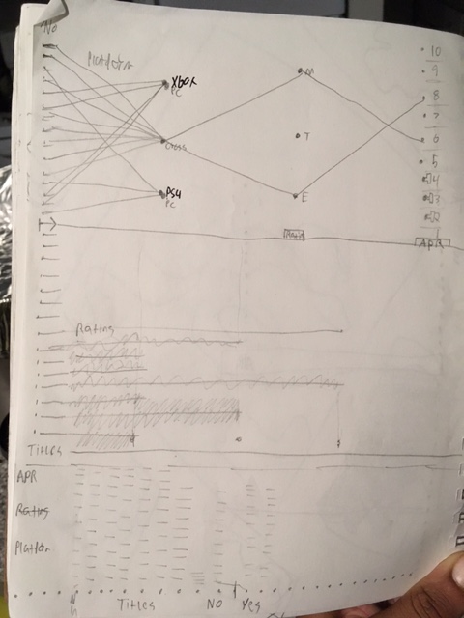

My final three versions of graphs that I would use to represent data Platform, APR, and Rating.

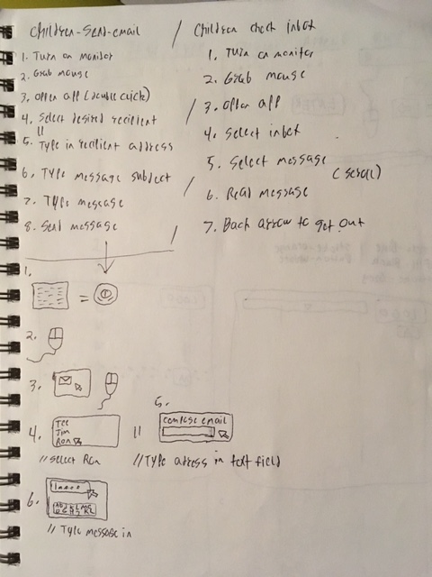

My first steps in data visualization and how I would do it. More of an algorithm for walking someone through how to do something. In this case it was emails. I realized an effective graph shouldn’t need instructions on how to read it.

Screenshots of Final Program

