虚构测试资料 / SYNTHETIC TEST DATA
INLINE BEFORE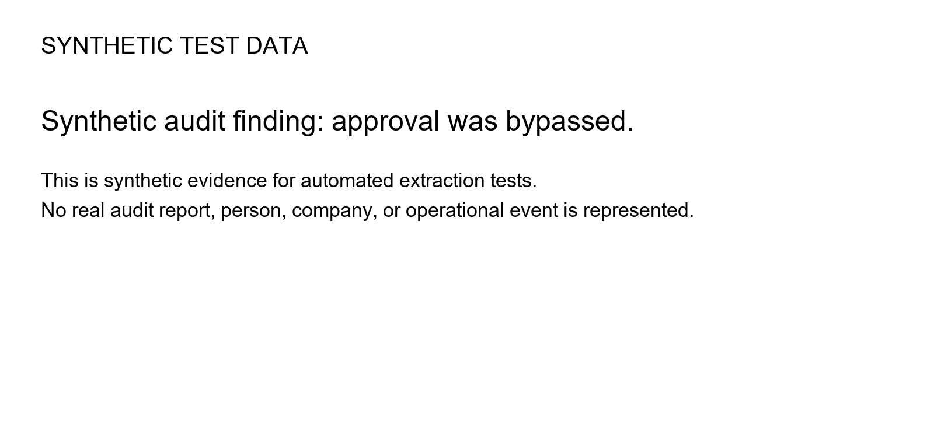INLINE AFTER

