虚构测试资料 / SYNTHETIC TEST DATA
Synthetic opening paragraph before the embedded finding.
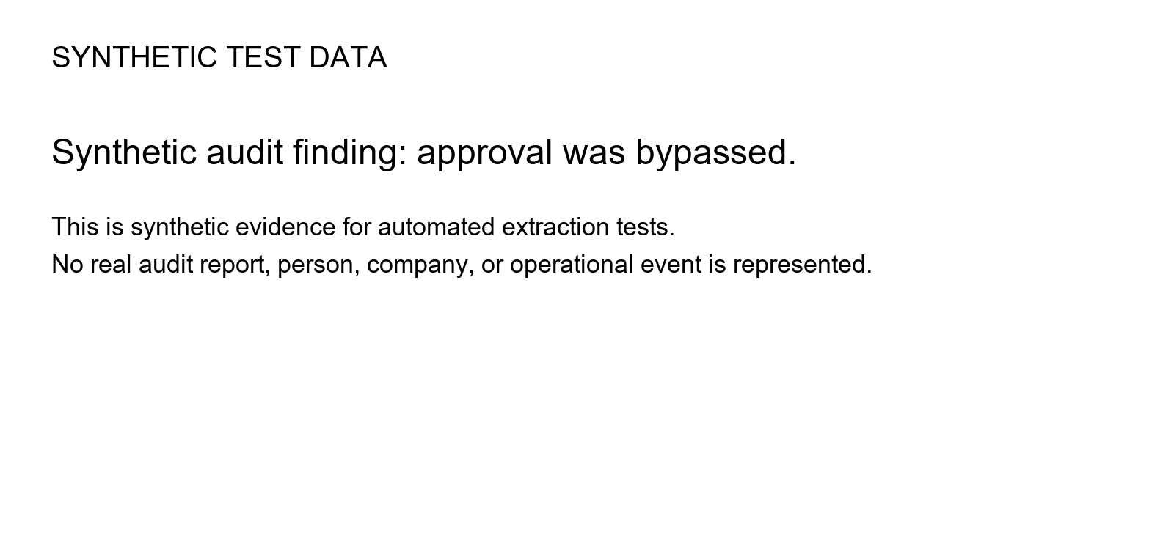
Synthetic closing paragraph after the embedded finding.

