虚构测试资料 / SYNTHETIC TEST DATA
CELL BEFORE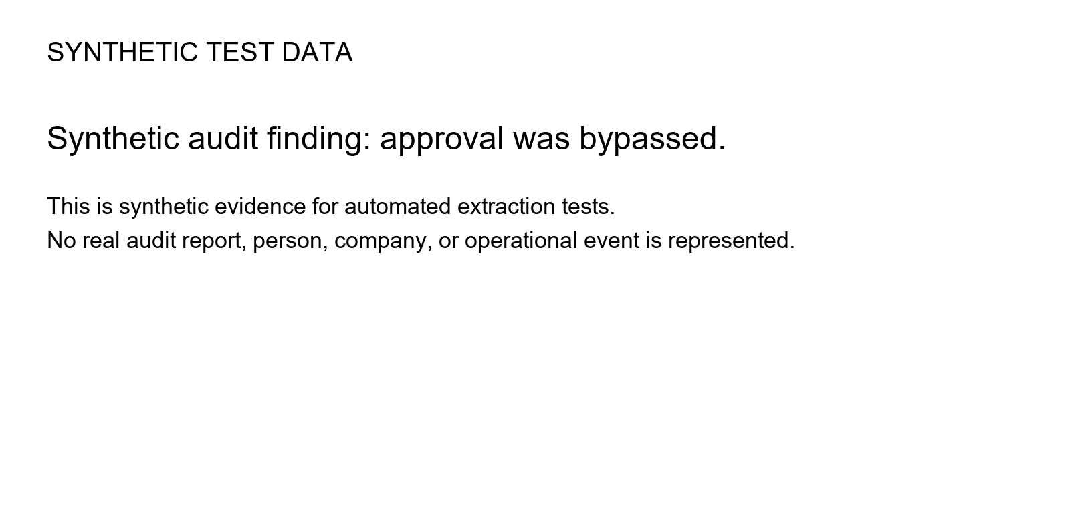CELL AFTER | SECOND CELL

