**Instructions for IGME-119 Platformer**

**By Jonathan So**

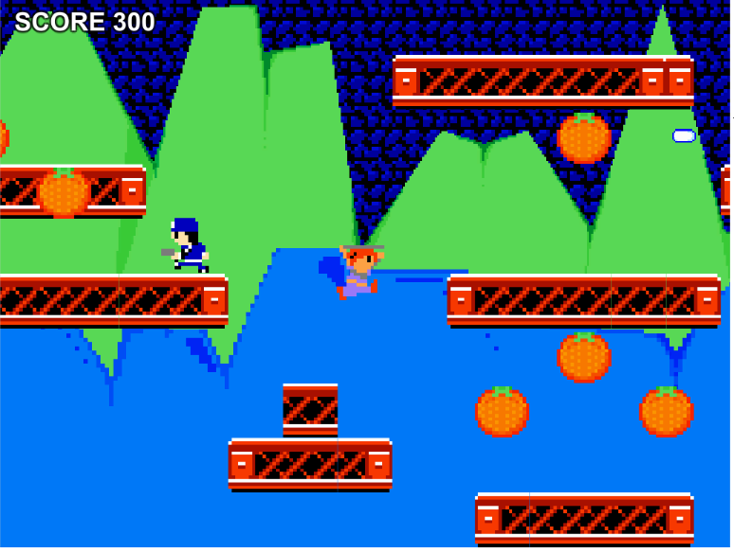

Playable Preview Here: <https://jonathan-so.itch.io/igme-119-platformer>

GitHub Link: <https://github.com/jon101514/IGME-119-Platformer>

**Introductory Notes**

Welcome to IGME-119, 2D Animation and Asset Production! Over the semester, you will be creating graphics for game sprites, UI elements, and even your own cutscene to replace the default ones found in this Unity project. If you wish to add your own gameplay-related personal touches to your copy of the game, I’ve developed tools in-engine which allow you to modify gameplay without programming knowledge.

Please use **Unity 5.6.0f3** for this project; this is the version used in the classroom for other courses in the department. Opening this project with other versions of Unity (especially older ones) may result in errors.

Thank you very much to **Prof. Elouise Oyzon** for affording me this opportunity to create a tool and game that can be helpful to the students. Thank you to **Dan Giaime** for creating the previous version of this project and for the cutscene placeholder video. Thank you to **Prof. Wyllona Harris and Prof. Sten McKinzie** for providing helpful feedback and feature suggestions, and for letting this piece of software into their classrooms.

**Importing Sprites**

Enclosed in the Sprites folder (IGME-119 Platformer > Assets > Sprites), you will find multiple images that will be overwritten by your artwork. For the UI elements, background, and two parallax layers, **saving your graphics in place of the file** is fine; however, the objects displayed during gameplay, such as collectibles, NPCs, etc., require a different solution.

All of the gameplay sprites are stored in a spritesheet, and Active_Sheet.png is the spritesheet currently being used by Unity to display all of the objects during gameplay; the engine pulls graphics from that sheet and places them into the game with carefully-calculated bounding boxes created for every sprite. To make sure that your own sprites make it into the game without any errors, I have created Blank_Sheet.png, which is a guideline that displays proper sprite positions and resolutions on the sheet.

I suggest that in a graphics editor, you work on your sprites on a layer above Blank_Sheet.png and, when completed, save the whole file over Completed_Sheet. The layer containing none of the guidelines and only the sprites should be saved as Active_Sheet, and once you have saved over Active_Sheet, your sprites should be in the game if you view it in the Unity Editor.

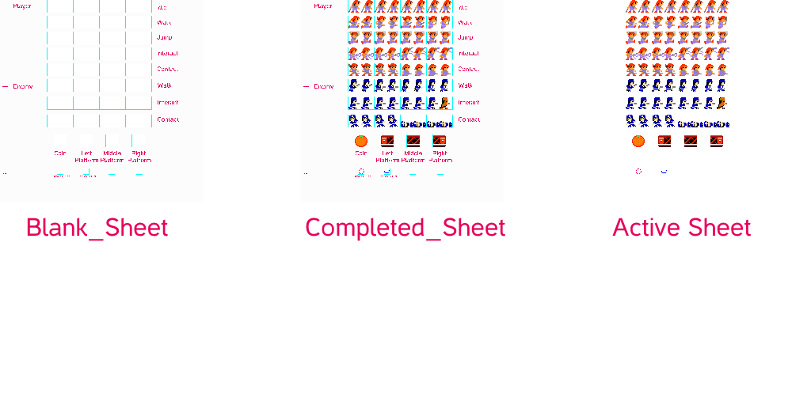

**Please ensure that your artwork is the same resolution as the file you’re saving it over to avoid problems.**

**Importing the Cutscene**

In this course, you will create a cutscene which plays before gameplay begins. To override the cutscene placeholder video, I suggest uploading your cutscene to YouTube and downloading it with a website, then saving the output from that website over Cutscene.mov. I have tested this method with y2mate.com, pickvideo.net, and keepvid.com, which all work for getting a file playable by Unity’s video player without error.

**Adding Personal Touches to the Game**

Normal

In the Hierarchy, clicking on the Player Manager, NPC Manager, or Level Manager will display in the Inspector variables which you may change. For example, selecting the **Player Manager** allows you to determine whether or not the player will disappear on contact with an NPC, if they will have knockback on contact with an NPC, their interaction style (shooter or melee-style interaction), and even the controls of the game.

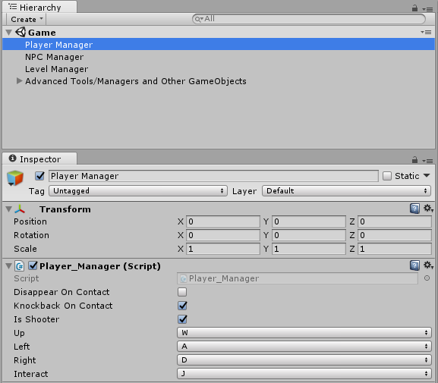

The **NPC Manager** handles every NPC in the game, and you may control whether or not they disappear upon contact with the player’s interaction, whether or not to have knockback, if they stop to perform their interaction, if they know how to avoid falling off platforms, if they perform shooting or melee-based interaction, and even adjust the amount of knockback they have.

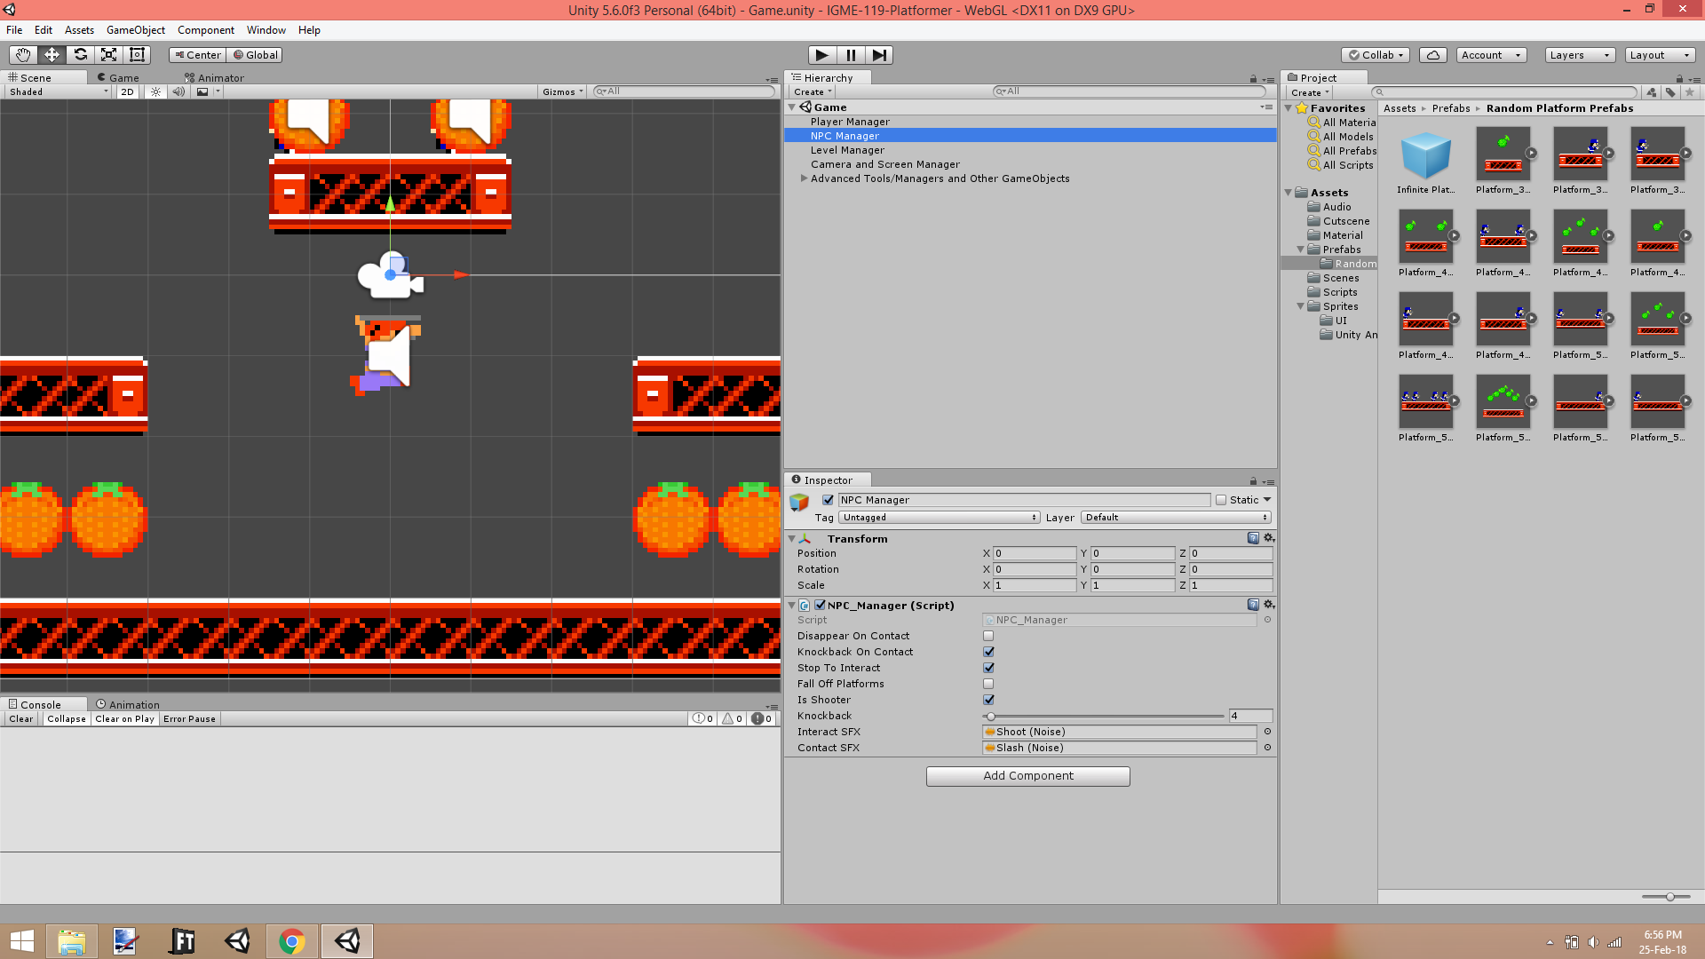

The **Level Manager** determines what kind of level is played. If LevelWillScroll is checked, then the level will scroll instead of being a fixed camera. If LevelIsInfiniteAutoScroller, then this overrides all other variables in the manager and procedurally generates an infinitely scrolling level. If ProcedurallyGenerateLevel, then it erases the level architecture built by hand and the computer creates a level randomly. If ProceduralLevelHasBottomPlatform, then the player may not lose the game by falling off platforms because a platform at the bottom prevents them from doing so. LevelHasNoCoins will remove all collectible objects from the level. Finally, the ScrollingLevelSize is the width of a scrolling level, assuming the level does not scroll.

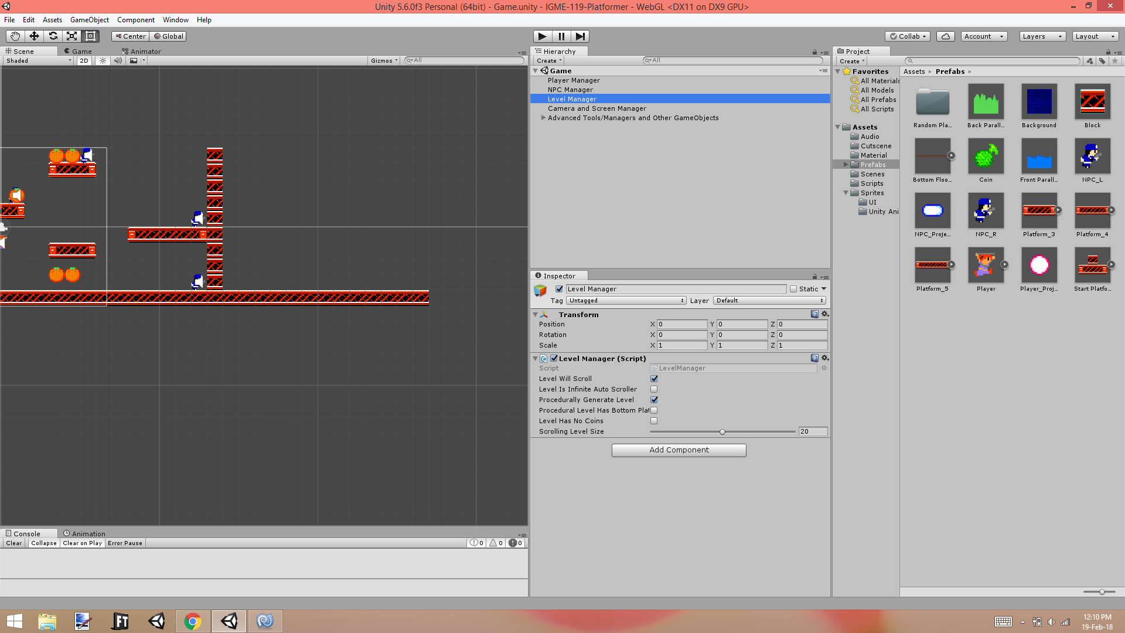

The **Camera and Screen Manager** handles camera-based special effects that play during the game, and you may control whether or not both the player and NPCs trigger screen shaking and screen flashing upon the contact event. Shake time is the time in seconds that the screen shake effect lasts, shake magnitude is the magnitude at which the screen shakes, and flash frames is the number of frames that the screen flash will last.

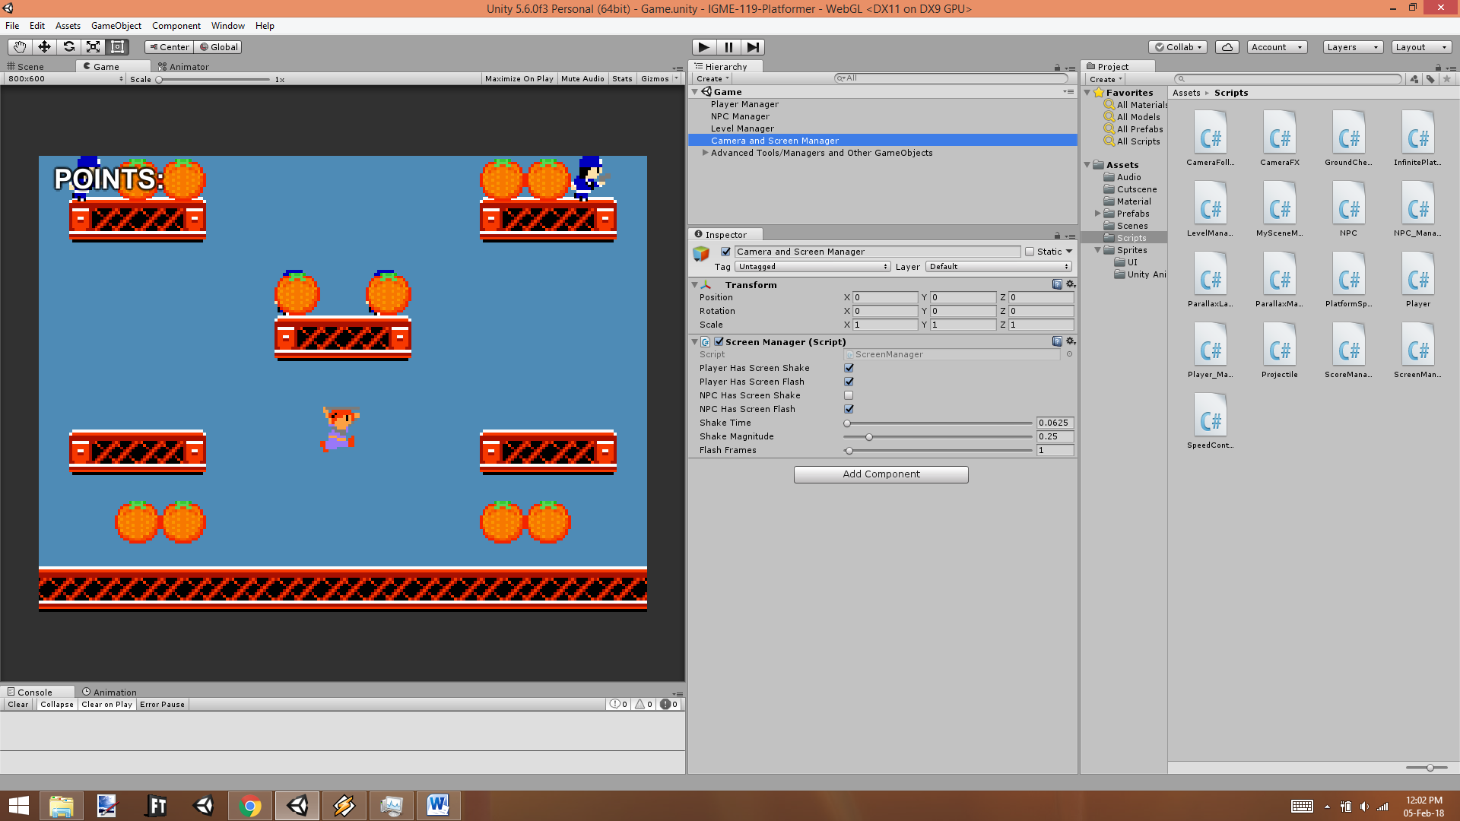

Advanced

Every object’s behavior in the game, from the player character to the level, is handled via **scripts**. Scripts are code files which dictate how these objects move, make sound, react to keyboard input, and more, and **you can modify them** if you want to add a personal touch to your copy of the game. Just head over to the Scripts folder in the Project tab and double-click on the script you want to change; I have provided detailed documentation on the code I have written. **If you make a mistake in programming and want to revert your project back to its original state, *backup your work* and download the original Unity project at the GitHub link.**

Modifying the User Interface Layout

All scenes in this project have some form of UI element, usually in the form of buttons. These UI elements are always children of the Canvas object, and you can change their positions by changing their Rect Transform components. If you wish to modify the layout of the game’s user interface, I suggest watching the following official Unity tutorial:

<https://unity3d.com/learn/tutorials/modules/beginner/ui/rect-transform?playlist=17111>

Applying the skills from the above tutorial, you can change the buttons’ positions from the default (left) to suit your own personal design (right).

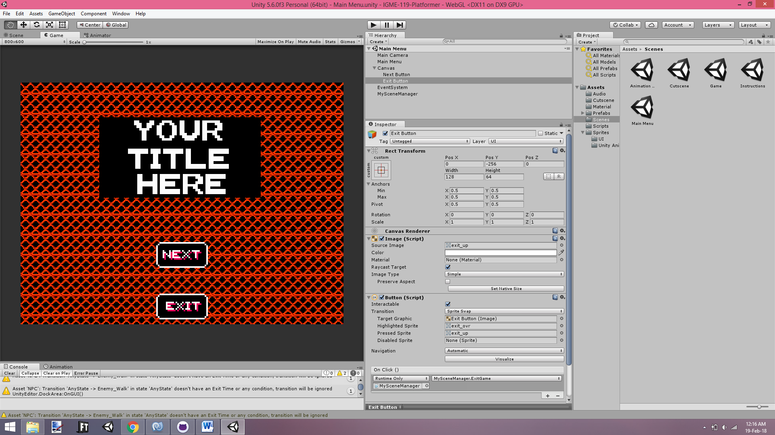 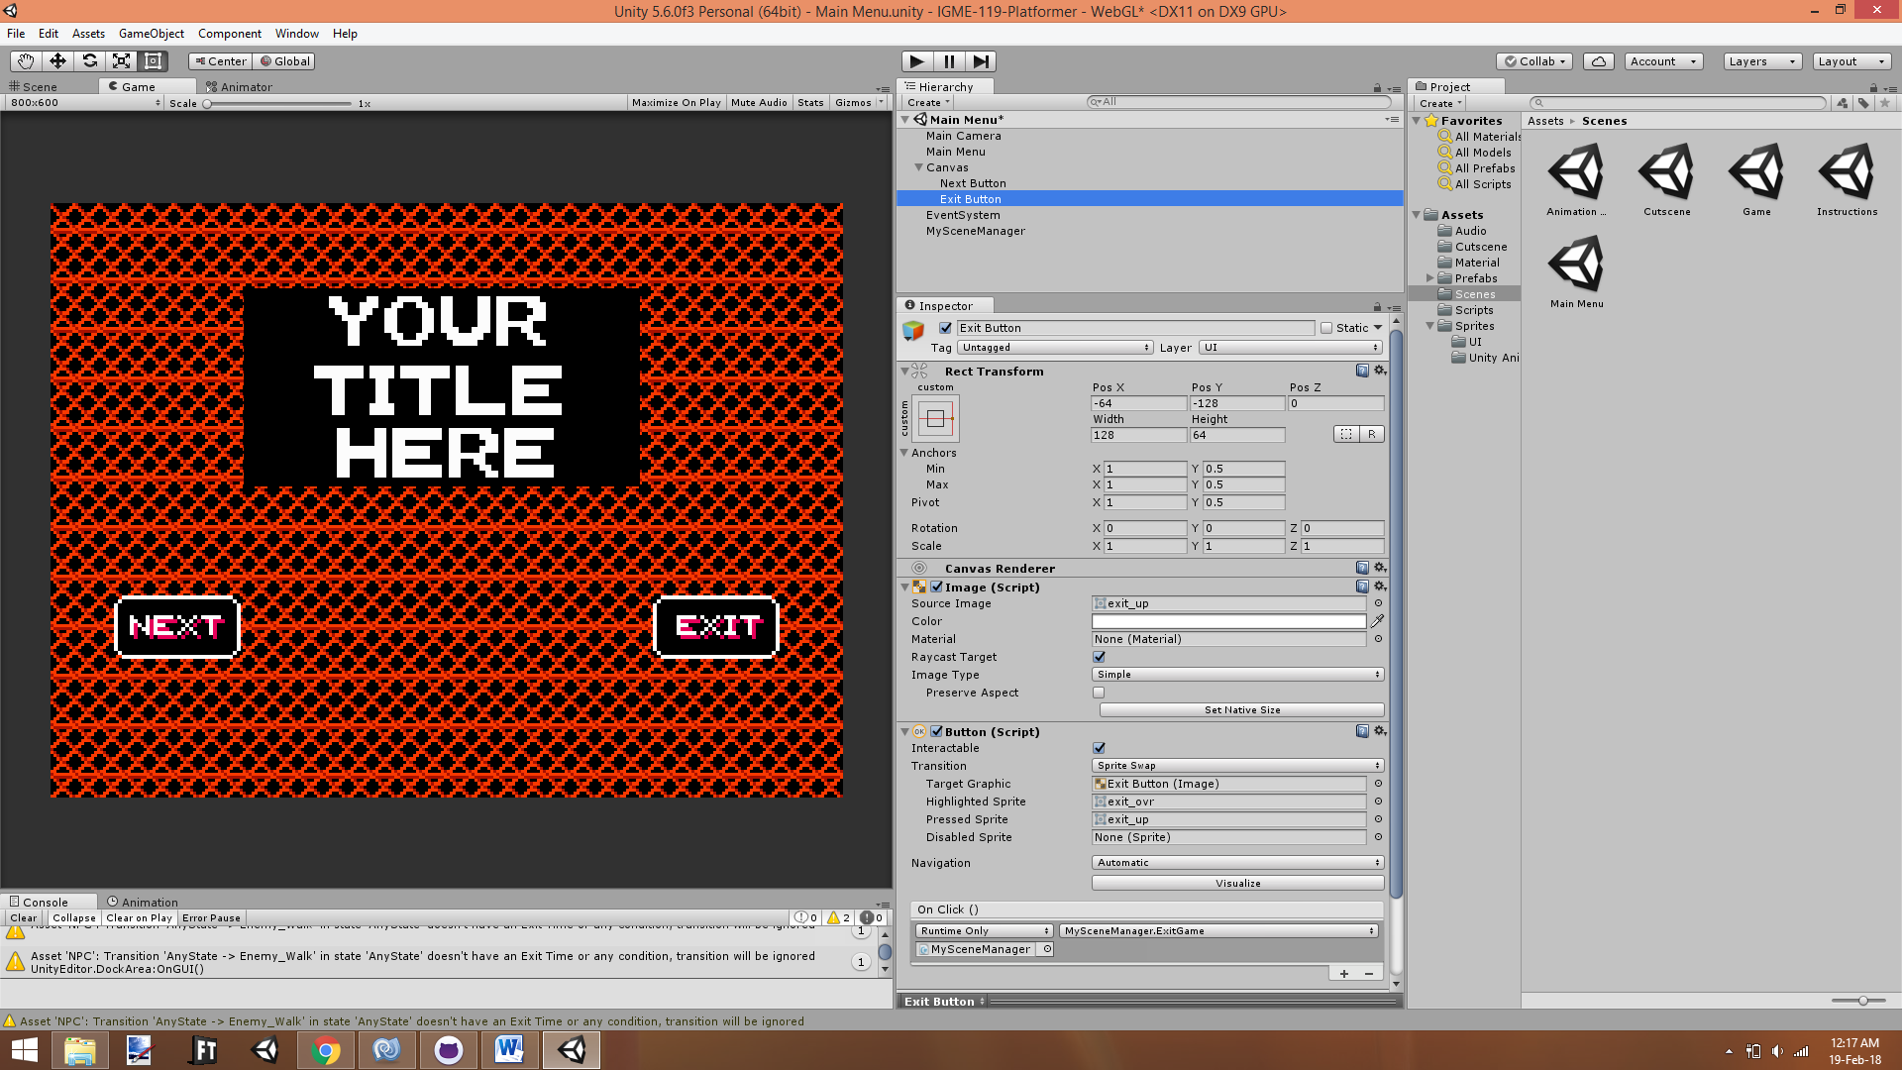

**Troubleshooting**

Checking Your Animations

Want to preview all available animations in the game? In the Scenes folder of the project, open the scene labeled “Animation Test,” where you can play every animation of every game character, and even adjust the speed at which they play (in this scene only). This may be useful for fine-tuning details in each of your animations.

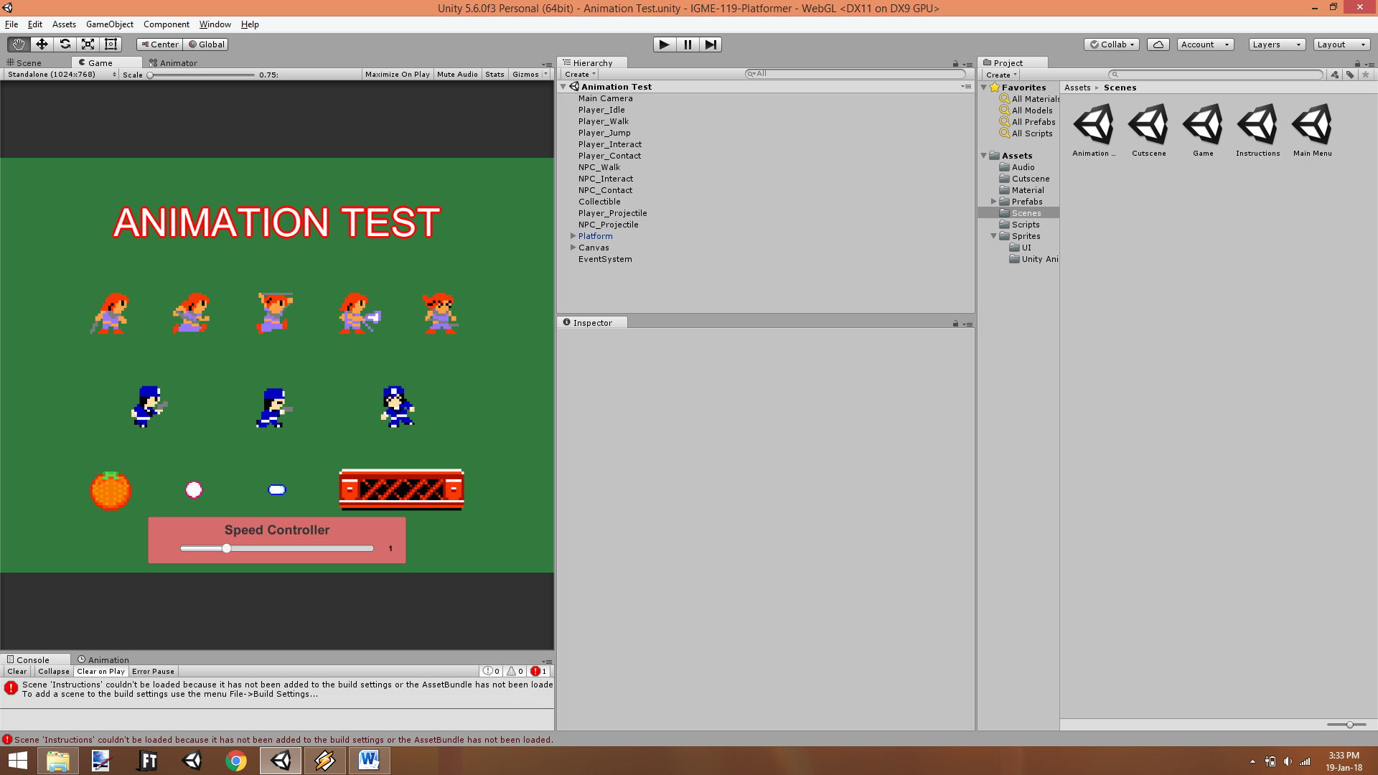

The Build Settings Error and How to Fix It

If you’re downloading this project from GitHub, you might come across this issue upon changing scenes:

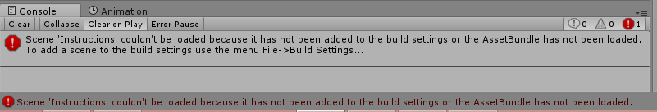

This issue is occurring because **the Build Settings do not include a scene the program is trying to load.** You can fix this by modifying the Build Settings; follow these steps:

1. In the Unity Editor, **open the Build Settings** (Ctrl + Shift + B)

2. The Build Settings window should pop up. We’re going to make sure that Scenes In Build contains **all scenes in the project.**

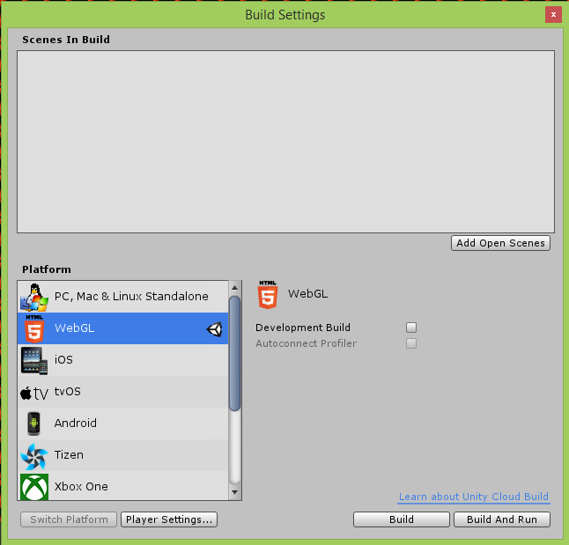

3. In the Project window, **drag all of the scenes (except “Animation Test”) in the Scenes folder into the Scenes In Build space, and ensure that the Main Menu is the first.** If your Build Settings look similar to the ones in the picture, the program should run smoothly.

