Software Requirements and Design Document

For

Group <Lease Up Noles>

Version 1.0

Authors:
Jaylon Coad
Andrea Miranda
Pedro De Lana
Caleb Joseph
Jonathan Norton

Overview (5 points)
Lease Up Noles is a web application that brings the off-campus housing search for Florida State University students in Tallahassee into one place. Users can browse and filter listings by monthly price, number of bedrooms, and straight-line distance to campus, sort the results by price, distance, or average review rating, and open a detail page for each listing that shows its price, address, amenities, distance to campus, and average rating. Each listing also shows reviews written by other students who have lived there, and registered students can add their own star rating and comment. Distance to campus is calculated once for each listing and stored, instead of being looked up live, which keeps the app free to run.
Students looking for housing near FSU currently have to piece together price, location, and word-of-mouth information from general listing sites, Facebook groups, and the university’s own housing site, and none of these combines price, real distance to campus, and honest student reviews. The app has three kinds of users: Guests, who can browse listings and read reviews; Registered students, who can also submit reviews; and Admins, who can add, edit, and remove listings and moderate reviews. The system is built with Next.js (React and TypeScript) and deployed on Vercel, with Supabase (PostgreSQL, authentication, and row-level security) as the back end. Saving and comparing listings, a map view, and driving or walking distances are planned as stretch features once the core app works end to end.

Functional Requirements (10 points)
Each requirement below describes something the system shall do. Requirements are numbered FR1 to FR11 to match the feature list in the project proposal and the feature issues in the GitHub issue tracker. FR1 to FR7 are core requirements for the first complete release. FR8 to FR11 are stretch requirements that will be started only after the core requirements work end to end. A priority is given for each numbered requirement and applies to all of its sub-requirements: High means the app is not usable or demonstrable without it, Medium means it is expected in the finished app but is not needed for a first demo, and Low means it is optional.
Three kinds of user are referred to throughout. A Guest is a visitor who is not logged in. A Registered student is a logged-in user with the role “student”. An Admin is a logged-in user with the role “admin”. A Registered student can do everything a Guest can do, and an Admin can do everything a Registered student can do.
Core requirements

FR1: Search and filter listings (Priority: High)
FR1.1 The system shall display a browse page that lists every listing in the system to all users, including Guests, without requiring login.
FR1.2 The system shall let the user filter the listings by monthly price by setting a minimum price, a maximum price, or both, in US dollars. A limit that is not set shall mean no limit. If the minimum price is greater than the maximum price, the system shall treat the two values as swapped.
FR1.3 The system shall let the user filter the listings by number of bedrooms, choosing one or more of Studio, 1, 2, 3, and 4 or more. The listings shown shall be those that match any of the chosen options.
FR1.4 The system shall let the user filter the listings by a maximum distance to campus, in miles. A limit that is not set shall mean no limit.
FR1.5 When more than one filter is set, the system shall show only the listings that satisfy all of them. A filter that is not set shall not exclude any listing.
FR1.6 Each listing in the results shall show its name, monthly price, address, number of bedrooms, distance to campus, and amenities, and shall link to that listing’s detail page (FR3).
FR1.7 The system shall show how many listings match the current filters. When no listing matches, the system shall display a message saying so instead of an empty page.
FR1.8 The system shall provide a control that clears all filters and shows every listing again.
FR1.9 The system shall ignore any filter value that is not valid, such as non-numeric text or a negative number, and shall continue to display results without an error.
Rationale: Search by price, bedrooms, and distance is the main reason students would use the app, so it is the most visible core feature. Keeping the filter values in the page address (so a filtered search can be shared) is a design choice and is not required here.

FR2: Sort search results (Priority: Medium)
FR2.1 The system shall let the user sort the listing results by price, by distance to campus, or by average review rating.
FR2.2 The system shall sort by price from lowest to highest, by distance from closest to farthest, and by average review rating from highest to lowest. When the user has not chosen a sort, the system shall list the results by price from lowest to highest.
FR2.3 Sorting shall apply to the results of the current filters and shall not clear or change them.
FR2.4 When sorting by average review rating, listings that have no reviews shall appear after all listings that have a rating.
FR2.5 Listings that are equal on the chosen sort shall be ordered by price, and then by name, so that the order of any two listings does not change when filters are applied.
Rationale: Students compare options by what matters to them most (cost, commute, or reputation), so results need to be reorderable. Unrated listings are placed last so that a missing rating is never treated as a low or high one.

FR3: Listing detail page (Priority: High)
FR3.1 The system shall provide a detail page for each listing, available to all users including Guests, and reachable from the listing’s entry in the browse results.
FR3.2 The detail page shall show the listing’s name, monthly price, number of bedrooms, address, amenities, distance to campus, and average review rating together with the number of reviews it is based on.
FR3.3 When a listing has no reviews, the detail page shall say so instead of showing a rating.
FR3.4 When a user requests the detail page of a listing that does not exist, the system shall show a not-found message and a way back to the browse page.
Rationale: The detail page is where a student decides whether a listing is worth pursuing, so everything stored about the listing that matters for that decision appears in one place.

FR4: View reviews (Priority: High)
FR4.1 The detail page shall list all reviews that have been submitted for that listing, and shall make them visible to all users including Guests.
FR4.2 Each review shall show its star rating from 1 to 5, its comment text, the date it was submitted, and the display name of the student who wrote it.
FR4.3 Reviews shall be listed with the most recent first.
FR4.4 The average rating of a listing shall be the mean of the star ratings of all its reviews, shown to one decimal place, and shall be updated whenever a review is added or removed.
Rationale: Honest reviews from students who have lived in a place are the feature that separates this app from existing listing sites, so they must be readable without an account.

FR5: Accounts and review submission (Priority: High)
FR5.1 The system shall let a visitor create an account by providing an email address, a password, and a display name.
FR5.2 The system shall let a user with an account log in with their email address and password and log out. A wrong email address or password shall produce an error message and shall not log the user in. The system shall make it clear whether the current user is logged in.
FR5.3 Every newly created account shall automatically be given the role Registered student.
FR5.4 The system shall allow only logged-in users to submit a review. When a Guest tries to submit a review, the system shall ask them to log in or sign up.
FR5.5 A review shall consist of a star rating that is a whole number from 1 to 5 and a text comment of at most 1,000 characters. Both parts are required.
FR5.6 The system shall reject a review whose rating is missing or outside 1 to 5, or whose comment is empty or too long, and shall tell the user what must be corrected.
FR5.7 The system shall allow each user to submit at most one review per listing.
FR5.8 After a review is submitted successfully, it shall appear on the listing’s detail page and be included in the listing’s average rating (FR4.4).
Rationale: Requiring an account for reviews limits spam and anonymous abuse. Accounts are included here because submitting reviews, saving listings (FR8), and the Admin functions (FR7) all depend on them.

FR6: Distance to campus (Priority: High)
FR6.1 The system shall calculate the straight-line distance, in miles, between a listing’s latitude and longitude and a fixed campus reference point, using the Haversine formula with an Earth radius of 3,958.7613 miles.
FR6.2 The campus reference point shall be Westcott Fountain on the FSU campus, at latitude 30.44072 and longitude −84.29115, and shall be the same for every listing.
FR6.3 The system shall calculate a listing’s distance when the listing is created and again only if its latitude or longitude changes. The result shall be stored with the listing, and the system shall not recalculate it when listings are browsed, filtered, or sorted.
FR6.4 The stored distance shall be set by the system. No user, including an Admin, shall be able to enter or change it directly.
FR6.5 The system shall reject a latitude outside −90 to 90 or a longitude outside −180 to 180.
FR6.6 Distances shall be displayed in miles rounded to one decimal place.
Rationale: Calculating and storing the distance once removes the need for a paid mapping service, which keeps the app free to run and avoids putting a credit card on file. Fixing the reference point in one place keeps every listing measured the same way.

FR7: Admin tools (Priority: Medium)
FR7.1 The system shall let an Admin add a new listing by entering its name, address, monthly price, number of bedrooms, amenities, latitude, and longitude. The listing’s distance to campus shall then be calculated as described in FR6.
FR7.2 The system shall let an Admin edit any of those details of an existing listing.
FR7.3 The system shall let an Admin remove a listing. A removed listing and its reviews shall no longer be shown to any user.
FR7.4 The system shall let an Admin remove any review, for example one that is spam or has no relation to the property. A removed review shall no longer be shown and shall no longer count toward the listing’s average rating.
FR7.5 The system shall prevent users who are not Admins from adding, editing, or removing listings and from removing reviews, including attempts made outside the normal pages of the app.
FR7.6 A user shall not be able to change their own role. A user shall become an Admin only when a project maintainer changes the role directly in the database.
Rationale: Listing data is entered by the team, so Admins need a way to keep it correct. Because anyone can create an account, administrative power must never be something a user can grant to themselves.
Stretch requirements (to be started only after FR1 to FR7 work end to end)

FR8: Saved listings (Stretch, Priority: Low)
FR8.1 The system shall let a Registered student save a listing to a personal list of favorites and remove it from that list.
FR8.2 The system shall provide a page where a Registered student can see all of their saved listings.
FR8.3 Saved listings shall remain saved between sessions.
FR8.4 When a Guest tries to save a listing, the system shall ask them to log in or sign up.

FR9: Side-by-side comparison (Stretch, Priority: Low)
FR9.1 The system shall let a Registered student choose two or three of their saved listings and view them side by side, showing for each its price, number of bedrooms, distance to campus, amenities, and average rating.
FR9.2 The system shall not allow a comparison of fewer than two or more than three listings.

FR10: Map view (Stretch, Priority: Low)
FR10.1 The system shall provide a map that shows a pin at the location of each listing in the current results.
FR10.2 When a user selects a pin, the system shall show that listing’s name and price and a link to its detail page.
FR10.3 The map shall also mark the campus reference point from FR6.2.

FR11: Driving and walking distance (Stretch, Priority: Low)
FR11.1 The system shall show, for each listing, the driving distance and the walking distance to campus obtained from a mapping service, in addition to the straight-line distance.
FR11.2 These distances shall be obtained once when a listing is created or its location changes, and stored, as in FR6.3.
FR11.3 If these distances are not available for a listing, the system shall show only the straight-line distance.
Rationale: Straight-line distance is a rough estimate. Real route distances are more useful to students but depend on a mapping service, so this is attempted only if it can be done without cost.

Non-functional Requirements (10 points)
Each requirement below describes a property the system shall have, rather than a feature it provides. Requirements are numbered NFR1 to NFR6 by category, and each one can be checked by a test, a review of the code or database schema, or a setting in the services the project uses. A priority is given for each category and applies to all of its sub-requirements, using the same meaning of High, Medium, and Low as in Section 2.
Most of these requirements follow from three facts about the project: students will mostly use the app on their phones, anyone can create an account, and the app must cost nothing to run.

NFR1: Usability and mobile responsiveness (Priority: High)
NFR1.1 The browse page, listing detail page, log-in page, and sign-up page shall be fully usable on a screen 375 pixels wide (the width of an iPhone SE) without any horizontal scrolling and without any text or control being cut off.
NFR1.2 The browse page shall adapt its layout to the screen width: listings shall be shown in one column on screens narrower than 640 pixels, two columns from 640 to 1,023 pixels, and three columns at 1,024 pixels and wider.
NFR1.3 Controls shall be easy to use on a touch screen. Each listing in the browse results shall be selectable by tapping anywhere on it, and on screens narrower than 640 pixels the Apply and Clear filter buttons shall span the full width of the filter area.
NFR1.4 The top bar shall fit on a single line at 375 pixels, including when a user is logged in. On screens narrower than 640 pixels the logged-in user’s email address shall be hidden so that the app name and the Log out control are never squeezed onto two lines.
Rationale: The project proposal states that the app must be responsive down to mobile screen sizes because students mostly browse for housing on their phones. 375 pixels was chosen as the smallest common phone width. These requirements were checked in Safari’s Responsive Design Mode at iPhone SE size (issue #11).

NFR2: Security (Priority: High)
NFR2.1 Row-level security shall be enabled on every table in the database (listings, profiles, and reviews), so that no data can be read or changed unless a security policy explicitly allows it.
NFR2.2 Access rules shall be enforced by the database itself and not only by hiding buttons in the user interface, so that a request sent directly to the database, outside the normal pages of the app, is refused in the same way.
NFR2.3 Listings shall be readable by everyone, including Guests, but shall not be creatable or changeable by Guests or Registered students.
NFR2.4 User accounts and passwords shall be handled entirely by the authentication service (Supabase Auth). The application shall never store, log, or display a user’s password.
NFR2.5 A user shall be able to read only their own profile, and no security policy shall allow a user to update their own role.
NFR2.6 Secret keys shall never be committed to the GitHub repository or sent to the browser. They shall be kept only in local environment files that are excluded from version control and in the hosting service’s environment settings. Only keys that are safe to expose (marked with the NEXT_PUBLIC_ prefix) may be used in code that runs in the browser.
Rationale: Anyone can create an account, and the key the browser uses to talk to the database is visible to any user who inspects the page. The database therefore has to be the place that decides who may read or change what. These requirements support FR5.4, FR7.5, and FR7.6.

NFR3: Cost (Priority: High)
NFR3.1 The system shall cost nothing to run: the database and authentication shall use the Supabase Free plan, and the website shall be hosted on Vercel’s free Hobby tier (deployment is tracked in issue #12).
NFR3.2 The core requirements (FR1 to FR7) shall not depend on any paid service or on any service that requires a credit card, such as a paid mapping or geocoding API.
NFR3.3 A stretch requirement that needs an outside service (such as FR10 or FR11) shall be built only if that service can be used for free within the project’s expected usage.
Rationale: This is a student project with no budget, and the app must stay available for grading and demonstrations without any member of the team paying for it.

NFR4: Performance (Priority: Medium)
NFR4.1 Browsing, filtering, and sorting listings shall not require any request to an outside service. Distances to campus shall be read from the value stored with each listing (FR6.3) rather than calculated or looked up while the user waits.
NFR4.2 Filtering and sorting shall be carried out by the database query, so that only the listings that match are sent to the browser.
NFR4.3 With the seed data loaded, the browse page shall display its results within 3 seconds on a typical home broadband or 4G mobile connection.
Rationale: Storing the distance once and letting the database do the filtering keeps pages fast while the number of listings grows, and avoids the delays and usage limits of live mapping services.

NFR5: Reliability and data integrity (Priority: High)
NFR5.1 The system shall include a set of about 20 realistic, fictional Tallahassee listings that can be loaded by a seed script, so that the app is never demonstrated with an empty page.
NFR5.2 The seed script shall be safe to run more than once. Running it again shall not create duplicate listings.
NFR5.3 The database shall reject invalid data regardless of how it is submitted: a listing’s name and address shall not be blank, its price and number of bedrooms shall not be negative, its latitude and longitude shall be within valid ranges, and a review’s rating shall be a whole number from 1 to 5 with a comment that is not blank.
NFR5.4 When a listing is removed, its reviews shall be removed with it, so that no review is ever left pointing to a listing that no longer exists.
NFR5.5 If a page cannot load its data, for example because the database cannot be reached, the system shall show an error message with a Try again button instead of a blank or broken page.
Rationale: A listings app with no listings cannot be demonstrated or tested (the cold-start problem described in the project proposal). Placing the data rules in the database means that bad data cannot get in through the seed script, the Admin tools, or a direct request.

NFR6: Software quality and maintainability (Priority: Medium)
NFR6.1 All code shall be written in TypeScript with strict type checking turned on.
NFR6.2 All code shall pass the project’s ESLint checks and follow the project’s Prettier formatting rules.
NFR6.3 Core calculations, starting with the distance calculation in FR6, shall be covered by automated tests that can be run with a single command (npm test).
NFR6.4 All changes shall be made on a separate branch and added to the main branch through a pull request on GitHub, linked to the GitHub issue it addresses.
NFR6.5 Every change to the database structure or security policies shall be recorded as a migration file in the repository, so that any team member can rebuild the same database.
Rationale: Five people are working on the same code base. Shared checks, tests, and a single pull-request workflow keep the code consistent and make it less likely that one person’s change breaks another person’s work.

Use Case Diagram (10 points)
Figure 1 shows the use cases of Lease Up Noles and the users who take part in them. Each use case is numbered UC1 to UC17 and refers to the functional requirements (FR) that it satisfies. UC1 to UC13 are core use cases. UC14 to UC17 are stretch use cases and are drawn with dashed outlines.
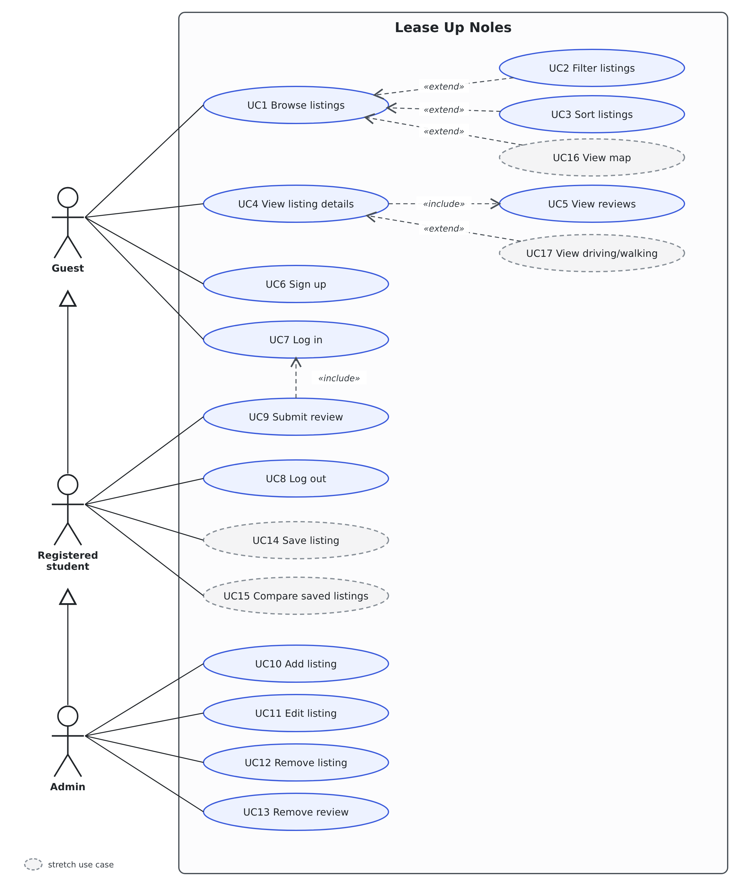
Figure 1: Use case diagram for Lease Up Noles
The Registered student is a kind of Guest and the Admin is a kind of Registered student, as shown by the arrows between the actors, so each actor can also do everything the actor above it can do. Filtering (UC2) and sorting (UC3) are optional extensions of browsing (UC1). Viewing the details of a listing (UC4) always includes viewing its reviews (UC5), and submitting a review (UC9) always includes being logged in (UC7). The Admin use cases (UC10 to UC13) are available only to logged-in Admins, and this is enforced by the database itself (FR7.5).

Summary of use cases
ID | Use case | Actor | Requirements | Priority
UC1 | Browse listings | Guest (all users) | FR1.1, FR1.6, FR1.7 | High
UC2 | Filter listings | Guest (all users) | FR1.2 to FR1.5, FR1.8, FR1.9 | High
UC3 | Sort listings | Guest (all users) | FR2 | Medium
UC4 | View listing details | Guest (all users) | FR3 | High
UC5 | View reviews | Guest (all users) | FR4 | High
UC6 | Sign up | Guest | FR5.1, FR5.3 | High
UC7 | Log in | Guest | FR5.2 | High
UC8 | Log out | Registered student, Admin | FR5.2 | High
UC9 | Submit review | Registered student | FR5.4 to FR5.8 | High
UC10 | Add listing | Admin | FR7.1, FR6 | Medium
UC11 | Edit listing | Admin | FR7.2, FR6.3 | Medium
UC12 | Remove listing | Admin | FR7.3 | Medium
UC13 | Remove review | Admin | FR7.4 | Medium
UC14 | Save listing (stretch) | Registered student | FR8 | Low
UC15 | Compare saved listings (stretch) | Registered student | FR9 | Low
UC16 | View map (stretch) | Guest (all users) | FR10 | Low
UC17 | View driving and walking distance (stretch) | Guest (all users) | FR11 | Low

Textual descriptions of use cases
Each description gives the actor, the requirements the use case satisfies, what must be true before it starts, the main flow of events, alternative flows, and the result. Use cases marked “planned” are not built yet.
UC1: Browse listings
Actor | Guest (and therefore every user)
Requirements | FR1.1, FR1.6, FR1.7
Before | None. The user does not need to log in.
Main flow | 1. The user opens the home page.  2. The system retrieves all listings together with their average ratings.  3. The system shows one card for each listing with its name, monthly price, address, number of bedrooms, distance to campus, amenities, and average rating, ordered by price from lowest to highest, and shows how many listings are displayed.  4. The user selects a card to see the listing’s details (UC4).
Alternatives | A1. There are no listings, or none match the current filters: the system shows a message saying so instead of an empty page.  A2. The listings cannot be loaded, for example because the database cannot be reached: the system shows an error message with a Try again button.
After | The listings are displayed.

UC2: Filter listings (extends UC1)
Actor | Guest (and therefore every user)
Requirements | FR1.2 to FR1.5, FR1.8, FR1.9
Before | The browse page is open.
Main flow | 1. The user sets a price range, chooses one or more bedroom counts, and/or sets a maximum distance to campus.  2. Shortly after the last change, the system updates the results to show only the listings that satisfy every filter that is set, and updates the number of listings shown.  3. The system keeps the filters in the page address, so the same filtered view can be shared or returned to with the browser’s Back button.  4. The user may clear all filters, and the system shows every listing again.
Alternatives | A1. A filter value is not valid, for example text instead of a number: the system ignores it and shows results without an error.  A2. The minimum price is greater than the maximum price: the system treats the two values as swapped.  A3. No listing matches: the system shows a message saying so.
After | The results match the filters that are set.

UC3: Sort listings (extends UC1)
Actor | Guest (and therefore every user)
Requirements | FR2
Before | The browse page is open.
Main flow | 1. The user chooses to sort by price, distance, or rating.  2. The system reorders the current results: by price from lowest to highest, by distance from closest to farthest, or by average rating from highest to lowest.  3. Listings that are equal on the chosen sort are ordered by price, then by name.  4. The filters stay as they were, and clearing the filters keeps the chosen sort.
Alternatives | A1. When sorting by rating, listings that have no reviews are placed after all listings that have a rating.
After | The results are shown in the chosen order.

UC4: View listing details
Actor | Guest (and therefore every user)
Requirements | FR3
Before | The listing exists.
Main flow | 1. The user selects a listing on the browse page.  2. The system shows the listing’s detail page with its name, monthly price, number of bedrooms, address, amenities, distance to campus, and average rating with the number of reviews it is based on.  3. The system shows the listing’s reviews (UC5).
Alternatives | A1. The listing does not exist: the system shows a not-found message and a way back to the browse page.  A2. The listing has no reviews: the page says so instead of showing a rating.
After | The listing’s details are displayed.

UC5: View reviews (included in UC4)
Actor | Guest (and therefore every user)
Requirements | FR4
Before | The detail page of a listing is being shown.
Main flow | 1. The system retrieves all reviews of the listing.  2. The system shows each review with its star rating, comment, date submitted, and the display name of the student who wrote it, with the most recent first.  3. The system calculates the average rating from all of the listing’s reviews and shows it to one decimal place.
Alternatives | A1. The listing has no reviews: the system shows a message saying so.
After | The reviews and the average rating are displayed.

UC6: Sign up
Actor | Guest
Requirements | FR5.1, FR5.3
Before | The user is not logged in.
Main flow | 1. The Guest opens the sign-up page.  2. The Guest enters a display name, an email address, and a password, and submits the form.  3. The system creates the account with the authentication service (Supabase Auth).  4. The system automatically creates a profile for the new account with the role Registered student.  5. The system logs the user in and returns to the home page, where the header shows the user’s email address and a Log out control.
Alternatives | A1. The email address is already in use or an input is not valid: the system shows an error message and keeps the form so it can be corrected.
After | The account and its profile exist and the user is logged in.

UC7: Log in
Actor | Guest
Requirements | FR5.2
Before | The user has an account and is not logged in.
Main flow | 1. The Guest opens the log-in page.  2. The Guest enters an email address and a password and submits the form.  3. The system checks the credentials with the authentication service.  4. The system starts a session that is kept between visits, and returns to the home page, where the header shows a Log out control.
Alternatives | A1. The email address or password is wrong: the system shows an error message and the user is not logged in.
After | The user is logged in.

UC8: Log out
Actor | Registered student, Admin
Requirements | FR5.2
Before | The user is logged in.
Main flow | 1. The user selects Log out in the header.  2. The system ends the session.  3. The header shows the Log in and Sign up links again.
Alternatives | None.
After | The user is logged out and can no longer submit reviews or use Admin functions.

UC9: Submit review (planned)
Actor | Registered student
Requirements | FR5.4 to FR5.8
Before | The user is logged in (UC7) and is viewing a listing’s detail page.
Main flow | 1. The student chooses a star rating from 1 to 5.  2. The student writes a comment of up to 1,000 characters.  3. The student submits the review.  4. The system checks the rating and the comment.  5. The system saves the review, linked to the listing and to the student.  6. The new review appears on the detail page and is included in the listing’s average rating.
Alternatives | A1. The user is not logged in: the system asks the user to log in or sign up (UC7, UC6).  A2. The rating is missing or outside 1 to 5, or the comment is empty or too long: the system rejects the review and tells the student what to correct.  A3. The student has already reviewed this listing: the system rejects the review and says so.
After | The review is stored and visible to all users.

UC10: Add listing (planned)
Actor | Admin
Requirements | FR7.1, FR6, FR7.5
Before | The user is logged in as an Admin.
Main flow | 1. The Admin opens the page for adding a listing.  2. The Admin enters the name, address, monthly price, number of bedrooms, amenities, latitude, and longitude.  3. The Admin submits the form and the system checks the data.  4. The system saves the listing and calculates and stores its distance to campus (FR6).  5. The listing appears in the browse results.
Alternatives | A1. The data is not valid, for example a blank name or address, a negative price or number of bedrooms, or coordinates out of range: the system rejects it and shows a message.  A2. The user is not an Admin: the system refuses the request.
After | The listing exists and has its distance to campus stored.

UC11: Edit listing (planned)
Actor | Admin
Requirements | FR7.2, FR6.3, FR7.5
Before | The user is logged in as an Admin and the listing exists.
Main flow | 1. The Admin selects the listing to edit.  2. The Admin changes one or more of its details and submits.  3. The system checks and saves the changes.  4. If the latitude or longitude changed, the system calculates and stores the distance to campus again.
Alternatives | A1. The data is not valid: the system rejects it and shows a message.  A2. The user is not an Admin: the system refuses the request.
After | The listing shows the new details.

UC12: Remove listing (planned)
Actor | Admin
Requirements | FR7.3, FR7.5
Before | The user is logged in as an Admin and the listing exists.
Main flow | 1. The Admin selects the listing and chooses to remove it.  2. The system asks the Admin to confirm.  3. The Admin confirms.  4. The system removes the listing and its reviews.
Alternatives | A1. The Admin cancels at the confirmation: nothing is removed.
After | The listing and its reviews are no longer shown to any user.

UC13: Remove review (planned)
Actor | Admin
Requirements | FR7.4, FR7.5
Before | The user is logged in as an Admin and is viewing a listing’s detail page.
Main flow | 1. The Admin selects a review that is spam or has no relation to the property.  2. The system asks the Admin to confirm.  3. The Admin confirms.  4. The system removes the review and updates the listing’s average rating.
Alternatives | A1. The Admin cancels at the confirmation: nothing is removed.
After | The review is no longer shown and no longer counts toward the average rating.

UC14: Save listing (stretch)
Actor | Registered student
Requirements | FR8
Before | The user is logged in.
Main flow | 1. The student chooses to save a listing.  2. The system adds it to the student’s saved listings, which are kept between sessions.  3. The student can open the list of saved listings and remove a listing from it.
Alternatives | A1. A Guest tries to save a listing: the system asks the Guest to log in or sign up.
After | The listing is in (or removed from) the student’s saved listings.

UC15: Compare saved listings (stretch)
Actor | Registered student
Requirements | FR9
Before | The student has at least two saved listings.
Main flow | 1. The student chooses two or three saved listings to compare.  2. The system shows them side by side with their price, number of bedrooms, distance to campus, amenities, and average rating.
Alternatives | A1. The student chooses fewer than two or more than three listings: the system does not allow the comparison.
After | The comparison is displayed.

UC16: View map (stretch)
Actor | Guest (and therefore every user)
Requirements | FR10
Before | The browse page is open.
Main flow | 1. The user opens the map view.  2. The system shows a map with a pin for each listing in the current results and a mark for the campus reference point.  3. The user selects a pin, and the system shows the listing’s name and price and a link to its detail page.
Alternatives | None.
After | The map is displayed.

UC17: View driving and walking distance (stretch)
Actor | Guest (and therefore every user)
Requirements | FR11
Before | A listing’s detail page is being shown (UC4).
Main flow | 1. The system shows the stored driving distance and walking distance to campus, in addition to the straight-line distance.
Alternatives | A1. The distances are not available for the listing: the system shows only the straight-line distance.
After | The distances are displayed.

Class Diagram and/or Sequence Diagrams (15 points)
The application is written in TypeScript with Next.js and React, so much of it is organized as functions in modules and as page components rather than as classes. The classes below therefore stand for two things: the data the system stores, and the modules, services, and pages that work on that data. Each operation shown is a function in the corresponding module. The design is preliminary and will be refined in later increments. Classes marked «planned» are not built yet.

Class diagrams
Figure 2 shows the data that the system stores. A Listing has zero or more Reviews, and each Review belongs to exactly one Listing. When a listing is removed, its reviews are removed with it (FR7.3). A Profile writes zero or more Reviews. Each AuthUser, which is managed by Supabase Auth and is the only place where a password is kept, has exactly one Profile, created automatically at sign-up, and each Profile has one UserRole, either student or admin. A listing’s distance to campus is stored in Listing.distanceMiles (FR6).
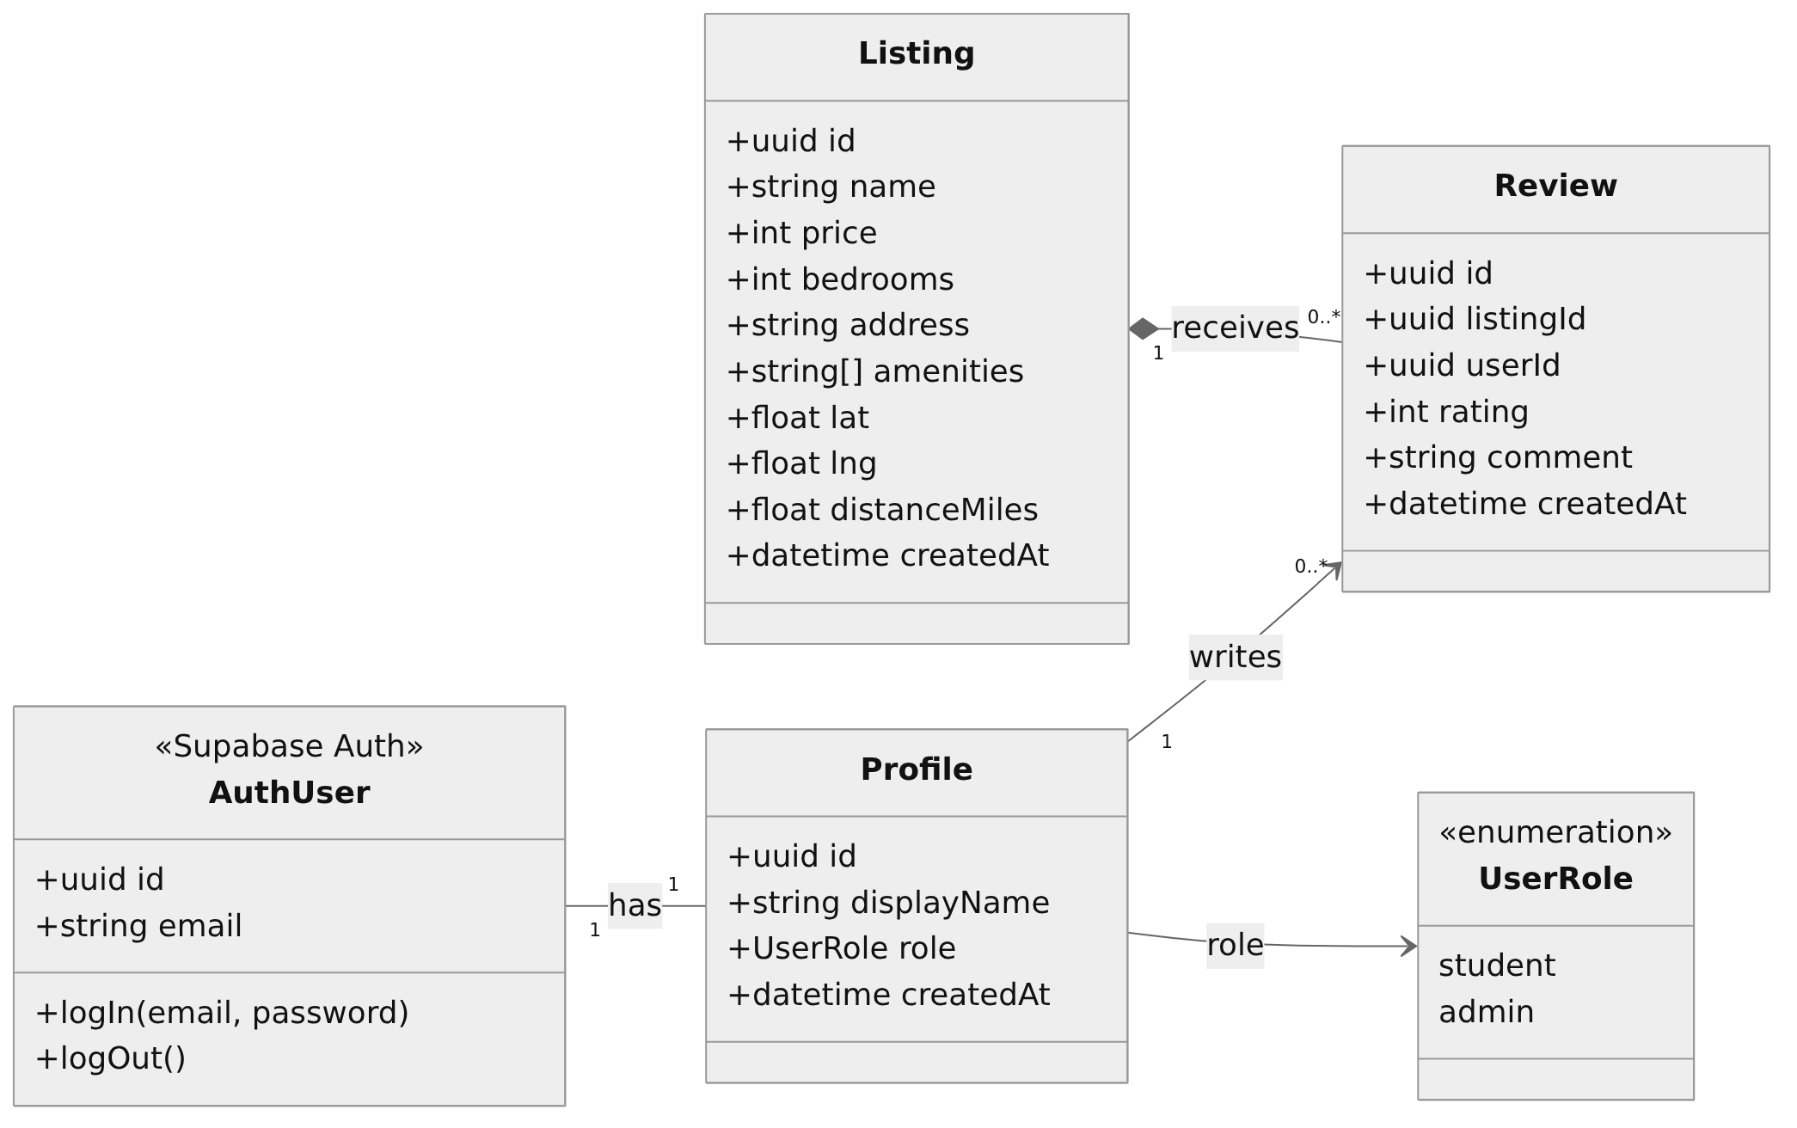
Figure 2: Class diagram of the data stored by the system
Figure 3 shows how the browse and detail pages find, filter, and order listings. BrowsePage reads the filters and the sort option from the page address (ListingFilters), asks ListingRepository for the matching listings, and then orders them (ListingSorter). ListingDetailPage uses ListingRepository to load one listing and its reviews.
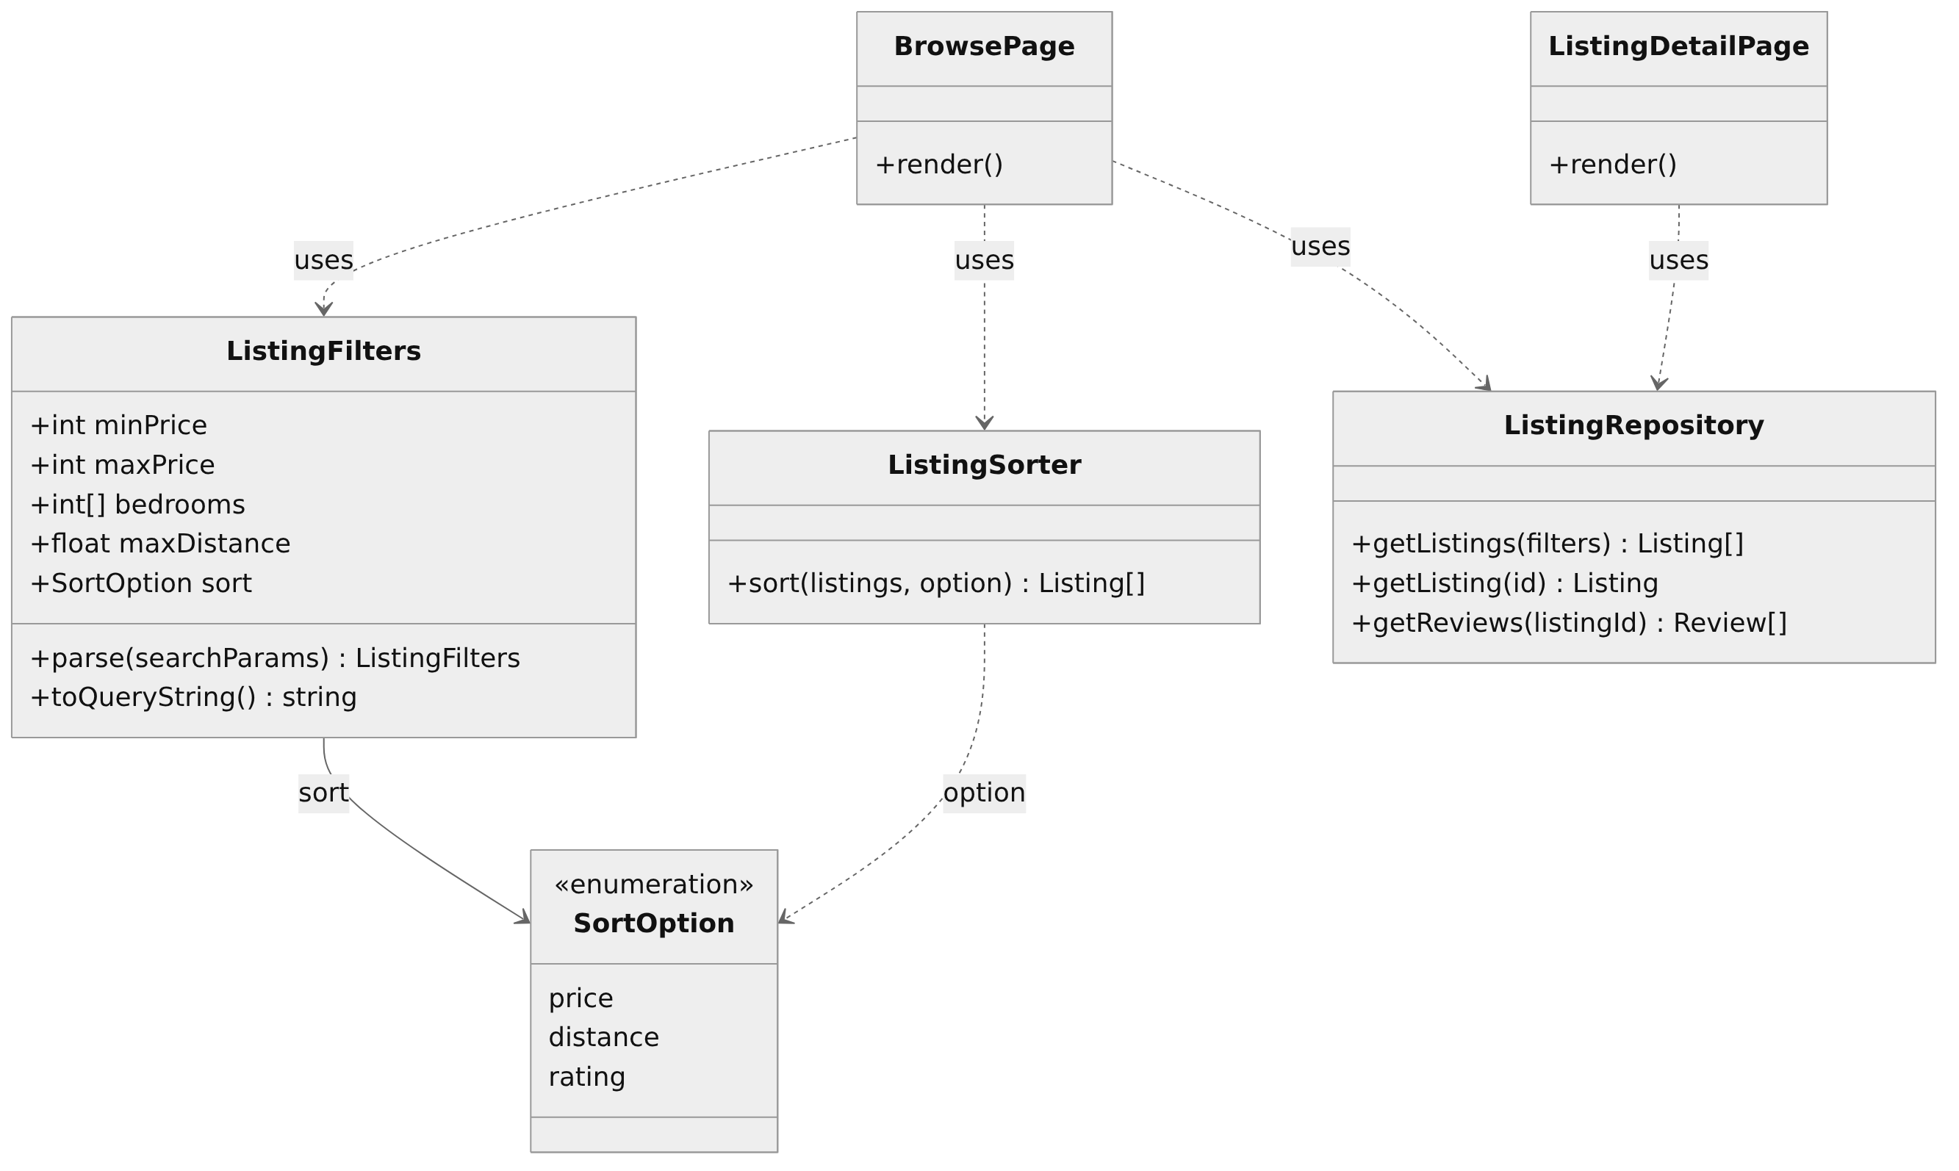
Figure 3: Class diagram of the browsing logic and pages
Figure 4 shows accounts, reviews, and administration. SignupPage and LoginPage use AuthService. ReviewService and AdminService are planned: each one checks who the current user is (AuthService) before it changes any data, and AdminService uses the same distance rule as FR6 when a listing’s location is set or changed.
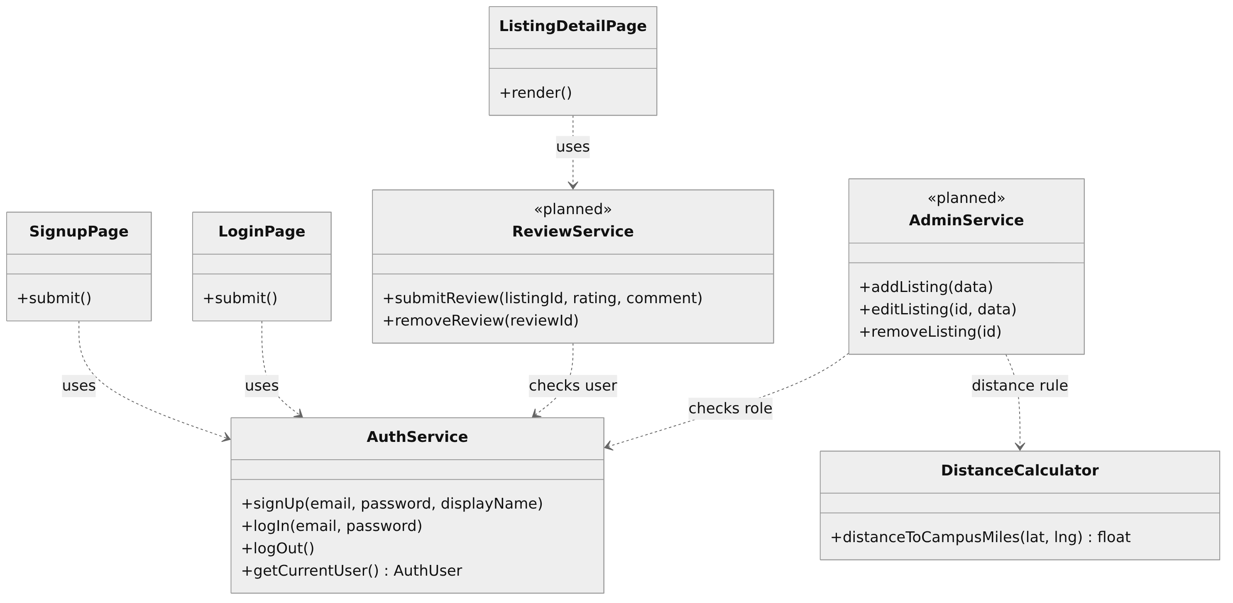
Figure 4: Class diagram of accounts, reviews, and administration
The table below shows where each class is found in the project.
Class in the diagrams | Where it lives in the project
Listing, Review, Profile | Database tables listings, reviews, and profiles in Supabase (created by the migration files in supabase/migrations) and the TypeScript types in src/types.
BrowsePage | src/app/page.tsx and the listing card and filter components in src/components.
ListingDetailPage | The page for a single listing, at the address /listings/[id].
ListingFilters | src/lib/listing-filters.ts
ListingSorter | src/lib/listing-sort.ts
ListingRepository | src/lib/listings.ts, which queries Supabase.
DistanceCalculator | src/lib/distance.ts, with the same formula in the database (the migration that stores each listing’s distance).
AuthService, AuthUser | Supabase Auth, used through the code in src/lib/supabase and the log-in, sign-up, and log-out actions.
SignupPage, LoginPage | The pages at /signup and /login.
ReviewService, AdminService | Not built yet (planned).

Sequence diagrams
Sequence diagrams are given for the three most important use cases: browsing, filtering, and sorting listings (UC1 to UC3), signing up (UC6), and submitting a review (UC9, planned).
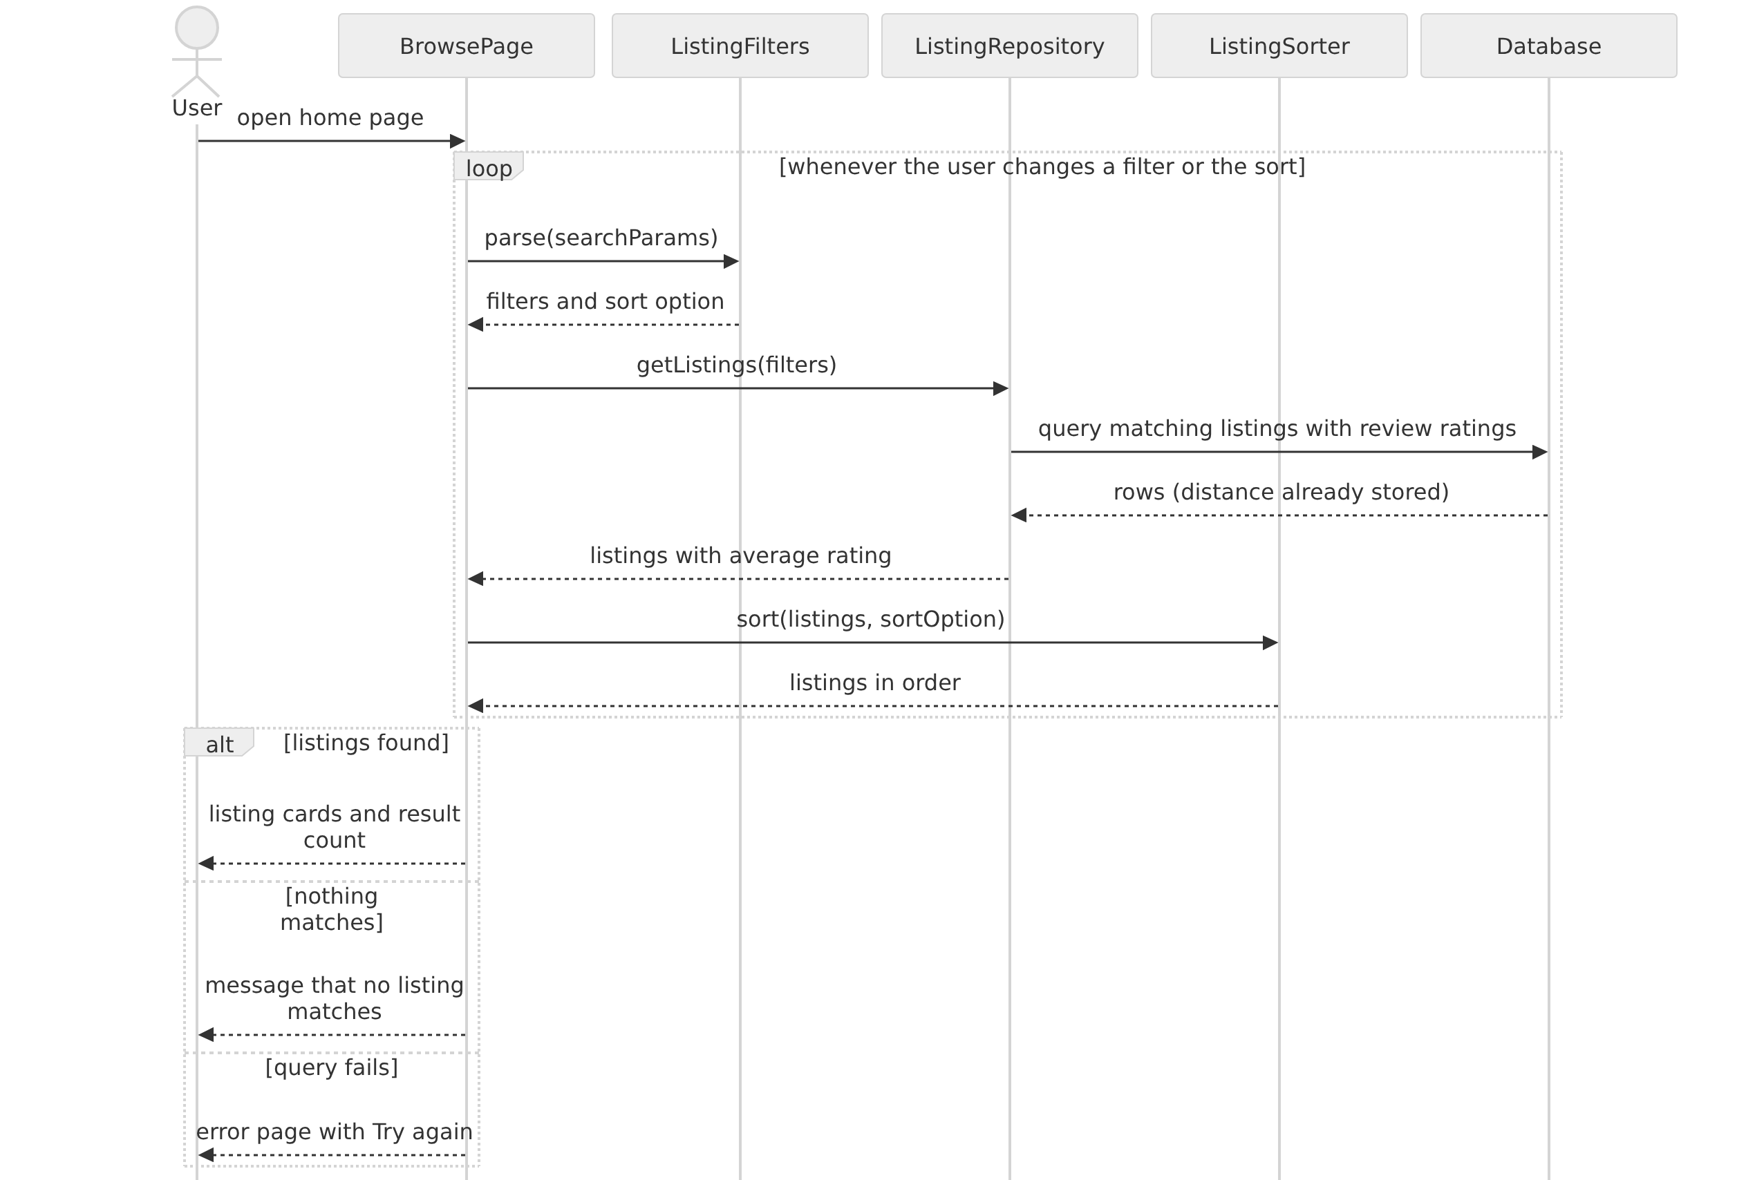
Figure 5: Sequence diagram for browsing, filtering, and sorting listings
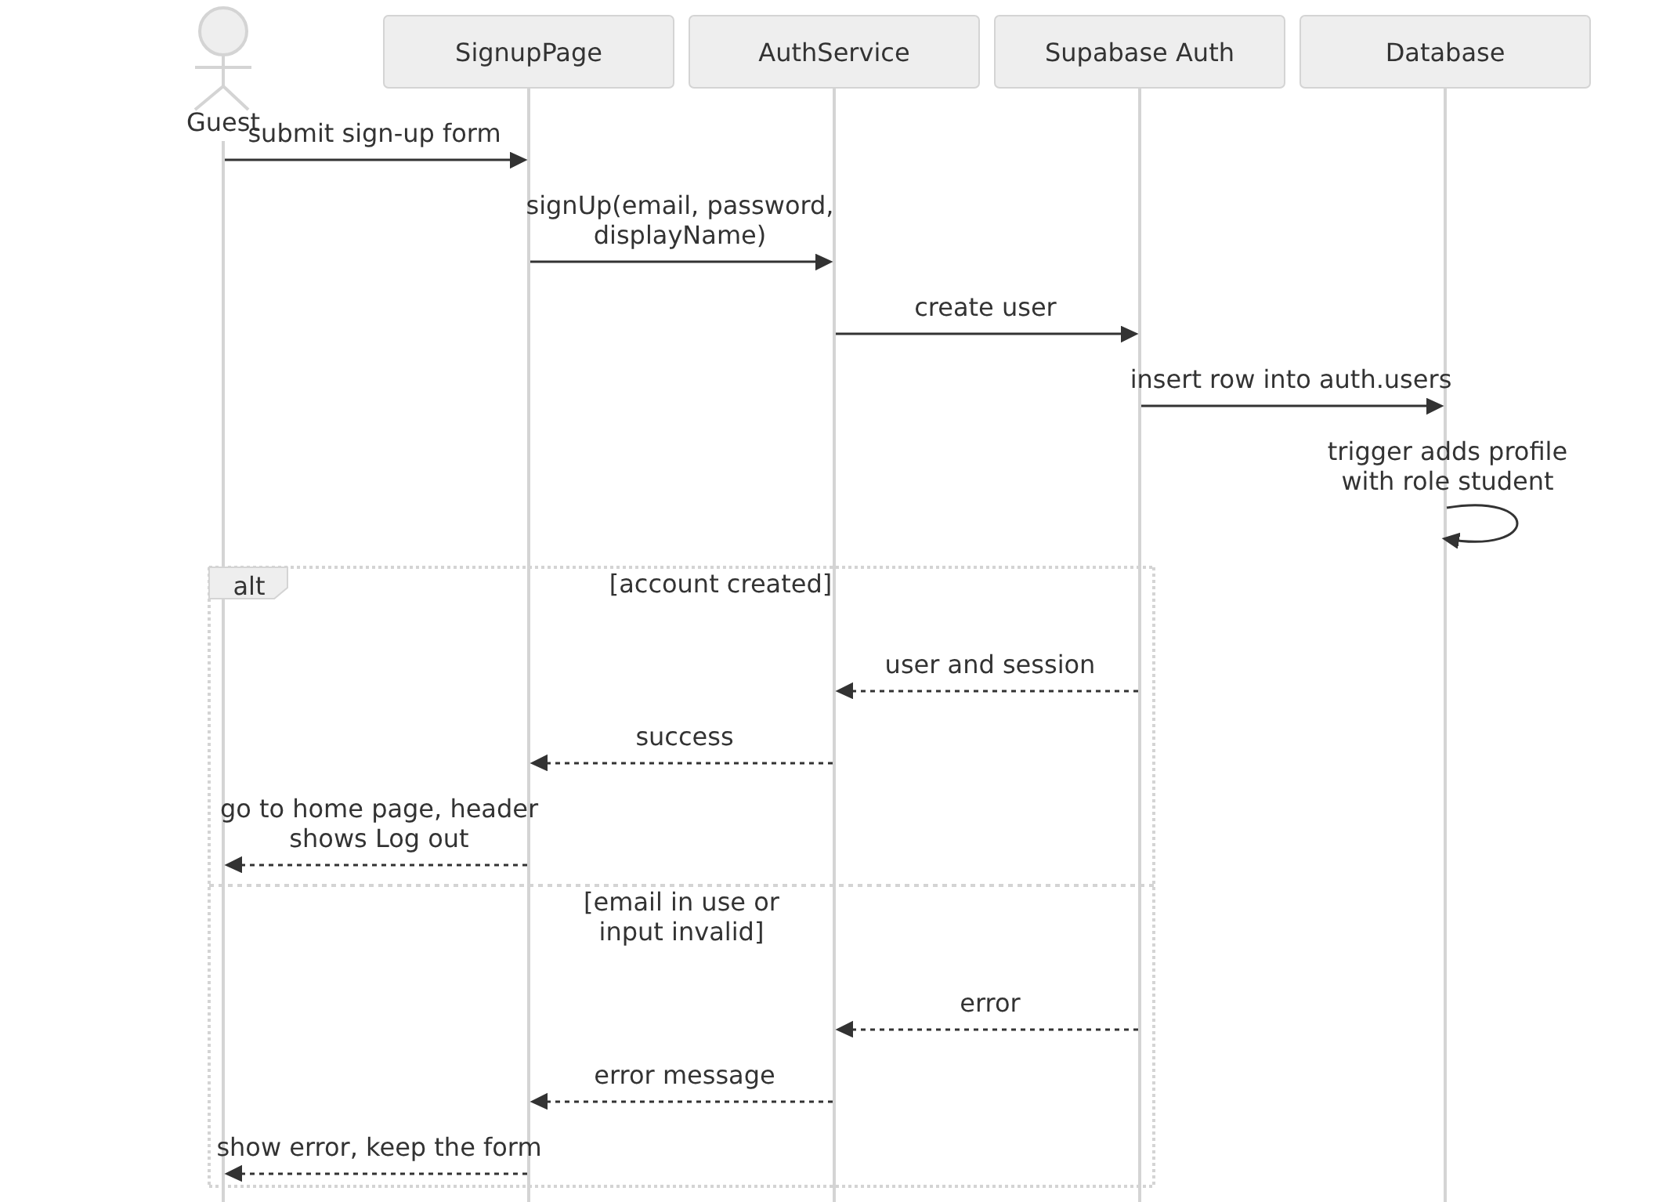
Figure 6: Sequence diagram for signing up. The database adds the profile automatically.
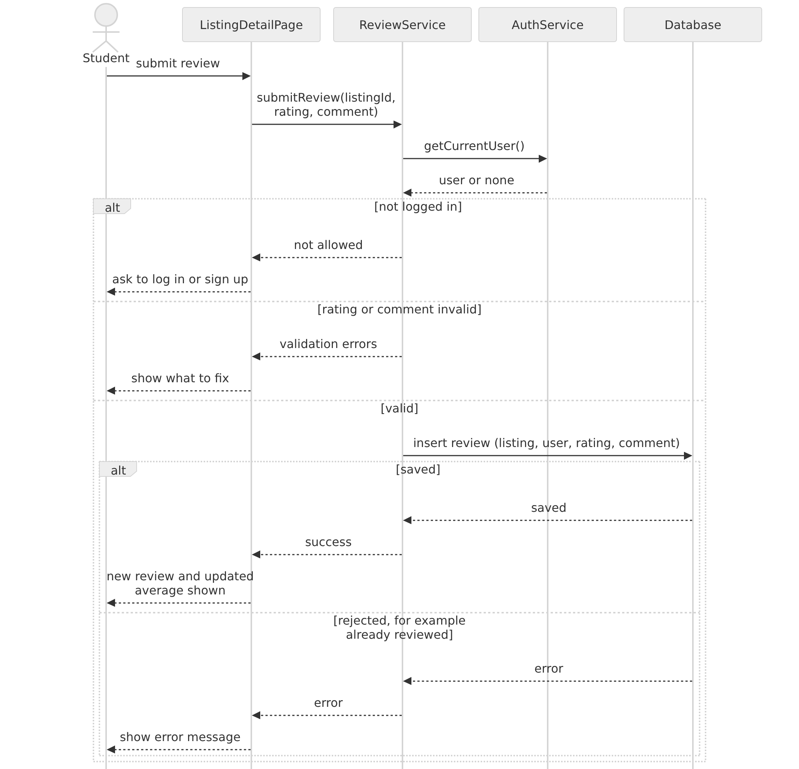
Figure 7: Sequence diagram for submitting a review (planned). Row-level security in the database lets a user add only their own review, one per listing.

Operating Environment (5 points)
Lease Up Noles is a web application. A user needs only a device with a web browser and an internet connection, and nothing has to be installed.
Users’ devices and browsers: Phones, tablets, laptops, and desktop computers running a current version of Chrome, Safari, Edge, or Firefox on iOS, Android, macOS, or Windows. The pages must work at screen widths from 375 pixels (a small phone) up to wide desktop screens (NFR1). Browser JavaScript and cookies are used for the live filter updates and for keeping a user logged in. Without JavaScript the filters still work through the Apply button.
Web hosting: The Next.js application is built and hosted on Vercel (Hobby plan). Vercel runs the server-side code and serves the pages over HTTPS. Every pull request also gets its own preview deployment for testing before it is merged.
Database and authentication: Supabase (Free plan), in a project hosted in the East US (Ohio) region. It provides the PostgreSQL database with row-level security and Supabase Auth for accounts.
Development environment: Team members work on their own laptops with Node.js and npm (Node.js 22 or newer is recommended, because the test tool needs it), Git, and GitHub for source control, issues, and pull requests. The code is checked with ESLint, formatted with Prettier, and tested with vitest.
Hardware: No special hardware is needed by users or by the team. Servers and the database are provided by Vercel and Supabase.

Assumptions and Dependencies (5 points)

Assumptions
A1. The free plans stay available and large enough. Supabase Free (500 MB of database storage, 50,000 monthly active users) and Vercel Hobby are assumed to cover the project for the semester. If those limits or terms change, the cost requirements (NFR3) may have to change.
A2. Users have a current browser and an internet connection, and most of them use a phone.
A3. The listings in the demo are fictional seed data and listings added by the team. Listings will not be copied from other websites. If that changes, the terms of service of each source must be checked first.
A4. Straight-line distance to a single campus reference point (Westcott Fountain) is accepted as a good enough measure of distance for students. Real driving and walking distances are a stretch feature (FR11).
A5. Email confirmation is turned off, because FSU blocks the confirmation emails and the free plan limits how many can be sent. Accounts are therefore not verified, and the system cannot confirm that a reviewer is a real FSU student. The Admin’s ability to remove reviews (FR7.4) is the protection against fake or abusive reviews.
A6. Reviewers are assumed to write honestly about places where they have actually lived. The system does not check this.
A7. Admin accounts are created by the project maintainers directly in the database (FR7.6), and until the Admin pages exist, listings are added by the team through the seed script or the database.
A8. Each of the five team members can spend about 5 to 6 hours a week on the project. Because of this, the stretch requirements (FR8 to FR11) will be attempted only after the core requirements work end to end.

Dependencies
D1. Supabase provides the PostgreSQL database, authentication, and row-level security. All data and accounts depend on it.
D2. Vercel hosts and deploys the application.
D3. Open-source libraries: Next.js, React, TypeScript, Tailwind CSS, and the Supabase JavaScript client (@supabase/supabase-js). A major change in any of them could require rework.
D4. GitHub is used for source control, the issue tracker, and pull requests. The course uses these records to assess each member’s work.
D5. Development tools: Node.js and npm, ESLint, Prettier, and vitest.
D6. The stretch requirements FR10 and FR11 would need a mapping service. None has been chosen. It must be usable for free and without a credit card (NFR3).

