**Family Tree**

Tech Stack used:  
  
Node.js  
React.js  
Bootstrap  
mongoose   
MongoDB

Rest API Endpoints:  
  
/familyadd  
method: POST  
  
 - Responsible for adding submitted data to database.

/family  
method: GET  
  
 - Fetching all the data from collection called families.  
  
/family/:role  
method: GET  
  
- Fetch data based on role field passed by the client side.

/familydelete   
method: DELETE  
  
- Delete data based on _id.

/familyupdate  
method: PUT  
  
- Responsible for updating the specific data sent by the client side

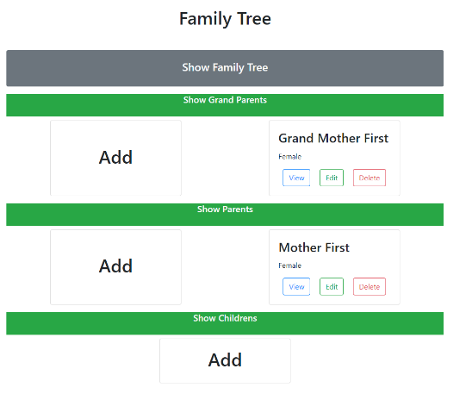  
Here’s how it looks from client side I use bootstrap for styling and some action like collapsible element. You can hide and show the family tree by clicking the show family div and you can hide or show any branch of the family. I only show the grandparents, parents, and children because if I make It more dynamic I don’t I will finish It but it’s showing all the crud functionality which is the main purpose of this app.  
  
  
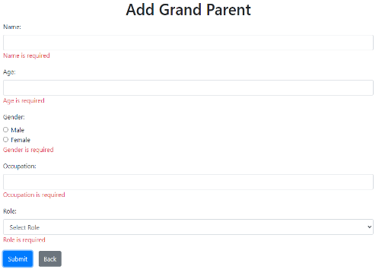For Grand Parents you only can add up to 4 persons. For Parents you only can add up to 2 persons. For Children you can add as many as you want. You can Add person by clicking the Add div on their respective role if you click Add div on children it will add only on children tab same for the 2 add div. After clicking the add you will redirect to add form. You can click the back button to return to the family tree tab. All the fields are required so you need to fill up all the fields if you don’t fill up all the fields the system will output an error.

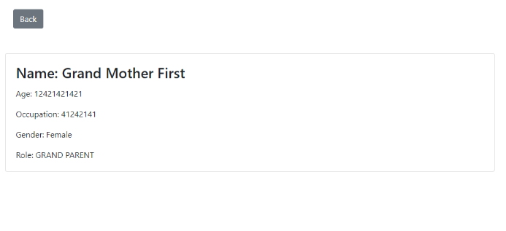  
  
For the view button you can see the more detailed information of the person you click.

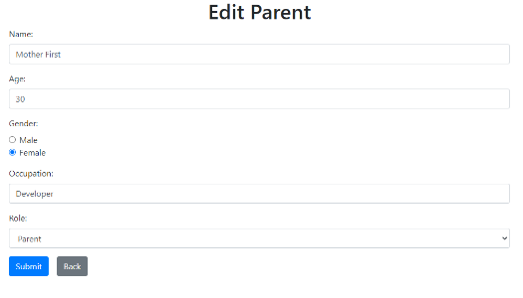You can choose to delete who ever you want to remove from the family tree by clicking the delete button there’s no pop-up. It will delete immediately after you clicked it. For the edit button it’s the same design from Add but it’s all pre filled all the fields after submitting the person you choose will be updated.