RETRIEVAL-AUGMENTED GENERATION (RAG)
SESSION 1 -Introduction to RAG & Why It's NeededPending
Tasks

1.In your own words, explain what Retrieval-Augmented Generation (RAG) is and give one example of how it could improve a feature in an app you use daily, like Zomato, Flipkart, or Instagram.
Task 1. What is Retrieval-Augmented Generation (RAG)?
Definition: RAG stands for Retrieval-Augmented Generation. It is an AI technique that retrieves relevant information from external sources, such as documents, databases, or websites, and uses that information to generate accurate and updated answers.
In simple words, RAG = Search for information + LLM + Generate an answer.
How does RAG work?
1. User Question
"Which restaurant offers the best pizza near me?"
2. Retrieve Documents
Search restaurant details, menus, prices, and reviews.
3. Combine with LLM
Provide the retrieved information and question to the AI model.
4. Generate Answer
Recommend suitable restaurants using the available information.
Real-world example: Zomato
Suppose you ask Zomato's AI assistant, "Find a vegetarian restaurant under ₹300 that is open now."
- Retrieval: The system searches restaurant menus, prices, ratings, and current opening information.
- Augmentation: The relevant information is provided to the language model.
- Generation: The AI gives recommendations based on the retrieved information.

2.Imagine you are chatting with a travel assistant bot that uses a Large Language Model (LLM) trained in 2022. List 3 questions about IRCTC train schedules or IPL 2024 that the bot would struggle to answer, and explain why outdated LLM knowledge is a problem in this scenario.
Task 2. Three questions an LLM trained in 2022 would struggle to answer
An LLM trained only on information available up to 2022 would not automatically know future events, such as the 2024 IPL season or later train schedule changes.
Question | Why would the bot struggle?
1. What is the current departure time and platform number of my train today? | Train timings, platforms, delays, and cancellations can change in real time.
2. Who won IPL 2024, and which team won the final? | IPL 2024 happened after the model's 2022 training cutoff.
3. What was the playing XI and final score of the IPL 2024 final? | The match details and final score were not available in its original training data.
Why is outdated knowledge a problem?
- Outdated information: The model may not know about events that happened after its training cutoff.
- Incorrect answers: It may generate plausible but incorrect details, sometimes called hallucinations.
- Real-world consequences: Incorrect train information could cause a passenger to miss a train or reach the wrong platform.
Solution: RAG can retrieve current train information from reliable railway sources and historical match results from trusted cricket sources, then use the retrieved data to answer the questions. Real-time accuracy still depends on the quality and freshness of those sources.

3.Create a diagram (hand-drawn or digital) that shows the basic workflow of RAG: start from user question, show how external documents are retrieved, and how the answer is generated using both the documents and the LLM.<br><br><em><strong>Hint:</strong> Include at least these steps: User Query → Retrieve Documents → Combine with LLM → Generate Answer.</em>
Task 3. Diagram of the basic RAG workflow
You can copy this diagram into your assignment or draw it in your notebook.
User Query
"What is the refund policy for this product?"
Retrieve Documents
Search product details, company policies, FAQs, or a knowledge base.
Combine Retrieved Context with LLM
Send the user's question and relevant documents to the language model.
Generate Answer
Explain the refund policy based on the retrieved documents.
Conclusion: RAG connects the LLM to external information so that it can generate answers using relevant documents instead of relying only on its training data.

4.Compare RAG, Fine-tuning, and Prompt Engineering by filling out a table with 3 columns (RAG, Fine-tuning, Prompt Engineering) and 4 rows: Cost, Data Freshness, Use Case Example, and Speed of Implementation. Use real-world app examples for at least one row.
Task 4. Comparison of RAG, Fine-tuning, and Prompt Engineering
Criteria | RAG | Fine-tuning | Prompt Engineering
Cost | Medium; requires retrieval infrastructure and may have search costs. | Usually high; requires training data, computing resources, and training time. | Low; mainly requires writing and testing prompts.
Data Freshness | High if the external data and indexes are updated regularly. | Usually low for changing facts; new training or other data access may be needed. | Depends on the model's existing knowledge and information supplied in the prompt.
Use Case Example | A customer-support chatbot retrieves the latest refund policy from company documents. | A medical text-classification model is adapted to recognize specialized medical terminology using suitable training data. | Asking ChatGPT to explain Python code in simple language with examples.
Speed of Implementation | Medium; documents must be prepared, indexed, and connected to a model. | Slow; requires preparing data, training, and evaluation. | Fast; instructions can be written and tested immediately.
Simple explanation
- RAG: Gives the AI relevant external information when it answers.
- Fine-tuning: Further trains an existing model to change or improve its behavior for a specific task.
- Prompt engineering: Improves the response by changing how instructions and questions are written.
Example using a shopping app:
- RAG retrieves the latest product specifications and return policy.
- Fine-tuning adapts a model to classify customer complaints into categories.
- Prompt engineering instructs an AI assistant to compare two products in a table.
These techniques can also be combined in one application.

5.Use ChatGPT or any AI tool to find a real-world example where RAG is used in a popular app or service (not the one shown in class). Briefly describe how RAG helps that app provide better answers or features.
Task 5. Real-world example of RAG in a popular service

Example: Microsoft Copilot Studio
Microsoft Copilot Studio supports RAG to help AI agents answer questions using trusted organizational information, such as company documents and knowledge bases.

Microsoft Learn
How does it use RAG?
- User asks a question: An employee asks, "What is our company's leave policy?"
- Retrieval: The system searches connected knowledge sources, such as SharePoint documents or other configured data sources.
- LLM processing: Relevant information is provided to the language model.
- Answer generation: The AI explains the leave policy using the retrieved information and can provide citations to its sources.
Microsoft Learn
Benefits of RAG
- More relevant answers: Responses can be based on company-specific documents.
- Updated information: When connected sources and indexes are maintained, the assistant can use updated policies without retraining the entire LLM.
- Better verification: Citations can help employees check the original information.
- Less hallucination: Grounding answers in retrieved information can reduce unsupported responses, although it cannot eliminate errors.
Conclusion: Microsoft Copilot Studio is an example of how RAG helps AI assistants provide answers grounded in an organization's own information rather than relying only on the model's pre-trained knowledge.

SESSION 2 - Chunking & EmbeddingsPending
Tasks

1.Write a Python function chunk_text(text, chunk_size, overlap) that splits a long string into chunks of the given size with the specified overlap. Test your function with a 500-word sample from a Wikipedia article.
Task 1. Python function to split text into chunks
Definition: Chunking is the process of dividing a large text document into smaller pieces called chunks. In RAG, chunks help the system retrieve only the relevant parts of a document instead of processing the entire document at once.
Chunk size means the number of words or characters in each chunk. Here, we will use words.
Overlap means the number of words repeated from the previous chunk in the next chunk.
Python code
def chunk_text(text, chunk_size, overlap): if chunk_size <= 0: raise ValueError("chunk_size must be greater than 0") if overlap < 0 or overlap >= chunk_size: raise ValueError("overlap must be between 0 and chunk_size - 1") words = text.split() chunks = [] step = chunk_size - overlap for start in range(0, len(words), step): chunk = words[start:start + chunk_size] if not chunk: break chunks.append(" ".join(chunk)) return chunks# Sample text for testingsample_text = """Artificial intelligence is transforming many industries.Machine learning helps computers learn patterns from data.Natural language processing enables computers to understandhuman language. Retrieval augmented generation combinesinformation retrieval with large language models to providerelevant and informative answers.""" * 20chunks = chunk_text(sample_text, chunk_size=50, overlap=10)for i, chunk in enumerate(chunks, start=1): print(f"Chunk {i}: {chunk}\n")
Explanation
- text.split() converts the text into a list of words.
- step = chunk_size - overlap calculates how far the next chunk should move.
- range() moves through the word list using that step.
- words[start:start + chunk_size] extracts the current chunk.
- " ".join(chunk) combines the words back into a string.
- chunks.append() stores each chunk in the list.
For the assignment's exact Wikipedia requirement, replace sample_text with approximately 500 words copied from a Wikipedia article. The sample above demonstrates the function but is not a Wikipedia excerpt.
Example: with chunk_size=100 and overlap=20, the first chunk contains words 1–100 and the second contains words 81–180.

2.Take the privacy policy text from any popular app (such as Instagram or Zomato), and use your chunk_text function to split it into 100-word chunks with 20-word overlap. Print the first 3 chunks.
Task 2. Split a popular app's privacy policy into 100-word chunks
For this task, we can use Instagram's privacy policy. Copy the policy text from the official Instagram Privacy Policy into a local file named instagram_policy.txt. This ensures that you work with the actual policy text rather than an invented example.
Python code
# Reuse the chunk_text() function from Task 1with open("instagram_policy.txt", "r", encoding="utf-8") as file: policy_text = file.read()chunks = chunk_text( policy_text, chunk_size=100, overlap=20)# Print the first 3 chunksfor i, chunk in enumerate(chunks[:3], start=1): print(f"\n--- Chunk {i} ---") print(chunk) print("Word count:", len(chunk.split()))
Expected result
- Chunk 1: Words 1–100 of the policy.
- Chunk 2: Words 81–180 of the policy.
- Chunk 3: Words 161–260 of the policy.
Each full chunk contains 100 words, and adjacent chunks share 20 words, except when the document ends before a full chunk can be created.
Why is this useful? A RAG system can search these smaller sections to find relevant privacy information, such as data collection, account security, or information sharing.

3.Use the Sentence Transformers library (sentence-transformers) in Python to generate embeddings for three different food review sentences (e.g., 'The pizza was amazing', 'Service was slow', 'Loved the ambience'). Print the embedding vector for each sentence.<br><br><em><strong>Hint:</strong> Use the 'all-MiniLM-L6-v2' model from sentence-transformers.</em>
Task 3. Generate embeddings using Sentence Transformers
Definition: An embedding is a numerical representation of text in the form of a vector. It captures semantic information about the text so that a computer can compare its meaning with other text.
For example, a sentence about delicious food and another sentence about enjoying a meal may have similar embeddings even if their words are different.
Install the required libraries
Run this command in your terminal or Jupyter Notebook:
pip install sentence-transformers
Python code
from sentence_transformers import SentenceTransformer# Load the embedding modelmodel = SentenceTransformer("all-MiniLM-L6-v2")sentences = [ "The pizza was amazing", "Service was slow", "Loved the ambience"]# Generate embeddingsembeddings = model.encode(sentences)# Print each sentence and its embeddingfor sentence, embedding in zip(sentences, embeddings): print("\nSentence:", sentence) print("Embedding vector:", embedding) print("Vector dimensions:", len(embedding))
Explanation
- SentenceTransformer() loads the pre-trained embedding model.
- sentences stores three food-review sentences.
- model.encode() converts each sentence into a numerical vector.
- zip() pairs each sentence with its corresponding embedding.
- len(embedding) prints the number of values in the vector.

4.Calculate the cosine similarity between the embedding of the sentence 'The burger was delicious' and 'I enjoyed the burger a lot' using the same embedding model. Interpret the similarity score — are these sentences semantically similar?

from sentence_transformers import SentenceTransformer
from sklearn.metrics.pairwise import cosine_similarity

model = SentenceTransformer("all-MiniLM-L6-v2")

sentences = [
"The burger was delicious",
"I enjoyed the burger a lot"
]

# Generate embeddings
embeddings = model.encode(sentences)

# Calculate cosine similarity
score = cosine_similarity(
[embeddings[0]],
[embeddings[1]]
)[0][0]

print("Sentence 1:", sentences[0])
print("Sentence 2:", sentences[1])
print("Cosine Similarity:", score)

if score > 0.7:
print("Interpretation: The sentences are semantically similar.")
elif score > 0.4:
print("Interpretation: The sentences are moderately similar.")
else:
print("Interpretation: The sentences have relatively low similarity.")
Understanding the result
Similarity score | General interpretation
Close to 1 | Very similar direction in embedding space
Close to 0 | Little semantic alignment
Close to -1 | Opposite directions; uncommon for many ordinary sentence comparisons
The two burger sentences express nearly the same idea, so we expect a relatively high similarity score. The actual score should be taken from your program's output; the thresholds above are illustrative, not universal.
Note: Install scikit-learn if needed:
pip install scikit-learn

5.Use ChatGPT or any AI tool to explain in your own words why chunk overlap is important in document retrieval, and give an example scenario where too little overlap could cause problems in a Zomato-style restaurant review search.
Task 5. Why is chunk overlap important in document retrieval?
Definition: Chunk overlap means repeating some words from the end of one chunk at the beginning of the next chunk. It helps preserve context when a document is divided into smaller pieces.
Example: Zomato restaurant reviews
Imagine a customer writes:
The pizza was excellent and the cheese was fresh. However, the delivery was late, and the food arrived cold despite the restaurant packaging it carefully.
Suppose this review is split into chunks with no overlap:
- Chunk 1: "The pizza was excellent and the cheese was fresh. However, the delivery was late..."
- Chunk 2: "...and the food arrived cold despite the restaurant packaging it carefully."
If a chunk boundary separates the phrase "delivery was late" from the related explanation about cold food, the retrieval system may return only part of the complaint. The context may be incomplete.
With overlap, the end of one chunk is repeated in the next chunk, helping the retrieval system preserve the relationship between connected ideas.
Benefits of chunk overlap
- Preserves context: Related sentences and phrases are less likely to be separated without enough surrounding information.
- Improves retrieval: Relevant details may be found even when they lie near a chunk boundary.
- Supports better answers: The LLM receives more complete context when generating a response.
- Reduces information loss: Important phrases at the edges of chunks are less likely to become disconnected from their meaning.
Conclusion
Chunk overlap is important in RAG because it helps maintain context between adjacent chunks. In a Zomato-style restaurant review search, this can help an AI assistant answer questions such as, "What complaints did customers have about pizza delivery?" more accurately.
However, too much overlap creates redundant text and increases storage and processing costs. The ideal chunk size and overlap depend on the documents and retrieval task.

SESSION 3 - Vector DB & RetrievalPending
Tasks

1.Install FAISS in your Python environment and write a script to create a simple vector index with 5 song embeddings (random 4-dimensional vectors), then print the index size.
Task 1. Create a FAISS vector index with 5 song embeddings
Definition: FAISS (Facebook AI Similarity Search) is a library used to search for similar vectors quickly. In RAG, it can help retrieve documents whose embeddings are most similar to a user's query.
Step 1: Install FAISS
Run this command in your terminal or Jupyter Notebook:
pip install faiss-cpu numpy
Step 2: Python code
import faissimport numpy as np# Generate 5 random song embeddings, each with 4 dimensionsnp.random.seed(42)song_embeddings = np.random.rand(5, 4).astype("float32")# Create a FAISS index for 4-dimensional vectorsdimension = 4index = faiss.IndexFlatL2(dimension)# Add song embeddings to the indexindex.add(song_embeddings)# Print the index sizeprint("Number of songs:", index.ntotal)print("Vector dimensions:", index.d)print("Song embeddings:\n", song_embeddings)
Explanation
- np.random.rand(5, 4) creates five vectors, each containing four numbers.
- IndexFlatL2(4) creates a FAISS index using Euclidean (L2) distance.
- index.add() stores the five vectors in the index.
- index.ntotal returns the number of indexed vectors.
Expected output:
Number of songs: 5
Vector dimensions: 4

2.Using ChromaDB, store embeddings for 5 different restaurants (use random 3-dimensional vectors and names like 'Barbeque Nation', 'Domino's', etc.), then retrieve and print the restaurant most similar to a given query vector.
Task 2. Store restaurant embeddings using ChromaDB
Definition: ChromaDB is a vector database that stores embeddings and associated information, such as restaurant names. It supports similarity search to retrieve vectors closest to a query vector.
Step 1: Install ChromaDB
pip install chromadb numpy
Step 2: Python code
import chromadbimport numpy as npnp.random.seed(42)# Create an in-memory ChromaDB clientclient = chromadb.Client()# Create a collectioncollection = client.create_collection( name="restaurants")# Restaurant namesrestaurants = [ "Barbeque Nation", "Domino's", "Pizza Hut", "McDonald's", "Subway"]# Generate 5 random 3-dimensional vectorsembeddings = np.random.rand(5, 3).tolist()# Store names and embeddingscollection.add( ids=["1", "2", "3", "4", "5"], documents=restaurants, embeddings=embeddings)# Random query vectorquery_vector = np.random.rand(1, 3).tolist()
Explanation
- chromadb.Client() creates an in-memory database client.
- create_collection() creates a collection named restaurants.
- collection.add() stores restaurant names and their vectors.
- collection.query() searches for the nearest vector to the query.
- n_results=1 requests the single closest restaurant.

3.Write a function that takes a user's search query (e.g., 'action movie') and a list of movie description embeddings, then uses FAISS to find and display the top 2 most similar movie titles.
Task 3. Find the top 2 similar movies using FAISS
In this task, we use FAISS to compare a query vector with movie-description embeddings and return the two closest movie titles.
import faissimport numpy as np# Movie titlesmovie_titles = [ "Avengers: Endgame", "The Notebook", "John Wick", "Finding Nemo", "Mission Impossible"]# Example movie-description embeddings (random vectors)np.random.seed(10)movie_embeddings = np.random.rand(5, 4).astype("float32")# Create FAISS indexindex = faiss.IndexFlatL2(4)index.add(movie_embeddings)def search_movies(query_embedding, titles, index): query_embedding = np.array( [query_embedding], dtype="float32" ) distances, indices = index.search(query_embedding, 2) print("Top 2 similar movies:") for rank, movie_index in enumerate(indices[0], start=1): print( rank, titles[movie_index], "| Distance:", distances[0][rank - 1]
How it works
- index.search(query_embedding, 2) finds the two nearest vectors.
- indices contains the positions of the matching movie titles.
- distances contains their squared Euclidean distances; smaller values indicate closer vectors.
For a real movie search application, generate the query and movie-description embeddings using the same semantic embedding model. Random vectors demonstrate the retrieval mechanics but cannot identify action movies by meaning.

4.Suppose you have a database of Instagram captions stored as embeddings in ChromaDB. Simulate a scenario where a user wants to find captions similar to 'Weekend vibes'. Write code to retrieve and print the 3 most similar captions, and explain in one line how retrieval works in this example.<br><br><em><strong>Hint:</strong> Use ChromaDB's similarity search function and random vectors for embeddings.</em>
Task 4. Retrieve 3 similar Instagram captions using ChromaDB
Objective: Store Instagram captions as embeddings and retrieve the three closest captions to the search query "Weekend vibes".
Python code
import chromadbimport numpy as npnp.random.seed(20)client = chromadb.Client()collection = client.create_collection( name="instagram_captions")captions = [ "Weekend vibes with my friends", "Enjoying a peaceful Sunday", "Working hard on Monday", "Beach day and sunshine", "Relaxing at home this weekend"]# Generate random embeddings for demonstrationembeddings = np.random.rand(5, 3).tolist()collection.add( ids=["1", "2", "3", "4", "5"], documents=captions, embeddings=embeddings)# Simulate a query for "Weekend vibes"query_embedding = np.random.rand(1, 3).tolist()results = collection.query( query_embeddings=query_embedding, n_results=3)
One-line explanation of retrieval
ChromaDB compares the query embedding with stored caption embeddings and returns the three nearest vectors.
Note: Since the vectors above are random, the results are not guaranteed to match the meaning of "Weekend vibes." A semantic embedding model would produce meaningful similarity results.

5.Use ChatGPT to generate 5 sample product descriptions for a Flipkart-style app, then create embeddings for each (using any embedding API or random vectors). Store them in FAISS and demonstrate how to query for the most similar product to 'wireless headphones'.<br><br><em><strong>Hint:</strong> Paste your ChatGPT prompt and results in your submission along with the code.</em>
Task 5. Flipkart-style product search using FAISS
Step 1: Sample product descriptions
The following are five sample descriptions generated for this assignment.
Product | Description
Wireless Headphones | Bluetooth wireless headphones with deep bass, clear sound, and a long-lasting battery.
Smart Watch | Fitness smartwatch with heart-rate monitoring, step tracking, and smartphone notifications.
Laptop | Lightweight laptop with a fast processor, SSD storage, and a high-resolution display.
Running Shoes | Comfortable running shoes with cushioned soles for jogging and everyday exercise.
Bluetooth Speaker | Portable Bluetooth speaker with powerful audio, deep bass, and a rechargeable battery.
Step 2: Prompt and results for your submission
Prompt used
Generate five unique product descriptions for a Flipkart-style shopping application. Include wireless headphones, a smartwatch, a laptop, running shoes, and a Bluetooth speaker. Describe each product's main features in one sentence.
Result
Five sample descriptions are listed in the table above. These descriptions will be converted into embeddings for similarity search.
Copy prompt
Step 3: Generate semantic embeddings and search with FAISS
For this task, use Sentence Transformers to generate meaningful embeddings instead of random vectors. This makes the product search more useful because similar descriptions are represented by related vectors.
Install the libraries:
pip install sentence-transformers faiss-cpu
Python code:
from sentence_transformers import SentenceTransformerimport faissimport numpy as np# Product namesproduct_names = [ "Wireless Headphones", "Smart Watch", "Laptop", "Running Shoes", "Bluetooth Speaker"]# Product descriptionsproduct_descriptions = [ "Bluetooth wireless headphones with deep bass, clear sound, and a long-lasting battery.", "Fitness smartwatch with heart-rate monitoring, step tracking, and smartphone notifications.", "Lightweight laptop with a fast processor, SSD storage, and a high-resolution display.", "Comfortable running shoes with cushioned soles for jogging and everyday exercise.", "Portable Bluetooth speaker with powerful audio, deep bass, and a rechargeable battery."]# Load embedding modelmodel = SentenceTransformer("all-MiniLM-L6-v2")# Convert descriptions to vectorsembeddings = model.encode( product_descriptions, convert_to_numpy=True).astype("float32")# Create FAISS indexdimension = embeddings.shape[1]index = faiss.IndexFlatL2(dimension)index.add(embeddings)
Expected output
Search query: wireless headphones
Most similar product: Wireless Headphones
Product description: Bluetooth wireless headphones with deep bass, clear sound, and a long-lasting battery.
Distance: A small non-negative value
The exact distance depends on the model's embedding output.
Explanation
- model.encode() converts product descriptions into semantic vectors.
- IndexFlatL2() creates a FAISS index using Euclidean distance.
- index.add() stores the five product embeddings.
- The query "wireless headphones" is converted into an embedding using the same model.
- index.search(query_embedding, 1) finds the closest product vector.
Result: The application can retrieve the wireless headphones product because its description is semantically related to the user's search query.

SESSION 4 - Build PDF ChatbotPending
Tasks

1.Install the PyPDF2 library and write a Python script that extracts all text from a given PDF file named sample_resume.pdf, then prints the text to the console.
Task 1. Extract text from a PDF using PyPDF2
Objective: Read a PDF file named sample_resume.pdf, extract all available text, and print it to the console.
Step 1: Install the library
Run in your terminal:
pip install PyPDF2
Step 2: Python code
from PyPDF2 import PdfReader# Open the PDF filereader = PdfReader("sample_resume.pdf")# Store extracted textall_text = ""# Read each pagefor page_number, page in enumerate(reader.pages, start=1): text = page.extract_text() or "" all_text += text + "\n"# Print the extracted textprint("PDF Text:")print(all_text)
Explanation
- PdfReader() opens the PDF file.
- reader.pages provides access to all pages.
- page.extract_text() extracts available text from each page.
- all_text += text combines the extracted text.
- print(all_text) displays the content.

2.Take a long WhatsApp chat exported as a PDF (or any e-book PDF), extract the text, and split it into chunks of 500 characters each, storing each chunk in a list.<br><br><em><strong>Hint:</strong> Use simple string slicing or a loop to create the chunks after extracting the text.</em>
Task 2. Extract PDF text and split it into 500-character chunks
Definition: Chunking divides a long document into smaller text sections. Here, each chunk contains up to 500 characters, rather than 500 words.
from PyPDF2 import PdfReader# Read the PDFreader = PdfReader("whatsapp_chat.pdf")# Extract text from every pageall_text = ""for page in reader.pages: all_text += (page.extract_text() or "") + "\n"# Split the text into 500-character chunkschunks = []for start in range(0, len(all_text), 500): chunk = all_text[start:start + 500] chunks.append(chunk)# Print resultsprint("Total chunks:", len(chunks))for i, chunk in enumerate(chunks, start=1): print(f"\n--- Chunk {i} ---") print(chunk)
Explanation
For example, if the extracted text has 1,200 characters, the code creates three chunks:
- Chunk 1: characters 1–500
- Chunk 2: characters 501–1,000
- Chunk 3: characters 1,001–1,200
The last chunk can contain fewer than 500 characters.

3.Use the sentence-transformers library to generate embeddings for each chunk from the previous task and store the embeddings in a list.<br><br><em><strong>Hint:</strong> Use the 'paraphrase-MiniLM-L6-v2' model from sentence-transformers for quick results.</em>
Task 3. Generate embeddings for each chunk
Definition: An embedding is a numerical vector representing the meaning of text. We generate one embedding for every chunk so the chatbot can search for relevant information when a user asks a question.
Step 1: Install the library
pip install sentence-transformers
Step 2: Python code
Run this after completing Task 2, so the chunks list is already available.
from sentence_transformers import SentenceTransformer# Load the embedding modelmodel = SentenceTransformer("paraphrase-MiniLM-L6-v2")# Generate an embedding for every chunkembeddings = model.encode(chunks)# Store embeddings in a Python listembedding_list = embeddings.tolist()print("Total chunks:", len(chunks))print("Total embeddings:", len(embedding_list))# Print the first embeddingif embedding_list: print("First embedding:", embedding_list[0]) print("Embedding dimensions:", len(embedding_list[0]))
Explanation
- SentenceTransformer() loads the pre-trained model.
- model.encode(chunks) converts every text chunk into a vector.
- .tolist() converts the embedding array into a regular Python list.
- len(embedding_list) gives the number of embeddings.

4.Write a function that takes a user question (e.g., 'Who messaged the most?') and finds the most relevant chunk from your WhatsApp chat chunks using cosine similarity between the question's embedding and your chunk embeddings.<br><br><em><strong>Constraint:</strong> Return the chunk with the highest similarity score.</em>
Task 4. Find the most relevant chunk using cosine similarity
Objective: When a user asks a question such as "Who messaged the most?", the chatbot compares the question's embedding with all chunk embeddings and returns the chunk with the highest cosine similarity.
Python code
Run this after Task 3.
from sentence_transformers import SentenceTransformerfrom sklearn.metrics.pairwise import cosine_similarity# Load the modelmodel = SentenceTransformer("paraphrase-MiniLM-L6-v2")def find_relevant_chunk(question, chunks, embeddings): if not chunks or len(chunks) != len(embeddings): raise ValueError("Chunks and embeddings must match and not be empty.") # Generate the question embedding question_embedding = model.encode([question]) # Calculate cosine similarity with all chunks scores = cosine_similarity( question_embedding, embeddings )[0] # Find the index with the highest score best_index = scores.argmax() # Return the most relevant chunk return chunks[best_index], float(scores[best_index])# Example questionquestion = "Who messaged the most?"best_chunk, similarity_score = find_relevant_chunk( question, chunks, embeddings)
Install scikit-learn if necessary:
pip install scikit-learn
How does it work?
- The user's question is converted into an embedding.
- Cosine similarity measures how closely the question embedding matches each chunk embedding.
- argmax() finds the index of the highest similarity score.
- The function returns the corresponding chunk and its score.

5.Use ChatGPT or Copilot to help you brainstorm and list 3 real-world deployment ideas for a PDF chatbot in apps you use daily (like Zomato, IRCTC, or BookMyShow), and briefly describe how users would benefit from each.

Task 5. Three real-world deployment ideas for a PDF chatbot
A PDF chatbot lets users ask questions in natural language and receive answers based on information extracted from PDF documents.
1. IRCTC — Train ticket and travel document assistant
Users could upload a ticket PDF or railway travel guide and ask:
- "What is my train number?"
- "What time does my train depart?"
- "What is my coach and seat number?"
Benefit: Passengers can find important ticket details quickly without manually reading the entire PDF.
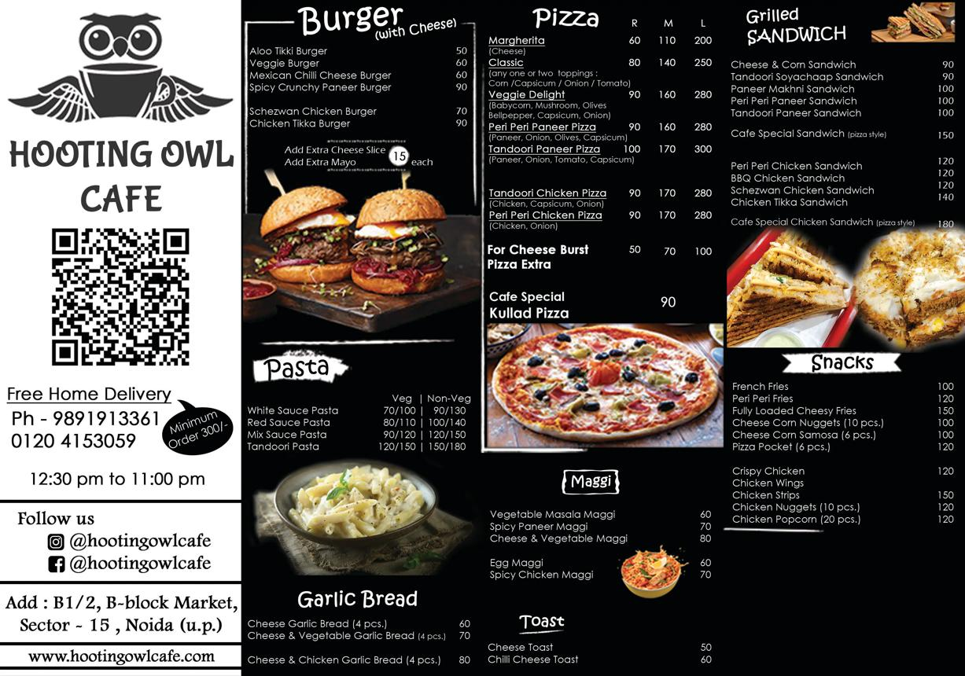
2. Zomato — Restaurant menu chatbot
A restaurant could provide its menu as a PDF and allow customers to ask:
- "Which dishes are vegetarian?"
- "Which pizza costs less than ₹300?"
- "Does the menu mention any allergens?"
Benefit: Customers can find dishes, prices, and dietary information faster. Allergen information should be verified against reliable restaurant-provided details.
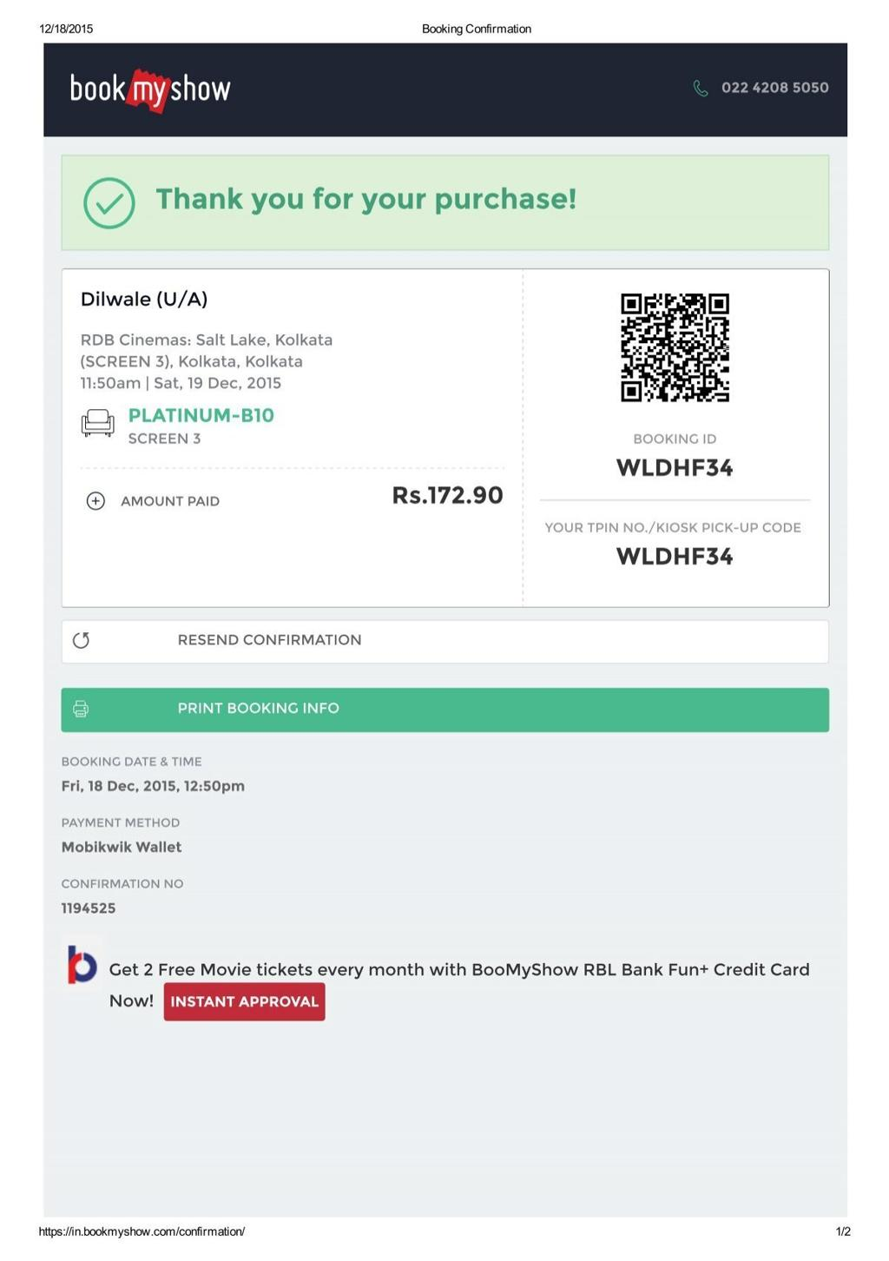
3. BookMyShow — Ticket and event guide assistant
Users could upload an event ticket or venue guide PDF and ask:
- "What time does the show start?"
- "Which seat is assigned to me?"
- "What are the venue's entry instructions?"
Benefit: Users can quickly locate event details and entry instructions without searching through multiple pages.
These are proposed applications, not claims that these companies currently offer these exact PDF chatbot features.
Final conclusion
A PDF chatbot combines PDF text extraction, chunking, embeddings, similarity search, and answer generation.
The basic workflow is:
PDF document
Extract text and create chunks
Generate embeddings
Retrieve the most relevant chunk
Answer the user's question

